TDTMS Meeting
August 03, 2016
09:30 AM

Agenda
1. | - Antitrust Statement  - Introductions  Kyle Patrick – NRG  Catherine Meiners – ERCOT  Tammy Stewart – ERCOT  Kathy Scott – CNP  Sheri Wiegand – TXU  Monica Jones - NRG  Lindsay Butterfield – ERCOT  Jim Lee – AEP  Dave Pagliai – ERCOT  Debbie McKeever – Oncor  Michael Glass – Sharyland  Rita Cardenas – AEP  Teresa Rodriguez – Stream  Vikram Gupta – ERCOT  - Review of Agenda
2. | Review/Approve July Meeting Notes  - approved
3. | ERCOT System Instances & MarkeTrak Monthly Performance Review
4. | MarkeTrak Upgrade - Discuss additional functionality/requirements (parking lot items)  ** MPs wishing to invoke modifications to MT, shall use TDTMS Issue Tracking Request Form (on the TDTMS Home Page) to submit desired changes**  - Leadership will issue a Tracking Number  - Leadership will develop a matrix which will link to the Tracking Number and include:  - Tracking Number, Enhancement Requested, System Impacts, Benefits, etc.  TDTMS will sync with TXSET and RMTTF to add/remove functionality to the MT tool. Thought being, if TXSET implements any transactional solutions, it could mean functionality is not needed within MT. Also, with RMTTF, if there are lessons learned through market training to add process flow improvements or inconsistencies between drop down choices available and MarkeTrak UG, those improvements/inconsistencies can be addressed through functionality upgrades.  - Content within drop down choices  - Match up choices in the MT UG with the choices within the MT tool.  - Unexecutable transitions – Changing requirements to add Comments for any negative transitions (ie: Unexecutable)  - Each subtype would have it’s own group of Unexecutable reasons  - Opt-out  - Move away from Market Rule; develop a separate subtype of Opt Out  - Switch Hold Removal  - Validate with ERCOT back-end systems for “No Switch Hold Pending on ESIID” and;  - “Issue Should Not be Submitted by ROR”  - Cancel w/ Approval – not needed due to NPRR778  - IAG  - Change UE reasons to match MT UG – drop down does not match.  - Rescission  - Change UE reasons to match MT UG – drop down does not match.  - AMS LSE Disputes  - UIDAMSINTERVAL validation  - Clarify proper usage of subtype if different in the future  - Possible creation of new subtype to address 867 vs LSE disputes  - Although disputing the LSE, include 867_03 TranID field for reference  - Clarify proper usage of subtype if included in release  - Changing the requirement to make any Comments mandatory  Added 8/3:  - Evaluate removing/modifying the “Autoclose” feature – if autocloses, use the ‘last modified’ date for more accurate reporting.  - Adding the proper date and time stamp format when submitting U/B issues  - Common TDSP Comments on the ‘Unexecutable’ transition:  - Move Out Cancelled  - Issue submitted prior to next scheduled cycle read  - Invalid data  - Duplicate issue  - Move Out order still pending  - Invalid date and/or time stamp  - If “Other” is added, make Comments mandatory  - Switch Hold validations:  - Linking to ERCOT backend systems to validate “No Switch Hold Pending on ESIID” and “Issue Should not be Submitted by ROR”
5. | MarkeTrak Subtype Analysis  - Feedback re: MT User’s Guide changes – AMS LSE – Dispute language  - Review of all other MarkeTrak subtype volumes - ERCOT stats  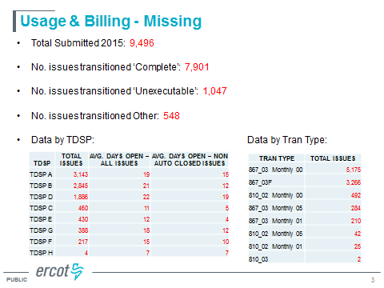  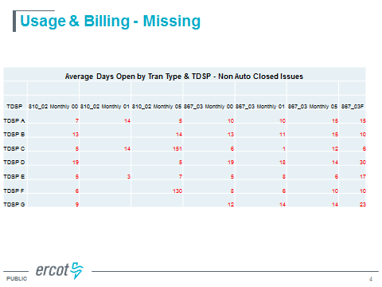  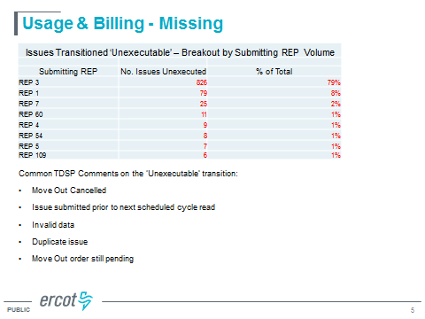  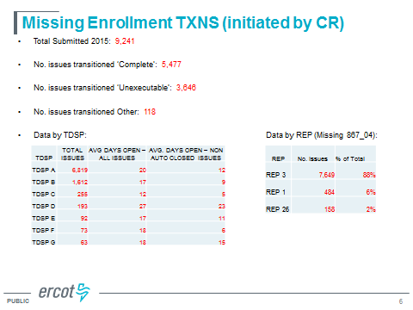  - 94% of Missing Enrollments were “Unexecuted”; of these REP 3 accounted for 88%  - If we can eliminate 7,649 issues, that would help reporting for the entire market.  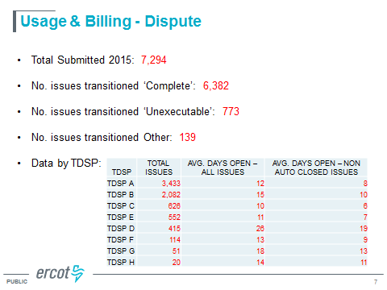  - Were the “UE” due to Invalid time stamp or Invalid dates? Need to add clarity in UG or on the tool to reflect the correct formatting for dates and time stamps to reduce UEs.  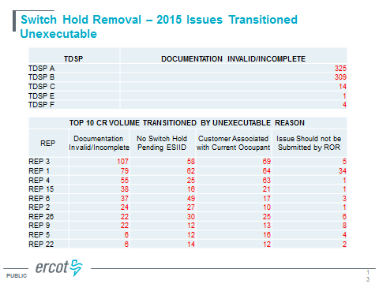  - “Issue should not be submitted by ROR” – this means that CR should send 650 instead of MT
6. | Inadvertent Gain Reporting Refinements  - As requested, ERCOT combined all 3 breakout graphs into one slide. TDTMS was very happy with the results.  - Group would like to see “original” (all-inclusive) graph broken into the 3 buckets (showing the reporting month’s performance) & “new” graph with the 3 buckets (showing the rolling 12 month performance).  - For the old IAG report (‘Mountain’/’trends’), ERCOT will add the raw data of “total IAG + IAL + Rescission” as an embedded Excel sheet within the monthly IAG report so users can mine their own data.  - ERCOT will also add this to the slide containing the raw data also:  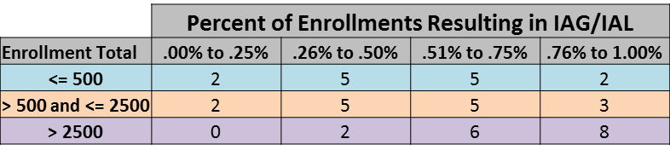  - Action Item: TDTMS will review again in September – if ERCOT has June 2016 data available, they will report the June numbers. If not, ERCOT will present the March 2016 data in the new format to see if the proposed changes would have made the report more intuitive.
7. | October 5th meeting conflicts – New proposed meeting date: 10/11  TDTMS will meet on October 11th.  Other business:  October meeting: TDTMS to review 2016 Goals & Objectives to ensure we are on the right track  Look ahead (Nov/Dec):  - 2016 Accomplishments  - 2017 meeting schedule (take into consideration possible RMS meeting changes)
8. | Adjourn

