Dual Grid Operations of Tenaska Frontier Generation

Background
The Tenaska Frontier Facility is an 830 MW dual-fuel, dual grid, natural gas fired combined-cycle electric-power generation plant located on approximately 224-acre parcel of land near Shiro, TX. Tenaska Frontier Partners, LTD are the Generator Owner (GO) and Generator Operator (GOP) and Exelon Generation Company; LLC is the Market Participant (MP) for the plant. The configuration at Tenaska’s Frontier Generating Station allows interconnection with both the ERCOT and the Eastern Interconnections as shown in figure 1.The 345kV lines coming from Singleton and King connect to CenterPoint Energy interconnection and the line going to Grimes is the Frontier plant’s connection to the Entergy system. The GO and MP, under an existing long term Power Purchase Agreement, have the ability to maintain the dual-grid injection to either CenterPoint Energy (ERCOT) or Entergy or both. However, switching of the Tenaska Frontier Generating Station between CenterPoint Energy and Entergy is “break before make” to avoid direct connection between the ERCOT interconnection and Eastern interconnection at all times.
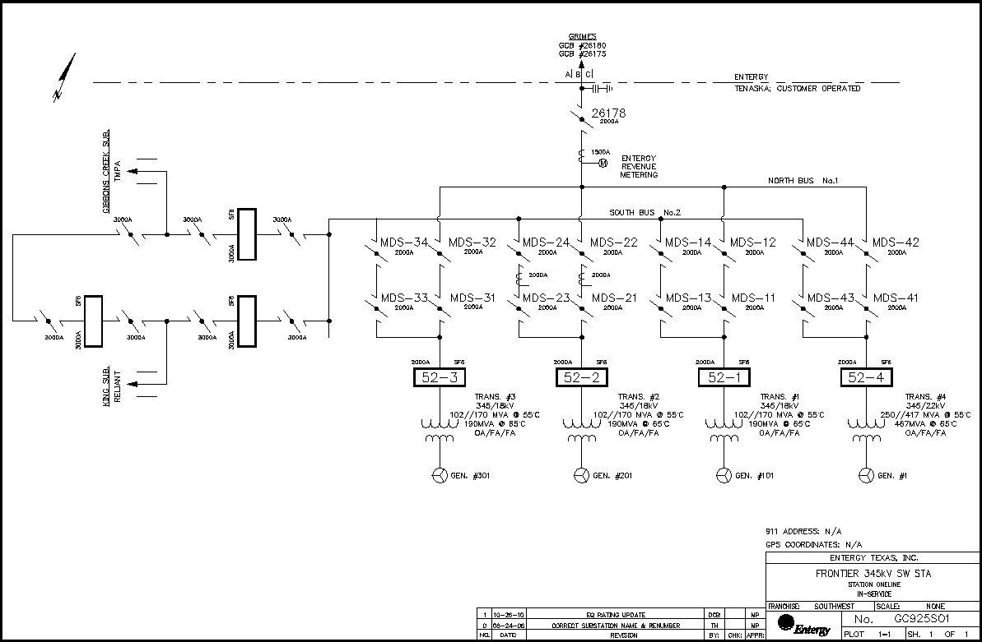
Figure 1: Frontier Station with Tenaska Frontier Generation Connection

Purpose
The purpose of this Operating Guide is to coordinate day ahead scheduling and real time operation of Tenaska Frontier Generation among the GO/GOP, CenterPoint Energy/ERCOT and Entergy/MISO. This guide may be modified at any time upon review and discussion by the entities that are coordinating operations.

General:
- The MP will be able to source and schedule energy from the Tenaska Frontier units similar to other generation within the MISO or ERCOT transmission system on both a real-time and day ahead basis. MISO and ERCOT will be required to create and show each Tenaska Frontier unit as a source in the MISO/ERCOT system/area to allow for each unit to be selected as a valid source point for scheduling power both day-ahead and real time. A unit specific identifier will be created for each unit for the purposes of tagging and scheduling consistency.

- MISO and ERCOT Reliability Coordination shall monitor system conditions and by exception, not approve requests to generate in Real Time based on Tenaska Frontier Units adversely impacting system conditions in accordance with applicable procedures.

- The GO/MP shall notify MISO and ERCOT of the intent to switch from one market to the other at least one hour prior to projected transition time. This time will allow for sufficient reliability analyses.

Day Ahead Scheduling
- The MP shall be responsible for the Day Ahead scheduling of the Frontier Tenaska Generating Units.
- The MP will meet the MISO Module E DA Must Offer Requirement for the portion of capacity committed to the MISO region for the applicable Planning Year from a combination of the units that make up the entire 830 MW Frontier plant.
- For the Frontier Tenaska Generating Units scheduled to deliver energy into MISO, the GO/MP will follow applicable MISO procedures.

- For Frontier Tenaska Generating Units scheduled to deliver energy into CenterPoint Energy (ERCOT), the GO/MP will follow applicable ERCOT procedures.

- The MP shall not offer capacity for a single physical unit into the MISO and ERCOT Day Ahead Markets for the same operating day. If the MP schedules capacity into the ERCOT Day Ahead Market, the same capacity shall not be offered into the MISO Day Ahead Market and vice versa.

Real Time Operations for Scheduling to Entergy (MISO)

- General

- The MISO and ERCOT have reliability coordination responsibility for the respective bulk transmission systems.

- For the Tenaska Frontier Generating Units connected to the Entergy 345kV system, Exelon (MP) will communicate with MISO, and Tenaska (GO), shall follow MISO dispatch set points as communicated by Exelon.

- For the Tenaska Frontier Generating Units connected to the Entergy 345 kV system, the GO, Tenaska, will follow a voltage schedule provided by the current Transmission Operator for the station (e.g. Entergy Transmission Operations Center (TOC) or ITC Holdings).

- The GO shall also follow applicable MISO, Entergy, SERC and NERC requirements concerning the operation of voltage and reactive control devices and the reporting of such control system status.

B. Normal Real Time Operations

- The GO is responsible for switching between the Entergy 345kV Bus and the Center Point Energy 345kV Bus. This is a dual grid plant and can provide MWs on both grids at the same time, although individual generating units within the plant can only be connected to one grid at a time.
- Entergy Transmission Operating Center (TOC) and CenterPoint Energy shall be responsible for coordination of their switching orders for Tenaska Frontier, Grimes, Singleton and King Substations to ensure that the ERCOT Interconnection and the Eastern Interconnection are not connected at any time. This connection shall be a break before make.
- The GO shall follow the instructions from the current Transmission Operator for the station (e.g. Entergy Transmission Operations Center (TOC) or ITC Holdings) to synchronize the Tenaska Frontier Generating Station to the Entergy transmission system.

C. Emergency Real Time Operations

- The MP, Exelon, shall follow MISO’s Emergency Real Time directives involving Tenaska Frontier Generating Units connected to the Entergy 345kV transmission system. The capacity available during an Emergency is dependent on which grid the emergency occurs and may require coordination between the ERCOT and MISO grids as well as the MP and GO to facilitate the timing of the grid switch if required. The capacity rights are defined for each grid based on the GO’s ERCOT filings for dual grid generators and MISO’s requirements for generators with capacity obligations.
2. MISO Operations will communicate any MISO Emergency directive to the Entergy System Operating Center and ERCOT Operations, as appropriate:
  - The Entergy System Operating Center will communicate the MISO Emergency directives to the MP, Exelon.
b. ERCOT Operations will communicate the MISO Emergency directive to CenterPoint Energy Transmission Operations, as appropriate.

Real Time Operations for Scheduling to Center Point Energy (ERCOT)

- General

- The MISO and ERCOT have reliability coordination responsibility for the respective bulk transmission systems.

- For the Tenaska Frontier Generating Units connected to the CenterPoint Energy 345kV system, the MP/GO shall follow ERCOT dispatch set points.

- For the Tenaska Frontier Generating Units connected to the CenterPoint Energy 345 kV system, the GO shall follow a voltage schedule provided by CenterPoint Energy Operations or ERCOT.

- The GOP shall also follow applicable ERCOT, CenterPoint Energy, Texas RE and NERC requirements concerning the operation of voltage and reactive control devices and the reporting of such control system status.

- Normal Real Time Operations

- The GO is responsible for switching between the Entergy 345kV Bus and the Center Point Energy 345kV Bus.

- Entergy Transmission Operating Center (TOC) and CenterPoint Energy Operations shall be responsible for coordination of their switching orders for Tenaska Frontier, Grimes, Singleton and King substations to ensure that the ERCOT Interconnection and the Eastern Interconnection are not connected at any time. This connection shall be a break before make.
- The GO shall follow the instructions from CenterPoint Energy Transmission Operations to synchronize the Tenaska Frontier Generating Station to the Center Point Energy transmission system.

- Emergency Real Time Operations

- The MP/GO shall follow ERCOT’s emergency real time directives involving Tenaska Frontier Generating units connected to the CenterPoint Energy 345kV transmission system. The capacity available during an emergency is dependent on which grid the emergency occurs and may require coordination between the ERCOT and MISO grids as well as the MP and GO to facilitate the timing of the grid switch if required. The capacity rights are defined for each grid based on the GO’s ERCOT filings for dual grid generators and MISO’s requirements for generators with capacity obligations.2. ERCOT Operations will communicate any ERCOT directive to CenterPoint Energy Transmission Operations, the MP, and MISO Operations, as appropriate:
a. The MP will communicate the ERCOT directive to the GO.
  - MISO Operations will communicate the ERCOT directive to Entergy Transmission Operating Center, as appropriate.

Capacity Allocation During Derates and Forced Outages

When a capacity obligation is made with an entity in MISO, i.e. considered “MISO capacity” and units for operation have been specified for a schedule in Real Time, then the following parameters hold:

- If a Unit specified for MISO operations to meet MISO Capacity obligations was operating when an Unplanned Outage occurred that reduced the Capacity of such Unit to less than 150 MW, such Unit shall continue to be designated for MISO for the duration of the Unplanned Outage and the outage recorded in MISO’s CROW. Outages for the physical units and the market units shall be entered into MISO’s CROW as appropriate.

- If a Unit is required to be declared for operations in MISO and is less than 150 MW as a result of an Unplanned Outage, and such Unit was not operating at the time of such Unplanned Outage, then the Unit shall be designated to the grid it last operated with until the duration of the Unplanned Outage; and

- If the amount of Capacity that will be available from a unit in any hour of the day is less than 150 MW as a result of Planned Maintenance, such unit may be designated as a MISO unit for the hour, if it is designated as capacity in MISO and was designated for MISO in the Planned Maintenance Schedule in effect OR the unit was a MISO designated unit in the last hour of the Planned Maintenance.

- MP may substitute a unit operationally designated for MISO capacity with a unit of equal or greater available capacity operating in ERCOT (Substitute Unit), if ERCOT allows. Consideration of this substitution is normal procedure when the unit operationally designated for MISO capacity undergoes an Unplanned Outage

- If MP so elects (4) above, Exelon shall notify MISO through the protocols agreed upon. Once such notification is made, the unit shall be determined to be a unit operationally designated for MISO capacity and the unit experiencing the unplanned outage shall not be considered a unit designated for MISO capacity.

Planned and Un-Planned Outage Reporting

Planned and un-planned outages to the units at the Frontier Generating Station will be reported to both MISO and ERCOT. Outage reporting will include sufficient details to identify if the unit outage is allocated to MISO or ERCOT system.

Planned outage allocation between the ERCOT and MISO systems is based on a pro rata share of ~2/3 MISO and ~1/3 ERCOT for GT outages. When a GT is on outage, the facility is unavailable on either grid. When a GT is on outage, then the Steam Turbine is derated an amount corresponding to impact of the GT outage.

Unplanned outage allocation is based on current unit system allocation when a unit failure occurs. Exception: failed units on the MISO system may be substituted from the ERCOT to meet capacity requirements. See “Capacity Allocation during Forced and un-planned outages” section for details.

Data Exchange
All entities involved agree to coordinate information, as needed and available, to support reliability assessments.

Contact Names and Phone Numbers:
MISO
Tim Aliff-Senior Manager Southern Regional Operations
317-697-4837

ERCOT
Colleen Frosch-Manager System Operations
512-248-4219
Jimmy Hartmann-Control Room Operations Manager
512-248-6986
Entergy

Tenaska
Tenaska Frontier Partners, LTD Plant-24 hour desk
936-874-2880
Todd Bading – Plant Engineer
(936) 874-2695Exelon

