June 2016 ERCOT Monthly Operations Report
Reliability and Operations Subcommittee Meeting
August 4th, 2016

Table of Contents
1. Report Highlights 1
2. Frequency Control 2
2.1. Frequency Events 2
2.2. Responsive Reserve Events 3
2.3. Load Resource Events 3
3. Reliability Unit Commitment 3
4. Wind Generation as a Percent of Load 5
5. Congestion Analysis 5
5.1. Notable Constraints for June 5
5.2. Generic Transmission Constraint Congestion 8
5.3. Manual Overrides for June 8
5.4. Congestion Costs for Calendar Year 2016 8
6. System Events 9
6.1. ERCOT Peak Load 9
6.2. Load Shed Events 9
6.3. Stability Events 9
6.4. Notable PMU Events 9
6.5. TRE/DOE Reportable Events 9
6.6. New/Updated Constraint Management Plans 9
6.7. New/Modified/Removed SPS 9
6.8. New Procedures/Forms/Operating Bulletins 9
7. Emergency Conditions 10
7.1. OCNs 10
7.2. Advisories 10
7.3. Watches 10
7.4. Emergency Notices 10
8. Application Performance 10
8.1. TSAT/VSAT Performance Issues 10
8.2. Communication Issues 10
8.3. Market System Issues 10
Appendix A: Real-Time Constraints 11

Report Highlights
- The unofficial ERCOT peak for June was 65,184 MW.
- There were three frequency events in June. PMU data indicates the ERCOT system transitioned well in each case.
- There were three instances where Responsive Reserves were deployed, all of which were the result of frequency events.
- There were twenty-six RUC commitments in June.
- The level of reportable SCED congestion increased in June. This congestion was due primarily to planned outages and area load/gen patterns. There were thirty-four instances over 25 days on the Generic Transmission Constraints (GTCs) in June. There were five days of activity on the Zorillo – Ajo GTC, eight days on the Panhandle GTC, and twenty-one days on the Liston GTC in June. There was no activity on the remaining GTCs during the Month.
- There were no significant system events for the month of June.
- There were no application issues to report for June.

Frequency Control

Frequency Events
The ERCOT Interconnection experienced seven frequency events in June, all of which resulted from Resource trips. The average event duration was approximately 0:03:00.

When analyzing frequency events, ERCOT evaluates PMU data according to industry standards. Events with an oscillating frequency of less than 1 Hz are considered to be inter-area, while higher frequencies indicate local events. Industry standards specify that damping ratio for inter-area oscillations should be 3.0% or greater. All events listed below indicate the ERCOT system met these standards and transitioned well after each disturbance.

Reported frequency events will include both frequency events where frequency was outside the range of 60±0.1 Hz as well as those determined to be Frequency Measurable Events (FME) as defined by BAL-001-TRE-1. Delta Frequency is defined as the difference between the pre-perturbation and post-perturbation frequency. The Duration of Event is defined as the time it takes for the frequency to recover to lesser/greater of the frequency at the time of the frequency event (t(0) or “A-point”) for low/high-frequency events, respectively. Further details on FMEs can be found in the MIS posted BAL-001-TRE-1 PDCWG Unit Performance reports. A summary of the frequency events is provided below:

 | Date and Time |  | Delta Frequency | Max/Min Frequency | Duration of Event | PMU Data |  | Load | Wind |  | Inertia |  | Comments
 |  |  | (Hz) | (Hz) |  | Oscillation Mode (Hz) | Damping Ratio | (MW) | % |  | (GW-s)
6/6/2016 16:21 |  | 0.064 |  | 59.90 | 0:05:32 | 0.65 | 7% | 36,327 |  | 29% |  | 221,026 |  | Unit Trip of 517 MW
6/19/2016 18:14 |  | 0.082 |  | 59.88 | 0:05:39 | 0.76 | 15% | 53,972 |  | 1% |  | 309,402 |  | Unit Trip of 669 MW
 |  |  |  |  |  | 0.63 | 12%
6/24/2016 14:44 |  | 0.049 |  | 59.88 | 0:03:19 | 0.64 | 10% | 56,582 |  | 9% |  | 320,633 |  | Unit Trip of 484 MW

(Note: frequency events highlighted in blue have been identified as FMEs per BAL-001-TRE-1 and the Performance Disturbance Compliance Working group.)

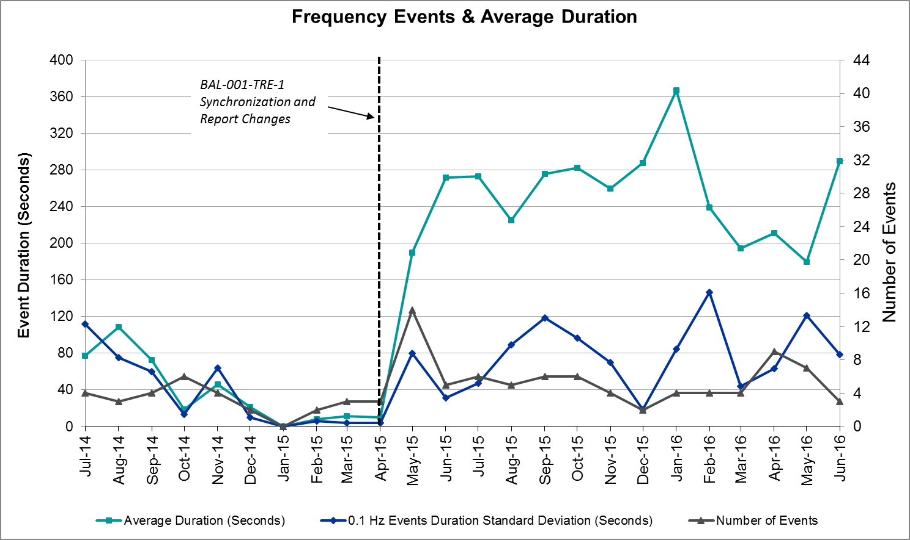

Responsive Reserve Events
There were seven events where Responsive Reserve MWs were released to SCED in June. The events highlighted in blue were related to frequency events reported in Section 2.1 above.

Date and Time Released to SCED | Date and Time Recalled | Duration of Event | Maximum MWs Released | Comments
6/6/2016 16:21:50 | 6/6/2016 16:26:02 | 0:04:12 | 500.03
6/19/2016 18:14:40 | 6/19/2016 18:19:00 | 0:04:20 | 459.95
6/24/2016 14:44:48 | 6/24/2016 14:48:32 | 0:03:44 | 396.94

Load Resource Events
None.

Reliability Unit Commitment
ERCOT reports on Reliability Unit Commitments (RUC) on a monthly basis. Commitments are reported grouped by operating day and weather zone. The total number of hours committed is the sum of the hours for all the units in the specified region. Additional information on RUC commitments can be found on the MIS secure site at Grid Generation Reliability Unit Commitment.

There were no DRUC commitments in June.

There were 26 HRUC commitments in June.

HRUC Commitments
Resource Location | # of Resources | Operating Day | Total # of Hours Committed | Total MWhs | Reason for Commitment
Coastal | 8 | 6/1/2016 | 22 | 8296 | Local Congestion
Coastal | 1 | 6/3/2016 | 1 | 11 | Local Congestion
South Central | 1 | 6/3/2016 | 2 | 50 | Local Congestion
Coastal | 1 | 6/6/2016 | 6 | 3216 | Local Congestion
Coastal | 2 | 6/7/2016 | 15 | 8217 | Houston Import, Local Congestion
Southern | 2 | 6/7/2016 | 15 | 735 | Valley Import
Coastal | 1 | 6/8/2016 | 5 | 3745 | Local Congestion
Coastal | 3 | 6/9/2016 | 23 | 14907 | Local Congestion
Southern | 1 | 6/9/2016 | 8 | 2640 | Local Congestion
Coastal | 1 | 6/10/2016 | 14 | 10486 | Local Congestion
Coastal | 1 | 6/11/2016 | 4 | 676 | Local Congestion
Coastal | 1 | 6/13/2016 | 5 | 3745 | Local Congestion
Coastal | 5 | 6/14/2016 | 41 | 23244 | North to Houston
Coastal | 2 | 6/15/2016 | 24 | 17904 | Local Congestion
Coastal | 2 | 6/16/2016 | 26 | 17396 | Local Congestion
Coastal | 1 | 6/17/2016 | 2 | 492 | Local Congestion
Southern | 2 | 6/21/2016 | 3 | 698 | Local Congestion, Valley Import
Coastal | 1 | 6/21/2016 | 4 | 676 | Local Congestion
North Central | 9 | 6/22/2016 | 49 | 8014 | Local Congestion
North Central | 2 | 6/23/2016 | 7 | 427 | Local Congestion
Southern | 1 | 6/23/2016 | 8 | 2640 | Local Congestion
Coastal | 1 | 6/24/2016 | 8 | 4288 | Local Congestion
Coastal | 1 | 6/25/2016 | 3 | 1608 | Local Congestion
North Central | 1 | 6/28/2016 | 5 | 2615 | Local Congestion
South Central | 1 | 6/28/2016 | 5 | 630 | Local Congestion
Coastal | 2 | 6/29/2016 | 8 | 1352 | Local Congestion

Wind Generation as a Percent of Load
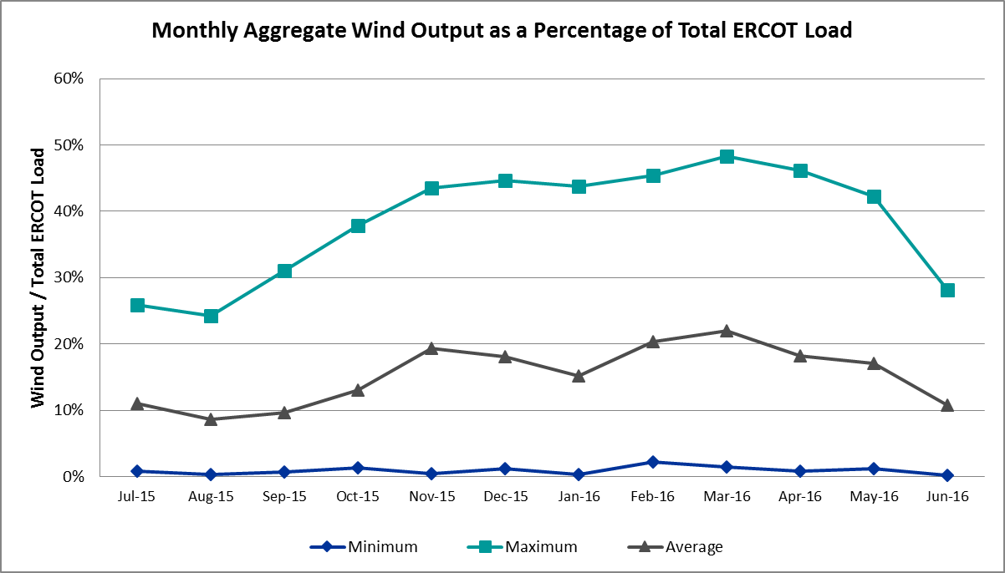

Congestion Analysis
The number of congestion events experienced by the ERCOT system decreased in June. There were thirty-four instances of activity on the Generic Transmission Constraints (GTCs) in June.

Notable Constraints for June
Nodal protocol section 3.20 specifies that ERCOT shall identify transmission constraints that are active or binding three or more times within a calendar month. As part of this process, ERCOT reports congestion that meets this criterion to ROS. In addition ERCOT also highlights notable constraints that have an estimated congestion rent exceeding $1,000,000 for a calendar month. These constraints are detailed in the table below. Rows highlighted in blue indicate the congestion was affected by one or more outages. For a list of all constraints activated in SCED for the month of June, please see Appendix A at the end of this report.

Contingency | Overload | # of Days Constraint Active | Estimated Congestion Rent | Transmission Project
Ph Robinson At1l_H (3)345/138 kV | Meadow AT1 345/138kV | 14 | $33,467,561.08 | 4708
Bm-Sr73 & Sr81 138kV | Bellaire - San Felipe 138kV | 3 | $7,119,922.62 | 4703
DCKT Jewett - Singleton 345 kV | Btu_Jack_Creek - Twin Oak Switch 345kV | 16 | $4,959,861.57 | Hourton Import Project
Fort Worth Subsation to West Denton 138 kV | Jim Christal Substation - West Denton 138kV | 3 | $2,607,972.70
DKCT Roans Prarie-Rothwood & Singleton-Tomball 345kV | Singleton - Zenith 345kV | 11 | $2,444,807.48 | Houston Import Project
Garfield-Hicross And Onion-Stoney_R 138kV | Mcneil Lcra - Mcneil Aen 138kV | 3 | $2,384,574.67
Lewisville Switch Axfmr22 345/138 kV | Carrollton Northwest 138 kV Reactor | 1 | $2,040,251.79 | 2013 to 2015 RTP
Lewisville Switch Axfmr22 345/138 kV | Fort Worth Subsation - West Denton 138kV | 2 | $1,697,644.28
Btu_Atkins Axfmr1 138/69 kV | Btu_Briarcrest - Btu_Nall_Lane 69kV | 14 | $1,325,722.87 | 4574
Ph Robinson At1l_H (3)345/138 kV | Seminole Tnp - Friendswood Tnp 138kV | 1 | $1,322,908.13
Sn-Str26 & Bfp-Vl82 | Hofman - Lake Jackson 138kV | 1 | $1,089,700.68
DCKT Marion - Zorn and Clear Springs 345 kV | Clear Springs - Geronimo 138kV | 8 | $962,359.19
Gila - Hiway 9 138 kV | Morris Street - Gila 138kV | 21 | $864,694.17
Bevo Substation - Asherton 138 kV | Hamilton Road - Maverick 138kV | 3 | $676,009.33 | 16TPIT0024
DCKT Chambers - King and Cedar Bayou - Jordan 345 kV | Brine - Langston 138kV | 3 | $543,836.38
DCKT STP - Hillje and STP - Whitepoint 345 kV | Blessing - Lolita 138kV | 8 | $445,679.51
Zorn-Marion & Cleasp 345kV | Comal - Henne 138kV | 7 | $424,355.80 | 4454
Sn-Str26 & Bfp-Vl82 | Markham Tie To Aep - Van Vleck Switch 69kV | 3 | $376,809.52
Basecase | Liston GTC | 21 | $290,113.24
Hutto - Round Rock & Gabriel 138 kV | Gilleland - Mcneil Lcra 138kV | 11 | $282,384.33 | 5269
DCKT Singleton - Zenith 345 kV | Betka - Hockley 138kV | 3 | $182,666.40 | 3682A,3682,3682C
Eagle Mountain 2 Compressor Station to Eagle Mountain Poi (5)138/138/138/138/138 kV | Eagle Mountain Ses - Wagley Robertson 138kV | 3 | $138,381.85 | 15TPIT0085
Carrolton Northwest - Lewisville Switch 345 kV | Lewisville Switch - Jones Street Tnp 138kV | 4 | $96,794.28
Laquinta - Lobo 138 kV | Bruni Sub 69_1 138/69kV | 6 | $90,784.80
Bosque Switch - Elm Mott 345 kV | Bosque Switch - Rogers Hill Bepc 138kV | 11 | $80,252.43 | 4356
Bosque Switch - Elm Mott 345 kV | Rogers Hill Bepc - Elm Mott 138kV | 4 | $79,500.53
Marbfa-Lakewy &Wirtz-Palefa 138kV | Flat Rock Lcra - Wirtz 138kV | 11 | $77,992.60 | 4465
Emses-Sagna 138kV | Eagle Mountain Ses - Morris Dido 138kV | 3 | $68,299.99 | 4252
Mercers Gap Sw to Comanche Switch (Oncor) 138 kV | Camp Bowie (Oncor) - Brownwood Switch 138kV | 6 | $65,243.28
Hicks Switch - Alliance & Roanoke Switch 345 kV | Eagle Mountain Ses - Eagle Mountain Poi 138kV | 3 | $58,161.70
Zorn-Marion & Cleasp 345kV | Henne - Zorn 138kV | 4 | $57,197.87
Ph Robinson to Center 345 kV | Aritek - Chorin 138kV | 4 | $56,403.75 | 4426
Basecase | Randado Aep - Zapata 138kV | 12 | $51,269.93
Wharton to Caney (2)138/138 kV | El Campo - Lane City Pump 138kV | 7 | $47,561.38
Basecase | Panhandle GTC | 8 | $46,310.13 | Panhandle Upgrade
Uvalde Aep - Odlaw Switchyard 138 kV | Hamilton Road - Maverick 138kV | 6 | $45,921.85 | 16TPIT0024
Basecase | Zorillo to Ajo GTC | 5 | $38,463.87 | LRGV (lower Rio Grande Valley) Import Project
Aspermont Aep - Spur 138 kV | Girard Tap - Jayton 69kV | 3 | $33,106.38
Victoria - Coleto Creek 138 kV (COLETO_VICTOR1) | Coleto Creek - Victoria 138kV | 4 | $31,727.13 | Live Oak RPG
Lobo 2_345_138 345/138 kV | Javalina Tap - Molina 138kV | 3 | $25,151.29 | 4401
Hiway_9 - Citgo N Oak Park 138 kV | Citgo N Oak Park - Cantwell 138kV | 5 | $23,133.96
Sweetwater Downtown to Haynes Substation (7)138/138/138/138/138/138/138 kV | Eskota Switch - Trent 69kV | 3 | $12,307.04
Dyann-Wr&Eb-Wr 138kV | El Campo - Lane City Pump 138kV | 3 | $10,470.56
DCKT Gibbons Creek - Singleton 345 kV | Jewett - Singleton 345kV | 5 | $6,487.27
Ennis Switch - Desoto Switch 138 kV | Ennis West Switch - Waxahachie 138kV | 3 | $5,976.51
DCKT Ferguson - Granite Mountain and Wirtz - Starcke - Paleface 138 kV | Flat Rock Lcra - Wirtz 138kV | 6 | $5,341.77 | 4465
Lopeno to Zapata 138 kV | Javalina Tap - Molina 138kV | 4 | $3,632.91 | 4401
Wharton to Caney (2)138/138 kV | Lane City Reactor | 3 | $683.96

Generic Transmission Constraint Congestion
There were five days of activity on the Zorillo – Ajo GTC, eight days on the Panhandle GTC, and twenty-one days on the Liston GTC in June. There was no activity on the remaining GTCs during the Month.

Note: This is how many times a constraint has been activated to avoid exceeding a GTC limit, it does not imply an exceedance of the GTC occurred or that the GTC was binding.

Manual Overrides for June
There were no manual overrides for the month of June 2016.

Congestion Costs for Calendar Year 2016
The following table represents the top twenty active constraints for the calendar year based on the estimated congestion rent attributed to the congestion. ERCOT updates this list on a monthly basis.

Contingency | Binding Element | # of 5-min SCED Intervals | Estimated Congestion Rent | Transmission Project
Ph Robinson At1l_H (3)345/138 KV | Meadow AT1 345/138kV | 1,470 | $ 37,410,531.94 | 4708
Villa Cavazos to Military Highway Aep (2)138/138 KV | Los Fresnos - Loma Alta Substation 138kV | 3,272 | $ 26,026,381.24
Rnksw-W_Dent&Lwssw-Krwsw 345kv | Fort Worth Subsation - West Denton 138kV | 1,774 | $ 10,027,611.63
Hcksw-Allnc&Rnksw 345kv | Eagle Mountain Ses - Morris Dido 138kV | 1,420 | $ 8,755,553.47 | 4252
Basecase | Panhandle GTC | 4,595 | $ 7,937,227.06 | Panhandle Upgrade
Bm-Sr73 & Sr81 138kv | Bellaire - San Felipe 138kV | 196 | $ 7,119,922.62
Rosen Heights to Eagle Mountain Compressor (5)138/138/138/138/138 KV | Rosen Heights Tap 2 - Morris Dido 138kV | 857 | $ 6,945,775.57 | 4252
Meadow to Ph Robinson 345 KV | Meadow AT1 345/138kV | 89 | $ 6,552,987.55 | 4708
Jewet-Sng 345kv | Btu_Jack_Creek - Twin Oak Switch 345kV | 3,221 | $ 6,507,814.08 | Hourton Import Project
Basecase | Valley Import | 110 | $ 6,494,964.50 | LRGV (lower Rio Grande Valley) Import Project
Lwssw-Krwsw&Rnksw 345kv | Fort Worth Subsation - West Denton 138kV | 788 | $ 5,462,367.54
Hcksw-Allnc&Rnksw 345kv | Rosen Heights Tap 2 - Morris Dido 138kV | 805 | $ 5,063,292.44 | 4252
South Carbide to Loma Alta Substation 138 KV | La Palma - Villa Cavazos 138kV | 505 | $ 5,060,645.62
Rns-Rtw & Sng-Tb 345kv | Singleton - Zenith 345kV | 2,090 | $ 5,047,008.96 | Houston Import Project
Mason Road to Obrien 138 KV | Betka - Hockley 138kV | 257 | $ 4,451,883.67 | 3682A,3682,3682C
South Texas # 1 & # 2 | Marion - Clear Springs 345kV | 18 | $ 4,402,597.52
Nelson Sharpe to Ajo 345 KV | Javalina Tap - Molina 138kV | 4,406 | $ 4,208,950.27 | 4401
Ph Robinson At4_H (3)345/138 KV | Meadow AT1 345/138kV | 62 | $ 3,994,537.45 | 4708
Eagle Mountain Ses Axfmr1l (3)345/138 KV | Eagle Mountain Ses AX2L 345/13.8/138kV | 329 | $ 3,993,367.46
Eagle Mountain Ses Axfmr1l (3)345/138 KV | Eagle Mountain Ses AX2H 345/13.8/138kV | 813 | $ 3,865,585.22

System Events

ERCOT Peak Load
The unofficial ERCOT peak load for the month was 65,184 MW and occurred on June 15th during hour ending 17:00.

Load Shed Events
None.

Stability Events
None.

Notable PMU Events
ERCOT analyzes PMU data for any significant system disturbances that do not fall into the Frequency Events category reported in section 2.1. The results are summarized in this section once the analysis has been completed.

There were no reportable events in June.

TRE/DOE Reportable Events
None.

New/Updated Constraint Management Plans
None.

New/Modified/Removed SPS
None.

New Procedures/Forms/Operating Bulletins
ERCOT has revised the following procedure manuals, effective June 30, 2016.

Procedure Title | POB
Communications Protocols | 746
DC Tie Desk | 747
Real-Time Desk | 748
Reliability Unit Commitment Desk | 749
Resource Desk | 750
Scripts | 751
Shift Supervisor Desk | 752
Transmission & Security Desk | 753

Emergency Conditions

OCNs
None.

Advisories
Date and Time | Description
06/06/16 16:30 | Physical Responsive Capability < 3000 MW: ERCOT is issued an Advisory due to Physical Responsive Capability being below 3000 MW.

Watches
None.

Emergency Notices
Date and Time | Description
06/13/16 13:35 | Transmission Emergency Notice issued for a post-contingency over load in the Laredo-Hamilton Rd Area.
.

Application Performance
There were no issues to report for June.

TSAT/VSAT Performance Issues
None.

Communication Issues
None.

Market System Issues
None.

Appendix A: Real-Time Constraints
The following is a complete list of constraints activated in SCED for the month of June. Full contingency descriptions can be found in the Standard Contingencies List located on the MIS secure site at Grid Generation Reliability Unit Commitment.

Contingency | Constrained Element | From Station | To Station | # of Days Constraint Active
BASE CASE | LISTON | n/a | n/a | 21
SGILNU78 | GILA_MORRIS1_1 | GILA | MORRIS | 21
DJEWSNG5 | JK_TOKSW_1 | TOKSW | JK_CK | 16
XATK89 | NAL_BRIR_1 | NALL_LN | BRIRCRT | 14
XPHR58 | MDO_AT1 | MDO | MDO | 14
BASE CASE | RANDAD_ZAPATA1_1 | RANDADO | ZAPATA | 12
DRNS_TB5 | SNGZEN99_A | SNG | ZEN | 11
SBOSELM5 | 1030__B | BOSQUESW | RGH | 11
DMARPA_8 | 38T365_1 | WIRTZ | FLATRO | 11
DHUTGAB8 | 211T147_1 | GILLCR | MCNEIL_ | 11
BASE CASE | PNHNDL | n/a | n/a | 8
DSTPWHI5 | BLESSI_LOLITA1_1 | BLESSING | LOLITA | 8
DMARZOR5 | 505T505_1 | CLEASP | GERONI | 8
SWRDYN8 | EL_CAM_LANCTY1_1 | LANCTYPM | EL_CAMPO | 7
DCLEZOR5 | 86T235_1 | HENNE | COMAL | 7
SZEPCMN8 | 670__B | BRNSW | CMPBW | 6
SLAQLOB8 | BRUNI_69_1 | BRUNI | BRUNI | 6
SBRAUVA8 | HAMILT_MAVERI1_1 | HAMILTON | MAVERICK | 6
DFERPAL8 | 38T365_1 | WIRTZ | FLATRO | 6
BASE CASE | ZO_AJO | n/a | n/a | 5
SHIWCIT8 | 11T436_1 | CITGO_NO | CANTWELL | 5
DGIBSNG5 | 260_A_1 | JEWET | SNG | 5
SBOSELM5 | 1030__A | RGH | ELMOT | 4
SRANZA28 | JAVALT_MOLINA1_1 | JAVALTAP | MOLINA | 4
SPHRCTR5 | ATKRIN87_A | RIN | ATK | 4
DCLEZOR5 | 89T204_1 | ZORN | HENNE | 4
DCRLLSW5 | 590__A | LWSSW | LWVJS | 4
SVICCO28 | COLETO_VICTOR2_1 | COLETO | VICTORIA | 4
DWR_EB28 | EL_CAM_LANCTY1_1 | LANCTYPM | EL_CAMPO | 3
DBM_BM_8 | BI_SF_09_A | BI | SF | 3
DGARSTO8 | MCN_MCN_1 | MCNEIL_ | MCNEIL | 3
DEMSSAG8 | 6265__A | EMSES | MRSDO | 3
SSWDMGS8 | 6585__A | ESKSW | TRNT | 3
SSPUASP8 | JATN_SPUR_1C_1 | GIRA_TAP | DKEC | 3
SFTWW_D8 | AIR_W_DE_1 | W_DENT | JMCRSTL | 3
SWRDYN8 | LANCTYR1_1 | LAN_CTY | LAN_CTY | 3
DHCKRNK5 | 6270__A | EMSES | EGPOI | 3
SBEVASH8 | HAMILT_MAVERI1_1 | HAMILTON | MAVERICK | 3
SEMMEM28 | 6271__A | EMSES | WGROB | 3
DSNGZEN5 | BETHK_66_A | HK | BET | 3
XLOB58 | JAVALT_MOLINA1_1 | JAVALTAP | MOLINA | 3
DSN_BFP8 | MRK_VNVL_1 | MRKHMSW | VNVLKSW | 3
SRDODES8 | 940__C | ENWSW | WXHCH | 3
DCHBJOR5 | BRNLAN86_A | LAN | BRN | 3
XLOB58 | DILLEY_JARDIN1_1 | DILLEYSW | JARDIN | 2
SFORYEL8 | FORTMA_MASN1_1 | FORTMA | MASN | 2
XLWS158 | FTW_W_DE_1 | W_DENT | FTWORTH | 2
SBIGDIL8 | HAMILT_MAVERI1_1 | HAMILTON | MAVERICK | 2
DEMSSAG8 | 6265__D | MRSDO | RHTP2 | 2
SWEBVEN5 | 6300__G | EVRSW | OAKT2 | 2
DDILPE89 | BIG_FO_PEARSA1_1 | BIG_FOOT | PEARSAL1 | 2
DWR_EB28 | LANCTY_LAN_CT1_1 | LAN_CTY | LANCTYPM | 2
XLK2W89 | OLSE_BOS_1 | BOSQUESW | OLSEN | 2
BASE CASE | PAREDS_CNTRLAV_1 | PAREDES | MV_CNTRA | 2
DSHREVR5 | 6300__G | EVRSW | OAKT2 | 2
DCHBJOR5 | ATKRIN87_A | RIN | ATK | 2
SVICCOL8 | COLETO_VICTOR1_1 | COLETO | VICTORIA | 2
XVIC89 | MAGRUD_VICTOR2_1 | VICTORIA | MAGRUDER | 2
SGIBSNG5 | SNGXGC99_1 | GIBCRK | SNG | 2
DTRCELK5 | 1760__A | SHBSW | TYLNW | 2
XLOB58 | BESSEL_LON_HI1_1 | LON_HILL | BESSEL | 2
SGILHI28 | GILA_HIWAY_2_1 | GILA | HIWAY_9 | 2
DGARHIC8 | MCN_MCN_1 | MCNEIL_ | MCNEIL | 2
SJARDIL8 | DIL_COTU_1 | DILLEYSW | COTULAS | 2
SSNDAU15 | 450__A | SNDSW | AUSTRO | 2
SBIGDIL8 | BAT_CRST_1 | BATESVL | CRSTLSW | 1
XWI2N89 | WINKS_MR2L | WINKS | WINKS | 1
XPHR58 | G138_10C_1 | FRDSWOOD | SEMINOLE | 1
SFALROM8 | JAVALT_MOLINA1_1 | JAVALTAP | MOLINA | 1
SY4T18 | T0_Y4_1 | T0 | Y4 | 1
SHLSWHT8 | 1030__B | BOSQUESW | RGH | 1
SSCLWF28 | 6560__B | MRKLY | RICSW | 1
SSWDMGS8 | 6780_B_1 | ROBY | LONGWRTH | 1
SSWDMGS8 | 6780__A | ESKSW | LONGWRTH | 1
SMARO2B8 | BETHK_66_A | HK | BET | 1
XLOB58 | FREER_SAN_DI1_1 | SAN_DIEG | FREER | 1
BASE CASE | GLE_MERI_1 | MERIDIAN | GLENROSE | 1
SWRDYN8 | LANCTY_LAN_CT1_1 | LAN_CTY | LANCTYPM | 1
XASP89 | MUNDAY_WEIN1_1 | MUNDAYST | WEIN | 1
BASE CASE | S104A_1 | RIOHONDO | MV_BURNS | 1
BASE CASE | SNYDER_WKN_BK1_1 | ENAS | WKN_BKR | 1
XLWS158 | 2650_CBRATING_1 | CRLNW | CRLNW | 1
SMCEABS8 | MKLT_TRNT1_1 | TRNT | MKLT | 1
SRAZD18 | 2584_1 | DOWNIES | UVALDE | 1
XLWS158 | 570_B_1 | POCKRUSC | CRNTH | 1
SWHISTP5 | BLESSI_LOLITA1_1 | BLESSING | LOLITA | 1
DCHB_NB5 | CBYRNG87_A | CBY | RNG | 1
XATK89 | NOR_TABO_1 | TABOR | NORTHBR | 1
SSKISIN9 | THREE_RI_69A1 | THREE_RI | THREE_RI | 1
UFO5FOR1 | FORMOSA_TR21 | FORMOSA | FORMOSA | 1
SJMCN_D8 | FTW_W_DE_1 | W_DENT | FTWORTH | 1
SSPUASP8 | GIRA_T_SPUR1_1 | SPUR | GIRA_TAP | 1
SSWDMGS8 | HAMLIN_PLST1_1 | HAMLIN | PLST | 1
SAJORI25 | LASPUL_RIOHON1_1 | LASPULGA | RIOHONDO | 1
XWFA89 | 6945__A | LKWSW | WFALS | 1
DSN_BFP8 | HN_LJ_02_A | LJ | HN | 1
DAUSSND5 | MCN_MCN_1 | MCNEIL_ | MCNEIL | 1
DONISTO8 | MCN_MCN_1 | MCNEIL_ | MCNEIL | 1
SSPUASP8 | SPUR_69_1 | SPUR | SPUR | 1
XWI2N89 | WINKS_MR2H | WINKS | WINKS | 1
DAUSSND5 | 211T147_1 | GILLCR | MCNEIL_ | 1
SSPUMW18 | ASPM_69T1 | ASPM | ASPM | 1
DCHBJOR5 | CBYRNG87_A | CBY | RNG | 1
SLAQLOB8 | FALFUR_PREMON1_1 | FALFUR | PREMONT | 1
BASE CASE | JAVALT_MOLINA1_1 | JAVALTAP | MOLINA | 1
SSWDMGS8 | MKLT_TRNT1_1 | TRNT | MKLT | 1
XDOW58 | MRK_VNVL_1 | MRKHMSW | VNVLKSW | 1
BASE CASE | RIOHND_ERIOHND_1 | MV_RIOHO | RIOHONDO | 1
SCABWES8 | ARANSA_SEAWAL1_1 | ARANSAS | SEAWALL | 1
XMCC58 | BNDVS_DT1H | BNDVS | BNDVS | 1
DAUSGAR5 | CKT_975_1 | DUNLAP | TRIDGE | 1

