TDTMS Meeting
July 07, 2016
09:30 AM

Agenda
1 | - Introductions  Kaci Jacobs - TXU  Sheri Wiegand - TXU  Dave Pagliai - ERCOT  Tammy Stewart - ERCOT  Debbie McKeever - Oncor  Catherine Meiners - ERCOT  Kyle Patrick - NRG  Lindsay Butterfield - ERCOT  Jim Lee - AEP  Monica Jones - NRG  Carolyn Reed - CenterPoint  Isabelle Durham - CenterPoint  Kathy Scott – CenterPoint  Diana Rehfeldt – TNMP  - Review of Agenda  - Antitrust Statement
2 | Review/Approve April/June Meeting Notes  Minor edits to April meeting notes under agenda item #8  Added Sheri Wiegand to June meeting attendee list
3 | ERCOT System Instances (Outages and Failures)  Primary event in June: 6/12/16 -- Planned Maintenance Site Failover – Retail Processing, MarkeTrak
4 | MarkeTrak Monthly Performance Review  MT performance hit all metrics and SLOs  ERCOT will post change to the Retail SLA to reflect the newly added table for MT SLO performance – August RMS for consideration
5 | MarkeTrak Upgrade Update  Scheduled to begin December 2016.  ERCOT to upgrade MarkeTrak to the latest version in order to support compatibility issues and potential functionality upgrades in the future. MT has been due for an upgrade for a while (several versions behind). ERCOT to provide the specs due to the version upgrade, when available.  RMS (and other subcommittees) will not need to vote on rank/priority because it is an internal ERCOT project. However, all impacts will still be communicated to the Market.  ----------------------------------------------------------------------------------------------------------------------------  As a separate discussion:  TDTMS to revisit the ‘parking lot’ left over from MTTF to refresh functionality:  - content within drop down choices  - Opt-out  - Switch Hold Removal  - Cancel w/ Approval  - IAG  - Rescission  - AMS LSE Disputes  - Changing the requirement to add Comments for any negative transitions (ie Unexecutable)  - Validation to check “No Switch Hold Pending on this ESIID”  Will leave it as standing agenda item, and leadership will start a matrix to capture addition of desired functionality (whether left over from the MTTF archives or new functionality desired).
6 | MarkeTrak Subtype Analysis  - Usage/Billing review of AMS LSE – Dispute MarkeTrak  - Tammy pulled the start/stop times for this subtype and nearly all of them are being disputed for the entire month’s 867 vs LSE (very few “one day” disputes).  - TDTMS updated the MarkeTrak UG to reflect what is happening today and circulating for feedback/comments: allow the AMS LSE-Dispute subtype to be filed for 1 single interval AND/OR 1 contiguous billing period (no gaps in days).  - Action item: review any feedback on MT UG changes (Aug)  - Review of all other MarkeTrak subtype volumes – ERCOT stats  - 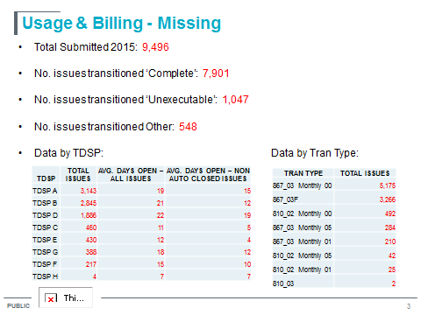  - Action Item: Tammy to breakdown “Data by Tran Type” by “Avg days open – non auto closed” per TDSP  - Buckets: 867_03 Monthly, 867_03F, 810_02 Monthly, 867 Cancel/Rebill, 810 Cancel/Rebill  - Action item: Looking at just 1 month worth of data, Tammy to sample the “Completed” to see what might be happening within the 7,901 “Completed”.  - Action Item: Breakdown to check if there is a particular CR causing the 1,047 Unexecutables?  - Action Item (TDSP): If a CR submits a “missing 867_03” and it is in transit from the TDSP already, does the TDSP Unexecute or Close?  - Majority of times, it is Completed. Unexecutables are used when erroneous dates are submitted.  - 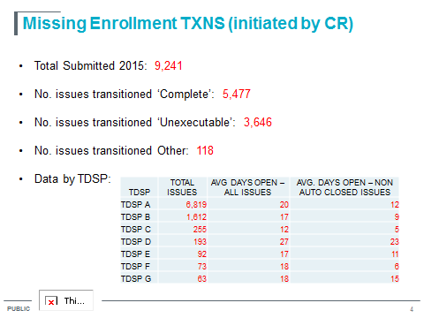  - For the 3,646 Unexecutable, comments indicate it is due to Pending Construction  - Action Item: 94% of 9,241 was due to 867_04: need to break out the 867_04 request by CRs.  - 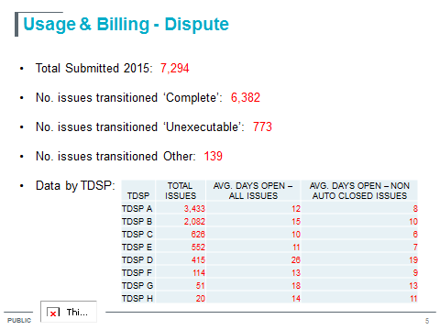  - Need clarification: Unexecutables due to invalid TIME STAMPS or invalid DATES?  - Tammy to touch base with TDSP D to inform them that U/B – Dispute performance is high.  - 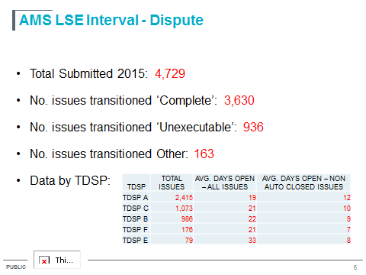  - No discussion here. Discussion occurred above in AGENDA #6.  - 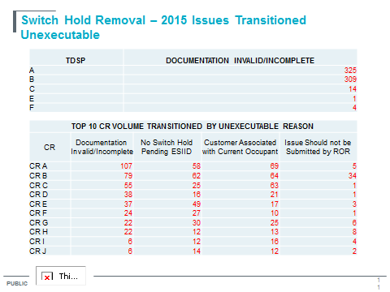  - Action Item: align the CR number with the REP number used in the IAG reporting for consistency.  - 481 due to “No SH on ESIID” could be due to timing issue of 814_20.
7 | Discussion of Potential Inadvertent Gain Reporting Refinements  Action Item: Catherine to break out the Enroll Category into 3 separate charts. Adding the hit rate to those individual charts. Bring this back in August for further discussion.  Will be added as a standing agenda for TDTMS review.
8 | Next Meeting
9 | Adjourn

