Methodology to Develop the High Impact Transmission Elements (HITEs) List

June 21st 2016

Background

The Outage Coordination Improvements Task Force (OCITF) is a task force reporting to the Reliability and Operations Subcommittee (ROS) that was formed in Feb. 2015 to determine the applicability and criteria for considering the economic impact of outages. The OCITF discussed several options to improve the outage coordination process related to the economic impact of outages, including items that were ultimately rejected after consulting with WMS and ROS (like developing tools to simulate and forecast the economic impact of outages and rejecting outages that were projected to have a high economic impact).
Following nine stakeholder meetings over the course of a year, ERCOT submitted the OCITF-developed NPRR758. Improved Transparency for Outages Potentially Having a High Economic Impact which introduces language to:
- Identify a list of Outages that are likely enough to result in high congestion costs that they will receive specific categorization and treatment. This list will be seeded based on historic congestion and finalized through a stakeholder review process to account for upgrades and other changes that would affect the predictive value of the list.
- Encourage earlier submission of these Outages.
- Formalize a rescheduling process when these Outages must be moved due to Forced Outages or later-arriving generator Outages.
- Provide improved transparency to Market Participants when Outages with this potential congestion impact are submitted with less than 90 days’ notice.
PRS and TAC approved NPRR758 in May 2016 and BOD approved it in June 2016. Although the recommended priority date for NPRR758 is in 2017, TAC requested ERCOT, along with WMS and ROS, to begin developing the High Impact Transmission Elements (HITEs) list for TAC approval, with the intent of posting this HITE list prior to the implementation of the rest of the NPRR. Purposes of this document is to describe the process by which ERCOT staff and stakeholders will identify the HITEs and develop the HITE list.
Consideration should be given to converting OCITF into a standing Working Group (Outage Coordination Working Group) (OCWG) which would report jointly to both ROS and WMS in order to facilitate the stakeholder review described in this document. This would provide a single working group where the level of detailed discussion that will be needed for this review can occur, rather than having a similar discussion in a ROS working group and also in a WMS working group.

methodology

Seed List of Potential HITEs
As demonstrated for OCITF at its 12/01/2015 meeting, ERCOT will produce an initial seed list from two existing sources:
- The list will include outages that impacted significant congestion in the past, based on analyses to produce the Operations Report submitted to ROS each month, incorporating data from previous 12-months, May 1st to April 31st.
  - Significant congestion refers to congestion that incurred over $1 million of real-time congestion rent during any given month.
  - When multiple outages are attributed as causing significant congestion, perhaps in combination, all of them are included.
  - Both forced and planned outages are included.
- The list will also include outages that previous Outage Coordination studies have indicated could cause significant congestion under certain conditions that were identified in those studies. Some of these outages may not have actually caused congestion because the outage was cancelled, rescheduled, rejected, or withdrawn as the result of the Outage Coordination studies.
There are many different Transmission Elements (breakers, switches, etc.) whose outage may interrupt flow on a particular line, transformer or bus (which, for the purpose of this procedure will be defined as Major Transmission Elements). Rather than include each of the Elements that interrupts flow on one of these Major Transmission Elements (MTEs), the seed list will only list the MTEs corresponding to the items listed on the sources above. This should facilitate the stakeholder discussion of which MTEs should be on the HITE list, rather than trying to use a more-detailed list. Once TAC has approved the list, as described below, ERCOT will process the list to identify each Transmission Element associated with interruption of flow on the approved set of MTEs on the HITE list to produce the final Detailed HITE List that will be posted and used for comparing to Outages in order to identify High Impact Outages.
In subsequent years, ERCOT will begin with the MTEs on the currently approved HITE list, and use the same two sources described above to add any MTEs that are not included in the MTEs on the currently approved HITE list, to produce the seed list for the subsequent year’s stakeholder discussion and approval.
Stakeholder Input and Review
ERCOT will provide the seed list of MTE HITEs to the OCWG for stakeholder review and input. This seed list will be provided in a format that facilitates clear discussion about individual items on the list.
Stakeholders may propose MTEs to be added to or removed from the seed list. OCWG should attempt to reach a consensus decision about whether to add or remove each of these elements from the seed list. To facilitate this consensus, the proposer should provide justification as to why the element should be added to or removed from the list. For example, a stakeholder may propose to remove an element because the element will no longer result in congestion when outaged because a relevant transmission project has been completed. For another example, a stakeholder may propose to add an element to the list because there is a new generating unit that will cause the outage of the element to result in significant congestion that was not experienced for that outage in the past because the new unit was not injecting into the grid.
If OCWG consensus is achieved, the OCWG Chair will seek endorsement by ROS and WMS, and approval by TAC, of the resulting list. If OCWG cannot reach consensus on any of the proposed additional or subtractions, the Chair of OCWG will seek a decision on the list, and the inclusion of any non-consensus elements, from ROS and WMS. The chair of OCWG will then seek approval of the resulting HITE list, and a decision on any elements about whose inclusion ROS and WMS did not agree, from the TAC.
Timing
Two timing factors are considered while developing the HITE review process:
- Align the effective date of the HITEs list with the major outage seasons. In ERCOT, the majority of planned outages occur March to May and October to November.
- Provide adequate grace period for TDSPs to plan complex transmission projects. The proposed timeline allow a six month grace period.
Annually, ERCOT will provide the MTE HITE seed list by June 1st. This will allow Market Participants time to evaluate the proposed HITE list prior to an Outage Coordination Working Group (OCWG) meeting that will be held in June.
OCWG will hold one or more meetings during June to review the HITE seed list and identify elements that should be added or removed due to upgrades or other changes. The Chair of OCWG will submit the resulting proposed MTE HITE list to ROS, WMS, and TAC in July for approvals. Upon approval, the HITE list will take effect starting Mar. 1st of the following year.

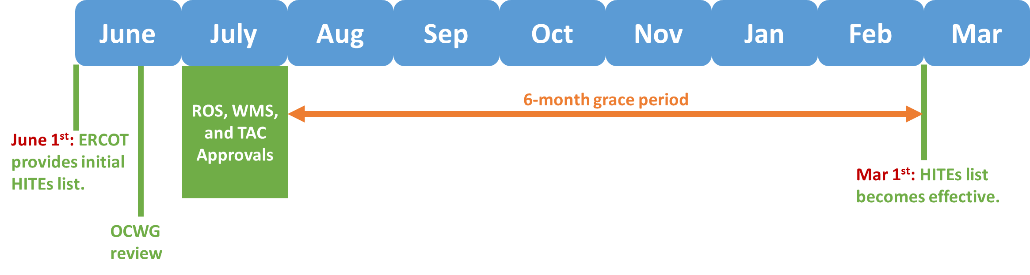
Posting
Once TAC has approved the MTE HITE list, ERCOT will process the list to identify each Transmission Element associated with the approved set of MTEs on the HITE list to produce the final Detailed HITE List that will be posted on the MIS.

