May 2016 ERCOT Monthly Operations Report
Reliability and Operations Subcommittee Meeting
July 7th, 2016

Table of Contents
1. Report Highlights 1
2. Frequency Control 2
2.1. Frequency Events 2
2.2. Responsive Reserve Events 3
2.3. Load Resource Events 3
3. Reliability Unit Commitment 4
4. Wind Generation as a Percent of Load 5
5. Congestion Analysis 6
5.1. Notable Constraints for May 6
5.2. Generic Transmission Constraint Congestion 8
5.3. Manual Overrides for May 8
5.4. Congestion Costs for Calendar Year 2016 8
6. System Events 9
6.1. ERCOT Peak Load 9
6.2. Load Shed Events 9
6.3. Stability Events 9
6.4. Notable PMU Events 9
6.5. TRE/DOE Reportable Events 9
6.6. New/Updated Constraint Management Plans 9
6.7. New/Modified/Removed SPS 10
6.8. New Procedures/Forms/Operating Bulletins 10
7. Emergency Conditions 10
7.1. OCNs 10
7.2. Advisories 10
7.3. Watches 10
7.4. Emergency Notices 10
8. Application Performance 10
8.1. TSAT/VSAT Performance Issues 10
8.2. Communication Issues 10
8.3. Market System Issues 11
Appendix A: Real-Time Constraints 12

Report Highlights
- The unofficial ERCOT peak for May was 57,589 MW.
- There were seven frequency events in May. PMU data indicates the ERCOT system transitioned well in each case.
- There were seven instances where Responsive Reserves were deployed, three of which were the result of frequency events.
- There were twenty-five RUC commitments in May.
- The level of reportable SCED congestion slightly increased in May. This congestion was due primarily to planned outages and area load/gen patterns. There were sixty instances over 27 days on the Generic Transmission Constraints (GTCs) in May. There were twelve days of activity on the Zorillo – Ajo GTC, twenty days on the Panhandle GTC, one on the Laredo GTC, three on the Valley Import and twenty-four days on the Liston GTC in May. There was no activity on the remaining GTCs during the Month.
- There were no significant system events for the month of May.
- On 5/12/16, VSAT experienced completion issues and went 38 minutes between runs. Additionally, RTNET was taken down for the application of a DPC and was unable to be restarted. RTNET did not solve from the next run at 15:22:30 till 15:46:12, missing the solution for almost 24 mins.

Frequency Control

Frequency Events
The ERCOT Interconnection experienced seven frequency events in May, all of which resulted from Resource trips. The average event duration was approximately 0:03:00.

When analyzing frequency events, ERCOT evaluates PMU data according to industry standards. Events with an oscillating frequency of less than 1 Hz are considered to be inter-area, while higher frequencies indicate local events. Industry standards specify that damping ratio for inter-area oscillations should be 3.0% or greater. All events listed below indicate the ERCOT system met these standards and transitioned well after each disturbance.

Reported frequency events will include both frequency events where frequency was outside the range of 60±0.1 Hz as well as those determined to be Frequency Measurable Events (FME) as defined by BAL-001-TRE-1. Delta Frequency is defined as the difference between the pre-perturbation and post-perturbation frequency. The Duration of Event is defined as the time it takes for the frequency to recover to lesser/greater of the frequency at the time of the frequency event (t(0) or “A-point”) for low/high-frequency events, respectively. Further details on FMEs can be found in the MIS posted BAL-001-TRE-1 PDCWG Unit Performance reports. A summary of the frequency events is provided below:

Date and Time | Delta Frequency | Max/Min Frequency | Duration of Event | PMU Data |  | Load | Wind | Inertia | MW Lost
 | (Hz) | (Hz) |  | Oscillation Mode (Hz) | Damping Ratio | (MW) | % | (GW-s)
5/1/2016 12:32 | 0.078 | 59.88 | 0:03:14 | 0.69 | 8% | 38,194 | 22% | 241,896 | Unit Trip of 562 MW
5/1/2016 20:20 | 0.057 | 59.71 | 0:00:30 | 0.82 | 8% | 40,693 | 20% | 236,738 | Unit Trip of 1311 MW
 |  |  |  | 0.76 | 8%
5/5/2016 12:31 | 0.107 | 59.87 | 0:06:10 | 1.15 | 16% | 40,365 | 2% | 275,544 | Unit Trip of 627 MW
 |  |  |  | N/A
 |  |  |  | 0.72 | 15%
5/7/2016 18:00 | 0.040 | 59.91 | 0:01:35 | PMU Data Not Available |  | 43,891 | 26% | 236,575 | Unit Trip of 307 MW
5/12/2016 14:31 | 0.095 | 59.90 | 0:05:10 | 0.96 | 6% | 47,713 | 6% | 299,895 | Unit Trip of 588 MW
5/21/2016 8:18 | 0.055 | 59.88 | 0:02:15 | 0.93 | 10% | 32,689 | 22% | 227,312 | Unit Trip of 559 MW
5/26/2016 2:39 | 0.041 | 59.87 | 0:02:06 | 0.91 | 25% | 36,327 | 29% | 221,026 | Unit Trip of 454 MW
 |  |  |  | 0.63 | 5%

(Note: frequency events highlighted in blue have been identified as FMEs per BAL-001-TRE-1 and the Performance Disturbance Compliance Working group.)

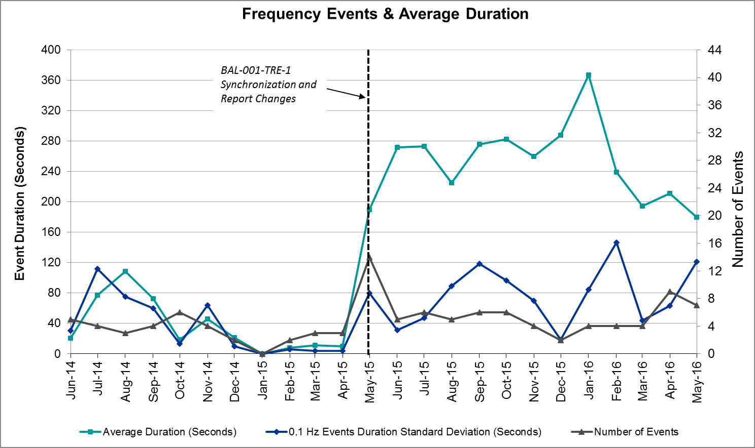

Responsive Reserve Events

There were seven events where Responsive Reserve MWs were released to SCED in May. The events highlighted in blue were related to frequency events reported in Section 2.1 above.

Date and Time Released to SCED | Date and Time Recalled | Duration of Event | Maximum MWs Released | Comments
5/1/2016 12:32:36 | 5/1/2016 12:34:52 | 0:02:16 | 368.75
5/1/2016 20:20:44 | 5/1/2016 20:20:56 | 0:00:12 | 1821.65
5/5/2016 12:31:12 | 5/5/2016 12:35:52 | 0:04:40 | 523.63
5/7/2016 18:00:40 | 5/7/2016 18:02:12 | 0:01:32 | 355.50
5/12/2016 14:31:38 | 5/12/2016 14:35:14 | 0:03:36 | 244.48
5/21/2016 8:18:54 | 5/21/2016 8:21:26 | 0:02:32 | 216.44
5/26/2016 2:39:18 | 5/26/2016 2:42:02 | 0:02:44 | 476.43

Load Resource Events
There was one load resource deployment events in May. Frequency was near, but not exceeding 59.7 Hz that caused some load resources to trip offline.
 | Total LR RRS Responsibility (MW) | LR Response (MW) | Number of Load Resources Responding | Number of Load Resources Participating as ONRL
System Totals | 1323.1 | 927.1 | 73 | 180

Reliability Unit Commitment
ERCOT reports on Reliability Unit Commitments (RUC) on a monthly basis. Commitments are reported grouped by operating day and weather zone. The total number of hours committed is the sum of the hours for all the units in the specified region. Additional information on RUC commitments can be found on the MIS secure site at Grid Generation Reliability Unit Commitment.

There were no DRUC commitments in May.

There were 25 HRUC commitments in May.

HRUC Commitments
Resource Location | # of Resources | Operating Day | Total # of Hours Committed | Total MWhs | Reason for Commitment
Southern | 1 | 5/9/16 | 7 | 278 | Local Congestion
Northern | 1 | 5/10/16 | 7 | 1854.5 | Local Congestion
Southern | 1 | 5/11/16 | 6 | 231 | Local Congestion
Northern | 1 | 5/12/16 | 5 | 2539 | Local Congestion
Southern | 1 | 5/12/16 | 2 | 106 | Local Congestion
Southern | 2 | 5/13/16 | 19 | 935 | Valley Import
Southern | 1 | 5/14/16 | 2 | 80 | Local Congestion
Southern | 1 | 5/16/16 | 5 | 210 | Valley Import
Southern | 1 | 5/16/16 | 5 | 210 | Local Congestion
Coastal | 1 | 5/17/16 | 9 | 4833 | Local Congestion
Southern | 2 | 5/17/16 | 7 | 314 | Local Congestion
Coastal | 1 | 5/18/16 | 6 | 3222 | Local Congestion
Southern | 1 | 5/20/16 | 1 | 53 | Local Congestion
Southern | 1 | 5/21/16 | 3 | 118 | Local Congestion
Southern | 1 | 5/22/16 | 3 | 117 | Local Congestion
Coastal | 1 | 5/23/16 | 6 | 3222 | Local Congestion
Southern | 2 | 5/23/16 | 6 | 262 | Local Congestion
Coastal | 1 | 5/24/16 | 4 | 676 | Local Congestion
Southern | 1 | 5/23/16 | 6 | 262 | Local Congestion
Coastal | 1 | 5/26/16 | 11 | 4518 | Local Congestion
Coastal | 1 | 5/26/16 | 11 | 4518 | Local Congestion
Coastal | 1 | 5/26/16 | 11 | 4518 | Local Congestion
Coastal | 2 | 5/27/16 | 10 | 3947 | Local Congestion
Coastal | 1 | 5/31/16 | 9 | 3778 | Local Congestion
Coastal | 1 | 5/31/16 | 9 | 3778 | Local Congestion

Wind Generation as a Percent of Load

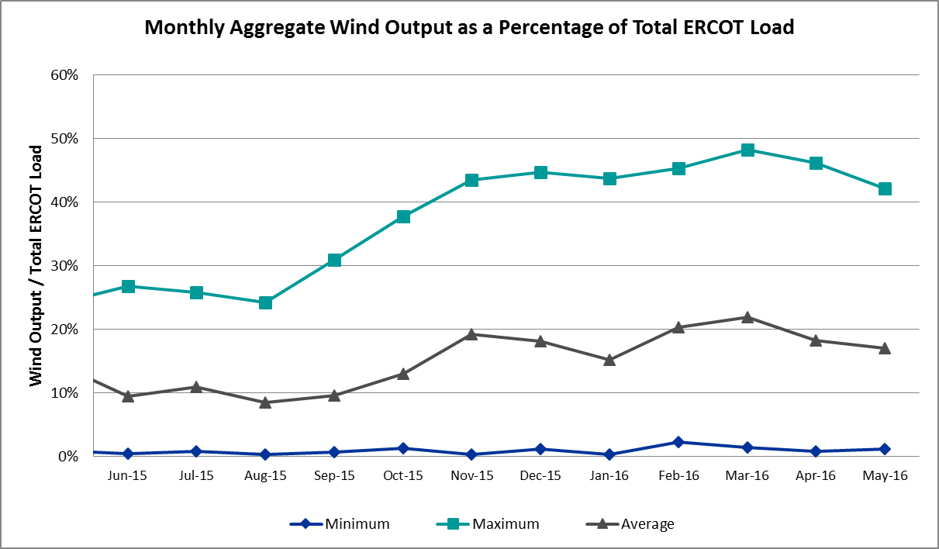

Congestion Analysis
The number of congestion events experienced by the ERCOT system increased in May. There were sixty instances of activity on the Generic Transmission Constraints (GTCs) in May.

Notable Constraints for May
Nodal protocol section 3.20 specifies that ERCOT shall identify transmission constraints that are active or binding three or more times within a calendar month. As part of this process, ERCOT reports congestion that meets this criterion to ROS. In addition ERCOT also highlights notable constraints that have an estimated congestion rent exceeding $1,000,000 for a calendar month. These constraints are detailed in the table below. Rows highlighted in blue indicate the congestion was affected by one or more outages. For a list of all constraints activated in SCED for the month of May, please see Appendix A at the end of this report.

Contingency | Overload | # of Days Constraint Active | Estimated Congestion Rent | Transmission Project
Meadow to Ph Robinson 345 KV | Meadow AT1 345/138kV | 2 | $ 6,552,987.55 | 4708
Lewisville Switch - Krum West Switch and Roanoke Switch 345 kV | Fort Worth Subsation - West Denton 138kV | 6 | $ 5,462,367.54
South Carbide to Loma Alta Substation 138 KV | La Palma - Villa Cavazos 138kV | 11 | $ 5,060,645.62
Ph Robinson At4_H (3)345/138 KV | Meadow AT1 345/138kV | 1 | $ 3,994,537.45 | 4708
Ph Robinson At1l_H (3)345/138 KV | Meadow AT1 345/138kV | 3 | $ 3,942,970.86 | 4708
Basecase | Valley Import | 3 | $ 3,402,231.72
Basecase | Panhandle GTC | 20 | $ 3,290,104.35 | Panhandle Upgrade
DKCT Roans Prarie-Rothwood & Singleton-Tomball 345kV | Singleton - Zenith 345kV | 15 | $ 2,539,236.01 | Houston Import Project
Loma Alta Substation T1 138/69 KV | La Palma - Villa Cavazos 138kV | 5 | $ 1,693,019.02
DCKT Chambers - King and Cedar Bayou - Jordan 345 kV | Cedar Bayou Plant AT3 345/1kV | 1 | $ 1,274,724.80
DCKT Marion - Zorn and Clear Springs 345 kV | Clear Springs AT1 345/138kV | 9 | $ 1,121,165.91
DCKT Jewett - Singleton 345 kV | Btu_Jack_Creek - Twin Oak Switch 345kV | 11 | $ 815,470.75
Nelson Sharpe - Lon Hill 345 kV | Javalina Tap - Molina 138kV | 6 | $ 592,342.85 | 4401
Spur - Scurry Switch 138 kV | Aspermont Aep 69T1 138/69kV | 15 | $ 455,128.52
Gila - Hiway 9 138 kV | Morris Street - Gila 138kV | 11 | $ 425,891.13
Carrolton Northwest - Lewisville Switch 345 kV | Carrollton Northwest - Lakepointe Tnp 138kV | 3 | $ 268,162.14 | 2013 to 2015 RTP
Dupont Pp1 - Ingleside to Ingleside Cogen Switch (2)138/138 KV | Dupont Pp1 - Ingleside - Dupont Switch - Ingleside 138kV | 11 | $ 246,147.34
Falcon Switch Station to Roma Switch 138 KV | Javalina Tap - Molina 138kV | 15 | $ 243,083.19 | 4402
Marbfa-Lakewy &Wirtz-Palefa 138kv | Flat Rock Lcra - Wirtz 138kV | 19 | $ 227,195.35 | 4465
Basecase | Paredes Switching Station - Central Avenue Sub 138kV | 6 | $ 223,221.39
DCKT Rio Hondo - North Edinburg 345 kV and Rio - Hondo Harlingen Switch 138 kV | Burns Sub - Rio Hondo 138kV | 4 | $ 208,316.17
DCKT Ferguson - Granite Mountain and Wirtz - Starcke - Paleface 138 kV | Flat Rock Lcra - Wirtz 138kV | 13 | $ 179,884.56 | 4465
Mercers Gap Sw to Comanche Switch (Oncor) 138 KV | Camp Bowie (Oncor) - Brownwood Switch 138kV | 12 | $ 171,649.81
Scurry Switch to Sun Switch 138 KV | Aspermont Aep 69T1 138/69kV | 13 | $ 161,598.36
Basecase | Liston GTC | 24 | $ 139,854.33
Basecase | Javalina Tap - Molina 138kV | 10 | $ 88,586.61
Sweetwater Downtown to Haynes Substation (7)138/138/138/138/138/138/138 KV | Eskota Switch - Trent 69kV | 8 | $ 69,934.07
Laquinta - Lobo 138 kV | Bruni Sub 69_1 138/69kV | 7 | $ 53,582.45
Bosque Switch - Elm Mott 345 kV | Bosque Switch - Rogers Hill Bepc 138kV | 14 | $ 48,428.93 | 4356
Hiway_9 - Citgo N Oak Park 138 kV | Citgo N Oak Park - Cantwell 138kV | 5 | $ 35,001.51
Lobo 2_345_138 345/138 kV | Javalina Tap - Molina 138kV | 5 | $ 25,058.63 | 4404
Zorn-Marion & Cleasp 345kv | Comal - Henne 138kV | 6 | $ 22,344.14 | 4454
Sweetwater Downtown to Haynes Substation (7)138/138/138/138/138/138/138 KV | Eskota Switch - Longworth 69kV | 5 | $ 4,896.85
Basecase | Wkn_Bkr - Ena Snyder Wind 69kV | 4 | $ 1,306.02

Generic Transmission Constraint Congestion
There were twelve days of activity on the Zorillo – Ajo GTC, twenty days on the Panhandle GTC, one on the Laredo GTC, three on the Valley Import and twenty-four days on the Liston GTC in May. There was no activity on the remaining GTCs during the Month.

Note: This is how many times a constraint has been activated to avoid exceeding a GTC limit, it does not imply an exceedance of the GTC occurred or that the GTC was binding.

Manual Overrides for May
There were no manual overrides for the month of May 2016.

Congestion Costs for Calendar Year 2016
The following table represents the top twenty active constraints for the calendar year based on the estimated congestion rent attributed to the congestion. ERCOT updates this list on a monthly basis.

Contingency | Binding Element | # of 5-min SCED Intervals | Estimated Congestion Rent | Transmission Project
Villa Cavazos to Military Highway Aep (2)138/138 KV | Los Fresnos - Loma Alta Substation 138kV | 3272 | $ 22,631,690.71
DCKT Roanoke Switch - West Denton and Lewisville Switch - Krum West Switch 345 kV | Fort Worth Subsation - West Denton 138kV | 1774 | $ 9,674,767.71
Hicks Switch - Alliance & Roanoke Switch 345 kV | Eagle Mountain Ses - Morris Dido 138kV | 1420 | $ 8,429,342.09 | 4252
Basecase | Panhandle GTC | 4321 | $ 8,035,579.91
Rosen Heights to Eagle Mountain Compressor (5)138/138/138/138/138 KV | Rosen Heights Tap 2 - Morris Dido 138kV | 857 | $ 6,790,310.87 | 4252
Meadow to Ph Robinson 345 KV | Meadow AT1 345/138kV | 89 | $ 7,342,050.55 | 4708
Basecase | Valley Import | 110 | $ 5,314,871.29 | LRGV (lower Rio Grande Valley) Import Project
Lewisville Switch - Krum West Switch and Roanoke Switch 345 kV | Fort Worth Subsation - West Denton 138kV | 788 | $ 5,315,930.26
Hicks Switch - Alliance & Roanoke Switch 345 kV | Rosen Heights Tap 2 - Morris Dido 138kV | 805 | $ 4,960,392.20 | 4252
South Carbide to Loma Alta Substation 138 KV | La Palma - Villa Cavazos 138kV | 505 | $ 4,494,488.24
Mason Road to Obrien 138 KV | Betka - Hockley 138kV | 256 | $ 4,613,830.45
South Texas # 1 & # 2 | Marion - Clear Springs 345kV | 18 | $ 4,733,737.88
Nelson Sharpe - Lon Hill 345 kV | Javalina Tap - Molina 138kV | 4406 | $ 4,389,131.57 | 4401
Ph Robinson At4_H (3)345/138 KV | Meadow AT1 345/138kV | 62 | $ 4,473,189.74 | 4708
Eagle Mountain Ses Axfmr1l (3)345/138 KV | Eagle Mountain Ses AX2L 345/13.8/138kV | 329 | $ 3,611,133.80
Ph Robinson At1l_H (3)345/138 KV | Meadow AT1 345/138kV | 267 | $ 4,346,128.19 | 4708
Eagle Mountain Ses Axfmr1l (3)345/138 KV | Eagle Mountain Ses AX2H 345/13.8/138kV | 813 | $ 3,635,732.04
Carrolton Northwest - Lewisville Switch 345 kV | Carrollton Northwest - Lakepointe Tnp 138kV | 1726 | $ 3,317,130.77 | 2013 to 2015 RTP
DCKT Lon Hill - North Edinburg 345 kv and Orange Grove Switching Station 138 kV | Javalina Tap - Molina 138kV | 3453 | $ 2,606,621.76 | 4401
DKCT Roans Prarie-Rothwood & Singleton-Tomball 345kV | Singleton - Zenith 345kV | 923 | $ 3,176,671.23 | Houston Import Project

System Events

ERCOT Peak Load
The unofficial ERCOT peak load for the month was 57,589 MW and occurred on May 10th during hour ending 17:00.

Load Shed Events
None.

Stability Events
None.

Notable PMU Events
ERCOT analyzes PMU data for any significant system disturbances that do not fall into the Frequency Events category reported in section 2.1. The results are summarized in this section once the analysis has been completed.

There were no reportable events in May.

TRE/DOE Reportable Events
None.

New/Updated Constraint Management Plans
Annual Review Completed.
- One RAP deleted. No New
- No PCAPs Deleted or Added.

New/Modified/Removed SPS
None.

New Procedures/Forms/Operating Bulletins
- 05/04/2016 Scripts V1 Rev 6

Emergency Conditions

OCNs
None.

Advisories
Date and Time | Description
5/8/16 01:52 | Advisory issued due to a GMD alert of K7
5/8/16 22:29 | Advisory issued due to a GMD alert of K7
5/12/16 14:09 | Advisory issued due to ERCOT's Voltage Security Assessment Tool is being unavailable.
5/20/16 21:49 | Advisory issued due to ERCOT’s Voltage Security Assessment Tool is being unavailable.

Watches
None.

Emergency Notices
Date and Time | Description
05/27/16 14:39 | Transmission Emergency Notice issued for the Rio Grande Valley due to the Valley Import.
.

Application Performance
There were two issues to report for May.

TSAT/VSAT Performance Issues
- 05/12/16 13:06 - VSAT results completed with a good calculation, however the next two runs failed with “Abnormal Completion”. The next good calculation did not complete until 13:44, resulting in approximately 38 minutes in between VSAT runs.

Communication Issues
None.

Market System Issues
- 05/23/2016 15:17 – RTNET was taken down for the application of a DPC and was unable to be restarted. RTNET was restored at 15:46. Time between State Estimator runs was 24 minutes, 42 seconds.

Appendix A: Real-Time Constraints
The following is a complete list of constraints activated in SCED for the month of May. Full contingency descriptions can be found in the Standard Contingencies List located on the MIS secure site at Grid Generation Reliability Unit Commitment.

Contingency | Constrained Element | From Station | To Station | # of Days Constraint Active
BASE CASE | LISTON |  |  | 24
BASE CASE | PNHNDL |  |  | 20
DMARPA_8 | 38T365_1 | WIRTZ | FLATRO | 19
DRNS_TB5 | SNGZEN99_A | SNG | ZEN | 15
SSPUMW18 | ASPM_69T1 | ASPM | ASPM | 15
SFALROM8 | JAVALT_MOLINA1_1 | JAVALTAP | MOLINA | 15
SBOSELM5 | 1030__B | BOSQUESW | RGH | 14
DFERPAL8 | 38T365_1 | WIRTZ | FLATRO | 13
SSCUSU28 | ASPM_69T1 | ASPM | ASPM | 13
SZEPCMN8 | 670__B | BRNSW | CMPBW | 12
BASE CASE | ZO_AJO |  |  | 12
SSCALOM8 | LA_PAL_VCAVAZ1_1 | LA_PALMA | VCAVAZOS | 11
DJEWSNG5 | JK_TOKSW_1 | TOKSW | JK_CK | 11
SGILNU78 | GILA_MORRIS1_1 | GILA | MORRIS | 11
SI_DI_48 | I_DUPP_I_DUPS2_1 | I_DUPP1 | I_DUPSW | 11
BASE CASE | JAVALT_MOLINA1_1 | JAVALTAP | MOLINA | 10
DMARZOR5 | CLEASP_AT1 | CLEASP | CLEASP | 9
SSWDMGS8 | 6585__A | ESKSW | TRNT | 8
SLAQLOB8 | BRUNI_69_1 | BRUNI | BRUNI | 7
BASE CASE | RANDAD_ZAPATA1_1 | RANDADO | ZAPATA | 7
DLWSRNK5 | FTW_W_DE_1 | W_DENT | FTWORTH | 6
SN_SAJO5 | JAVALT_MOLINA1_1 | JAVALTAP | MOLINA | 6
BASE CASE | PAREDS_CNTRLAV_1 | PAREDES | MV_CNTRA | 6
DCLEZOR5 | 86T235_1 | HENNE | COMAL | 6
XLOM89 | LA_PAL_VCAVAZ1_1 | LA_PALMA | VCAVAZOS | 5
SHIWCIT8 | 11T436_1 | CITGO_NO | CANTWELL | 5
XLOB58 | JAVALT_MOLINA1_1 | JAVALTAP | MOLINA | 5
SSWDMGS8 | 6780__A | ESKSW | LONGWRTH | 5
BASE CASE | S104A_1 | RIOHONDO | MV_BURNS | 4
DRIOHAR5 | S104A_1 | RIOHONDO | MV_BURNS | 4
DMARZOR5 | 86T235_1 | HENNE | COMAL | 4
BASE CASE | SNYDER_WKN_BK1_1 | ENAS | WKN_BKR | 4
XPHR58 | MDO_AT1 | MDO | MDO | 3
BASE CASE | VALIMP |  |  | 3
SFORYEL8 | FORTMA_MASN1_1 | FORTMA | MASN | 3
DCRLLSW5 | 591__A | LKPNT | CRLNW | 3
SRANZA28 | JAVALT_MOLINA1_1 | JAVALTAP | MOLINA | 3
SSCUSU28 | ROTN_WOLFGA1_1 | WOLFGANG | ROTN | 3
DSTPWHI5 | BLESSI_LOLITA1_1 | BLESSING | LOLITA | 3
SLOBSA25 | JAVALT_MOLINA1_1 | JAVALTAP | MOLINA | 3
SSWDMGS8 | 6585__A | TRNT | ESKSW | 3
SMDOPHR5 | MDO_AT1 | MDO | MDO | 2
DCRLLSW5 | 590__A | LWSSW | LWVJS | 2
DBIGKEN5 | FRIR_ROCKSP1_1 | FRIR | ROCKSPRS | 2
DRIOHAR5 | HAINE__LA_PAL1_1 | LA_PALMA | HAINE_DR | 2
SLOBSA25 | ASHERT_CATARI1_1 | ASHERTON | CATARINA | 2
SWRDYN8 | EL_CAM_LANCTY1_1 | LANCTYPM | EL_CAMPO | 2
SMCEABS8 | 6585__A | ESKSW | TRNT | 2
SS_MRAI8 | JAVALT_MOLINA1_1 | JAVALTAP | MOLINA | 2
SSWDMGS8 | MKLT_TRNT1_1 | TRNT | MKLT | 2
SSONFRI8 | SONR_69-1 | SONR | SONR | 2
DHCKRNK5 | 1140__C | DFWD1 | DFWCE | 2
XPH3R58 | MDO_AT1 | MDO | MDO | 1
DCHBJOR5 | CBY_AT3 | CBY | CBY | 1
SCITNE28 | KEY_SW_PALMHR1_1 | KEY_SW | PALMHRTP | 1
SPRILOM8 | LA_PAL_VCAVAZ1_1 | LA_PALMA | VCAVAZOS | 1
XLOB58 | DILLEY_JARDIN1_1 | DILLEYSW | JARDIN | 1
DCLEZOR5 | 89T204_1 | ZORN | HENNE | 1
SDAVMCS8 | 3210__A | MCSES | CDHSW | 1
SMDLODE5 | ODEHV_MR2H | ODEHV | ODEHV | 1
SBAKHLT8 | 6596__F | HLTSW | EMATP | 1
SLCSTH25 | 505__A | THSES | SAMSW | 1
XJEW58 | 1240__K | TRSES | WINKLER | 1
SKOCNU28 | GILA_HIWAY_2_1 | GILA | HIWAY_9 | 1
DJEWSNG5 | SNGXGC99_1 | GIBCRK | SNG | 1
XLOB58 | FREER_SAN_DI1_1 | SAN_DIEG | FREER | 1
SJONCPS5 | 152__A | WOFHO | RKCRK | 1
SSCUSU28 | 6780__A | ESKSW | LONGWRTH | 1
SLISBAT8 | JAVALT_MOLINA1_1 | JAVALTAP | MOLINA | 1
SILLFTL8 | 2584_1 | DOWNIES | UVALDE | 1
BASE CASE | ASPM_69T1 | ASPM | ASPM | 1
SBATPAL8 | 2584_1 | DOWNIES | UVALDE | 1
SBIGOR55 | FRIR_ROCKSP1_1 | FRIR | ROCKSPRS | 1
SKOCNU28 | GILA_MORRIS1_1 | GILA | MORRIS | 1
SLCDYN8 | SE_WA_65_A | WA | SE | 1
DWH_STP5 | AIRCO4_RINCON1_1 | RINCON | AIRCO4 | 1
SRNGMO29 | BOW_FMR1 | BOW | BOW | 1
SMCEABS8 | 6780__A | ESKSW | LONGWRTH | 1
DPHRBBP8 | CA_DE_96_A | DE | CA | 1
SBRAUVA8 | HAMILT_MAVERI1_1 | HAMILTON | MAVERICK | 1
SSCLWF28 | 6560__B | MRKLY | RICSW | 1
DWIRPAL8 | 30T108_1 | BUCHAN | BURNET | 1
DWH_STP5 | BONIVI_RINCON1_1 | RINCON | BONIVIEW | 1
XLOB58 | CATARI_PILONC1_1 | CATARINA | PILONCIL | 1
XPTE58 | 842__D | RMNJUARZ | BRG | 1
DHCKRNK5 | 6270__A | EMSES | EGPOI | 1
DHUTGAB8 | 211T147_1 | GILLCR | MCNEIL_ | 1
DLONOR58 | JAVALT_MOLINA1_1 | JAVALTAP | MOLINA | 1
SSPUASP8 | ROTN_WOLFGA1_1 | WOLFGANG | ROTN | 1
SSPUMW18 | ROTN_WOLFGA1_1 | WOLFGANG | ROTN | 1
BASE CASE | LAREDO |  |  | 1
SCOLPAW5 | COLETO_KENEDS1_1 | COLETO | KENEDSW | 1
SI_DI_38 | I_DUPP_I_DUPS1_1 | I_DUPP1 | I_DUPSW | 1
SILLFTL8 | BGLK_PHBL_T1_1 | BGLK | PHBL_TAP | 1
SPOLPHA8 | GCB_100_1 | N_MCALLN | W_MCALLN | 1
DSNGZEN5 | SNGTB_74_A | SNG | TB | 1
DMARZOR5 | 89T204_1 | ZORN | HENNE | 1
SILLFTL8 | FRIR_ROCKSP1_1 | FRIR | ROCKSPRS | 1

