TDTMS Meeting
June 08, 2016
09:30 AM

Agenda
1. | Antitrust Statement  Review of Agenda  Introductions  Attendees:  Jim Lee - AEP  Catherine Meiners - ERCOT  Kathy Scott - CenterPoint  Vikram Gupta - ERCOT  Kyle Patrick - NRG  Tammy Stewart - ERCOT  Kaci Jacobs - TXU  Carolyn Reed - CenterPoint  Lindsay Butterfield - ERCOT  Dave Pagliai - ERCOT  Debbie McKeever - Oncor  Diana Rehfeldt – TNMP  Tomas Fernandez - NRG | J Lee
2. | Review/Approve April Meeting Notes  April notes were not posted in time; will review/approve April and June during the July meeting. | J Lee
3. | ERCOT System Instances (Outages and Failures)  No incidents or maintenance issues in May | ERCOT – D Pagliai
4. | MarkeTrak Monthly Performance Review  MT SLOs: RMS asked for the SLOs to be documented into the Retail Market Services SLA.  Action item: Dave will incorporate into SLA document and bring back to TDTMS for review & endorsement in July. If endorsed, RMS will consider new SLA in August. | ERCOT – D Pagliai
5. | Review Q1 Performance Measures  Only one metric dipped below 99% (98%) - was caused by holding transactions for TDSPs during a Transition event in March. | ERCOT – C Meiners
6. | MT Subtype Analysis  - Usage/Billing review of AMS LSE – Dispute MarkeTrak  - This is essentially combining AMS LSE & the 867 monthly dispute  - Want subtypes to be as pure as possible – due to reporting performed on MT performance.  - MT has hardcoded the name of the subtype and any changes to the subtype name will cause a Release  - For this particular situation, creating a new subtype that compares 867s vs sum of LSEs  - Group’s feeling is to update documentation to reflect proper usage of “Other” subtype for these particular disputes; create a new subtype (which will require a release at a future date); & rename the Usage and Billing AMS LSE (Dispute) subtype to be more indicative of what it should be used for.  - Based on discussion, TXUE agreed to withdrawal the Issue and leave the current processes as-is until the timing is right to implement a MT release and include the new subtype at that time.  - Review of all other MarkeTrak subtype volumes - ERCOT stats  - Usage/Billing – Missing:  - ERCOT to bring back “complete” vs “auto complete” to determine actual length of time for TDSP resolution by taking out the instances where the CR lets the issue auto-close.  - Sort by 867_03; 867_03F; 810  - Missing Enrollment Transaction:  - ERCOT to bring back “complete” vs “auto complete” to determine actual length of time for TDSP resolution by taking out the instances where the CR lets the issue auto-close.  - ERCOT analysis shows 94% of missing enrollment requests were for 867_04; 2.3% for 814_20; 1.05% for 814_06  - In regards to Unexecutables, large volume due to “pending construction”  - Usage/Billing – Dispute:  - ERCOT to bring back “complete” vs “auto complete” to determine actual length of time for TDSP resolution by taking out the instances where the CR lets the issue auto-close.  - How to determine validity of disputes? Possibly by the response in the “complete” Comments. ERCOT will see if they can pull back any meaningful information for U/B Disputes to confirm validity.  - Regarding Unexecutables, large volume due to “invalid dates”  - AMS LSE Interval – Dispute  - ERCOT to bring back “complete” vs “auto complete” to determine actual length of time for TDSP resolution by taking out the instances where the CR lets the issue auto-close.  - Regarding Unexecutables, large volume due to “invalid dates” – is this possibly due to REPs not using the “Other” subtype, or asking for multiple days?  - Switch Hold Removal  - ERCOT to bring back CR breakout for all 4 Unexecutable reasons to determine if there is one (or some) REPs contributing to the volume of UE’s.  - ERCOT to bring back TDSP break out for the first category: “Documents Invalid/Incomplete” to determine if there is on particular TDSP using this response. | All
7. | Retail SCR786 Market Test Environment  - Business requirements review – minor administrative changes made by Catherine.  - So far, SCR786 is tracking in a promising trajectory.  - Action item: Catherine will incorporate changes, finalize, and post to the TDTMS main page.  - No additional input needed from TDTMS. | ERCOT - C Meiners
8. | Discussion of Potential Inadvertent Gain Reporting Refinement  Action item: ERCOT to transpose the IAG data currently being presented into a Scatterplot format and bring back to TDTMS in July.  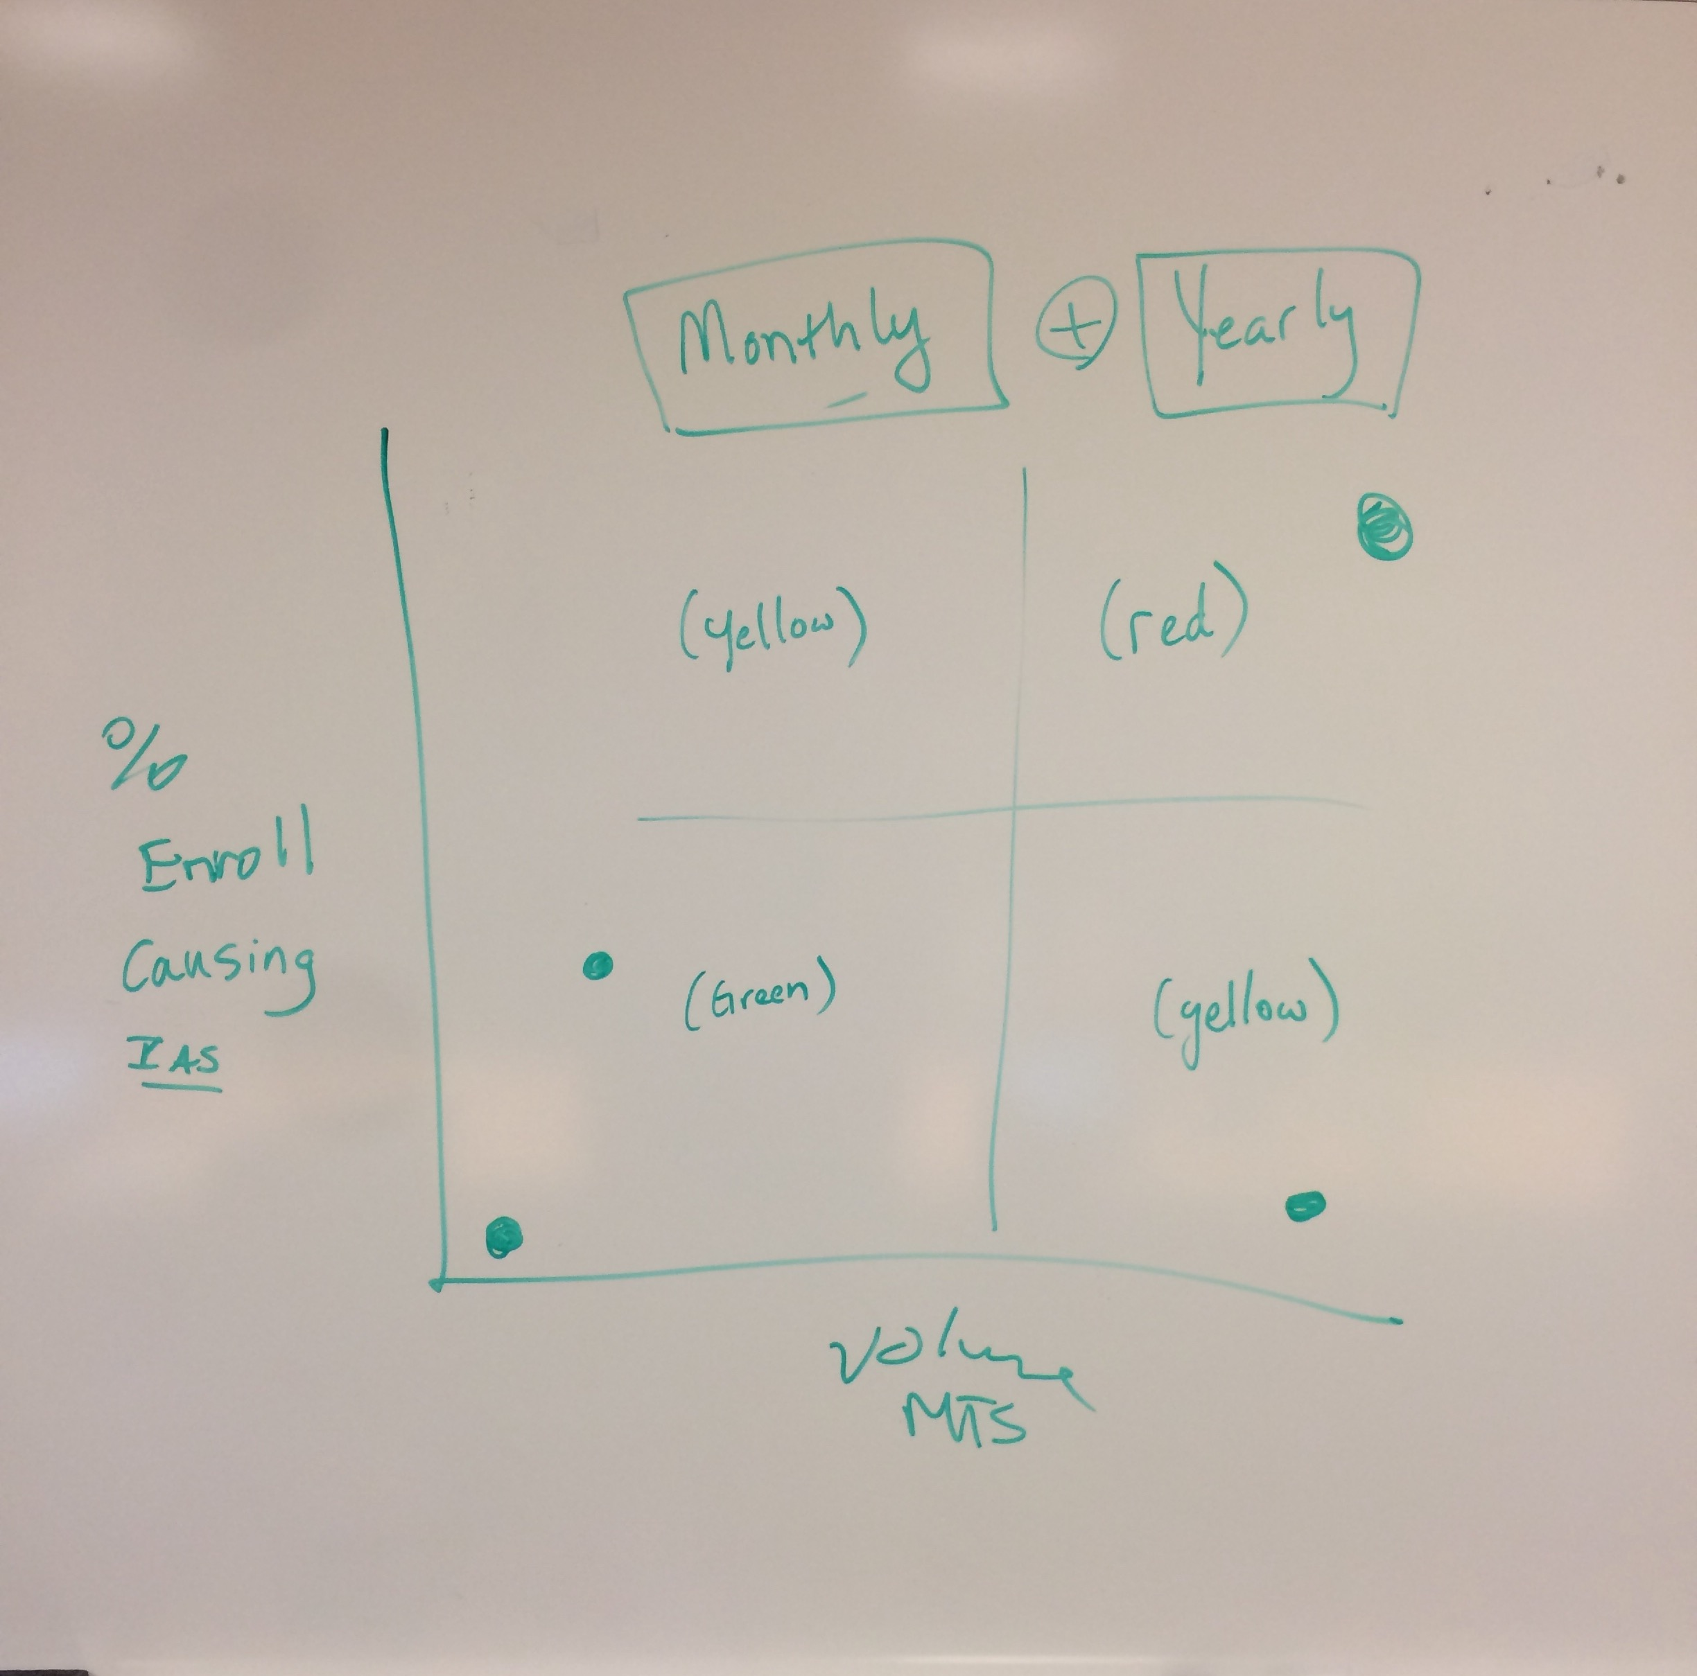
 | July Meeting Date: July meeting has been moved back one day to July 7th
 | Adjourn

