2016
Black Start Training Summary
Version 1.0

Document Revisions
Date | Version | Description | Author(s)
 | 1.0 | First draft

Sign-Off
Title
Name Date
Title
Name Date

Table of Contents
1. Executive Summary 1
2. Detailed Description 1
3. Blackstart Regular Training Sessions Details (Weeks 1-6) 2
3.1 Weekly Results 3
4. Blackstart Special Training Session 6
4.1. Special Session Results 7
5. Participant Feedback 8
6. Lessons Learned 9
7. Recomendation 10
8. 2017 Black Start Training 11
8.1 Future Training for ERCOT Operators 11
8.2 Black Start Working Group and Operations Training Working Group 11
8.3 Training Module Description 11
8.4 Generator/Load Modeling Data 12
9. Recognition 12

Executive Summary
2016 Black Start training comprised of eight sessions and engaged 764 participants including Transmission Operators (TOs), Generator Operators (GOPs), Qualified Scheduling Entities (QSEs) and ERCOT Personnel. In addition, NERC (including members from the Electricity Information Sharing and Analysis Center (E-ISAC)) and TRE representatives observed multiple sessions of the training. A pilot course to solicit feedback from members was conducted on January 12 through 14. Then, between February 2 and March 10, six regular system restoration training sessions were conducted, each spanning three days. Finally, a special session was held March 15 through March 17, where select participants continued the restoration from the best regular session case.

Detailed Description
Each of the six training sessions began with an instructor-led presentation and focused on the ERCOT Black Start Plan, related NERC Reliability Standard Requirements, and operational theory regarding system restoration. A one-hour simulator instruction tutorial followed. Day 2 consisted of a ten-hour simulation, which began with the system blacked out. Day 3 was a continuation of the previous day’s simulation until noon.. During the entire training session the generator operators and QSEs operated their own generation using the Macomber Map. The transmission operators controlled the transmission system equipment also using the Macomber Map. The opportunity to see an overview of the entire ERCOT system allowed participants to more effectively rebuild their systems and synchronize with neighboring TOs.
ERCOT System Operators were able to monitor the member’s progress in restoring their “islands” of responsibility within the ERCOT system starting from a completely “blacked out” condition. The Macomber Map, which showed each transmission line as it was energized during the restoration process, provided an excellent overview of the network for the ERCOT System Operators.
The simulator performed well throughout the entire 8-week period. Feedback from participants and instructors will be used to make improvements in response and fidelity. Improvements are planned for the Macomber Map and training format for 2017 Black Start training.
All NERC-certified participants (and some Professional Engineers) were awarded 19 Continuing Education Hours after completing the instructor-led course and passing the online exam.
Feedback from participants regarding the new, interactive lecture approach was extremely positive. Feedback also indicated that opportunities remain to engage participants with renewable resources during the simulation portion.
Overall, the simulator (EMS portion) performed very well. Two major improvements for the GOP/QSE participants identified from the 2015 Black Start training were addressed and implemented in 2016 —a newly developed Generator Control Panel and a Generator Summary Display. The operators were pleased with the ease of use and realism of these new tools. The trainers identified the need for further enhancements to the generator capabilities in the Macomber Map tool.
In the past, Black Start training has been conducted as a ‘performance-based’ exercise rather than as a ‘training’ exercise. The inconsistencies noted in operator performance could not be addressed in a ‘performance-based’ exercise. In response, future Black Start training will be conducted in a modular format, allowing all operators to practice on each stage of the restoration. The modular format will also allow the operators, for the first time, to practice restarting the Market. Additionally, estimating an accurate total time of restoration requires using a more rigorous methodology than was possible during this training exercise.
The 2016 Black Start exercise performance will be reviewed with the ERCOT Operators to collectively identify areas for improvement. The results of this analysis will be shared with the Operations Training Working Group (OTWG) and the Black Start Working Group (BSWG).

Blackstart Regular Training Sessions Details (Weeks 1-6)
Consistencies Between Weeks
- Approximately 2,000 MW load was restored to stabilize generating units within the first 7 hours of simulation.
- Operators were able to execute the Black Start restoration plans, which identified a starting point (individual Black Start units) and a destination (specified synchronization points). Plans also identified the path (transmission corridors) needed to get from the starting point to the destination.
Inconsistencies Between Weeks
- Identifying switching errors caused some significant delays in resuming simulation. When the responsible TO self-identified a switching error, the length of delay was dramatically reduced resulting in more time for restoration efforts.
- Load restoration after the first 7 hours varied in amount, rate, and location.
- Island stability was not uniform throughout session weeks.
- Improper switching was still the leading cause of island collapse.
- Load/available generation ratio progression varied from week-to-week. In some cases this caused island collapse due to frequency excursions.
- 345 kV infrastructure was not always utilized effectively to strengthen transmission system. This limited power transfers and load restoration and also created voltage and thermal issues on the 138 kV system.
- Due to all issues, the total amount of load restoration varied between sessions.

Weekly Results
Load restoration progression and final transmission system snapshot for each of the six weeks are presented in the following images.

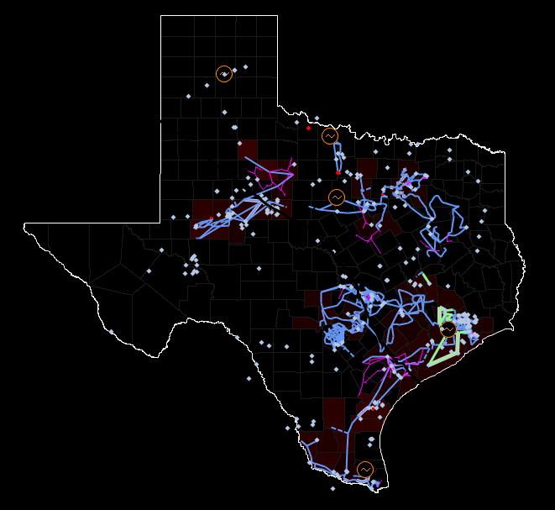
Week 1: 6,593 MW Restored/14 Islands

Week 2: 16,156 MW Restored/5 Islands
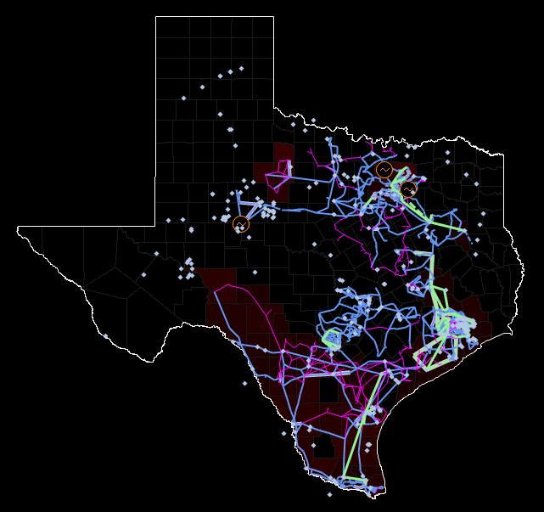

Week 3: 8,404 MW Restored/7 Islands
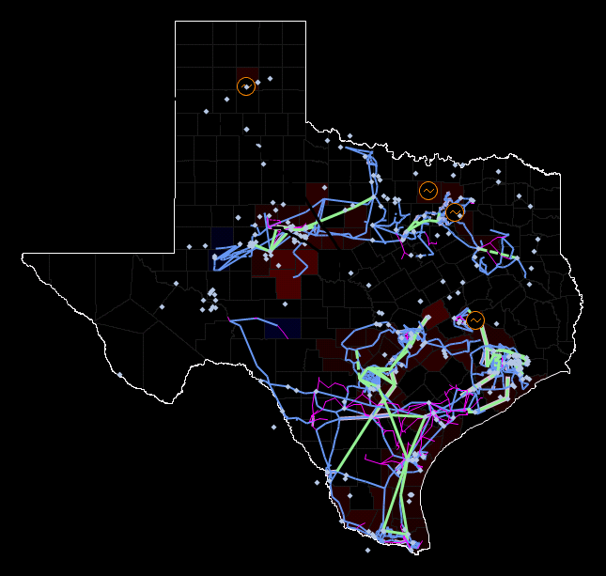

Week 4: 8,729 MW Restored/4 Islands
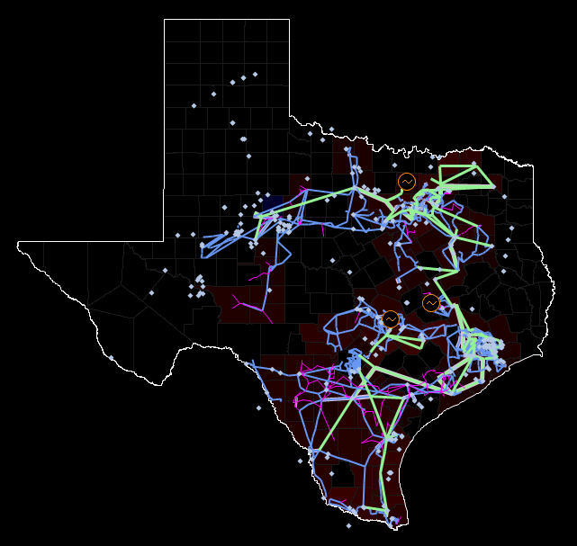

Week 5: 11,766 MW Restored/9 Islands
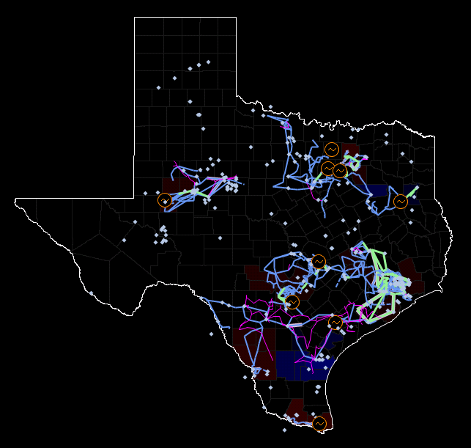

Week 6: 22,362 MW Restored/1 Island
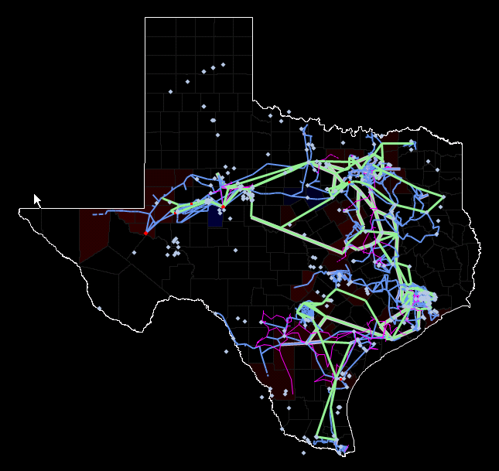

Blackstart Special Training Session
After the regular session training, a special session was held March 15 through March 17 with the goal of determining the time required to return the system to ninety percent of pre-disturbance load. The “best” case from the six regular training sessions was used as a starting point for the special session. The training week 6 case was selected because this case had 22,362 MW load restored, significant 345 kV infrastructure rebuilt, and a load/available generation ratio of 62%. The case was allowed to run so that all cold load pick-up was diminished prior to the beginning of the special session. This reduced the case load to 22,119 MW.
The final load restored during the special session was 56,143 MW. This is higher than the maximum load from the original case used to create the simulation, which was approximately 40,000 MW.
Typically ERCOT publishes an overall restoration time for the special session using assumptions from the prior weeks training time and adding in the special sessions added time. Currently the assumptions and methodology for an accurate restoration time estimate are being reviewed for improvement; therefore, no estimated time of restoration will be provided in this years report. Additionally, comparisons to restoration simulations from previous years will not be appropriate due to different system conditions. The major difference in this years restoration is that system outages were introduced and therefore comparisions to prior years would not translate into valid comparisons.
It is important to note that there are several additional factors that would cause the actual time to restore the system from a blacked-out state to be more or less than the time taken to complete blackstart simulation. For example, many of the mistakes made were switching errors and might have been prevented by having switchmen in the stations. This would be the normal restoration plan for a system restoration. On the other hand, because this was a simulation, the MPs had access to most of their equipment and there were no problems with the associated with equipment, which cannot be expected during a real event. Equipment issues that are likely to be seen in an actual event include dead batteries at stations requiring the switchman to hand crank breakers open or closed, delayed response due to drive time between stations in large metropolitan areas (Houston, Austin, San Antonio, and the DFW area), damaged transmission equipment from the cause of the event (if weather related), damaged generators, communication issues, SCADA not available to TOs and ERCOT, and the availability of natural gas to Black Start and Next Start units. Lastly, human error that leads to island collapse drastically increases the restoration time.
The Black Start training that ERCOT provides is critical because of the unknowns that we will not be able to address in planning. The more efficient we are in performing the parts of the plan we have control over, the more effective the outcome.Overall the special training session demonstrated the blackstart plans will allow operators to restore the system. The special session focused on the condition where once a single island is created from the separate company blackstart plans then ERCOT can build out the remining system and restore the complete system.

Special Session Results
The images and table below display the final results of the Special Session.

Total Load Restoration Progression

Total Load Restoration Description
Hours | Session | Events
6-11 | Regular, Week 6 | - Restoration effort focused on the 345 kV system, strengthening transmission line infrastructure.  - Rate of load restoration increased.
11-13 | Regular, Week 6 | - All islands synchronized.  - Restoration effort focused on restoring load.
13-16 | Special | - State Estimator and Contingency Analysis begins to solve successfully.  - Adjusted generation and load to relieve post-contingent thermal overloads and high/low voltage issues.  - N-to-H interface power flow issues limited the pace of restoration.
16-32 | Special | - Continued Load and Generation restoration.  - Generator loading and power flow issues with NRG on Constant Frequency Control (Houston area) and load restoration continuing in Western Texas

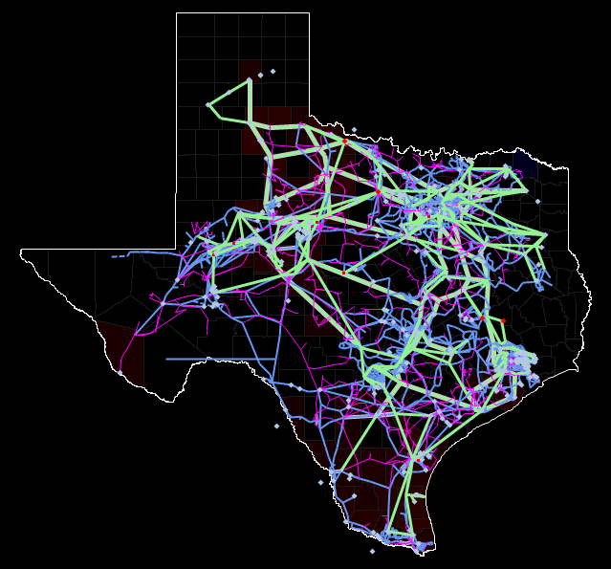
Final Transmission System Snapshot

Participant Feedback
Honest feedback was solicited from participants at the end of each training session. A change in approach for the 2016 Black Start presentation was the incorporation of group activities for the participants during the instructor-led portion of the training. Feedback on this change was positive overall, with the recommendation that smaller groups for the activities would have been more effective. The simulation part of the exercise was well-received, however feedback from some operators indicated a lack of participation due to system topology (starting from a completely blacked-out situation). Operators also commented negatively on the extended periods of paused simulation time. This issue was minimized in later weeks by encouraging operators to self-identify any switching errors that may have been the cause of an island collapse.

Lessons Learned
The 2016 restoration replicated the total system restoration seen in 2015. Items of note are listed below.
- Outages selected did not provide a uniform training opportunity for all Transmission Operators.
The case modeled was November 28, 2015. For the first time, outages for that day were also modeled and the operators successfully recognized, communicated, and modified their Black Start plan appropriately. Because the outages were from a specific day, the outages only affected two Transmission Operators.
- ERCOT coordination and communication of load/transmission restoration following synchronization was inconsistent.
Black Start plans are written to outline the course of action from the initial event to reaching synchronization points. Restoration performance following individual Black Start plans was observed to be consistent week-to-week. After the initial island synchronizations; however, the operators used different approaches with varying results. Depending on the approach taken, operators struggled to control voltage, thermal, or generator loading (MW and MVAR) issues that would arise. The transition of frequency control from single-unit isochronous control to QSE-fleet Constant Frequency Control was also an area of inconsistent performance.
- Communication between Generator Operators and Transmission Operators was inconsistent.
Generator operators had two new tools available for the 2016 Black Start: a Generator Control Panel that identified individual generator MW/MVAR ratings, and a Generator Summary Panel that summarized the real-time MW/MVAR generator loading throughout the simulation. The Generator Operators did not communicate consistently, or in some cases timely enough, to prevent adverse conditions from arising.
- The majority of island collapses were due to improper switching actions.
Transmission Operators did not consistently follow proper switching guidelines for a restoration scenario. Operators were observed switching with disconnects when breakers were available, failing to clear transmission paths prior to energization, and inadvertently synchronizing islands.
- Participants were not consistently engaged throughout the entire simulation.
Operators not part of the initial Black Start restoration (from initial event through island synchronization) were not able to perform tasks until much later in the restoration due to transmission topology.
- Operator logs were inadequate, inconsistent, and incomplete.
The logs collected at the completion of each week varied in the amount and quality of information captured and recorded by operators.
- Modeling data for generators is incomplete.
Generator capabilities are incomplete (i.e., Lower Emergency Limits [LEL], Isochronous-mode [Isoc] capable, Constant Frequency Control [CFC] capable), creating an unrealistic simulation.

Recomendation
While a record amount of load was restored during the 2016 Black Start drill, skill and knowledge gaps among Generator, Transmission, and ERCOT operators still remain. The current Black Start drill is designed as a performance event rather than as a focused training exercise, which limits the instructional opportunities when gaps are identified. Future restoration drills can incorporate performance and training elements to maximize the benefit for all participants. A proposed training template is broken up into modules as shown in the following tables.
Day 1 |  |  | Day 2 |  |  | Day 3
1130-1230 | Lunch |  | 0630-0700 | Breakfast |  | 0630-0700 | Breakfast
1230-1300 | Introduction |  | 0700-1200 | Blackout, System Assessment, and Initial Restoration Module |  | 0700-1100 | Cumulative System Restoration Module
Targeted topics  1300-1600 | Basic Restoration Principles Module |  | 1200-1300 | Lunch |  | 1100-1200 | Feedback and Review
 | Advanced Restoration Principles Module |  | 1300-1700 | Stable Island Assessment Module
 | Specialized Restoration Topic for TO Module
 | Specialized Restoration Topic for GO Module
1600-1700 | Simulator Review / Familiarization Module

Advantages to the suggested modular format are listed below.
- Smaller class size (30 vs. 120 operators in one class)
- More effective and engaging training
- Ability to present advanced topics specific and tailored to each group
- Simulation broken into smaller pieces to ensure all operators are exposed to all phases of restoration
- Cost savings due to no “Special Session”
- Evaluate the conditions required to restart the Market

2017 Black Start Training

Future Training for ERCOT Operators
The results from Black Start restoration drills have not been previously analyzed beyond tracking the total amount of re-energized load and transmission. In 2016, the Operations Training Instructors noted a significant number of differences in restoration decisions throughout the exercise. This is most likely due to the complex nature of a restoration of this magnitude. While there is no single correct method with which to restore a completely blacked out system, there is value in reviewing the results of the 2016 Black Start exercise with the ERCOT Operators to leverage their expertise and identify guidelines for later stages of the restoration.
A Black Start review for the ERCOT Operators will be delivered in Cycle 4 (7/4/16 – 8/12/16). The contents of the training will review the results of the Black Start exercise for each of the seven weeks, including the special session. The simulation exercise scheduled for Cycle 4 is focused on System Islanding events and responses, and will incorporate some of the lessons learned from the 2016 Black Start.

Black Start Working Group (BSWG) and Operations Training Working Group (OTWG)
The trainers suggest BSWG develop an overall strategy to fully restore the system. OTWG will develop training to assist with different aspects of the restoration. This would improve the consistency of actions after the Transmission Operators reach synchronization points and synchronized islands.

Training Module Description
- Introduction: Security Brief, Administration, and Agenda.
- Basic Restoration Principles Module: System Theory, System guidelines (i.e. voltage control, generator MW/MVAR loading, etc.)
- Advanced Restoration Principles Module: Immediate actions and responsibilities after an event, Restoration Priorities, Strategies and Communication. Use Phaser Simulator for Operator Training (PSOT) to show 3 different restoration scenarios: Good, acceptable and poor. This will allow the operators to see how the system stresses affect restoration efforts.
- Specialized Restoration Topic for TO Module: Topic specific for Transmission Operators.
- Specialized Restoration Topic for GO Module: Topic specific for Generator Operators/QSEs.
- Simulator Review Module: Macomber Map operation review and familiarization simulation.
- Blackout, System Assessment, and Initial Restoration Module: Simulation starts with system running normally, events occur, and the system blacks out. Use Phaser Simulator for Operator Training (PSOT) to show how the system fell apart. This will allow the operators to see how the system stresses can cause a blackout. Transmission Operators, Generator Operators and ERCOT will assess system conditions. Planned outages for each Transmission Operator and Generator Operator will affect the restoration corridors. There will be small islands left in each area. The System Operators will start the restoration.
- Stable Island Assessment Module: A pre-built case will be used where each island in the system is near the points of synchronization. The simulation will concentrate on stable island criteria, synchronization issues, determining isochronous (ISOC) units and issues with Constant Frequency Control.
- Cumulative System Restoration Module: The pilot week will start with the Blackout, System Assessment, and Initial Restoration Module, then participants will perform the Stable Island Assessment module. On Day 3, they will continue from where they left off on the Blackout, System Assessment, and Initial Restoration Module. Subsequent weeks will be presented with the Blackout, System Assessment, and Initial Restoration Module and the Stable Island Assessment module. However on the third morning, the operators will continue from where the previous week’s Cumulative System Restoration Module left off. The group will have access to previous week’s logs and a turnover sheet. This will allow each session to experience the different phases of restoration and will remove the need for the Special Session. There will be forced outages (multiple structures down in critical transmission paths or substation outages) that will impact this stage of restoration.
Previous restoration exercises have not simulated the restart of the Market. The Cumulative System Restoration Module will provide an opportunity to examine and test different system conditions for re-establishing the Market.
- Feedback and Review. Operators will be asked to fill out an online feedback form prior to leaving and a review of the major events will be covered.

Generator/Load Modeling Data
Requested enhancements to the generator and load modeling in the Macomber Map are listed below.
- Lower Emergency Level (LEL) added to the Generator Control Panel and Generator Summary Display
- Only units capable of ISOC will have that option available
- Constant Frequency Control updated for QSEs that are not currently available
- Maximum load set in Macomber Map to be appropriate fraction of 70,000 MW of System Load
- Reactive Devices and Auto Transformers AVRs set to Manual
- A system activity log for each TO and GO

Recognition
Credit for the success of this training activity goes to the diverse team of actively involved trainers, engineers, technical experts and support personnel. These include Kelly Blackmer (former Manager of System Operations Training), Stacy Wozny (ERCOT System Operations Training Coordinator), ERCOT System Operations Trainers (John Jarmon, Erik Johnson, Brian Legg, Misty Revenew, Mark Spinner, and James Stone), Greeshma Nissankala, Murali Boddeti, Jithender Polusani, Karthik Gopinath, Paul Li, Tone Richmond, Kishore Rachamalla, Steve White, Richard Howard, Sreenivas Badri, Dave Dickenson, Bill Chastain, Jennifer Hibbard, Ray Landry, Jeff Simien, Yancy Harlow, Nate Gamble, and other Deskside support personnel including the ERCOT Helpdesk staff, the Citrix Support group, Jeremiah Smith, Jimmy Mizell, and other physical security personnel, and Mike Legatt. It is also important to recognize the efforts and cooperation of the ERCOT Black Start Working Group (BSWG).

