April 2016 ERCOT Monthly Operations Report
Reliability and Operations Subcommittee Meeting
June 9th, 2016

Table of Contents
1. Report Highlights 1
2. Frequency Control 2
2.1. Frequency Events 2
2.2. Responsive Reserve Events 3
2.3. Load Resource Events 3
3. Reliability Unit Commitment 4
4. Wind Generation as a Percent of Load 5
5. Congestion Analysis 5
5.1. Notable Constraints for February 5
5.2. Generic Transmission Constraint Congestion 7
5.3. Manual Overrides for February 7
5.4. Congestion Costs for Calendar Year 2016 7
6. System Events 8
6.1. ERCOT Peak Load 8
6.2. Load Shed Events 8
6.3. Stability Events 8
6.4. Notable PMU Events 9
6.5. TRE/DOE Reportable Events 9
6.6. New/Updated Constraint Management Plans 9
6.7. New/Modified/Removed SPS 9
6.8. New Procedures/Forms/Operating Bulletins 9
7. Emergency Conditions 9
7.1. OCNs 9
7.2. Advisories 9
7.3. Watches 10
7.4. Emergency Notices 10
8. Application Performance 10
8.1. TSAT/VSAT Performance Issues 10
8.2. Communication Issues 10
8.3. Market System Issues 10
Appendix A: Real-Time Constraints 11

Report Highlights
- The unofficial ERCOT peak for April was 51,036 MW.
- There were nine frequency events in April. PMU data indicates the ERCOT system transitioned well in each case.
- There were six instances where Responsive Reserves were deployed, three of which were the result of frequency events.
- There were twelve RUC commitments in April.
- The level of reportable SCED congestion slightly decreased in April. This congestion was due primarily to planned outages and area load/gen patterns. There were forty-seven instances of activity distributed over 21 days on the Generic Transmission Constraints (GTCs) in April. This included twenty-five days on the Liston GTC, nine days on the Panhandle GTC and thirteen days on the Zorillo – Ajo GTC.
- There were no significant system events for the month of April.
- ERCOT Applications performed well throughout the month. There were no ERCOT related application performance issues.

Frequency Control

Frequency Events
The ERCOT Interconnection experienced nine frequency events in April, all of which resulted from Resource trips. The average event duration was approximately 0:03:31.

When analyzing frequency events, ERCOT evaluates PMU data according to industry standards. Events with an oscillating frequency of less than 1 Hz are considered to be inter-area, while higher frequencies indicate local events. Industry standards specify that damping ratio for inter-area oscillations should be 3.0% or greater. All events listed below indicate the ERCOT system met these standards and transitioned well after each disturbance.

Reported frequency events will include both frequency events where frequency was outside the range of 60±0.1 Hz as well as those determined to be Frequency Measurable Events (FME) as defined by BAL-001-TRE-1. Delta Frequency is defined as the difference between the pre-perturbation and post-perturbation frequency. The Duration of Event is defined as the time it takes for the frequency to recover to lesser/greater of the frequency at the time of the frequency event (t(0) or “A-point”) for low/high-frequency events, respectively. Further details on FMEs can be found in the MIS posted BAL-001-TRE-1 PDCWG Unit Performance reports. A summary of the frequency events is provided below:

Date and Time | Delta Frequency | Max/Min Frequency | Duration of Event | PMU Data |  | Load | Wind | Inertia
 | (Hz) | (Hz) |  | Oscillation Mode (Hz) | Damping Ratio | (MW) | % | (GW-s)
4/9/2016 5:00 | 0.047 | 59.86 | 0:03:59 | No PMU Data Available. |  | 25,895 | 29% | 150,365
4/17/2016 23:26 | 0.073 | 59.91 | 0:03:07 | No PMU Data Available. |  | 32,138 | 19% | 205,430
4/17/2016 23:30 | 0.087 | 59.81 | 0:02:48 | 0.73 | 12% | 31,986 | 19% | 201,524
4/20/2016 13:04 | 0.032 | 59.91 | 0:02:58 | No PMU Data Available. |  | 37,489 | 2% | 247,687
4/23/2016 1:54 | 0.077 | 59.91 | 0:03:41 | No PMU Data Available. |  | 27,617 | 21% | 195,621
4/23/2016 14:02 | 0.054 | 59.87 | 0:01:41 | 0.70 | 12% | 39,435 | 17% | 236,447
4/29/2016 21:37 | 0.060 | 59.92 | 0:05:03 | No PMU Data Available. |  | 42,499 | 20% | 247,860
4/30/2016 1:16 | 0.075 | 59.89 | 0:04:56 | 0.74 | 17% | 33,280 | 18% | 208,233
4/30/2016 3:58 | 0.054 | 59.89 | 0:03:27 | 0.86 | 6% | 30,364 | 16% | 205,676

(Note: frequency events highlighted in blue have been identified as FMEs per BAL-001-TRE-1 and the Performance Disturbance Compliance Working group.)

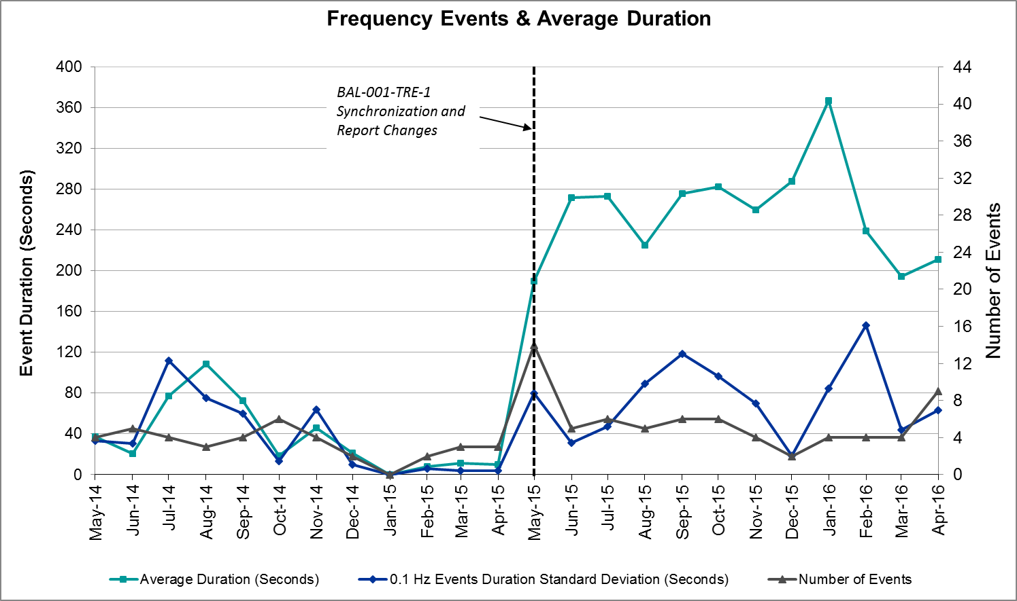

Responsive Reserve Events
There were six events where Responsive Reserve MWs were released to SCED in April. The events highlighted in blue were related to frequency events reported in Section 2.1 above.

Date and Time Released to SCED | Date and Time Recalled | Duration of Event | Maximum MWs Released | Comments
4/9/2016 5:00:16 | 4/9/2016 5:04:00 | 0:03:44 | 633.41
4/17/2016 23:26:14 | 4/17/2016 23:28:22 | 0:02:08 | 891.64
4/17/2016 23:30:50 | 4/17/2016 23:32:54 | 0:02:04 | 101.37
4/23/2016 14:02:48 | 4/23/2016 14:06:44 | 0:03:56 | 639.07
4/30/2016 1:16:28 | 4/30/2016 1:19:52 | 0:03:24 | 383.58
4/30/2016 3:58:16 | 4/30/2016 4:01:44 | 0:03:28 | 341.26

Load Resource Events
There were no load resource deployment events in April.

Reliability Unit Commitment
ERCOT reports on Reliability Unit Commitments (RUC) on a monthly basis. Commitments are reported grouped by operating day and weather zone. The total number of hours committed is the sum of the hours for all the units in the specified region. Additional information on RUC commitments can be found on the MIS secure site at Grid Generation Reliability Unit Commitment.

There were no DRUC commitments in April.

There were 12 HRUC commitments in April.

HRUC Commitments
Resource Location | # of Resources | Operating Day | Total # of Hours Committed | Total MWhs | Reason for Commitment
Southern | 1 | 4/4/2016 | 6 | 236 | Local Congestion
North Central | 1 | 4/5/2016 | 1 | 435 | Local Congestion
Southern | 1 | 4/5/2016 | 6 | 229 | Local Congestion
North Central | 1 | 4/6/2016 | 11 | 4785 | Local Congestion
Southern | 1 | 4/6/2016 | 1 | 55 | Local Congestion
North Central | 2 | 4/7/2016 | 2 | 870 | Local Congestion
Southern | 2 | 4/7/2016 | 6 | 266 | Local Congestion
Southern | 1 | 4/8/2016 | 6 | 250 | Local Congestion
North Central | 1 | 4/11/2016 | 3 | 1569 | Local Congestion
Southern | 1 | 4/14/2016 | 5 | 190 | Local Congestion
Coastal | 2 | 4/26/2016 | 11 | 2527 | Local Congestion
Southern | 2 | 4/30/2016 | 11 | 1024 | Local Congestion

Wind Generation as a Percent of Load
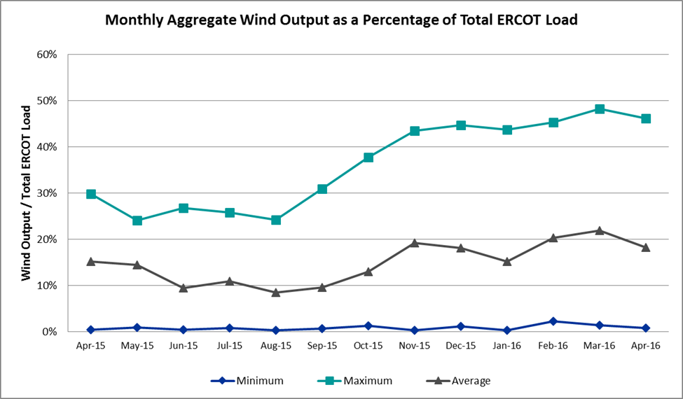

Congestion Analysis
The number of congestion events experienced by the ERCOT system decreased slightly in April. There were forty-seven instances of activity on the Generic Transmission Constraints (GTCs) in April.

Notable Constraints for April
Nodal protocol section 3.20 specifies that ERCOT shall identify transmission constraints that are active or binding three or more times within a calendar month. As part of this process, ERCOT reports congestion that meets this criterion to ROS. In addition ERCOT also highlights notable constraints that have an estimated congestion rent exceeding $1,000,000 for a calendar month. These constraints are detailed in the table below. Rows highlighted in blue indicate the congestion was affected by one or more outages. For a list of all constraints activated in SCED for the month of April, please see Appendix A at the end of this report.

Contingency | Overload | # of Days Constraint Active | Estimated Congestion Rent | Transmission Project
DCKT Roanoke Switch - West Denton and Lewisville Switch - Krum West Switch 345 kV | Fort Worth Subsation - West Denton 138kV | 15 | $ 10,027,611.63
Rosen Heights to Eagle Mountain Compressor (5)138/138/138/138/138 KV | Rosen Heights Tap 2 - Morris Dido 138kV | 5 | $ 4,566,197.25 | 4252
Mason Road to Obrien 138 KV | Betka - Hockley 138kV | 4 | $ 4,225,345.49
Eagle Mountain Ses Axfmr1l (3)345/138 KV | Eagle Mountain Ses AX2H 345/13.8/138kV | 11 | $ 3,865,585.22
Eagle Mountain Ses Axfmr1l (3)345/138 KV | Eagle Mountain Ses AX2L 345/13.8/138kV | 6 | $ 3,993,367.46
Villa Cavazos to Military Highway Aep (2)138/138 KV | Los Fresnos - Loma Alta Substation 138kV | 7 | $ 3,652,416.36
Emses-Sagna 138kv | Rosen Heights Tap 2 - Morris Dido 138kV | 7 | $ 2,571,742.43 | 4252
Rosen Heights to Eagle Mountain Compressor (5)138/138/138/138/138 KV | Eagle Mountain Ses - Morris Dido 138kV | 3 | $ 1,237,438.30 | 4252
Scurry Switch to Sun Switch 138 KV | Paint Creek 69-2 138/69kV | 1 | $ 1,266,891.99 | 5362
Nelson Sharpe - Lon Hill 345 kV | Javalina Tap - Molina 138kV | 14 | $ 981,160.75 | 4401
Nueces Bay to Citgo N Oak Park 138 KV | Nueces Bay - Whitepoint 138kV | 3 | $ 831,355.83
DCKT Jewett - Singleton 345 kV | Btu_Jack_Creek - Twin Oak Switch 345kV | 8 | $ 625,142.74
Bosque Switch - Elm Mott 345 kV | Bosque Switch - Rogers Hill Bepc 138kV | 9 | $ 511,941.98 | 4356
Falcon Switch Station to Roma Switch 138 KV | Javalina Tap - Molina 138kV | 23 | $ 442,929.58 | 4401
Basecase | Liston GTC | 25 | $ 305,088.58
Marbfa-Lakewy &Wirtz-Palefa 138kv | Flat Rock Lcra - Wirtz 138kV | 9 | $ 104,871.28 | 4465
Mercers Gap Sw to Comanche Switch (Oncor) 138 KV | Camp Bowie (Oncor) - Brownwood Switch 138kV | 4 | $ 95,872.86
King Ranch Gas Plant to Falfurrias 138 KV | Falfurrias - Premont 69kV | 5 | $ 66,635.88
Laquinta - Lobo 138 kV | Bruni Sub 69_1 138/69kV | 9 | $ 71,655.76
Hiway_9 - Citgo N Oak Park 138 kV | Citgo N Oak Park - Cantwell 138kV | 4 | $ 77,124.04
Basecase | Paredes Switching Station - Central Avenue Sub 138kV | 5 | $ 64,204.00
DCKT Marion - Zorn and Clear Springs 345 kV | Clear Springs - Geronimo 138kV | 3 | $ 51,664.01
Basecase | Zorillo to Ajo GTC | 13 | $ 41,338.31
Cottonwood Road Switch - Loftin 69 kV | Bowie FMR1 138/69kV | 5 | $ 29,957.67
DCKT Ferguson - Granite Mountain and Wirtz - Starcke - Paleface 138 kV | Flat Rock Lcra - Wirtz 138kV | 7 | $ 24,815.58 | 4465
DCKT Lon Hill - North Edinburg 345 kv and Orange Grove Switching Station 138 kV | Javalina Tap - Molina 138kV | 5 | $ 24,428.52 | 4401
Uvalde Aep - Odlaw Switchyard 138 kV | Hamilton Road - Maverick 138kV | 4 | $ 21,404.84 | 16TPIT0024
Zorn-Marion & Cleasp 345kv | Henne - Zorn 138kV | 3 | $ 19,884.60
Basecase | Randado Aep - Zapata 138kV | 16 | $ 10,547.58
Basecase | Wkn_Bkr - Ena Snyder Wind 69kV | 5 | $ 4,811.13

Generic Transmission Constraint Congestion
There were thirteen days of activity on the Zorillo – Ajo GTC, nine days on the Panhandle GTC, and twenty-five days on the Liston GTC in April. There was no activity on the remaining GTCs during the Month.

Note: This is how many times a constraint has been activated to avoid exceeding a GTC limit, it does not imply an exceedance of the GTC occurred or that the GTC was binding.

Manual Overrides for April
There were no manual overrides for the month of April 2016.

Congestion Costs for Calendar Year 2016
The following table represents the top twenty active constraints for the calendar year based on the estimated congestion rent attributed to the congestion. ERCOT updates this list on a monthly basis.

Contingency | Binding Element | # of 5-min SCED Intervals | Estimated Congestion Rent | Transmission Project
Villa Cavazos to Military Highway Aep (2)138/138 KV | Los Fresnos - Loma Alta Substation 138kV | 3272 | $ 26,026,381.24
DCKT Roanoke Switch - West Denton and Lewisville Switch - Krum West Switch 345 kV | Fort Worth Subsation - West Denton 138kV | 1774 | $ 10,027,611.63
Hicks Switch - Alliance & Roanoke Switch 345 kV | Eagle Mountain Ses - Morris Dido 138kV | 1420 | $ 8,755,553.47 | 4252
Rosen Heights to Eagle Mountain Compressor (5)138/138/138/138/138 KV | Rosen Heights Tap 2 - Morris Dido 138kV | 857 | $ 6,945,775.57 | 4252
Hicks Switch - Alliance & Roanoke Switch 345 kV | Rosen Heights Tap 2 - Morris Dido 138kV | 805 | $ 5,063,292.44 | 4252
South Texas # 1 & # 2 | Marion - Clear Springs 345kV | 18 | $ 4,402,597.52
Basecase | Panhandle GTC | 2412 | $ 4,600,812.58
Mason Road to Obrien 138 KV | Betka - Hockley 138kV | 256 | $ 4,451,883.67
Nelson Sharpe - Lon Hill 345 kV | Javalina Tap - Molina 138kV | 3727 | $ 3,631,835.12 | 4401
Eagle Mountain Ses Axfmr1l (3)345/138 KV | Eagle Mountain Ses AX2H 345/13.8/138kV | 813 | $ 3,865,585.22
Eagle Mountain Ses Axfmr1l (3)345/138 KV | Eagle Mountain Ses AX2L 345/13.8/138kV | 329 | $ 3,993,367.46
Carrolton Northwest - Lewisville Switch 345 kV | Carrollton Northwest - Lakepointe Tnp 138kV | 1637 | $ 2,880,637.43 | 2013 to 2015 RTP
DCKT Lon Hill - North Edinburg 345 kv and Orange Grove Switching Station 138 kV | Javalina Tap - Molina 138kV | 3426 | $ 2,657,778.47 | 4401
Basecase | Valley Import | 25 | $ 3,092,732.78
Emses-Sagna 138kv | Rosen Heights Tap 2 - Morris Dido 138kV | 632 | $ 2,571,742.43 | 4252
DCKT Paris Switch - Valley Ses and Valley South 345 kV | Monticello Ses - Sulphur Springs Switch 345kV | 8 | $ 2,505,612.99
Basecase | Liston GTC | 7119 | $ 1,622,030.44
Rosen Heights to Eagle Mountain Compressor (5)138/138/138/138/138 KV | Eagle Mountain Ses - Morris Dido 138kV | 238 | $ 1,658,264.01
Stp-Dow 345kv | South Texas Project - Wa Parish 345kV | 84 | $ 1,093,419.21
Basecase | North to Houston GTC | 51 | $ 886,981.84 | Houston Import Project

System Events

ERCOT Peak Load
The unofficial ERCOT peak load for the month was 51,036 MW and occurred on April 25th during hour ending 18:00.

Load Shed Events
None.

Stability Events
None.

Notable PMU Events
ERCOT analyzes PMU data for any significant system disturbances that do not fall into the Frequency Events category reported in section 2.1. The results are summarized in this section once the analysis has been completed.

There were no reportable events in April.

TRE/DOE Reportable Events
None.

New/Updated Constraint Management Plans
None.

New/Modified/Removed SPS
- 04/18/2016 - With the upgrade of the 138 kV bus at Morgan Creek now complete, the arming limit for protecting the 138/69 kV autotransformer Morgan Creek SPS has been modified from 600 A to 740 A (i.e. 177 MVA) as proposed.

New Procedures/Forms/Operating Bulletins
- 04/29/2016 Transmission and Security Desk V1, Rev 45
- 04/29/2016 Shift Supervisor Desk V1, Rev 38
- 04/29/2016 Resource Desk V1, Rev 42
- 04/29/2016 Real Time Desk V1, Rev41
- 04/29/2016 DC Tie Desk V1, Rev 37

Emergency Conditions

OCNs
Date and Time | Description
04/27/16 07:13 | A Forecasted Probability Wind Generation Large Down Ramp Event of 4000mws in a 180min period.

Advisories
Date and Time | Description
04/04/16 17:06 | Physical Responsive Capability < 3000 MW: ERCOT is issuing an Advisory due to Physical Responsive Capability being below 3000 MW.
04/12/16 10:47 | Physical Responsive Capability < 3000 MW: ERCOT is issuing an Advisory due to Physical Responsive Capability being below 3000 MW.
04/14/16 10:51 | Physical Responsive Capability < 3000 MW: ERCOT is issuing an Advisory due to Physical Responsive Capability being below 3000 MW.
04/17/16 13:02 | Physical Responsive Capability < 3000 MW: ERCOT is issuing an Advisory due to Physical Responsive Capability being below 3000 MW.
04/18/16 11:01 | Physical Responsive Capability < 3000 MW: ERCOT is issuing an Advisory due to Physical Responsive Capability being below 3000 MW.
04/19/16 13:05 | Physical Responsive Capability < 3000 MW: ERCOT is issuing an Advisory due to Physical Responsive Capability being below 3000 MW.
04/20/16 15:48 | Physical Responsive Capability < 3000 MW: ERCOT is issuing an Advisory due to Physical Responsive Capability being below 3000 MW.
04/30/16 14:00 | Physical Responsive Capability < 3000 MW: ERCOT is issuing an Advisory due to Physical Responsive Capability being below 3000 MW.

Watches
None.

Emergency Notices
None.

Application Performance
ERCOT system applications performed well in April. There were no issues to report.

TSAT/VSAT Performance Issues
None.

Communication Issues
None.

Market System Issues
None.

Appendix A: Real-Time Constraints
The following is a complete list of constraints activated in SCED for the month of April. Full contingency descriptions can be found in the Standard Contingencies List located on the MIS secure site at Grid Generation Reliability Unit Commitment.

Contingency | Constrained Element | From Station | To Station | # of Days Constraint Active
SFALROM8 | JAVALT_MOLINA1_1 | JAVALTAP | MOLINA | 21
BASE CASE | LISTON |  |  | 19
DRNKKRW5 | FTW_W_DE_1 | W_DENT | FTWORTH | 14
SN_SAJO5 | JAVALT_MOLINA1_1 | JAVALTAP | MOLINA | 12
XEMS58 | EMSES_AX2H | EMSES | EMSES | 10
BASE CASE | RANDAD_ZAPATA1_1 | RANDADO | ZAPATA | 9
SBOSELM5 | 1030__B | BOSQUESW | RGH | 9
DJEWSNG5 | JK_TOKSW_1 | TOKSW | JK_CK | 7
SLAQLOB8 | BRUNI_69_1 | BRUNI | BRUNI | 7
SVCAMIL8 | LOMA_A_L_FRES1_1 | L_FRESNO | LOMA_ALT | 7
DEMSSAG8 | 6265__D | MRSDO | RHTP2 | 6
DMARPA_8 | 38T365_1 | WIRTZ | FLATRO | 6
BASE CASE | SNYDER_WKN_BK1_1 | ENAS | WKN_BKR | 5
DFERPAL8 | 38T365_1 | WIRTZ | FLATRO | 5
SCRDLOF9 | BOW_FMR1 | BOW | BOW | 5
SKINFAL8 | FALFUR_PREMON1_1 | FALFUR | PREMONT | 5
XEMS58 | EMSES_AX2L | EMSES | EMSES | 5
BASE CASE | PAREDS_CNTRLAV_1 | PAREDES | MV_CNTRA | 4
SHIWCIT8 | 11T436_1 | CITGO_NO | CANTWELL | 4
SMARO2B8 | BETHK_66_A | HK | BET | 4
SRSNEMS8 | 6265__D | MRSDO | RHTP2 | 4
SZEPCMN8 | 670__B | BRNSW | CMPBW | 4
BASE CASE | ZO_AJO |  |  | 3
DCLEZOR5 | 89T204_1 | ZORN | HENNE | 3
DLONOR58 | JAVALT_MOLINA1_1 | JAVALTAP | MOLINA | 3
DMARZOR5 | 505T505_1 | CLEASP | GERONI | 3
SBRAUVA8 | HAMILT_MAVERI1_1 | HAMILTON | MAVERICK | 3
SCITNUE8 | NUECES_WHITE_2_1 | NUECES_B | WHITE_PT | 3
SRSNEMS8 | 6265__A | EMSES | MRSDO | 3
BASE CASE | JAVALT_MOLINA1_1 | JAVALTAP | MOLINA | 2
BASE CASE | PNHNDL |  |  | 2
DAUSLOS5 | 155T217_1 | BELLSO | PT | 2
DAUSLOS5 | FAYETT_6AT2 | FAYETT | FAYETT | 2
DCNSLHS8 | 3660__A | LHSES | PRCSW | 2
DMCSCDH8 | 3150__A | OKCLS | CDCSW | 2
SBESLON8 | ALICE_N_ELLA1_1 | ALICE | N_ELLA | 2
SBRAUVA8 | FRIR_ROCKSP1_1 | FRIR | ROCKSPRS | 2
SGILNU78 | GILA_MORRIS1_1 | GILA | MORRIS | 2
SLAQLOB8 | JAVALT_MOLINA1_1 | JAVALTAP | MOLINA | 2
SSCUSU28 | ROTN_WOLFGA1_1 | WOLFGANG | ROTN | 2
SSPUASP8 | ROTN_WOLFGA1_1 | WOLFGANG | ROTN | 2
BASE CASE | RIOHND_ERIOHND_1 | MV_RIOHO | RIOHONDO | 1
DCLEZOR5 | 87T233_1 | MCCALA | HENNE | 1
DEMSSAG8 | 6260__C | EMSES | EMMCP | 1
DGARHIC8 | MCN_MCN_1 | MCNEIL_ | MCNEIL | 1
DHILELM5 | MAR_SKY_1 | MARION | SKYLINE | 1
DKOCNUE8 | CHAMPL_WEIL_T1_1 | WEIL_TRC | CHAMPLIN | 1
DMARPA_8 | 43T365_1 | FLATRO | PALEPE | 1
DMARZOR5 | CLEASP_AT1 | CLEASP | CLEASP | 1
DSTEXP12 | BLESSI_LOLITA1_1 | LOLITA | BLESSING | 1
DSTPDOW5 | CKT_3124_1 | STP | HLJ | 1
DSTPWHI5 | BLESSI_LOLITA1_1 | BLESSING | LOLITA | 1
DTOKJK_5 | 260_A_1 | JEWET | SNG | 1
DWH_STP5 | AIRCO4_RINCON1_1 | RINCON | AIRCO4 | 1
DWH_STP5 | BLESSI_LOLITA1_1 | BLESSING | LOLITA | 1
SAJORI25 | CELANE_KLEBER1_1 | CELANEBI | KLEBERG | 1
SATKDAN8 | SHA_EAST_1 | EAST | SHADY_LN | 1
SBIGOR55 | FRIR_ROCKSP1_1 | FRIR | ROCKSPRS | 1
SCHABSP9 | CEDRHILL_69_1 | CEDRHILL | CEDRHILL | 1
SDHUACS8 | 6596__F | HLTSW | EMATP | 1
SESPSPU9 | CROWEL_TRSCTH1_1 | CROWELL | TRSCTHMT | 1
SFORGIL8 | CORONA_AT4 | CORONA | CORONA | 1
SHOLNLA8 | NLARSW_PILONC1_1 | NLARSW | PILONCIL | 1
SILLFTL8 | BGLK_PHBL_T1_1 | BGLK | PHBL_TAP | 1
SKLELOY8 | LOYOLA_69_1 | LOYOLA | LOYOLA | 1
SKNADM48 | ROTN_WOLFGA1_1 | WOLFGANG | ROTN | 1
SMARZOR5 | 89T204_1 | ZORN | HENNE | 1
SMUNEAS9 | PAIP_69-2 | PAIP | PAIP | 1
SSCLWF28 | OLN_FMR2 | OLN | OLN | 1
SSCUSU28 | PAIP_69-2 | PAIP | PAIP | 1
SSPUMW18 | ASPM_69T1 | ASPM | ASPM | 1
SSPUMW18 | ROTN_WOLFGA1_1 | WOLFGANG | ROTN | 1
SVLDO2W8 | BAY_SARG_1 | BAYCTYS | SARGNTS | 1
XDOW58 | BAY_SARG_1 | BAYCTYS | SARGNTS | 1
XKOC89 | HEARN__KOCH_U1_1 | HEARN_RD | KOCH_UP | 1
XWHT58 | WHTNY_MR2L | WHTNY | WHTNY | 1
SFALROM8 | JAVALT_MOLINA1_1 | JAVALTAP | MOLINA | 21
BASE CASE | LISTON |  |  | 19
DRNKKRW5 | FTW_W_DE_1 | W_DENT | FTWORTH | 14
SN_SAJO5 | JAVALT_MOLINA1_1 | JAVALTAP | MOLINA | 12
XEMS58 | EMSES_AX2H | EMSES | EMSES | 10
BASE CASE | RANDAD_ZAPATA1_1 | RANDADO | ZAPATA | 9
SBOSELM5 | 1030__B | BOSQUESW | RGH | 9
DJEWSNG5 | JK_TOKSW_1 | TOKSW | JK_CK | 7
SLAQLOB8 | BRUNI_69_1 | BRUNI | BRUNI | 7
SVCAMIL8 | LOMA_A_L_FRES1_1 | L_FRESNO | LOMA_ALT | 7
DEMSSAG8 | 6265__D | MRSDO | RHTP2 | 6
DMARPA_8 | 38T365_1 | WIRTZ | FLATRO | 6

