1. **Day to Day Issues – Other**
2. Required Fields for Other Issues

Refer to Section 10 – Bulk Insert Appendix - D2D Issues

1. Definition of Other Issues

## Examples of Other

* CR Cancel without Approval- Safety Net Order
* Questions pertaining to Siebel Reports
* Questions pertaining to request for filenames
* Questions pertaining to 997 reports
* Questions pertaining to CSAs
* Questions pertaining to missing information on non-required EDI fields
* Request for reprocessing of transactions
* Questions pertaining to Texas Set
* Questions pertaining to the processing time of transactions (Protocols)
* Questions pertaining to Portal
* Usage/Billing Dispute when the CR is no longer the Rep of Record and cannot submit a Usage/Billing – Dispute MarkeTrak issue

## Submitting an Other Issue

A CR or a TDSP can submit this sub type.

## Day to Day Issues - Usage and Billing AMS LSE (Dispute)



This subtype is used by a CR to dispute AMS LSE interval data from the TDSP. The start and stop time fields should reflect the period being disputed, formatted as mm/dd/yyyy 00:00:00 (as StartTime), and mm/dd/yyyy 23:59:59 (as StopTime). Each issue must reflect the intervals from a consecutive period ; a new issue must be created for each additionalperiod.

This subtype should only include ESIIDs with an AMS meter profile. Before submitting an AMS LSE – Dispute issue, the CR should allow five (5) business days for transaction processing to complete.

The usage data must be loaded in the ERCOT system and is identified by the unique identifier ‘UIDAMSINTERVAL’ from the Supplemental AMS Interval Data Extract. This field uniquely identifies the specific interval(s) being disputed for a one day service period. When disputing a period greater than one day, enter the ‘UIDAMSINTERVAL’ of the STOP Time date. (NOTE: if this date is not available in the Supplemental AMS Interval Data Extract, use the oldest date posted as the extract only displays the past 30 days)

The Supplemental AMS Interval Data Extract is posted daily to the ERCOT Market Information System (MIS). Additional information about the extract can be found in the Supplemental AMS Interval Data Extract User Guide located on ERCOT.com.



* 2. 1. **Required fields for Usage and Billing AMS LSE Dispute**

Refer to Section 10 – Bulk Insert Appendix - D2D Issues

* + 1. **Submitting a Usage and Billing AMS LSE Dispute Issue**
       1. **Main Success Scenario:**
          1. Select “Submit to my Preferred Projects” under Basic Tasks under the Submit Icon. (for this example, the Submitter is the CR).
          2. From the Submit Tree, select “selects *Usage/Billing AMS LSE Interval (Dispute)*” (**Fig 4.18.2.1a**)

**Fig. 4.18.2.1a**

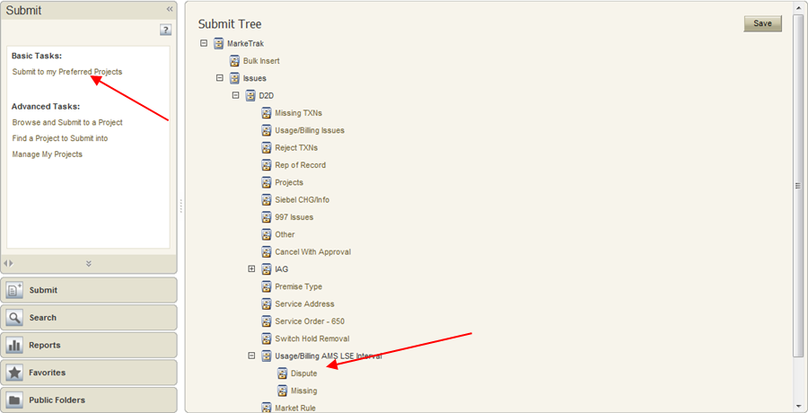

* + - * 1. User enters all required information (**Fig 4.18.2.1b**)

**Assignee**

**ESI ID**

**UIDAMSINTERVAL**

**Interval Starttime formatted as MM/DD/YYYY 00:00:00**

**Interval Stoptime formatted as MM/DD/YYYY 23:59:59**

**Fig. 4.18.2.1b**

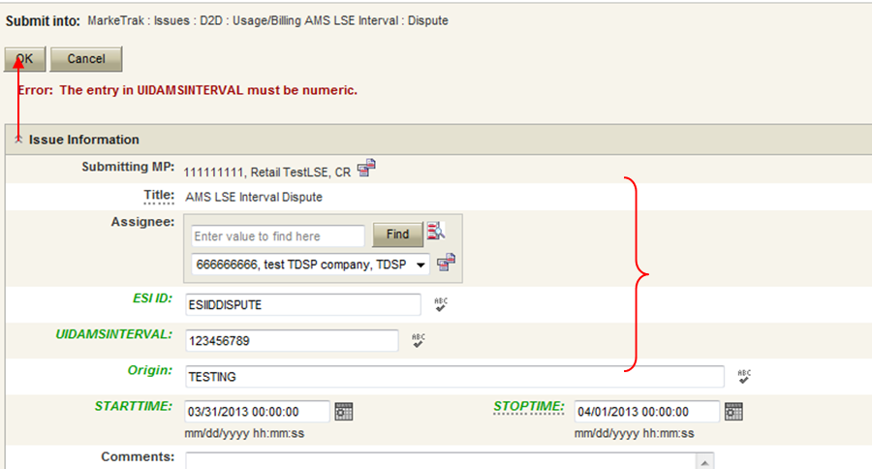

* + - * 1. User Selects **OK** to create the issue
        2. MarkeTrak Issue is assigned to the state of **New** with the TDSP as the Responsible Party.
        3. TDSP User selects **Begin Working**.
        4. MarkeTrak issue is assigned to the state of **In Progress (Assignee)** with the TDSP as the Responsible Party
        5. TDSP User selects **Complete** and adds appropriate comments (**Fig 4.18.2.1c**)

**Fig. 4.18.2.1c**

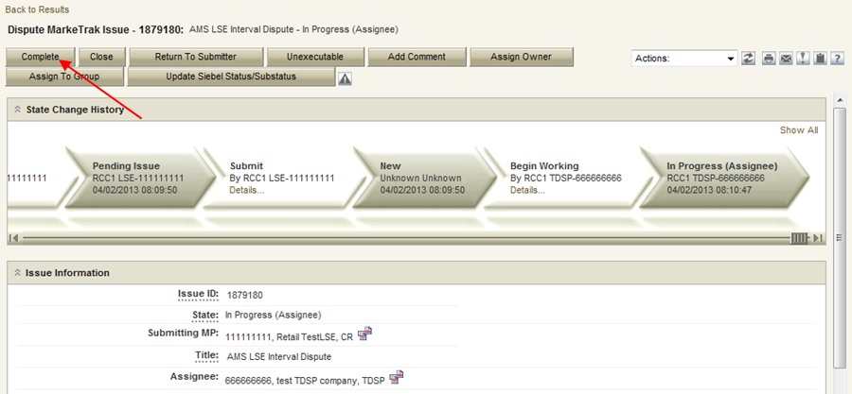

* + - * 1. MarkeTrak Issue is assigned to the state of **Pending Complete** with the Submitting MP as the Responsible Party
        2. Submitting MP User Selects **Complete**. MarkeTrak Issue is assigned to the state of **Complete** with the Submitting MP as the Responsible Party (**Fig 4.18.2.1d**)

**Fig. 4.18.2.1d**

