March 2016 ERCOT Monthly Operations Report
Reliability and Operations Subcommittee Meeting
May 5th, 2016

Table of Contents
1. Report Highlights 1
2. Frequency Control 2
2.1. Frequency Events 2
2.2. Responsive Reserve Events 3
2.3. Load Resource Events 3
3. Reliability Unit Commitment 3
4. Wind Generation as a Percent of Load 4
5. Congestion Analysis 5
5.1. Notable Constraints for February 5
5.2. Generic Transmission Constraint Congestion 6
5.3. Manual Overrides for February 7
5.4. Congestion Costs for Calendar Year 2016 7
6. System Events 8
6.1. ERCOT Peak Load 8
6.2. Load Shed Events 8
6.3. Stability Events 8
6.4. Notable PMU Events 8
6.5. TRE/DOE Reportable Events 8
6.6. New/Updated Constraint Management Plans 8
6.7. New/Modified/Removed SPS 8
6.8. New Procedures/Forms/Operating Bulletins 8
7. Emergency Conditions 8
7.1. OCNs 8
7.2. Advisories 8
7.3. Watches 9
7.4. Emergency Notices 9
8. Application Performance 9
8.1. TSAT/VSAT Performance Issues 9
8.2. Communication Issues 9
8.3. Market System Issues 9
Appendix A: Real-Time Constraints 10

Report Highlights
- The unofficial ERCOT peak for March was 43,456 MW.
- There were four frequency events in March. PMU data indicates the ERCOT system transitioned well in each case.
- There were four instances where Responsive Reserves were deployed, three of which were the result of frequency events.
- There were seven RUC commitments in March.
- The level of reportable SCED congestion increased in March. This congestion was due primarily to planned outages and area load/gen patterns. There were forty instances of activity distributed over 19 days on the Generic Transmission Constraints (GTCs) in March. This included twenty-six days on the Liston GTC, five days on the Panhandle GTC, six days on the Zorillo – Ajo GTC, two on the North to Houston and one day on the Valley Import GTC.
- There were no significant system events for the month of March.
- ERCOT Applications performed well throughout the month. There were no ERCOT related application performance issues.

Frequency Control

Frequency Events
The ERCOT Interconnection experienced four frequency events in March, all of which resulted from Resource trips. The average event duration was approximately 0:03:15.

When analyzing frequency events, ERCOT evaluates PMU data according to industry standards. Events with an oscillating frequency of less than 1 Hz are considered to be inter-area, while higher frequencies indicate local events. Industry standards specify that damping ratio for inter-area oscillations should be 3.0% or greater. All events listed below indicate the ERCOT system met these standards and transitioned well after each disturbance.

Reported frequency events will include both frequency events where frequency was outside the range of 60±0.1 Hz as well as those determined to be Frequency Measurable Events (FME) as defined by BAL-001-TRE-1. Delta Frequency is defined as the difference between the pre-perturbation and post-perturbation frequency. The Duration of Event is defined as the time it takes for the frequency to recover to lesser/greater of the frequency at the time of the frequency event (t(0) or “A-point”) for low/high-frequency events, respectively. Further details on FMEs can be found in the MIS posted BAL-001-TRE-1 PDCWG Unit Performance reports. A summary of the frequency events is provided below:

Date and Time | Delta Frequency | Max/Min Frequency | Duration of Event | PMU Data |  | Load | Wind  % | Inertia
 | (Hz) | (Hz) |  | Oscillation Mode (Hz) | Damping Ratio | (MW) |  | (GW-s)
3/8/2016 5:03 | 0.069 | 59.92 | 0:03:15 | PMU Data Not Available. |  | 28,130 | 27% | 190,850
3/8/2016 10:18 | 0.080 | 59.87 | 0:04:15 | PMU Data Not Available. |  | 35,742 | 7% | 233,975
3/15/2016 20:00 | 0.043 | 59.90 | 0:02:54 | PMU Data Not Available. |  | 41,264 | 7% | 244,913
3/22/2016 21:29 | 0.065 | 59.91 | 0:02:34 | 0.73 | 8% | 35,504 | 38% | 177,863

(Note: frequency events highlighted in blue have been identified as FMEs per BAL-001-TRE-1 and the Performance Disturbance Compliance Working group.)

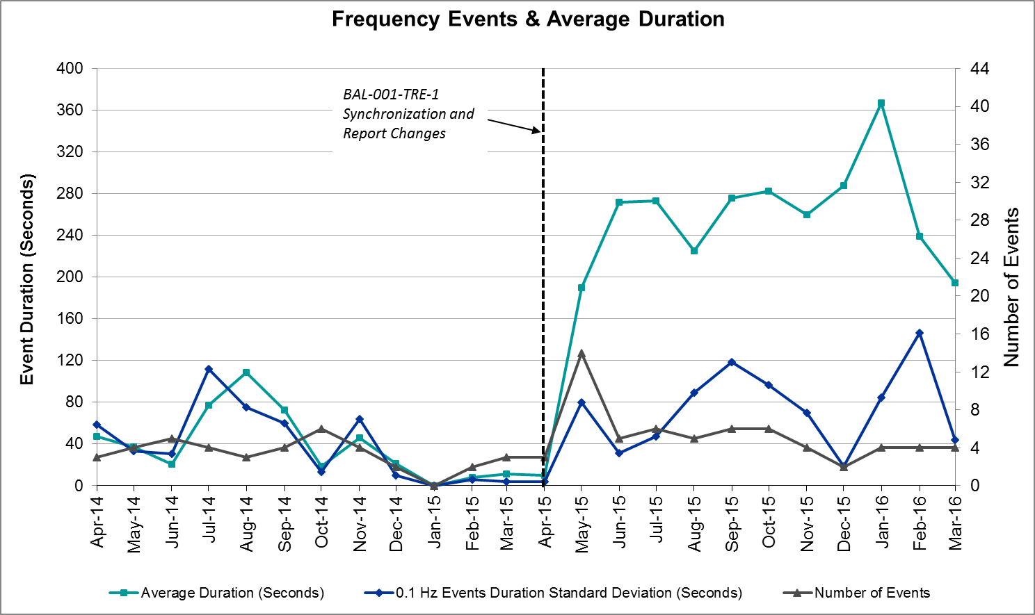

Responsive Reserve Events
There were four events where Responsive Reserve MWs were released to SCED in March. The events highlighted in blue were related to frequency events reported in Section 2.1 above.

Date and Time Released to SCED | Date and Time Recalled | Duration of Event | Maximum MWs Released | Comments
3/8/2016 10:18:32 | 3/8/2016 10:22:40 | 0:04:08 | 692.86
3/10/2016 2:29:10 | 3/10/2016 2:33:46 | 0:04:36 | 452.50 | Several units coming off-line causing frequency to drop to 59.906Hz and drag. High wind forecast error causing lower commitment.
3/15/2016 20:00:46 | 3/15/2016 20:03:14 | 0:02:28 | 425.99
3/22/2016 21:29:42 | 3/22/2016 21:31:06 | 0:01:24 | 201.28

Load Resource Events
There were no load resource deployment events in March.

Reliability Unit Commitment
ERCOT reports on Reliability Unit Commitments (RUC) on a monthly basis. Commitments are reported grouped by operating day and weather zone. The total number of hours committed is the sum of the hours for all the units in the specified region. Additional information on RUC commitments can be found on the MIS secure site at Grid Generation Reliability Unit Commitment.

There were no DRUC commitments in March.

There were six HRUC commitments in March.

HRUC Commitments
Resource Location | # of Resources | Operating Day | Total # of Hours Committed | Total MWhs | Reason for Commitment
Southern | 2 | 3/3/2016 | 10 | 511 | Local Congestion
Southern | 1 | 3/15/2016 | 9 | 475 | Local Congestion
Southern | 2 | 3/18/2016 | 8 | 396 | Local Congestion
North Central | 1 | 3/23/2016 | 2 | 244 | Local Congestion
Southern | 1 | 3/29/2016 | 1 | 43 | Local Congestion
Southern | 1 | 3/30/2016 | 5 | 193 | Local Congestion
Southern | 1 | 3/31/2016 | 9 | 366 | Local Congestion

Wind Generation as a Percent of Load
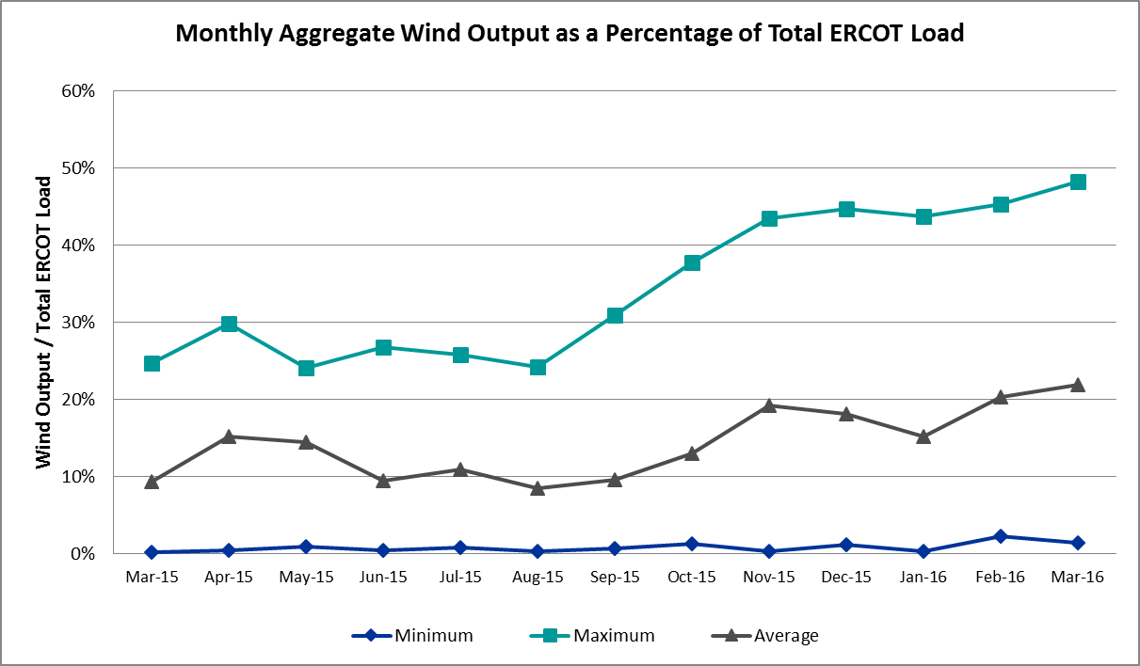

Congestion Analysis
The number of congestion events experienced by the ERCOT system increased in March due to planned outages and area load/gen patterns. There were forty instances of activity distributed over 19 days on the Generic Transmission Constraints (GTCs) in March.

Notable Constraints for March
Nodal protocol section 3.20 specifies that ERCOT shall identify transmission constraints that are active or binding three or more times within a calendar month. As part of this process, ERCOT reports congestion that meets this criterion to ROS. In addition ERCOT also highlights notable constraints that have an estimated congestion rent exceeding $1,000,000 for a calendar month. These constraints are detailed in the table below. Rows highlighted in blue indicate the congestion was affected by one or more outages. For a list of all constraints activated in SCED for the month of March, please see Appendix A at the end of this report.

Contingency | Overload | # of Days Constraint Active | Estimated Congestion Rent | Transmission Project
Villa Cavazos to Military Highway 138/138 KV | Los Fresnos - Loma Alta 138kV | 14 | $ 9,843,847.22
Hicks Switch - Alliance & Roanoke Switch 345 kV | Rosen Heights Tap 2 - Morris Dido 138 kV | 9 | $ 4,960,392.20 | 4252
South Texas # 1 & # 2 | Marion - Clear Springs 345kV | 1 | $ 4,733,737.88
Basecase | Panhandle GTC | 5 | $ 4,334,264.96
Hicks Switch - Alliance & Roanoke Switch 345 kV | Eagle Mountain Ses - Morris Dido 138kV | 7 | $ 4,142,077.28 | 4253
Basecase | Valley Import | 1 | $ 2,548,546.27
Nelson Sharpe - Lon Hill 345 kV | Javalina Tap - Molina 138kV | 15 | $ 2,348,061.66 | 4401
DCKT Paris Switch - Valley Ses and Valley South 345 kV | Monticello Ses - Sulphur Springs Switch 345kV | 1 | $ 1,861,967.93
Carrolton Northwest - Lewisville Switch 345 kV | Carrollton Northwest - Lakepointe Tnp 138kV | 12 | $ 1,373,961.36 | 2013 to 2015 RTP
STP - Dow 345 kV | South Texas Project - Wa Parish 345 kV | 1 | $ 1,156,972.67
Basecase | North to Houston GTC | 2 | $ 1,136,146.64
Rosen Heights to Eagle Mountain Compressor 138 kV | Rosen Heights Tap 2 - Morris Dido 138 kV | 4 | $ 775,590.54 | 4252
Basecase | Liston GTC | 26 | $ 454,513.87
DCKT Lon Hill - North Edinburg 345 kV and Orange Grove Switching Station 138 kV | Javalina Tap - Molina 138kV | 5 | $ 348,267.16
Mercers Gap Sw to Comanche Switch 138 KV | Camp Bowie - Brownwood Switch 138kV | 16 | $ 324,564.58
Bosque Switch - Elm Mott 345 kV | Bosque Switch - Rogers Hill 138kV | 15 | $ 317,173.84 | 4356
Koch_Up-Gila&Lon_Hill-Nueces_B 138 kV | Champlin - Weil Tract 138kV | 3 | $ 294,487.86
Laquinta - Lobo 138 kV | Bruni Sub 69_1 138/69 kV | 11 | $ 195,194.17
Mcses - Cdhsw 138 kV | Sargent Road - Saint Augustine Tap 2 138 kV | 3 | $ 177,494.50 | 19TPIT0001
DCKT Ferguson - Granite Mountain and Wirtz - Starcke - Paleface 138 kV | Flat Rock Lcra - Wirtz 138kV | 22 | $ 175,482.38 | 4465
Twinbu - Dvide 345kv | Nicole - Orient 138kV | 4 | $ 168,464.57
DCKT Whitepint - Lon Hill and South Texas Project 345 kV | Airco AEP - Rincon 138kV | 6 | $ 150,088.38 | 08TPIT0132
DCKT Rio Hondo - North Edinburg 345 kV and Rio - Hondo Harlingen Switch 138 kV | Burns Sub - Rio Hondo 138kV | 3 | $ 138,822.66
Falcon Switch Station to Roma Switch 138 KV | Javalina Tap - Molina 138kV | 9 | $ 94,805.33 | 4401
Marbfa-Lakewy &Wirtz-Palefa 138kv | Flat Rock Lcra - Wirtz 138kV | 11 | $ 81,328.88 | 4465
Basecase | Javalina Tap - Molina 138kV | 12 | $ 76,683.98
Nelson Sharpe - Lon Hill 345 kV | Las Pulgas - Raymondville 2 138kV | 3 | $ 59,445.29 | 4496
Spur 138_69_1 138/69 KV | Wolfgang - Rotan 69kV | 18 | $ 44,473.50
Basecase | Wkn_Bkr - Ena Snyder Wind 69kV | 14 | $ 34,214.24
Basecase | Randado Aep - Zapata 138kV | 14 | $ 32,274.30
Whitney Wht1t_H 345/138 kV | Whitney MR2L 345/13.8/138kV | 4 | $ 10,046.54 | 12TPIT0090
Aspermont Aep - Spur 138 kV | Wolfgang - Rotan 69kV | 9 | $ 6,875.61
Knapp to Bluff Creek Switch | Wolfgang - Rotan 69kV | 17 | $ 5,091.91
Spur - Scurry Switch 138 kV | Wolfgang - Rotan 69kV | 4 | $ 2,833.97

Generic Transmission Constraint Congestion
There were six days of activity on the Zorillo – Ajo GTC, five days on the Panhandle GTC, two days on the North-Houston GTC, one on the Valley Import and twenty-six days on the Liston GTC in March. There was no activity on the remaining GTCs during the Month.

Manual Overrides for March
There were no manual overrides for the month of March 2016.

Congestion Costs for Calendar Year 2016
The following table represents the top twenty active constraints for the calendar year based on the estimated congestion rent attributed to the congestion. ERCOT updates this list on a monthly basis.

Contingency | Binding Element | # of 5-min SCED Intervals | Estimated Congestion Rent | Transmission Project
Villa Cavazos to Military Highway Aep (2)138/138 KV | Los Fresnos - Loma Alta Substation 138kV | 2920 | $ 19,483,723.63
Hicks Switch - Alliance & Roanoke Switch 345 kV | Eagle Mountain Ses - Morris Dido 138kV | 1420 | $ 8,429,342.09 | 4253
Hicks Switch - Alliance & Roanoke Switch 345 kV | Rosen Heights Tap 2 - Morris Dido 138kV | 805 | $ 4,960,392.20 | 4252
South Texas # 1 & # 2 | Marion - Clear Springs 345kV | 18 | $ 4,733,737.88
Basecase | Panhandle GTC | 1507 | $ 4,669,343.85
Carrolton Northwest - Lewisville Switch 345 kV | Carrollton Northwest - Lakepointe Tnp 138kV | 1637 | $ 3,035,373.75 | 2013 to 2015 RTP
Nelson Sharpe - Lon Hill 345 kV | Javalina Tap - Molina 138kV | 2549 | $ 2,768,462.12 | 4401
DCKT Lon Hill - North Edinburg 345 kv and Orange Grove Switching Station 138 kV | Javalina Tap - Molina 138kV | 3330 | $ 2,580,921.52 | 4401
Basecase | Valley Import | 25 | $ 2,548,546.27
Rosen Heights to Eagle Mountain Compressor (5)138/138/138/138/138 KV | Rosen Heights Tap 2 - Morris Dido 138kV | 393 | $ 2,308,139.72 | 4252
DCKT Paris Switch - Valley Ses and Valley South 345 kV | Monticello Ses - Sulphur Springs Switch 345kV | 8 | $ 1,861,967.93
Basecase | Liston GTC | 5648 | $ 1,343,789.03
Stp-Dow 345kv | South Texas Project - Wa Parish 345kV | 84 | $ 1,156,972.67
Basecase | North to Houston GTC | 51 | $ 1,136,146.64
DCKT Gibbons Creek - Singleton 345 kV | Jewett - Singleton 345kV | 998 | $ 1,065,468.33 | 4485, 3937, 3950 (a,b)
Bluff Creek T2 (3) 345/138 kV | Bluff Creek T1_H 345/34.5/138kV | 1592 | $ 868,393.80
DCKT Lon Hill - North Edinburg 345 kv and Orange Grove Switching Station 138 kV | Airco Aep - Rincon 138kV | 2527 | $ 770,593.87 | 08TPIT0132
Twinbu-Dvide 345kv | Nicole - Orient 138kV | 763 | $ 769,944.20
Laquinta - Lobo 138 kV | Bruni Sub 69_1 138/69kV | 3043 | $ 758,575.20
Adamsville - Evant 138 KV | Goldthwaite 9AT2 138/69kV | 1062 | $ 743,432.65

System Events

ERCOT Peak Load
The unofficial ERCOT peak load for the month was 43,456 MW and occurred on March 31st during hour ending 18:00.

Load Shed Events
None.

Stability Events
None.

Notable PMU Events
ERCOT analyzes PMU data for any significant system disturbances that do not fall into the Frequency Events category reported in section 2.1. The results are summarized in this section once the analysis has been completed.

There were no reportable events in March.

TRE/DOE Reportable Events
None.

New/Updated Constraint Management Plans
None.

New/Modified/Removed SPS
None.

New Procedures/Forms/Operating Bulletins
- 03/01/2016 Transmission and Security Desk V1, Rev44
- 03/01/2016 Shift Supervisor Desk V1, Rev37
- 03/01/2016 Resource Desk V1 Rev41
- 03/01/2016 Reliability Unit Commitment Desk V1, Rev34
- 03/01/2016 Real Time Desk V1, Rev 40
- 03/01/2016 DC Tie Desk V1, Rev36

Emergency Conditions

OCNs
None.

Advisories
Date and Time | Description
03/06/16 17:55 | ERCOT issued an Advisory because The Space Weather Prediction Center issued a GMD Warning of K7 level,
03/13/16 13:28 | ERCOT issued an Advisory due to postponement of the deadline for posting the DAM Solution for Operating day 3/14/2016.
03/21/16 13:24 | ERCOT issued an Advisory due to postponement of the deadline for posting the DAM Solution for Operating day 3/22/2016.
03/27/16 16:59 | Physical Responsive Capability < 3000 MW: ERCOT is issuing an Advisory due to Physical Responsive Capability being below 3000 MW.

Watches
None.

Emergency Notices
None.

Application Performance
ERCOT system applications performed well in March. There were no issues to report.

TSAT/VSAT Performance Issues
None.

Communication Issues
None.

Market System Issues
None.

Appendix A: Real-Time Constraints
The following is a complete list of constraints activated in SCED for the month of March. Full contingency descriptions can be found in the Standard Contingencies List located on the MIS secure site at Grid Generation Reliability Unit Commitment.

Contingency | Constrained Element | From Station | To Station | # of Days Constraint Active
DFERPAL8 | 38T365_1 | WIRTZ | FLATRO | 19
BASE CASE | LISTON |  |  | 17
XSPU89 | ROTN_WOLFGA1_1 | WOLFGANG | ROTN | 17
SKNADM48 | ROTN_WOLFGA1_1 | WOLFGANG | ROTN | 16
SBOSELM5 | 1030__B | BOSQUESW | RGH | 15
SN_SAJO5 | JAVALT_MOLINA1_1 | JAVALTAP | MOLINA | 14
SVCAMIL8 | LOMA_A_L_FRES1_1 | L_FRESNO | LOMA_ALT | 14
SZEPCMN8 | 670__B | BRNSW | CMPBW | 13
BASE CASE | SNYDER_WKN_BK1_1 | ENAS | WKN_BKR | 12
DCRLLSW5 | 591__A | LKPNT | CRLNW | 10
DMARPA_8 | 38T365_1 | WIRTZ | FLATRO | 10
BASE CASE | JAVALT_MOLINA1_1 | JAVALTAP | MOLINA | 9
SLAQLOB8 | BRUNI_69_1 | BRUNI | BRUNI | 9
BASE CASE | RANDAD_ZAPATA1_1 | RANDADO | ZAPATA | 8
DHCKRNK5 | 6265__D | MRSDO | RHTP2 | 7
SFALROM8 | JAVALT_MOLINA1_1 | JAVALTAP | MOLINA | 7
BASE CASE | PNHNDL |  |  | 5
DLONOR58 | JAVALT_MOLINA1_1 | JAVALTAP | MOLINA | 5
DWH_STP5 | AIRCO4_RINCON1_1 | RINCON | AIRCO4 | 5
SRSNEMS8 | 6265__D | MRSDO | RHTP2 | 4
XWHT58 | WHTNY_MR2L | WHTNY | WHTNY | 4
DHCKRNK5 | 6265__A | EMSES | MRSDO | 3
DKOCNUE8 | CHAMPL_WEIL_T1_1 | WEIL_TRC | CHAMPLIN | 3
DMCSCDH8 | 3140__F | SARRD | SATP2 | 3
DRIOHAR5 | S104A_1 | RIOHONDO | MV_BURNS | 3
DTWIDIV5 | NICOLE_ORNT1_1 | NICOLE | ORNT | 3
SN_SAJO5 | LASPUL_RAYMND1_1 | LASPULGA | RAYMND2 | 3
SSPUASP8 | ROTN_WOLFGA1_1 | WOLFGANG | ROTN | 3
SSPUMW18 | ROTN_WOLFGA1_1 | WOLFGANG | ROTN | 3
DBIGKEN5 | FRIR_ROCKSP1_1 | FRIR | ROCKSPRS | 2
DCLEZOR5 | 86T235_1 | HENNE | COMAL | 2
DELMMAR5 | MAR_SKY_1 | MARION | SKYLINE | 2
DLHSCNR8 | 3650__A | LHSES | SATP1 | 2
DRIOHAR5 | JAVALT_MOLINA1_1 | JAVALTAP | MOLINA | 2
DRNS_TB5 | SNGZEN99_A | SNG | ZEN | 2
SADALAM8 | GOLDTH_9AT2 | GOLDTH | GOLDTH | 2
SAJORI25 | LASPUL_RAYMND1_1 | LASPULGA | RAYMND2 | 2
SMARZOR5 | 419T419_1 | CLEASP | MARION | 2
SPAWSAN5 | PAWNEE_XF1 | PAWNEE | PAWNEE | 2
SRSNEMS8 | 6265__A | EMSES | MRSDO | 2
BASE CASE | N_TO_H |  |  | 1
BASE CASE | VALIMP |  |  | 1
BASE CASE | ZO_AJO |  |  | 1
DCPSJON5 | 6005__A | PKRSW | BNBSW | 1
DJEWSNG5 | JK_TOKSW_1 | TOKSW | JK_CK | 1
DKOCNUE8 | MCKENZ_WESTSI1_1 | WESTSIDE | MCKENZIE | 1
DLONOR58 | AIRCO4_RINCON1_1 | RINCON | AIRCO4 | 1
DLONWAR5 | AIRCO4_RINCON1_1 | RINCON | AIRCO4 | 1
DMCARIO8 | BARL_FTSW1_1 | FTSW | BARL | 1
DMCSCDH8 | 3150__A | OKCLS | CDCSW | 1
DPRSVLY5 | 205__A | MNSES | SSPSW | 1
DSAMTHS5 | 1030__B | BOSQUESW | RGH | 1
DSTEXP12 | 419T419_1 | CLEASP | MARION | 1
DSTPDOW5 | STPWAP39_1 | STP | WAP | 1
DTOKJK_5 | 240__A | JEWET | SNG | 1
SAJORI25 | JAVALT_MOLINA1_1 | JAVALTAP | MOLINA | 1
SBRAUVA8 | FRIR_ROCKSP1_1 | FRIR | ROCKSPRS | 1
SBRAUVA8 | HAMILT_MAVERI1_1 | HAMILTON | MAVERICK | 1
SBRTORA8 | 6560__E | SCTLD | WFSSW | 1
SCOLBAL8 | BALG_HUMBLT1_1 | BALG | HUMBLTAP | 1
SCRDLOF9 | BOW_FMR1 | BOW | BOW | 1
SDUKNE28 | ADERHO_DUKE1_1 | DUKE | ADERHOLD | 1
SESPSPU9 | ROBY_ROTN1_1 | ROTN | ROBY | 1
SFORYEL8 | FORTMA_MASN1_1 | FORTMA | MASN | 1
SFTLMES8 | RIOPEC_SCROSS1_1 | RIOPECOS | SCROSSTP | 1
SILLFTL8 | BGLK_PHBL_T1_1 | BGLK | PHBL_TAP | 1
SKLELOY8 | LOYOLA_69_1 | LOYOLA | LOYOLA | 1
SKNADM28 | 6240__A | SACRC | SNYDR | 1
SKNADM48 | ASPM_69T1 | ASPM | ASPM | 1
SKNADM48 | SPUR_69_1 | SPUR | SPUR | 1
SKOCNU28 | GILA_HIWAY_2_1 | GILA | HIWAY_9 | 1
SL_FLA_8 | LA_PAL_VCAVAZ1_1 | LA_PALMA | VCAVAZOS | 1
SLAQLOB8 | FALFUR_69A1 | FALFUR | FALFUR | 1
SLCDYN8 | SE_WA_65_A | WA | SE | 1
SLULLOC8 | LOCKHA_6AT3 | LOCKHA | LOCKHA | 1
SMARO2B8 | BETHK_66_A | HK | BET | 1
SMARO2B8 | FOSPT_25_A | PT | FOS | 1
SORE2B8 | FOSPT_25_A | PT | FOS | 1
SORNSAR8 | BALG_FTCHAD1_1 | FTCHADBT | BALG | 1
SROMROM8 | JAVALT_MOLINA1_1 | JAVALTAP | MOLINA | 1
SSPUASP8 | JATN_SPUR_1C_1 | GIRA_TAP | DKEC | 1
SSPUASP8 | SPUR_69_1 | SPUR | SPUR | 1
SSPUMW18 | ASPM_69T1 | ASPM | ASPM | 1
SSPUMW18 | SPUR_69_1 | SPUR | SPUR | 1
XBL2U58 | BLUF_CRK_T1_H | BLUF_CRK | BLUF_CRK | 1
XFO3R89 | FORMOSA_TR21 | FORMOSA | FORMOSA | 1
XNOR358 | BARL_FTSW1_1 | FTSW | BARL | 1
XSPU89 | ROBY_ROTN1_1 | ROTN | ROBY | 1

