MGRR Number | 0026 | MGRR Title | Shunt Compensator required links update
Date |  | 10/20/2015
Submitter’s Information
Name |  | Chris Ngai
E-mail Address |  | cngai@ercot.com
Company |  | ERCOT
Phone Number |  | 512-248-3941
Cell Number
Market Segment

Comments
Update Modeling Guidelines adding required links to Shunt Compensator to match current validation rules.

Overall NMMS User Benefit | Clarifies required links
Overall NMMS User Impact
ERCOT Impact

Revised Proposed Modeling Guidelines Language

Modeling Shunt Compensators

Modeling Approach
In the ERCOT CIM model, a ShuntCompensator is defined as a shunt capacitor or reactor or switchable bank of shunt capacitors or reactors. A section of a Shunt Compensator is an individual capacitor or reactor. Negative values for attributes mVArPerSection and nominalMVAr indicate that the Compensator is a Reactor. Postive values for attributes mVArPerSection and nominalMVAr indicate that the compensator is a Capacitor. ERCOT shall develop the naming convention with the assistance of the TSP and the approval of TAC.
A Shunt Compensator is modeled under a VoltageLevel in a Substation. One Terminal is modeled under the Shunt Compensator as a connection point to the circuit. Figure below shows a Shunt Compensator modeled in the Information Model Manager model hierarchy with parent/child associations labeled. For more information on modeling SCADA values, refer to the SCADA section of this document.
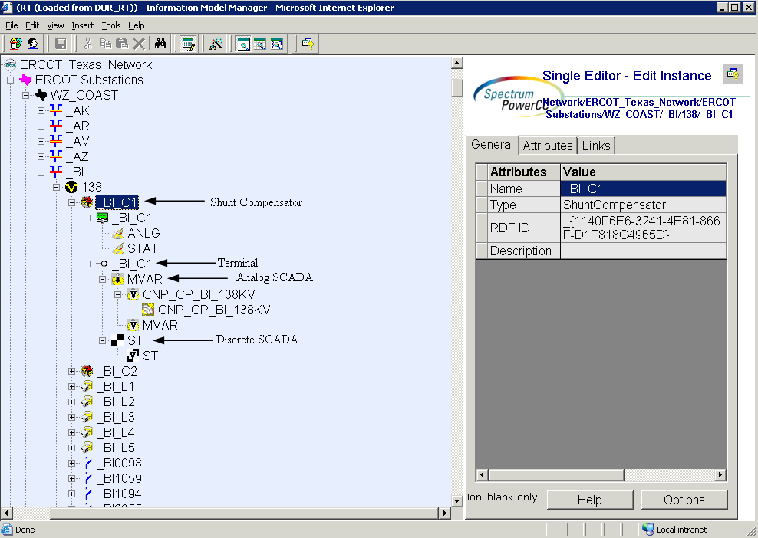
Figure 1 - Shunt Compensator

Attributes
The attributes for a Shunt Compensator are shown in the table below.

Attribute | Description | Data Type | Default Value | Sample Data
name | Name of the instance of this class | String |  | CB_1
Switching Priority | Switching priority number. | Integer | 1 | 12345
Alias Name | Free text name of the object or instance. | String | None
Automatic Voltage Regulation Delay | Time delay in seconds required for the device to be connected or disconnected by automatic voltage regulation (AVR). | Seconds | None
Automatic Voltage Regulation Enabled | T = Automatic voltage regulation enabled. | Boolean
DAM Monitored | The Boolean flags to indicate which process(s) monitor the branch devices and by which process the devices is secured. | Boolean | False
DAM Secured | The Boolean flags to indicate which process(s) monitor the branch devices and by which process the devices is secured. | Boolean | True
Impedance | The positive sequence impedance of the device. | Impeadance | None
Latitude | Latitude coordinates. | Float | None
Load Based Regulation Enabled | T = Load based voltage regulation enabled. | Boolean
Local Name | The localName is a human readable name of the object. It is only used with objects organized in a naming hierarchy. The simplest naming hierarchy has just one parent (the root) giving a flat naming hierarchy. However, the naming hierarchy usually has several levels, e.g. Substation, VoltageLevel, Equipment etc. Children of the same parent have names that are unique among them. If the uniqueness requirement cannot be met IdentifiedObject.localName shall not be used, use IdentifiedObject.name instead. | String | None
Longitude | Longitude coordinates. | Float | None
Maximum Sections | For a reactive device bank, the maximum number of sections that may be switched in. | Counter | None
Maximum kV | The maximum voltage at which the device should operate. | Voltage | None
Minimum kV | The minimum voltage at which the device should operate. | Voltage | None
Model Resource ID | A Model Authority issues mRIDs. Given that each Model Authority has a unique id and this id is part of the mRID, then the mRID is globally unique. | Integer | Auto-populated
Nominal MVAr | Nominal MVAr output of the device at the nominal kV. This number should be positive for capacitors and negative for reactors | Reactive Power | None
Nominal kV | The nominal voltage at which the nominal MVAr was measured. This should normally be within 10% of the voltage at which the device is connected to the network. | Voltage | None
Normal Sections | For a capacitor bank, the normal number of sections switched in. This number should correspond to the Nominal MVAr. | Counter | None
OUS Priority | An Outage Scheduler priority is included in all ConductingEquipment classes except BusbarSection and TransformerWinding. | Integer | None
Path Name | The pathname is a system unique name composed from all IdentifiedObject.names in a standard naming hierarchy path from the object to the root. | String | None
Phases | Describes the phases carried by a conducting equipment. Possible values { ABCN , ABC, ABN, ACN, BCN, AB, AC, BC, AN, BN, CN, A, B, C, N }. | PhaseCode | None
PSS/E ID | Attribute will give Information Model Manager modelers control over the PSS/E ID that the Topology Processor uses to properly name units, loads, branches, and transformers | String | None
Remove | The equipment is removed from the network. | Boolean | False
Remove Enable | The equipment can be removed from the network. | Boolean | False
RUC Monitored | The Boolean flags to indicate which process(s) monitor the branch devices and by which process the devices is secured. | Boolean | False
RUC Secured | The Boolean flags to indicate which process(s) monitor the branch devices and by which process the devices is secured. | Boolean | True
Switch On Count | The switch on count since the device count was last reset or initialized. | Counter | None
Switch On Date | The date and time when the device was last switched on. | Absolute Date/Time | None
Voltage Sensitivity | Voltage sensitivity required for the device to regulate the bus voltage, in per unit voltage/MVAr. | PU kV per MVAr
Y Per Section | For a capacitor bank, the admittance of each switchable section. Calculated using the MVAr per section and corrected for network voltage. | Admittance | None
mVAr Per Section | For a capacitor bank, the size in MVAr of each switchable section at the Nominal kV. | Reactive Power | None

Linkage
The required links for a Shunt Compensator are defined in Table below.

Link Name | Description | Path Name
Operatorship | The Operatorship link is used for permission rights. The Operator of equipment has the right to edit the equipment. An operator can only be assigned by the creator or owner of the equipment. Creator is the person who is submitting the entry through PTC, who is associated with the company that owns the equipment. Ownership and Operatorship point to a company whereas a creator points to a userid. | Network/Companies
Ownership | The Ownership link is used for permission rights. The owner of equipment has editing and administrative rights. An owner can only be assigned by the creator of the equipment. | Network/Companies
RegulatingCondEq-RegulationSchedule | A type of conducting equipment may have a voltage regulation schedule | Schedules/RegulationSchedules
RegulatingCondEq-Terminal | The regulated terminal of a shuntcompensator is the other side of breaker or disconnector connecting to shunt compensator’s terminal. | Network/ERCOT Texas Network/ERCOT Substations/Sub Geographical Region/Substation/VoltageLevel/[Breaker/Disconnector]/Terminal
ShuntCompensator-Switch | The switch of a shuntcompensator is the one switching in and out of the compensator; it can be a breaker or a disconnector. | Network/ERCOT Texas Network/ERCOT Substations/Sub Geographical Region/Substation/VoltageLevel/[Breaker/Disconnector]

