MGRR Number | 025 | MGRR Title | Add line length requirement to AC Line Segment
Date |  | 04/19/2016
Submitter’s Information
Name |  | Chris Ngai
E-mail Address |  | cngai@ercot.com
Company |  | ERCOT
Phone Number |  | 512-248-3941
Cell Number
Market Segment

Comments

Add line length as required attribute in AC Line Segment.

Overall NMMS User Benefit | More accurate line model in IMM because of enhanced line data validation using line length.
Overall NMMS User Impact | Add line length as required field; however, most of the AC Line Segments have line length not equal to zero in IMM.
ERCOT Impact | More accurate line model in IMM because of enhanced line data validation using line length.

Revised Proposed Modeling Guidelines Language

- Modeling ACLineSegment
  - Modeling Approach
The ACLineSegment class represents an AC transmission line that connects two different Substations. An ACLineSegment cannot be contained within a single Substation. Additionally, an ACLineSegment must be underneath a Line instance and must have two Terminals. ERCOT shall develop the naming convention with the assistance of the TSP and the approval of TAC.
ACLinesegment cannot go between different voltage levels.
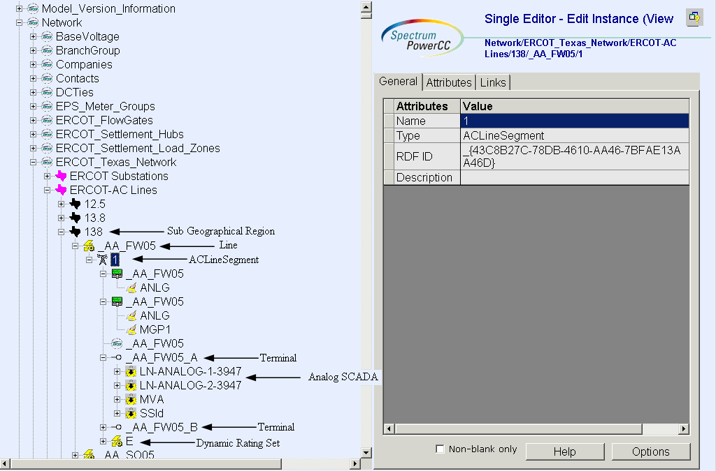
Figure 1 - ACLineSegment

  - Attributes
Attributes for a ACLineSegment are shown in the table below.

Attribute | Description | Data Type | Default Value | Sample Data
name | Name of the instance of this class | String |  | CB_1
15 minute rating Max Shadow Price | 15 minute rating Max Shadow price | Double Float
Alias Name | Free text name of the object or instance. | String | None
b0ch | Zero sequence shunt (charging) susceptance, uniformly distributed, of the entire line section. | Double Float
bch | Positive sequence shunt (charging) susceptance, uniformly distributed, of the entire line section. | Double Float
DAM Monitored | The Boolean flags to indicate which process(s) monitor the branch devices and by which process the devices is secured. | Bool
DAM Secured | The Boolean flags to indicate which process(s) monitor the branch devices and by which process the devices is secured. | Bool
Emergency Max Shadow Price | Emergency Max Shadow price | Double Float
g0ch | Zero sequence shunt (charging) conductance, uniformly distributed, of the entire line section. | Double Float
gch | Positive sequence shunt (charging) conductance, uniformly distributed, of the entire line section. | Double Float
Latitude | Latitude coordinates. | Float | None
length | Segment length for calculating line section capabilities (long length units). | Float
Local Name | The localName is a human readable name of the object. It is only used with objects organized in a naming hierarchy. The simplest naming hierarchy has just one parent (the root) giving a flat naming hierarchy. However, the naming hierarchy usually has several levels, e.g. Substation, VoltageLevel, Equipment etc. Children of the same parent have names that are unique among them. If the uniqueness requirement cannot be met IdentifiedObject.localName shall not be used, use IdentifiedObject.name instead. | String | None
Longitude | Longitude coordinates. | Float | None
Max Shadow Price | Max shadow price | Double Float
Model Resource ID | A Model Authority issues mRIDs. Given that each Model Authority has a unique id and this id is part of the mRID, then the mRID is globally unique. | String
OUS Priority | An Outage Scheduler priority is included in all ConductingEquipment classes except BusbarSection and TransformerWinding. | Long Int | None
Path Name | The pathname is a system unique name composed from all IdentifiedObject.names in a standard naming hierarchy path from the object to the root. | String
Phases | Describes the phases carried by a conducting equipment. Possible values { ABCN , ABC, ABN, ACN, BCN, AB, AC, BC, AN, BN, CN, A, B, C, N }. | String
PSS/E | Attribute will give Information Model Manager modelers control over the PSS/E ID that the Topology Processor uses to properly name units, loads, branches, and transformers. | String
r | Positive sequence series resistance of the entire line section. | Double Float
R0 | Zero sequence series resistance of the entire line section. | Double Float
Remove | The equipment is removed from the network. | Bool
Remove Enable | The equipment can be removed from the network in the EMS. | Bool
RUC Monitored | The Boolean flags to indicate which process(s) monitor the branch devices and by which process the devices is secured. | Bool
RUC Secured | The Boolean flags to indicate which process(s) monitor the branch devices and by which process the devices is secured. | Bool
teid | Transmission Element ID | Integer | Auto-populated
x | Positive sequence series reactance of the entire line section. | Double Float
X0 | Zero sequence series reactance of the entire line section. | Double Float

  - Linkage
The required links for ACLineSegment are defined in Table below.

Link Name | Description | Path Name
BaseVoltage | BaseVoltage to which this ACLineSegment belongs | Network/Base Voltage
Operatorship | The Operatorship link is used for permission rights. The Operator of equipment has the right to edit the equipment. An operator can only be assigned by the creator or owner of the equipment. Creator is the person who is submitting the entry through PTC, who is associated with the company that owns the equipment. Ownership and Operatorship point to a company whereas a creator points to a userid. | Network/Companies
Ownership | The Ownership link is used for permission rights. The owner of equipment has editing and administrative rights. An owner can only be assigned by the creator of the equipment. | Network/Companies

