December 2015 ERCOT Monthly Operations Report
Reliability and Operations Subcommittee Meeting
February 4th, 2016

Table of Contents
1 Report Highlights 3
2 Frequency Control 4
2.1 Frequency Events 4
2.2 Responsive Reserve Events 5
2.3 Load Resource Events 5
3 Reliability Unit Commitment 5
4 Wind Generation as a Percent of Load 6
5 Congestion Analysis 6
5.1 Notable Constraints for December 7
5.2 Generic Transmission Constraint Congestion 8
5.3 Manual Overrides for December 8
5.4 Congestion Costs for Calendar Year 2015 9
6 System Events 10
6.1 ERCOT Peak Load 10
6.2 Load Shed Events 10
6.3 Stability Events 10
6.4 Notable PMU Events 10
6.5 TRE/DOE Reportable Events 10
6.6 New/Updated Constraint Management Plans 10
6.7 New/Modified/Removed SPS 10
6.8 New Procedures/Forms/Operating Bulletins 10
7 Emergency Conditions 10
7.1 OCNs 11
7.2 Advisories 11
7.3 Watches 11
7.4 Emergency Notices 11
8 Application Performance 11
8.1 TSAT/VSAT Performance Issues 11
8.2 Communication Issues 11
8.3 Market System Issues 11
9 Net-Forecast Bias Applied to NSRS Procurement for December 2015 12
Appendix A: Real-Time Constraints 13

Report Highlights
- The unofficial ERCOT peak for December was 44,878 MW.
- There were two frequency events in December. PMU data indicates the ERCOT system transitioned well in each case.
- There were two instances where Responsive Reserves were deployed, both of which were the result of frequency events.
- There was one RUC commitment in December.
- The level of reportable SCED congestion Increased in December. This congestion was due primarily to planned outages and area load/gen patterns. There were thirty-nine instances of activity distributed over twenty-two days on the Generic Transmission Constraints (GTCs) in December. This included nineteen days on the Molina GTC, nine days on the Liston GTC, five days on the Panhandle GTC and six days of activity on the Zorillo – Ajo GTC.
- There were no significant system events for the month of December.
- On 12/10/15 there was an advisory because ERCOT’s Voltage Security Assessment Tool was unavailable.

Frequency Control

Frequency Events

The ERCOT Interconnection experienced two frequency events in December, all of which resulted from Resource trips. The average event duration was approximately 0:04:48.

When analyzing frequency events, ERCOT evaluates PMU data according to industry standards. Events with an oscillating frequency of less than 1 Hz are considered to be inter-area, while higher frequencies indicate local events. Industry standards specify that damping ratio for inter-area oscillations should be 3.0% or greater. All events listed below indicate the ERCOT system met these standards and transitioned well after each disturbance.

Reported frequency events will include both frequency events where frequency was outside the range of 60±0.1 Hz as well as those determined to be Frequency Measurable Events (FME) as defined by BAL-001-TRE-1. Delta Frequency is defined as the difference between the pre-perturbation and post-perturbation frequency. The Duration of Event is defined as the time it takes for the frequency to recover to lesser/greater of the frequency at the time of the frequency event (t(0) or “A-point”) for low/high-frequency events, respectively. Further details on FMEs can be found in the MIS posted BAL-001-TRE-1 PDCWG Unit Performance reports. A summary of the frequency events is provided below:

Date and Time | Delta Frequency | Max/Min Frequency | Duration of Event | PMU Data
 | (Hz) | (Hz) |  | Oscillation Mode (Hz) | Damping Ratio
12/2/2015 23:25 | 0.066 | 59.90 | 0:04:35 | 0.65 | 8%
12/30/2015 11:17 | 0.107 | 59.87 | 0:05:01 | 0.72 | 8%
 |  |  |  | 1.00 | 14%
(Note: frequency events highlighted in blue have been identified as FMEs per BAL-001-TRE-1 and the Performance Disturbance Compliance Working group.)

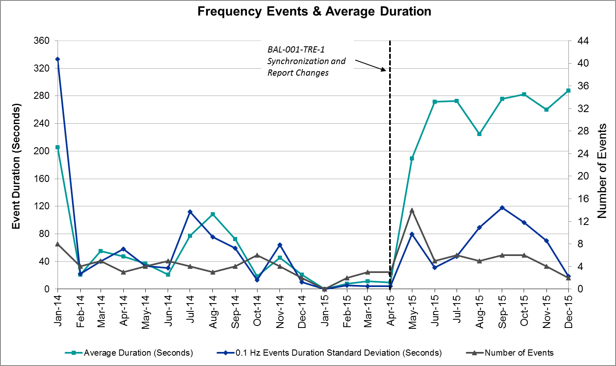

Responsive Reserve Events

There were two events where Responsive Reserve MWs were released to SCED in December. The events highlighted in blue were related to frequency events reported in Section 2.1 above.

Date and Time Released to SCED | Date and Time Recalled | Duration of Event | Maximum MWs Released | Comments
12/2/2015 23:25:56 | 12/2/2015 23:28:44 | 0:02:48 | 141.12
12/30/2015 11:17:32 | 12/30/2015 11:21:16 | 0:03:44 | 328.88

Load Resource Events
There were no load resource deployment events in December.

Reliability Unit Commitment
ERCOT reports on Reliability Unit Commitments (RUC) on a monthly basis. Commitments are reported grouped by operating day and weather zone. The total number of hours committed is the sum of the hours for all the units in the specified region. Additional information on RUC commitments can be found on the MIS secure site at Grid Generation Reliability Unit Commitment.

There were no DRUC commitments in December.

There was one HRUC commitment in December.

HRUC Commitments
Resource Location | # of Resources | Operating Day | Total # of Hours Committed | Total MWhs | Reason for commitment
Northern | 1 | 12/15/2015 | 2 | 1,244 | Local Congestion

Wind Generation as a Percent of Load
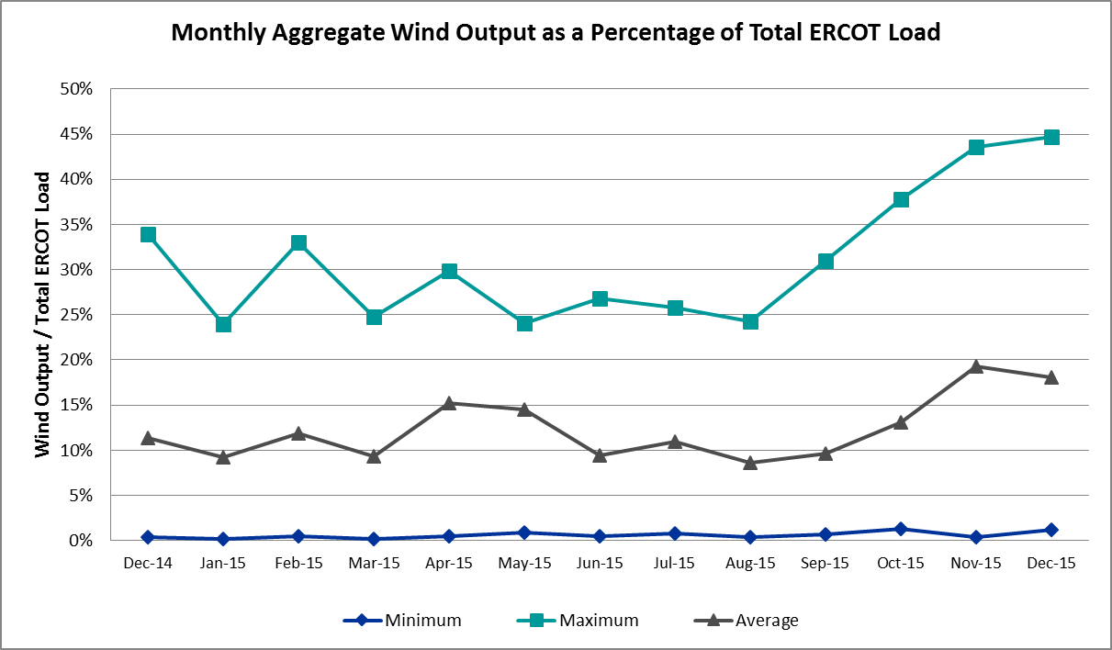

Congestion Analysis
The number of congestion events experienced by the ERCOT system increased in December due to planned outages and area load/gen patterns. There were thirty-nine instances of activity distributed over 22 days on the Generic Transmission Constraints (GTCs) in December.

Notable Constraints for December

Nodal protocol section 3.20 specifies that ERCOT shall identify transmission constraints that are active or binding three or more times within a calendar month. As part of this process, ERCOT reports congestion that meets this criterion to ROS. In addition ERCOT also highlights notable constraints that have an estimated congestion rent exceeding $1,000,000 for a calendar month. These constraints are detailed in the table below. Rows highlighted in blue indicate the congestion was affected by one or more outages. For a list of all constraints activated in SCED for the month of December, please see Appendix A at the end of this report.

Contingency | Overload | # of Days Constraint Active | Estimated Congestion Rent | Transmission Project
DKCT Roans Prarie-Rothwood & Singleton-Tomball 345 kV | Singleton - Zenith 345kV | 8 | $ 9,254,344.29 | 4485, 3937, 3950 (a,b)
Basecase | Molina GTC | 22 | $ 5,167,387.61
DKCT Roans Prarie-Rothwood & Singleton-Tomball 345 kV | Singleton - Zenith 345kV | 7 | $ 3,803,551.86 | 4485, 3937, 3950 (a,b)
Basecase | Panhandle GTC | 10 | $ 3,726,468.95
Bluff Creek T2 345/138 kV | Bluff Creek T1_H 345/34.5/138kV | 9 | $ 1,268,853.56
Carrolton Northwest - Lewisville Switch 345 kV | Carrollton Northwest - Lakepointe Tnp 138kV | 11 | $ 1,246,813.46 | 2014 RTP
DCKT Jewett - Singleton 345 kV | Singleton - Gibbons Creek 345kV | 7 | $ 1,244,158.14 | 3937
La Palma - Rio Hondo 138 kV | Paredes Switching Station - Central Avenue Sub 138kV | 11 | $ 1,234,012.71 | 3267B
Bosque Switch - Elm Mott 345 kV | Bosque Switch - Rogers Hill Bepc 138kV | 13 | $ 870,297.82
Pawnee Switching Station - Lon Hill 345 kV | Javalina Tap - Molina 138kV | 10 | $ 559,528.31 | 4401
Cagnon-Calavers & Braunig 345 kV | Skyline - Calaveras 345kV | 4 | $ 516,748.35 | 18TPIT0002
Loyola Sub to Kleberg Aep 138 kV | Loyola Sub 69_1 138/69kV | 8 | $ 508,935.98
Mercers Gap Sw to Comanche Switch 138 KV | Camp Bowie (Oncor) - Brownwood Switch 138kV | 10 | $ 298,494.52
DCKT Ferguson - Granite Mountain and Wirtz - Starcke - Paleface 138 kV | Flat Rock Lcra - Wirtz 138kV | 17 | $ 274,083.94 | 4465
DCKT Whitepint - Lon Hill and South Texas Project 345 kV | Airco Aep - Rincon 138kV | 10 | $ 266,315.60 | 08TPIT0132
Basecase | Liston GTC | 9 | $ 256,252.65
Whitney Wht1t_H 345/138 KV | Whitney MR2L 345/13.8/138kV | 3 | $ 192,557.36 | 12TPIT0090
DCKT Scurry County South Switch - Faraday and Long Draw 345 kV | Bluff Creek Switch - Exxon Sharon Ridge 138kV | 4 | $ 140,484.39
Pawnee Switching Station - Lon Hill 345 kV | Edroy - Smith 69kV | 4 | $ 101,992.65
Wharton to Caney (2)138/138 kV | Lane City 138 kV | 8 | $ 70,902.69
La Palma - Rio Hondo 138 kV | Rio Hondo - East Rio Hondo Sub 138kV | 3 | $ 70,181.24
Basecase | Zorillo to Ajo GTC | 11 | $ 69,204.40
Basecase | Wkn_Bkr - Ena Snyder Wind 69kV | 9 | $ 42,164.26
Gila - Hiway 9 138 kV | Morris Street - Gila 138kV | 3 | $ 23,439.88
Wharton to Caney 138/138 kV | El Campo - Lane City Pump 138kV | 4 | $ 12,269.83
Scurry Switch - Sun Switch 138 kV | Wolfgang - Rotan 69kV | 4 | $ 3,090.60

Generic Transmission Constraint Congestion
There were six days of activity on the Zorillo – Ajo GTC, five days on the Panhandle GTC, nineteen days on the Molina GTC and nine days on the Liston GTC in December. There was no activity on the remaining GTCs during the Month of December.

Manual Overrides for December
There were no manual overrides for the month of December 2015.

Congestion Costs for Calendar Year 2015
The following table represents the top twenty active constraints for the calendar year based on the estimated congestion rent attributed to the congestion. ERCOT updates this list on a monthly basis.
Contingency | Binding Element | # of 5-min SCED Intervals | Estimated Congestion Rent | Transmission Project
DKCT Roans Prarie-Rothwood & Singleton-Tomball 345kV | Singleton - Zenith 345kV | 2798 | $25,034,946 | 4485, 3937, 3950 (a,b)
Basecase | Valley Import | 199 | $15,591,256
San Angelo North 138_69T1 138/69kV | San Angelo College Hills 69T1 138/69kV | 1100 | $12,124,531
Los Fresnos - Loma Alta Substation 138 kV | La Palma - Villa Cavazos 138kV | 1079 | $10,680,014
DKCT Roans Prarie-Rothwood & Singleton-Tomball 345kV | Singleton - Zenith 345kV | 667 | $9,396,616
DCKT Flewellen - Obrien and Maso Road 138 kV | Betka - Hockley 138kV | 235 | $9,098,021
Collin Ses to Collin Switch 345 Kv 138 KV | Collin Ses - Collin Switch 345 Kv 138kV | 2325 | $7,584,280
Carrolton Northwest - Lewisville Switch 345 kV | Carrollton Northwest - Lakepointe Tnp 138kV | 276 | $7,327,162
DCKT Jewett - Singleton 345 kV | Btu_Jack_Creek - Twin Oak Switch 345kV | 1328 | $7,321,029 | 4485, 3937, 3950 (a,b)
Topeka Termination - West Levee Switch 345 kV | Cedar Hill Switch - Mountain Creek Ses 138kV | 4898 | $7,318,336 | 13TPIT0060
DCKT Hill Country - Marion and Elmcreek 345 kV | Skyline - Marion 345kV | 1456 | $7,141,012 | 4081
San Angelo College Hills 138_69T1 138/69 kV | San Angelo Power Station 69T1 138/69kV | 187 | $6,531,939
North Alvin Tnp to Meadow 138 KV | Southshore Tnp - Ph Robinson 138kV | 2975 | $6,416,648
DCKT Lost Pines - Austrop & Dunlop 345 kV | Fayette Plant 1 - Fayette Plant 2 345kV | 565 | $4,639,067
Bluff Creek T2 (3) 345/138 kV | Bluff Creek T1_H 345/34.5/138kV | 320 | $4,635,315
Basecase | Molina GTC | 2420 | $4,234,392
Hutto Switch Axfmr 1 (3) 345/138 kV | Pflugerville - Gilleland 138kV | 4186 | $4,156,156 | 16TPIT0062
Bevo Substation - Asherton 138 kV | Hamilton Road - Maverick 138kV | 121 | $4,047,071
DCKT Calaveras-Hotwells & Laredo1 138 kV | Calaveras - Streich 138kV | 70 | $3,753,436
Orange Grove Switching Station - Lon Hill 138 kV | Lon Hill - Smith 69kV | 92 | $3,656,328 | 16TPIT0026

System Events

ERCOT Peak Load
The unofficial ERCOT peak load for the month was 44,878 MW and occurred on December 28th during hour ending 19:00.

Load Shed Events
None.

Stability Events
None.

Notable PMU Events
ERCOT analyzes PMU data for any significant system disturbances that do not fall into the Frequency Events category reported in section 2.1. The results are summarized in this section once the analysis has been completed.

There were no reportable events in December.

TRE/DOE Reportable Events
ERCOT ISO submitted an EOP-004 on 12/30/2015 at 11:17 due to the simultaneous loss of multiple transmission lines in the central region along with the loss of approximately 688MW of generation.

New/Updated Constraint Management Plans
None.

New/Modified/Removed SPS
None.

New Procedures/Forms/Operating Bulletins
- Transmission and Security Desk V1 Rev42
- Shift Supervisor Desk V1 Rev36
- Resource Desk V1 Rev39
- Reliability Unit Commitment Desk V1 Rev32
- Real Time Desk V1 Rev 39
- DC Tie Desk V1 Rev35

- Scripts_V1R3

Emergency Conditions

OCNs
Date and Time | Description
12/01/15 12:00 | ERCOT issued an OCN due to ERCOT developing a new Generic Transmission Constraint near Laredo area for the Molina voltage stability constraint.

Advisories
Date and Time | Description
12/10/15 14:59 | ERCOT issued an Advisory due to ERCOT's Voltage Security Assessment Tool being unavailable.

Watches
None.

Emergency Notices
None.

Application Performance
ERCOT system applications performed well in December. There were no issues to report.

TSAT/VSAT Performance Issues
On 12/10/15 ERCOT Voltage Security Assessment Tool was unavailable from 14:21:50 to 15:08:00.

Communication Issues
None.

Market System Issues
None.

Net-Forecast Bias Applied to NSRS Procurement for December 2015
Each month, ERCOT calculates a net Forecast Bias pursuant to the ERCOT Ancillary Services Methodology for procurement of Non-Spinning Reserve Service (NSRS). The table below indicates the amount of net Forecast Bias that was applied to the NSRS procurement for specified blocks of time for the month of December 2015.

**The Ancillary Service methodology changed effective January 2016. This table will no longer be posted starting the January 2016 report.

Blocks | Negative Net Load Forecast Average Error - By Weather Zone for the 5 Largest Zones
 | Coast | East | North Central | South Central | Southern
1-2 | 0 | 0 | 0 | 0 | 0
3-6 | 0 | 0 | 0 | 0 | 0
7-10 | 0 | 0 | 0 | 0 | 0
11-14 | 0 | 0 | 0 | 0 | 0
15-18 | 0 | 0 | 0 | 0 | 0
19-22 | 0 | 0 | 0 | 0 | 0
23-24 | 0 | 0 | 0 | 0 | 0

Appendix A: Real-Time Constraints
The following is a complete list of constraints activated in SCED for the month of December. Full contingency descriptions can be found in the Standard Contingencies List located on the MIS secure site at Grid Generation Reliability Unit Commitment.

Contingency | Constrained Element | From Station | To Station | # of Days Constraint Active
DRNS_TB5 | SNGZEN98_A | SNG | ZEN | 8
BASE CASE | MOLINA |  |  | 22
DRNS_TB5 | SNGZEN99_A | SNG | ZEN | 7
BASE CASE | PNHNDL |  |  | 10
XBL2U58 | BLUF_CRK_T1_H | BLUF_CRK | BLUF_CRK | 9
DCRLLSW5 | 591__A | LKPNT | CRLNW | 11
DJEWSNG5 | SNGXGC75_1 | GIBCRK | SNG | 7
SLA_RIO8 | PAREDS_CNTRLAV_1 | PAREDES | MV_CNTRA | 11
SBOSELM5 | 1030__B | BOSQUESW | RGH | 13
XWI2N89 | WINKS_FMR1 | WINKS | WINKS | 2
DCALHOT8 | N4_X3_1 | CALAVERS | X3 | 1
SPAWLON5 | JAVALT_MOLINA1_1 | JAVALTAP | MOLINA | 10
DCAGBRA5 | N5_P4_2_1 | CALAVERS | SKYLINE | 4
SKLELOY8 | LOYOLA_69_1 | LOYOLA | LOYOLA | 8
DHUTHUT5 | HUTTO_MR1L | HUTTO | HUTTO | 3
BASE CASE | AGUILAR-JAVLTP_1 | AGUILAR | JAVALTAP | 3
BASE CASE | PHR_AT2L | PHR | PHR | 1
SWCOW2C8 | G138_16_1 | BRAZORIA | WCOLMAIN | 1
SZEPCMN8 | 670__B | BRNSW | CMPBW | 10
DFERPAL8 | 38T365_1 | WIRTZ | FLATRO | 17
SWRDYN8 | BLESSI_LAN_CT1_1 | LAN_CTY | BLESSING | 1
DWH_STP5 | AIRCO4_RINCON1_1 | RINCON | AIRCO4 | 10
BASE CASE | LISTON |  |  | 9
SN_SAJO5 | JAVALT_MOLINA1_1 | JAVALTAP | MOLINA | 2
XWHT58 | WHTNY_MR2L | WHTNY | WHTNY | 3
DJEWSNG5 | JK_TOKSW_1 | TOKSW | JK_CK | 3
DSCOFAR5 | 6216__A | SHRNE | BCKSW | 4
SPAWLON5 | EDROY_SMITH1_1 | SMITH | EDROY | 4
SWRDYN8 | LANCTYR1_1 | LAN_CTY | LAN_CTY | 8
SLA_RIO8 | RIOHND_ERIOHND_1 | RIOHONDO | MV_RIOHO | 3
BASE CASE | ZO_AJO |  |  | 11
SBRAUVA8 | EAGLHY_ESCOND1_1 | EAGLHYTP | ESCONDID | 2
BASE CASE | SNYDER_WKN_BK1_1 | ENAS | WKN_BKR | 9
DDILPE89 | BIG_FO_PEARSA1_1 | BIG_FOOT | PEARSAL1 | 1
SVLSANA5 | 562__D | PAYSW | MEMWT | 2
SWEILON8 | CHAMPL_WEIL_T1_1 | WEIL_TRC | CHAMPLIN | 3
SDOWUVA8 | DOWNIES_AX1H | DOWNIES | DOWNIES | 1
DEMSHCK5 | BNBSW_MR1H | BNBSW | BNBSW | 1
DWH_STP5 | BONIVI_RINCON1_1 | RINCON | BONIVIEW | 1
SGILNU78 | GILA_MORRIS1_1 | GILA | MORRIS | 3
XLO2N58 | EDROY_SMITH1_1 | SMITH | EDROY | 2
DCAGCI58 | 460T460_1 | MEDILA | W1 | 3
SSPUASP8 | JATN_SPUR_1C_1 | GIRA_TAP | DKEC | 2
SFORYEL8 | FORTMA_MASN1_1 | FORTMA | MASN | 2
SADALAM8 | GOLDTH_9AT2 | GOLDTH | GOLDTH | 5
DWH_STP5 | SND_ORAN_1 | SNDIEGS | ORNGROV | 2
SPAWSAN5 | PAWNEE_XF1 | PAWNEE | PAWNEE | 1
SBRAUVA8 | HAMILT_MAVERI1_1 | HAMILTON | MAVERICK | 2
SLOBSAN5 | UVALDE_W_BATE1_1 | UVALDE | W_BATESV | 1
SWRDYN8 | EL_CAM_LANCTY1_1 | LANCTYPM | EL_CAMPO | 4
DCAGCI58 | 255T279_1 | PIPECR | MEDILA | 4
SVLSANA5 | VLSES_MR1L | VLSES | VLSES | 1
XLO2N58 | AIRCO4_RINCON1_1 | RINCON | AIRCO4 | 1
XLOB58 | NLARSW_PILONC1_1 | NLARSW | PILONCIL | 1
XKEN458 | KENDAL_AT4H | KENDAL | KENDAL | 1
BASE CASE | SMS_SPUR_1 | SPUR | SMS_SW_9 | 1
SCOLPAW5 | COLETO_KENEDS1_1 | COLETO | KENEDSW | 2
DWH_STP5 | EDROY_SMITH1_1 | SMITH | EDROY | 1
SSCUSUN8 | ROTN_WOLFGA1_1 | WOLFGANG | ROTN | 4
SCOLBAL8 | COLJ_SANA1_1 | SANA | COLJ | 1
XCO2L58 | COLETO_KENEDS1_1 | COLETO | KENEDSW | 2
XSPU89 | ROTN_WOLFGA1_1 | WOLFGANG | ROTN | 2
SGEOGEO8 | EDROY_SMITH1_1 | SMITH | EDROY | 1
BASE CASE | LV1BL_1 | LV1 | LV1 | 1
XSPU89 | JATN_SPUR_1C_1 | GIRA_TAP | DKEC | 2
DMARPA_8 | 38T365_1 | WIRTZ | FLATRO | 2
SN_SLON5 | HOLLY4_RODD_F1_1 | RODD_FLD | HOLLY4 | 1
SPAWLON5 | EDROY_MATHIS1_1 | EDROY | MATHIS | 1
SLA_RIO8 | HARLNS_OLEAND1_1 | HARLNSW | OLEANDER | 1
DKOCNUE8 | CHAMPL_WEIL_T1_1 | WEIL_TRC | CHAMPLIN | 1
STNWRIO8 | M_69_N1_1 | TNPINION | TNFS | 1
SLOBSAN5 | ASHERT_CATARI1_1 | ASHERTON | CATARINA | 1
SMCEABS8 | 6585__A | ESKSW | TRNT | 1
DKRWLWS5 | NSA_SPR_1 | SPR | NSANGER | 1
DGIBSNG5 | 260_A_1 | JEWET | SNG | 2
XLOB58 | FREER_SAN_DI1_1 | SAN_DIEG | FREER | 1
SCAGKEN5 | 75T243_1 | KENDAL | COMFOR | 1

