Position Paper on ORDC Options Whitepaper
Apex CAES, LLC, Calpine Corporation, First Solar Inc., GDF Suez Energy Marketing North America Inc., Lower Colorado River Authority, Luminant Energy Company LLC, SunEdison Inc., SunPower Corporation, and Talen Energy (collectively, “Coalition members”) appreciate the opportunity to review and evaluate the performance of the Operating Reserve Demand Curve (ORDC) and to support certain adjustments that the Coalition believes are necessary to ensure continued robust wholesale participation in ERCOT’s energy-only market design.
The Coalition members agree with Commissioner Anderson’s memo that since the ORDC has been in effect, it has improved operational reliability by providing an incentive to loads to hedge forward, and an incentive to resources to be available during peak hours. However, Coalition members believe that the ORDC’s pricing signals are not correct. Modifications to the ORDC will help to address the concern that Commissioner Anderson observed: that during certain days in August of 2015, the ORDC adder did not seem to appropriately reflect the operational scarcity that ERCOT experienced.
In an energy-only market it is vital that energy prices accurately reflect system conditions, especially as operating reserves are being depleted. In ERCOT, the ORDC has improved scarcity price formation, but additional adjustments are necessary to ensure that prices align with operational realities, and to improve convergence between the Day-Ahead and Real-Time markets.
I. Proposal
Modifications to the ORDC should have two primary objectives: first, the probability of reserves falling below the minimum contingency level, referred to as the PBMCL, should be established with the minimum contingency (i.e., “Value of X”) set at a number that values and maintains contingency reserves under steady state conditions, and second, the ORDC should be modified to create a more efficient pricing outcome for the market. Focusing on these objectives will address the concerns raised in Commissioner Anderson’s memo, by better aligning the ORDC reserves (Real-Time On-Line Capacity, i.e., RTOLCAP) with Physical Responsive Capability (PRC) during scarcity and by developing pricing signals that both loads and resources can respond to before emergency conditions develop.
A. Adjust Ancillary Services Procurement to Establish a Floor of 2,750 MW of Responsive Reserve Service in Each Hour
The Coalition members have evaluated the ORDC parameters and the events from August 2015, and recommend first, that ERCOT amend the Nodal Operating Guides and the Ancillary Services Methodology to establish a minimum procurement of Responsive Reserve Service (RRS) at 2,750 MW in each hour. One of the direct benefits of procuring at least 2,750 MW of RRS is that it will ensure that SCED can work to deploy all market reserves, including Non-Spinning Reserve Service (Non-Spin), before ERCOT depletes its frequency responsive reserves to a level that triggers emergency conditions. As a result of direction from the PUC, from April 2012 through June 2015, ERCOT transferred 500 MW from the minimum Non-Spin requirement to the minimum RRS requirement, resulting in the procurement of 2,800 MW of RRS in each hour. The benefit of that change, as described by Commissioner Anderson in his November 10, 2011 memo, was to “signal[] scarcity more quickly, ideally before ERCOT begins to release Emergency Alerts.” We agree, and the Coalition members’ proposal to set the minimum RRS requirement at 2,750 MW in each hour will provide that same benefit.
Making this change will also automatically result in a better convergence of RTOLCAP and PRC as scarcity conditions develop. Because PRC measures only frequency-responsive reserves, and because RRS must be frequency responsive, ERCOT will be able to deploy all other on-line reserves and quick-start reserves through SCED before PRC drops below 2,750 MW and before ERCOT declares an Energy Emergency Alert.
This change would also be consistent with ERCOT’s long history of planning for the simultaneous loss of two nuclear units as a single contingency for determining the amount of RRS to purchase and for ERCOT’s Real-Time Contingency Analysis. Since at least 2002, as far back as ERCOT has public records on its website, the ERCOT Board has approved a minimum purchase of RRS “derived based on studies done in the past to determine the amount of Responsive Reserve that might be required to prevent the shedding of firm load upon the simultaneous loss of the two largest generation units in ERCOT.” At that time, the two largest generation units in ERCOT were South Texas Project Units 1 & 2, with approximately 2,300 MW gross capacity. In more recent years, both South Texas Project Units and Comanche Peak Units 1 & 2 have undergone a series of component upgrades that have increased their output by several hundred megawatts. Thus, it makes sense to re-align the minimum RRS value with the current simultaneous loss of the two largest generation units in ERCOT. This would also make RRS procurements match the values that ERCOT uses for its Real-Time Contingency Analysis, which evaluates the simultaneous loss of the two STP units as a credible single contingency, so that ERCOT’s Security Constrained Economic Dispatch (SCED) manages dispatch to ensure that ERCOT can reliably serve load even if that contingency occurs.
Finally, ERCOT’s RRS procurement needs to adequately protect grid reliability in the conditions expected in the future. One important consideration that must be accounted for is the significant increases in non-synchronous wind generation that ERCOT has experienced since the build-out of the Competitive Renewable Energy Zones. According to ERCOT’s most recent Capacity Demand and Reserves Report, ERCOT has 15,035 MW of installed wind capacity currently, and expects to add 9,810 MW of installed wind capacity by the peak season of 2017 – a 65% increase in just two years. ERCOT has also repeatedly broken records in 2015 for increasing the amount of load served by wind; the most recent set on November 16, 2015, when the actual average wind penetration for the entire day was 32%. These resources along with all thermal resources, except the marginal unit and units reserving RRS, typically operate at or very near their HSL and as a result will not contribute governor-like primary frequency response on peak, absent local congestion. As wind generation increasingly replaces thermal generation on the system, less frequency responsive generation will be available to help the system recover from contingency events. Moreover, ERCOT’s methodology for determining RRS obligations yields the lowest values during the summer super-peak hours: the average obligation for Hours Ending 15-19 for June through September in 2016 is 2,493 MW. This methodology assumes a very high participation in RRS supply by load resources based on the previous year’s hourly participation rates. However, on days when the system is likely to set a Coincident Peak (e.g., temperatures are forecasted to be very hot across the system), many load resources choose to not participate in the RRS market in order to reduce load voluntarily to avoid future transmission charges, which are based on demand during the highest four Coincident Peak intervals during the summer. Establishing a minimum RRS obligation of 2,750 MW would help to mitigate these issues by ensuring more availability of frequency responsive reserves during peak hours.
B. Set the Minimum Contingency Value for the Operating Reserve Demand Curve to Equal the Sum of Responsive Reserve Service and Up Regulation Service
The Coalition members recommend setting the Value of X in the PBMCL calculation for the ORDC to equal the sum of RRS and Up-Regulation Service (URS) that ERCOT is buying each hour, to reflect their critical reliability reserve importance. In effect, the contingency constraint provides a vertical demand curve that adds horizontally to the probabilistic operating reserve demand curve. Because ERCOT must maintain RRS and URS reserves for reliable system operation, and URS is reserved from SCED dispatch, it is important that the ORDC reflect their value. Setting the Value of X equal to the sum of RRS and URS will create the opportunity for market prices to reflect the reliability value of the reserves, and will protect those reserves from being deployed at discounted prices during steady state conditions to serve energy demand. It also allows for scarcity price formation to occur while ERCOT protects those reserves.
The current minimum contingency value of 2,000 MW allows the potential for deploying RRS and URS when real time prices are approximately 25% of the System Wide Offer Cap (SWOC). Because these reserves are purchased and maintained for reliability, prices should reflect scarcity conditions before the reliability reserves are depleted and ERCOT is in emergency conditions.
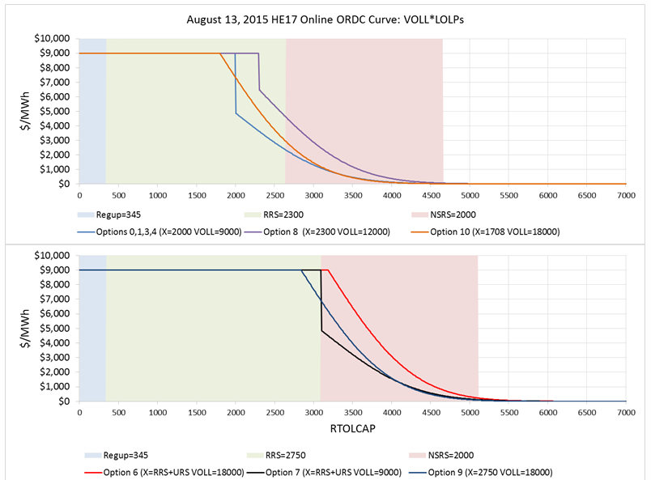
As illustrated in the chart above, making the Value of X equal the sum of RRS and URS will reestablish the principle that the Commissioners recognized back in 2011 – when they set the offer floor for RRS and URS at the System-Wide Offer Cap – namely that prices should reflect the reliability actions that ERCOT takes to maintain the system.
The Coalition members’ proposal to make the value of X equal the sum of RRS + URS will ensure that these critical operating reserves will not be compromised at price levels below the SWOC.
C. Mitigate the Abrupt Price Escalation in the ORDC
Under the current ORDC, where the Value of Lost Load (VOLL) and SWOC are both $9,000/MWh, the ORDC has a sharp “knee” that drives the price from $4,500/MWh to $9,000/MWh with the loss of one megawatt of capacity. The Coalition members recommend making changes to the ORDC parameters in order to achieve a smoother transition of prices up to the SWOC during scarcity events.
There are various ways to tackle this issue, including by increasing the Value of Lost Load (VOLL) in the ORDC calculation while capping effective prices at SWOC. Alternatively, the Loss of Load Probability (LOLP) calculation can be modified, or the ORDC could use a linear function as an approximation of LOLP.
The lack of a smoother transition of prices impairs the ability of market participants to respond to scarcity price signals, so Coalition members recommend that VOLL be increased to $18,000/MWh while effective energy prices continue to be capped at $9,000/MWh, or that some other modifications be made to achieve a less binary ORDC.
D. Add the Operating Reserve Demand Curve to the Day Ahead Market
The Coalition members also recommend adding the ORDC to the ERCOT Day Ahead Market (DAM) to match the Real-Time Market (RTM) ORDC. The original ORDC proposals included adding an ORDC to both the DAM and RTM. In order to expedite implementation, however, the ORDC was only established for the RTM.
Adding the ORDC in the DAM will make it easier for ancillary services prices to converge with ORDC prices between the DAM and RTM, especially during periods of scarcity. During periods of extreme scarcity in the DAM, when an insufficient amount of RRS is offered, having an ORDC in the DAM will allow RRS to rise to the price cap, and ensure that ERCOT can purchase adequate reserves by making resources indifferent to potentially higher prices in the RTM. Stakeholders discussed adding the ORDC in DAM when designing ORDC in 2013, and it was concept that many stakeholders wanted to revisit once the market had operational experience with ORDC in the RTM. Discussion of implementing the ORDC in the DAM is timely and consistent with good market design principles.
Second, adding the ORDC to the DAM will allow the markets to more effectively value incremental ancillary services capacity and appropriately reflect the vertical demand curve for those high quality reserves that ERCOT must procure for reliability (RRS and Up Regulation Service). The California Independent System Operator, the Midcontinent Independent System Operator, the PJM Regional Transmission Operator, the New York Independent System Operator and the Southwest Power Pool each have a demand curve for ancillary services in both their day-ahead and real-time markets. Without adding a demand curve for ancillary services to the DAM, the market is reliant on the offers and bids of market participants to set clearing prices, whereas adding the ORDC to the DAM will act as a penalty function that will appropriately value reserves when energy shortages are expected in Real-Time.
Adding ORDC to the DAM sequence, while a significant improvement in seeking convergence between the DAM and RT sequence pricing outcomes, can certainly be viewed as an independent recommendation that can be implemented simultaneous with or following our other recommended changes.
II. Results
A. Revenue Impacts of Proposal
ERCOT has evaluated the impacts of the Coalition members’ proposal (represented by a combination of Options 2 and 6) in its back cast analysis. The average annualized increase in Peaker Net Margin (PNM) that would have been expected from the proposal is $47,195/MW-year. The total PNM actually achieved in 2014 was just under $47,000/MW-year and in 2015 is trending below $30,000/MW-year. Thus, even if generators realized all of the incremental PNM calculated in ERCOT’s analysis, the total PNM would still have been just within range in 2014 and significantly less in 2015 than the $90,000 - $116,000/MW-year that generation developers must expect to earn on average over many years in order to justify building a simple cycle gas-fired combustion turbine. Perhaps more relevant, the average energy price would have increased to $40.15/MWh for On-Peak hours and $22.09/MWh for Off-Peak hours. These are not excessive prices, even in a relatively mild weather year, in an energy-only market.
B. It is Inappropriate to Predict Outcomes Based on 2011 Data
The model back cast using system load and weather data from the time period where ORDC has been in place is the only relevant analysis. Some market participants requested that the scenarios be modeled by ERCOT using load and weather data from 2011. The outcome of ERCOT’s analysis using data from that extreme “black swan” weather year yielded hyperbolic results. The objective function of running modeling scenarios is to better approximate the expected incremental impact on PNM from the different scenarios. The 2011 data results are not useful for this purpose because the market structure was quite different in 2011, including that there was no ORDC in place. Attempting to adjust for these differences is nigh impossible. The graph below demonstrates this point, by illustrating that even in 2011 there were a number of hours where there was additional capacity that could have been committed (the reduction of RTORPA hours between Scenarios 0 and 1 is a result of the model committing additional available offline generation), if the ORDC pricing and incentive structures had existed in 2011.
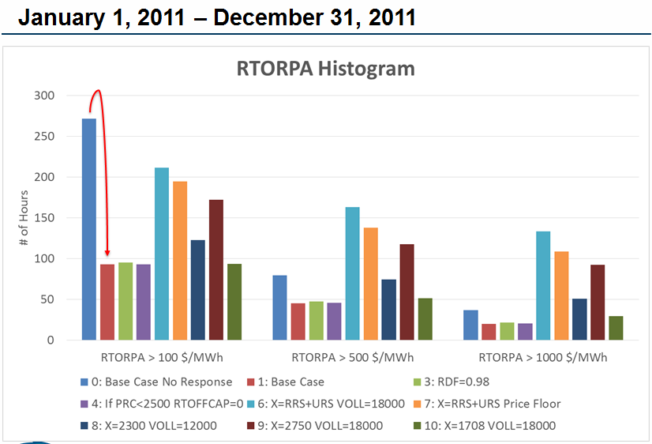
Furthermore, it should be noted that if market participants are concerned about the risk of financial impacts from an event similar to the extreme weather of 2011, it must follow that ERCOT should also be concerned about the potential reliability impacts of such an event, which would be similarly severe. The Coalition members’ proposed changes are intended to support better alignment between prices and operational realities and to improve convergence between the DAM and RTM. In promoting a more efficient and competitive market these recommendations will also support a market that is responsive to any future reliability needs. Thus, to the extent that market participants are concerned about the recurrence of events similar to those experienced in 2011, these recommendations will help mitigate the potential reliability concerns associated with such events.
II. Conclusion
The Coalition members appreciate the opportunity to provide input on this important issue and believe that the modifications to the ORDC proposed above will appropriately value ERCOT’s contingency reserves under steady state conditions, and will create a more efficient pricing outcome for the market. This proposal will address the concerns raised in Commissioner Anderson’s memo, by better aligning the RTOLCAP with PRC during scarcity and by developing pricing signals that both loads and resources can respond to before emergency conditions develop.

Commission Proceeding to Ensure Resource Adequacy in Texas, P.U.C. Project No. 40000, Commissioner Anderson Memo, Item 667 (October 7, 2015).
Methodology for Implementing Operating Reserve Demand Curve (ORDC) to Calculate Real-Time Reserve Price Adder, pg.1 (October22, 2015), available on ERCOT’s website at: http://www.ercot.com/mktinfo/rtm/kd/Methodology%20for%20Implementing%20ORDC%20to%20Calculate%20Real-Time%20Res.zip
See “2012 ERCOT Methodologies for Determining Ancillary Service Requirements,” adopted by the ERCOT Board on February 21, 2012, and available on ERCOT’s website at: http://www.ercot.com/calendar/2012/2/21/33724-BOARD
Commission Proceeding to Ensure Resource Adequacy in Texas, P.U.C. Project No. 40000, Commissioner Anderson Memo, Item 64 (November 20, 2011).
See “2003 ERCOT Methodologies for Determining Ancillary Service Requirements,” adopted by the ERCOT Board on October 15, 2002, and available on ERCOT’s website at: http://www.ercot.com/calendar/2002/10/15/41199-BOARD.
See “Report on the Capacity, Demand and Reserves (CDR) in the ERCOT Region, 2016-2025,” (December 1, 2015), available on ERCOT’s website at: http://www.ercot.com/content/gridinfo/resource/2015/adequacy/cdr/CapacityDemandandReserveReport-December2015.pdf
See “CEO Update,” (December 8, 2015), available on ERCOT’s website at: http://www.ercot.com/content/wcm/key_documents_lists/76324/4.1_CEO_Update.pdf.
Extracted from “ORDC Options Analysis,” p. 27 (December 16, 2015), available on ERCOT’s website at: http://www.ercot.com/content/wcm/key_documents_lists/80833/20151216_SAWG_ORDC_Options_Analysis.pptx).
See “Back Cast of Interim Solution B+ to Improve Real-Time Scarcity Pricing,” available on ERCOT’s website at http://www.ercot.com/content/gridinfo/resource/2013/mktanalysis/White_Paper_Back%20Cast%20of%20Interim%20Solution%20B+%20to%20Improve%20Re.pdf. (“Implementing this proposal in Real-Time will require a change to the DAM to incorporate an ORDC in order for the markets to converge”).
See “ORDC Options Analysis,” (December 16, 2015), available on ERCOT’s website at: http://www.ercot.com/content/wcm/key_documents_lists/80833/20151216_SAWG_ORDC_Options_Analysis.pptx).
Because there is only 17 months of available data, Coalition members annualized the data and averaged it between two years. In comparison, the annualized incremental PNM for options 7, 8 and 9 yielded only $27,932/MW-year, $2,366/MW-year, and $21,742/MW-year, respectively. Options 4 & 10 would have reduced PNM from the ORDC as compared to that achieved with the current parameters.
See Potomac Economics, “ERCOT Wholesale Electricity Market Monthly Report,” (November 17, 2015), available on ERCOT’s website at: http://www.ercot.com/content/wcm/key_documents_lists/76324/5_IMM_Report__PUCT_.pdf.
Although ERCOT has created a sophisticated tool, it is difficult to capture the complete impact of market participants’ behavioral changes in a back cast. It is likely that competitive forces will work to eliminate excess ORDC revenues in all but a few hours each year, when resources are truly scarce.
See The Brattle Group, “ERCOT Investment Incentives and Resource Adequacy,” pp. 48, 54 (June 1, 2012), available on ERCOT’s website at: http://www.ercot.com/content/gridinfo/resource/2015/mktanalysis/Brattle_ERCOT_Resource_Adequacy_Review_2012-06-01.pdf.
Philip Oldham, on behalf of Texas Industrial Energy Consumers, represented that 2011 weather was a “black swan” event in the market. See “Finding the ‘Sweet Spot’ to Solve Texas’ Resource Adequacy Concerns,” quoting Mr. Oldham, and available at: http://www.poweracrosstexas.org/finding-the-sweet-spot-to-solve-texas-resource-adequacy-concerns-full-report/
Extracted from “ORDC Options Analysis,” p. 18 (December 16, 2015), available on ERCOT’s website at: http://www.ercot.com/content/wcm/key_documents_lists/80833/20151216_SAWG_ORDC_Options_Analysis.pptx).

