Solar Generation Integration Whitepaper

Prepared by: Emerging Technologies Working Group
Document Revisions
Date | Version | Description | Author(s)
December 1, 2013 | 1.0 | White paper | ERCOT Staff
Oct. 2, 2015 | 2.0 | Update | ERCOT Staff
Dec. 23, 2015 | 3.0 | Update | ERCOT Staff

Acronyms and Abbreviations
ERCOT: Electric Reliability Council of Texas
IRRs: Intermittent Renewable Resources
DRUC: Day-Ahead Reliability Unit Commitment
HRUC: Hour-Ahead Reliability Unit Commitment
DOE: Department of Energy
CSP: Concentrated Solar Power
PV: Photovoltaics
NWP: Numerical Weather Prediction
NOAA: National Oceanic and Atmospheric Administration
MAE: Mean Absolute Error
MAPE: Mean Absolute Percentage Error
STSPF: Short-term Solar Power Forecast
QSE: Qualified Scheduling entity
POA: Plane of Array
GI: Global Irradiance
GHI: Global Horizontal Irradiance
DNI: Direct Normal Irradiance
DHI: Diffuse Horizontal Irradiance
Table of Contents

1. Background 4
2. Solar Technologies at ERCOT 5
3. Variability of Irradiance 6
4. Solar Generation Production Forecast 8
4.1. Characteristics of Solar Power Forecast 9
4.2. Solar Forecasting Methodologies 10
4.3. Solar Forecasting Performance Metrics 12
4.4. ERCOT Data Requirements 13
4.5. Data Quality Control and Archive 16
4.6. Path Forward for Integration of Solar Power Forecast 16
4.7. Summary 17
5. PVGR Solar Forecast 17
6. Dynamic Models of Solar Generation 19
6.1. GE solar plant model 20
6.2. WECC Central Station PV System Model (PV1G, PV1E, PV1P) 23
6.2.1. PV1G model 23
6.2.2. PV1E model 24
6.2.3. PV1P model 25
6.3. Generic Solar Photovoltaic Model in PSSE 26
7. Distributed Solar Resources 27
7.1. Distributed PV system model 27

Background
The combination of several forces such as declining cost of solar panel per kW and regulatory policy has led to an anticipated rapid and significant addition of solar generation in Texas from 2015 to 2017. The projected installed capacity of solar generation is shown in Figure 1 and the planned solar resources with executed SGIA is given in Table I.

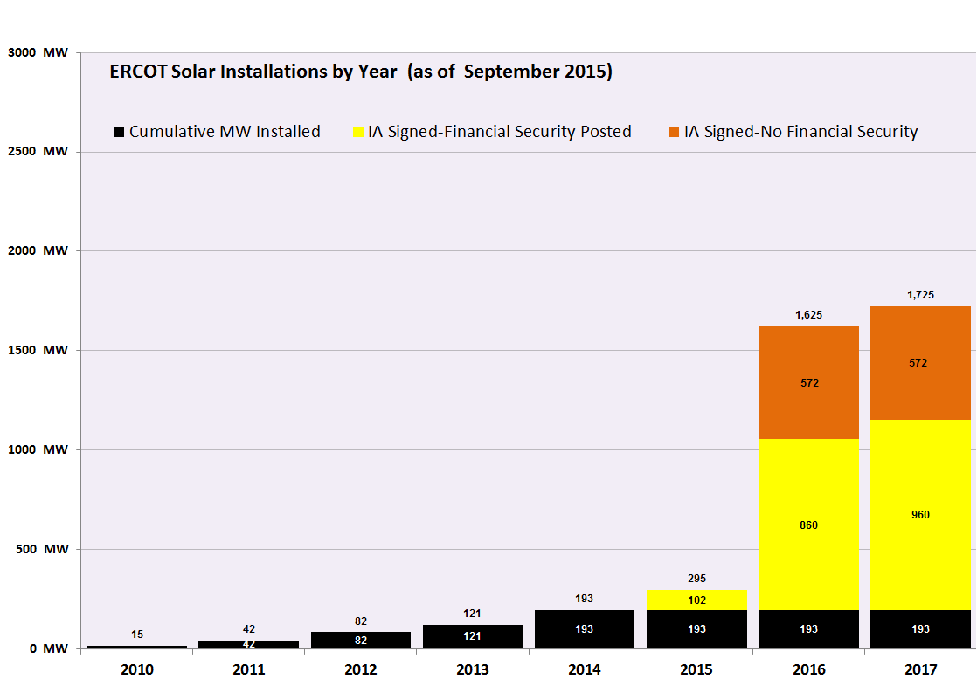
Figure 1. Projected installed capacity of solar generation

Table I. Planned Solar Resources with Executed Standard Generation Interconnection Agreement (SGIA)
Planned Solar Resources with Executed SGIA | START DATE | SUMMER | WINTER
FS BARILLA SOLAR 1B [HOVEY_UNIT2] | 11/10/2015 | 7.4 | 7.4
FS BARILLA SOLAR 2 | 12/31/2016 | 21 | 21
DOWNIE RANCH SOLAR (ALAMO 5) [HELIOS_UNIT1] | 12/15/2015 | 95 | 95
RE ROSEROCK SOLAR | 7/31/2016 | 150 | 150
OCI ALAMO 6 SOLAR | 9/30/2016 | 110 | 110
SE BUCKTHORN WESTEX SOLAR (OAK) | 3/31/2017 | 100 | 100
FS EAST PECOS SOLAR | 12/1/2016 | 100 | 100
OCI ALAMO 7 SOLAR | 8/1/2016 | 110 | 110
NAZARETH SOLAR | 9/1/2016 | 201 | 201
PECOS SOLAR POWER I | 12/31/2016 | 108 | 108
BNB LAMESA SOLAR | 12/31/2016 | 200 | 200
CAPRICORN RIDGE SOLAR | 12/1/2016 | 100 | 100
SP-TX-12 | 12/1/2016 | 180 | 180
OCI ALAMO 6 PHASE II | 9/30/2016 | 50 | 50
Planned Capacity Total (Solar) |  | 1532.4 | 1532.4

Solar Technologies at ERCOT
Solar technologies that are normally connected to transmission systems may be classified as concentrated solar power (CSP) and photovoltaic (PV) applications. CSP systems first convert solar energy into thermal energy and later into electricity, while photovoltaic systems directly convert solar energy to electricity. Driven by advances in technology and increases in manufacturing scale and sophistication, the cost of photovoltaics has declined steadily.
All of the installed solar generation and the planned solar resources connected to the transmission system at ERCOT falls into the category of photovoltaics. Photovoltaics is the only solar generation technology modelled as required by NPRR 588/615.

Variability of Irradiance
The solar and the PV production forecasting accuracy are mainly influenced by the variability of the meteorological and climatological conditions, and the forecast horizon. Forecast accuracies decrease as the forecast time horizon increases.

Clear skies are relatively easier to forecast than the cloudy weather conditions. The output of PV plants is variable simply because the sun changes position throughout the day and throughout the seasons - see Figure 2. The rising and setting of the sun regularly leads to 10-13% changes in PV output over a period of 15 minutes for single-axis tracking PV plants. Clouds, however, are largely responsible for rapid changes in the output of PV plants that concern system operators and planners. Changes in solar insolation at a point due to a passing cloud can exceed 60% of the peak insolation in a matter of seconds. The time it takes for a passing cloud to shade an entire PV system, in contrast, depends on the PV system size, cloud speed, cloud height, and other factors. For PV systems with a rated capacity of 100 MW, the time it takes to shade the system will be on the order of minutes rather than seconds [4].

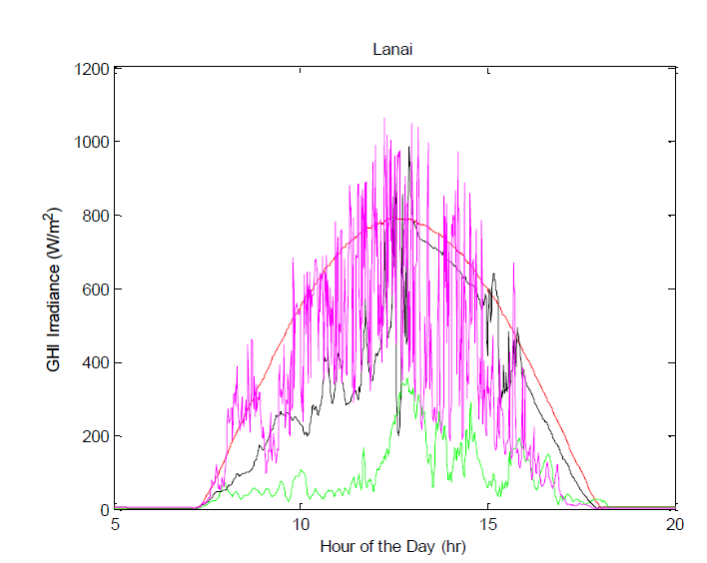
Figure 2. Irradiance patterns from hour selected days from Lanai, HI [4]

Variability in irradiance over time has important implications for power generation from solar PV plants. A variability index was proposed by Joshua et al. to measure irradiance variability over a period of time, which is calculated as

$$\text{VI}=\frac{\sum_{k=2}^{n}{\sqrt{({\text{GHI}}_{k}−{\text{GHI}}_{k−1})^{2}+{Δt}^{2}}}}{\sum_{k=2}^{n}{\sqrt{({\text{CHI}}_{k}−{\text{CHI}}_{k−1})^{2}+{Δt}^{2}}}}$$

where GHI is a vector of length n of global horizontal irradiance values averaged at time interval in minutes, $Δt$, CHI is a vector of calculated clear sky irradiance value for the same times as GHI data.

Examples of variability are given in Figure 3 for those days with various sky irradiance.
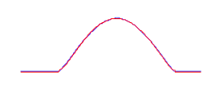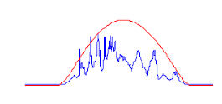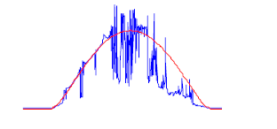
Figure 3. Examples of variability (clear sky irradiance is shown in red) Left: VI=1; Middle: VI=4; right: VI=16[4]

An alternative indictor to the variability is the measure of the way that the atmosphere attenuates light on an hour to hour or day to day basis. This is “clear sky index”. It is equal to the global solar radiation on the surface of the earth divided by the extraterrestrial radiation at the top of the atmosphere. In other words, it is the proportion of the extraterrestrial solar radiation that makes it through to the surface. It varies from around 0.8 in the clearest conditions to near zero in overcast conditions.

Unlike changes in the position of the sun which affects the output of all PV plants in a nearly uniform, highly correlated way, changes in PV output due to clouds are not driven by a similar uniform process. The degree of diversity between points or plants can be characterized by the correlation of simultaneous changes in the output. As shown in Figure 4, diversity from the aggregate of multiple plants can help to smooth the relative reduction in the magnitude of ramps relative to a single point.

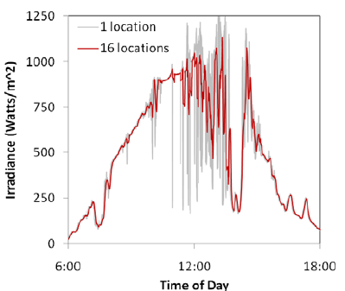

Figure 4. Aggregating the output of several different solar insolation meters illustrates the reduction in variability of multiple sites relative to a single site[4]
Variability of solar resources can be also subdivided in long-term and short-term fluctuations.

Short-term variability studies use second-to-minute averaged data to investigate the effect on operating reserves and frequency regulation. When the short-term variability of
solar and wind power is no longer masked by the load variability, grid operators must increase system operating reserves and regulation services to maintain the grid’s
reliability. This approach, in turn, raises the operating costs associated with integrating photovoltaic (PV) renewable energy into the grid. The long-term variability of solar resources ranging from hours to a few day ahead of time could make the solar forecasting more difficult, thereby resulting in large solar forecast errors. Adequate amount of flexibility will be needed to compensate for these errors and ensure the conventional generators have fast ramping rates to follow those fluctuations.

$$\text{VI}=\frac{\sum_{k=2}^{n}{\sqrt{({\text{GHI}}_{k}−{\text{GHI}}_{k−1})^{2}+{Δt}^{2}}}}{\sum_{k=2}^{n}{\sqrt{({\text{CHI}}_{k}−{\text{CHI}}_{k−1})^{2}+{Δt}^{2}}}}$$

$Δt$

Solar Generation Production Forecast
This flux of solar will exaggerate the variability and intermittency of net load currently experienced by ERCOT. If not addressed properly, it will result in numerous challenges in maintaining bulk electric system reliability and wholesale market functionality. To mitigate this potential problem, protocols section 3.13 (2) Renewable Production Potential Forecasts clearly state that ERCOT needs to produce accurate and unbiased forecast for the potential of renewable production:

“ERCOT shall develop cost-effective tools or services to forecast energy production from Intermittent Renewable Resources (IRRs) with technical assistance from QSEs scheduling IRRs. ERCOT shall use its best efforts to develop accurate and unbiased forecasts, as limited by the availability of relevant explanatory data. ERCOT shall post on the MIS Secure Area objective criteria and thresholds for unbiased, accurate forecasts within five Business Days of change.”

Since 2008, ERCOT has been working with wind forecast service providers to produce the rolling forecast for the next 48-hour production potential of Wind Generation Resources (WGR), which is used as input to DRUC and HRUC and also presented to operators visually for situation awareness. This tool has successfully helped ERCOT integrate very high penetration levels of wind generation. From the lessons learned with wind integration and given anticipated growth of solar power in Texas, ERCOT needs to have a tool specially designed to produce accurate solar generation forecast.

Considering this need, NPRR 615 was approved, which directed ERCOT to provide Short-Term PhotoVoltaic Power Forecast (STPPF) and PhotoVoltaic Generation Resource Production Potential (PVGRPP), as detailed below.

- Short-Term PhotoVoltaic Power Forecast (STPPF)
An ERCOT produced hourly 50% probability of exceedance forecast of the generation in MWh per hour from each PhotoVoltaic Generation Resource (PVGR) that could be generated from all available units of that Resource.

- PhotoVoltaic Generation Resource Production Potential (PVGRPP)
The generation in MWh per hour from a PVGR that could be generated from all available units of that Resource allocated from the 80% probability of exceedance of the Total ERCOT PhotoVoltaic Power Forecast (TEPPF).

Characteristics of Solar Power Forecast
Accurate solar forecasting will allow power system operators to integrate more solar energy into the electricity grid, and ensure the economic and reliable delivery of renewable energy. Wind speed forecasting has been developed for decades and wind forecasting for renewable energy is a fairly mature field with several major market players. However, the methods and approach for more accurate solar forecasting are still evolving. Solar radiation forecasting is standard in numerical weather prediction, but the accuracy on solar radiation forecasts is still low for cloudy days compared to the magnitude of errors for load forecast. Consequently, there is significant potential for improvements of solar forecasts for long horizon (from a few hours to several days). Recently, the Department of Energy (DOE) funded projects helping utilities, grid operators, solar power plant owners, and other stakeholders better forecast when, where, and how much solar power will be produced at the desired locations in the United States.

In addition, for solar forecasting, different types of solar power systems need to be distinguished. There are two different ways to convert sunlight into electricity, either indirectly using concentrated solar power or directly using photovoltaics . Concentrated solar power systems use lenses or mirrors and tracking systems to focus a large area of sunlight into a small beam. Photovoltaics convert light into electric current using the photoelectric effect. The solar farms that will be connected to the ERCOT system by 2016 will fall into the second category (PV).

For solar concentrating systems (CPS), the direct normal incident irradiance (DNI) must be forecasted. Due to non-linear dependence of concentrating solar thermal efficiency on DNI and the controllability of power generation through thermal energy storage (if available), DNI forecasts are especially important for the management and operation of concentrating solar thermal power plants. Without detailed knowledge of solar thermal processes and controls, it is difficult for solar forecast providers to independently forecast power plant output.

For non-concentrating systems (i.e. most PV systems), primarily the global irradiance (GI = diffuse + projected DNI) on a tilted surface is required which is less sensitive to errors in DNI since a reduction in clear sky DNI usually results in an increase in the diffuse irradiance. Power output for flat horizontal PV systems depends only on GHI, for fixed-tilt south-facing systems, it depends primarily on GHI, while for dual-axis tracking systems the power output depends primarily on DNI on sunny days and GHI on cloudy days, and for other system types it is more of a mixture of GHI and DNI. A good forecast uses the sun-PV system geometry to calculate the exact contribution of diffuse and direct components on a minute-by-minute basis as the sun moves through the sky and as PV panel orientation shifts if the array is tracking. PV systems which have power output depending more on DNI will have larger forecast errors because DNI is inherently more difficult to predict than GHI. For example, DNI ranges from full clear-sky values when the sun is unobstructed even if there are clouds in other parts of the sky to near zero when GHI is around half of the clear sky condition, and DNI drops down more sharply than GHI under hazy conditions and even more so when a cloud passes in front of the sun. For higher accuracy, forecasts of PV panel temperature are needed to account for the (weak) dependence of solar conversion efficiency on PV panel temperature. Also, accurate forecasts for sun-tracking systems require knowledge of the panel orientation through the day. The panels typically rest horizontal overnight and can take around two hours in the morning after sunrise to rise up to the optimal position and two hours in the evening before sunset to return to horizontal.
Comparing the predictability of solar and wind energy, solar has the advantage of the clear sky baseline. In locations and seasons characterized by clear skies, variability is small compared to power generation, allowing for low forecast errors. At other times and locations, solar energy forecast errors tend to be of similar percentage magnitude as wind energy forecast errors. When clouds are present, resulting in more difficult solar energy forecasts, satellite imagery indicating current cloud cover and cloud motion helps to reduce forecast error during the first few hours, as discussed in the next section. This improvement is limited by clouds evolving rather than simply moving and by uncertainties in converting cloud information seen by the satellite above the top of the atmosphere into irradiance at ground level and power. Wind power gains similar short-term forecast improvements through assimilation of lidar, Doppler radar, and wind farm nacelle observations into short-range numerical weather prediction models. Solar energy forecasts tend to have the most difficulty with predicting the onset and ending of fog and low clouds when there is dry air aloft but moisture trapped under temperature inversions at low altitudes, while wind forecasts can have difficulty with turbulence and timing of ramps associated with the onset, decay, and subtle shifts in altitude of the nocturnal low-level jet. Both wind and solar energy forecasts have difficulty with localized or rapidly evolving events such as thunderstorms, and both have predictability at longer time horizons limited by the predictability of the general weather scenario. As with wind energy forecasts, solar energy forecast errors are reduced by geographic aggregation and also by time averaging across periods of variability. For example, daily averages will be more accurate than 1-hour averages, which will be more accurate than 15-minute averages, which will be more accurate than 5-minute averages.

The field of PV forecasting is rapidly evolving and further improvement in the forecast accuracy will be anticipated.

The future of PV forecasting includes predicting uncertainty and variability. For example, the variability index can be predicted even into the day-ahead time period although the timing and amplitude of individual high-frequency fluctuations are not predictable at all except perhaps up to 15-30 minutes ahead of time using well-placed total sky imagers. Creating and evaluating this type of forecast information is an area of ongoing research and development.

Solar Forecasting Methodologies
There are a various number of methods developed for solar forecasting, and different methodologies are preferred depending on the forecast horizon. The key features of the four methods are provided as follows. The first method can utilize power data directly. The other methods predict irradiance which must be converted into power by splitting the irradiance into direct and diffuse components, projecting it onto the plane of the PV array, and modeling the relationship between the plane-of-array irradiance and power output by the site.

- A persistence forecast is based on current or recent PV power plant or radiometer output and extrapolated to account for changing sun angles. Persistence forecasts accuracy decrease strongly with forecast duration as cloudiness changes from the current state.

- Total sky imagery can be used to forecast from real time up to 15-30 minutes.by applying image processing and cloud tracking techniques to sky photographs. The method assumes persistence in the opacity, direction, and velocity of movement of the clouds. Irradiance is predicted for the current cloud shadow and then the cloud shadow is moved forward in time based on cloud velocity and direction.

- For satellite imagery the same methods as in total sky imagery are applied. Clouds reflect more light from earth into the satellite leading to detection and the ability to calculate the amount of light transmitted through the cloud (transmissivity = 1 – reflectivity – absorptivity). The lower spatial and temporal resolution causes satellite forecasts to be less accurate than sky imagery on intra-hour time scales. Satellite imagery is the best forecasting technique in the 1 to 5 hour forecast range. Classical satellite methods only use the visible channels (i.e. they only work in day time), which makes morning forecasts less accurate due to a lack of time history. To obtain accurate morning forecasts, it is important to integrate infra-red (IR) channels (which work day and night) into the satellite cloud motion forecasts. However, the accuracy of IR-based estimates is limited by considerable uncertainty converting IR data to visible transmissivity and by poor ability to define cloud motion of low clouds based on IR imagery due to small thermal contrast between the cloud and its surroundings in the imagery.

At longer time horizons, the best forecast sources are based on numerical weather prediction (NWP) models. NWP models predict all aspects of the weather including solar irradiance, applying the equations of fluid dynamics on a rotating sphere and accounting for incoming energy from the sun, outgoing energy to space, phase change of water condensing into clouds and evaporating, exchange of heat, water, and momentum with the earth’s surface, and more. Solar irradiance is modeled using radiative transfer physics in the model, accounting for the model forecast cloud water, cloud ice, rain, snow, and absorbers such as water vapor. The initial condition at the start of the forecast utilizes real-time observations from polar and geostationary satellites, radar, upper air balloons, instrumented aircraft, ground stations, and other observing platforms.
There are myriad NWP models, some customized more for short-term localized forecasts and some for global forecasts extending to longer time ranges. As of December 2015, the US National Weather Service runs an operational High Resolution Rapid Refresh (HRRR) at 3 km grid spacing, with forecast data available for forecast times every 15 minutes out to 15 hours and new updated forecasts issued every hour. In contrast, the global forecast model has much coarser spatial resolution, has output parameters including GHI only every 3 hours of forecast time, runs out much longer to 16 days, and updated forecasts are issued every 6 hours. Additionally, the global forecast model is run at coarser resolution 20 separate times with small perturbations imposed which amplify over time due to the nonlinear dynamics, resulting in 20 alternative forecast scenarios that help define the forecast distribution and the uncertainty in the forecast. Also, the US National Weather Service runs other operational NWP models, national and international modeling centers in other countries run their own operational NWP models, and universities, private companies, and other entities run even more models, some of which are more advanced or experimental cutting-edge but may not be as 24/7/365 reliable as those from the operational centers.
Even the finest resolution NWP model cannot accurately predict when a particular solar installation will be under a cloud or cloud shadow and when the cloud will pass, leaving the site basking in sunlight. Better accuracy results from averaging through the short-term variability, such as to hourly averages, and likewise better accuracy is attained for large-scale cloud fields producing overcast conditions continuously for hours.
Research organizations are currently experimenting with new methods of assimilating satellite cloud analyses into a NWP model specifically to improve the short-term irradiance forecast, though this is not on the immediate horizon for operational forecast models.
Because the sun is moving through the sky, changing its angle relative to the PV panels during the typically 1-hour or 3-hour averaging time for model irradiance forecasts, the model irradiance must be scaled to finer time increments following the diurnal curve before being geometrically projected onto the panels.
The model forecast can be improved through bias correction against ground measurements of irradiance and further improved by blending the bias-corrected forecasts from multiple model runs. The bias can be a function of forecast conditions, not usually a simple offset.

A summary of the comparison between those four different solar power forecast methods is given in the Table II. A typical illustration shown in Figure 55 below indicates that NWP is best suitable for the forecast of long time horizon of 5-hour while the satellite image based technique is more accurate for short-tere solar power forecast less than 5 hours. The cross-over time varies by model, for example it can be shorter for the HRRR. Additionally, blends of the various methods can be better than one method alone forecast time horizons less than 5 hours, particularly with NWP-based forecasts infused with lower weights at the shortest time horizons (HA) and increasing weight at increasing time horizons.

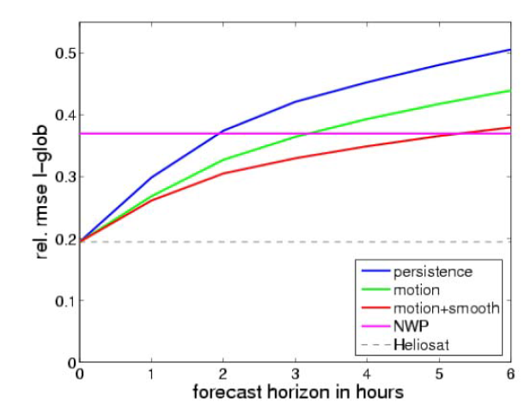
Figure 5. Comparison of performance of different forecast methods (up to 5 hours: forecast based on satellite images; more than 5 hours: NWP based forecast)

Table II. Comparison between Different Solar Forecast Methods
Methods | Suitable forecast horizon | Performance
Persistence forecast | From real-time to a few hours | accuracy decrease strongly with forecast duration as cloudiness changes from the current state
Total sky imagery | from real time up to 15-30 minutes | the method assumes persistence in the opacity, direction, and velocity of movement of the clouds
Satellite imagery | 1 to 5 hour forecast range | the lower spatial and temporal resolution causes satellite forecasts to be less accurate than sky imagery on intra-hour time scales
NWP | long time horizons of more than 5 hours | Operational National Weather Service models do not have the spatial or temporal resolution for accurate hour-ahead forecast

Solar Forecasting Performance Metrics
Due to the binary nature of solar radiation (cloudy or clear) the choice of error metric is very important for the evaluation of solar forecast models. The root mean square error (RMSE) metric is problematic as it is dominated by large errors. Thus if a forecast model is usually correct but occasionally off by a large amount it may score worse than a model that is always slightly off but never way off. It is recommended to use the mean absolute error (MAE) or mean absolute percentage error (MAPE) as a standard evaluation metric since it is less sensitive to large errors.

The MAE is given by

$$\text{MAE}=\frac{1}{N}\sum_{i=1}^{N}{\left|p_{i}−p_{i}\right|}$$
where $p_{i}$represents the actual solar irradiance or power generation at the i^{th} time step, $p_{i}$ is the corresponding solar irradiance or power generation estimated based on a forecast model, and N is the number of points estimated in the forecast period.

Solar irradiance (power) forecast evaluations can calculate the forecast error in W/m² (MW) or % of solar irradiance (% of capacity).. This has the advantage of comparability, but is not the most economically metric or relevant to the grid operations. In addition, a forecast error during peak load is likely both economically and operationally more significant than an error during off-peak times. To consider this, we recommend evaluating the solar power forecast errors listed in Table III.
Table III. Forecast Performance Metrics
Solar Power Forecast Error | Peak hours | Non-peak hours | All hours | Cloudy Days | Clear Days
Solar Power Forecast Error | MAPE | MAPE | MAPE | MAPE | MAPE
Solar Power Forecast Error | MAE | MAE | MAE | MAE | MAE

ERCOT Data Requirements
The performance of a PV system largely depends on the incident irradiance on the array. Thus, the forecast of a PV system involves:

•Defining or determining the orientation of the array, which can be either fixed or variable in time (tracking arrays).
•Estimating the contributions of the beam and diffuse irradiance components.

Alternatively, one can measure the plane of array irradiance directly with a pyranometer, reference cell, or reference module mounted in the same orientation of the array.

ERCOT requires that QSEs representing solar generation larger than 10 MW send the telemetered data to ERCOT, which are listed in Table IV. These data will be communicated with the solar forecasting service vendor every 5 minutes to provide real-time update of the status of those solar resources. The data, which will be exchanged between ERCOT and solar forecast service provider, is detailed in Table V.

Table IV. ERCOT Telemetered Data for Solar Power Forecasting (PV)
 | Telemetered data | Unit
1 | Telemetered Date
2 | Telemetered hour
3 | Resource ID
4 | QSE
5 | Plane of array irradiance | w/m2
6 | Back panel temperature | +/- 1 C
7 | Ambient Temperature | +/- 1 C
8 | Wind speed | (+/- 1 m/s)
9 | Wind direction | +/- 5 degrees)
10 | PRES - barometric pressure in millibars
11 | Number of inverters online
12 | Number of inverters offline
13 | Number of inverters with unknown status
14 | MW output of PVGR | MW
15 | HSL of PVGR | MW

Table V. Solar Power Forecasting Data (PV)
1 | DUNS
2 | UNIT_NAME
3 | QSEID
4 | SITE
5 | TIMESTAMP
6 | STPPF | MW
7 | TEPPF | MW

To collect telemetered data required, the various meteorological instruments can be installed in the solar farm. These meteorological instruments, as shown in Table VI, include, but are not limited to,
- Data Logger
- Ambient Temperature Probe and Relative Humidity Probe
- Anemometer and Wind Vane
- Back panel temperature probe
- Pluviometer
- Pyrheliometer **
- Pyranometer
- Pyranometer
- Barometer
- Meteorological enclosure

Table VI. Meteorological Instruments Installed in One Solar Farm
ITEM | DESCRIPTION | RESOLUTION | QUANTITY
Data Logger | Campbell Scientific CR1000 with internet module |  | 15
Ambient Temperature Probe and Relative Humidity Probe | Campbell Scientific CS215-L tem and relative humidity probe with one (1) 41303-5A 6 plate Grill Radiation Shield | 1 ºC | 2
Anemometer and Wind Vane | RM Young Wind Sentry set with mounting brackets | -50 to +50 ºC | 2
Back panel temperature probe | Campbell Scientific 109 temperature sensor; type E thermocouple | -50 to +70 ºC | 38
Pluviometer | Texas Electronics TE525-L 6” rain gauge |  | 2
Pyrheliometer** | Kipp&Zonen CHP1_ Pt 100 class A _ 10kohm termistor  0-1000 Wm2 | Solar radiation spectrum 97-98% 200-4000nm | 2
Pyranometer | (Horizontal) Kipp&Zonen CMP11 _sensitivity 8.92 μV/W/m2 @ normal irradiance | 305 to 32800 nm  15uV/W·m2  -40 to 80ºC  0 to 2000 Wm2 | 6
Pyranometer | (Plane of Array) Kipp&Zonen CMP11 | 305 to 32800 nm  15uV/W·m2  -40 to 80ºC  0 to 2000 Wm2 | 6
Barometer | Measured at HectoPascals (HPa)  PTB110 Vaisala | 60 pA | 2
Meteorological enclosure | Power meters Power Logic Ion 6200 | 1 m/s  5 degrees

Data Quality Control and Archive
Data received from ERCOT will be put through a quality control module. Each data element will be checked to determine whether the value is in range for the given parameter, for the same data value is being reported for each interval and whether the data elements are consistent with each other (e.g. high irradiance with high solar generation values).

ERCOT will load the Solar Power Forecast data into EMS relational database. From EMS relational database the Solar Power Forecast data will be available to QSEs through MIS Portal and through the Messaging System. Also, this data will be archived for 7 years of retention.

Path Forward for Integration of Solar Power Forecast
Ultimately, the solar power forecast should be as fully functioning as the wind, i.e., to be integrated into the ERCOT’s EMS system. As such, solar power forecast service provider shall host a web service WS Notification Listener (Web Service Server) to receive the Observation Message from ERCOT (see Figure 6). Conversely, ERCOT shall host a web service WS Notification listener (Web Service Server) to receive the Forecast and Performance messages from solar power forecast service provider. The basic service level description is described in the following diagram:
Figure 6. Message Exchange between ERCOT←→Solar Power Forecast Service Provider

While the full integration of solar power forecast into the EMS system is advantageous in validating the full spectrum of the performance metrics (accuracy, reliability and usability), other options are also attractive due to its simplicity and less potential impacts on the EMS system. The simplest way is to transfer the data file containing the information requested between ERCOT and the solar power forecast service provider, as shown in Figure 7. Since this is done manually, the number of data file transfer is limited and its main purpose is to validate and test the accuracy of the solar power forecasting.

Figure 7. Data File Exchange between ERCOT←→Solar Power Forecast Service Provider

Summary
Solar power forecasting is an area that is still evolving and there are a few solar power forecast service providers competing for more accurate and better service. It is recognized that NWP is most suitable for the forecast of long time horizon of 5-hours while blends of satellite image, statistical, and NWP model-based forecasts will be most accurate at shorter ranges.. While accurate solar power forecasting is challenging, solar has some characteristics that make it easier than wind forecasting, particularly in climates or seasons that are mostly sunny.

The performance of solar power forecast should be evaluated in the full spectrum, measured by its accuracy, reliability, usability, integration and cost.

In the control room, we should look toward a unified view of wind and solar forecasting.

PVGR Solar Forecast
To facilitate the selection of a qualified solar forecast service provider, ERCOT issued an RFP for PVGR solar forecast in 2014 to comprehensively evaluate the performance of solar forecasts from different vendors. It is anticipated that this selection process will be periodic to keep pace with the latest development and technologies for solar forecast.

The time line of the RFP is shown in Figure 8, begining in 2014 and ending in the summer of 2015. The whole process was constructed into two different phases. The purpose of Phase 1 is to examine the accuracy of solar forecasting with a simple mechanism allowing exchange of the data between the vendors and ERCOT. The second phase involved more complicated integration of the solar forecast with ERCOT IT system and the solar forecast vendors being able to receive telemetered data from solar farm every five minutes.

Figure 8. Timeline of PVGR solar forecast RFP

There were eight vendors having responded to this RFP. Based on a thorough evaluation of the technical merits and cost-structure of these proposals, AWS, MDA, WEPROG and DNV-GL were selected to participate in the RFP Phase 1. By the end of Phase 1, the performance of these four vendors has been scored based on their day-ahead and short-term solar forecast, as shown in Figure 9. Overall, the vendor “B” performed best in both categories of day-ahead and short-term forecast, with a MAPE of 7.74% for short-term forecast and of 10.64% for day-ahead forecast. The vendor “C” performed in the second place. Two vendors “A” and “D” were eliminated by the end of Phase 1 and only the vendors “B” and “C” proceeded to Phase 2.

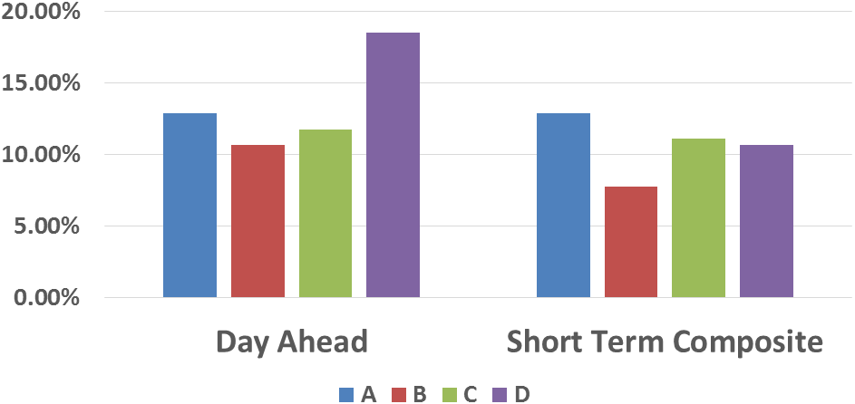
Figure 9. Performance of PVGR solar forecast in RFP Phase 1

In Phase 2, the solar forecast performance has been significantly improved compared to Phase 1 thanks to the availability of the real-time telemetered data. This field experience also confirmed the critical role of a valid and accurate real-time telemetered data to the accuracy of the PV forecast. The MAPE of the solar forecast from vendor “B” and “C” in Phase 2 is given in Table VII and VIII, and the difference between those two is that the performance score in Table VIII was evaluated only for peak hours. It can be seen that vendor “B” continued to outperform vendor “C” in Phase 2.

Table VII. MAPE of Solar Forecast for All Hours
 | Short-term Solar Forecast | Day-ahead Solar Forecast
Vendor C | 6.99% | 7.28%
Vendor B | 5.70% | 5.67%

Table VIII. MAPE of Solar Forecast for Peaks Hours
 | Short-term Solar Forecast | Day-ahead Solar Forecast
Vendor C | 8.41% | 8.45%
Vendor B | 6.11% | 7.87%

Dynamic Models of Solar Generation
The model of solar plants is intended to capture the most important dynamic characteristics of large scale (>10 MW) PV systems with a central Point of Interconnection (POI) at the transmission level. The following general requirements shall apply.

- The models shall provide a reasonably good representation of dynamic electrical performance of solar photovoltaic power plants at the point of interconnection with the bulk electric system.

- The models shall be suitable for studying system response to electrical disturbances, not solar irradiance transients (i.e., available solar power is assumed constant through the duration of the simulation). Electrical disturbances of interest are primarily balanced transmission grid faults (external to the solar PV power plant), typically 3 - 9 cycles in duration, and other major disturbances such as loss of generation or large blocks of load.

- Systems integrators, inverter manufacturers and model users (with guidance from the integrators and manufacturers) shall be able to represent differences among specific inverter and/or plant controller responses by selecting appropriate model parameters and feature flags.

- Simulations performed using these models typically cover a 20-30 second time frame, with integration time steps in the range of 1 to 10 milliseconds.

- The models shall be valid for analyzing electrical phenomena in the frequency range of zero to approximately 10 Hz.

- The models shall incorporate protection functions that trip the associated generation represented by the model, or shall include the means for external modules to be connected to the model to accomplish such generator tripping.

- The models shall perform accurately at the network connected to, independent of the Short Circuit Ratio (SCR) value atits POI.

PV models from the PSSe library are recommended, with tuned parameters to represent the dynamic of the PV plant.

In practice, a solar plant has a local grid collecting the output from the converters into a single point of connection to the grid. Since the solar plant is made up of many identical converters, it is a reasonable approximation to parallel all the converters into a single equivalent large converter. While there are limitations, simulations of bulk system dynamics using a single converter equivalent are adequate for most planning studies.

The electrical dynamic performance of a solar plant is completely dominated by the converter. The control of active and reactive power is handled by fast, high bandwidth regulators within the converter controls, and can be greatly simplified for simulation of bulk power system dynamic performance.

The converter model injects real and reactive current into the network in response to control commands. The control model includes closed loop reactive controls and voltage regulation with either a simplified solar plat supervisory control system or a separate, detailed control model.

GE solar plant model

A GE solar plant model consists of a converter model and an electrical control model – see Figure 9-12.

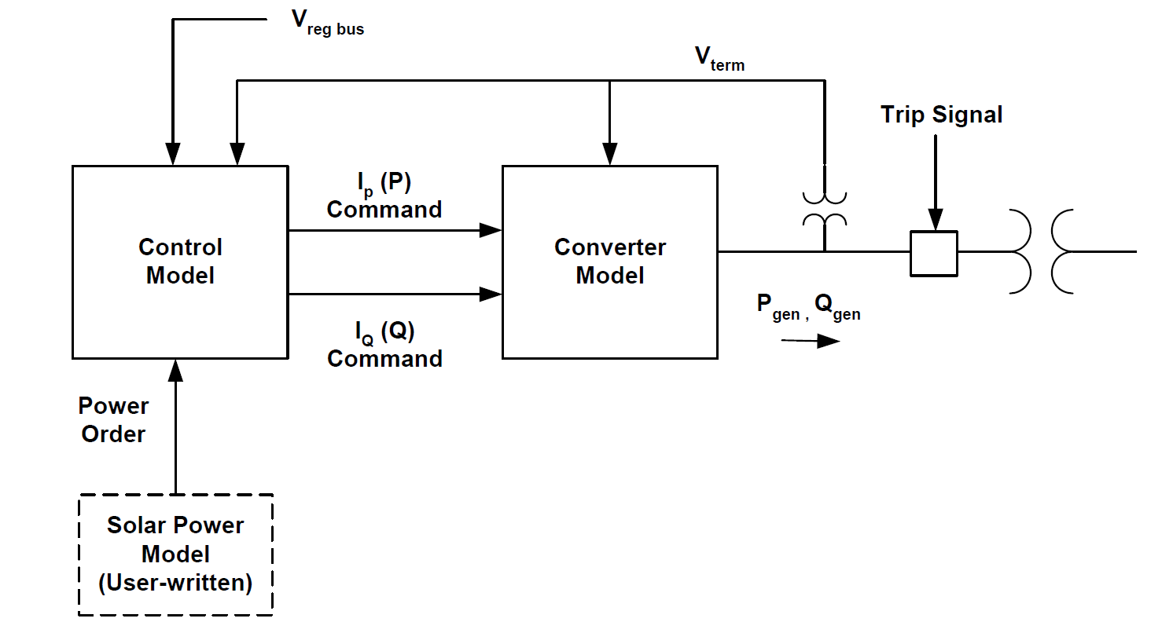
Figure 9. GE Solar Plant Dynamic Model

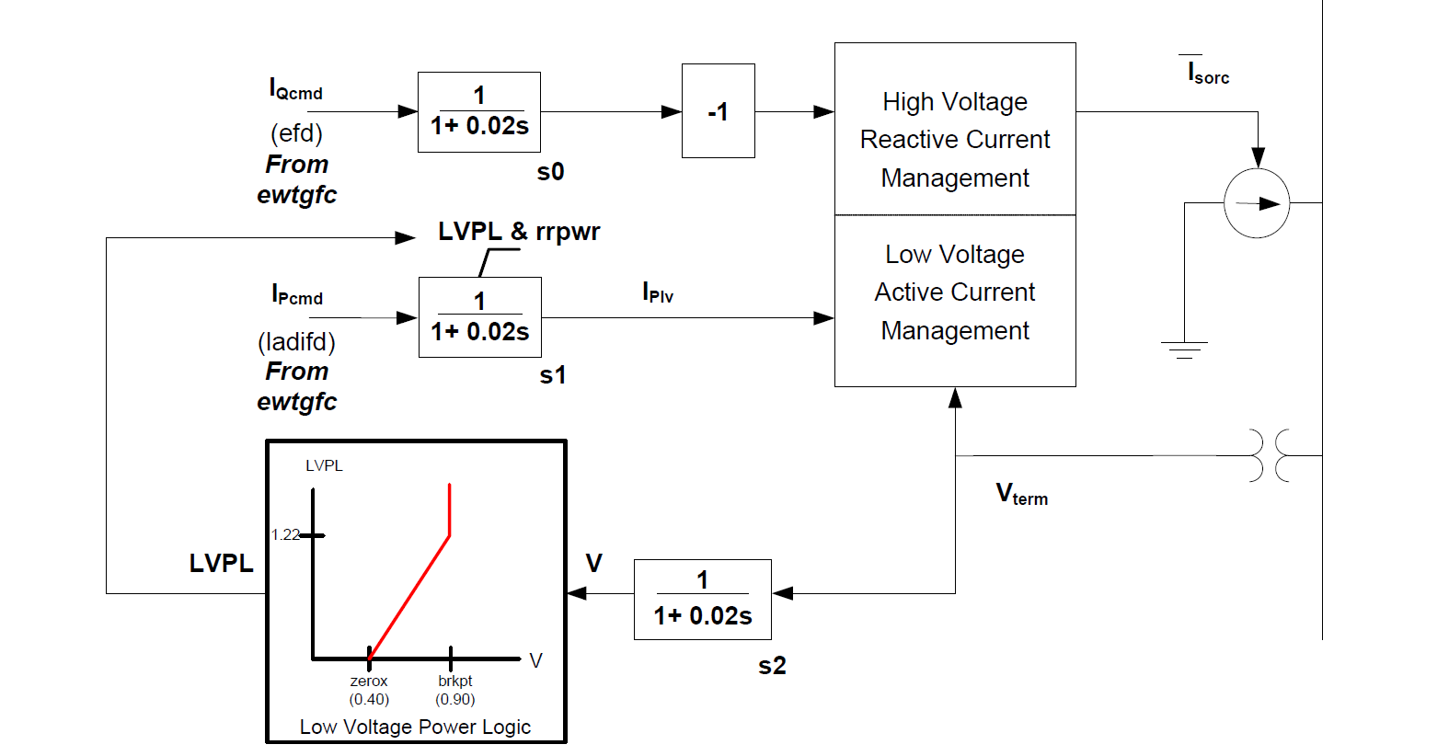
Figure 10. Converter Model

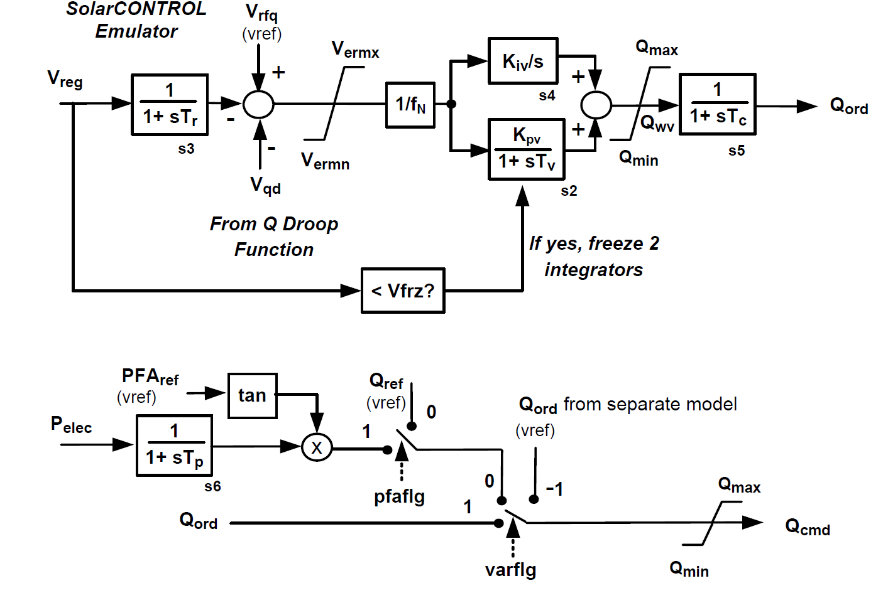
Figure 11. Reactive Power Control Model
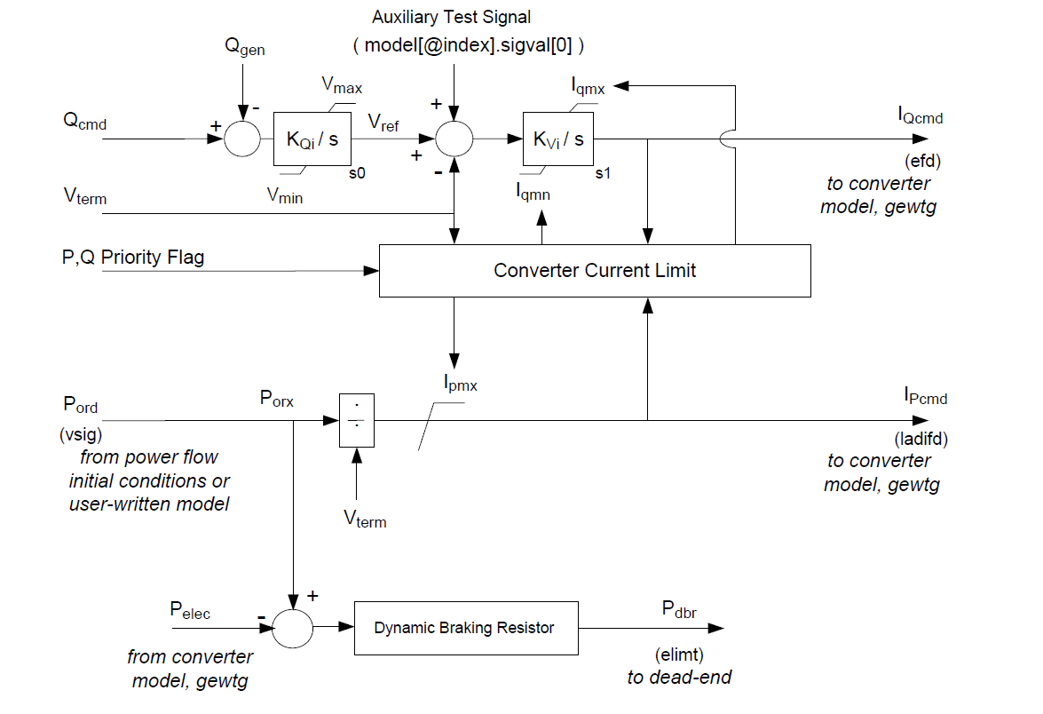
Figure 12. Electrical Control Model

WECC Central Station PV System Model (PV1G, PV1E, PV1P)
The overall model structure is shown in Figure 13, below, and consists of a “generator” model (PV1G) to provide current injections into the network solution, an electrical control model (PV1E) for local active and reactive power control, and an optional plant controller model (PV1P) to allow for plant-level active and reactive power control.

Figure 3. Overall Model Structure for PV1X Central Station PV System Model

PV1G model
The current injection model incorporates a high bandwidth current regulator (similar to the existing WECC WT4G model) that injects real and reactive components of inverter current into the external network during the network solution in response to real and reactive current commands. Current injection shall include the following capabilities:

- User settable high voltage reactive current management at the generator (inverter) bus similar to that in the WT4G model
- Low voltage active current management similar to that in the WT4G model to approximate the response of the inverter PLL controls during voltage dips
- Low voltage power logic similar to that in the WT4G model to allow for a controlled response of active current during and immediately following voltage dips

The protective function model incorporates either of the following:

- A set of six or more definite time voltage and frequency protective elements used to trip the generation represented by the model. Each element shall have an independent user-settable pickup and time delay.

- The ability to trip the generation represented by the model via external models providing the same functionality.
Figure 14. PV1G Model Block Diagram

PV1E model
The active power control subsystem shall provide the active current command to the current injection model. The active current command shall be subject to apparent current limiting, with user-selectable priority between active and reactive current. The active current command shall be derived from a reference active power and the inverter terminal voltage determined in the network solution. The reference active power shall be the initial active power from the solved power flow case; or, in the case where a plant controller model (PV1P) is included, from the plant controller.

The reactive power control subsystem shall provide the reactive current command to the current injection model. The reactive current command shall be subject to apparent current limiting, with user-selectable priority between active and reactive current. The following reactive power control modes shall be accommodated:

- Constant power factor, based on the inverter power factor in the solved power flow case
- Constant reactive power, based either on the inverter absolute reactive power in the solved power flow case or, in the case where a plant controller model (PV1P) is included, from the plant controller.

The option to process the reactive power command via cascaded set of PI regulators for local reactive power and terminal voltage control, or to bypass these regulators and directly derive a reactive current command from the inverter terminal voltage, shall be provided. In addition, a supplementary, fast-acting reactive current response to abnormally high or low terminal voltages (again, refer to Figure 3) shall be provided.

Figure 15. PV1E Model Block Diagram

PV1P model
The plant controller model (PV1P) is an optional model used when plant-level control of active and/or reactive power is desired. The model shall incorporate the following:
- Closed loop voltage regulation at a user-designated bus. The voltage feedback signal shall have provisions line drop compensation, voltage droop response and a user-settable deadband on the voltage error signal.
- Closed loop reactive power regulation on a user-designated branch with a user-settable deadband on the reactive power error signal.
- A plant-level governor response signal derived from frequency deviation at a user-designated bus. The frequency droop response shall be applied to active power flow on a user user-designated branch. Frequency droop control shall be capable of being activated in both over and under frequency conditions. The frequency deviation applied to the droop gain shall be subject to a user-settable deadband.

Figure 16. PV1P Model Block Diagram

Generic Solar Photovoltaic Model in PSSE
A PSSE Generic Photovoltaic Model is composed of four models
- Irradiance model (IRRADU1) - this model allows users to vary the amount of solar irradiance. Users can enter up to 10 data points (time(s), irradiance(W/m2)) as CONs
- PV panel model (PANELU1) – this model linearize the electrical characteristic of a PV panel (I-V curve) with the assumption of maximum power point tracker (MPPT) is instantaneous. For each simulation step, the model reads irradiance level and outputs linearized power order.
- Electrical control model (PVEU1): this model is very similar to WT4E with variable power reference from PANELU1.
- Converter model (PVGU1): this model is identical to WT4G.

Figure 17. PSSE Generic Photovoltaic Model

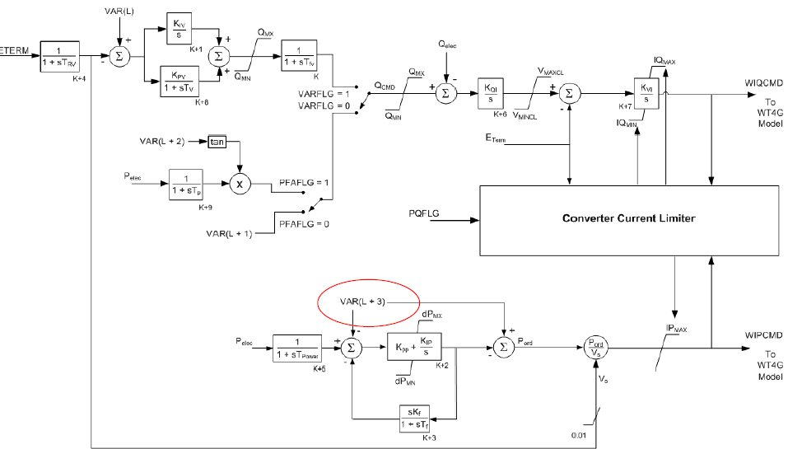
Figure 18. Electrical control model (PVEU1)

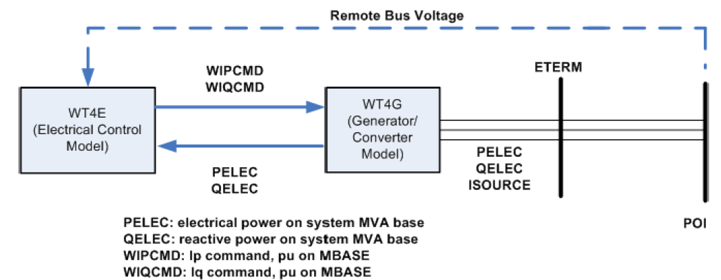
Figure 19. Converter model (PVGU1)

Distributed Solar Resources

Distributed PV system model
Unlike central station PV plants, distributed PV systems are connected at the distribution level as shown in Figure 20. In contrast with NERC central station reliability requirements, distributed PV systems at this time normally do not participate in steady state voltage regulation, and tighter bounds on operation for off-nominal voltage and frequency conditions result in significantly different fault ride-through capability.

Figure 20. An example of PV connected on distribution system

In the near term, it is anticipated that the PV inverters applied in distributed systems will continue to comply with IEEE 1547, and will operate under constant power factor or constant reactive power modes of operation.Unlike a Central Station plant, the terminal voltages seen by the individual inverters within the composite load in the bulk system dynamic model are likely to vary substantially. A different protection model is used to capture the effect of the diverse terminal conditions on the aggregate generation.

The modeling of distributed PV systems for transmission studies is still evolving. A model for a distributed PV system uses existing PV models for transmission networks, modified and tuned to comply with IEEE 1547 requirements. WECC is proposing to add a PV model within the composite load model- see Figure 21. Desired control features of a distributed PV system follows.

Figure 21. WECC Composite Load Model (CMPLDW) + PV

The active power control subsystem shall provide the active current injection to the network solution. The active current command shall be subject to apparent current limiting, with user-selectable priority between active and reactive current. The active current command shall be derived from a reference active power and the inverter terminal voltage determined in the network solution. The reference active power shall be the initial active power from the solved power flow case.

The active power control subsystem shall provide a high frequency droop (governor response) function with user-settable deadband and droop gain.

The reactive power control subsystem shall provide the reactive current command to the network solution. The reactive current command shall be subject to apparent current limiting, with user-selectable priority between active and reactive current. The reactive power control mode shall be limited to constant reactive power. The reference reactive power shall be the sum of the following:

- The initial reactive power from the solved power flow case
- A droop signal derived from voltage deviation at a user-specified bus. The voltage deviation applied to the droop characteristic shall be subject to deadband control and line drop compensation.

The protective function model shall incorporate functions which reduce generation outside of user-specified deadbands on voltage and frequency in an amount proportional to the voltage or frequency deviation. User-settable flags shall determine whether recovery of generation shall occur when voltage or frequency excursions reverse and return toward the deadband, and in what proportion.

Figure 22. Distributed PV Model Block Diagram

References
[1] Muller, H., et al. “Concentrating solar power. A review of the technology. “Quarterly of the Royal Academy of Engineering. Ingenia 18, February/march 2004.” Available at: Available at: http://www.trec-uk.org.uk/resources/ingenia_18_Feb_March_2004.pdf
[2] Standard Models for Variable Generation, The North American Electric Reliability Corporation (NERC), May 2010
[3] Generic Solar Photovoltaic System Dynamic Simulation Model Specification, Western Electricity Coordinating Council Modeling and Validation Work Group, 2012
[4] Joshua S. Stein, Clifford W. Hansen, Matthew J. Reno, “The variability index: a new and novel metric for quantifying irradiance and PV output variability,” presented at the World Renewable Energy Forum, Denver, CO, 2012.
[5] Photovoltaic and Solar Forecasting:State of the Art, Sophie Pelland, Jan Remund, Jan Kleissl, Takashi Oozeki, Karel De Brabandere, Report IEA‐PVPS T14‐01, 2013
[6] Predicting Solar Power Production: Irradiance Forecasting Models, Applications and Future Prospects, Steven Letendre, Miriam Makhyoun, Mike Taylor, 2014

NPRR 588 is Clarifications for PV Generation Resources, which was approved by Board of Directors on 06/10/2014. NPRR 615 is PVGR Forecasting, which was approved by Board of Directors on 08/12/2014.
Solar Insolation is the power per unit area produced by the Sun in the form of electromagnetic radiation.
J. Zhang, B.-M. Hodge, and A. Florita, "Metrics for evaluating the accuracy of solar power forecasting," NREL, 2013, https://solarhighpen.energy.gov/projects/solar_forecasting
Operations load forecast performance - monthly average day-ahead load forecasts measured by mean average percent error (MAPE) is less than 4%.
http://energy.gov/eere/sunshot/improving-accuracy-solar-forecasting-funding-opportunity
http://www.uwig.org/pvwork/7-ahlstrom.pdf?bcsi_scan_a7ccf25998285488=0&bcsi_scan_filename=7-ahlstrom.pdf
Altitude of sensors would be best to be within the height range of the panels.
** The pyrheliometers are use don the site to measure the direct beam solar irradiance. They must track the sun in two axis to accomplish this so they are mounted on a small 2 axis tracker system. From this measurement and the other pyranometer measurements the diffuse irradiance can be calculated by subtracting the global irradiance from the direct beam irradiance.
The full station has wind speed/direction, ambient temperatura/barometric pressure/ % rain gauge, global horizontal irradiance pyranometer, PVmodule for power supply with battery/charger, lightening rod and mounting system.
For reference only, not endorsed by ERCOT

