November 2015 ERCOT Monthly Operations Report

Reliability and Operations Subcommittee Meeting
January 7th, 2016

Table of Contents
1 Report Highlights 3
2 Frequency Control 4
2.1 Frequency Events 4
2.2 Responsive Reserve Events 5
2.3 Load Resource Events 5
3 Reliability Unit Commitment 5
4 Wind Generation as a Percent of Load 6
5 Congestion Analysis 6
5.1 Notable Constraints for November 6
5.2 Generic Transmission Constraint Congestion 7
5.3 Manual Overrides for November 8
5.4 Congestion Costs for Calendar Year 2015 8
6 System Events 9
6.1 ERCOT Peak Load 9
6.2 Load Shed Events 9
6.3 Stability Events 9
6.4 Notable PMU Events 9
6.5 TRE/DOE Reportable Events 9
6.6 New/Updated Constraint Management Plans 9
6.7 New/Modified/Removed SPS 9
6.8 New Procedures/Forms/Operating Bulletins 9
7 Emergency Conditions 9
7.1 OCNs 9
7.2 Advisories 9
7.3 Watches 9
7.4 Emergency Notices 9
8 Application Performance 10
8.1 TSAT/VSAT Performance Issues 10
8.2 Communication Issues 10
8.3 Market System Issues 10
9 Net-Forecast Bias Applied to NSRS Procurement for December 2015 10
Appendix A: Real-Time Constraints 11

Report Highlights
- The unofficial ERCOT peak for November was 45,014 MW.
- There were four frequency events in November. PMU data indicates the ERCOT system transitioned well in each case.
- There were four instances where Responsive Reserves were deployed, three of which were the result of frequency events.
- There were no RUC commitments in November.
- The level of reportable SCED congestion decreased in November. This congestion was due primarily to planned outages and area load/gen patterns. There were thirteen days of activity on the Generic Transmission Constraints (GTCs) in November. This included one day of activity on the Laredo GTC, nine on the Zorillo – Ajo GTC and three on the Panhandle GTC.
- There were no significant system events for the month of November.
- ERCOT Applications performed well throughout the month. There were no ERCOT related application performance issues.

Frequency Control

Frequency Events

The ERCOT Interconnection experienced four frequency events in November, all of which resulted from Resource trips. The average event duration was approximately 0:04:20.

When analyzing frequency events, ERCOT evaluates PMU data according to industry standards. Events with an oscillating frequency of less than 1 Hz are considered to be inter-area, while higher frequencies indicate local events. Industry standards specify that damping ratio for inter-area oscillations should be 3.0% or greater. All events listed below indicate the ERCOT system met these standards and transitioned well after each disturbance.

Reported frequency events will include both frequency events where frequency was outside the range of 60±0.1 Hz as well as those determined to be Frequency Measurable Events (FME) as defined by BAL-001-TRE-1. Delta Frequency is defined as the difference between the pre-perturbation and post-perturbation frequency. The Duration of Event is defined as the time it takes for the frequency to recover to lesser/greater of the frequency at the time of the frequency event (t(0) or “A-point”) for low/high-frequency events, respectively. Further details on FMEs can be found in the MIS posted BAL-001-TRE-1 PDCWG Unit Performance reports. A summary of the frequency events is provided below:

Date and Time | Delta Frequency | Max/Min Frequency | Duration of Event | PMU Data |  | Comments
 | (Hz) | (Hz) |  | Oscillation Mode (Hz) | Damping Ratio
11/7/2015 3:39 | 0.095 | 59.82 | 0:05:25 | PMU Data Not Available. |  | Unit Trip of 755 MW
11/30/2015 10:45 | 0.086 | 59.88 | 0:03:33 | 0.64 | 8% | Unit Trip of 574 MW
 |  |  |  | 0.65 | 7%
11/30/2015 19:42 | 0.084 | 59.87 | 0:05:15 | 0.7 | 5% | Unit Trip of 575 MW
 |  |  |  | 0.64 | 7%
11/30/2015 23:36 | 0.058 | 59.93 | 0:03:07 | 0.76 | 8% | Unit Trip of 303 MW
(Note: frequency events highlighted in blue have been identified as FMEs per BAL-001-TRE-1 and the Performance Disturbance Compliance Working group.)

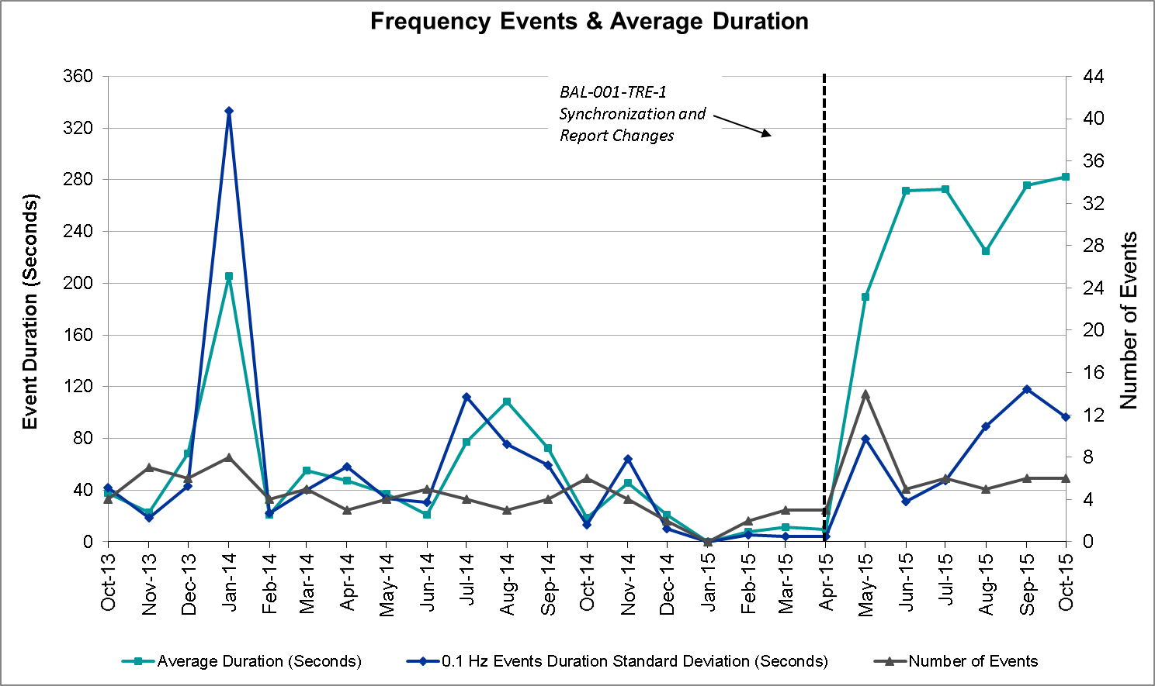

Responsive Reserve Events

There were four events where Responsive Reserve MWs were released to SCED in November. The events highlighted in blue were related to frequency events reported in Section 2.1 above.

Date and Time Released to SCED | Date and Time Recalled | Duration of Event | Maximum MWs Released | Comments
11/7/2015 3:39:46 | 11/7/2015 3:44 | 00:04:52 | 823
11/24/2015 00:13:08 | 11/24/2015 00:17:56 | 00:04:48 | 467 | Frequency dragged down due to units coming off-line.
11/30/2015 10:45:35 | 11/30/2015 10:48 | 00:02:48 | 140
11/30/2015 19:42:41 | 11/30/2015 19:46 | 00:04:04 | 388

Load Resource Events
There were no load resource deployment events in November.

Reliability Unit Commitment
ERCOT reports on Reliability Unit Commitments (RUC) on a monthly basis. Commitments are reported grouped by operating day and weather zone. The total number of hours committed is the sum of the hours for all the units in the specified region. Additional information on RUC commitments can be found on the MIS secure site at Grid Generation Reliability Unit Commitment.

There were no DRUC commitments in November.

There were no HRUC commitments in November.

Wind Generation as a Percent of Load
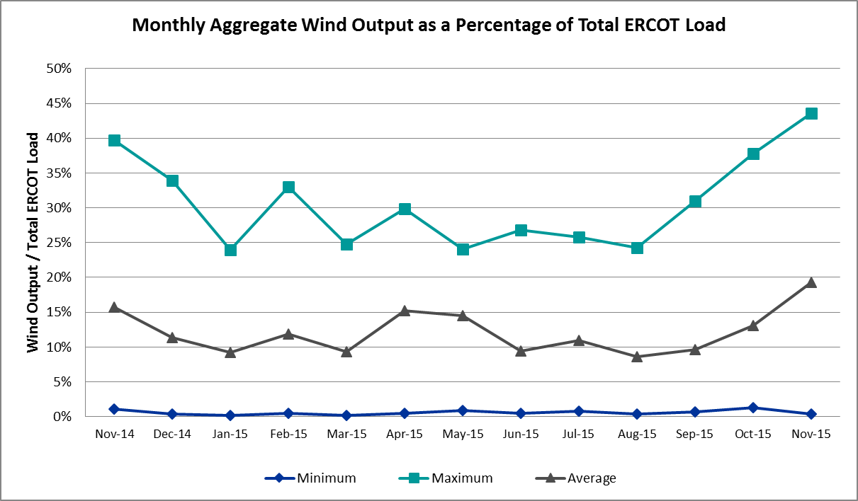

Congestion Analysis
The number of congestion events experienced by the ERCOT system decreased in November due to planned outages and area load/gen patterns. There were thirteen days of activity on the Generic Transmission Constraints (GTCs) in November.

Notable Constraints for November

Nodal protocol section 3.20 specifies that ERCOT shall identify transmission constraints that are active or binding three or more times within a calendar month. As part of this process, ERCOT reports congestion that meets this criterion to ROS. In addition ERCOT also highlights notable constraints that have an estimated congestion rent exceeding $1,000,000 for a calendar month. These constraints are detailed in the table below. Rows highlighted in blue indicate the congestion was affected by one or more outages. For a list of all constraints activated in SCED for the month of November, please see Appendix A at the end of this report.

Contingency | Overload | # of Days Constraint Active | Estimated Congestion Rent | Transmission Project
Carrollton Northwest - Lewisville Switch 345 kV | Carrollton Northwest - Lakepointe Tnp 138 kV | 17 | $6,533,539
Cagnon - Kendall 345 kV & Cico - Menger Creek 138 kV | Medina Lake - Pipe Creek 138 kV | 17 | $3,555,053
Bluff Creek T2_H 345/138 kV | Bluff Creek T1_H 345/34.5/138 kV | 11 | $1,880,356
Base Case | Panhandle | 3 | $426,888
Ferguson - Granite Mountain & Wirtz - Paleface 138kv | Flat Rock Lcra - Wirtz 138 kV | 20 | $348,847 | 4465
Base Case | Zorillo to Ajo | 12 | $323,594
Victoria - Coleto Creek 138 kV | Coleto Creek - Victoria 138 kV | 7 | $280,663
Adamsville - Evant 138 kV | Goldthwaite 9AT2 138/69 kV | 6 | $211,621
Gila - Hiway 9 138 kV | Morris Street - Gila 138 kV | 6 | $139,812
Laredo Vft North - Lobo 138 kV | Bruni Sub 69_1 138/69 kV | 7 | $97,849
Whitepoint 345a 345/138 kV | Airco Aep - Rincon 138 kV | 5 | $90,237 | 08TPIT0132
Mercers Gap Sw - Comanche Switch (Oncor) 138 kV | Camp Bowie (Oncor) - Brownwood Switch 138 kV | 8 | $87,127
Snyder - Sacroc 138 kV | Morgan Creek Ses - Sun Switch 138 kV | 7 | $63,790 | 4213
Koch Up River - Gila & Lon Hill - Nueces Bay 138 kV | Champlin - Weil Tract 138 kV | 6 | $35,473
Zorn - Marion & Clear Springs 345 kV | Henne - Mccarty Lane 138 kV | 5 | $19,499 | 4453
Ennis Creek Tap - Ennis Creek Switch 138 kV | Snyder - Sacroc 138 kV | 4 | $12,669
Barton Chapel Wind Farm - Oran Sub 138 kV | Scotland (Oncor) - Wichita Falls South Switch 138 kV | 4 | $10,010
Scurry Switch - Sun Switch 138 kV | Wolfgang - Rotan 69 kV | 7 | $7,595
Aspermont Aep - Spur 138 kV | Wolfgang - Rotan 69 kV | 5 | $4,557

Generic Transmission Constraint Congestion
There was one day of activity on the Laredo GTC, nine days of activity on the Zorillo – Ajo GTC and three days of activity on the Panhandle GTC in November. There was no activity on the remaining GTCs during the Month of November.

Manual Overrides for November
There were no manual overrides for the month of November 2015.

Congestion Costs for Calendar Year 2015
The following table represents the top twenty active constraints for the calendar year based on the estimated congestion rent attributed to the congestion. ERCOT updates this list on a monthly basis.

Contingency | Binding Element | # of 5-min SCED Intervals | Estimated Congestion Rent | Transmission Project
Roans Prairie - Rothwood & Singleton - Tomball 345 kV | Singleton - Zenith 345 kV | 2798 | $25,034,946 | 4485, 3937, 3950 (a,b)
Base Case | Valley Import | 199 | $15,591,256
San Angelo North 138_69t1 138/69 kV | San Angelo College Hills 69T1 138/69 kV | 1100 | $12,124,531
Los Fresnos - Loma Alta Substation 138 kV | La Palma - Villa Cavazos 138 kV | 1079 | $10,680,014
Flewellen - Obrien & Mason Road 138 kV | Betka - Hockley 138 kV | 667 | $9,396,616
Collin Switch 345 kV - Collin Ses 138 kV | Collin Ses - Collin Switch 345 Kv 138 kV | 235 | $9,098,021
Carrollton Northwest - Lewisville Switch 345 kV | Carrollton Northwest - Lakepointe Tnp 138 kV | 2325 | $7,584,280
Topeka Termination - West Levee Switch 345 kV | Cedar Hill Switch - Mountain Creek Ses 138 kV | 276 | $7,327,162 | 13TPIT0060
Hill Country - Marion & Elmcreek 345 kV | Skyline - Marion 345 kV | 1328 | $7,321,029 | 4081
Jewett - Singleton 345 kV | Btu_Jack_Creek - Twin Oak Switch 345 kV | 4898 | $7,318,336 | 4485, 3937, 3950 (a,b)
San Angelo College Hills 138_69t1 138/69 kV | San Angelo Power Station 69T1 138/69 kV | 1456 | $7,141,012
North Alvin Tnp - Meadow 138 kV | Southshore Tnp - Ph Robinson 138 kV | 187 | $6,531,939
Lost Pines Lcra - Austrop & Aen Dunlap 345 kV | Fayette Plant 1 - Fayette Plant 2 345 kV | 2975 | $6,416,648
Hutto Switch Axfmr1h 345/138 kV | Pflugerville - Gilleland 138 kV | 565 | $4,639,067 | 16TPIT0062
Bevo Substation - Asherton 138 kV | Hamilton Road - Maverick 138 kV | 320 | $4,635,315
Bluff Creek T2_H 345/138 kV | Bluff Creek T1_H 345/34.5/138 kV | 2420 | $4,234,392
Orange Grove Switching Station - Lon Hill 138 kV | Lon Hill - Smith 69 kV | 4186 | $4,156,156 | 16TPIT0026
Rio Hondo 345_138_1l 345/138 kV | Aderhold Sub - Elsa 138 kV | 121 | $4,047,071
Falcon Seaboard - Midland East 345 kV | Glenhaven - Odessa 138 kV | 70 | $3,753,436
Base Case | North to Houston | 92 | $3,656,328 | 4485, 3937, 3950 (a,b)

System Events

ERCOT Peak Load
The unofficial ERCOT peak load for the month was 45,014 MW and occurred on November 5th during hour ending 19:00.

Load Shed Events
None.

Stability Events
None.

Notable PMU Events
ERCOT analyzes PMU data for any significant system disturbances that do not fall into the Frequency Events category reported in section 2.1. The results are summarized in this section once the analysis has been completed.

There were no reportable events in November.

TRE/DOE Reportable Events
None.

New/Updated Constraint Management Plans
None.

New/Modified/Removed SPS
None.

New Procedures/Forms/Operating Bulletins
None.

Emergency Conditions

OCNs
Date and Time | Description
11/12/15 10:46 | ERCOT issued an OCN due to ERCOT developing a new Generic Transmission Constraint near Garza JL Bates area for voltage stability.

Advisories
None.

Watches
None.

Emergency Notices
None.

Application Performance
ERCOT system applications performed well in November. There were no issues to report.

TSAT/VSAT Performance Issues
None.

Communication Issues
None.

Market System Issues
None.

Net-Forecast Bias Applied to NSRS Procurement for December 2015
Each month, ERCOT calculates a net Forecast Bias pursuant to the ERCOT Ancillary Services Methodology for procurement of Non-Spinning Reserve Service (NSRS). The table below indicates the amount of net Forecast Bias that was applied to the NSRS procurement for specified blocks of time for the month of December 2015.

Blocks | Negative Net Load Forecast Average Error - By Weather Zone for the 5 Largest Zones
 | Coast | East | North Central | South Central | Southern
1-2 | 0 | 0 | 0 | 0 | 0
3-6 | 0 | 0 | 0 | 0 | 0
7-10 | 0 | 0 | 0 | 0 | 0
11-14 | 0 | 0 | 0 | 0 | 0
15-18 | 0 | 0 | 0 | 0 | 0
19-22 | 0 | 0 | 0 | 0 | 0
23-24 | 0 | 0 | 0 | 0 | 0

Appendix A: Real-Time Constraints
The following is a complete list of constraints activated in SCED for the month of November. Full contingency descriptions can be found in the Standard Contingencies List located on the MIS secure site at Grid Generation Reliability Unit Commitment.

Contingency | Constrained Element | From Station | To Station | # of Days Constraint Active
DCRLLSW5 | 591__A | LKPNT | CRLNW | 17
DCAGCI58 | 255T279_1 | PIPECR | MEDILA | 17
XBL2U58 | BLUF_CRK_T1_H | BLUF_CRK | BLUF_CRK | 11
BASE CASE | PNHNDL |  |  | 3
DCHLDPW8 | CR_DT_91_A | CR | DT | 2
DFERPAL8 | 38T365_1 | WIRTZ | FLATRO | 20
BASE CASE | ZO_AJO |  |  | 12
DZEN_OB5 | THWZEN71_A | ZEN | THW | 2
SVICCO28 | COLETO_VICTOR2_1 | COLETO | VICTORIA | 7
DDUNLOS5 | AUSTRO_AT1H | AUSTRO | AUSTRO | 1
SADALAM8 | GOLDTH_9AT2 | GOLDTH | GOLDTH | 6
DKENCA58 | V3_W1_1 | V3 | W1 | 1
DRIOHAR5 | HAINE__LA_PAL1_1 | LA_PALMA | HAINE_DR | 1
SGILNU78 | GILA_MORRIS1_1 | GILA | MORRIS | 6
DCHB_NB5 | CD_TX_87_A | CD | TX | 1
SLARLO28 | BRUNI_69_1 | BRUNI | BRUNI | 7
XWHI58 | AIRCO4_RINCON1_1 | RINCON | AIRCO4 | 5
SZEPCMN8 | 670__B | BRNSW | CMPBW | 8
SSACSUN8 | 6474__A | SUNSW | MGSES | 7
XKOC89 | HEARN__KOCH_U1_1 | HEARN_RD | KOCH_UP | 1
SKLELOY8 | LOYOLA_69_1 | LOYOLA | LOYOLA | 3
SGYRDPW8 | CR_DT_91_A | CR | DT | 1
SLAQLOB8 | BRUNI_69_1 | BRUNI | BRUNI | 1
DKOCNUE8 | CHAMPL_WEIL_T1_1 | WEIL_TRC | CHAMPLIN | 6
SSKISIN9 | EDROY_SMITH1_1 | SMITH | EDROY | 1
SPAWLON5 | EDROY_SMITH1_1 | SMITH | EDROY | 1
DCLEZOR5 | 87T233_1 | MCCALA | HENNE | 5
DGIBSNG5 | 240__A | JEWET | SNG | 1
SWEILON8 | CHAMPL_WEIL_T1_1 | WEIL_TRC | CHAMPLIN | 2
SCOLPAW5 | COLETO_KENEDS1_1 | COLETO | KENEDSW | 1
SKNADM28 | 6240__A | SACRC | SNYDR | 4
SMCEABS8 | ESKSW_FMR1 | ESKSW | ESKSW | 2
SBRTORA8 | 6560__E | SCTLD | WFSSW | 4
DSNGZEN5 | KDLRNS75_A | RNS | KDL | 3
SSCLWF28 | 6850__B | NVKSW | ARCTY | 1
SSCUSUN8 | ROTN_WOLFGA1_1 | WOLFGANG | ROTN | 7
XPAI89 | MUNDAY_WEIN1_1 | MUNDAYST | WEIN | 1
SWHISTP5 | AIRCO4_RINCON1_1 | RINCON | AIRCO4 | 1
SSPUASP8 | ROTN_WOLFGA1_1 | WOLFGANG | ROTN | 5
SFORYEL8 | FORTMA_MASN1_1 | FORTMA | MASN | 1
DTWIDIV5 | NICOLE_ORNT1_1 | NICOLE | ORNT | 1
DMARPA_8 | 38T365_1 | WIRTZ | FLATRO | 3
BASE CASE | ABSO_VINSON1_1 | ABSO | VINSON | 1
SSPUMW18 | ROTN_WOLFGA1_1 | WOLFGANG | ROTN | 3
BASE CASE | LAREDO |  |  | 1
UCOLCOL1 | AIRCO4_RINCON1_1 | RINCON | AIRCO4 | 1
SDTCR8 | DT_GS_32_A | GS | DT | 1
DCHB_NB5 | CTRPHR97_A | CTR | PHR | 1
DRIOHAR5 | S104A_1 | RIOHONDO | MV_BURNS | 1
SAJORI25 | CELANE_KLEBER1_1 | CELANEBI | KLEBERG | 1
SSCLWF28 | 6845__A | HOLDY | LKWSW | 1
DAUSSND5 | 211T147_1 | GILLCR | MCNEIL_ | 1
SVICCOL8 | COLETO_VICTOR1_1 | COLETO | VICTORIA | 2
SKOCNU28 | CHAMPL_WEIL_T1_1 | WEIL_TRC | CHAMPLIN | 1
SGARROM8 | GARZA_69A1 | GARZA | GARZA | 1
DHUTHUT5 | HUTTO_MR1H | HUTTO | HUTTO | 1
SMCEABS8 | 6585__A | TRNT | ESKSW | 1
SPELPAP8 | REACTOR2_SEC_1 | WHITE_PT | WHITE_PT | 2
SBMADK8 | SA_TAP76_1 | SA | SA | 1
SBRTORA8 | 6560__E | WFSSW | SCTLD | 2
SCAGKEN5 | 74T148_1 | COMFOR | CICO | 2
BASE CASE | SNYDER_WKN_BK1_1 | ENAS | WKN_BKR | 4
SMCEABS8 | 6585__A | ESKSW | TRNT | 1
SMCDBSP8 | 6470__E | FRSTP | PCTSW | 2
DLB_GBY8 | HR_NS_91_A | HR | NS | 1
DCAGBRA5 | N5_P4_2_1 | CALAVERS | SKYLINE | 1
SWHISTP5 | AIRCO4_NCARBI1_1 | AIRCO4 | NCARBIDE | 1
SSUNMGS8 | 6240__A | SACRC | SNYDR | 1
SSNYCGR8 | SNYDR_FMR1 | SNYDR | SNYDR | 1
XLOB58 | ASHERT_CATARI1_1 | ASHERTON | CATARINA | 1

