A Review of ORDC Options
12-2-15

ERCOT Supply Analysis Working Group
Brandon Whittle, Chair

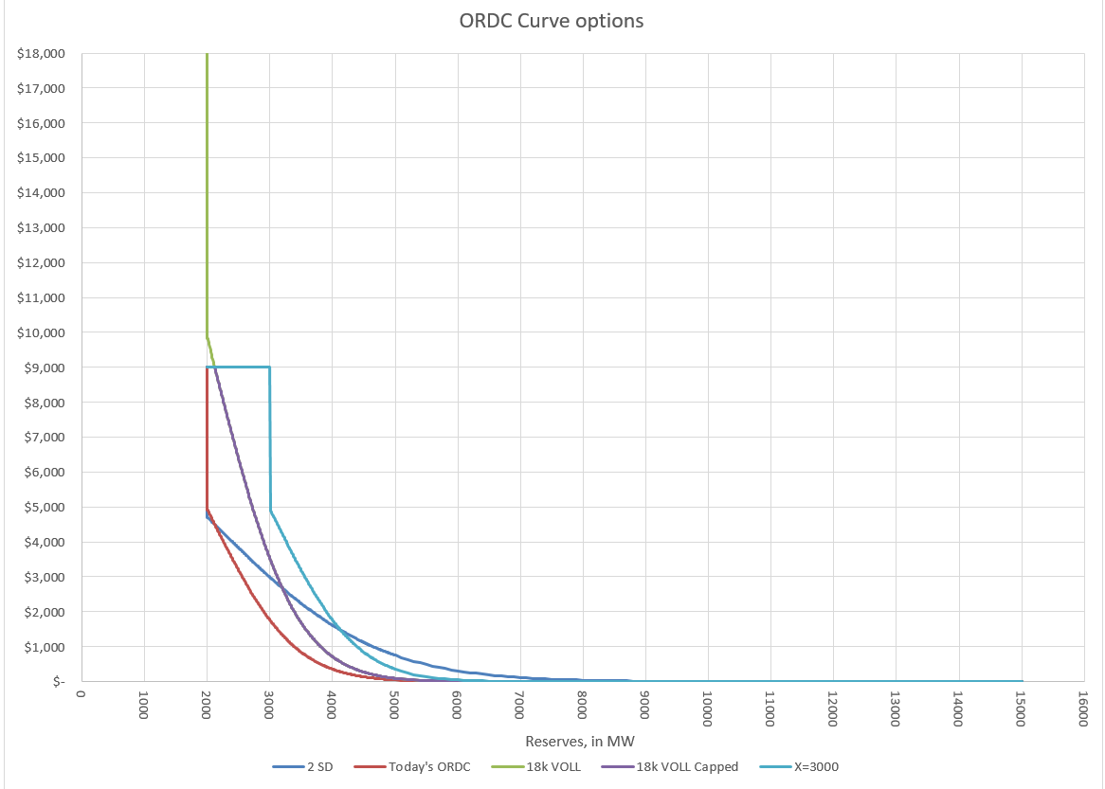
Figure 1, ORDC Options – Examples only

- Introduction
The Supply Analysis Working Group (SAWG) was asked by the Wholesale Market Subcommittee (WMS) to review and consider whether there is a need for minor adjustments to ORDC per the 10-7-2015 memo filed by Commissioner Anderson. The SAWG should deliver a preliminary outline of work product to December WMS meeting with a final work product no later than January WMS meeting.
This paper’s purpose is to be that work product and to inform discussion on the topic. Its contents are an aggregation of recommendations from ERCOT stakeholders and analysis by ERCOT Staff. This paper is not intended to address any threshold issues such as what an appropriate reserve margin is for the ERCOT region or how it should be attained.
The main body of the paper is the work of the SAWG which is intended to be agnostic of potential changes. Following the main body are position papers submitted by market participants which provide viewpoints on what, if anything, should be done to the ERCOT market design.
CURRENT STATUS – This status section to be deleted before 1/6 WMS.
12/3/15, updated following 12/2 SAWG. This will be redrafted and graphics to be updated after ERCOT’s analysis is available for inclusion before the 12/16 SAWG.
11/16/15, this is modified to reflect discussion at 11/13/15 SAWG meeting and amended to include specific possible adjustments.
11/12/15, this is purely a draft strawman outline.

- List of Observations regarding ORDC performance
This list does not imply stakeholder consensus and is merely a listing of various stakeholder observations.
- ORDC is performing as intended and designed.
- ORDC is not aligned with operations demonstrated by the 8/13/2015 event. The event is described both in ERCOT’s presentation to TAC and this comment from Commissioner Anderson’s memo, “I ask this question because at certain hours of certain days last summer the price adder resulting from the ORDC seemed to suggest LOLP of well under 1% even though ERCOT was considering making conservation appeals.”
- Hockey stick curve makes optimization difficult and is driven by VOLL being identical to SWOC. Pricing outcomes during scarcity events are extremely volatile.
- The value of X being lower than RRS and URS can lead to reserves being converted to energy at prices less than 25% of SWOC.
- Because X=2,000 is lower than Ancillary Service reserve requirements, when ORDC reserves fall below 2,000 MW it’s too late to send signals to resources and consumers.
- Current mechanism introduces the potential for lack of consistency and convergence in DAM outcomes compared to RTM. Differentiation of value of different ancillary reserves is needed.

- Stakeholder Proposals for Improvement
This section serves as a summary for different options, none of which is a consensus view or an endorsement by any stakeholder group. Due to their similarity, proposals 5 through 8 are repeated in table form.
- There is no need to make any changes. Addresses item A from section II.
- Add ORDC to the DAM. The ORDC curve would be used as the demand curve for AS procurement and pricing instead of today’s inelastic procurement. Could be applied to all other options (1, 3-8). Addresses F
- Apply dynamic Reserve Discount Factor (RDF) from PRC calculation instead of the static RDF in the RTOLCAP. Addresses B
- Set RTOFFCAP = 0 at PRC =2500 to increase adder amounts. Addresses B
- Set minimum RRS procurement at 2,750; Set X each hour equal to the sum of RRS & URS procured; Set VOLL = $18,000; Retain “effective price cap” = SWOC ($9,000); Addresses B,C,D,E
- Set minimum RRS procurement at 2,750; Set X each hour = sum of RRS & URS; Modify calculation in ORDC where the price adder plus system lambda is >= $4,500 when PRC is less than 2500MW and is at offer cap when PRC is less than 2300MW. Addresses B,C,D,E
- Set X =2,300; Set VOLL = $12,000; Retain “effective price cap” = SWOC ($9,000); Addresses B,C,D,E
- Set minimum RRS procurement at 2750; Set X =2,750; Set VOLL = $18,000; “effective price cap” = SWOC ($9,000); Addresses B,C,D,E

Table 1 Summary of proposals 5 though 8
# | Minimum RRS | Value of X (MCL) | VOLL | “Effective Price Cap” | Other | Addresses
5 | 2,750 MW | Sum of RRS & URS | $18,000 | $9,000 |  | B,C,D,E
6 | 2,750 MW | Sum of RRS & URS | $9,000 | N/A | PRC Based Adder Floor | B,C,D,E
7 | 2,300 MW | 2,300 MW | $12,000 | $9,000 |  | B,C,D,E
8 | 2,750 MW | 2,750 MW | $18,000 | $9,000 |  | B,C,D,E

INSERT ERCOT ANALYSIS

- The Back Cast Tool
To aid in this analysis, ERCOT developed a tool reminiscent the 2011-12 back casts for the original ORDC discussion. The tool is flexible enough to handle different combinations of these changes including behavioral changes.
Understanding where back casts excel and where they have difficulty is important, especially when considering policy changes.
Pros:
- Relatively easy to produce.
- Familiar to analysists and decision makers, used for previous ORDC analysis.
- Better suited to gauge relative differences in options.
Cons:
- Magnitude of impact due to a modeled change can be misleading.
- Behavioral changes from resources are difficult to model, and when those changes lead to additional commitment the model will generally overestimate the effect of ORDC changes. ERCOT has supplied some ability to modify behavior in the tool but currently it can only anticipate changes interval by interval so temporal considerations are ignored.

- Level of X
From the memo: “The level of X used in the ORDC formula, which is 2,000 MW of operating reserves, selected to represent a level below which ERCOT operators cease relying on the market and begin to take out-of-market actions”
Discussion: X is also called the Minimum Contingency Level (MCL), and it is the level of ORDC Online Reserves which will trigger a price at VOLL (currently $9,000). It is important to remember that the Online Reserves is typically more than the Physical Responsive Capability (PRC) reserves, (see Chapter VII).
Alternatives:
- X=2000 – Current level. The rationale for retaining X=2000 is:
  - There is not clarity in what needs to be fixed or what goal is to be achieved by adjustment
- X=Regup + RRS - The rationale is:
  - Would continuously keep ERCOT in compliance with NERC BAL-003-1
  - From practical standpoint would ensure ERCOT could recover frequency from a loss of 2,750 MW
- X= Regup + RRS with RRS floor of 2750 - The rationale is:
  - Provides appropriate prices signals during scarcity triggered by EEA
  - Makes ORDC consistent with Demand curves in Real-Time Co-Optimization
- X= 2000 with a multiplier of RT Load/average Load - The rationale is:
  - Ties the X value to the level of unloaded capacity in the Market
- X= Reduced value when used in conjunction with other changes
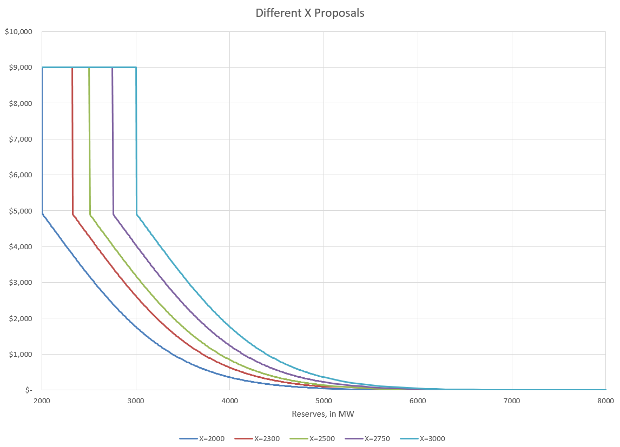
Figure 3, X Options

Conclusion: As you can see in the figure above, the higher X merely shifts the curve to the right.

- Standard Deviation of the LOLP
From the memo: “The number of standard deviations used to formulate of the loss of load probability curve in the ORDC.”
Discussion: The LOLP is determined by analyzing historic events defined as the difference between the hour-ahead forecasted reserves with the reserves that were available in Real-Time during the Operating Hour. Currently we use one Standard Deviation when calculating the LOLP.
Alternatives:
- Use One Standard Deviation (SD) – Current practice The rationale for retaining the current value is:
- There is not clarity in what needs to be fixed or what goal is to be achieved by adjustment
- Increase SD – The rationale is:
- Shifts the slope of the curve to make it more gradual of a change between reserve levels.
- A value higher than one SD may be appropriate to better capture the risk on some winter mornings where RUC has been necessary (Further analysis may be necessary).

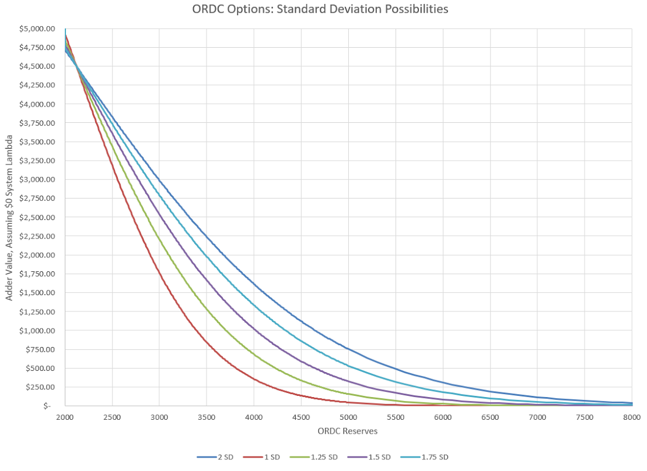
Figure 4, Effect of increasing the Standard Deviation used in LOLP

Conclusion: As you can see in the figure above, adding standard deviations “flattens” the curve and extends the duration of a meaningful adder.

- VOLL
From the memo: “The value of lost load (VOLL) used in the ORDC, which currently is $9,000 MWh (and whether $9,000 MWh should remain as the effective price cap even if the VOLL is increased)”
Discussion: A significant issue is the consideration of the “effective price cap”. Currently VOLL is the effective price cap, not the System Wide Offer Cap (SWOC), so if VOLL is greater than the SWOC the energy price could exceed SWOC even in intervals without congestion.
Alternatives:
- VOLL = $9,000. Current value, as there is not clarity in what needs to be fixed or what goal is to be achieved by adjustment.

- VOLL = $18,000, but the effective price cap remains at $9,000.
  - Shifts the slope of the curve resulting in a more gradual change between reserve levels
  - Places a higher value on real-time operating reserves during periods of increased system risk

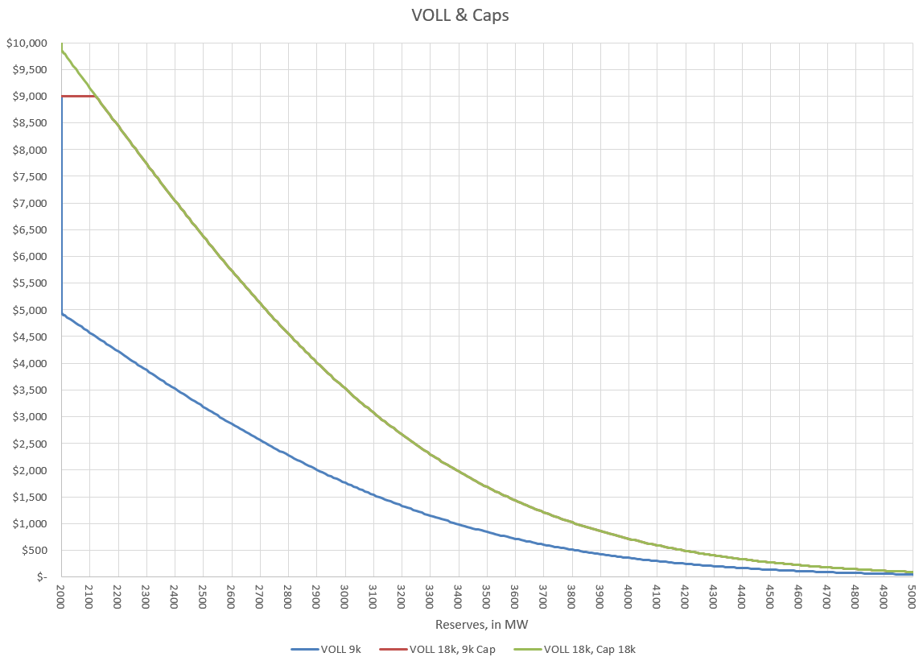
Figure 5, VOLL at 9 & 18k, with and without 9k cap. Note, the 18k capped curve does go to 18k but the chart is truncated at 10k for ease of viewing.
Conclusion: In the figure above we see that an increase in VOLL would be a straight forward increase to the ORDC adder (RTORPA) but the cap question is an important one. It’s also important to note that the only time the “effective price cap” issue matters is when reserves are near the minimum contingency level.

- PRC vs Online Operating Reserves
From the memo: “Should operating reserves counted in ORDC become more closely correlated to PRC, and if so, how?”
Discussion: The PRC, which ERCOT uses to determine if it’s in an Energy Emergency Alert (EEA), is a more conservative value than the Operating Reserves calculation due to the requirement that PRC only count frequency responsive resource capacity. ERCOT presented an analysis located here at the 10-29-15 TAC. ERCOT and stakeholders have identified a few options.
Possible solutions:
- When Non-Spin Reserve Service (NSRS) is deployed, require all NSRS to be physically online which increases PRC so less likely EEA events, but also could decrease system lambda and the ORDC adder. QSGRs providing NSRS should also be required to be physically online at a particular PRC level which may be in economic order(after offline NSRS is deployed at 2500 MW)
  - Manual deployment is out of market action
  - Is deploying a reliability product procured to provide more capacity online when PRC drops below 2500?
  - Bringing on capacity could depress prices – could consider 0-LSL in NPRR626 pricing run
- Increase Responsive Reserve Service (RRS) Procurement by putting a min RRS level above 2300 MW with a buffer
  - Market based solution
  - Would be procuring RRS more than what is needed per ERCOT’s reliability analysis for Frequency Response Obligation (FRO)
- Require all NSRS to be offline and to be brought online upon ERCOT deployment
  - Removes the ability for small fleet to provide NSRS
  - Reduces competition in NSRS market by reducing the supply stack
  - Will help converge ORDC to PRC if offline NSRS is required to be physically online when PRC=2300 MW
  - Aggravates price reversal issues
  - No additional service is provided if the behavior is otherwise the same
- Allow operator to use more discretion in calling EEA – Modification to NPRR708. 11/13/15 SAWG consensus is to not recommend any more discretion in calling EEA than what is stated in NPRR708
- Increase ORDC parameters to create economic incentive for resources to be online.

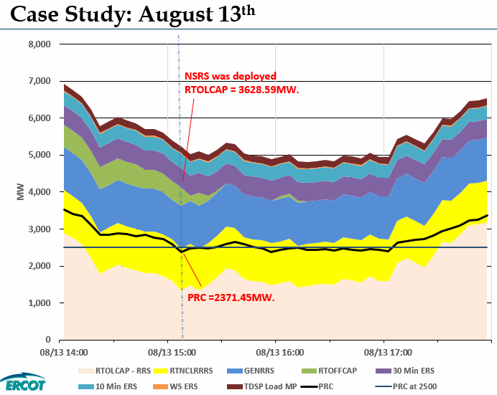
Figure 6, Low PRC from ERCOT analysis presented to 10-29-15 TAC.

- Other inputs to LOLP
From the memo: “Are the current inputs used to calculate the loss of load probability (LOLP) for any given period a sufficiently reasonable approximation or should the method and inputs be reevaluated? I ask this question because at certain hours of certain days last summer the price adder resulting from the ORDC seemed to suggest LOLP of well under 1% even though ERCOT was considering making conservation appeals.”
Discussion: Alternatives to LOLP cannot be considered in a vacuum. Alternatives would necessitate a review of recommendations/options to the above and below questions.
  - Does the error distribution used for the LOLP calculation need to be re-examined?
  - Is the error distribution capturing risk appropriately?
  - Should the timing of conservation appeals be re-evaluated?
Recommendations: None.
- Other Suggestions
Stakeholders have suggested these other considerations which have not been evaluated in this effort.
1) Has the Non-Spin floor created a de-facto cap on energy prices? Should Non-Spin offer floors be increased?
2) LCAP/HCAP - Drop the HCAP as a pressure release (Should the pressure release valve remain or be applied to another value such as VOLL)?

- Record of Stakeholder Meetings
10-29-15 Technical Advisory Committee (TAC)
11-4-15 Wholesale Market Subcommittee (WMS)
11-11-15 Supply Analysis Working Group (SAWG)
11-13-15 Supply Analysis Working Group (SAWG)
11-19-15 Technical Advisory Committee (TAC)
12-2-15 Wholesale Market Subcommittee (WMS)
12-2-15 Supply Analysis Working Group (SAWG)
12-16-15 Supply Analysis Working Group (SAWG)
12-17-15 Technical Advisory Committee (TAC)
1-5-16 Supply Analysis Working Group (SAWG)
1-6-16 Wholesale Market Subcommittee (WMS)
1-28-16 Technical Advisory Committee (TAC)

http://interchange.puc.state.tx.us/WebApp/Interchange/Documents/40000_667_868214.PDF
“As we approach scarcity PRC will be around 2500 and ORDC will gradually approach PRC as prices increase causing QSGRs to come online, resources to put their duct firing online and SCED to move resources to the top making the remaining capacity within 20%HSL. However, since minimum RRS level is 2300MW there could be situations where PRC stays just above 2300MW for a long time and could drop below 2300 when we still have lot of quick starts physically offline but available to SCED. “ http://www.ercot.com/content/wcm/key_documents_lists/77254/14._08132015_Analysis_of_PRC_Vs_ORDC_Corrected.pptx
Hockey Stick refers to the price being equal to $9,000 at reserves less than or equal to 2,000 MW while sharply decreasing to roughly $4,500 with the addition of one MW of additional reserves.
“Effective Price Cap” is a suggestion to form the ORDC adder such that system lambda plus the adder does not exceed the system wide offer cap (SWOC). Today the “effective price cap” is equal to VOLL which happens to be the same as SWOC.
X would change hourly and be equal to sum of RRS and URS procured for that hour.
Floor RTORPA plus System Lambda at $4,500 when PRC is below 2,500 MW and at $9,000 when PRC is below 2,300 MW.
RRS minimum of 2,300 is today’s practice and this recommendation does not suggest a change.
The latest versions of the tool can be found at the 12/2/15 SAWG meeting page. http://www.ercot.com/calendar/2015/12/2/80827-SAWG
Methodology for Implementing Operating Reserve Demand Curve

