TDTMS Meeting Notes – November 11, 2015
Location: WebEx
Time: 1:00 PM – 5:00 PM

Agenda Item | Leading Discussion
- Introductions  - Review of Agenda  - Antitrust Statement | Monica Jones
Review/Approve October Meeting Notes - APPROVED | Monica Jones
ERCOT System Instances (Outages and Failures)  • Updates to RMS were presented on November 2nd by ERCOT – Dave Pagliai  All SLA targets met for the month of October 2015 | ERCOT- Dave Pagliai
Review MarkeTrak Monthly Performance  - Updates to RMS presented on November 2nd by ERCOT – Dave Pagliai  New proposed SLOs  - ERCOT continues to work with vender on developing new SLOs for QueryList, QueryDetails  - ERCOT and TDTMS agreed to review QueryList and QueryDetail Average Response time in January 2016 based on numbers from March of 2015 to December 2015 to facilitate a proposal for the new SLO.  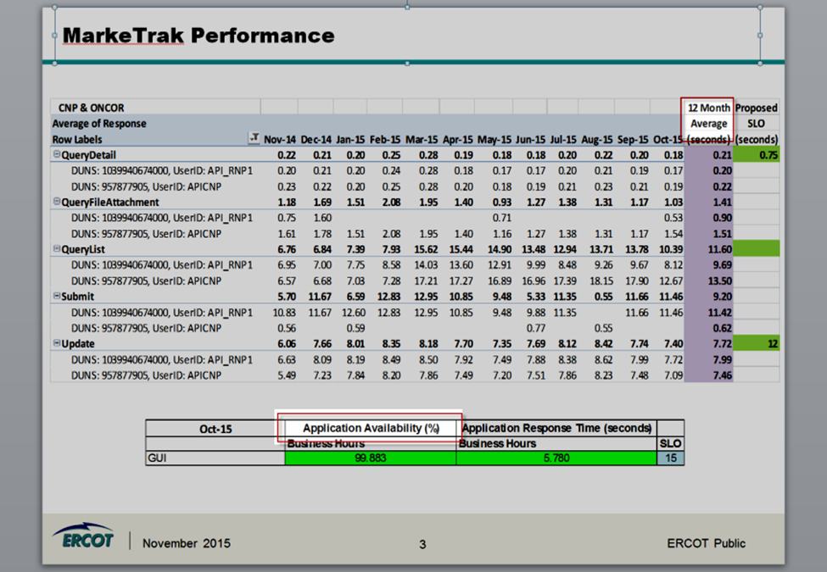  Action item: ERCOT to make modifications to the report to include GUI API Availability QueryList and QueryDetails | ERCOT – Dave Pagliai
3Rd Qtr Performance Measures  Catherine confirmed no metric available until 45 days after the end of the quarter for filing. Group agreed going forward, ERCOT would only present metrics to TDTMS if the percentage of protocols were below 100% to warrant a discussion. TDTMS suggested ERCOT provided heads up when it would present metrics to the group so that could be included in the TDTMS agenda as a discussion point. | Catherine Meiners
2016 SLA DRAFT REVIEW  ERCOT introduced draft of 2016 SLA with updates to the following:  - Retail Release Calendar  - Service availability Section  - MarkeTrak Performance  - Browser Compatibility  Action Item: ERCOT to make updates to Browser Compatibility text to add a generalized statement and send out via list Serv. ERCOT to remove the graph under 2.2.2 Service  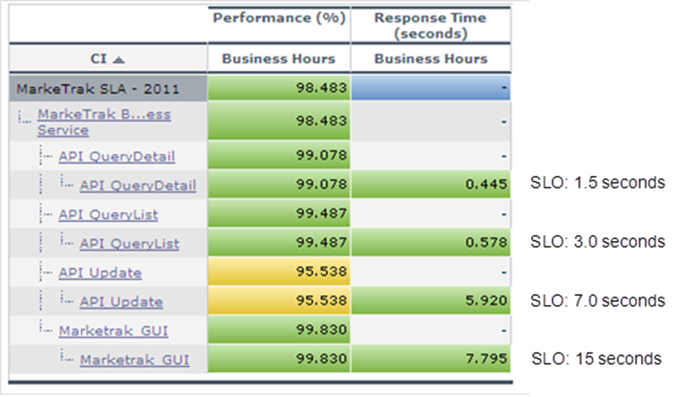  Action Item: TDTMS to review updates in Dec 8th meeting for RMS voting on Dec 9th. | ERCOT – Dave Pagliai
TDTMS Procedure Document  TDTMS and MPs reviewed draft version of TDTMS Procedures. TDTMS reviewed comments provided by Jim Lee and due to his absence the group required clarification before finalizing the document. Lindsay will reach out to Jim for a better understanding of his comments for final review on Dec 8th | All
ERCOT Test Environment (SCR 786)  RMS meeting with PRS for approval on November 12th then sending SCR786 to TAC on November 19th, then ERCOT Board on December 7th. | ERCOT
TDTMS Implementation Guide  Vikram Gupta with ERCOT shared TDTWG Implementation Guide was updated replacing TDTWG with TDTMS within the guide and the name to “TDTMS Implementation Guide”. Vikram and Lindsay will work together to confirm all updates have been completed and present to RMS for voting on 12/9/15. | ERCOT – Vikram Gupta
TDTMS 2016 Meeting Dates  All MPs and TDTMS agreed on 2016 Meeting Calendar with all being Face to Face meeting dates. | All
ADHOC Items  TDTMS discussed MarkeTrak TaskForce documents transition to confirm ERCOT’s next steps:  - Create new TDTMS Working Group Main page  - House documents currently located on both the MTTF and TDTWG sites  - Determine which docs will need to transition from the TDTWG page  - Create new TDTMS Listserv  This new TDTMS listserv will contain All subscribed market participants of TDTWG, MarkeTrak GUI and MarkeTrak API listservs.  Subscribers will have access to all archives under the old stakeholder group folders (TDTWG and MarkeTrak TF)  - Discontinue TDTWG, MarkeTrak GUI and MarkeTrak API listservs after new TDTMS listserv is established | All
Action Items

- Action item from November: ERCOT to make modifications to the report to include GUI API Availability QueryList and QueryDetails
- Action Item: ERCOT to make updates to Browser Compatibility text to add a generalized statement and send out via list Serv. ERCOT to remove the graph under 2.2.2 Service availability for MarkeTrak Performance and review again in February with new proposed SLOs
- Action Item: TDTMS to review updates in Dec 8th meeting for RMS voting on Dec 9th.
- Finalize TDTMS Procedures for RMS voting Dec 9th
- TDTMS Implementation Guide finalized for RMS voting Dec 9th

Attending MPs:

Isabelle Durham – CNP
Monica Jones – NRG
Vikram Gupta – ERCOT
Dave Pagliai – ERCOT
Lindsay Butterfield – ERCOT
Kaci Jacobs – TXU
Catherine Meiners – ERCOT
Carolyn Reed – CNP
Kathy Scott – CNP
Diana Rehfeldt – TNMP
David Michelsen - ERCOT

Update to RMS | Monica Jones
Adjourn
Future Meeting Dates:
- December 8, 2015 Face-to-face

