A Review of ORDC Options
11-16-15

ERCOT Supply Analysis Working Group
Brandon Whittle, Chair

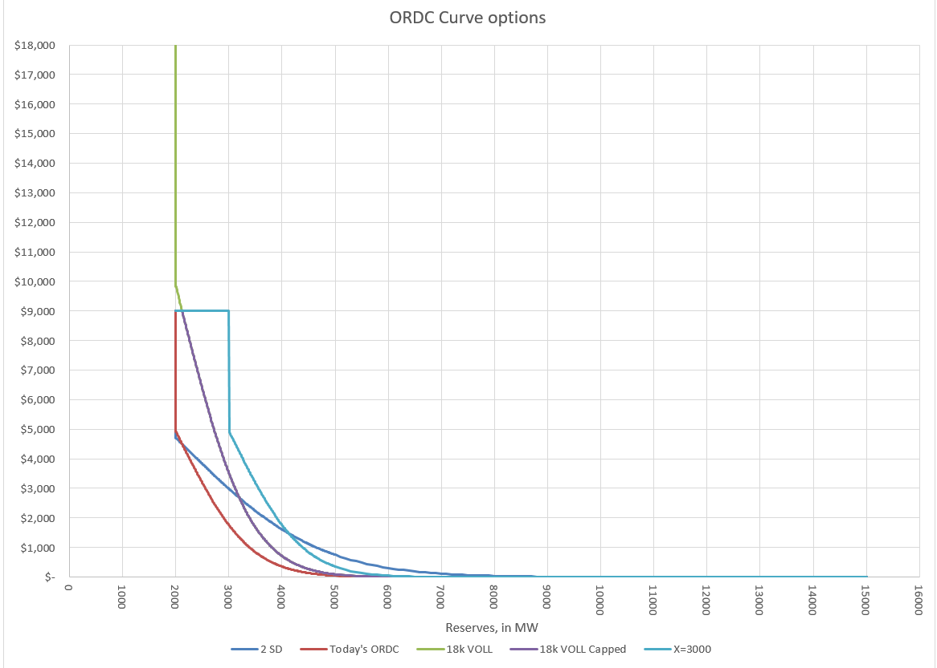
Figure 1, ORDC Options – Examples only

- Introduction
The Supply Analysis Working Group (SAWG) was asked by the Wholesale Market Subcommittee (WMS) to review and consider whether there is a need for minor adjustments to ORDC per the 10-7-2015 memo filed by Commissioner Anderson. The SAWG should deliver a preliminary outline of work product to December WMS meeting with a final work product no later than February WMS meeting.
This paper’s purpose is to be that work product and to inform discussion on the topic. Its contents are an aggregation of recommendations from ERCOT stakeholders and analysis by ERCOT Staff.
This paper is not intended to address any threshold issues such as what an appropriate reserve margin is for the ERCOT region or how it should be attained.

CURRENT STATUS –
11/16/15, this is modified to reflect discussion at 11/13/15 SAWG meeting and amended to include specific possible adjustments.
11/12/15, this is purely a draft strawman outline.
- Proposals from Stakeholders
This section serves as a summary for different options.
- Do not make any changes
- Calpine: Modify X to change hourly equal to RRS plus Regulation Up Service procured each hour, assuming RRS procurement is floored at 2,750MW
- GDF Suez: Modify X to change each interval, multiplied by the current load divided by Average Load, increase the standard deviation by an undetermined amount, increase VOLL to $18,000 while limiting adder plus system lambda to $9,000; i.e. institute an effective price cap at $9,000.
- Etc.
- Etc.
- Etc.

INSERT ERCOT ANALYSIS

- The Back Cast Tool
To aid in this analysis, ERCOT developed a tool reminiscent the 2011-12 back casts for the original ORDC discussion. The tool is flexible enough to handle different combinations of these changes including behavioral changes. The latest version of the tool is available at the 11/13/2015 SAWG meeting page.
Understanding where back casts excel and where they have difficulty is important, especially when considering policy changes.
Pros:
- Relatively easy to produce.
- Familiar to analysists and decision makers, used for previous ORDC analysis.
- Better suited to gauge relative differences in options.
Cons:
- Magnitude of impact due to a modeled change can be misleading.
- Behavioral changes from resources are difficult to model, and when those changes lead to additional commitment the model will generally overestimate the effect of ORDC changes. ERCOT has supplied some ability to modify behavior in the tool but currently it can only anticipate changes interval by interval so temporal considerations are ignored.

- Level of X
From the memo: “The level of X used in the ORDC formula, which is 2,000 MW of operating reserves, selected to represent a level below which ERCOT operators cease relying on the market and begin to take out-of-market actions”
Discussion: X is also called the Minimum Contingency Level (MCL), and it is the level of ORDC Online Reserves which will trigger a price at VOLL (currently $9,000). It is important to remember that the Online Reserves is typically more than the Physical Responsive Capability (PRC) reserves, (see Chapter VII).
Alternatives:
- X=2000 – Current level. (Potomac Economics – Independent Market Monitor) The rationale for retaining X=2000 is:
  - There is not clarity in what needs to be fixed or what goal is to be achieved by adjustment
- X=Regup + RRS (Calpine) - The rationale is:
  - Would continuously keep ERCOT in compliance with NERC BAL-003-1
  - From practical standpoint would ensure ERCOT could recover frequency from a loss of 2,750 MW
- X= Regup + RRS with RRS floor of 2750 (Crescent Power) - The rationale is:
  - Provides appropriate prices signals during scarcity triggered by EEA
  - Makes ORDC consistent with Demand curves in Real-Time Co-Optimization
- X= 2000 with a multiplier of RT Load/average Load (GDF Suez) The rationale is:
  - Ties the X value to the level of unloaded capacity in the Market
- X= Reduced value when used in conjunction with other changes
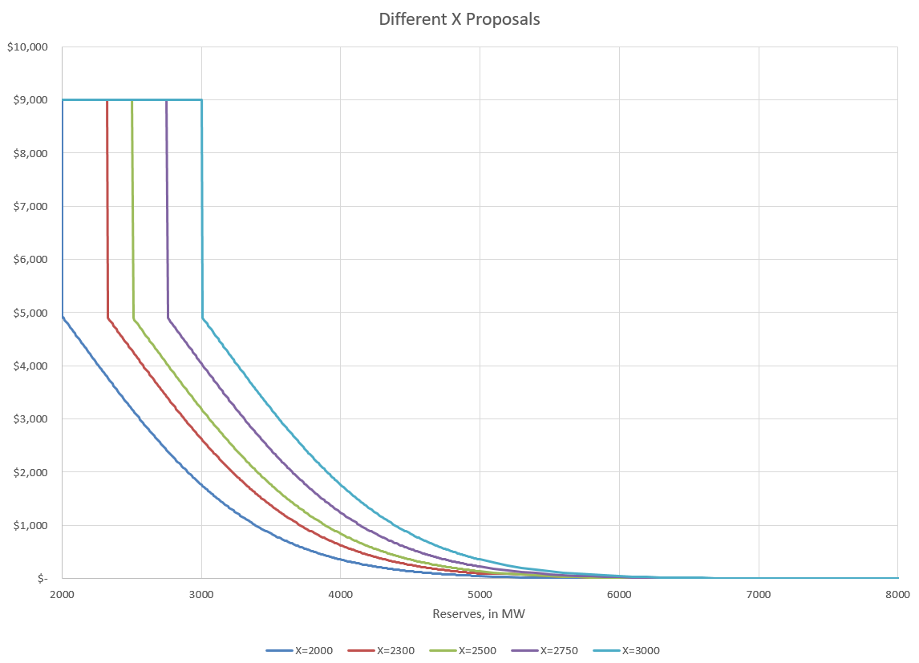
Figure 3, X Options

Conclusion: As you can see in the figure above, the higher X merely shifts the curve to the right.

- Standard Deviation of the LOLP
From the memo: “The number of standard deviations used to formulate of the loss of load probability curve in the ORDC.”
Discussion: The LOLP is determined by analyzing historic events defined as the difference between the hour-ahead forecasted reserves with the reserves that were available in Real-Time during the Operating Hour. Currently we use one Standard Deviation when calculating the LOLP.
Alternatives:
- Use One Standard Deviation (SD) – Current practice The rationale for retaining the current value is:
- There is not clarity in what needs to be fixed or what goal is to be achieved by adjustment
- Increase SD – The rationale is:
- Shifts the slope of the curve to make it more gradual of a change between reserve levels (GDF Suez).
- A value higher than one SD may be appropriate to better capture the risk on some winter mornings where RUC has been necessary (Further analysis may be necessary) (Luminant).

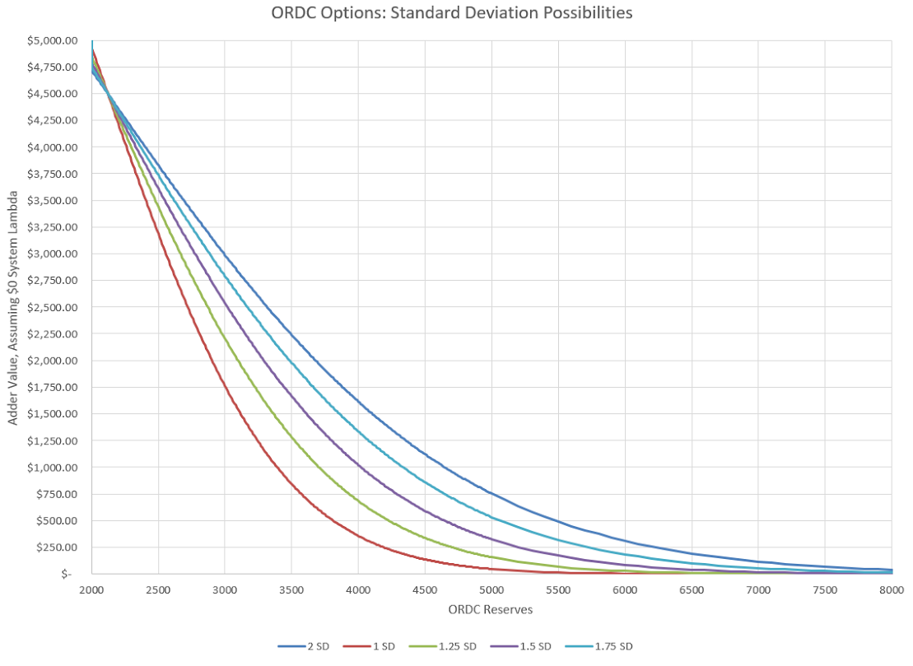
Figure 4, Effect of increasing the Standard Deviation used in LOLP

Conclusion: As you can see in the figure above, adding standard deviations “flattens” the curve and extends the duration of a meaningful adder.

- VOLL
From the memo: “The value of lost load (VOLL) used in the ORDC, which currently is $9,000 MWh (and whether $9,000 MWh should remain as the effective price cap even if the VOLL is increased)”
Discussion: A significant issue is the consideration of the “effective price cap”. Currently VOLL is the effective price cap, not the System Wide Offer Cap (SWOC), so if VOLL > SWOC the energy price could exceed SWOC even in intervals without congestion.
Alternatives:
  - VOLL = $9,000. Current value,
  - as there is not clarity in what needs to be fixed or what goal is to be achieved by adjustment.

- VOLL = $18,000, but the effective price cap remains at $9,000 (GDF Suez).
  - Shifts the slope of the curve resulting in a more gradual change between reserve levels
  - Places a higher value on real-time operating reserves during periods of increased system risk

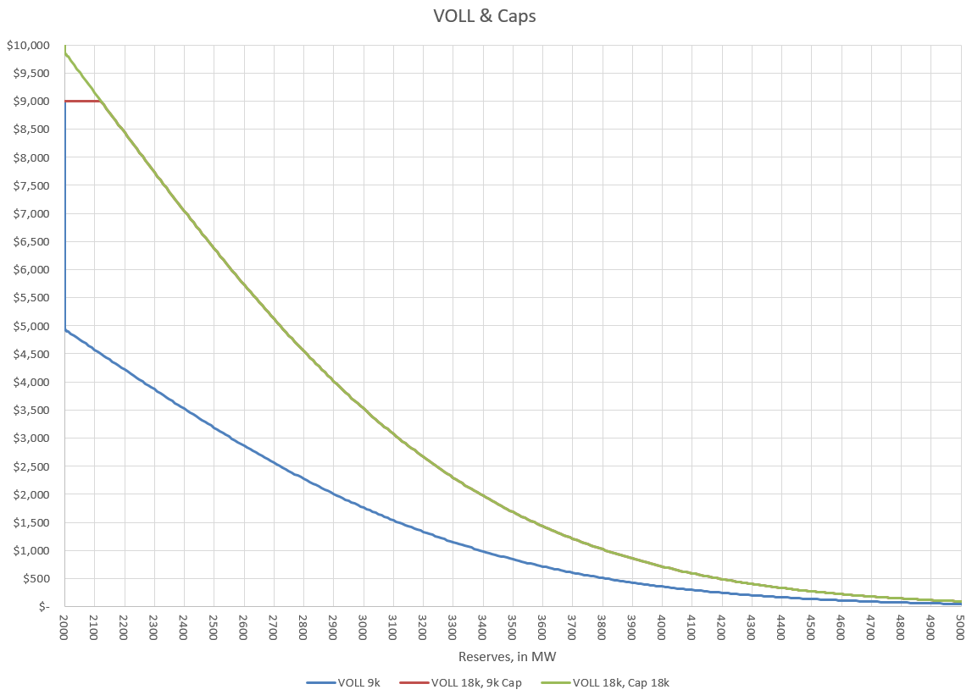
Figure 5, VOLL at 9 & 18k, with and without 9k cap. Note, the 18k capped curve does go to 18k but the chart is truncated at 10k for ease of viewing.
Conclusion: In the figure above we see that an increase in VOLL would be a straight forward increase to the ORDC adder (RTORPA) but the cap question is an important one. It’s also important to note that the only time the “effective price cap” issue matters is when reserves are near the minimum contingency level.

- PRC vs Online Operating Reserves
From the memo: “Should operating reserves counted in ORDC become more closely correlated to PRC, and if so, how?”
Discussion: The PRC, which ERCOT uses to determine if it’s in an Energy Emergency Alert (EEA), is a more conservative value than the Operating Reserves calculation due to the requirement that PRC only count frequency responsive resource capacity. ERCOT presented an analysis located here at the 10-29-15 TAC. ERCOT and stakeholders have identified a few options.
Possible solutions:
- When Non-Spin Reserve Service (NSRS) is deployed, require all NSRS to be physically online - increases PRC so less likely EEA, also could decrease system lambda and the ORDC adder; QSGRs providing NSRS are required to be physically online at a particular PRC level – may be in economic order(after offline NSRS is deployed at 2500 MW)
  - Manual deployment is out of market action
  - Is deploying a reliability product procured to provide more capacity online when PRC drops below 2500?
  - Bringing on capacity could depress prices – could consider 0-LSL in NPRR626 pricing run
- Increase Responsive Reserve Service (RRS) Procurement by putting a min RRS level above 2300 MW with a buffer
  - Market based solution
  - Would be procuring RRS more than what is needed per ERCOT’s reliability analysis for Frequency Response Obligation (FRO)
- Require all NSRS to be offline and to be brought online upon ERCOT deployment
  - Removes the ability for small fleet to provide NSRS
  - Reduces competition in NSRS market by reducing the supply stack
  - Will help converge ORDC to PRC if offline NSRS is required to be physically online at PRC=2300 MW
  - Aggravates price reversal issues
  - No additional service is provided if the behavior is otherwise the same
- Allow operator to use more discretion in calling EEA – Modification to NPRR708. 11/13/15
- SAWG consensus on not recommending any more discretion in calling EEA than what is stated in NPRR708
- Increase
- ORDC parameters to create economic incentive for resources to be online.

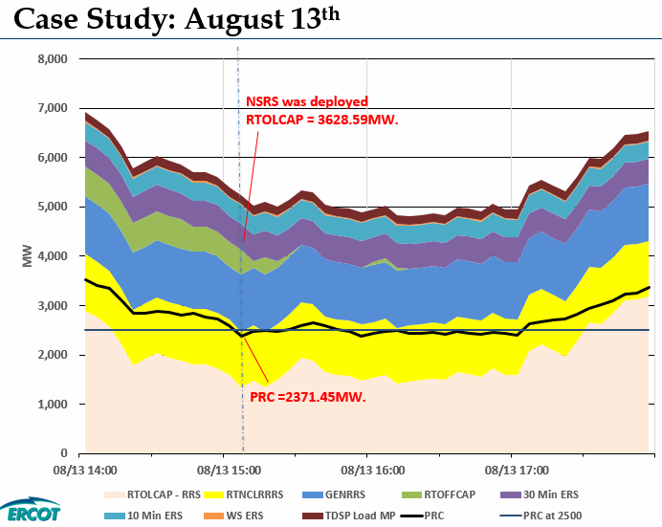
Figure 6, Low PRC from ERCOT analysis presented to 10-29-15 TAC.

- Other inputs to LOLP
From the memo: “Are the current inputs used to calculate the loss of load probability (LOLP) for any given period a sufficiently reasonable approximation or should the method and inputs be reevaluated? I ask this question because at certain hours of certain days last summer the price adder resulting from the ORDC seemed to suggest LOLP of well under 1% even though ERCOT was considering making conservation appeals.”
Discussion:
Alternatives to LOLP cannot be considered in a vacuum. Alternatives would necessitate a review of recommendations/options to the above and below questions.
  - Does the error distribution used for the LOLP calculation need to be re-examined?
  - Is the error distribution capturing risk appropriately?
  - Should the timing of conservation appeals be re-evaluated?
Recommendations: ?
- Other Suggestions
  - Stakeholders have suggested these other considerations:

1. Modify ORDC calculation where price over adder + system lambda approaches offer cap when PRC less than 2,500 and is at offer cap when PRC is less than 2,300.
2. Has the de-facto Non-Spin floor created a cap on energy prices?
Should Non-Spin offer floors be increased?
3. LCAP/HCAP -
Drop the HCAP as a pressure release (Should the pressure release valve remain or be applied to another value such as VOLL)?
4. Allowance of time for stabilization? Maintain status-quo?

- Moving Forward

Ask ERCOT to insert analysis with recommendations section.
Include yet to be suggested recommendations, ensuring all stakeholder recommendations are captured.
Consider how to include dissenting opinions.
Decide what to do with the “other suggestions”.
Determine whether to sever the PRC/ORDC section.
Consider Enhancing the Recommendations section and moving the discussion on each memo point to an appendix.
Set additional meeting dates.

Meetings where discussions possible through the end of 2015:
10-29-15 Technical Advisory Committee (TAC)
11-4-15 Wholesale Market Subcommittee (WMS)
11-11-15 Supply Analysis Working Group (SAWG)
11-13-15 Supply Analysis Working Group (SAWG)
11-19-15 TAC
12-2-15 WMS
12-17-15 TAC

Methodology for Implementing Operating Reserve Demand Curve

