October 2015 ERCOT Monthly Operations Report

Reliability and Operations Subcommittee Meeting
December 3rd, 2015

Table of Contents
1 Report Highlights 3
2 Frequency Control 4
2.1 Frequency Events 4
2.2 Responsive Reserve Events 5
2.3 Load Resource Events 5
3 Reliability Unit Commitment 5
4 Wind Generation as a Percent of Load 7
5 Congestion Analysis 7
5.1 Notable Constraints for October 7
5.2 Generic Transmission Constraint Congestion 9
5.3 Manual Overrides for October 9
5.4 Congestion Costs for Calendar Year 2015 9
6 System Events 10
6.1 ERCOT Peak Load 10
6.2 Load Shed Events 10
6.3 Stability Events 10
6.4 Notable PMU Events 10
6.5 TRE/DOE Reportable Events 11
6.6 New/Updated Constraint Management Plans 11
6.7 New/Modified/Removed SPS 11
6.8 New Procedures/Forms/Operating Bulletins 11
7 Emergency Conditions 11
7.1 OCNs 11
7.2 Advisories 11
7.3 Watches 11
7.4 Emergency Notices 11
8 Application Performance 11
8.1 TSAT/VSAT Performance Issues 11
8.2 Communication Issues 12
8.3 Market System Issues 12
9 Net-Forecast Bias Applied to NSRS Procurement for October 2015 12
Appendix A: Real-Time Constraints 12

Report Highlights
- The unofficial ERCOT peak for October was 59,193 MW.
- There were six frequency events in October. PMU data indicates the ERCOT system transitioned well in each case.
- There were four instances where Responsive Reserves were deployed, all of which were the result of frequency events.
- There were seventeen RUC commitments in October. Seven in the Northern region, seven in the Southern region and three in the Coastal region. All were due to local congestion.
- The level of reportable SCED congestion decreased in October. This congestion was due primarily to planned outages and area load/gen patterns. There were thirteen days of activity on the Generic Transmission Constraints (GTCs) in October. This included one day of activity on the Laredo GTC, nine on the Zorillo – Ajo GTC and three on the Valley Import GTC.
- There were no significant system events for the month of October.
- ERCOT Applications performed well throughout the month. There were no ERCOT related application performance issues.

Frequency Control

Frequency Events

The ERCOT Interconnection experienced six frequency events in October, all of which resulted from Resource trips. The average event duration was approximately 0:04:42.

When analyzing frequency events, ERCOT evaluates PMU data according to industry standards. Events with an oscillating frequency of less than 1 Hz are considered to be inter-area, while higher frequencies indicate local events. Industry standards specify that damping ratio for inter-area oscillations should be 3.0% or greater. All events listed below indicate the ERCOT system met these standards and transitioned well after each disturbance.

Reported frequency events will include both frequency events where frequency was outside the range of 60±0.1 Hz as well as those determined to be Frequency Measurable Events (FME) as defined by BAL-001-TRE-1. Delta Frequency is defined as the difference between the pre-perturbation and post-perturbation frequency. The Duration of Event is defined as the time it takes for the frequency to recover to lesser/greater of the frequency at the time of the frequency event (t(0) or “A-point”) for low/high-frequency events, respectively. Further details on FMEs can be found in the MIS posted BAL-001-TRE-1 PDCWG Unit Performance reports. A summary of the frequency events is provided below:

Date and Time | Delta Frequency | Max/Min Frequency | Duration of Event | PMU Data |  | Comments
 | (Hz) | (Hz) |  | Oscillation Mode (Hz) | Damping Ratio
10/2/2015 16:11 | 0.028 | 59.91 | 0:03:33 | PMU Data Not Available. |  | Unit Trip of 358 MW
10/3/2015 10:00 | 0.078 | 59.90 | 0:06:37 | PMU Data Not Available. |  | Unit Trip of 494 MW
10/23/2015 5:31 | 0.107 | 59.82 | 0:05:33 | 0.72 | 9% | Unit Trip of 834 MW
10/23/2015 6:05 | 0.068 | 59.79 | 0:03:56 | 0.73 | 11% | Unit Trip of 830 MW
10/24/2015 10:43 | 0.038 | 59.92 | 0:02:31 | PMU Data Not Available. |  | Unit Trip of 306 MW
10/27/2015 15:47 | 0.115 | 59.85 | 0:06:04 | PMU Data Not Available. |  | Unit Trip of 680 MW
(Note: frequency events highlighted in blue have been identified as FMEs per BAL-001-TRE-1 and the Performance Disturbance Compliance Working group.)

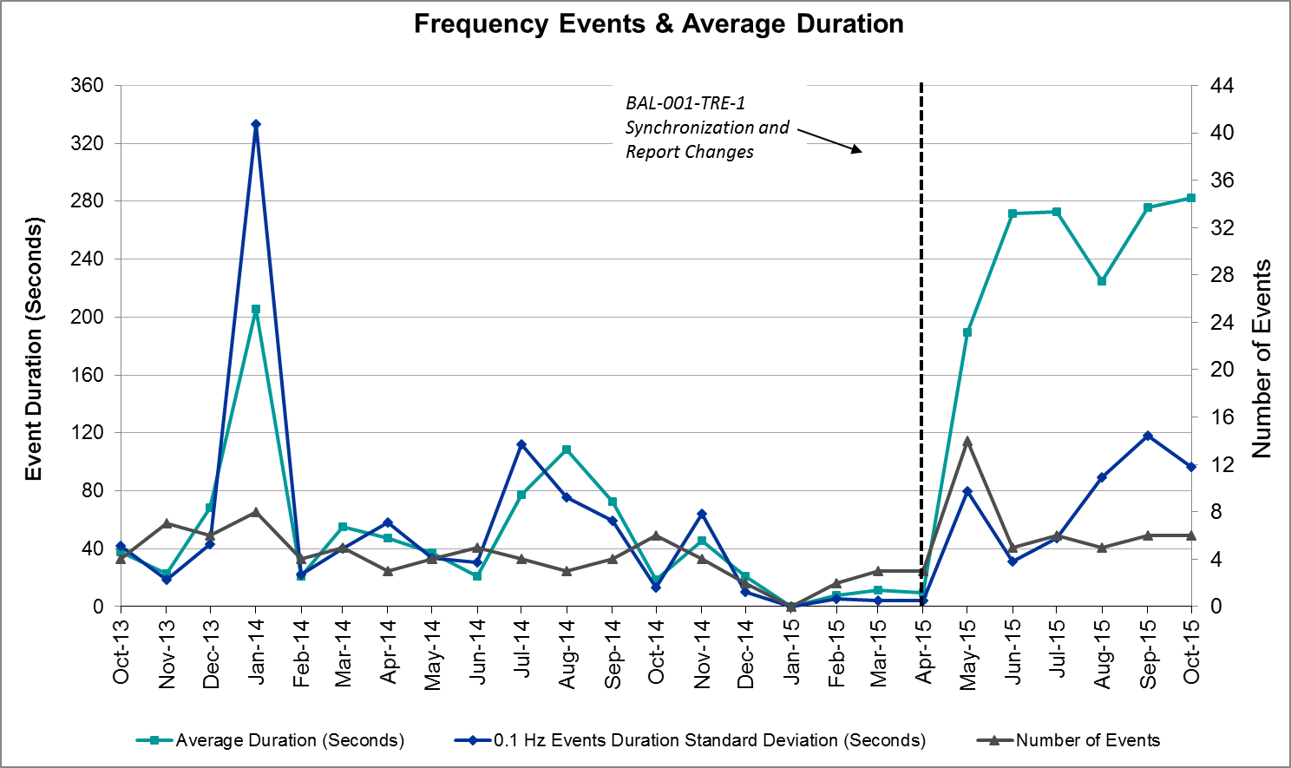

Responsive Reserve Events

There were four events where Responsive Reserve MWs were released to SCED in October. The events highlighted in blue were related to frequency events reported in Section 2.1 above.

Date and Time Released to SCED | Date and Time Recalled | Duration of Event | Maximum MWs Released | Comments
10/2/2015 16:11:26 | 10/2/2015 16:14 | 00:02:56 | 121
10/23/2015 5:31:36 | 10/23/2015 5:35 | 00:04:08 | 520
10/23/2015 6:05:22 | 10/23/2015 6:09 | 00:03:40 | 881
10/27/2015 15:47:21 | 10/27/2015 15:51 | 00:04:24 | 538

Load Resource Events
There were no load resource deployment events in October.

Reliability Unit Commitment
ERCOT reports on Reliability Unit Commitments (RUC) on a monthly basis. Commitments are reported grouped by operating day and weather zone. The total number of hours committed is the sum of the hours for all the units in the specified region. Additional information on RUC commitments can be found on the MIS secure site at Grid Generation Reliability Unit Commitment.

There were no DRUC commitments in October.

Resource Location | # of Resources | Operating Day | Total # of Hours Committed | Total MWhs | Reason for commitment
Southern | 1 | 10/2/2015 | 6 | 1,821 | Local Congestion
Northern | 1 | 10/7/2015 | 1 | 118 | Local Congestion
Southern | 1 | 10/12/2015 | 11 | 547 | Local Congestion
Southern | 1 | 10/13/2015 | 14 | 720 | Local Congestion
Southern | 1 | 10/13/2015 | 14 | 5,834 | Local Congestion
Northern | 1 | 10/142015 | 3 | 1,704 | Local Congestion
Northern | 1 | 10/15/2015 | 18 | 10,224 | Local Congestion
Northern | 1 | 10/21/2015 | 7 | 1,681 | Local Congestion
Northern | 1 | 10/23/2015 | 8 | 1,846 | Local Congestion
Northern | 1 | 10/25/2015 | 1 | 628 | Local Congestion
Northern | 1 | 10/26/2015 | 6 | 3,782 | Local Congestion
Coast | 1 | 10/27/2015 | 12 | 6,540 | Local Congestion
Southern | 1 | 10/28/2015 | 18 | 897 | Local Congestion
Southern | 1 | 10/28/2015 | 3 | 125 | Local Congestion
Southern | 1 | 10/29/2015 | 15 | 809 | Local Congestion
Coast | 1 | 10/29/2015 | 12 | 3,259 | Local Congestion
Coast | 1 | 10/29/2015 | 12 | 3,209 | Local Congestion

Wind Generation as a Percent of Load
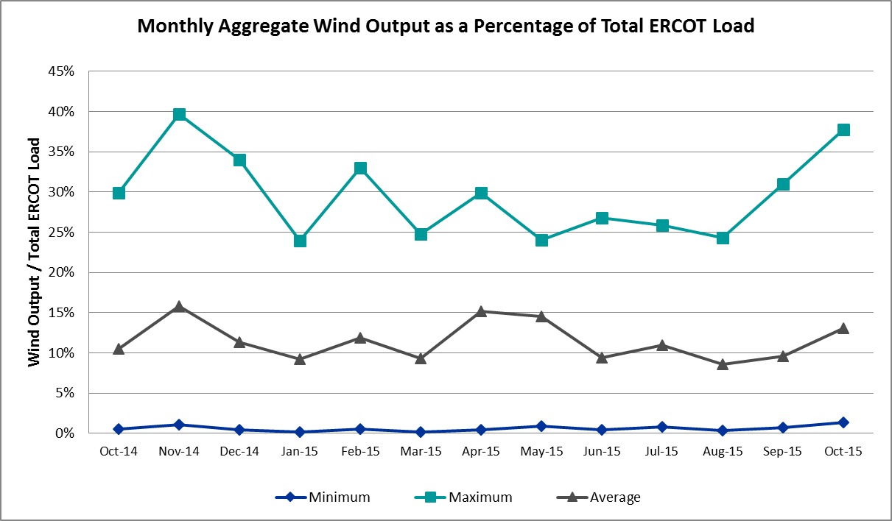

Congestion Analysis
The number of congestion events experienced by the ERCOT system increased in October due to planned outages and area load/gen patterns. There were thirteen days of activity on the Generic Transmission Constraints (GTCs) in October.

Notable Constraints for October

Nodal protocol section 3.20 specifies that ERCOT shall identify transmission constraints that are active or binding three or more times within a calendar month. As part of this process, ERCOT reports congestion that meets this criterion to ROS. In addition ERCOT also highlights notable constraints that have an estimated congestion rent exceeding $1,000,000 for a calendar month. These constraints are detailed in the table below. Rows highlighted in blue indicate the congestion was affected by one or more outages. For a list of all constraints activated in SCED for the month of October, please see Appendix A at the end of this report.

Contingency | Overload | # of Days Constraint Active | Estimated Congestion Rent | Transmission Project
Base case | Valley Import | 3 | $13,810,161
Nacogdoches Se - Mt Enterprise 345 kV | Centerville I45 - Pleasant Springs (Hcec) 138kV | 5 | $1,389,209
Gibbons Creek -Singleton 345 kV | Jewett - Singleton 345kV | 8 | $674,685 | 4298
Base case | Zorillo to Ajo | 11 | $525,418
West Levee Switch Axfmr1h_H 345/138 KV | Industrial Blvd - Compton Street 138kV | 3 | $485,314
Laquinta - Lobo 138 KV | Bruni Sub 138/69kV | 10 | $359,937
Bluff Creek T2_H 345/138 kV | Bluff Creek 345/34.5/138kV | 6 | $350,601
Alazan - Barney Davis 138/138 kV | Rodd Field - Holly 138kV | 3 | $328,854
Marion - Hill Country & Skyline 345 kV | E C Mornhinweg - Parkway Lcra 138kV | 8 | $298,905 | 13TPIT0047
Laredo Vft North - Lobo 138 kV | Bruni Sub 138/69kV | 3 | $217,031
Ferguson – Granite Mountain & Wirtz-Paleface 138 kV | Flat Rock Lcra - Wirtz 138kV | 11 | $177,181 | 4465
Tortuga - Koch Up River 138 KV | Morris Street - Gila 138kV | 11 | $176,374
Ennis Southeast - Ennis 138 KV | Ennis West Switch - Waxahachie 138kV | 3 | $117,816
Roans Prairie - Rothwood & Singleton - Tomball 345 Kv | Singleton - Zenith 345kV | 3 | $112,560 | 4485, 3937, 3950 (a,b)
Mercers Gap Sw to Comanche Switch 138 kV | Camp Bowie (Oncor) - Brownwood Switch 138kV | 6 | $103,220
Mg Industries - Waxahachie North 138 kV | Trumbull 138/69kV | 4 | $64,031 | 2014 RTP Reliability Need
Marion - Zorn 345 kV | Marion - Clear Springs 345kV | 9 | $58,320
Lobo 2_345_138_H 345/138 KV | Freer - San Diego 69kV | 3 | $38,806 | 3903
Marion – Clear Springs & Zorn 345 kvV | Clear Springs 345/13.2/138kV | 5 | $35,701 | 4462
Asphalt Mines - Odlaw Switchyard 138 KV | Hamilton Road - Maverick 138kV | 3 | $28,339 | In 2014 LTSA
Twin Oak Switch –Gibbons Creek & Btu Jack Creek 345 kV | Jewett - Singleton 345kV | 5 | $18,188 | 4485, 3937, 3950 (a,b)
Marion –Hill Country & Skyline 345 kV | Marion 345/138kV | 3 | $16,940 | 4081
Bosque Switch to Whitney 138 kV | Lake Whitney Tnp - Bosque Switch 138kV | 3 | $6,607

Generic Transmission Constraint Congestion
There was one day of activity on the Laredo GTC, nine days of activity on the Zorillo – Ajo GTC and three days of activity on the Valley Import GTC in October. There was no activity on the remaining GTCs during the Month of October.

Manual Overrides for October
There were no manual overrides for the month of October 2015

Congestion Costs for Calendar Year 2015
The following table represents the top twenty active constraints for the calendar year based on the estimated congestion rent attributed to the congestion. ERCOT updates this list on a monthly basis.

Contingency | Binding Element | # of 5-min SCED Intervals | Estimated Congestion Rent | Transmission Project
Roans Prairie - Rothwood & Singleton - Tomball 345 kV | Singleton - Zenith 345kV | 2798 | $25,034,946 | 4485, 3937, 3950 (a,b)
Base case | Valley Import | 199 | $15,591,256
San Angelo North 138_69t1 138/69 kV | San Angelo College Hills 138/69kV | 1100 | $12,124,531
Los Fresnos - Loma Alta Substation 138 kV | La Palma - Villa Cavazos 138kV | 1079 | $10,680,014 | 4490
Flewellen – Obrien & Mason Road 138 kV | Betka - Hockley 138kV | 667 | $9,396,616
Collin Switch 345 kV - Collin Ses 138 kV | Collin Ses - Collin Switch 345 Kv 138kV | 235 | $9,098,021
Topeka Termination to West Levee Switch 345/345 KV | Cedar Hill Switch - Mountain Creek Ses 138kV | 276 | $7,327,162 | 13TPIT0060
Hill Country – Marion & Elmcreek 345 kV | Skyline - Marion 345kV | 1328 | $7,321,029 | 4081
Jewett - Singleton 345 kV | Btu_Jack_Creek - Twin Oak Switch 345kV | 4898 | $7,318,336
San Angelo College Hills 138_69t1 138/69 kV | San Angelo Power Station 138/69kV | 1456 | $7,141,012
North Alvin Tnp to Meadow 138 KV | Southshore Tnp - Ph Robinson 138kV | 187 | $6,531,939
Lost Pines Lcra – Austrop & Aen Dunlap 345 kV | Fayette Plant 1 - Fayette Plant 2 345kV | 2975 | $6,416,648
Hutto Switch Axfmr1h (3)345/138 KV | Pflugerville - Gilleland 138kV | 565 | $4,639,067 | 16TPIT0062
Bevo Substation - Asherton 138 kV | Hamilton Road - Maverick 138kV | 320 | $4,635,315
Orange Grove Switching Station - Lon Hill 138 kV | Lon Hill - Smith 69kV | 4186 | $4,156,156 | 16TPIT0026
Rio Hondo 345_138_1l 345/138 KV | Aderhold Sub - Elsa 138kV | 121 | $4,047,071
Falcon Seaboard - Midland East 345 kV | Glenhaven - Odessa 138kV | 70 | $3,753,436
Base case | North to Houston (Houston Import) | 92 | $3,656,328 | 4485, 3937, 3950 (a,b)
Calaveras – Hotwells & Laredo1 138 kV | Calaveras - Streich 138kV | 738 | $3,654,243
Falcon Seaboard to Morgan Creek Ses 345 kV | Crmwd 8 Tap - Glenhaven 138kV | 65 | $3,638,593

System Events

ERCOT Peak Load
The unofficial ERCOT peak load for the month was 59,153 MW and occurred on October 12th during hour ending 17:00.

This demand value was a record peak for ERCOT.

Load Shed Events
None.

Stability Events
None.

Notable PMU Events
ERCOT analyzes PMU data for any significant system disturbances that do not fall into the Frequency Events category reported in section 2.1. The results are summarized in this section once the analysis has been completed.

There were no reportable events in October.

TRE/DOE Reportable Events
10/13/15 - ERCOT issued a Media Appeal for energy conservation as a precautionary measure due to a potential Rio Grande Valley Import limit exceedance.

New/Updated Constraint Management Plans
None.

New/Modified/Removed SPS
None.

New Procedures/Forms/Operating Bulletins
None.

Emergency Conditions

OCNs
Date and Time | Description
10/23/15 06:14 | ERCOT issued an OCN due to a projected Reserve Capacity Insufficiency.
10/23/15 14:27 | ERCOT issued an OCN due to a significant rain event affecting the ERCOT region.

Advisories
Date and Time | Description
10/7/15 14:43 | ERCOT issued an Advisory due to a geomagnetic disturbance of K-7.

Watches
None.

Emergency Notices
Date and Time | Description
10/13/15 10:25 | ERCOT issued a Transmission Emergency Notice due to a potential Rio Grande Valley Import limit exceedance.
10/28/15 14:18 | ERCOT issued a Transmission Emergency Notice due to a potential Rio Grande Valley Import limit exceedance.

Application Performance
ERCOT system applications performed well in October. There were no issues to report.

TSAT/VSAT Performance Issues
None.

Communication Issues
None.

Market System Issues
None.

Net-Forecast Bias Applied to NSRS Procurement for November 2015
Each month, ERCOT calculates a net Forecast Bias pursuant to the ERCOT Ancillary Services Methodology for procurement of Non-Spinning Reserve Service (NSRS). The table below indicates the amount of net Forecast Bias that was applied to the NSRS procurement for specified blocks of time for the month of November 2015.

Blocks | Negative Net Load Forecast Average Error - By Weather Zone for the 5 Largest Zones
 | Coast | East | North Central | South Central | Southern
1-2 | -28 | -5 | -33 | -17 | -8
3-6 | 0 | 0 | 0 | 0 | 0
7-10 | 0 | 0 | 0 | 0 | 0
11-14 | 0 | 0 | 0 | 0 | 0
15-18 | -8 | -1 | -10 | -5 | -3
19-22 | 0 | 0 | 0 | 0 | 0
23-24 | -28 | -5 | -33 | -17 | -8

Appendix A: Real-Time Constraints
The following is a complete list of constraints activated in SCED for the month of October. Full contingency descriptions can be found in the Standard Contingencies List located on the MIS secure site at Grid Generation Reliability Unit Commitment.

Contingency | Constrained Element | From Station | To Station | # of Days Constraint Active
BASE CASE | VALIMP |  |  | 3
SNCDTRS5 | 1230__D | CNI45 | PLSSP | 5
DFRAPAR8 | G0_L2_1 | G0 | L2 | 1
DGIBSNG5 | 260_A_1 | JEWET | SNG | 8
DGIBSNG5 | 240__A | JEWET | SNG | 2
BASE CASE | ZO_AJO |  |  | 11
XWI2N89 | WINKS_FMR1 | WINKS | WINKS | 2
XWL2V58 | 3130__B | INDST | CMPST | 3
DLONWAR5 | LONHILL_PAWNEE_1 | PAWNEE | LON_HILL | 1
SWCOW2C8 | G138_18_1 | WCOLMAIN | WCOLLOCL | 2
BASE CASE | LAREDO |  |  | 1
SELMTH25 | WHTNY_HT1L | WHTNY | WHTNY | 2
SLAQLOB8 | BRUNI_69_1 | BRUNI | BRUNI | 10
XBL2U58 | BLUF_CRK_T1_H | BLUF_CRK | BLUF_CRK | 6
XEMS58 | EMSES_AX2H | EMSES | EMSES | 1
SALAN_28 | HOLLY4_RODD_F1_1 | RODD_FLD | HOLLY4 | 3
DMARSKY5 | 581T581_1 | ECMORN | PARKWA | 8
SLARLO28 | BRUNI_69_1 | BRUNI | BRUNI | 3
STELMCN8 | 6465__C | MDLNE | MDDTN | 3
DFL_MAR8 | BETHK_66_A | HK | BET | 1
DFPPFAY5 | 192T175_1 | SMITHV | WINCHE | 2
DEMSHCK5 | 6110__A | BNBSW | CMTSW | 1
DFERPAL8 | 38T365_1 | WIRTZ | FLATRO | 11
SKOCNU28 | GILA_MORRIS1_1 | GILA | MORRIS | 11
SPLKMCS8 | 3160__A | CDCSW | OKCLS | 1
SVLSANA5 | 404__A | VLYSO | FMRVL | 2
SGARROM8 | GARZA_69A1 | GARZA | GARZA | 1
SENSENW8 | 940__C | ENWSW | WXHCH | 3
DRNS_TB5 | SNGZEN99_A | SNG | ZEN | 3
SKLELOY8 | LOYOLA_69_1 | LOYOLA | LOYOLA | 2
SLULLOC8 | 124T157_1 | LOCKHA | MAGNME | 1
SZEPCMN8 | 670__B | BRNSW | CMPBW | 6
SCOLLON5 | VICTO_WARBU_1A_1 | VICTORIA | WARBURTN | 1
XNCD58 | 1230__D | CNI45 | PLSSP | 1
SSANELM5 | SANMIGL_ATBL | SANMIGL | SANMIGL | 1
SHRSREN8 | 755__D | RENSW | NPKWY | 1
SENSENS8 | 940__C | ENWSW | WXHCH | 1
DRNS_TB5 | SNGZEN98_A | SNG | ZEN | 1
SMGIENW8 | TRU_UAT1 | TRU | TRU | 4
SMARZOR5 | 419T419_1 | CLEASP | MARION | 9
XLOB58 | SANMIGL_ATAH | SANMIGL | SANMIGL | 3
SLOCMEN8 | 101T158_1 | ZORN | POOLRO | 1
XLOB58 | FREER_SAN_DI1_1 | SAN_DIEG | FREER | 3
DMARZOR5 | CLEASP_AT2H | CLEASP | CLEASP | 5
XWFA89 | 6945__A | LKWSW | WFALS | 1
SBIGDIL8 | BAT_CRST_1 | BATESVL | CRSTLSW | 1
SZEPCMN8 | 670__C | CMPBW | BRNSO | 1
SCRNLC38 | 6465__C | MDLNE | MDDTN | 2
SCHABSP9 | SACH_SAGT1_1 | SACH | SAGT | 1
SBRAUVA8 | HAMILT_MAVERI1_1 | HAMILTON | MAVERICK | 3
DJEWSNG5 | JK_TOKSW_1 | TOKSW | JK_CK | 1
SPAWLON5 | KENEDS_KENEDY1_1 | KENEDSW | KENEDY | 1
DSTPWHI5 | COLETO_KENEDS1_1 | COLETO | KENEDSW | 1
SBRAUVA8 | EAGLHY_ESCOND1_1 | EAGLHYTP | ESCONDID | 1
DTOKJK_5 | 260_A_1 | JEWET | SNG | 5
DMARSKY5 | MARION_4AT2 | MARION | MARION | 3
SCLNWLC8 | 565__D | PAYSW | SHRTI | 1
DHUTGAB8 | 211T147_1 | GILLCR | MCNEIL_ | 2
XLWS158 | 180001_D_1 | N_DENT | DENARCOC | 1
DFPPFAY5 | AUSTRO_AT1H | AUSTRO | AUSTRO | 1
DCHBJOR5 | CBYCD_84_A | CBY | CD | 2
DDUNLOS5 | AUSTRO_AT1H | AUSTRO | AUSTRO | 2
DCALBEC8 | G0_L2_1 | G0 | L2 | 1
DHILELM5 | MAR_SKY_1 | MARION | SKYLINE | 2
DMARPA_8 | 38T365_1 | WIRTZ | FLATRO | 2
SBOSWHT8 | OLKW_BOS_1 | BOSQUESW | LKWHITNY | 3
SCOLBAL8 | BALG_HUMBLT1_1 | BALG | HUMBLTAP | 1
SLOBSAN5 | BESSEL_LON_HI1_1 | LON_HILL | BESSEL | 1
SLOBSAN5 | FREER_SAN_DI1_1 | SAN_DIEG | FREER | 1
XPAW58 | COLETO_KENEDS1_1 | COLETO | KENEDSW | 1
DLONOR58 | KINGSV_KLEBER1_1 | KLEBERG | KINGSVIL | 2
SAJORI25 | CELANE_KLEBER1_1 | CELANEBI | KLEBERG | 1
SBOSELM5 | WHTNY_HT1L | WHTNY | WHTNY | 1
SLOBSAN5 | DILLEY_JARDIN1_1 | DILLEYSW | JARDIN | 1
SSPUASP8 | ROTN_WOLFGA1_1 | WOLFGANG | ROTN | 1
DCLEZOR5 | 87T233_1 | MCCALA | HENNE | 1
SSCUSUN8 | ROTN_WOLFGA1_1 | WOLFGANG | ROTN | 3
DTRSTRC5 | 940__C | ENWSW | WXHCH | 1
DCHBJOR5 | BRNLAN86_A | LAN | BRN | 1
DMCSCDC8 | 3405__C | MCSES | TRIRA | 2
SSPUMW18 | ROTN_WOLFGA1_1 | WOLFGANG | ROTN | 2
DCLEZOR5 | 86T235_1 | HENNE | COMAL | 1
DMARZOR5 | 91T335_1 | COMAL | LOP337 | 1
SKOCNU28 | GILA_MORRIS1_1 | MORRIS | GILA | 1
DMARSKY5 | 293T304_1 | CIBOLO | SCHERT | 2
DVLYANA5 | 565__D | PAYSW | SHRTI | 1
SCLEMAR5 | 5T248_1 | ZORN | MARION | 1
SVLSANA5 | 562__D | PAYSW | MEMWT | 1
SHILMAR5 | MAR_SKY_1 | MARION | SKYLINE | 1
DELMTEX5 | PLEASANT_69A1 | PLEASANT | PLEASANT | 1
BASE CASE | SNYDER_WKN_BK1_1 | ENAS | WKN_BKR | 2
SWLALCS8 | 1290__A | LCSES | RBNSN | 1
SCOLPAW5 | COLETO_KENEDS1_1 | COLETO | KENEDSW | 1
DMARZOR5 | CLEASP_AT1 | CLEASP | CLEASP | 1
SCRDLOF9 | POS_SHAN_1 | SHANNON | POSTOKSW | 2
XEMS58 | EMSES_AX2L | EMSES | EMSES | 1
STBSNG5 | SNGZEN99_A | SNG | ZEN | 1

