A Review of ORDC Options
11-12-15

ERCOT Supply Analysis Working Group
Brandon Whittle, Chair

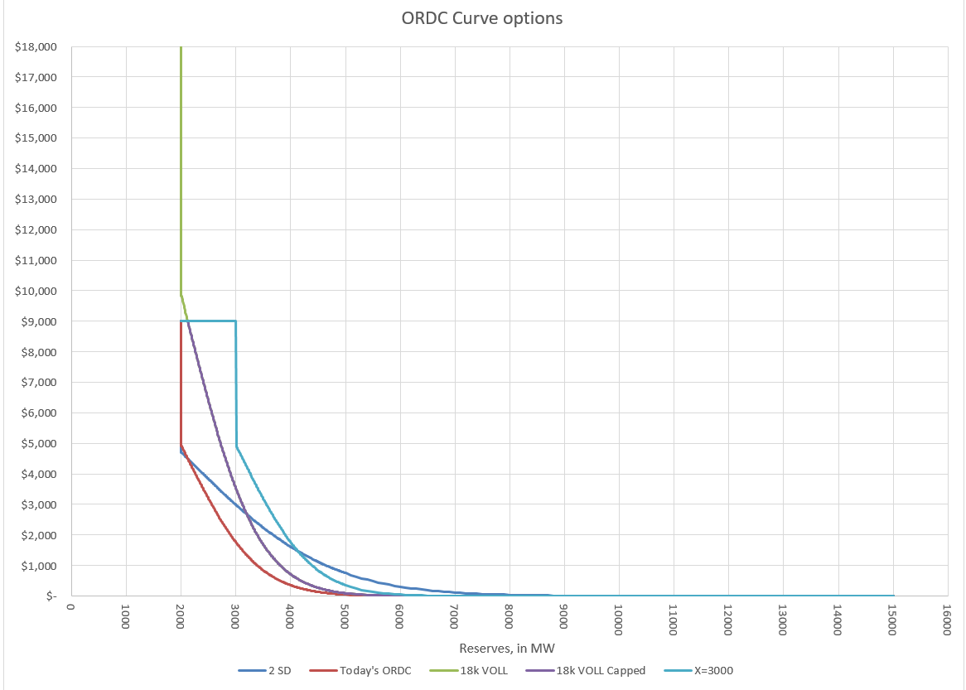
Figure 1, ORDC Options – Examples only

- Introduction
The Supply Analysis Working Group (SAWG) was asked by the Wholesale Market Subcommittee (WMS) to review and develop enhancements to ORDC per the 10-7-2015 memo filed by Commissioner Anderson. The SAWG should deliver a preliminary outline of work product to December WMS meeting with a final work product no later than February WMS meeting.
This paper’s purpose is to be that work product and to inform discussion on the topic. Its contents are an aggregation of recommendations from ERCOT stakeholders and analysis by ERCOT Staff.
This paper is not intended to address any threshold issues such as what an appropriate reserve margin is for the ERCOT region or how it should be attained.

CURRENT STATUS – as of 11/12/15, this is purely a draft strawman outline.
- The Back Cast Tool
To aid in this analysis, ERCOT developed a tool reminiscent the 2011-12 back casts for the original ORDC discussion. The tool is flexible enough to handle different combinations of these changes including behavioral changes. The tool is available at the 11/11/2015 SAWG meeting page.
Understanding where back casts excel and where they have difficulty is important, especially when considering policy changes.
Pros:
- Relatively easy to produce.
- Familiar to analysists and decision makers, used for previous ORDC analysis.
- Better suited to gauge relative differences in options.
Cons:
- Magnitude of impact due to a modeled change can be misleading.
- Behavioral changes from resources are difficult to model, and when those changes lead to additional commitment the model will generally overestimate the effect of ORDC changes. ERCOT has supplied some ability to modify behavior in the tool but currently it can only anticipate changes interval by interval so temporal considerations are ignored.

- Level of X
From the memo: “The level of X used in the ORDC formula, which is 2,000 MW of operating reserves, selected to represent a level below which ERCOT operators cease relying on the market and begin to take out-of-market actions”
Discussion: X is also called the Minimum Contingency Level (MCL), and it is the level of ORDC Online Reserves which will trigger a price at VOLL (currently $9k). It is important to remember that the Online Reserves is typically more than the Physical Responsive Capability (PRC), but more on that later under item V.
Alternatives:
- X=2000 – Current level. The rational for retaining X=2000 is….
- X=???? The rational is …….
- X=????
- X=?
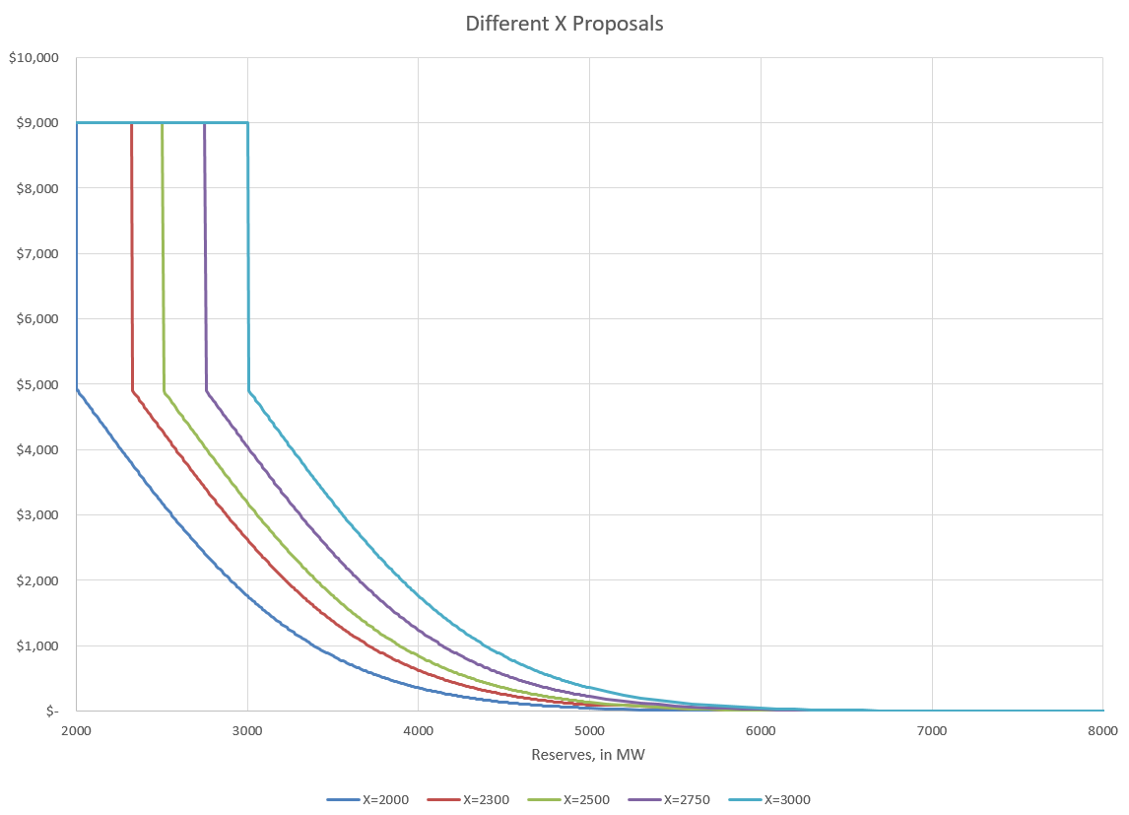
Figure 3, X Options

Conclusion: As you can see in the figure above, the higher X merely shifts the curve to the right.

INSERT ERCOT ANALYSIS

- Standard Deviation of the LOLP
From the memo: “The number of standard deviations used to formulate of the loss of load probability curve in the ORDC.”
Discussion: The LOLP is determined by analyzing historic events defined as the difference between the hour-ahead forecasted reserves with the reserves that were available in Real-Time during the Operating Hour. Currently we use 1 Standard Deviation when calculating the LOLP.
Alternatives:
- Use 1 Standard Deviation – Current practice
- Use y SD because…..
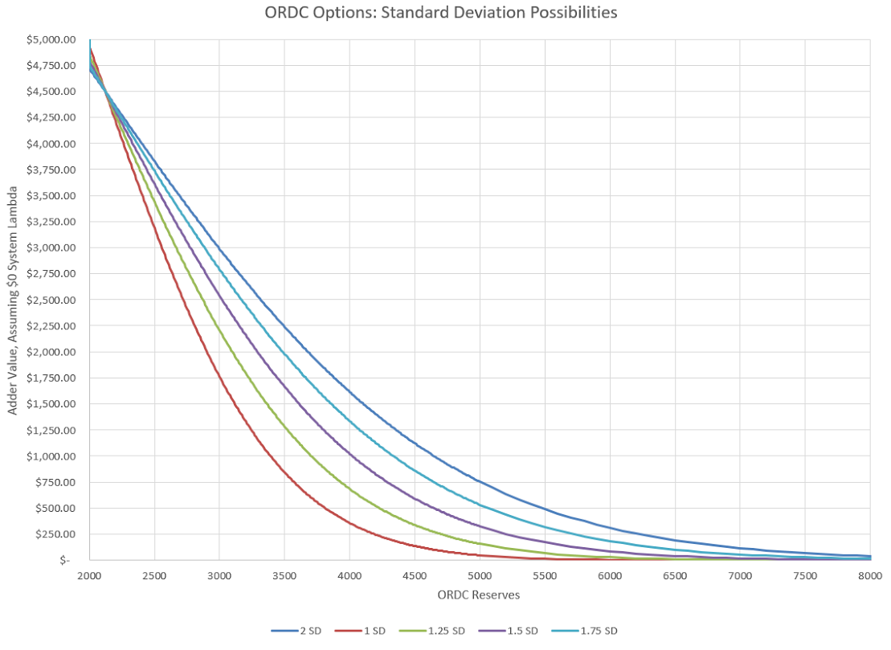
Figure 4, Effect of increasing the Standard Deviation used in LOLP

Conclusion: As you can see in the figure above, adding standard deviations “flattens” the curve and extends the duration of a meaningful adder.
INSERT ERCOT ANALYSIS

- VOLL
From the memo: “The value of lost load (VOLL) used in the ORDC, which currently is $9,000 MWh (and whether $9,000 MWh should remain as the effective price cap even if the VOLL is increased)”
Discussion: A significant issue is the consideration of the “effective price cap”. Currently VOLL is the effective price cap, not the System Wide Offer Cap (SWOC), so if VOLL > SWOC the energy price could exceed SWOC even in intervals without congestion.
Alternatives:
- VOLL = $9,000. Current value
- VOLL = $x based on ….
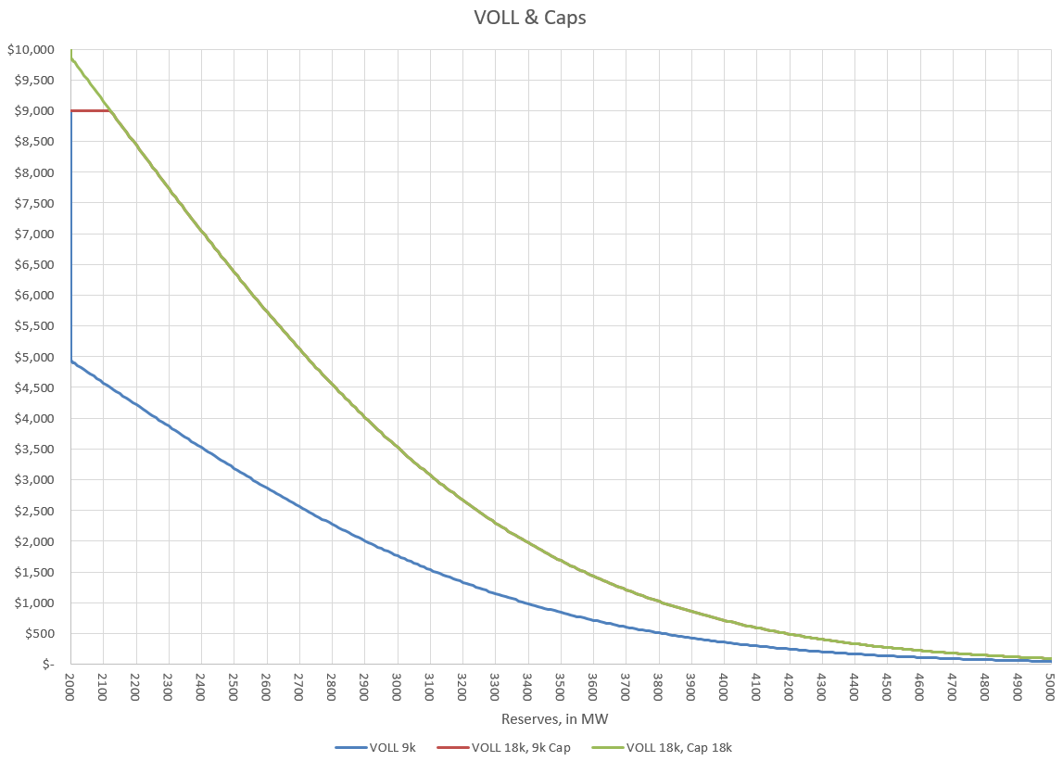
Figure 5, VOLL at 9 & 18k, with and without 9k cap. Note, the 18k capped curve does go to 18k but the chart is truncated at 10k for ease of viewing.
Conclusion: In the figure above we see that an increase in VOLL would be a straight forward increase to the ORDC adder (RTORPA) but the cap question is an important one. It’s also important to note that the only time the “effective price cap” issue matters is when reserves are near the minimum contingency level.
INSERT ERCOT ANALYSIS

- PRC vs Online Operating Reserves
From the memo: “Should operating reserves counted in ORDC become more closely correlated to PRC, and if so, how?”
Discussion: The PRC, which ERCOT uses to determine if it’s in an Emergency (EEA), is a more conservative value than the Operating Reserves calculation due to the requirement that PRC only count frequency responsive resource capacity. ERCOT presented an analysis located here at the 10-29-15 TAC. ERCOT and stakeholders have identified a few options, some of which may tend to reduce prices.
Alternatives:
- When NSRS is deployed, require all NSRS to be online - increases PRC so less likely EEA, also could decrease system lambda and the ORDC adder.
- Allow operator to use more discretion in calling EEA
- Increase RRS Procurement -
- Require all NSRS to be offline and to be online brought online upon ERCOT deployment -

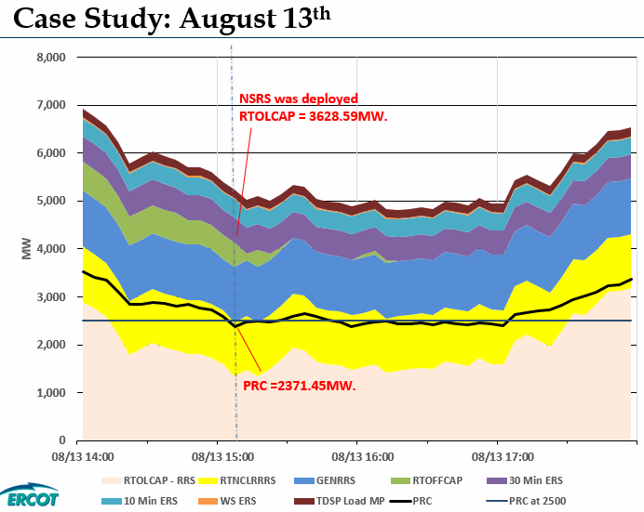
Figure 6, Low PRC from ERCOT analysis presented to 10-29-15 TAC.

INSERT ERCOT ANALYSIS

- Other inputs to LOLP
From the memo: “Are the current inputs used to calculate the loss of load probability (LOLP) for any given period a sufficiently reasonable approximation or should the method and inputs be reevaluated? I ask this question because at certain hours of certain days last summer the price”
Discussion: …..
Alternative LOLP recommendation & rational……..

INSERT ERCOT ANALYSIS

- Proposals from Stakeholders

- Do not make any changes, Supported by abc co, xyz co
- Modify X alone to xxxxx, supported by fgh co.
- Modify X to xxxxx, SD to yyyyy, supported by …
- etc

INSERT ERCOT ANALYSIS

- Moving Forward
Meetings where discussions possible through the end of 2015:
10-29-15 Technical Advisory Committee (TAC)
11-4-15 Wholesale Market Subcommittee (WMS)
11-11-15 Supply Analysis Working Group (SAWG)
11-13-15 Supply Analysis Working Group (SAWG)
11-19-15 TAC
12-2-15 WMS
12-17-15 TAC

Methodology for Implementing Operating Reserve Demand Curve

