September 2015 ERCOT Monthly Operations Report

Reliability and Operations Subcommittee Meeting
November 5th, 2015

Table of Contents
Table of Contents 2
1 Report Highlights 3
2 Frequency Control 4
2.1 Frequency Events 4
2.2 Responsive Reserve Events 5
2.3 Load Resource Events 5
3 Reliability Unit Commitment 6
4 Wind Generation as a Percent of Load 7
5 Congestion Analysis 7
5.1 Notable Constraints for September 7
5.2 Generic Transmission Constraint Congestion 9
5.3 Manual Overrides for September 9
5.4 Congestion Costs for Calendar Year 2015 10
6 System Events 11
6.1 ERCOT Peak Load 11
6.2 Load Shed Events 11
6.3 Stability Events 11
6.4 Notable PMU Events 11
6.5 TRE/DOE Reportable Events 11
6.6 New/Updated Constraint Management Plans 11
6.7 New/Modified/Removed SPS 11
6.8 New Procedures/Forms/Operating Bulletins 11
7 Emergency Conditions 11
7.1 OCNs 11
7.2 Advisories 12
7.3 Watches 12
7.4 Emergency Notices 12
8 Application Performance 12
8.1 TSAT/VSAT Performance Issues 12
8.2 Communication Issues 12
8.3 Market System Issues 12
9 Net-Forecast Bias Applied to NSRS Procurement for October 2015 12
Appendix A: Real-Time Constraints 13

Report Highlights
- The unofficial ERCOT peak for September was 64,465MW.
- There were six frequency events in September. PMU data indicates the ERCOT system transitioned well in each case.
- There were six instances where Responsive Reserves were deployed, all of which were the result of frequency events.
- There were seventeen RUC commitments in September. Seven in the Northern region, eight in the Southern region and two in the Coastal region. All were due to local congestion.
- The level of reportable SCED congestion increased in September. This congestion was due primarily to planned outages and area load/gen patterns. There were fourteen days of activity on the Generic Transmission Constraints (GTCs) in September. This included five days of activity on the Laredo GTC, six on the Zorilla – Ajo GTC and three on the Panhandle GTC.
- There were no significant system events for the month of September.
- ERCOT Applications performed well throughout the month. There were no ERCOT related application performance issues.

Frequency Control

Frequency Events

The ERCOT Interconnection experienced six frequency events in September, all of which resulted from Resource trips. The average event duration was approximately 0:04:36.

When analyzing frequency events, ERCOT evaluates PMU data according to industry standards. Events with an oscillating frequency of less than 1 Hz are considered to be inter-area, while higher frequencies indicate local events. Industry standards specify that damping ratio for inter-area oscillations should be 3.0% or greater. All events listed below indicate the ERCOT system met these standards and transitioned well after each disturbance.

Reported frequency events will include both frequency events where frequency was outside the range of 60±0.1 Hz as well as those determined to be Frequency Measurable Events (FME) as defined by BAL-001-TRE-1. Delta Frequency is defined as the difference between the pre-perturbation and post-perturbation frequency. The Duration of Event is defined as the time it takes for the frequency to recover to lesser/greater of the frequency at the time of the frequency event (t(0) or “A-point”) for low/high-frequency events, respectively. Further details on FMEs can be found in the MIS posted BAL-001-TRE-1 PDCWG Unit Performance reports. A summary of the frequency events is provided below:

Date and Time | Delta Frequency | Max/Min Frequency | Duration of Event | PMU Data |  | Comments
 | (Hz) | (Hz) |  | Oscillation Mode (Hz) | Damping Ratio
9/6/2015 15:22 | 0.056 | 59.91 | 0:06:13 | PMU Data Not Available. |  | Unit Trip of 419 MW
9/10/2015 13:10 | 0.059 | 59.86 | 0:03:41 | 0.71 | 15% | Unit Trip of 514 MW
9/12/2015 13:36 | 0.069 | 59.90 | 0:07:18 | PMU Data Not Available. |  | Unit Trip of 464 MW
9/17/2015 7:45 | 0.072 | 59.83 | 0:05:12 | PMU Data Not Available. |  | Unit Trip of 815 MW
9/17/2015 22:20 | 0.059 | 59.87 | 0:02:16 | PMU Data Not Available. |  | Unit Trip of 643 MW
9/26/2015 3:32 | 0.041 | 59.90 | 0:02:54 | PMU Data Not Available. |  | Unit Trip of 422 MW

(Note: frequency events highlighted in blue have been identified as FMEs per BAL-001-TRE-1 and the Performance Disturbance Compliance Working group.)

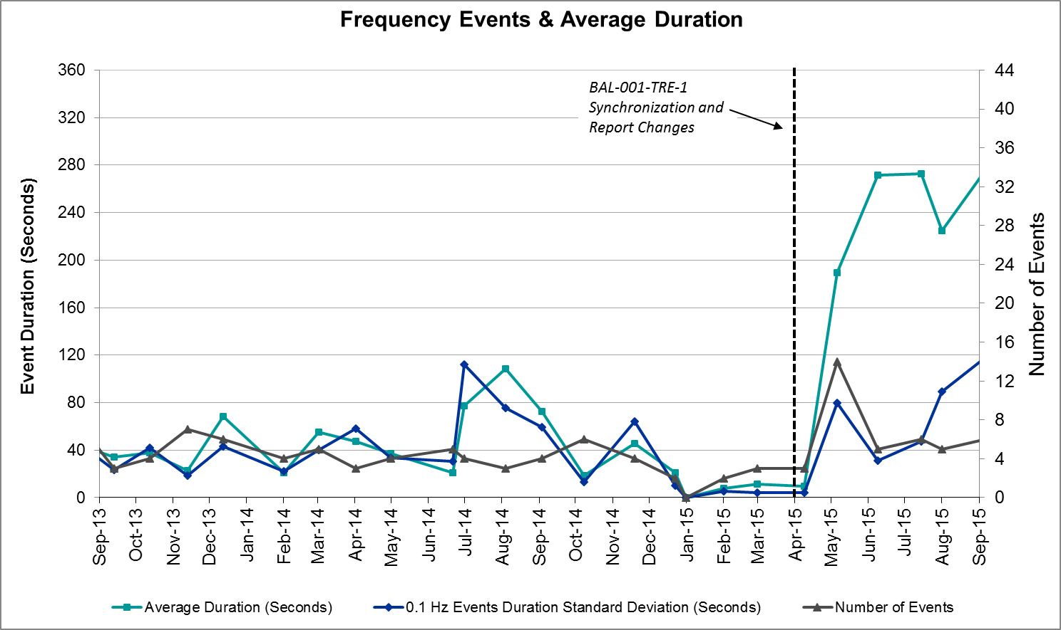

Responsive Reserve Events

There were six events where Responsive Reserve MWs were released to SCED in September. The events highlighted in blue were related to frequency events reported in Section 2.1 above.

Date and Time Released to SCED | Date and Time Recalled | Duration of Event | Maximum MWs Released | Comments
9/6/2015 15:22:20 | 9/6/2015 15:25 | 00:03:36 | 150
9/10/2015 13:10:59 | 9/10/2015 13:15 | 00:04:24 | 632
9/12/2015 13:36:47 | 9/12/2015 13:38 | 00:02:08 | 195
9/17/2015 7:45:02 | 9/17/2015 7:49 | 00:04:48 | 551
9/17/2015 22:20:14 | 9/17/2015 22:22 | 00:01:56 | 248
9/26/2015 3:32:41 | 9/26/2015 3:35 | 00:02:24 | 176

Load Resource Events
There were no load resource deployment events in September.

Reliability Unit Commitment
ERCOT reports on Reliability Unit Commitments (RUC) on a monthly basis. Commitments are reported grouped by operating day and weather zone. The total number of hours committed is the sum of the hours for all the units in the specified region. Additional information on RUC commitments can be found on the MIS secure site at Grid Generation Reliability Unit Commitment.

There were no DRUC commitments in September.

HRUC Commitments
Resource Location | # of Resources | Operating Day | Total # of Hours Committed | Total MWhs | Reason for commitment
Northern | 1 | 9/2/2015 | 1 | 11 | Local Congestion
Southern | 1 | 9/8/2015 | 4 | 212 | Local Congestion
Coast | 1 | 9/8/2015 | 2 | 320 | Local Congestion
Coast | 1 | 9/8/2015 | 1 | 515 | Local Congestion
Southern | 1 | 9/9/2015 | 5 | 201 | Local Congestion
Southern | 1 | 9/9/2015 | 8 | 331 | Local Congestion
Southern | 1 | 9/10/2015 | 1 | 38 | Local Congestion
Southern | 1 | 9/11/2015 | 7 | 274 | Local Congestion
Northern | 1 | 9/14/2015 | 8 | 976 | Local Congestion
Northern | 1 | 9/15/2015 | 2 | 236 | Local Congestion
Northern | 1 | 9/16/2015 | 1 | 118 | Local Congestion
Northern | 1 | 9/17/2015 | 1 | 118 | Local Congestion
Northern | 1 | 9/17/2015 | 9 | 5,112 | Local Congestion
Southern | 1 | 9/17/2015 | 13 | 615 | Local Congestion
Northern | 1 | 9/18/2015 | 7 | 3,976 | Local Congestion
Southern | 1 | 9/18/2015 | 10 | 421 | Local Congestion
Southern | 1 | 9/21/2015 | 9 | 469 | Local Congestion

Wind Generation as a Percent of Load
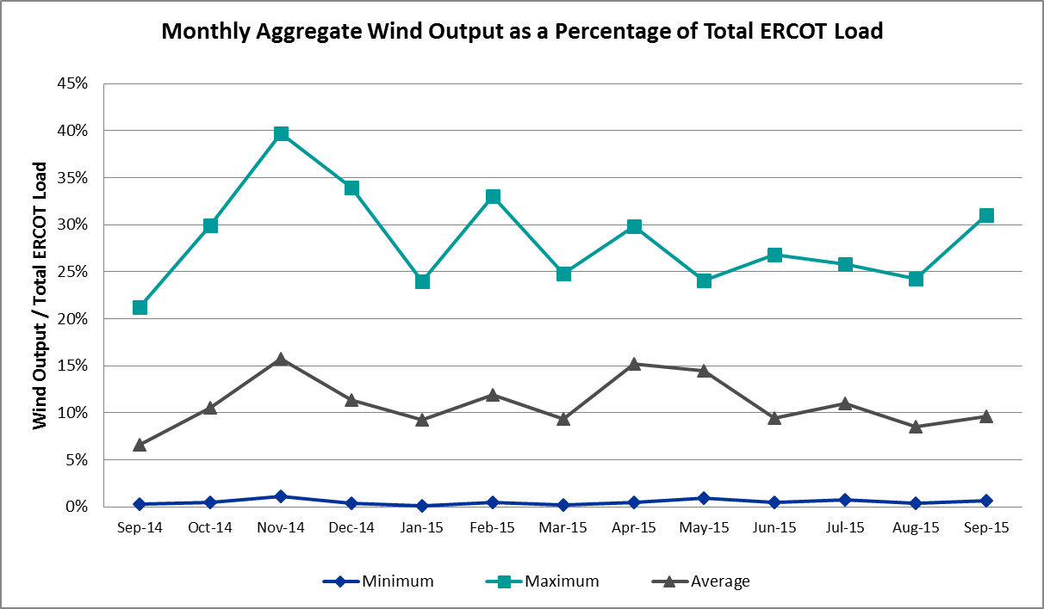

Congestion Analysis
The number of congestion events experienced by the ERCOT system increased in September due to planned outages and area load/gen patterns. There were fourteen days of activity on the Generic Transmission Constraints (GTCs) in September.

Notable Constraints for September

Nodal protocol section 3.20 specifies that ERCOT shall identify transmission constraints that are active or binding three or more times within a calendar month. As part of this process, ERCOT reports congestion that meets this criterion to ROS. In addition ERCOT also highlights notable constraints that have an estimated congestion rent exceeding $1,000,000 for a calendar month. These constraints are detailed in the table below. Rows highlighted in blue indicate the congestion was affected by one or more outages. For a list of all constraints activated in SCED for the month of September, please see Appendix A at the end of this report.

Contingency | Overload | # of Days Constraint Active | Estimated Congestion Rent | Transmission Project
Los Fresnos - Loma Alta Substation 138 kV | La Palma - Villa Cavazos 138 kV | 8 | $5,881,730 | 4490
Dermott Switch Ax1hh (3)345/138 KV | Morgan Creek Ses - Sun Switch 138 kV | 2 | $2,504,197 | 4213
Waco Mm Mars 2 to Robinson (6) 138 KV | Elm Mott - Northcrest Tap 138kV | 3 | $1,569,660 | 10TPIT0091
Polk Street to Oak Cliff South (6) 138 KV | Cedar Crest Switch - Oak Cliff South 138kV | 7 | $1,546,926 | 16TPIT0052
Nacogdoches Se to Mt Enterprise 345 KV | Centerville I45 - Pleasant Springs 138kV | 4 | $1,432,926
Royse Switch Axfmr3 345/138 KV | Forney Switch - Forney West 138kV | 2 | $1,105,467
Basecase | Laredo GTC | 5 | $1,098,375
Tradinghouse Ses to Lake Creek Ses 345 KV | Tradinghouse SES - Sam Switch 345kV | 2 | $1,077,721 | 4304
West Levee Switch Axfmr1h_H (3)345/138 KV | Industrial Blvd. - Compton Street 138kV | 8 | $633,195
Laquinta - Lobo 138 kV | Bruni 138_69_1 138/69 kV | 22 | $568,153
Lake Wichita Switch - Bowman Switch 138 kV | Certain Teed - Wichita Falls Cogen Switch 138 kV | 3 | $520,310
Bakke to Unocal Parker Bakke (8) 138 KV | Holt Switch - Emma Tap 69kV | 4 | $387,154 | 14TPIT0008
Fratt to Parkway Lcra 138 KV | Weiderstein - Randolph 138kV | 3 | $352,026
Decker To Sandhsyd And -Onion 138kv | Onion Creek - Pilot Knob 138kV | 10 | $327,839
DKCT Roans Prarie-Rothwood & Singleton-Tomball 345kV | Singleton - Zenith 345 kV (SNGZEN99) | 3 | $218,221 | 4485, 3937, 3950 (a,b)
Marion to Zorn 345 KV | Clear Springs - Marion 345kV | 7 | $171,274
Bbses-Navarro 345kv | Richland Chambers - Trinidad SES 345kV | 3 | $144,706
Lobo - San Miguel 345_138 kV Switchyards 345 kV | San Diego - Freer 69kV | 5 | $114,104 | 3903
Basecase | Zorillo - Ajo GTC | 6 | $82,321
Uvalde Aep - Odlaw Switchyard 138 kV | Hamilton Road - Maverick 138kV | 3 | $24,755
Lolita to Blessing 138 KV | Blessing - Palacios 69kV | 4 | $9,442
Coleto Creek - Pawnee Switching Station 345 KV | Coleto Creek to Kenedy Switch 138 kV | 4 | $9,262
DCKT Ferguson - Granite Mountain and Wirtz - Starcke - Paleface 138 kV | Wirtz - Flat Rock Lcra 138 kV | 5 | $4,157 | 4465
Dupont-Whitepoint & Whitepoint To Hecker 138 Kv | Rincon - Witepoint 138kV | 6 | -$19
Ingleside Dupont -Whitepoint 138kv | Rincon - Witepoint 138kV | 8 | -$3,200

Generic Transmission Constraint Congestion
There were five days of activity on the Laredo GTC, six of activity on the Zorilla – Ajo GTC and 3 days of activity on the Panhandle GTC in September. There was no activity on the remaining GTCs during the Month of September.

Manual Overrides for September
There were no manual overrides for the month of September 2015

Congestion Costs for Calendar Year 2015
The following table represents the top twenty active constraints for the calendar year based on the estimated congestion rent attributed to the congestion. ERCOT updates this list on a monthly basis.

Contingency | Binding Element | # of 5-min SCED Intervals | Estimated Congestion Rent | Transmission Project
DKCT Roans Prarie-Rothwood & Singleton-Tomball 345kV | Singleton - Zenith 345 kV (SNGZEN99) | 2532 | $24,922,386 | 4485, 3937, 3950 (a,b)
San Angelo North 138_69T1 138/69kV | San Angelo College Hills 138_69T1 138/69 kV | 1100 | $12,124,531
Los Fresnos - Loma Alta Substation 138 kV | La Palma - Villa Cavazos 138 kV | 1079 | $10,680,014 | 4490
DCKT Flewellen - Obrien and Maso Road 138 kV | Hockley - Betka 138 kV | 634 | $9,190,633
Collin Ses to Collin Switch 345 Kv 138 KV | Collin Switch to Collin SES 138 kV | 235 | $9,098,021
Topeka Termination - West Levee Switch 345 kV | Cedar Hill Switch - Mountain Creek 138 kV | 276 | $7,327,162 | 13TPIT0060
DCKT Hill Country - Marion and Elmcreek 345 kV | Marion - Skyline 345 kV | 1261 | $7,312,564 | 4081
DCKT Jewett - Singleton 345 kV | Twin Oak Switch - Btu_Jack_Creek 345 kV | 4791 | $7,291,879 | 4485, 3937, 3950 (a,b)
San Angelo College Hills 138_69T1 138/69 kV | SA Power 69T1 138/69 kV | 1456 | $7,141,012
North Alvin Tnp to Meadow 138 KV | PH Robinson to Southshore TNP 138 kV | 187 | $6,531,939
DCKT Lost Pines - Austrop & Dunlop 345 kV | Fayette Plant 1 - Fayette Plant 2 345 kV | 2975 | $6,416,648
Hutto Switch Axfmr 1 (3) 345/138 kV | Gilleland - Pflugerville 138 kV | 565 | $4,639,067 | 16TPIT0062
Bevo Substation - Asherton 138 kV | Hamilton Road - Maverick 138 kV | 320 | $4,635,315
Orange Grove Switching Station - Lon Hill 138 kV | Lon Hill - Smith 69 kV | 4186 | $4,156,156 | 16TPIT0026
Rio Hondo (2H) Axfmr 345/138 kV | Aderhold - Elsa 138 kV | 121 | $4,047,071
Falcon Seaboard - Midland East 345 kV | Odessa - Glenhaven 138kV | 70 | $3,753,436
DCKT Calaveras-Hotwells & Laredo1 138 kV | Calaveras - Streich 138 kV | 738 | $3,654,243
Falcon Seaboard to Morgan Creek Ses 345 KV | Glenhaven - Crmwd 8 Tap 138 kV | 65 | $3,638,593
DCKT West Levee Switch - 800/900 Network 138 kV | East Levee Switch - Reagan Street 138 kV (3410_A) | 366 | $3,589,511 | 16TPIT0061
Bates - Frontera 138 kV | Frontera - Goodwin 138 kV | 249 | $3,476,829

System Events

ERCOT Peak Load
The unofficial ERCOT peak load for the month was 64,465MW and occurred on September 8th during hour ending 17:00.

This demand value was a record peak for ERCOT.

Load Shed Events
None.

Stability Events
None.

Notable PMU Events
ERCOT analyzes PMU data for any significant system disturbances that do not fall into the Frequency Events category reported in section 2.1. The results are summarized in this section once the analysis has been completed.

There were no reportable events in September.

TRE/DOE Reportable Events
None.

New/Updated Constraint Management Plans
None.

New/Modified/Removed SPS
One Special Protection System was removed in September.
- Liggett Switching Station SPS

New Procedures/Forms/Operating Bulletins
Date | Document | Description
9/9/2015 | Power Operations Bulletin 718 | Resource Desk V1 Rev36
9/9/2015 | Power Operations Bulletin 719 | Transmission and Security Desk V1 Rev40

Emergency Conditions

OCNs
Date and Time | Description
09/09/15 10:07 | ERCOT issued an OCN due to a new Generic Transmission Constraint due to Laredo area voltage stability.
09/21/15 05:46 | ERCOT issued an OCN due to a delay in the posting of MIS reports.

Advisories
Date and Time | Description
09/11/15 07:03 | ERCOT issued an Advisory due to a geomagnetic disturbance of K-7.
09/20/15 03:13 | ERCOT issued an Advisory due to a geomagnetic disturbance of K-7.

Watches
None.

Emergency Notices
None.

Application Performance
ERCOT system applications performed well in September. There were no issues to report.

TSAT/VSAT Performance Issues
None.

Communication Issues
None.

Market System Issues
None.

Net-Forecast Bias Applied to NSRS Procurement for October 2015
Each month, ERCOT calculates a net Forecast Bias pursuant to the ERCOT Ancillary Services Methodology for procurement of Non-Spinning Reserve Service (NSRS). The table below indicates the amount of net Forecast Bias that was applied to the NSRS procurement for specified blocks of time for the month of October, 2015.

Blocks | Negative Net Load Forecast Average Error - By Weather Zone for the 5 Largest Zones
 | Coast | East | North Central | South Central | Southern
1-2 | -131 | -21 | -154 | -78 | -39
3-6 | -35 | -6 | -42 | -21 | -11
7-10 | -15 | -3 | -19 | -10 | -5
11-14 | -6 | -1 | -7 | -4 | -2
15-18 | 0 | 0 | 0 | 0 | 0
19-22 | 0 | 0 | 0 | 0 | 0
23-24 | -131 | -21 | -154 | -78 | -39

Appendix A: Real-Time Constraints
The following is a complete list of constraints activated in SCED for the month of September. Full contingency descriptions can be found in the Standard Contingencies List located on the MIS secure site at Grid Generation Reliability Unit Commitment.

Contingency | Constrained Element | From Station | To Station | # of Days Constraint Active
SL_FLA_8 | LA_PAL_VCAVAZ1_1 | LA_PALMA | VCAVAZOS | 8
XDMT158 | 6474__A | MGSES | SUNSW | 2
SWMMLCS8 | 1010__A | ELMOT | NCRTP | 3
SPLKMCS8 | 3160__A | CDCSW | OKCLS | 7
SNCDTRS5 | 1230__D | CNI45 | PLSSP | 4
XRYS58 | 1090__A | FORSW | FORWE | 2
BASE CASE | LAREDO |  |  | 5
SLCSTH25 | 505__A | THSES | SAMSW | 2
DFL_MAR8 | BETHK_66_A | HK | BET | 1
XWL2V58 | 3130__B | INDST | CMPST | 8
XWLV258 | 14030__A | MGSES | BRBSW | 1
SLAQLOB8 | BRUNI_69_1 | BRUNI | BRUNI | 22
SLKWBOM8 | 6170__D | CNTED | WFCOG | 3
SL_FLA_8 | LAUREL_LA_PAL1_1 | LA_PALMA | LAURELES | 2
SBAKHLT8 | 6596__F | HLTSW | EMATP | 4
SSKISIN9 | LON_HI_SMITH1_1 | LON_HILL | SMITH | 2
SFRAPAR8 | WEIDER_RAND_1 | WEIDER | W2 | 3
DDECSAN8 | CKT_948_1 | ONION | PILOT | 10
DEMSSAG8 | 6265__A | EMSES | MRSDO | 3
DRNS_TB5 | SNGZEN99_A | SNG | ZEN | 3
SBIGDIL8 | BAT_CRST_1 | BATESVL | CRSTLSW | 1
SMDLODE5 | ODEHV_MR2H | ODEHV | ODEHV | 1
SELMTH25 | 1280__A | LCSES | WLASL | 1
XFSH58 | 6170__D | CNTED | WFCOG | 2
SMARZOR5 | 419T419_1 | CLEASP | MARION | 7
DNAVBBS5 | 31__A | RCHBR | TRSES | 3
XLOB58 | DILLEY_JARDIN1_1 | DILLEYSW | JARDIN | 1
DWH_STP5 | KENEDS_KENEDY1_1 | KENEDSW | KENEDY | 2
SLOBSAN5 | FREER_SAN_DI1_1 | SAN_DIEG | FREER | 5
DWAP_BI5 | JN_AT3 | JN | JN | 1
DLHSCNR8 | 3650__A | LHSES | SATP1 | 1
DZEN_OB5 | OB_AT2H | OB | OB | 1
SLANLAN8 | BLESSING_69A1 | BLESSING | BLESSING | 1
SPAUSAR8 | REDCRE_SACK1_1 | REDCREEK | SACK | 1
SUVAD18 | 2584_1 | DOWNIES | UVALDE | 2
BASE CASE | ZO_AJO |  |  | 6
DSALKLN5 | 630__A | BLTON | BLTSW | 2
SGILNU78 | GILA_MORRIS1_1 | GILA | MORRIS | 2
XNCD58 | 1230__D | CNI45 | PLSSP | 1
DELMSKY5 | MAR_SKY_1 | MARION | SKYLINE | 1
DJEWSNG5 | JK_TOKSW_1 | TOKSW | JK_CK | 3
DNAVLEG5 | 40__A | JEWET | BBSES | 1
DNEDPAL8 | ADERHO_DUKE1_1 | DUKE | ADERHOLD | 1
DCHBJOR5 | BRNLAN86_A | LAN | BRN | 1
DTHSLCS5 | 290__A | LCSES | THSES | 1
SCNRFOR5 | 210__A | FORSW | RYSSW | 2
SBRAUVA8 | HAMILT_MAVERI1_1 | HAMILTON | MAVERICK | 3
DWH_STP5 | BONIVI_RINCON1_1 | RINCON | BONIVIEW | 4
DGARHIC8 | LYTTON_S_AT2H | LYTTON_S | LYTTON_S | 1
DCAGCO58 | 419T419_1 | CLEASP | MARION | 1
DSTEXP12 | 419T419_1 | CLEASP | MARION | 2
SSIGSAN8 | NCA_SMTP_1 | SANMTAP | NCALHMS | 1
SLOLBLE8 | BLESSI_PALACI1_1 | BLESSING | PALACIOS | 4
SCOLPAW5 | COLETO_KENEDS1_1 | COLETO | KENEDSW | 4
DMCSCDC8 | 3405__C | MCSES | TRIRA | 1
XBL2U58 | BLUF_CRK_T1_H | BLUF_CRK | BLUF_CRK | 2
DBBSJEW5 | 31__A | RCHBR | TRSES | 1
SLCDYN8 | SE_WA_65_A | WA | SE | 1
XJEW58 | 1230__J | LFKSW | LFCML | 1
SLAQLOB8 | MOLINA_RIO_BR1_1 | RIO_BRAV | MOLINA | 1
DCLEZOR5 | 86T235_1 | HENNE | COMAL | 5
DMARZOR5 | CLEASP_AT2H | CLEASP | CLEASP | 2
DFERPAL8 | 38T365_1 | WIRTZ | FLATRO | 5
DMARZOR5 | CLEASP_AT1 | CLEASP | CLEASP | 2
SBRAUVA8 | EAGLHY_ESCOND1_1 | EAGLHYTP | ESCONDID | 1
SSPUASP8 | SPUR_69_1 | SPUR | SPUR | 1
SSPUASP8 | ROTN_WOLFGA1_1 | WOLFGANG | ROTN | 1
DI_DRIN8 | I_DUPS_WHITE_1_1 | I_DUPSW | WHITE_PT | 2
SSPUASP8 | JATN_SPUR_1C_1 | GIRA_TAP | DKEC | 1
XLOB58 | FREER_SAN_DI1_1 | SAN_DIEG | FREER | 1
DSAMTHS5 | 1200__A | WHTNY | HLSBR | 1
SZEPCMN8 | 670__B | BRNSW | CMPBW | 1
DHILELM5 | MAR_SKY_1 | MARION | SKYLINE | 1
DBIGKEN5 | BONDRO_SONR1_1 | SONR | BONDROAD | 2
DCAGTA58 | 419T419_1 | CLEASP | MARION | 1
SPRUOLI8 | OLI_BEN1_1 | OLINGR | BNDVS | 1
BASE CASE | LNCRK2_T2 | LNCRK2 | LNCRK2 | 1
DMARZOR5 | 581T581_1 | ECMORN | PARKWA | 1
SSCUSUN8 | ROTN_WOLFGA1_1 | WOLFGANG | ROTN | 1
SFORYEL8 | FORTMA_MASN1_1 | FORTMA | MASN | 1
SPAWLON5 | KENEDS_KENEDY1_1 | KENEDSW | KENEDY | 1
SLOLFOR8 | BLESSI_PALACI1_1 | BLESSING | PALACIOS | 1
DCAGBRA5 | SKYLINE_MR2H | SKYLINE | SKYLINE | 1
DHILELM5 | SKYLINE_MR2H | SKYLINE | SKYLINE | 1
SSPRDEC8 | CKT_948_1 | ONION | PILOT | 1
SHRSREN8 | 755__D | RENSW | NPKWY | 1
SLAQLOB8 | FRE_BRUN_1 | BRUNI | FREERS | 1
SRICEL_8 | BLESSI_PALACI1_1 | BLESSING | PALACIOS | 1
BASE CASE | PNHNDL |  |  | 3
DHCKRNK5 | 6265__A | EMSES | MRSDO | 2
DKOCNUE8 | CHAMPL_WEIL_T1_1 | WEIL_TRC | CHAMPLIN | 2
USCEUNI1 | 300__A | TMPSW | LCSES | 1
DCRLLSW5 | 590__A | LWSSW | LWVJS | 2
DWHII_D8 | RINCON_WHITE_2_1 | RINCON | WHITE_PT | 6
DI_DWHI8 | RINCON_WHITE_2_1 | RINCON | WHITE_PT | 8

