TDTWG Meeting Agenda – September 8, 2015
Location: Met Center
Time: 9:30 PM – 04:00 PM
Room 168

Agenda Item | Leading Discussion
- Introductions  - Review of Agenda  - Antitrust Statement | Isabelle Durham
Review/Approve August Meeting Notes - APPROVED | Isabelle Durham
ERCOT System Instances (Outages and Failures) | ERCOT- Dave Pagliai
Review MarkeTrak Monthly Performance  August was a quiet month. No large system issues or outages.  Dave also reviewed the Secure Socket Layer (SSL) certificate requirement for programmatic access to ERCOT’s External Web Services (EWS) API. SSL certificates expired on 9/7 and ERCOT renewed a few days early. No additional MPs have expressed issues/problems/concerns with SSL certificate renewal.  Dave reviewed MT API and ERCOT is still working to develop QueryList proposed SLO. ERCOT will hold off on proposing SLO until the QueryList numbers have stabilized. (ETA: Q1 2016)  Modifications to report: convert API performance report to ‘seconds’ instead of ‘milliseconds’; include GUI performance to report as well. | ERCOT – Dave Pagliai
TDTMS Working Group  - Create new Scope Statement for TDTMS – TDTWG to circulate to exploder list and post to October meeting page.  - Correct RMS Procedures to include this new working group name – will take up in October  - Created the new TDTMS Procedures document | All
ERCOT Test Environment  ERCOT will bring Full IA for Original SCR and language for Alternative IA to RMS on Oct 6th .  After presenting to RMS, ERCOT will take to PRS on October 15.  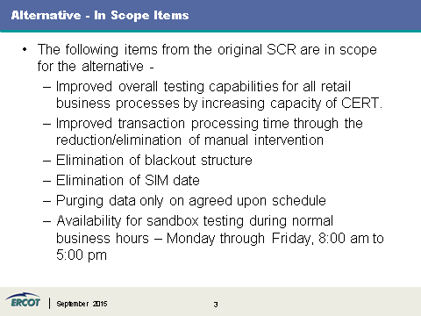  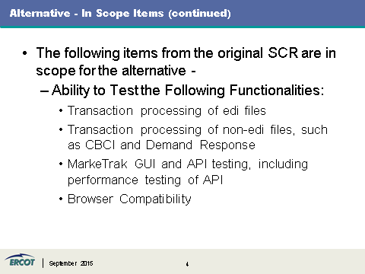  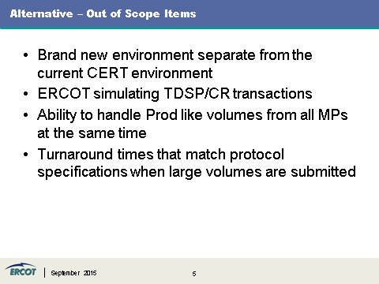  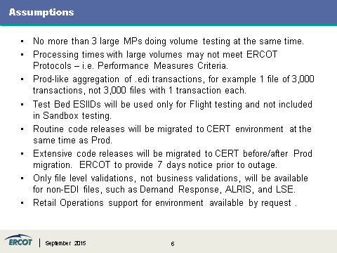  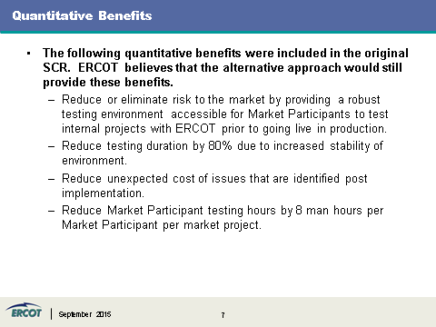 | All
ERCOT External Web SSL Certificate – covered this in Dave’s MT Performance Update  - Discuss any updates  - Impacts to SLA | ERCOT
Additional ad hoc items  TDTWG listserv:  Scope is in agreement – consensus to provide to RMS for vote (reply by Sept 22nd)  Bring attention to SCR786 Alternative IA proposal. | Isabelle Durham
Update to RMS | Isabelle Durham
Adjourn
Future Meeting Dates:
- October 13th Face-to-Face

Topic: TDTWG – September 2015
Date: Tuesday, September 8, 2015
Time: 9:30 pm, Central Daylight Time (GMT -04:00, Chicago)
Teleconference: 1-877-668-4493
Audio Passcode:
Meeting Number: 651 621 040
Meeting Password: Tdtwg
Please click the link below to see more information, or to join the meeting.
1. Go to https://ercot.webex.com/ercot/j.php?ED=131510397&UID=0&PW=620ea2a77453475538190b014a55540b134d
2. Enter your name and email address.
3. Enter the meeting password:
4. Click "Join Now

