Solar Generation Integration Whitepaper

Prepared by: Emerging Technologies Working Group
Document Revisions
Date | Version | Description | Author(s)
December 1, 2013 | 1.0 | White paper | ERCOT Staff

Acronyms and Abbreviations
ERCOT: Electric Reliability Council of Texas
IRRs: Intermittent Renewable Resources
DRUC: Day-Ahead Reliability Unit Commitment
HRUC: Hour-Ahead Reliability Unit Commitment
DOE: Department of Energy
CSP: Concentrated Solar Power
PV: Photovoltaics
NWP: Numerical Weather Prediction
NOAA: National Oceanic and Atmospheric Administration
MAE: Mean Absolute Error
MAPE: Mean Absolute Percentage Error
STSPF: Short-term Solar Power Forecast
QSE: Qualified Scheduling entity
POA: Plane of Array
GI: Global Irradiance

GHI: Global Horizontal Irradiance
DNI: Direct Normal Irradiance
DHI: Diffuse Horizontal Irradiance
….
Table of Contents

1. Background 4
2. Solar Technologies for grid connectivity 4
3. Registration in Resource Asset Registration Form 4
4. Solar Generation Production Forecast 4
4.1. Characteristics of Solar Power Forecast 5
4.2. Solar Forecasting Methodologies 6
4.3. Solar Forecasting Performance Metrics 8
4.4. ERCOT Data Requirements 8
4.5. Data Quality Control and Archive 11
4.6. Path Forward for Integration of Solar Power Forecast 11
4.7. Summary 12
5. Dynamic Models of Solar Generation 13
5.1. GE solar plant model 14
5.2. WECC Central Station PV System Model (PV1G, PV1E, PV1P) 16
5.2.1. PV1G model 17
5.2.2. PV1E model 17
5.2.3. PV1P model 18
5.3. Generic Solar Photovoltaic Model in PSSE 19
6. Distributed Solar Resources 21

Background
The combination of several forces has led to an anticipated rapid and significant addition of solar generation in Texas in the next a few years. As of today, there are two operational commercial solar farms in the ERCOT system: the 30 MW Webberville project and the 10 MW Acacia project. The total installed solar capacity is expected to reach 2539 MW by 2016, compared to the projected 18202 MW for wind generation by the same period.

Solar Technologies for grid connectivity
Solar technologies that can be synchronized to the grid, without consideration of some thermal applications such solar hot water heating systems that are not normally connected to transmission systems may be classified as concentrated solar power (CSP) and photovoltaic (PV) applications. CSP systems first convert solar energy into thermal energy and later into electricity, while photovoltaic systems directly convert solar energy to electricity. There are three main CSP technologies identified in the 10KW to 1000 KW range [1]:
- Dish/engine technology – directly generate electricity in isolated locations
- Parabolic and Fresnel trough technology- produces high pressure superheated steam, and

Not clear what other technologies need to be included or how much description of these we need to do – maybe ETWG can provide some feedback.

Registration in Resource Asset Registration Form

Variability of Irradiance
The output of PV plants is necessarily variable simply because the sun changes position throughout the day and throughout the seasons. The rising and setting of the sun regularly leads to 10-13% changes in PV output over a period of 15 minutes for single-axis tracking PV plants. Clouds, however, are largely responsible for rapid changes in the output of PV plants that concern system operators and planners. Changes in solar insolation at a point due to a passing cloud can exceed 60% of the peak insolation in a matter of seconds. The time it takes for a passing cloud to shade an entire PV system, in contrast, depends on the PV system size, cloud speed, cloud height, and other factors. For PV systems with a rated capacity of 100 MW, the time it takes to shade the system will be on the order of minutes rather than seconds.

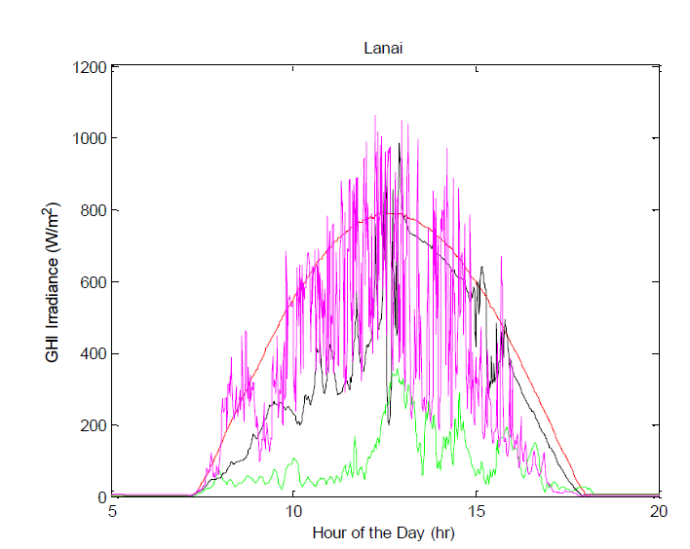
Figure 1 Irradiance patterns from hour selected days from Lanai, HI

Unlike changes in the position of the sun which affects the output of all PV plants in a nearly uniform, highly correlated way, changes in PV output due to clouds are not driven by a similar uniform process. Clouds move across plants affecting one part of a plant before another or leaving some parts of plants unobstructed as the cloud passes. Clouds therefore cause diverse changes in PV output across plants and between separate plants. Just as electrical connections are used to aggregate diverse loads and conventional plants, electrical connections aggregate the diverse output of separate PV panels and blocks of PV panels within a plant or between separate PV plants. The degree of diversity between points or plants can be characterized by the correlation of simultaneous changes in the output. Similarly, diversity can be characterized by the relative reduction in the magnitude of ramps for the aggregate of multiple plants relative to a single point, Figure 2.

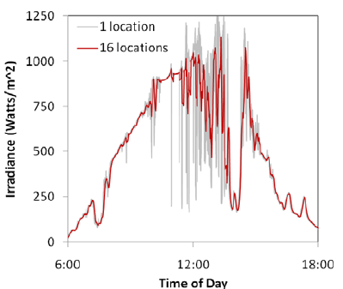

Figure 2 - Aggregating the output of several different solar insolation meters illustrates the reduction in variability of multiple sites relative to a single site.
At timescales in the seconds-to-minutes range, this is known as regulation reserve. Previous studies have shown that increasing the geographic diversity of solar resources can reduce the short-term variability of the power output.

Variability of solar resources is subdivided in long-term and short-term fluctuations.

Short-term variability studies use second-to-minute averaged data to investigate the effect on operating reserves and frequency regulation. When the short-term variability of
solar and wind power is no longer masked by the load variability, grid operators must increase system operating reserves and regulation services to maintain the grid’s
reliability. This approach, in turn, raises the operating costs associated with integrating photovoltaic (PV) renewable energy into the grid. The actual increase in cost depends
upon various factors, including the grid’s size and inherent flexibility, and the aggregated variation of all the renewable energy in a grid-balancing area

A central term in this study is the “ramp rate” (RRΔt), defined herein as the change in power output of a PV plant or irradiance sensor over two consecutive periods of the
duration Δt. In this study, we use power outputs (or irradiance values) that are averaged over 1min. We also use 1min as the time interval (Δt) for ramp rate calculations.

Variability in irradiance over time at a site has important implications for power generation from solar PV plants. Because PV output is highly correlated with the spatial average irradiance over the PV array, irradiance variability characteristics will be directly applicable to PV output variability, if plant size is taken into account. A variability index was proposed by Joshua et al. to measure irradiance variability over a period of time, which is calculated as

$$\text{VI}=\frac{\sum_{k=2}^{n}{\sqrt{({\text{GHI}}_{k}−{\text{GHI}}_{k−1})^{2}+{Δt}^{2}}}}{\sum_{k=2}^{n}{\sqrt{({\text{CHI}}_{k}−{\text{CHI}}_{k−1})^{2}+{Δt}^{2}}}}$$
where GHI is a vector of length n of global horizontal irradiance values averaged at time interval in minutes, $Δt$, CSI is a vector of calculated clear sky irradiance value for the same times as GHI data.
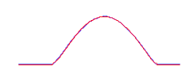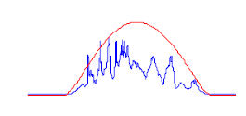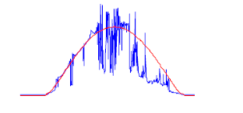
Figure 3 Example of variability (clear sky irradiance is shown in red) Left: VI=1; Middle: VI=4; right: VI=16

Solar Generation Production Forecast
This flux of solar will exaggerate the variability and intermittency of net load currently experienced by ERCOT. If not addressed properly, it will result in numerous challenges in maintaining bulk electric system reliability and wholesale market functionality. To mitigate this potential problem, protocols section 3.13 (2) Renewable Production Potential Forecasts clearly state that ERCOT needs to produce accurate and unbiased forecast for the potential of renewable production:

“ERCOT shall develop cost-effective tools or services to forecast energy production from Intermittent Renewable Resources (IRRs) with technical assistance from QSEs scheduling IRRs. ERCOT shall use its best efforts to develop accurate and unbiased forecasts, as limited by the availability of relevant explanatory data. ERCOT shall post on the MIS Secure Area objective criteria and thresholds for unbiased, accurate forecasts within five Business Days of change.”

Since 2008, ERCOT has been working with wind forecast service providers to produce the rolling forecast for the next 48-hour production potential of Wind Generation Resources (WGR), which is used as input to DRUC and HRUC and also presented to operators visually for situation awareness. This tool has successfully helped ERCOT integrate very high penetration levels of wind generation. From the lessons learned with wind integration and given anticipated growth of solar power in Texas, , ERCOT needs to have a tool specially designed to produce accurate solar generation forecast.

Characteristics of Solar Power Forecast
Accurate solar forecasting will allow power system operators to integrate more solar energy into the electricity grid, and ensure the economic and reliable delivery of renewable energy. Wind speed forecasting has been developed for decades and wind forecasting for renewable energy is a fairly mature field with several major market players. However, the methods and approach for more accurate solar forecasting are still evolving. Solar radiation forecasting is standard in numerical weather prediction, but the accuracy on solar radiation forecasts is still low for all days (clear-sky and cloudy). Consequently, there is significant potential for improvements of solar forecasts for long horizon (from a few hours to several days). Recently, the Department of Energy (DOE) funded two projects helping utilities, grid operators, solar power plant owners, and other stakeholders better forecast when, where, and how much solar power will be produced at the desired locations in the United States.

In addition, for solar forecasting, different types of solar power systems need to be distinguished. There are two different ways to convert sunlight into electricity, either indirectly using concentrated solar power or directly using photovoltaics . Concentrated solar power systems use lenses or mirrors and tracking systems to focus a large area of sunlight into a small beam. Photovoltaics convert light into electric current using the photoelectric effect. The solar farms that will be connected to the ERCOT system by 2016 will fall into the second category (PV).

For solar concentrating systems (CPS), the direct normal incident irradiance (DNI) must be forecasted. Due to non-linear dependence of concentrating solar thermal efficiency on DNI and the controllability of power generation through thermal energy storage (if available), DNI forecasts are especially important for the management and operation of concentrating solar thermal power plants. Without detailed knowledge of solar thermal processes and controls, it is difficult for solar forecast providers to independently forecast power plant output.

For non-concentrating systems (i.e. most PV systems), primarily the global irradiance (GI = diffuse + DNI) on a tilted surface is required which is less sensitive to errors in DNI since a reduction in clear sky DNI usually results in an increase in the diffuse irradiance. Power output of PV systems is primarily a function of global horizontal irradiance. For higher accuracy, forecast of PV panel temperature are needed to account for the (weak) dependence of solar conversion efficiency on PV panel temperature.

Since clouds are the number one influence on a solar forecast, solar energy is generally more predictable than wind energy as satellites provide frequent, high resolution cloud data - the most significant factor affecting solar radiation variability.

Solar Forecasting Methodologies
For solar forecasting very different methodologies are preferred depending on the forecast horizon: (This sentence is not clear – here is another way to say this)

- Different methodologies of solar forecasting are preferred depending on the forecast horizonPersistence forecast is based on current or recent PV power plant or radiometer output and extrapolated to account for changing sun angles. Persistence forecasts accuracy decrease strongly with forecast duration as cloudiness changes from the current state.

- Total sky imagery can be used to forecast from real time up to 15-30 minutes.by applying image processing and cloud tracking techniques to sky photographs. The method assumes persistence in the opacity, direction, and velocity of movement of the clouds. Irradiance is predicted for the current cloud shadow and then the cloud shadow is moved forward in time based on cloud velocity and direction.

- For satellite imagery the same methods as in total sky imagery are applied. Clouds reflect more light from earth into the satellite leading to detection and the ability to calculate the amount of light transmitted through the cloud (transmissivity = 1 – reflectivity – absorptivity). The lower spatial and temporal resolution causes satellite forecasts to be less accurate than sky imagery on intra-hour time scales. Satellite imagery is the best forecasting technique in the 1 to 5 hour forecast range. Classical satellite methods only use the visible channels (i.e. they only work in day time), which makes morning forecasts less accurate due to a lack of time history. To obtain accurate morning forecasts, it is important to integrate infra-red channels (which work day and night) into the satellite cloud motion forecasts.

- NWP is the best forecasting technique for long time horizons of more than 5 hours. NWP models solar radiation as it propagates through the atmosphere including the cloud layers represented in the model. Operational National Weather Service models do not have the spatial or temporal resolution for accurate HA forecast. Consequently, NWP models are probabilistic because they infer local cloud formation (and indirectly transmitted radiation) through numerical dynamic modeling of the atmosphere. NWP models currently cannot predict the exact position of cloud fields affecting a given solar installation. High-resolution rapid-refresh NWP that are currently developed by NOAA and wind forecasters may be able to approach the resolution of satellite forecasts (1 km) within a few years and allow the application of high-frequency variability techniques.

A summary of the comparison between those four (I suggest adding numbers to the options above since you state here a number) different solar power forecast methods is given in the Table 1. A typical illustration shown in Figure 4 below indicates that NWP is best suitable for the forecast of long time horizon of 5-hour while the satellite image based technique is more accurate for short time solar power forecast less than 5 hours.

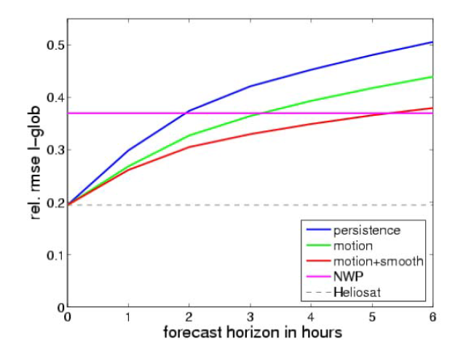
Figure 4 : Comparison of performance of different forecast methods (up to 5 hours: forecast based on satellite images; more than 5 hours: NWP based forecast)

Table 1: A comparison between different solar forecast methods
Methods | Suitable forecast horizon | Performance
Persistence forecast | From real-time to a few hours | accuracy decrease strongly with forecast duration as cloudiness changes from the current state
Total sky imagery | from real time up to 15-30 minutes | the method assumes persistence in the opacity, direction, and velocity of movement of the clouds
Satellite imagery | 1 to 5 hour forecast range | the lower spatial and temporal resolution causes satellite forecasts to be less accurate than sky imagery on intra-hour time scales
NWP | long time horizons of more than 5 hours | Operational National Weather Service models do not have the spatial or temporal resolution for accurate hour-ahead forecast

Solar Forecasting Performance Metrics
Due to the binary nature of solar radiation (cloudy or clear) the choice of error metric is very important for the evaluation of solar forecast models. The root mean square error (RMSE) metric is problematic as it is dominated by large errors. Thus if a forecast model is usually correct but occasionally off by a large amount it may score worse than a model that is always slightly off but never way off. It is recommended to use the mean absolute error (MAE) or mean absolute percentage error (MAPE) as a standard evaluation metric since it is less sensitive to large errors.

The MAE is given by

$$\text{MAE}=\frac{1}{N}\sum_{i=1}^{N}{\left|p_{i}−p_{i}\right|}$$
where $p_{i}$represents the actual wind power generation at the i^{th} time step, $p_{i}$ is the corresponding wind power generation estimated by a forecast model, and N is the number of points estimated in the forecast period.

Solar power forecast evaluations can calculate the forecast error in W m-2 or % of solar irradiance. This has the advantage of comparability, but is not the most economically metric or relevant to the grid operations. In addition, a forecast error during peak load is likely both economically and operationally more significant than an error during off-peak times. To consider this, we recommend evaluating the solar power forecast errors listed in the following table.
Table 2: Forecast Performance Metrics
Solar Power Forecast Error | Peak hours | Non-peak hours | All hours | Cloudy Days | Clear Days
Solar Power Forecast Error | MAPE | MAPE | MAPE | MAPE | MAPE
Solar Power Forecast Error | MAE | MAE | MAE | MAE | MAE

ERCOT Data Requirements
The performance of a PV system largely depends on the incident irradiance on the array. Global Horizontal Radiation - also called Global Horizontal Irradiance; total solar radiation; the sum of Direct Normal Irradiance (DNI), Diffuse Horizontal Irradiance (DHI), and ground-reflected radiation; however, because ground reflected radiation is usually insignificant compared to direct and diffuse, for all practical purposes global radiation is said to be the sum of direct and diffuse radiation only:

GHI = DHI + DNI * cos (Z)

where Z is the solar zenith angle.

Thus, the forecast of a PV system involves:

•Defining or determining the orientation of the array, which can be either fixed or variable in time (tracking arrays).
•Estimating the contributions of the beam and diffuse irradiance components.

Alternatively, one can measure the plane of array irradiance directly with a pyranometer, reference cell, or reference module mounted in the same orientation of the array.

The following section details the data, which will be exchanged between ERCOT and solar forecast service provider.

Table 3 ERCOT Telemetered Data for Solar Power Forecasting (PV)
 | Telemetered data | Unit
1 | Telemetered Date
2 | Telemetered hour
3 | Resource ID
4 | QSE
5 | Irradiance | w/m2
6 | plane of array for tracking PV systems | w/m2
7 | plane of array or global horizontal irradiance for fixed panels | w/m2
8 | Back panel temperature | +/- 1 C
9 | Air Temperature | +/- 1 C
10 | Wind speed | (+/- 1 m/s)
11 | Wind direction | +/- 5 degrees)

Table 4 Solar Power Forecasting Data (PV)
 | Forecast data | Unit
1 | Forecast Date
2 | Forecast hour
3 | STSPF | MW
4 | Resource ID
5 | QSE

Table 5 Meteorological Instruments Installed in One Solar Farm
ITEM | DESCRIPTION | RESOLUTION | QUANTITY
Data Logger | Campbell Scientific CR1000 with internet module |  | 15
Ambient Temperature Probe and Relative Humidity Probe | Campbell Scientific CS215-L tem and relative humidity probe with one (1) 41303-5A 6 plate Grill Radiation Shield | 1 ºC | 2
Anemometer and Wind Vane | RM Young Wind Sentry set with mounting brackets | -50 to +50 ºC | 2
Back panel temperature probe | Campbell Scientific 109 temperature sensor; type E thermocouple | -50 to +70 ºC | 38
Pluviometer | Texas Electronics TE525-L 6” rain gauge |  | 2
Pyrheliometer** | Kipp&Zonen CHP1_ Pt 100 class A _ 10kohm termistor  0-1000 Wm2 | Solar radiation spectrum 97-98% 200-4000nm | 2
Pyranometer | (Horizontal) Kipp&Zonen CMP11 _sensitivity 8.92 μV/W/m2 @ normal irradiance | 305 to 32800 nm  15uV/W·m2  -40 to 80ºC  0 to 2000 Wm2 | 6
Pyranometer | (Plane of Array) Kipp&Zonen CMP11 | 305 to 32800 nm  15uV/W·m2  -40 to 80ºC  0 to 2000 Wm2 | 6
Barometer | Measured at HectoPascals (HPa)  PTB110 Vaisala | 60 pA | 2
Meteorological enclosure | Power meters Power Logic Ion 6200 | 1 m/s  5 degrees

Data Quality Control and Archive
Data received from ERCOT will be put through a quality control module. Each data element will be checked to determine whether the value is in range for the given parameter, for the same data value is being reported for each interval and whether the data elements are consistent with each other (e.g. high irradiance with high solar generation values).

ERCOT will load the Solar Power Forecast data into EMS relational database. From EMS relational database the Solar Power Forecast data will be available to QSEs through MIS Portal and through the Messaging System. Also, this data will be archived for 7 years of retention in EDW.

Path Forward for Integration of Solar Power Forecast
Ultimately, the solar power forecast should be as fully functioning as the wind, i.e., to be integrated into the ERCOT’s EMS system. As such, solar power forecast service provider shall host a web service WS Notification Listener (Web Service Server) to receive the Observation Message from ERCOT (see Fig. 2). Conversely, ERCOT shall host a web service WS Notification listener (Web Service Server) to receive the Forecast and Performance messages from solar power forecast service provider. The basic service level description is described in the following diagram:
Figure 5 – Message Exchange between ERCOT←→Solar Power Forecast Service Provider

While the full integration of solar power forecast into the EMS system is advantageous in validating the full spectrum of the performance metrics (accuracy, reliability and usability), other options are also attractive due to its simplicity and less potential impacts on the EMS system. The simplest way is to transfer the data file containing the information requested between ERCOT and the solar power forecast service provider, as shown in Fig. 3. Since this is done manually, the number of data file transfer is limited and its main purpose is to validate and test the accuracy of the solar power forecasting.

Figure 6 – Data File Exchange between ERCOT←→Solar Power Forecast Service Provider

Alternatively, a data link can be set up between solar farm and solar power forecast service provider for a pilot project when not too many solar farms will be involved (see Fig. 4). The forecasted data can be sent back to ERCOT either through telemeter or through data files manually.
Figure 7 – Data Exchange between a Solar Farm under a Pilot←→Solar Power Forecast Service Provider

Summary
Solar power forecasting is an area that is still evolving and there are a few solar power forecast service providers compete for more accurate and better service. It is recognized that NWP is best suitable for the forecast of long time horizon of 5-hour while the satellite image based technique is more accurate for short time solar power forecast less than 5 hours. While the accurate solar power forecasting is challenging, solar has some characteristics that make it easier than wind forecasting.

The performance of solar power forecast should be evaluated in the full spectrum, measured by its accuracy, reliability, usability, integration and cost.

In the control room, we should look toward a unified view of wind and solar forecasting.

Dynamic Models of Solar Generation
The model of solar plants is intended to capture the most important dynamic characteristics of large scale (>10 MW) PV systems with a central Point of Interconnection (POI) at the transmission level. The following general requirements shall apply.

- The models shall provide a reasonably good representation of dynamic electrical performance of solar photovoltaic power plants at the point of interconnection with the bulk electric system, and not necessarily within the solar PV power plant itself.

- The models shall be suitable for studying system response to electrical disturbances, not solar irradiance transients (i.e., available solar power is assumed constant through the duration of the simulation). Electrical disturbances of interest are primarily balanced transmission grid faults (external to the solar PV power plant), typically 3 - 9 cycles in duration, and other major disturbances such as loss of generation or large blocks of load.

- Systems integrators, inverter manufacturers and model users (with guidance from the integrators and manufacturers) shall be able to represent differences among specific inverter and/or plant controller responses by selecting appropriate model parameters and feature flags.

- Simulations performed using these models typically cover a 20-30 second time frame, with integration time steps in the range of 1 to 10 milliseconds.

- The models shall be valid for analyzing electrical phenomena in the frequency range of zero to approximately 10 Hz.

- The models shall incorporate protection functions that trip the associated generation represented by the model, or shall include the means for external modules to be connected to the model to accomplish such generator tripping.

- The models shall perform accurately for systems with a Short Circuit Ratio (SCR) of two and higher at the POI.

In practice, a solar plant has a local grid collecting the output from the converters into a single point of connection to the grid. Since the solar plant is made up of many identical converters, it is a reasonable approximation to parallel all the converters into a single equivalent large converter. While there are limitations, simulations of bulk system dynamics using a single converter equivalent are adequate for most planning studies.

The fundamental frequency electrical dynamic performance of a solar plant is completely dominated by the converter. The control of active and reactive power is handled by fast, high bandwidth regulators within the converter controls, and can be greatly simplified for simulation of bulk power system dynamic performance.

The converter model injects real and reactive current into the network in response to control commands, and represents low and high voltage protective functions. The control model includes closed loop reactive controls and voltage regulation with either a simplified solar plat supervisory control system or a separate, detailed control model. In addition, user-written models can inject power profiles into the solar plant dynamic models, or to represent additional protective functions (e.g., over/under frequency).

GE solar plant model

A GE solar plant model consists of a converter model and an electrical control model.

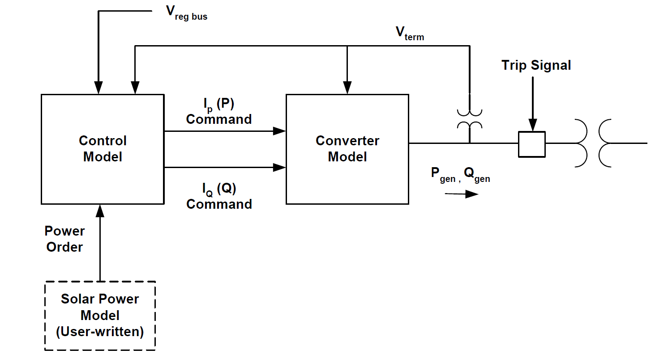
Figure 8 - GE Solar Plant Dynamic Model

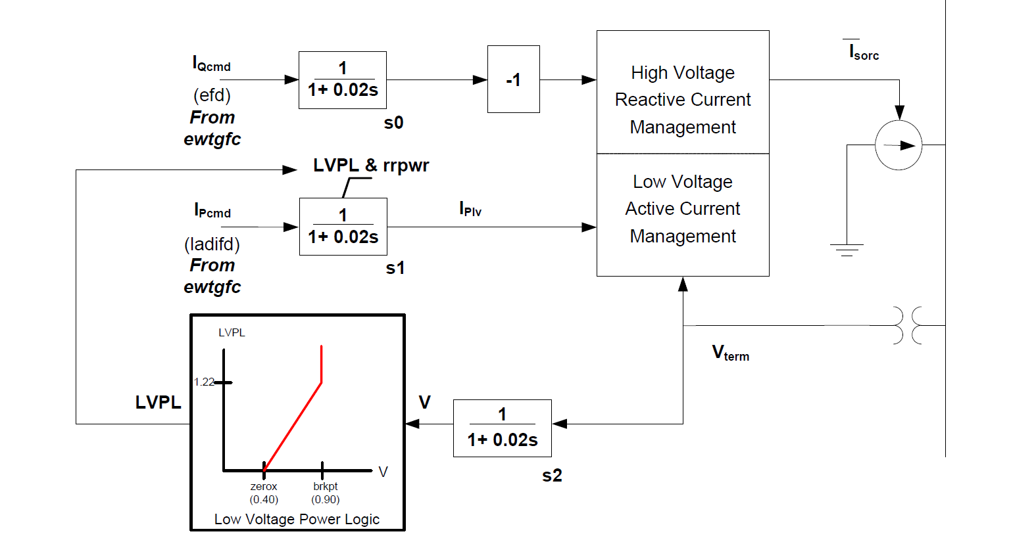
Figure 9 - Converter Model
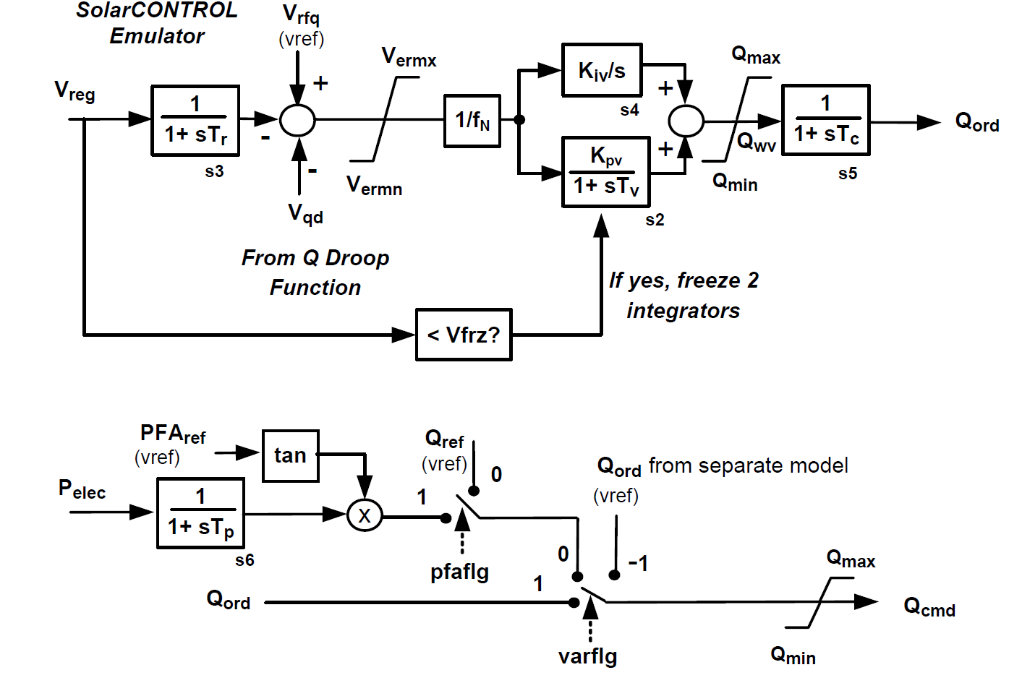
Figure 10 - Reactive Power Control Model
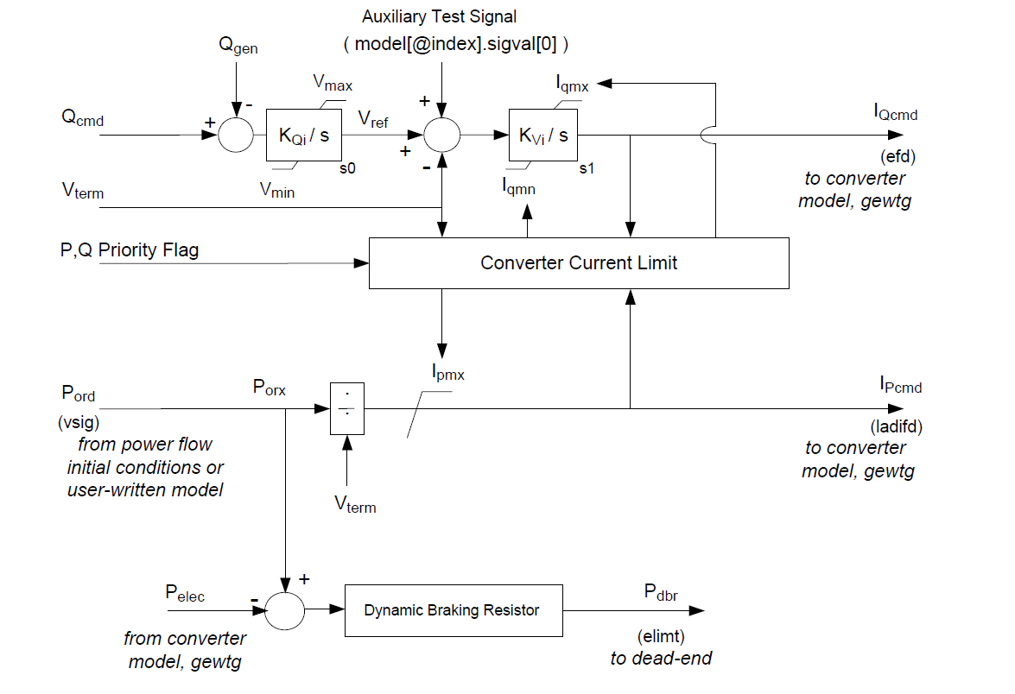
Figure 11 - Electrical Control Model

WECC Central Station PV System Model (PV1G, PV1E, PV1P)
The overall model structure is shown in Figure 9, below, and consists of a “generator” model (PV1G) to provide current injections into the network solution, an electrical control model (PV1E) for local active and reactive power control, and an optional plant controller model (PV1P) to allow for plant-level active and reactive power control.

Figure 12 Overall Model Structure for PV1X Central Station PV System Model

PV1G model
The current injection model incorporates a high bandwidth current regulator (similar to the existing WECC WT4G model) that injects real and reactive components of inverter current into the external network during the network solution in response to real and reactive current commands. Current injection shall include the following capabilities:

- User settable high voltage reactive current management at the generator (inverter) bus similar to that in the WT4G model
- Low voltage active current management similar to that in the WT4G model to approximate the response of the inverter PLL controls during voltage dips
- Low voltage power logic similar to that in the WT4G model to allow for a controlled response of active current during and immediately following voltage dips

The protective function model incorporates either of the following:

- A set of six or more definite time voltage and frequency protective elements used to trip the generation represented by the model. Each element shall have an independent user-settable pickup and time delay.

- The ability to trip the generation represented by the model via external models providing the same functionality.
Figure 13 - PV1G Model Block Diagram

PV1E model
The active power control subsystem shall provide the active current command to the current injection model. The active current command shall be subject to apparent current limiting, with user-selectable priority between active and reactive current. The active current command shall be derived from a reference active power and the inverter terminal voltage determined in the network solution. The reference active power shall be the initial active power from the solved power flow case; or, in the case where a plant controller model (PV1P) is included, from the plant controller.

The reactive power control subsystem shall provide the reactive current command to the current injection model. The reactive current command shall be subject to apparent current limiting, with user-selectable priority between active and reactive current. The following reactive power control modes shall be accommodated:

- Constant power factor, based on the inverter power factor in the solved power flow case
- Constant reactive power, based either on the inverter absolute reactive power in the solved power flow case or, in the case where a plant controller model (PV1P) is included, from the plant controller.

The option to process the reactive power command via cascaded set of PI regulators for local reactive power and terminal voltage control, or to bypass these regulators and directly derive a reactive current command from the inverter terminal voltage, shall be provided. In addition, a supplementary, fast-acting reactive current response to abnormally high or low terminal voltages (again, refer to Figure 3) shall be provided.
Figure 14 PV1E Model Block Diagram

PV1P model
The plant controller model (PV1P) is an optional model used when plant-level control of active and/or reactive power is desired. The model shall incorporate the following:
- Closed loop voltage regulation at a user-designated bus. The voltage feedback signal shall have provisions line drop compensation, voltage droop response and a user-settable deadband on the voltage error signal.
- Closed loop reactive power regulation on a user-designated branch with a user-settable deadband on the reactive power error signal.
- A plant-level governor response signal derived from frequency deviation at a user-designated bus. The frequency droop response shall be applied to active power flow on a user user-designated branch. Frequency droop control shall be capable of being activated in both over and under frequency conditions. The frequency deviation applied to the droop gain shall be subject to a user-settable deadband.

Figure 15 PV1P Model Block Diagram

Generic Solar Photovoltaic Model in PSSE
A PSSE Generic Photovoltaic Model is composed of three models
- Irradiance model (IRRADU1) - this model allows users to vary the amount of solar irradiance. Users can enter up to 10 data points (time(s), irradiance(W/m2)) as CONs
- PV panel model (PANELU1) – this model linearize the electrical characteristic of a PV panel (I-V curve) with the assumption of maximum power point tracker (MPPT) is instantaneous. For each simulation step, the model reads irradiance level and outputs linearized power order.
- Electrical control model (PVEU1): this model is very similar to WT4E with variable power reference from PANELU1.

Figure 16 - PSSE Generic Photovoltaic Model

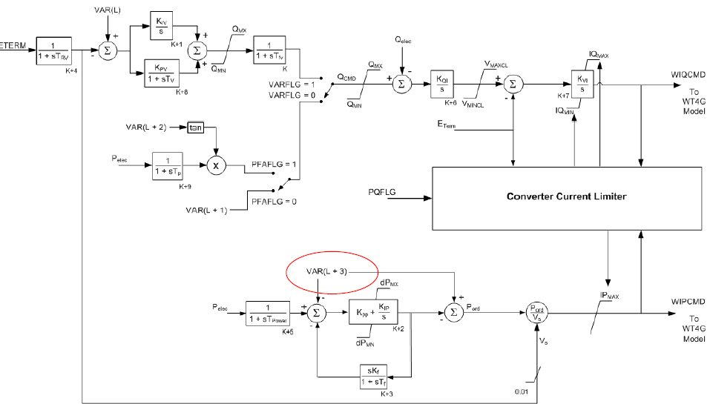
Figure 17 - Electrical control model (PVEU1)

- Converter model (PVGU1): this model is identical to WT4G.

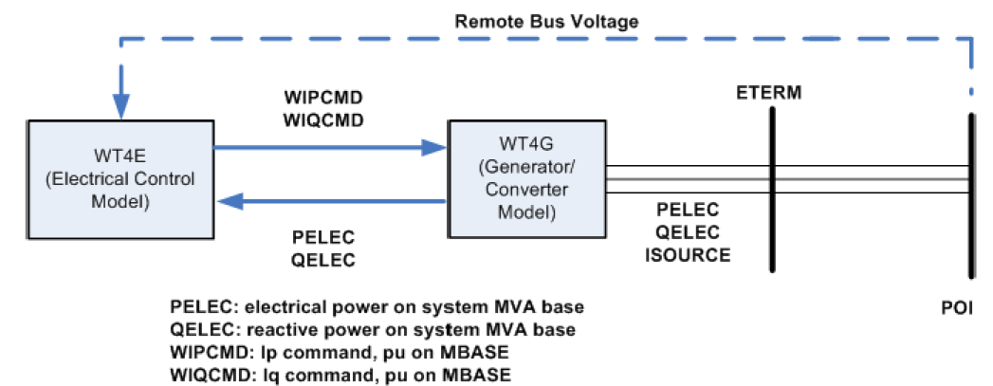
Figure 18 - Converter model (PVGU1)

Distributed Solar Resources

Distributed PV system model
Unlike central station PV plants, distributed PV systems are connected at the distribution level. In contrast with NERC and WECC central station reliability requirements, distributed PV systems at this time normally do not participate in steady state voltage regulation, and tighter bounds on operation for off-nominal voltage and frequency conditions result in significantly different fault ride-through capability.
In the near term, it is anticipated that the PV inverters applied in distributed systems will continue to comply with IEEE 1547, and will operate under constant power factor or constant reactive power modes of operation. The elimination of the closed-loop voltage regulator dynamics, along with the elimination of the DC dynamics (for the same reasons described for the Central Station model), allows for substantial simplification of the model with respect to that of the Central Station. However, unlike a Central Station plant, the terminal voltages seen by the individual inverters within the composite load in the bulk system dynamic model are likely to vary substantially. A different protection model is used to capture the effect of the diverse terminal conditions on the aggregate generation.

The active power control subsystem shall provide the active current injection to the network solution. The active current command shall be subject to apparent current limiting, with user-selectable priority between active and reactive current. The active current command shall be derived from a reference active power and the inverter terminal voltage determined in the network solution. The reference active power shall be the initial active power from the solved power flow case.

The active power control subsystem shall provide a high frequency droop (governor response) function with user-settable deadband and droop gain.

The reactive power control subsystem shall provide the reactive current command to the network solution. The reactive current command shall be subject to apparent current limiting, with user-selectable priority between active and reactive current. The reactive power control mode shall be limited to constant reactive power. The reference reactive power shall be the sum of the following:

- The initial reactive power from the solved power flow case
- A droop signal derived from voltage deviation at a user-specified bus. The voltage deviation applied to the droop characteristic shall be subject to deadband control and line drop compensation.

The protective function model shall incorporate functions which reduce generation outside of user-specified deadbands on voltage and frequency in an amount proportional to the voltage or frequency deviation. User-settable flags shall determine whether recovery of generation shall occur when voltage or frequency excursions reverse and return toward the deadband, and in what proportion.

Figure 19 Distributed PV Model Block Diagram

Forecast of distributed solar generation

References

[1] Muller, H., et al. “Concentrating solar power. A review of the technology. “Quarterly of the Royal Academy of Engineering. Ingenia 18, February/march 2004.” Available at:. Available at: http://www.trec-uk.org.uk/resources/ingenia_18_Feb_March_2004.pdf
[2] Standard Models for Variable Generation, The North American Electric Reliability Corporation (NERC), May 2010
[3] Generic Solar Photovoltaic System Dynamic Simulation Model Specification, Western Electricity Coordinating Council Modeling and Validation Work Group, 2012
[4] Joshua S. Stein, Clifford W. Hansen, Matthew J. Reno, “The variability index: a new and novel metric for quantifying irradiance and PV output variability,” presented at the World Renewable Energy Forum, Denver, CO, 2012.

https://solarhighpen.energy.gov/projects/solar_forecasting
http://www.uwig.org/pvwork/7-ahlstrom.pdf?bcsi_scan_a7ccf25998285488=0&bcsi_scan_filename=7-ahlstrom.pdf
** The pyrheliometers are use don the site to measure the direct beam solar irradiance. They must track the sun in two axis to accomplish this so they are mounted on a small 2 axis tracker system. From this measurement and the other pyranometer measurements the diffuse irradiance can be calculated by subtracting the global irradiance from the direct beam irradiance.
The full station has wind speed/direction, ambient temperatura/barometric pressure/ % rain gauge, global horizontal irradiance pyranometer, PVmodule for power supply with battery/charger, lightening rod and mounting system.

