August 2015 ERCOT Monthly Operations Report

Reliability and Operations Subcommittee Meeting
October 8th, 2015

Table of Contents
1 Report Highlights 3
2 Frequency Control 4
2.1 Frequency Events 4
2.2 Responsive Reserve Events 5
2.3 Load Resource Events 5
3 Reliability Unit Commitment 5
4 Wind Generation as a Percent of Load 6
5 Congestion Analysis 7
5.1 Notable Constraints for August 7
5.2 Generic Transmission Constraint Congestion 8
5.3 Manual Overrides for August 8
5.4 Congestion Costs for Calendar Year 2015 8
6 System Events 9
6.1 ERCOT Peak Load 9
6.2 Load Shed Events 9
6.3 Stability Events 9
6.4 Notable PMU Events 10
6.5 TRE/DOE Reportable Events 10
6.6 New/Updated Constraint Management Plans 10
6.7 New/Modified/Removed SPS 10
6.8 New Procedures/Forms/Operating Bulletins 10
7 Emergency Conditions 10
7.1 OCNs 10
7.2 Advisories 10
7.3 Watches 11
7.4 Emergency Notices 11
8 Application Performance 11
8.1 TSAT/VSAT Performance Issues 11
8.2 Communication Issues 11
8.3 Market System Issues 11
9 Net-Forecast Bias Applied to NSRS Procurement for August 2015 11
Appendix A: Real-Time Constraints 12

Report Highlights
- The unofficial ERCOT peak for August was 69,783MW. This was a record for the ERCOT region.
- There were five frequency events in August. PMU data indicates the ERCOT system transitioned well in each case.
- There were two instances where Responsive Reserves were deployed, all of which were the result of frequency events.
- There were four RUC commitments in August. Two in the Northern region, one in the Southern region and one in the Coastal region. All were due to local congestion.
- The level of reportable SCED congestion decreased in August. This congestion was due primarily to planned outages and area load/gen patterns. There were eleven days of activity on the Zorillo - Ajo Generic Transmission Constraint (GTC) in August.
- 08/13/15 - ERCOT issued a Media Appeal for energy conservation as a precautionary measure to ensure system reliability due to hot weather causing high ERCOT demands and reduced generation capability due to unplanned generation outages.
- An advisory was issued due to the Voltage Security Assessment Tool being unavailable.

Frequency Control

Frequency Events

The ERCOT Interconnection experienced six frequency events in August, all of which resulted from Resource trips. The average event duration was approximately 0:03:45.

When analyzing frequency events, ERCOT evaluates PMU data according to industry standards. Events with an oscillating frequency of less than 1 Hz are considered to be inter-area, while higher frequencies indicate local events. Industry standards specify that damping ratio for inter-area oscillations should be 3.0% or greater. All events listed below indicate the ERCOT system met these standards and transitioned well after each disturbance.

Reported frequency events will include both frequency events where frequency was outside the range of 60±0.1 Hz as well as those determined to be Frequency Measurable Events (FME) as defined by BAL-001-TRE-1. Delta Frequency is defined as the difference between the pre-perturbation and post-perturbation frequency. The Duration of Event is defined as the time it takes for the frequency to recover to lesser/greater of the frequency at the time of the frequency event (t(0) or “A-point”) for low/high-frequency events, respectively. Further details on FMEs can be found in the MIS posted BAL-001-TRE-1 PDCWG Unit Performance reports. A summary of the frequency events is provided below:

On 8/25/2015 there was a loss of approximately 445 MW of load in the Rio Grande Valley. This loss of load was not ERCOT initiated.

Date and Time | Delta Frequency | Max/Min Frequency | Duration of Event | PMU Data |  | Comments
 | (Hz) | (Hz) |  | Oscillation Mode (Hz) | Damping Ratio
8/19/2015 18:37 | 0.061 | 59.93 | 0:05:02 | PMU Data Not Available. |  | Unit Trip of 450 MW
8/25/2015 16:18 | -0.033 | 60.06 | 0:02:26 | PMU Data Not Available. |  | Loss of 443 MW of load
8/25/2015 22:41 | 0.023 | 59.90 | 0:01:57 | PMU Data Not Available. |  | Unit Trip of 481 MW
8/26/2015 14:37 | 0.058 | 59.91 | 0:05:12 | PMU Data Not Available. |  | Unit Trip of 456 MW
8/27/2015 21:11 | 0.064 | 59.89 | 0:04:07 | 0.8 | 5% | Unit Trip of 632 MW
 |  |  |  | 1.22 | 15%

(Note: frequency events highlighted in blue have been identified as FMEs per BAL-001-TRE-1 and the Performance Disturbance Compliance Working group.)

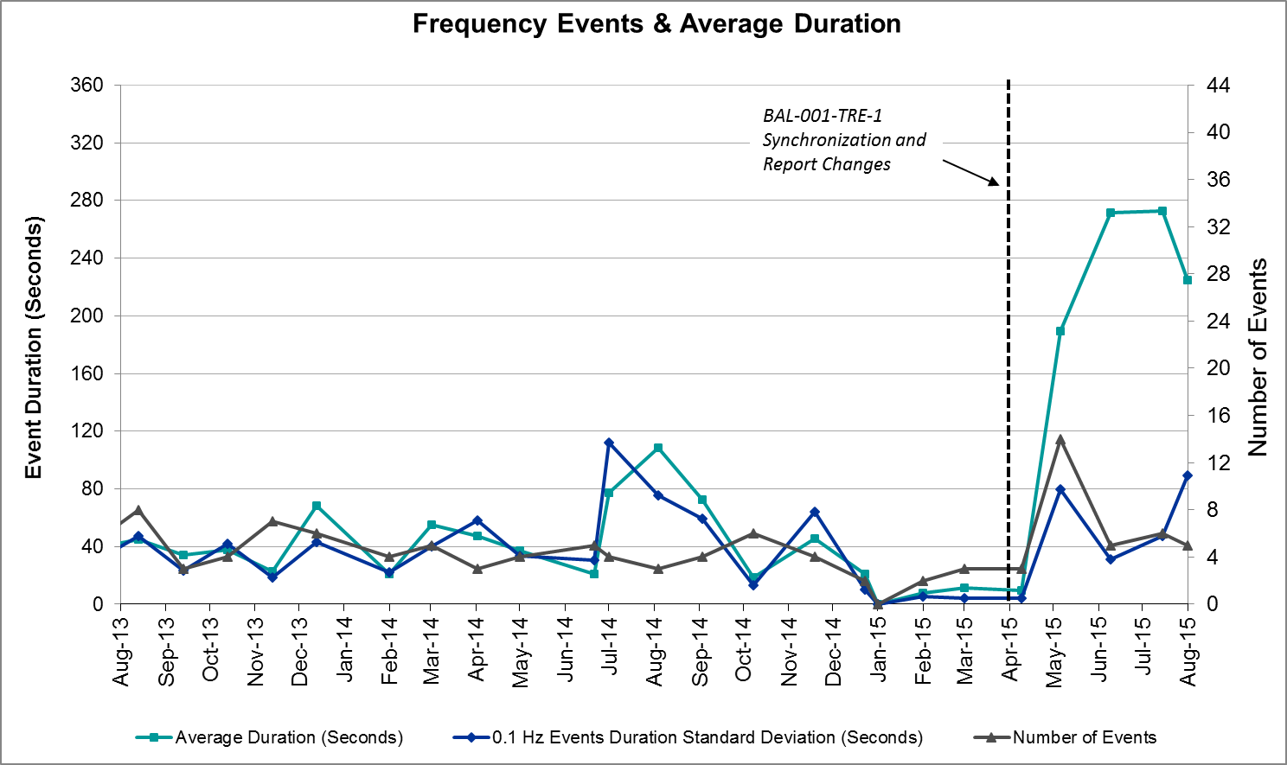

Responsive Reserve Events

There were two events where Responsive Reserve MWs were released to SCED in August. The events highlighted in blue were related to frequency events reported in section 2.1 above.

Date and Time | Date and Time | Duration of Event | Maximum MWs Released | Comments
Released to SCED | Recalled
8/25/2015 22:41:26 | 8/25/2015 22:43 | 00:01:57 | 158.03
8/27/2015 21:11:44 | 8/27/2015 21:15 | 00:04:07 | 87.26

Load Resource Events
There were no load resource deployment events in August.

Reliability Unit Commitment
ERCOT reports on Reliability Unit Commitments (RUC) on a monthly basis. Commitments are reported grouped by operating day and weather zone. The total number of hours committed is the sum of the hours for all the units in the specified region. Additional information on RUC commitments can be found on the MIS secure site at Grid Generation Reliability Unit Commitment.

There were no DRUC commitments in August.

HRUC Commitments
Resource Location | # of Resources | Operating Day | Total # of Hours Committed | Total MWhs | Reason for commitment
Northern | 1 | 8/10/2015 | 6 | 366 | Local Congestion
Coastal | 1 | 8/15/2015 | 6 | 1,440 | Local Congestion
Southern | 1 | 8/26/2015 | 3 | 117 | Local Congestion
Northern | 1 | 8/31/2015 | 1 | 118 | Local Congestion

Wind Generation as a Percent of Load
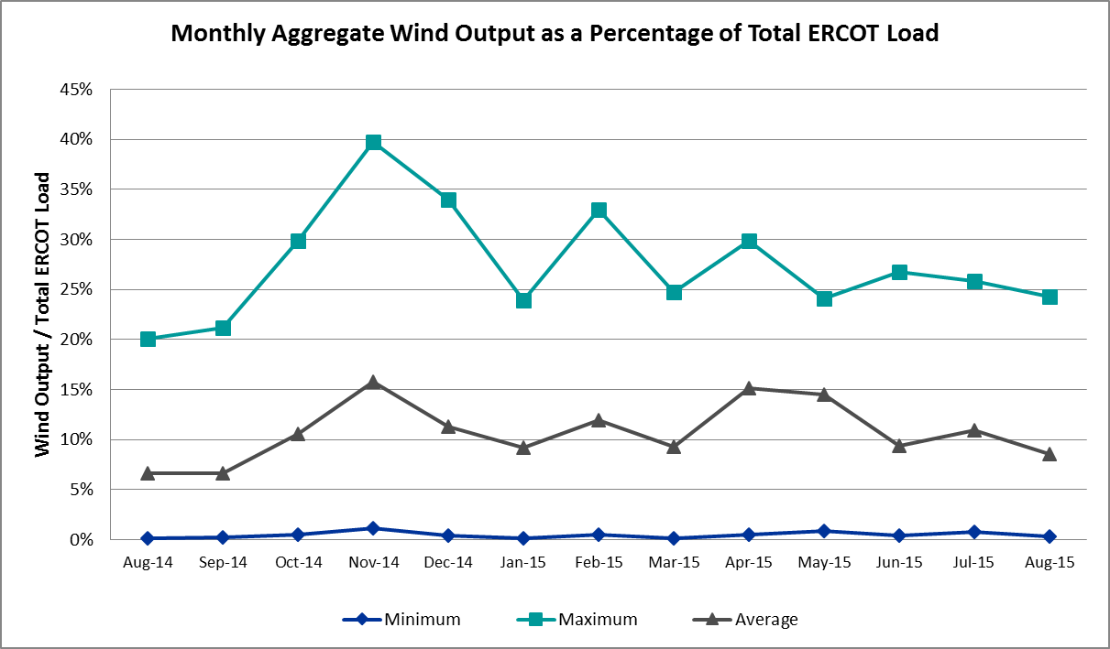

Congestion Analysis
The number of congestion events experienced by the ERCOT system increased in August due to planned outages and area load/gen patterns. There were fourteen days of activity on the Generic Transmission Constraints (GTCs) in August.

Notable Constraints for August

Nodal protocol section 3.20 specifies that ERCOT shall identify transmission constraints that are active or binding three or more times within a calendar month. As part of this process, ERCOT reports congestion that meets this criterion to ROS. In addition ERCOT also highlights notable constraints that have an estimated congestion rent exceeding $1,000,000 for a calendar month. These constraints are detailed in the table below. Rows highlighted in blue indicate the congestion was affected by one or more outages. For a list of all constraints activated in SCED for the month of August, please see Appendix A at the end of this report.

Contingency | Overload | # of Days Constraint Active | Estimated Congestion Rent | Transmission Project
Collin Ses to Collin Switch 345 Kv 138 KV | Collin Switch to Collin SES 138 kV | 5 | $9,098,021
North Alvin Tnp to Meadow 138 KV | PH Robinson to Southshore TNP 138 kV | 2 | $6,531,939
Oklaunion Xfh (3)345/138 KV | Southwest Vernon 138/69 kV | 7 | $1,370,440
Lewisville Switch Axfmr12 345/138 kV | Euless - Grapevine Highway 360 138 kV (1065_L) | 2 | $1,086,886 | 11TPIT0012  Nov-15
Basecase | Zorillo - Ajo GTC | 13 | $938,444
DKCT Roans Prarie-Rothwood & Singleton-Tomball 345kV | Singleton - Zenith 345 kV (SNGZEN99) | 4 | $877,771 | 2013-R63
Shamburger Switch - Martin Lake Ses 345 kV | Elkton - Tyler West 138 kV | 4 | $547,908 | 2014-E3
Olinger - Firewheel And Elm Grove 138kv | Olinger to Ben Davis 138 kV | 6 | $284,906 | 3774  Dec-17
Laquinta - Lobo 138 kV | Bruni 138_69_1 138/69 kV | 10 | $253,303
DCKT Whitepint - Lon Hill and South Texas Project 345 kV | Rincon to Bonnieview 69 kV | 4 | $208,322
Gila - Hiway 9 138 kV | Gila - Morris Street 138 kV | 6 | $158,986
Coleto Creek - Pawnee Switching Station 345 KV | Coleto Creek to Kenedy Switch 138 kV | 9 | $125,191
DCKT Marion - Zorn and Clear Springs 345 kV | Comal to Loop 337 138 kV | 5 | $20,613 | 4464  Dec -15
Laquinta - Lobo 138 kV | Falfurrias 138/69 kV | 5 | $18,040 | 3441  Dec-15
Ennis Switch - Desoto Switch 138 kV | Ennis West Switch - Waxahachie 138 kV | 7 | $10,519

Generic Transmission Constraint Congestion
There were eleven days of activity on the Zorillo - Ajo GTC in August. There was no activity on the remaining GTCs during the Month of August.

Manual Overrides for August
There were no manual overrides for the month of August 2015

Congestion Costs for Calendar Year 2015
The following table represents the top twenty active constraints for the calendar year based on the estimated congestion rent attributed to the congestion. ERCOT updates this list on a monthly basis.

Contingency | Binding Element | # of 5-min SCED Intervals | Estimated Congestion Rent | Transmission Project
DKCT Roans Prarie-Rothwood & Singleton-Tomball 345kV | Singleton - Zenith 345 kV | 2362 | $ 24,704,164.66 | 2013-R63
San Angelo North 138_69T1 138/69kV | San Angelo College Hills 138_69T1 138/69 kV | 1100 | $ 12,124,530.71 | 3663
Collin Ses to Collin Switch 345 Kv 138 KV | Collin Switch to Collin SES 138 kV | 235 | $ 9,098,020.82
DCKT Flewellen - Obrien and Maso Road 138 kV | Hockley - Betka 138 kV | 531 | $ 8,458,508.30 | 3682A, 3682B
Topeka Termination - West Levee Switch 345 kV | Cedar Hill Switch - Mountain Creek 138 kV | 276 | $ 7,327,162.35 | 13TPIT0060
DCKT Hill Country - Marion and Elmcreek 345 kV | Marion - Skyline 345 kV | 1250 | $ 7,311,520.20 | 4081
DCKT Jewett - Singleton 345 kV | Twin Oak Switch - Btu_Jack_Creek 345 kV | 4705 | $ 7,249,126.12
San Angelo College Hills 138_69T1 138/69 kV | SA Power 69T1 138/69 kV | 1456 | $ 7,141,012.26
North Alvin Tnp to Meadow 138 KV | PH Robinson - Southshore TNP 138 kV | 187 | $ 6,531,938.72
DCKT Lost Pines - Austrop & Dunlop 345 kV | Fayette Plant 1 - Fayette Plant 2 345 kV | 2975 | $ 6,416,648.12
Los Fresnos - Loma Alta Substation 138 kV | La Palma - Villa Cavazos 138 kV | 589 | $ 4,798,284.09
Hutto Switch Axfmr 1 (3) 345/138 kV | Gilleland - Pflugerville 138 kV | 565 | $ 4,639,066.89 | 16TPIT0062
Bevo Substation - Asherton 138 kV | Hamilton Road - Maverick 138 kV | 320 | $ 4,635,315.00 | 16TPIT0024
Orange Grove Switching Station - Lon Hill 138 kV | Lon Hill - Smith 69 kV | 4186 | $ 4,156,156.06 | 16TPIT0026
Rio Hondo (2H) Axfmr 345/138 kV | Aderhold - Elsa 138 kV | 121 | $ 4,047,071.38
Falcon Seaboard - Midland East 345 kV | Odessa to Glenhaven 138 kV | 70 | $ 3,753,435.92
DCKT Calaveras-Hotwells & Laredo1 138 kV | Calaveras - Streich 138 kV | 738 | $ 3,654,243.26 | 16TPIT0011
Falcon Seaboard to Morgan Creek Ses 345 KV | Glenhaven - Crmwd 8 Tap 138 kV | 65 | $ 3,638,593.37 | 4173
DCKT West Levee Switch - 800/900 Network 138 kV | East Levee Switch - Reagan Street 138 kV | 366 | $ 3,589,511.29 | 2014-NC28
Bates - Frontera 138 kV | Frontera - Goodwin 138 kV | 249 | $ 3,476,829.26

System Events

ERCOT Peak Load
The unofficial ERCOT peak load for the month was 69,783MW and occurred on August 10th during hour ending 17:00.

This demand value was a record peak for ERCOT.

Load Shed Events
None.

Stability Events
None.

Notable PMU Events
ERCOT analyzes PMU data for any significant system disturbances that do not fall into the Frequency Events category reported in section 2.1. The results are summarized in this section once the analysis has been completed.

There were no reportable events in August.

TRE/DOE Reportable Events

08/13/15 - ERCOT issued a Media Appeal for energy conservation as a precautionary measure to ensure system reliability due to hot weather causing high ERCOT demands and reduced generation capability due to unplanned generation outages.

New/Updated Constraint Management Plans
None.

New/Modified/Removed SPS
One Special Protection System was removed in August.
- Schertz to Parkway SPS
One Special protection System was modified in August.
- Morgan Creek Switching Station SPS

New Procedures/Forms/Operating Bulletins
None.

Emergency Conditions

OCNs
Date and Time | Description
8/10/15 02:33 | ERCOT issued an OCN for a projected reserve capacity shortage for hours ending 15:00 through 20:00.
08/12/15 09:54 | ERCOT issued an OCN for a projected reserve capacity shortage for hours ending 14:00 through 20:00.
08/13/15 03:00 | ERCOT issued an OCN for a projected reserve capacity shortage for hours ending 14:00 through 21:00.
08/14/15 02:58 | ERCOT issued an OCN for a projected reserve capacity shortage for hours ending 15:00 through 18:00.

Advisories
Date and Time | Description
08/05/15 15:22 | ERCOT issued an Advisory due to Physical Responsive Capability being below 3000 MW.
08/06/15 10:00 | ERCOT issued an Advisory due to the extreme hot weather with forecasted temperatures to be above 103°F in the North Central and South Central weather zones.
08/07/15 01:00 | ERCOT issued an Advisory due to the Voltage Security Assessment Tool being unavailable.
08/09/15 16:12 | ERCOT issued an Advisory due to Physical Responsive Capability being below 3000 MW
08/12/15 14:03 | ERCOT issued an Advisory due to Physical Responsive Capability being below 3000 MW
08/13/15 14:24 | ERCOT issued an Advisory due to Physical Responsive Capability being below 3000 MW
08/24/15 15:33 | ERCOT issued an Advisory due to Physical Responsive Capability being below 3000 MW

Watches
Date and Time | Description
08/13/15 15:10 | ERCOT issued a Watch due to Physical Responsive Capability being below 2500 MW.

Emergency Notices
None.

Application Performance
ERCOT system applications performed well in August. There were no issues to report.

TSAT/VSAT Performance Issues
On August 7th, an Advisory was issued due to the Voltage Security Assessment Tool being unavailable.

Communication Issues
None.

Market System Issues
None.

Net-Forecast Bias Applied to NSRS Procurement for August 2015
Each month, ERCOT calculates a net Forecast Bias pursuant to the ERCOT Ancillary Services Methodology for procurement of Non-Spinning Reserve Service (NSRS). The table below indicates the amount of net Forecast Bias that was applied to the NSRS procurement for specified blocks of time for the month of August, 2015.

Blocks | Negative Net Load Forecast Average Error - By Weather Zone for the 5 Largest Zones
 | Coast | East | North Central | South Central | Southern
1-2 | 0 | 0 | 0 | 0 | 0
3-6 | 0 | 0 | 0 | 0 | 0
7-10 | 0 | 0 | 0 | 0 | 0
11-14 | 0 | 0 | 0 | 0 | 0
15-18 | -155 | -25 | -182 | -91 | -46
19-22 | -141 | -23 | -167 | -84 | -43
23-24 | 0 | 0 | 0 | 0 | 0

Appendix A: Real-Time Constraints
The following is a complete list of constraints activated in SCED for the month of August. Full contingency descriptions can be found in the Standard Contingencies List located on the MIS secure site at Grid Generation Reliability Unit Commitment.

Contingency | Constrained Element | From Station | To Station | # of Days Constraint Active
SANACN15 | 860__A | CN345 | CNSES | 5
STNNMDO8 | PHR_SOU_1 | PHR | SOUSHORE | 2
XOKL58 | VERS_69_1 | VERS | VERS | 7
XLWS58 | 1065__L | EULES | GRHWY | 2
BASE CASE | ZO_AJO |  |  | 13
DRNS_TB5 | SNGZEN99_A | SNG | ZEN | 4
XWI2N89 | WINKS_FMR1 | WINKS | WINKS | 5
DFL_MAR8 | BETHK_66_A | HK | BET | 2
SSHBMLS5 | 1000__A | ELKTN | TYWST | 4
SBEVASH8 | DIL_COTU_1 | DILLEYSW | COTULAS | 1
SBIGDIL8 | ASHERT_W_BATE1_1 | W_BATESV | ASHERTON | 1
DOLIELM8 | OLI_BEN1_1 | OLINGR | BNDVS | 6
SLAQLOB8 | BRUNI_69_1 | BRUNI | BRUNI | 10
DWH_STP5 | BONIVI_RINCON1_1 | RINCON | BONIVIEW | 4
SGILNU78 | GILA_MORRIS1_1 | GILA | MORRIS | 6
SSIGSAN8 | NCA_SMTP_1 | SANMTAP | NCALHMS | 1
XLI2G58 | 1310__D | CDHSW | MFTPN | 2
SCOLPAW5 | COLETO_KENEDS1_1 | COLETO | KENEDSW | 9
SATKDAN8 | NAL_BRIR_1 | NALL_LN | BRIRCRT | 1
XLOB58 | DILLEY_JARDIN1_1 | DILLEYSW | JARDIN | 1
SFORYEL8 | FORTMA_MASN1_1 | FORTMA | MASN | 1
XBRK89 | 6635__B | LENSW | ESTTP | 1
DFPPFAY5 | 190T152_1 | GIDEON | WINCHE | 2
SCLALON8 | KOCH_H_LON_HI1_1 | LON_HILL | KOCH_HF | 2
SBRAUVA8 | HAMILT_MAVERI1_1 | HAMILTON | MAVERICK | 2
SWCOW2C8 | G138_18_1 | WCOLMAIN | WCOLLOCL | 1
DHUTGAB8 | 211T147_1 | GILLCR | MCNEIL_ | 1
SN_MNED8 | MCOLL__NEDIN1_1 | NEDIN | MCOLL_RD | 1
SMNHPBS8 | 6485__A | MOSSW | PBSES | 1
XATK89 | NAL_BRIR_1 | NALL_LN | BRIRCRT | 1
DMARZOR5 | 91T335_1 | COMAL | LOP337 | 5
XLOB58 | FREER_SAN_DI1_1 | SAN_DIEG | FREER | 2
SLAQLOB8 | FALFUR_69A1 | FALFUR | FALFUR | 5
SVEROK28 | VERS_69_1 | VERS | VERS | 1
DBIGKEN5 | BONDRO_SONR1_1 | SONR | BONDROAD | 1
DHILELM5 | MAR_SKY_1 | MARION | SKYLINE | 1
DFERPAL8 | 38T365_1 | WIRTZ | FLATRO | 3
SPAWSAN5 | PAWNEE_XF1 | PAWNEE | PAWNEE | 1
SRDODES8 | 940__C | ENWSW | WXHCH | 7
XBLE89 | BROOKH_P_LAVA1_1 | P_LAVACA | BROOKHOL | 2
XDMT158 | 6215__A | BCKSW | CGRSW | 1
DSTEXP12 | BLESSI_LOLITA1_1 | LOLITA | BLESSING | 1
DWIRPAL8 | 38T365_1 | WIRTZ | FLATRO | 1
XLOB58 | ASHERT_CATARI1_1 | ASHERTON | CATARINA | 2
SLOBSAN5 | FREER_SAN_DI1_1 | SAN_DIEG | FREER | 2
SMCSCDH8 | 3210__A | CDHSW | MCSES | 1
SZEPCMN8 | 670__B | BRNSW | CMPBW | 1
BASE CASE | LNCRK2_T2 | LNCRK2 | LNCRK2 | 1
SPAWCAL5 | PAWNEE_XF1 | PAWNEE | PAWNEE | 1
DMCSCDH8 | 3160__A | CDCSW | OKCLS | 1
XLOB58 | PALDRO_PEARSAL_1 | PEARSALL | PALODURO | 1
DMARZOR5 | 428T428_1 | SEGUIN | SEGUWE | 1
DJEWSNG5 | JK_TOKSW_1 | TOKSW | JK_CK | 1
SMNWORA8 | WHI_ORN_1 | ORN | WHITT | 1
SPAWSAN5 | COLETO_KENEDS1_1 | COLETO | KENEDSW | 1
DNB_JOR5 | DPWLYD70_A | LYD | DPW | 1
DTRCELK5 | 1820__A | SCSES | TROUP | 4
SPAWLON5 | PAWNEE_XF1 | PAWNEE | PAWNEE | 1
SREVDIL8 | ASHERT_CATARI1_1 | ASHERTON | CATARINA | 1
XPAW58 | COLETO_KENEDS1_1 | COLETO | KENEDSW | 1
SLOLBLE8 | BLESSI_PALACI1_1 | BLESSING | PALACIOS | 1
SMARZOR5 | 419T419_1 | CLEASP | MARION | 1
SMOOPEA8 | PEARSALL_69_4 | PEARSALL | PEARSALL | 1
SSCUSUN8 | ROTN_WOLFGA1_1 | WOLFGANG | ROTN | 1
SOAKNIC8 | NICOLE_ORNT1_1 | NICOLE | ORNT | 1
BASE CASE | VALIMP |  |  | 1
SBRAUVA8 | EAGLHY_ESCOND1_1 | EAGLHYTP | ESCONDID | 1
DEULLIG8 | 1140__C | DFWD1 | DFWCE | 2
DALNRYS5 | 1627__A | APOLLO | REAST | 1
XLOB58 | CATARI_PILONC1_1 | CATARINA | PILONCIL | 1
XDOW58 | BLESSI_MARKHA1_1 | BLESSING | MARKHAM | 1
DCHBJOR5 | CBYRNG87_A | CBY | RNG | 1
SDFWLI28 | 1140__C | DFWD1 | DFWCE | 3
STNWRIO8 | M_69_N1_1 | TNPINION | TNFS | 1
DHKBCRL5 | 1150__C | DFWD1 | IRVNR | 1
DEULLIG8 | 1150__C | DFWD1 | IRVNR | 1
SP5CAG8 | E1_R2_1 | E1 | R2 | 1
SVICCOL8 | COLETO_VICTOR1_1 | COLETO | VICTORIA | 1

