TDTWG Meeting Notes
August 18, 2015
9:30 AM - 4:00 PM

1 | Introductions  Review of Agenda  Antitrust Statement | Monica Jones | 9:30 AM
2 | Review / Approve July Meeting Notes  - July meeting notes were reviewed and no changes  - June meeting notes had some minor edits. | Monica Jones | 9:40 AM
3 | ERCOT System Instances (Outages and Failures)  - Dave presented Incident Report  - June/July met all metrics  - 7/1 NAESB issue: ERCOT ran MP NAESB configurations that were out of date which resulted in reverting NAESB configuration to a prior version and caused transaction backlog. Backlog was cleared and normal processing resumed.  - Supplemental AMS Interval Data Report fix was implemented on June 22nd and no issues have occurred since then. ERCOT considers this resolved. | Dave Pagliai | 9:50 AM
4 | MarkeTrak Monthly Performance Review  - Dave reviewed the MT API performance numbers.  - QueryList, QueryDetail and Update are the categories of most interest to the market. They are the most highly used API functionality.  - ERCOT proposed SLOs:  - QueryDetail: 750 milliseconds (0.75 seconds)  - Update: 12000 milliseconds (12.000 seconds)  - ERCOT still developing SLO for “QueryList”.  - Existing SLOs will be adjusted to reflect the new methodology that is actually happening in real life. The existing SLO methodology used “synthetic” MT commands and the new SLO methodology uses actual MT API commands to measure performance. | Dave Pagliai | 10:00 AM
5 | Review Q2 Performance Measures  - 100% across the board  - Going forward, TDTWG will review Quarterly performance metrics if/when there are percentages less than 100%. | Catherine Meiners | 10:20 AM
6 | TDTWG name change discussion -- Texas Data Transport & MarkeTrak Systems Working Group (TDTMS)  - TDTWG will absorb MTTF but if the complete name is to be changed, it is too labor intensive for ERCOT to port over all the historical documents. The history needs to stay intact.  - However, if keeping the name the same but add on the MarkeTrak Systems onto the name, the level of efforts required by ERCOT is relatively minimal.  - TDTWG needs to do the following:  - Transition all TDTWG documents to reflect TDTMS  - Update the Scope posted on the TDTWG  - Develop a TDTMS Working Group Procedures  - Review Data Transport Guide to see if anything needs to be added for the MT process and change references to TDTWG to reflect TDTMS  - ERCOT will help link all the MarkeTrak “Key Documents” to reside under TDTMS  - Keep MT Listserv alive indefinitely (ERCOT does not see problems with this)  - ACTION ITEM: Add TDTWG recommendation to the RMS Update in September “TDTWG to absorb MTTF and will transition all Key Documents as appropriate.” | All | 10:45 AM
7 | SCR786-IA discussion  Due to added scrutiny at PRS for budget dollars, ERCOT is in the middle of evaluating the full IA as well as additional ALTERNATIVES that will help reduce the costs.  Main cost driver: setting up an environment that 130 MPs can connect to that have all of ERCOT’s security and firewall functionality for a ‘market-facing’ environment.  Next Steps: Flush out the Alternative Option costs and price it out while Tabling the ‘full’ IA at PRS for further evaluation so TDTWG/RMS does not have to rewrite another SCR if the ‘full’ IA is not approved. ERCOT plans to bring both the ‘full’ IA and “alt” IA at the same time.  Alternatives to bring the price down:  ALT #1 – Build out the current CERT environment  2 big changes: 1) Remove SIM dates from CERT; 2) No blackout periods (will follow Prod schedule)  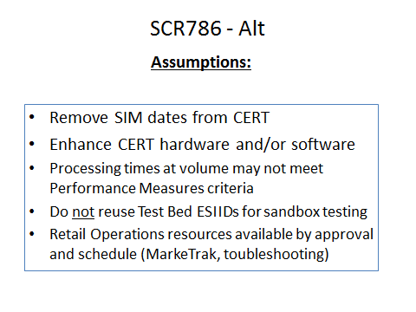  Notes: ERCOT would ask that MPs coordinate testing efforts done in the Testing Environment because internal ERCOT teams will not be monitoring the Testing Environment like they would Production.  - Does removing SIM dates from CERT cause any concerns to MPs? CNP and TXU agrees that removing SIM dates would be a great move.  - Should TXSET look at the value of SIM dates, and can the market remove that requirement?  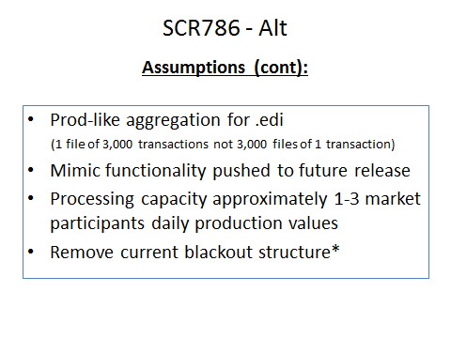  Notes: ERCOT’s ability to mimic CRs and TDSPs is unlikely to be built with the initial environment build out. It would double the cost because ERCOT would have to build out a complete copy of CR and TDSP functionality.  - ERCOT suggests that another SCR would be created when the time comes to implement the ‘mimic’ fuctionality – IF the market wants it. It would not be included in the intial build out – it is too big to fit in the SCR786 scope.  - Nothing would change with Flight procedures.  - For day to day testing efforts, schedule coordination would not necessarily be needed; but if MPs wish to do VOLUME TESTING, coordination needs to occur with ERCOT.  - ERCOT’s proposed environment would be able to handle “normal production volumes” for 1-3 MPs without breaking, but if more volume is encountered, the environment would not be able to handle it.  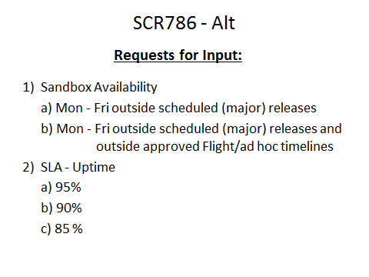  Notes: Sandbox availability would follow the same schedule as release schedules – with no blackout periods. It would follow the PROD timeline. It would be available M-F 8am-5pm.  - SLA uptime metric: Prod is 99%, what should the testing environment be?  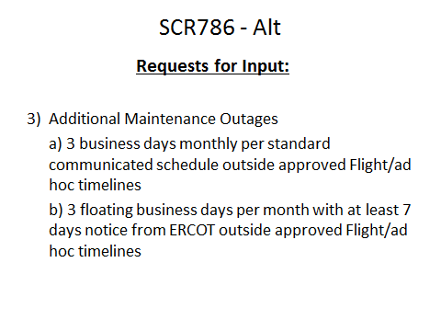 | All | 1:30 PM
8 | Remaining 2015 TDTWG meetings -- changing to Face-to-face  TDTWG to meet F2F for the remainder of the year to work on TDTMS transition documentation and efforts needed for SCR786.  • 9/9/15 moved to Tuesday, 9/8/15 9:30 am – 4:00 pm – Room 168 (COPS meeting on 9/9/15)  • 10/14/15 moved to Tuesday, 10/13/15 9:30 am – 4 pm; Room 168 (Board meeting 10/13/15 - COPS meeting on 10/14/15)  • November to stay the same – 11/11/15 1pm-5pm  • 12/9/15 moved to Tuesday, 12/8/2015 9:30 am – 4 pm; Room 168 (Board meeting 12/8/15 - COPS meeting on 12/9/15)  Jim to coordinate market participant communication with Suzy Clifton. | All | 3:00 PM
9 | Update to RMS | Monica Jones | 3:30 PM
10 | Adjourn |  | 4:00 PM

