July 2015 ERCOT Monthly Operations Report

Reliability and Operations Subcommittee Meeting
September 3, 2015

Table of Contents
1 Report Highlights 3
2 Frequency Control 4
2.1 Frequency Events 4
2.2 Responsive Reserve Events 5
2.3 Load Resource Events 5
3 Reliability Unit Commitment 6
4 Wind Generation as a Percent of Load 6
5 Congestion Analysis 7
5.1 Notable Constraints for July 7
5.2 Generic Transmission Constraint Congestion 8
5.3 Manual Overrides for July 8
5.4 Congestion Costs for Calendar Year 2015 8
6 System Events 9
6.1 ERCOT Peak Load 9
6.2 Load Shed Events 9
6.3 Stability Events 9
6.4 Notable PMU Events 10
6.5 TRE/DOE Reportable Events 10
6.6 New/Updated Constraint Management Plans 10
6.7 New/Modified/Removed SPS 10
6.8 New Procedures/Forms/Operating Bulletins 10
7 Emergency Conditions 10
7.1 OCNs 10
7.2 Advisories 10
7.3 Watches 10
7.4 Emergency Notices 10
8 Application Performance 11
8.1 TSAT/VSAT Performance Issues 11
8.2 Communication Issues 11
8.3 Market System Issues 11
9 Net-Forecast Bias Applied to NSRS Procurement for July 2015 11
Appendix A: Real-Time Constraints 12

Report Highlights
- The unofficial ERCOT peak for July was 67,624 MW. This was a record for the month of July.
- There were six frequency events in July. PMU data indicates the ERCOT system transitioned well in each case.
- There were six instances where Responsive Reserves were deployed, all of which were the result of frequency events.
- There were two RUC commitments in July. Both in the Southern region due to local congestion.
- The level of reportable SCED congestion increased in July. This congestion was due primarily to planned outages and area load/gen patterns. There were thirteen days of activity on the Zorillo - Ajo Generic Transmission Constraint (GTC) in July as well as one day on the North to Houston GTC.
- There were no significant system events for the month of July.
- ERCOT Applications performed well throughout the month. There were no ERCOT related application performance issues.
- Issued a new Generic Transmission Constraint due to outages in the panhandle region.
- 07/03/15 – ERCOTs initial indications showed approximately 317 MW tripped due to low voltage and loss of transmission southern region. This load was lost as a result of a multiple contingencies and NOT as a result of an ERCOT instruction.
- 07/29/15 – The simultaneous loss of three generators in the central region resulted in the loss of approximately 1507 MW.
- 07/30/15 - ERCOT issued a Media Appeal for energy conservation as a precautionary measure to ensure system reliability due to hot weather causing high ERCOT demands and reduced generation capability due to unplanned generation outages.

Frequency Control

Frequency Events

The ERCOT Interconnection experienced six frequency events in July, all of which resulted from Resource trips. The average event duration was approximately 0:04:39.

When analyzing frequency events, ERCOT evaluates PMU data according to industry standards. Events with an oscillating frequency of less than 1 Hz are considered to be inter-area, while higher frequencies indicate local events. Industry standards specify that damping ratio for inter-area oscillations should be 3.0% or greater. All events listed below indicate the ERCOT system met these standards and transitioned well after each disturbance.

Reported frequency events will include both frequency events where frequency was outside the range of 60±0.1 Hz as well as those determined to be Frequency Measurable Events (FME) as defined by BAL-001-TRE-1. Delta Frequency is defined as the difference between the pre-perturbation and post-perturbation frequency. The Duration of Event is defined as the time it takes for the frequency to recover to lesser/greater of the frequency at the time of the frequency event (t(0) or “A-point”) for low/high-frequency events, respectively. Further details on FMEs can be found in the MIS posted BAL-001-TRE-1 PDCWG Unit Performance reports. A summary of the frequency events is provided below:

Date and Time | Delta Frequency | Max/Min Frequency | Duration of Event | PMU Data |  | Comments
 | (Hz) | (Hz) |  | Oscillation Mode (Hz) | Damping Ratio
7/1/2015 1:15 | 0.06 | 59.85 | 0:04:09 | 0.68 | 10% | Unit Trip of 748 MW
7/5/2015 10:30 | 0.10 | 59.86 | 0:03:52 | 0.71 | 20% | Unit Trip of 845 MW
7/19/2015 13:35 | 0.07 | 59.85 | 0:04:07 | 0.6 | 7% | Unit Trip of 683 MW
7/21/2015 11:41 | 0.04 | 59.90 | 0:04:52 | PMU Data Not Available. |  | Unit Trip of 430 MW
7/21/2015 21:06 | 0.03 | 59.90 | 0:04:18 | PMU Data Not Available. |  | Unit Trip of 447 MW
7/29/2015 18:16 | 0.20 | 59.72 | 0:06:00 | 0.63 | 12% | Unit Trip of 1507 MW

(Note: frequency events highlighted in blue have been identified as FMEs per BAL-001-TRE-1 and the Performance Disturbance Compliance Working group.)

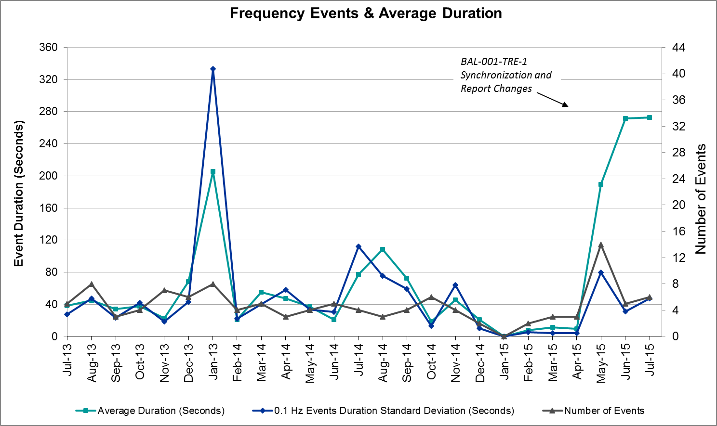

Note on 07/29/15 – The simultaneous loss of three generators in the central region resulted in the loss of approximate 1507 MW.

Responsive Reserve Events

There were five events where Responsive Reserve MWs were released to SCED in July. The events highlighted in blue were related to frequency events reported in section 2.1 above.

Date and Time  Released to SCED | Date and Time  Recalled | Duration of Event | Maximum MWs Released | Comments
7/1/2015 1:15:14 | 7/1/2015 1:18:58 | 00:03:44 | 535.72
7/5/2015 10:30:34 | 7/5/2015 10:33:26 | 00:02:52 | 171.02
7/19/2015 13:35:36 | 7/19/2015 13:39:12 | 00:03:36 | 667.81
7/21/2015 11:42:08 | 7/21/2015 11:45:24 | 00:03:16 | 434.69
7/21/2015 21:06:28 | 7/21/2015 21:09:52 | 00:03:24 | 369.33
7/29/2015 18:16:50 | 7/29/2015 18:22:14 | 00:05:24 | 1364.74

Load Resource Events
There were no load resource deployment events in July.

Reliability Unit Commitment

ERCOT reports on Reliability Unit Commitments (RUC) on a monthly basis. Commitments are reported grouped by operating day and weather zone. The total number of hours committed is the sum of the hours for all the units in the specified region. Additional information on RUC commitments can be found on the MIS secure site at Grid Generation Reliability Unit Commitment.

There were no DRUC commitments in July.

HRUC Commitments
Resource Location | # of Resources | Operating Day | Total # of Hours Committed | Total MWhs | Reason for commitment
Southern | 2 | 7/5/2015 | 7 | 280 | Local Congestion
Southern | 1 | 7/17/2015 | 4 | 161 | Local Congestion

Wind Generation as a Percent of Load
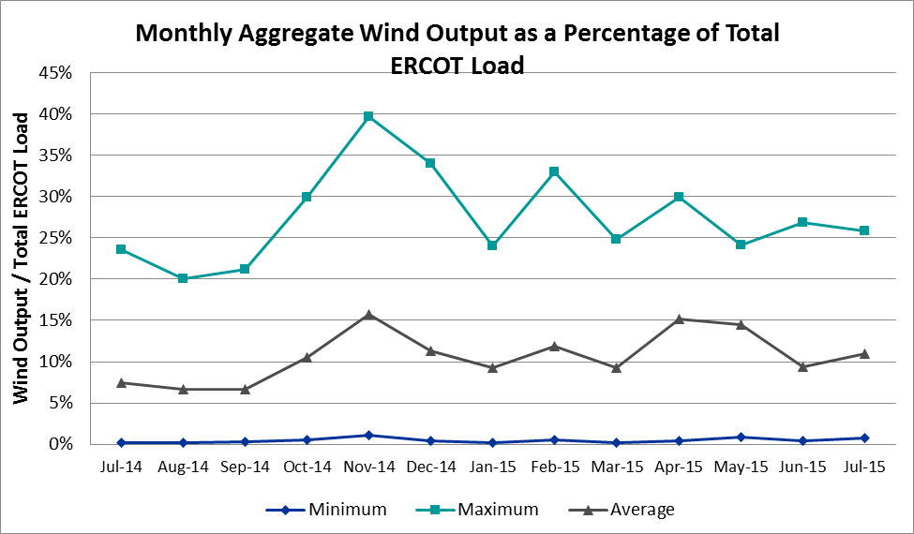

Congestion Analysis
The number of congestion events experienced by the ERCOT system increased in July due to planned outages and area load/gen patterns. There were fourteen days of activity on the Generic Transmission Constraints (GTCs) in July.

Notable Constraints for July

Nodal protocol section 3.20 specifies that ERCOT shall identify transmission constraints that are active or binding three or more times within a calendar month. As part of this process, ERCOT reports congestion that meets this criterion to ROS. In addition ERCOT also highlights notable constraints that have an estimated congestion rent exceeding $1,000,000 for a calendar month. These constraints are detailed in the table below. Rows highlighted in blue indicate the congestion was affected by one or more outages. For a list of all constraints activated in SCED for the month of July, please see Appendix A at the end of this report.

Contingency | Overload | # of Days Constraint Active | Estimated Congestion Rent | Transmission Project
DCKT Flewellen - Obrien and Mason Road 138 kV | Hockley - Betka 138 kV | 8 | $7,352,306 | 3682A, 3682B  May-17
San Angelo North 138_69T1 138/69kV | San Angelo College Hills 138_69T1 138/69 kV | 6 | $6,609,018 | 3663  May-17
San Angelo College Hills 138_69T1 138/69 kV | SA Power 69T1 138/69 kV | 10 | $4,409,778
DKCT Roans Prarie-Rothwood & Singleton-Tomball 345kV | Singleton - Zenith 345 kV (SNGZEN99) | 12 | $2,473,607 | 2013-R63
San Angelo North 138_69T1 138/69kV | SA Power 69T1 138/69 kV | 4 | $2,185,652
Eagle Mountain SES - Parker Switch and Hicks Switch 345 kv | Calmont Switch - Western Hills 138 kV | 1 | $1,949,390
Skidmore - Chase Field 69 kV | Orange Grove 69 Sub - Casa Blanca 69 kV | 5 | $1,662,002 | 16TPIT0037
Euless - Liggett Switch 138 kV | Roanoke Switch - McPhereson 138 kV | 1 | $1,598,473
La Palma - Rio Hondo 138 kV | Rio Hondo - East Rio Hondo 138 kV | 2 | $1,540,910 | 3267A  Jun-15
Lewisville Switch - Krum West Switch and Roanoke Switch 345 kV | Teasley Substaion - Pockrus Substation 138 k | 10 | $1,355,618
Basecase | Zorillo - Ajo GTC | 22 | $607,124
Lobo - San Miguel 345_138 kV Switchyards 345 kV | Laquinta - Lobo 138 kV | 7 | $584,616
DCKT Jewett - Singleton 345 kV | Twin Oak Switch - Btu_Jack_Creek 345 kV | 18 | $576,410 | 2013-R63
Laquinta - Lobo 138 kV | Bruni 138_69_1 138/69 kV | 13 | $393,925
DCKT Marion - Zorn and Clear Springs 345 kV | Comal - Loop 337 138 kV | 20 | $320,509 | 4464  Dec -15
Riley - Tesla and Jim Treece 345 kV | Edith Clarke - Gauss 345 kV | 4 | $295,151
DCKT Whitepoint - Lon Hill and South Texas Project 345 kV | Rincon - Bonnieview 69 kV | 7 | $185,840
Basecase | Sinton - Skidmore 69 kV | 3 | $107,569
Coleto Creek - Pawnee Switching Station 345 KV | Coleto Creek - Kenedy Switch 138 kV | 3 | $73,549
DCKT Ferguson - Granite Mountain and Wirtz - Starcke - Paleface 138 kV | Wirtz - Flat Rock Lcra 138 kV | 11 | $69,620 | 4465  May-19
Uvalde Aep - Odlaw Switchyard 138 kV | Hamilton Road - Maverick 138 kV | 3 | $48,595 | 16TPIT0024  May-18
Laquinta - Lobo 138 kV | Falfurria 138/69 kV | 6 | $20,306 | 16TPIT0024  May-18

Generic Transmission Constraint Congestion
There were thirteen days of activity on the Zorillo - Ajo GTC and one day on the North to Houston GTC in July. There was no activity on the remaining GTCs during the Month of July.

A new GTC for the panhandle was created July 31st 2015. This GTC has been created to address voltage stability concerns in the Panhandle that currently occur during transmission outages in the region. This GTC will also be used in the future to manage system strength issues in the Panhandle region if those system strength issues are more restrictive than the voltage stability limits.

Manual Overrides for July
There were no manual overrides for the month of July 2015

Congestion Costs for Calendar Year 2015
The following table represents the top twenty active constraints for the calendar year based on the estimated congestion rent attributed to the congestion. ERCOT updates this list on a monthly basis.

Contingency | Binding Element | # of 5-min SCED Intervals | Estimated Congestion Rent | Transmission Project
DKCT Roans Prarie - Rothwood & Singleton - Tomball 345 kV | Singleton - Zenith 345 kV | 2102 | $ 20,279,531.83 | 2013-R63
San Angelo North 138/69kV | San Angelo College Hills 138/69 kV | 1099 | $ 13,957,273.25 | 3663
Topeka Termination - West Levee Switch 345 kV | Cedar Hill Switch - Mountain Creek 138 kV | 275 | $ 8,199,322.66 | 13TPIT0060
San Angelo College Hills 138/69 kV | SA Power 138/69 kV | 1446 | $ 7,978,305.53
DCKT Hill Country - Marion and Elmcreek 345 kV | Marion - Skyline 345 kV | 1188 | $ 7,610,819.02 | 4081
DCKT Flewellen - Obrien and Maso Road 138 kV | Hockley - Betka 138 kV | 444 | $ 7,352,306.17 | 3682A, 3682B
DCKT Lost Pines - Austrop & Dunlop 345 kV | Fayette Plant 1 - Fayette Plant 2 345 kV | 2972 | $ 6,624,462.39
Bevo Substation - Asherton 138 kV | Hamilton Road - Maverick 138 kV | 320 | $ 6,277,749.92 | 16TPIT0024
DCKT Jewett - Singleton 345 kV | Twin Oak Switch - Btu_Jack_Creek 345 kV | 4648 | $ 6,150,063.48
Orange Grove Switching Station - Lon Hill 138 kV | Lon Hill - Smith 69 kV | 4192 | $ 6,052,131.26 | 16TPIT0026
Los Fresnos - Loma Alta Substation 138 kV | La Palma - Villa Cavazos 138 kV | 587 | $ 5,485,885.25
Hutto Switch Axfmr 1 345/138 kV | Gilleland - Pflugerville 138 kV | 565 | $ 5,340,238.22 | 16TPIT0062
Rio Hondo Axfmr 345/138 kV | Aderhold - Elsa 138 kV | 121 | $ 4,745,657.61
Falcon Seaboard - Midland East 345 kV | Odessa to Glenhaven 138 kV | 70 | $ 4,268,830.85 | 4173
DCKT West Levee Switch - 800/900 Network 138 kV | East Levee Switch - Reagan Street 138 kV | 366 | $ 4,170,639.70 | 2014-NC28
Bates - Frontera 138 kV | Frontera - Goodwin 138 kV | 249 | $ 4,074,787.83
Falcon Seaboard - Morgan Creek Ses 345 KV | Glenhaven - Crmwd 8 Tap 138 kV | 65 | $ 4,063,954.92 | 4173
DCKT Calaveras - Hotwells & Laredo1 138 kV | Calaveras - Streich 138 kV | 737 | $ 3,750,145.76 | 16TPIT0011
South Mission to Frontera 138/138 kV | South Mission to Frontera 138/138 kV | 70 | $ 3,335,332.47
Eagle Mountain SES - Parker Switch and Hicks Switch 345 kV | Calmont Switch - Western Hills 138 kV | 77 | $ 3,180,678.24

System Events

ERCOT Peak Load
The unofficial ERCOT peak load for the month was 67,630 MW and occurred on July 30th during hour ending 17:00.

Load Shed Events
07/03/15 – ERCOTs initial indications showed approximately 317 MW tripped due to low voltage and loss of transmission southern region. This load was lost as a result of a multiple contingencies and NOT as a result of an ERCOT instruction.

Stability Events
None.

Notable PMU Events
ERCOT analyzes PMU data for any significant system disturbances that do not fall into the Frequency Events category reported in section 2.1. The results are summarized in this section once the analysis has been completed.

There were no reportable events in July.

TRE/DOE Reportable Events

07/03/15 – ERCOTs initial indications showed approximately 317 MW tripped due to low voltage and loss of transmission southern region. This load was lost as a result of a multiple contingencies and NOT as a result of an ERCOT instruction.

07/29/15 – The simultaneous loss of three generators in the central region resulted in the loss of approximately 1507 MW.

07/30/15 - ERCOT issued a Media Appeal for energy conservation as a precautionary measure to ensure system reliability due to hot weather causing high ERCOT demands and reduced generation capability due to unplanned generation outages.

New/Updated Constraint Management Plans
None.

New/Modified/Removed SPS
None.

New Procedures/Forms/Operating Bulletins
None.

Emergency Conditions

OCNs
Date and Time | Description
07/30/15 06:36 | ERCOT issued an OCN due a capacity insufficiency.
07/31/15 15:12 | ERCOT issued an OCN due to the development of a new Generic Transmission Constraint (GTC) due to transmission outages in the region.

Advisories
Date and Time | Description
07/29/15 18:28 | ERCOT issued an Advisory due to Physically Responsive Capability being less than 3,000 MW.
07/31/15 15:12 | ERCOT issued an Advisory due to Physically Responsive Capability being less than 3,000 MW.

Watches
None.

Emergency Notices
None.

Application Performance
ERCOT system applications performed well in July. There were no issues to report.

TSAT/VSAT Performance Issues
None.

Communication Issues
None.

Market System Issues
None.

Net-Forecast Bias Applied to NSRS Procurement for July 2015
Each month, ERCOT calculates a net Forecast Bias pursuant to the ERCOT Ancillary Services Methodology for procurement of Non-Spinning Reserve Service (NSRS). The table below indicates the amount of net Forecast Bias that was applied to the NSRS procurement for specified blocks of time for the month of July, 2015.

Blocks | Negative Net Load Forecast Average Error - By Weather Zone for the 5 Largest Zones
 | Coast | East | North Central | South Central | Southern
1-2 | 0 | 0 | 0 | 0 | 0
3-6 | 0 | 0 | 0 | 0 | 0
7-10 | 0 | 0 | 0 | 0 | 0
11-14 | 0 | 0 | 0 | 0 | 0
15-18 | -155 | -25 | -182 | -91 | -46
19-22 | -141 | -23 | -167 | -84 | -43
23-24 | 0 | 0 | 0 | 0 | 0

Appendix A: Real-Time Constraints
The following is a complete list of constraints activated in SCED for the month of July. Full contingency descriptions can be found in the Standard Contingencies List located on the MIS secure site at Grid Generation Reliability Unit Commitment.

Contingency | Constrained Element | From Station | To Station | # of Days Constraint Active
DFL_MAR8 | BETHK_66_A | HK | BET | 8
XSA2N89 | SACH_69T1 | SACH | SACH | 6
XSA2C89 | SAPOWER_69T1 | SAPOWER | SAPOWER | 10
DRNS_TB5 | SNGZEN99_A | SNG | ZEN | 12
XSA2N89 | SAPOWER_69T1 | SAPOWER | SAPOWER | 4
DEMSHCK5 | 6185__A | CMTSW | WSTHL | 1
SSKISIN9 | CSA_ORN_1 | ORNGRVS | CASA_BLA | 5
DEULLIG8 | 1060__F | RNKSW | MCPHERSN | 1
SLA_RIO8 | RIOHND_ERIOHND_1 | RIOHONDO | MV_RIOHO | 2
DLWSRNK5 | POC_TEAS_1 | TEASLEY | POCKRUSC | 10
BASE CASE | ZO_AJO |  |  | 22
SLOBSAN5 | LAQUIN_LOBO1_1 | LAQUINTA | LOBO | 7
DJEWSNG5 | JK_TOKSW_1 | TOKSW | JK_CK | 18
SJNSWNT8 | OLSE_BOS_1 | BOSQUESW | OLSEN | 1
DLEOTRU8 | E1_R2_1 | E1 | R2 | 1
SLEOS18 | E1_R2_1 | E1 | R2 | 1
SLAQLOB8 | BRUNI_69_1 | BRUNI | BRUNI | 13
DWLV89N8 | 3410__A | ELVSW | REGST | 1
DMARZOR5 | 91T335_1 | COMAL | LOP337 | 20
DALNREN5 | 853__A | ALNSW | PCUST | 2
DRILTES5 | EDITHC_GAUSS2_1 | EDITHCLA | GAUSS | 4
DWH_STP5 | BONIVI_RINCON1_1 | RINCON | BONIVIEW | 7
DGARHIC8 | CKT_1027_1 | DUNLAP | DECKER | 3
SAVMBSP8 | 6610__D | BSPSW | BSCTP | 1
SL_FLA_8 | RIOHND_ERIOHND_1 | RIOHONDO | MV_RIOHO | 1
XOKL58 | VERS_69_1 | VERS | VERS | 3
SENSENW8 | 940__C | ENWSW | WXHCH | 1
BASE CASE | SINTON_SKIDMO1_1 | SINTON | SKIDMORE | 3
XBLE89 | BROOKH_P_LAVA1_1 | P_LAVACA | BROOKHOL | 2
SGEOGEO8 | CSA_ORN_1 | ORNGRVS | CASA_BLA | 2
SCOLPAW5 | COLETO_KENEDS1_1 | COLETO | KENEDSW | 3
DFERPAL8 | 38T365_1 | WIRTZ | FLATRO | 11
DDUNLOS5 | AUSTRO_AT2H | AUSTRO | AUSTRO | 2
SVEROK28 | VERS_69_1 | VERS | VERS | 2
BASE CASE | N_TO_H |  |  | 1
DSNGZEN5 | BETHK_66_A | HK | BET | 1
SFRAVL8 | BLESSI_PALACI1_1 | BLESSING | PALACIOS | 1
DRNS_TB5 | SNGZEN98_A | SNG | ZEN | 1
SBRAUVA8 | HAMILT_MAVERI1_1 | HAMILTON | MAVERICK | 3
DALNRYS5 | 1646__A | BNDVS | PKRMX | 1
SVICCOL8 | COLETO_VICTOR1_1 | COLETO | VICTORIA | 1
BASE CASE | CEDH_69_1 | CEDH | CEDH | 1
SVICCO28 | COLETO_VICTOR2_1 | COLETO | VICTORIA | 3
SFORYEL8 | FORTMA_MASN1_1 | FORTMA | MASN | 1
SGARROM8 | GARZA_69A1 | GARZA | GARZA | 1
DLONOR58 | ALICE_SAN_DI1_1 | ALICE | SAN_DIEG | 2
SLAQLOB8 | FALFUR_69A1 | FALFUR | FALFUR | 6
SVLDO2W8 | BLESSI_PALACI1_1 | BLESSING | PALACIOS | 1
XLWS158 | 589_C_1 | CRLNW | LWSVS | 1
SLOBSAN5 | FREER_SAN_DI1_1 | SAN_DIEG | FREER | 3
SFT_BAL8 | CEDH_69_1 | CEDH | CEDH | 1
SRDODES8 | 940__C | ENWSW | WXHCH | 3
DSC_SL28 | CO_WAS84_A | CO | WAS | 1
SBELHIG8 | 163T232_1 | CHAPHI | WALLER | 1
SBRAUVA8 | EAGLHY_ESCOND1_1 | EAGLHYTP | ESCONDID | 1
SGERCLE8 | 99T203_1 | ZORN | YORKCR | 1
XLOB58 | FREER_SAN_DI1_1 | SAN_DIEG | FREER | 1
SRICGRS8 | NVKSW_FMR1 | NVKSW | NVKSW | 1
DBIGKEN5 | BONDRO_SONR1_1 | SONR | BONDROAD | 1
XDOW58 | BLESSI_PALACI1_1 | BLESSING | PALACIOS | 1
SVCAMIL8 | RIOHND_ERIOHND_1 | RIOHONDO | MV_RIOHO | 1
SSONFRI8 | SONR_69-1 | SONR | SONR | 1
DHUTGAB8 | 211T147_1 | GILLCR | MCNEIL_ | 1
DEULLIG8 | 1140__C | DFWD1 | DFWCE | 3
SLAULA_8 | LA_PAL_VCAVAZ1_1 | LA_PALMA | VCAVAZOS | 1
XHUT58 | 1666__B | GILLCR | PFLGV | 2
SGILNU78 | GILA_MORRIS1_1 | GILA | MORRIS | 5
XJEW58 | 1240__K | TRSES | WINKLER | 1
DFERPAL8 | 318T313_1 | WIRTZ | JOHNCI | 1
SMARZOR5 | 419T419_1 | CLEASP | MARION | 2
SDAFAUS8 | CKT_1027_1 | DUNLAP | DECKER | 2
SFERZ48 | Y1_C4_1 | C4 | Y1 | 1
XBL2U58 | BLUF_CRK_T1_H | BLUF_CRK | BLUF_CRK | 1
SJMCW_D8 | POC_TEAS_1 | TEASLEY | POCKRUSC | 2
DODEQAL5 | 6511__A | MDLNE | WNDWD | 1
DGIBSNG5 | 240__A | JEWET | SNG | 11
DFMRMNS5 | 205__A | MNSES | SSPSW | 1
SGIBSNG5 | SNGXGC99_1 | GIBCRK | SNG | 2
SLAULA_8 | LOMA_A_L_FRES1_1 | L_FRESNO | LOMA_ALT | 1
DOLIELM8 | OLI_BEN1_1 | OLINGR | BNDVS | 2
XWI2N89 | WINKS_FMR1 | WINKS | WINKS | 1
SDFWLI28 | 1140__C | DFWD1 | DFWCE | 1
BASE CASE | FALFUR_69A1 | FALFUR | FALFUR | 1

