NPRR Number | 715 | NPRR Title | Clarification of Generator Modeling in the Market System
Date |  | August 3, 2015
Submitter’s Information
Name |  | Carrie Bivens
E-mail Address |  | carrie.bivens@ercot.com
Company |  | ERCOT
Phone Number |  | 512-248-6678
Market Segment |  | Not applicable.

Comments

ERCOT had productive discussions at the Qualified Scheduling Entity (QSE) Managers Working Group (QMWG) meeting on July 17, 2015, and we appreciated the opportunity to describe examples in detail and explain the history and context of this situation of transmission equipment between the generator and the Resource Node. These comments add some key points of that discussion to the Nodal Protocol Revision Request (NPRR) 715 record.

ERCOT’s purpose with filing this NPRR was to clarify how the system works today, and accordingly there is no system impact. It describes how the market system behaves if there is congestion between the generator’s connectivity node and its respective Resource Node; namely, that Resources may be backed down to clear the congestion, but since payment occurs at the Resource Node, there will be inconsistency (the Resource Node price will be higher that the Locational Marginal Price (LMP) at the connectivity node).

In accordance with the procedure for the initial placement of Resource Nodes as detailed in the Business Practice Manual, “Procedure for Identifying Resource Nodes,” ERCOT evaluates all submitted data at that point in time and places the Resource Node such that, based on available data, there cannot be congestion between the generator’s connectivity node and the Resource Node. The Resource Entity is required to review and accept or reject the suggested placement of the Resource Node. However, if a rating is subsequently changed via a Network Operations Model Change Request (NOMCR), it can introduce a constraint that did not exist previously. This has happened in one instance since Texas Nodal Market go-live. ERCOT is required to manage congestion on transmission equipment above 60 kV in compliance with North American Electric Reliability Corporation (NERC) Reliability Standards.

Section 7.4, Data Supplementation, of the Standard Generation Interconnection Agreement (SGIA) covers communication requirements between the Transmission Service Provider (TSP) and Resource Entity in the event of a ratings change on the transmission equipment, stating “[t]he TSP shall provide the Generator any data changes due to equipment replacement, repair, or adjustment in the directly connected substation or any adjacent TSP-owned substation that may affect the [Generator’s interconnection facilities] equipment ratings, protection or operating requirements.”

Below is a diagram showing an example of where there may be a transmission line between the generator connectivity node and the Resource Node. One of the guidelines is to place the Resource Node near the ERCOT-Polled Settlement (EPS) Meter location (represented in the picture as an M inside a circle).

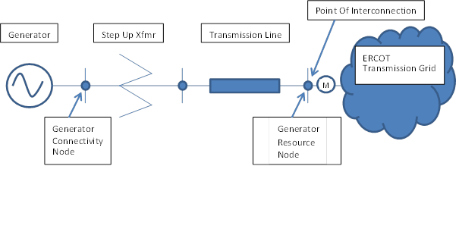

Revised Cover Page Language

None at this time.

Revised Proposed Protocol Language

None at this time.

