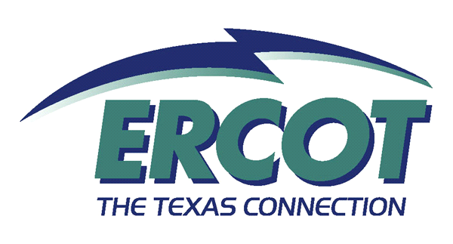

Retail 101

Training Need
Market Participants involved in ERCOT’s Competitive Retail Market should possess a broad knowledge of the environment in which they operate and the daily processes involved. As new Market Participants enter ERCOT and personnel move to new roles within Market Participant companies, thorough training on the Retail Market is critical to the continued success of the Market. This course, available on a regular basis, provides a high level overview of the Retail Market focusing on the following topics:

- Market History
  - Processes leading to retail competition
  - Transition from vertically integrated utilizes to competition
- Market Rules
  - Laws of Texas
  - Protocols and Market Guides
  - PUCT Substantive Rules
- Market Operations
  - Retail Processes
  - Retail Systems
- Market Structure
- Market Players

Target Audience
This course is designed for New Market Participants who have never been involved in the ERCOT Competitive Retail Market or have taken on new roles in the Market. This audience includes Competitive Retailers, Transmission and Distribution Service Providers and PUCT staff.

Course Objectives
Upon completion of this course the learner should be able to

- Summarize the key responsibilities of CRs, TDSPs, ERCOT and PUCT in the ERCOT Retail Market
- Describe how the Retail Market grew out of the vertically integrated utilities
- Describe how ERCOT, CR and TDSP systems are expected to process Retail Transactions
- Describe the role of an ESI ID.
- Illustrate the life cycle of the Move-in, Move-out and Switch Request Transactions (these involve ERCOT)
- List the retail transactions and processes that are Point-to-Point (no ERCOT)
- Identify the tools available through ERCOT for tracking, troubleshooting and reconciling Retail Transactions
- Demonstrate how to find key information and systems on the ERCOT Websites
- Recognize the impacts of Smart Meter technology
- Identify the Market Rules that impact Retail Market Operations

Content
From Regulated Utilities to Current Market Design
- In the beginning, there were vertically integrated utilities
- Then there was SB7
  - Unbundling of Investor-Owned Utilities
  - Competitive areas and Customer Choice

  - Non-Opt-in entities
  - Opt-ins?
- Current Market Design
  - Wholesale
  - Retail
  - Governance structure (light)

- Passing mention, but no details
  - Price to Beat
  - RECs

A Few Basic Definitions
- Premise
- ESI ID
- Meters
  - Non-Standard
    - Interval Data Recorder (IDR) Meter
    - Non-IDR
  - Standard
    - Advanced Meter System (AMS)

Introductions, Roles and Responsibilities
- CRs
- TDSPs
- ERCOT
- PUCT
  - What needs to be included here?
    - Oversight
    - Highest Rules
    - Power to Choose

Market Rules
- Protocols
  - Purpose
  - Much of course based on Section 15
  - Also introduce Sections 10 (Metering) and 11 (Data Aggregation)
  - Sections 3-9 have to do with System Ops and Wholesale Markets
- Market Guides – Really just point folks to the guides for more info
  - Purpose
  - Retail Market Guide
  - Texas SET Implementation Guides
  - MarkeTrak Users Guide
  - COPS Market Guide and by-products
  - Profiling Guide
- PUCT Substantive Rules
  - Purpose
  - What kind of coverage is needed?
  - Specific sections?

Retail Transactions
- Definition
- Introduce TX Set Transaction Names Inventory and Pocket Card
- ERCOT Involved Transactions
  - The Systems
  - Sample processes
    - Move-in
    - Move-out
    - Switch Request
- Point-to-Point Transactions
  - Are there standard systems among MPs?

  - Do we want to illustrate any? (They tend to be less complicated by nature)
    - DNP/RNP
    - Service Order

Smart Meter Technology – What does it mean for the Retail Market?
- More precise data
  - Interval data
  - Less shaping with Load Profiles
- Meter data available faster
  - More accurate initial settlement at ERCOT
  - Faster execution and completion of market processes
- More opportunities? → Time will tell
  - Prepay
  - Demand response
  - Time of Use products

Data Transparency and Availability
- Market Information System
  - Reports of interest
  - Digital Certificate access
  - Launch other ERCOT systems
    - Find Transaction
    - Find ESI ID
  - EMIL
- Data Extracts
  - The big picture
  - ESIID Service History and Usage
  - Subscribing
- MarkeTrak
  - Where to turn when things go wrong
    - IAGs
    - Switch holds
    - Missing Transactions
    - Usage and Billing
  - What it is
  - What it does

Recommended Competencies
Prior to attempting this course, participants should be able to:

- Know your company’s role in the market (CR, TDSP, etc.)

Prerequisites
None

Related Curriculum
- Nodal 101 – Get your feet wet in the Wholesale processes
- Load Serving Entities 201- Manage your Wholesale costs of serving retail customers.
- IAG Workshops
- MarkeTrak WBT

