May 2015 ERCOT Monthly Operations Report

Reliability and Operations Subcommittee Meeting
July 9, 2015

Table of Contents
1 Report Highlights 3
2 Frequency Control 4
2.1 Frequency Events 4
2.2 Responsive Reserve Events 5
2.3 Load Resource Events 6
3 Reliability Unit Commitment 6
4 Wind Generation as a Percent of Load 7
5 Congestion Analysis 7
5.1 Notable Constraints for May 7
5.2 Generic Transmission Constraint Congestion 10
5.3 Manual Overrides for May 10
5.4 Congestion Costs for Calendar Year 2015 10
6 System Events 11
6.1 ERCOT Peak Load 11
6.2 Load Shed Events 11
6.3 Stability Events 11
6.4 Notable PMU Events 12
6.5 TRE/DOE Reportable Events 12
6.6 New/Updated Constraint Management Plans 12
6.7 New/Modified/Removed SPS 12
6.8 New Procedures/Forms/Operating Bulletins 12
7 Emergency Conditions 12
7.1 OCNs 12
7.2 Advisories 12
7.3 Watches 13
7.4 Emergency Notices 13
8 Application Performance 13
8.1 TSAT/VSAT Performance Issues 13
8.2 Communication Issues 13
8.3 Market System Issues 13
9 Net-Forecast Bias Applied to NSRS Procurement for June 2015 13
Appendix A: Real-Time Constraints 14

Report Highlights
- The unofficial ERCOT peak for May was 53,311 MW.
- There were fourteen frequency events in May. PMU data indicates the ERCOT system transitioned well in each case.
  - Note that the reporting of frequency events changed to comply with the BAL-001-TRE-1 standard.
- There were thirteen instances where Responsive Reserves were deployed, all of which were the result of frequency events.
- There were nine RUC commitments in May. Seven in North Central for the purpose of relieving local congestion. Two in the Coast due to the North-Houston import and for the purpose of relieving local congestion.
- The level of reportable SCED congestion increased in May. This congestion was due primarily to planned outages and area load/gen patterns. There were fifteen days of activity on the Zorillo - Ajo Generic Transmission Constraint (GTC) and two days of activity on the North – Houston GTC in May.
- There were no significant system events for the month of May.

- On 5/6/15, AEP initiated a Block Load Transfer (BLT) and transferred 1.5 MW of load from CFE to ERCOT at Gonzales. This was a registered and modeled BLT.
- ERCOT Applications performed well throughout the month. There were no ERCOT related application performance issues.

Frequency Control

Frequency Events
The ERCOT Interconnection experienced 14 frequency events in May, all of which resulted from Resource trips. The average event duration was approximately 0:03:10.

When analyzing frequency events, ERCOT evaluates PMU data according to industry standards. Events with an oscillating frequency of less than 1 Hz are considered to be inter-area, while higher frequencies indicate local events. Industry standards specify that damping ratio for inter-area oscillations should be 3.0% or greater. All events listed below indicate the ERCOT system met these standards and transitioned well after each disturbance.

Reported frequency events will include both frequency events where frequency was outside the range of 60±0.1 Hz as well as those determined to be Frequency Measurable Events (FME) as defined by BAL-001-TRE-1. Delta Frequency is defined as the difference between the pre-perturbation and post-perturbation frequency. The Duration of Event is defined as the time it takes for the frequency to recover to lesser/greater of the frequency at the time of the frequency event (t(0) or “A-point”) for low/high-frequency events, respectively. Further details on FMEs can be found in the MIS posted BAL-001-TRE-1 PDCWG Unit Performance reports. A summary of the frequency events is provided below:

Date and Time | Delta Frequency | Max/Min Frequency | Duration of Event | PMU Data |  | Comments
 | (Hz) | (Hz) |  | Oscillation Mode (Hz) | Damping Ratio
5/6/2015 13:28:16 | 0.06 | 59.87 | 0:02:20 | 0.69 | 12% | Unit Trip of 438 MW
 |  |  |  | 1.11 | 15%
5/7/2015 12:37:10 | 0.03 | 59.88 | 0:02:05 | PMU data not available. |  | Unit Trip of 486 MW
5/7/2015 21:34:01 | 0.10 | 59.89 | 0:02:31 | 0.68 | 8% | Unit Trip of 431 MW
5/8/2015 16:48:19 | 0.08 | 59.89 | 0:03:21 | 0.64 | 6% | Unit Trip of 624 MW
5/8/2015 21:04:13 | 0.13 | 59.86 | 0:03:02 | 0.66 | 8% | Unit Trip of 604 MW
5/8/2015 23:53:42 | 0.09 | 59.86 | 0:02:46 | 0.70 | 10% | Unit Trip of 505 MW
5/9/2015 7:51:31 | 0.10 | 59.83 | 0:03:08 | 0.67 | 14% | Unit Trip of 770 MW
5/14/2015 12:29:20 | 0.05 | 59.87 | 0:02:17 | 0.74 | 10% | Unit Trip of 504 MW
5/25/2015 13:47:07 | 0.08 | 59.87 | 0:04:24 | 0.70 | 6% | Unit Trip of 493 MW
5/25/2015 17:18:33 | 0.04 | 59.89 | 0:03:02 | 0.72 | 8% | Unit Trip of 374 MW
5/27/2015 7:03:04 | 0.03 | 59.89 | 0:02:33 | 0.71 | 16% | Unit Trip of 413 MW
5/27/2015 20:32:12 | 0.11 | 59.86 | 0:03:58 | 0.66 | 9% | Unit Trip of 777 MW
5/29/2015 8:14:42 | 0.03 | 59.90 | 0:01:44 | PMU data not available. |  | Unit Trip of 479 MW
5/30/2015 4:20:33 | 0.07 | 59.90 | 0:07:03 | PMU data not available. |  | Unit Trip of 435 MW

(Note: frequency events highlighted in blue have been identified as FMEs per BAL-001-TRE-1 and the Performance Disturbance Compliance Working group.)

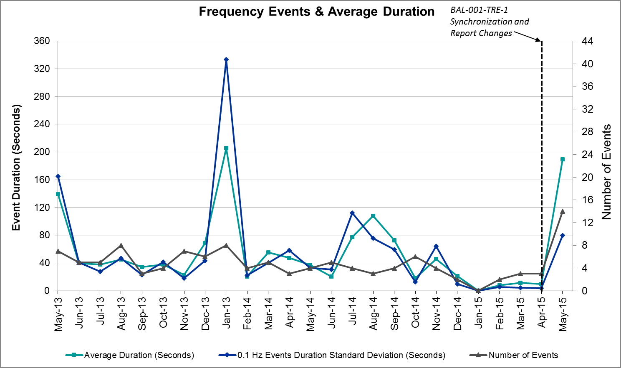

Responsive Reserve Events
There were thirteen events where Responsive Reserve MWs were released to SCED in May. The events highlighted in blue were related to frequency events reported in section 2.1 above.

Date and Time  Released to SCED | Date and Time  Recalled | Duration of Event | Maximum MWs Released | Comments
5/6/2015 13:28:26 | 5/6/2015 13:30:36 | 0:02:10 | 422.08
5/7/2015 12:37:18 | 5/7/2015 12:40:16 | 0:02:58 | 271.31
5/7/2015 21:34:10 | 5/7/2015 21:36:08 | 0:01:58 | 156.61
5/8/2015 16:48:30 | 5/8/2015 16:50:20 | 0:01:50 | 316.63
5/8/2015 21:04:22 | 5/8/2015 21:06:48 | 0:02:26 | 337.84
5/8/2015 23:53:54 | 5/8/2015 23:56:20 | 0:02:26 | 98.44
5/9/2015 7:51:38 | 5/9/2015 7:54:20 | 0:02:42 | 542.01
5/14/2015 12:29:28 | 5/14/2015 12:32:16 | 0:02:48 | 431.53
5/25/2015 13:47:18 | 5/25/2015 13:52:16 | 0:04:58 | 707.02
5/25/2015 17:18:40 | 5/25/2015 17:22:16 | 0:03:36 | 359.12
5/27/2015 7:03:14 | 5/27/2015 7:05:40 | 0:02:26 | 309.05
5/27/2015 20:32:22 | 5/27/2015 20:35:32 | 0:03:10 | 402.09
5/29/2015 8:14:54 | 5/29/2015 8:17:04 | 0:02:10 | 106.82

Load Resource Events
There were no load resource deployment events in May.

Reliability Unit Commitment
ERCOT reports on Reliability Unit Commitments (RUC) on a monthly basis. Commitments are reported grouped by operating day and weather zone. The total number of hours committed is the sum of the hours for all the units in the specified region. Additional information on RUC commitments can be found on the MIS secure site at Grid Generation Reliability Unit Commitment.

There were no DRUC commitments in May.

HRUC Commitments
Resource Location | # of Resources | Operating Day | Total # of Hours Committed | Total MWhs | Reason for commitment
N. Central | 1 | 05/07/15 | 6 | 2352 | Local Congestion
N. Central | 1 | 05/20/15 | 3 | 354 | Local Congestion
N. Central | 1 | 05/26/15 | 20 | 10600 | Local Congestion
N. Central | 1 | 05/27/15 | 1 | 530 | Local Congestion
N. Central | 1 | 05/28/15 | 4 | 1740 | Local Congestion
N. Central | 1 | 05/29/15 | 13 | 1534 | Local Congestion
N. Central | 1 | 05/29/15 | 3 | 1176 | Local Congestion
Coast | 12 | 05/30/15 | 30 | 2518 | Local Congestion
Coast | 3 | 05/31/15 | 3 | 508 | Local Congestion

Wind Generation as a Percent of Load
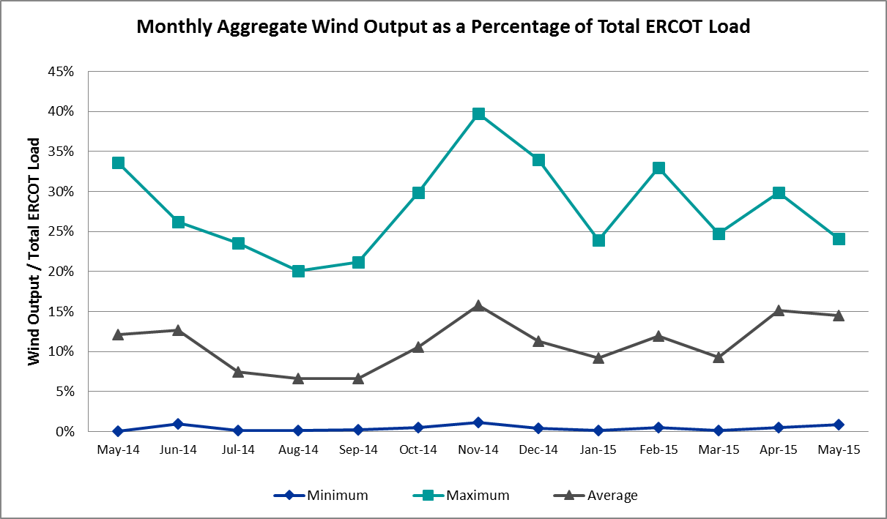

Congestion Analysis
The number of congestion events experienced by the ERCOT system increased in May due to planned outages and area load/gen patterns. There were seventeen days of activity on the Generic Transmission Constraints (GTCs) in May.

Notable Constraints for May
Nodal protocol section 3.20 specifies that ERCOT shall identify transmission constraints that are active or binding three or more times within a calendar month. As part of this process, ERCOT reports congestion that meets this criterion to ROS. In addition ERCOT also highlights notable constraints that have an estimated congestion rent exceeding $1,000,000 for a calendar month. These constraints are detailed in the table below. Rows highlighted in blue indicate the congestion was affected by one or more outages. For a list of all constraints activated in SCED for the month of May, please see Appendix A at the end of this report.

Contingency | Overload | # of Days Constraint Active | Estimated Congestion Rent | Transmission Project
DKCT Roans Prarie-Rothwood & Singleton-Tomball 345kV | Singleton - Zenith 345 kV (SNGZEN99) | 9 | $17,673,198 | 2013-R63
DCKT Jewett - Singleton 345 kV | Twin Oak Switch - Btu_Jack_Creek 345 kV | 12 | $5,242,861
Los Fresnos - Loma Alta Substation 138 kV | La Palma - Villa Cavazos 138 kV | 3 | $5,042,921
Falcon Seaboard - Midland East 345 kV | Odessa to Glenhaven 138 kV | 1 | $4,268,831
Falcon Seaboard - Morgan Creek Ses 345 kV | Glenhaven - Crmwd 8 Tap 138 kV | 1 | $4,063,955
South Mission -Frontera (2)138/138 kV | North McAllen to West McAllen 138 kV | 1 | $3,335,332
Basecase | North to Houston GTC | 2 | $3,027,252 | 2013-R63
DCKT Calaveras-Hotwells & Laredo1 138 kV | Calaveras - Streich 138 kV | 1 | $2,681,847 | 16TPIT0011  Jun-16
DCKT West Levee Switch - 800/900 Network 138 kV | East Levee Switch - Reagan Street 138 kV (3410_A) | 1 | $2,664,208 | 2014-NC28  May-16
Calaveras-Walzem&Skyline 138kV | Ball Park - Fern 138 kV | 3 | $1,775,553
Laquinta - Lobo 138 kV | Bruni 138_69_1 138/69 kV | 12 | $1,713,011
Bluff Creek T2 (3) 345/138 kV | Bluff Creek T1 (3) 345/138 kV | 6 | $1,665,153
Howard Lane Tap - Wells Branch 138 kV | McNeil - Howard Lane Tap 138 kV | 8 | $1,304,680
Dermott Switch Ax1hh (3)345/138 kV | China Grove Switch - Snyder 138 kV | 1 | $1,064,835
DCKT Carrolton Northwest - Lewisville Switch 345 kV | Lakepoint - Carrollton Northwest 138 kV | 4 | $1,017,144 | 2014-NC10  2019
Gila - Hiway 9 138 kV | Gila - Morris Street 138 kV | 3 | $942,722
Basecase | Zorillo - Ajo GTC | 15 | $805,179
Ph Robinson - Bayou Cogen & Bayway - Bigbay 138kV | Deer Park - Cardiff 138 kV | 3 | $719,268
Gray -Tesla 345 kV | Gray - Tesla 345 kV | 4 | $484,899
San Angelo College Hills 138_69t1 138/69 kV | SA Power 69T1 138/69 kV | 4 | $396,688
DCKT Trinidad SES - Stryker Creek SES & Mt. Enterprise 345 | Shamburger Switch - Royse Switch 345 kV | 5 | $396,529
Uvalde Aep - Odlaw Switchyard 138 kV | Hamilton Road - Maverick 138 kV | 4 | $331,883 | 16TPIT0024  May-18
Zenith - Singleton 345 kV | Singleton - Zenith 345 kV (SNGZEN99) | 4 | $316,920 | 2013-R63
Bluff Creek T1 (3) 345/138 kV | Nicole - Orient 138 kV | 3 | $308,998
DCKT Carrolton Northwest - Lewisville Switch 345 kV | Lewisville Switch - Jones Street Tnp 138 kV | 3 | $211,543 | 4282  May-17
Key Sub - Willow Valley Switch 138 kV | Big Spring Switch - Big Spring Crmwd Tap 69 kV | 3 | $205,571
Eskota Switch - Abilene South 138 kV | Eskota Switch 138/69 kV Axfrm1 | 3 | $169,443 | 3971  Nov-15
Cottonwood Road Switch - Loftin 69 kV | Shannon - Post Oak Switch 69 kV | 18 | $141,238 | 15TPIT0011
DCKT Singleton - Zenith 345 kV | Bellville South - Peters 138 kV | 3 | $135,964
Lobo - San Miguel 345_138 kV Switchyards 345 kV | San Diego - Freer 69kV | 5 | $128,455
Dermott Switch - Golden Switch 138 kV | Sacroc - Snyder 138 kV | 7 | $95,137
DCKT Marion - Zorn and Clear Springs 345 kV | Cibolo - Schertz 138 kV | 3 | $94,120
Lobo - San Miguel 345_138 kV Switchyards 345 kV | Laquinta - Lobo 138 kV | 4 | $85,328
Ennis Creek Tap -Ennis Creek Switch 138 kV | Sacroc - Snyder 138 kV | 5 | $81,164
DCKT Sandow Switch - Austrop 345kV | Howard Lane Tap - Howard Lane AEN 138 kV | 3 | $56,655
DCKT Garfield - Stoney Ridge & Hicross AEN 138 kV | Howard Lane AEN - McNeil LCRA 138 kV | 3 | $55,509
Eskota Switch - Abilene South 138 kV | Eskota Switch - Trent 69 kV | 3 | $49,262
Scurry Switch - Sun Switch 138 kV | Wolfgang - Rotan 69 kV | 4 | $32,098
Markley (Oncor) -Rice Switch 138 kV | Navy Kickapoo Switch - Anarene 69 kV | 3 | $21,917
Memc Southwest - Sherman South 138 kV | Payne Switch -Memc West Tap 138 kV | 3 | $20,971 | 17TPIT0024  May-17
DCKT Trinidad SES - Stryker Creek SES & Mt. Enterprise 345 | Palestine South - Lakeview 138 kV | 3 | $3,840

Generic Transmission Constraint Congestion
There were fifteen days of activity on the Zorillo - Ajo GTC and two days of activity on the North – Houston GTC in May. There was no activity on the remaining GTCs during the Month of May.

Manual Overrides for May
There were no manual overrides for the month of May 2015

Congestion Costs for Calendar Year 2015
The following table represents the top twenty active constraints for the calendar year based on the estimated congestion rent attributed to the congestion. ERCOT updates this list on a monthly basis.

Contingency | Binding Element | # of 5-min SCED Intervals | Estimated Congestion Rent | Transmission Project
DKCT Roans Prarie-Rothwood & Singleton-Tomball 345kV | Singleton - Zenith 345 kV (SNGZEN99) | 1678 | $17,673,198 | 2013-R63
Topeka Termination - West Levee Switch 345 kV | Cedar Hill Switch - Mountain Creek 138 kV | 356 | $8,199,323 | 13TPIT0060
DCKT Hill Country - Marion and Elmcreek 345 kV | Marion - Skyline 345 kV | 1188 | $7,610,819 | 4081
DCKT Lost Pines - Austrop & Dunlop 345 kV | Fayette Plant 1 - Fayette Plant 2 345 kV | 2975 | $6,624,462
Orange Grove Switching Station - Lon Hill 138 kV | Lon Hill - Smith 69 kV | 5663 | $6,052,131 | 16TPIT0026
DCKT Jewett - Singleton 345 kV | Twin Oak Switch - Btu_Jack_Creek 345 kV | 2176 | $5,242,861
Los Fresnos - Loma Alta Substation 138 kV | La Palma - Villa Cavazos 138 kV | 496 | $5,042,921
San Angelo North 138_69T1 138/69kV | San Angelo College Hills 138_69T1 138/69 kV | 362 | $5,017,850
Rio Hondo (2H) Axfmr 345/138 kV | Aderhold - Elsa 138 kV | 272 | $4,745,658
Falcon Seaboard - Midland East 345 kV | Odessa to Glenhaven 138 kV | 70 | $4,268,831
Bates - Frontera 138 kV | Frontera - Goodwin 138 kV | 249 | $4,074,788
Falcon Seaboard - Morgan Creek Ses 345 kV | Glenhaven - Crmwd 8 Tap 138 kV | 78 | $4,063,955
South Mission -Frontera (2)138/138 kV | North McAllen to West McAllen 138 kV | 70 | $3,335,332
Barber Lake Switch - Morgan Creek Ses 138 kV (14030) | Barber Lake Switch - Morgan Creek Ses 138 kV (14035) | 93 | $3,040,753 | 15TPIT0087  Dec-15
Basecase | North to Houston GTC | 80 | $3,027,252 | 2013-R63
DCKT Calaveras-Hotwells & Laredo1 138 kV | Calaveras - Streich 138 kV | 374 | $2,681,847 | 16TPIT0011  Jun-16
DCKT West Levee Switch - 800/900 Network 138 kV | East Levee Switch - Reagan Street 138 kV (3410_A) | 80 | $2,664,208 | 2014-NC28  May-16
Scurry Switch - Sun Switch 138 kV | Matador - Roaring Springs 69 kV | 182 | $2,047,958
Basecase | Valley Import | 32 | $1,989,446 | 14TPIT0050
DCKT Burleson - Carson Creek 138 kV and Pedernales - Advanced Micro Devices AEN 138 kV | Manesium Plant - Northlan 138kV | 28 | $1,784,116 | 14TPIT0038  Jun-16

System Events

ERCOT Peak Load
The unofficial ERCOT peak load for the month was 53,311 MW and occurred on May 18th during hour ending 17:00.

Load Shed Events
None.

Stability Events
None.

Notable PMU Events
ERCOT analyzes PMU data for any significant system disturbances that do not fall into the Frequency Events category reported in section 2.1. The results are summarized in this section once the analysis has been completed.

There were no reportable events in May.

TRE/DOE Reportable Events
None.

New/Updated Constraint Management Plans
One Constraint Management Plans was added in the month of May.
- MP_2015_03: Contingency Loss of IH20 TNP to Pecos TNP 69kV circuit overloads Wickett TNP to Pyote TNP 69kV circuit.
One Constraint Management Plans was updated in the month of May.
- MP_2015_01: Contingency Loss of Andrews North 138/69kV Auto #1/#2 overloads Frankel City to Whalen Lake POI 69kV circuit.
  - Expanded plan to include thermal overloads.

New/Modified/Removed SPS
One SPS was removed in the month of May.
- Allen Switch Special protection System (SPS #17)

New Procedures/Forms/Operating Bulletins
Date | Document | Description
5/1/2015 | Power Operations Bulletin 706 | DC Tie Desk V1 Rev33
5/1/2015 | Power Operations Bulletin 707 | Real Time Desk V1 Rev37
5/1/2015 | Power Operations Bulletin 708 | Reliability Unit Commitment Desk V1 Rev29
5/1/2015 | Power Operations Bulletin 709 | Resource Desk V1 Rev34
5/1/2015 | Power Operations Bulletin 710 | Shift Supervisor Desk V1 Rev33
5/1/2015 | Power Operations Bulletin 711 | Transmission and Security Desk V1 Rev38

Emergency Conditions

OCNs
Date and Time | Description
05/07/15 07:58 | ERCOT issued an OCN due to the development of a new Generic Transmission Constraint (GTC) due to a local voltage stability issue

Advisories
Date and Time | Description
05/27/15 13:28 | ERCOT issued an Advisory for missing the deadline for posting the DAM solution, delayed due to length of run time.
05/31/15 13:24 | ERCOT issued an Advisory for missing the deadline for posting the DAM solution, delayed due to length of run time.

Watches
None.

Emergency Notices
None.

Application Performance
ERCOT system applications performed well in May. There were no issues to report.

TSAT/VSAT Performance Issues
None.

Communication Issues
None.

Market System Issues
None.

Net-Forecast Bias Applied to NSRS Procurement for June 2015
Each month, ERCOT calculates a net Forecast Bias pursuant to the ERCOT Ancillary Services Methodology for procurement of Non-Spinning Reserve Service (NSRS). The table below indicates the amount of net Forecast Bias that was applied to the NSRS procurement for specified blocks of time for the month of June, 2015.

Blocks | Negative Net Load Forecast Average Error - By Weather Zone for the 5 Largest Zones
 | Coast | East | North Central | South Central | Southern
1-2 | 0 | 0 | 0 | 0 | 0
3-6 | 0 | 0 | 0 | 0 | 0
7-10 | 0 | 0 | 0 | 0 | 0
11-14 | -15 | -3 | -19 | -10 | -5
15-18 | -56 | -9 | -66 | -33 | -17
19-22 | -101 | -16 | -118 | -60 | -30
23-24 | 0 | 0 | 0 | 0 | 0

Appendix A: Real-Time Constraints
The following is a complete list of constraints activated in SCED for the month of May. Full contingency descriptions can be found in the Standard Contingencies List located on the MIS secure site at Grid Generation Reliability Unit Commitment.

Contingency | Constrained Element | From Station | To Station | # of Days Constraint Active
SCRDLOF9 | POS_SHAN_1 | SHANNON | POSTOKSW | 18
BASE CASE | ZO_AJO |  |  | 15
DJEWSNG5 | JK_TOKSW_1 | TOKSW | JK_CK | 12
SLAQLOB8 | BRUNI_69_1 | BRUNI | BRUNI | 12
DRNS_TB5 | SNGZEN99_A | SNG | ZEN | 9
SHWRWEL8 | 1163T163_1 | MCNEIL_ | HWRDTP | 8
MDMTGLD8 | 6240__A | SACRC | SNYDR | 7
XBL2U58 | BLUF_CRK_T1_H | BLUF_CRK | BLUF_CRK | 6
DTRSENT5 | 350__A | SHBSW | RYSSW | 5
SKNADM28 | 6240__A | SACRC | SNYDR | 5
SLOBSAN5 | FREER_SAN_DI1_1 | SAN_DIEG | FREER | 5
DCRLLSW5 | 591__A | LKPNT | CRLNW | 4
SBRAUVA8 | HAMILT_MAVERI1_1 | HAMILTON | MAVERICK | 4
SCTTTE35 | GRAY_TESLA_1_1 | CTT_GRAY | TESLA | 4
SLOBSAN5 | LAQUIN_LOBO1_1 | LAQUINTA | LOBO | 4
SSCUSUN8 | ROTN_WOLFGA1_1 | WOLFGANG | ROTN | 4
SZENSN25 | SNGZEN99_A | SNG | ZEN | 4
XSA2C89 | SAPOWER_69T1 | SAPOWER | SAPOWER | 4
DAUSSND5 | HWRDLN_1 | HWRDTP | HWRDLN | 3
DCALSKY8 | F4_Z4_1 | Z4 | F4 | 3
DCRLLSW5 | 590__A | LWSSW | LWVJS | 3
DGARHIC8 | CKT_972_1 | HWRDLN | MCNEIL | 3
DMARZOR5 | 293T304_1 | CIBOLO | SCHERT | 3
DPHRBBP8 | CA_DE_96_A | DE | CA | 3
DSNGZEN5 | 155T217_1 | BELLSO | PT | 3
DTRSENT5 | 1250__J | PLSTH | LKVEW | 3
SGILNU78 | GILA_MORRIS1_1 | GILA | MORRIS | 3
SKEYWLV8 | 6610__D | BSPSW | BSCTP | 3
SL_FLA_8 | LA_PAL_VCAVAZ1_1 | LA_PALMA | VCAVAZOS | 3
SMCEABS8 | 6585__A | ESKSW | TRNT | 3
SMCEABS8 | ESKSW_FMR1 | ESKSW | ESKSW | 3
SMEMPAY8 | 562__D | PAYSW | MEMWT | 3
SSCLWF18 | 6840__B | NVKSW | ANARN | 3
XBLU58 | NICOLE_ORNT1_1 | NICOLE | ORNT | 3
BASE CASE | LNCRK2_T2 | LNCRK2 | LNCRK2 | 2
BASE CASE | N_TO_H |  |  | 2
DVLYANA5 | 562__D | PAYSW | MEMWT | 2
SODNOD28 | 6475__E | MOSSW | WOVER | 2
SS_MRAI8 | GCB_100_1 | N_MCALLN | W_MCALLN | 2
SSPUMW18 | ASPM_69T1 | ASPM | ASPM | 2
XCDH58 | 3200__A | CDHSW | MCSES | 2
XDMT158 | 6215__A | BCKSW | CGRSW | 2
XLOB58 | ALICE_N_ELLA1_1 | ALICE | N_ELLA | 2
XLOB58 | FREER_SAN_DI1_1 | SAN_DIEG | FREER | 2
XLON489 | HEARN__KOCH_U1_1 | KOCH_UP | HEARN_RD | 2
BASE CASE | CEDH_69_1 | CEDH | CEDH | 1
DBI_GT_8 | DT_PK_91_A | DT | PK | 1
DCALHOT8 | N4_X3_1 | CALAVERS | X3 | 1
DEMSSAG8 | 6265__A | EMSES | MRSDO | 1
DFERPAL8 | 38T365_1 | WIRTZ | FLATRO | 1
DFPPFAY5 | 197T171_1 | AUSTRO | GIDEON | 1
DGIBSNG5 | 260_A_1 | JEWET | SNG | 1
DHCKRNK5 | 6270__A | EMSES | EGPOI | 1
DHKBCRL5 | 1140__C | DFWD1 | DFWCE | 1
DLHSCNR8 | 3650__A | LHSES | SATP1 | 1
DLONWAR5 | CHAS_T_SKIDMO1_1 | SKIDMORE | CHAS_TAP | 1
DLWSRNK5 | 1060__F | RNKSW | MCPHERSN | 1
DMCSCDH8 | 3380__I | WLVEE | DALLW | 1
DMCSCDH8 | 3950__A | FCRSW | MCSES | 1
DMTSCOS5 | 6429__B | ECRSW | ENCRT | 1
DMTSCOS5 | 6429__D | ENCRT | BRAND | 1
DSCOFAR5 | 6216__A | SHRNE | BCKSW | 1
DSNGZEN5 | BETHK_66_A | HK | BET | 1
DSTEXP12 | BLESSI_LOLITA1_1 | LOLITA | BLESSING | 1
DTRSENT5 | 1910__A | POYNR | ATHNS | 1
DTRSENT5 | 1930__Z | CHNDL | CHNDW | 1
DTRSENT5 | 980__A | ELKTN | TYRSW | 1
DVICV_D8 | GREENL_WEAVER1_1 | WEAVERRD | GREENLK | 1
DWLV89N8 | 3410__A | ELVSW | REGST | 1
SBUZLME8 | LMESA_FMR1 | LMESA | LMESA | 1
SCTTTES5 | GRAY_TESLA_2_1 | CTT_GRAY | TESLA | 1
SENSEN28 | 941__B | ENNIS | ENSSW | 1
SFLCMDL5 | 6510__A | GLNHV | CRM8T | 1
SFLCMDL5 | 6510__B | ODESA | GLNHV | 1
SFLCMGS5 | 6510__A | GLNHV | CRM8T | 1
SFT_BAL8 | CEDH_69_1 | CEDH | CEDH | 1
SKEYWLV8 | 6610__A | CHATP | BUZSW | 1
SLAQLOB8 | FALFUR_69A1 | FALFUR | FALFUR | 1
SLOBSAN5 | ALICE_N_ELLA1_1 | ALICE | N_ELLA | 1
SMARZOR5 | 419T419_1 | CLEASP | MARION | 1
SMCDBSP8 | 14030__A | MGSES | BRBSW | 1
SMCEABS8 | ABNW_ELYT1_1 | ABNW | ELYT | 1
SMCSCDH8 | 3210__A | CDHSW | MCSES | 1
SRICGRS8 | 6840__B | NVKSW | ANARN | 1
SRODB_D8 | AIRLIN_CABANI1_1 | AIRLINE | CABANISS | 1
SSCLWF28 | NVKSW_FMR1 | NVKSW | NVKSW | 1
SSCUSUN8 | HAMR_RADM1_1 | RADM | HAMR | 1
SSONFRI8 | ATSO_SONR1_1 | SONR | ATSO | 1
SWBJGOR8 | 562__D | PAYSW | MEMWT | 1
SWINPBS8 | 6545__A | PBSES | WGLFT | 1
XDMT158 | 14030__A | MGSES | BRBSW | 1
XDMT158 | 6235__A | CGRSW | SNYDR | 1
XSA2N89 | SACH_69T1 | SACH | SACH | 1
XSPU89 | ROTN_WOLFGA1_1 | WOLFGANG | ROTN | 1

