June 2015 ERCOT Monthly Operations Report

Reliability and Operations Subcommittee Meeting
July 9, 2015

Table of Contents
1 Report Highlights 3
2 Frequency Control 4
2.1 Frequency Events 4
2.2 Responsive Reserve Events 5
2.3 Load Resource Events 5
3 Reliability Unit Commitment 5
4 Wind Generation as a Percent of Load 7
5 Congestion Analysis 7
5.1 Notable Constraints for June 7
5.2 Generic Transmission Constraint Congestion 9
5.3 Manual Overrides for June 9
5.4 Congestion Costs for Calendar Year 2015 9
6 System Events 11
6.1 ERCOT Peak Load 11
6.2 Load Shed Events 11
6.3 Stability Events 11
6.4 Notable PMU Events 11
6.5 TRE/DOE Reportable Events 11
6.6 New/Updated Constraint Management Plans 11
6.7 New/Modified/Removed SPS 11
6.8 New Procedures/Forms/Operating Bulletins 11
7 Emergency Conditions 12
7.1 OCNs 12
7.2 Advisories 12
7.3 Watches 12
7.4 Emergency Notices 12
8 Application Performance 12
8.1 TSAT/VSAT Performance Issues 12
8.2 Communication Issues 12
8.3 Market System Issues 12
9 Net-Forecast Bias Applied to NSRS Procurement for July 2015 13
Appendix A: Real-Time Constraints 14

Report Highlights
- The unofficial ERCOT peak for June was 61,741 MW.
- There were five frequency events in June. PMU data indicates the ERCOT system transitioned well in each case.
- There were five instances where Responsive Reserves were deployed, all of which were the result of frequency events.
- There were eight RUC commitments in June. Three in South Central for the purpose of relieving local congestion. Five in the Southern region due to the Valley import and for the purpose of relieving local congestion.
- The level of reportable SCED congestion decreased in June. This congestion was due primarily to planned outages and area load/gen patterns. There were seven days of activity on the Zorillo - Ajo Generic Transmission Constraint (GTC) in June.
- There were no significant system events for the month of June.
- ERCOT Applications performed well throughout the month. There were no ERCOT related application performance issues.

Frequency Control

Frequency Events

The ERCOT Interconnection experienced six frequency events in June, all of which resulted from Resource trips. The average event duration was approximately 0:04:39.

When analyzing frequency events, ERCOT evaluates PMU data according to industry standards. Events with an oscillating frequency of less than 1 Hz are considered to be inter-area, while higher frequencies indicate local events. Industry standards specify that damping ratio for inter-area oscillations should be 3.0% or greater. All events listed below indicate the ERCOT system met these standards and transitioned well after each disturbance.

Reported frequency events will include both frequency events where frequency was outside the range of 60±0.1 Hz as well as those determined to be Frequency Measurable Events (FME) as defined by BAL-001-TRE-1. Delta Frequency is defined as the difference between the pre-perturbation and post-perturbation frequency. The Duration of Event is defined as the time it takes for the frequency to recover to lesser/greater of the frequency at the time of the frequency event (t(0) or “A-point”) for low/high-frequency events, respectively. Further details on FMEs can be found in the MIS posted BAL-001-TRE-1 PDCWG Unit Performance reports. A summary of the frequency events is provided below:

Date and Time | Delta Frequency | Max/Min Frequency | Duration of Event | PMU Data |  | Comments
 | (Hz) | (Hz) |  | Oscillation Mode (Hz) | Damping Ratio
6/9/2015 14:06:23 | 0.06 | 59.91 | 0:05:10 | PMU Data Not Available. |  | Unit Trip of 690 MW
6/17/2015 13:14:39 | 0.08 | 59.89 | 0:04:06 | 0.66 | 9% | Unit Trip of 534 MW
6/22/2015 2:10:04 | 0.05 | 59.88 | 0:04:47 | 0.92 | 24% | Unit Trip of 471 MW
 |  |  |  | 0.66 | 5%
6/25/2015 23:08:49 | 0.09 | 59.88 | 0:03:54 | PMU Data Not Available. |  | Unit Trip of 645 MW
6/26/2015 10:43:02 | 0.08 | 59.89 | 0:04:41 | 0.60 | 10% | Unit Trip of 639 MW

(Note: frequency events highlighted in blue have been identified as FMEs per BAL-001-TRE-1 and the Performance Disturbance Compliance Working group.)

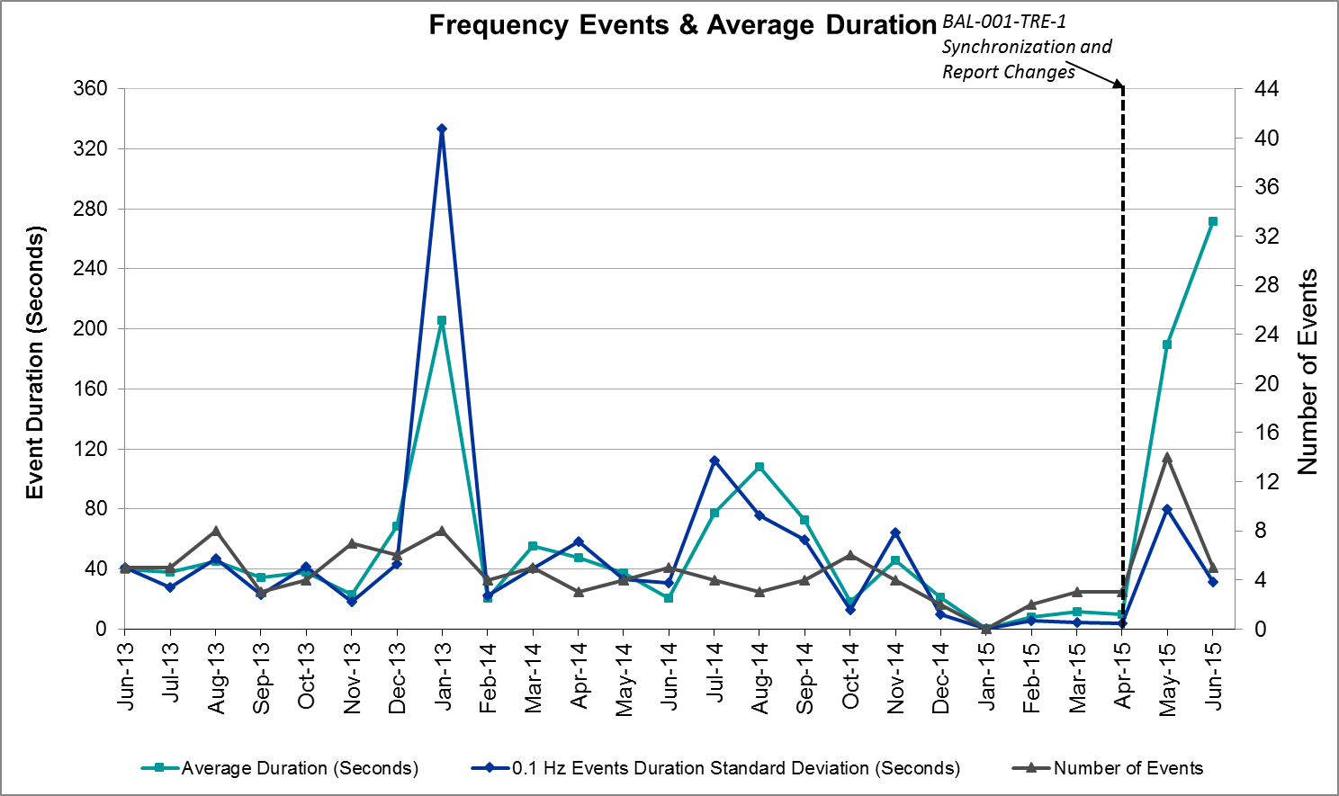

Responsive Reserve Events

There were five events where Responsive Reserve MWs were released to SCED in June. The events highlighted in blue were related to frequency events reported in section 2.1 above.

Date and Time  Released to SCED | Date and Time  Recalled | Duration of Event | Maximum MWs Released | Comments
6/9/2015 14:07:34 | 6/9/2015 14:11:09 | 0:03:35 | 231.48
6/17/2015 13:14:37 | 6/17/2015 13:17:39 | 0:03:02 | 176.95
6/22/2015 2:10:11 | 6/22/2015 2:12:36 | 0:02:25 | 177.95
6/25/2015 23:09:25 | 6/25/2015 23:12:21 | 0:02:56 | 140.71
6/26/2015 10:43:13 | 6/26/2015 10:46:29 | 0:03:16 | 60.23

Load Resource Events
There were no load resource deployment events in June.

Reliability Unit Commitment
ERCOT reports on Reliability Unit Commitments (RUC) on a monthly basis. Commitments are reported grouped by operating day and weather zone. The total number of hours committed is the sum of the hours for all the units in the specified region. Additional information on RUC commitments can be found on the MIS secure site at Grid Generation Reliability Unit Commitment.

There were no DRUC commitments in June.

HRUC Commitments
Resource Location | # of Resources | Operating Day | Total # of Hours Committed | Total MWhs | Reason for commitment
S. Central | 1 | 6/2/2015 | 16 | 5120 | Local Congestion
Southern | 1 | 6/2/2015 | 3 | 119 | Local Congestion
Southern | 2 | 6/2/2015 | 2 | 549 | Local Congestion
S. Central | 1 | 6/3/2015 | 13 | 5460 | Local Congestion
Southern | 1 | 6/3/2015 | 3 | 120 | Local Congestion
Southern | 1 | 6/3/2015 | 1 | 40 | Local Congestion
S. Central | 1 | 6/4/2015 | 9 | 3780 | Local Congestion
Southern | 1 | 6/4/2015 | 8 | 2584 | Local Congestion

Wind Generation as a Percent of Load
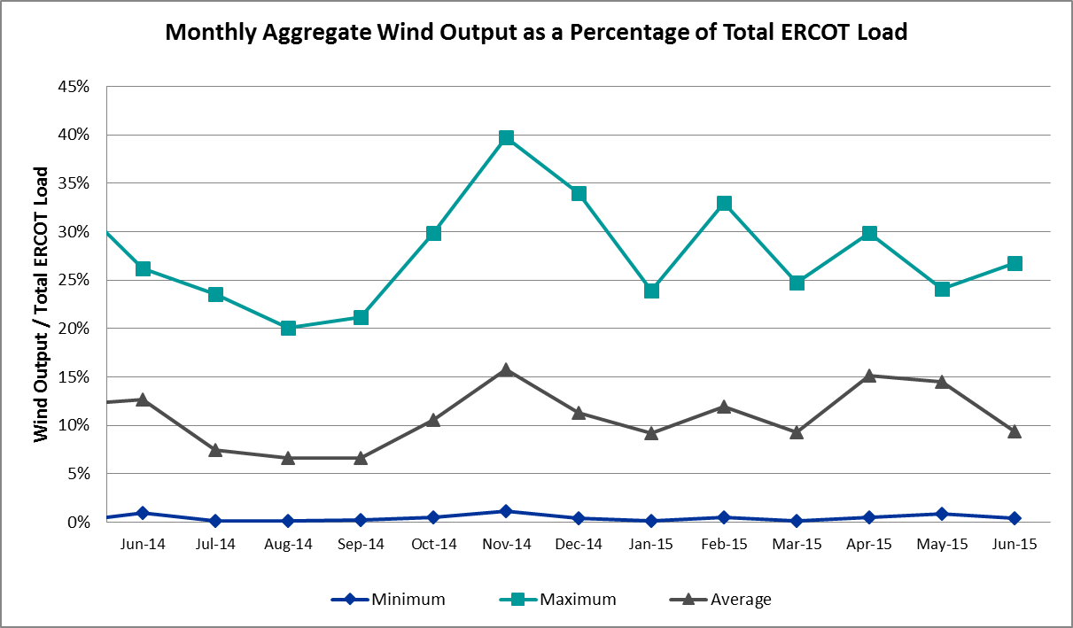

Congestion Analysis
The number of congestion events experienced by the ERCOT system decreased in June due to planned outages and area load/gen patterns. There were seven days of activity on the Generic Transmission Constraints (GTCs) in June.

Notable Constraints for June

Nodal protocol section 3.20 specifies that ERCOT shall identify transmission constraints that are active or binding three or more times within a calendar month. As part of this process, ERCOT reports congestion that meets this criterion to ROS. In addition ERCOT also highlights notable constraints that have an estimated congestion rent exceeding $1,000,000 for a calendar month. These constraints are detailed in the table below. Rows highlighted in blue indicate the congestion was affected by one or more outages. For a list of all constraints activated in SCED for the month of June, please see Appendix A at the end of this report.

Contingency | Overload | # of Days Constraint Active | Estimated Congestion Rent | Transmission Project
Bevo Substation - Asherton 138 kV | Hamilton Road - Maverick 138 kV | 4 | $6,277,750 | 16TPIT0024  May -18
Hutto Switch Axfmr 1 (3) 345/138 kV | Gilleland - Pflugerville 138 kV | 4 | $5,338,627 | 16TPIT0062  Dec-16
San Angelo College Hills 138_69T1 138/69 kV | SA Power 69T1 138/69 kV | 5 | $3,171,839
Key Sub - Willow Valley Switch 138 kV | Getty Vealmoor - Getty Vealmor Tap 138 kV | 1 | $2,484,327
San Angelo North 138_69T1 138/69kV | San Angelo College Hills 138_69T1 138/69 kV | 4 | $2,330,406 | 3663  May-17
Key Sub - Willow Valley Switch 138 kV | Big Spring Crmwd Tap - Big Spring Switch 69 kV | 4 | $1,428,088
Chevron Has - Wickett Whiting Oil 138 kV | Northward - Wink Sub 69 kV | 1 | $1,462,680
Eagle Mountain SES - Parker Switch and Hicks Switch 345kv | Calmont Switch - Western Hills 138 kV | 1 | $1,231,288
DCKT West Levee Switch - 800/900 Network 138 kV | East Levee Switch - Reagan Street 138 kV (3410_A) | 3 | $1,165,225 | 2014-NC28  May-16
DCKT Calaveras-Hotwells and Laredo1 138 kV | Calaveras - Streich 138 kV | 6 | $1,068,299 | 16TPIT0011  Jun-16
Poacks - City of College Station 138 kV Switch 138 kV | City of College Station 138 kV Switch - Cssc 138 kV | 5 | $535,704 | 4411  Jul-16
Saldo - Killeen Switch 345 kV | Belton - Belton Southwest 138 kV | 3 | $483,750
Eagle Mountain SES - Saginaw Switch 138 kV | Eagle Mountain SES - Morris Dido 138 kV | 3 | $427,106 | 4253  May-18
Bluff Creek T2 (3) 345/138 kV | Bluff Creek T1 (3) 345/138 kV | 3 | $351,393
Dunlap - Austrop and Lostpine 34 kV | Austrop AT2H 345/138 kV | 4 | $348,196
DCKT Jewett - Singleton 345 kV | Twin Oak Switch - Btu_Jack_Creek 345 kV | 9 | $330,793
Basecase | Zorillo - Ajo GTC | 6 | $257,269
DCKT Marion - Zorn and Clear Springs 345 kV | Cibolo - Schertz 138 kV | 4 | $232,783
Fppyd1-Salem and Fayett 345kv | Austrop - Sim Gideon 138 kV | 3 | $213,028
Laquinta - Lobo 138 kV | Bruni 138_69_1 138/69 kV | 10 | $179,697
Marion - Zorn 345 kV | Clear Springs - Marion 345 kV | 10 | $155,539
Roans Prarie - Rothwood and Singleton - Tomball 345 kV | Singleton - Zenith 345 kV (SNGZEN99) | 6 | $132,726 | 2013-R63
Lobo - San Miguel 345_138 kV Switchyards 345 kV | San Diego - Freer 69kV | 5 | $62,647
DCKT Marion - Zorn and Clear Springs 345 kV | Comal - Loop 337 138 kV | 7 | $27,797
DCKT Ferguson - Granite Mountain and Wirtz - Starcke - Paleface 138 kV | Wirtz - Flat Rock Lcra 138 kV | 6 | $28,729 | 4465  May-19
Cottonwood Road Switch - Loftin 69 kV | Shannon - Post Oak Switch 69 kV | 7 | $14,920 | 15TPIT0011

Generic Transmission Constraint Congestion
There were seven days of activity on the Zorillo - Ajo GTC in June. There was no activity on the remaining GTCs during the Month of June.

Manual Overrides for June
There were no manual overrides for the month of June 2015

Congestion Costs for Calendar Year 2015
The following table represents the top twenty active constraints for the calendar year based on the estimated congestion rent attributed to the congestion. ERCOT updates this list on a monthly basis.

Contingency | Binding Element | # of 5-min SCED Intervals | Estimated Congestion Rent | Transmission Project
DKCT Roans Prarie-Rothwood & Singleton-Tomball 345kV | Singleton - Zenith 345 kV (SNGZEN99) | 2,000 | $ 17,805,924.33 | 2013-R63
Topeka Termination - West Levee Switch 345 kV | Cedar Hill Switch - Mountain Creek 138 kV | 356 | $ 8,199,322.66 | 13TPIT0060
DCKT Hill Country - Marion and Elmcreek 345 kV | Marion - Skyline 345 kV | 1,188 | $ 7,610,819.02 | 4081
San Angelo North 138_69T1 138/69kV | San Angelo College Hills 138_69T1 138/69 kV | 5,663 | $ 7,348,255.62 | 3663
DCKT Lost Pines - Austrop & Dunlop 345 kV | Fayette Plant 1 - Fayette Plant 2 345 kV | 620 | $ 6,624,462.39
Bevo Substation - Asherton 138 kV | Hamilton Road - Maverick 138 kV | 2,975 | $ 6,277,749.92 | 16TPIT0024
Orange Grove Switching Station - Lon Hill 138 kV | Lon Hill - Smith 69 kV | 1,008 | $ 6,052,131.26 | 16TPIT0026
DCKT Jewett - Singleton 345 kV | Twin Oak Switch - Btu_Jack_Creek 345 kV | 3,206 | $ 5,573,653.67
Los Fresnos - Loma Alta Substation 138 kV | La Palma - Villa Cavazos 138 kV | 513 | $ 5,485,885.25
Hutto Switch Axfmr 1 (3) 345/138 kV | Gilleland - Pflugerville 138 kV | 589 | $ 5,338,627.43 | 16TPIT0062
Rio Hondo (2H) Axfmr 345/138 kV | Aderhold - Elsa 138 kV | 272 | $ 4,745,657.61
Falcon Seaboard - Midland East 345 kV | Odessa to Glenhaven 138 kV | 70 | $ 4,268,830.85 | 4173
Bates - Frontera 138 kV | Frontera - Goodwin 138 kV | 78 | $ 4,074,787.83
Falcon Seaboard to Morgan Creek Ses 345 KV | Glenhaven - Crmwd 8 Tap 138 kV | 249 | $ 4,063,954.92 | 4173
DCKT West Levee Switch - 800/900 Network 138 kV | East Levee Switch - Reagan Street 138 kV (3410_A) | 277 | $ 3,829,432.69 | 2014-NC28
DCKT Calaveras-Hotwells & Laredo1 138 kV | Calaveras - Streich 138 kV | 752 | $ 3,750,145.76 | 16TPIT0011
San Angelo College Hills 138_69T1 138/69 kV | SA Power 69T1 138/69 kV | 757 | $ 3,568,527.32
South Mission to Frontera 138/138 KV | North McAllen to West McAllen | 70 | $ 3,335,332.47
Barber Lake Swtich - Morgan Creek Ses 138 kV (14030) | Barber Lake Swtich - Morgan Creek Ses 138 kV (14035) | 80 | $ 3,040,753.33 | 15TPIT0087
Basecase | North to Houston | 93 | $ 3,027,252.14 | 2013-R63

System Events

ERCOT Peak Load
The unofficial ERCOT peak load for the month was 61,741 MW and occurred on June 10th during hour ending 17:00.

Load Shed Events
None.

Stability Events
None.

Notable PMU Events
ERCOT analyzes PMU data for any significant system disturbances that do not fall into the Frequency Events category reported in section 2.1. The results are summarized in this section once the analysis has been completed.

There were no reportable events in June.

TRE/DOE Reportable Events
None.

New/Updated Constraint Management Plans
Thirteen Constraint Management Plans were added in the month of June. Three remedial action plans and 10 mitigation plans.
- SSALFPP5: Salem To Fayette Power Plant 345Kv Line
- MP_2015_11: Forest Hill 138/69 kV Autotransformer
- MP_2015_09: Wink TNMP 138/69 kV Autotransformer OR Wink TNMP - Wink Oncor 138 kV Line
- MP_2015_08: Hutto - Round Rock/Gabriel 138kV Double Circuit Line
- MP_2015_07: Permian Basin 138/69 kV Autotransformer #1 OR Autotransformer #2
- MP_2015_06: Leon-Breckenridge 69 kV Line (Leon-Eastland)
- MP_2015_04: Henrietta Sw. - Bowie/Montague Sw. 69 kV Line (Bellevue - Montague Sw.)
- MP_2015_02: Fort Lancaster - Mesa View Switch 138kV line
- MP_2014_08: San Miguel to Sigmor 138 kV Line
- MP_2010_13: Jacksonville 138/69 kV Autotransformer # 1 (XJKS89-T1)
- DSALFA58: Salem To Fayette Power Plant 345Kv Line And Salem - Fayetteville 138Kv Line
- DNAVLEG5: Allen Sw - Royse/Monticello Double Circuit 345 kV Line
- MP_2015_03: Gillespie County

New/Modified/Removed SPS
None.

New Procedures/Forms/Operating Bulletins
None.

Emergency Conditions

OCNs
Date and Time | Description
06/12/15 15:55 | ERCOT issued an OCN due to the development of a new Generic Transmission Constraint (GTC) due to a local voltage stability issue.
06/15/15 21:42 | ERCOT issued an OCN due to Tropical Storm Bill approaching the ERCOT service area.

Advisories
Date and Time | Description
06/22/15 14:33 | ERCOT issued an Advisory for a geomagnetic disturbance of K7 and K8.

Watches
None.

Emergency Notices
None.

Application Performance
ERCOT system applications performed well in June. There were no issues to report.

TSAT/VSAT Performance Issues
None.

Communication Issues
None.

Market System Issues
None.

Net-Forecast Bias Applied to NSRS Procurement for July 2015
Each month, ERCOT calculates a net Forecast Bias pursuant to the ERCOT Ancillary Services Methodology for procurement of Non-Spinning Reserve Service (NSRS). The table below indicates the amount of net Forecast Bias that was applied to the NSRS procurement for specified blocks of time for the month of June, 2015.

Blocks | Negative Net Load Forecast Average Error - By Weather Zone for the 5 Largest Zones
 | Coast | East | North Central | South Central | Southern
1-2 | 0 | 0 | 0 | 0 | 0
3-6 | 0 | 0 | 0 | 0 | 0
7-10 | 0 | 0 | 0 | 0 | 0
11-14 | 0 | 0 | 0 | 0 | 0
15-18 | 0 | 0 | 0 | 0 | 0
19-22 | 0 | 0 | 0 | 0 | 0
23-24 | 0 | 0 | 0 | 0 | 0

Appendix A: Real-Time Constraints
The following is a complete list of constraints activated in SCED for the month of June. Full contingency descriptions can be found in the Standard Contingencies List located on the MIS secure site at Grid Generation Reliability Unit Commitment.

Contingency | Constrained Element | From Station | To Station | # of Days Constraint Active
SLAQLOB8 | BRUNI_69_1 | BRUNI | BRUNI | 10
SMARZOR5 | 419T419_1 | CLEASP | MARION | 10
DJEWSNG5 | JK_TOKSW_1 | TOKSW | JK_CK | 9
DMARZOR5 | 91T335_1 | COMAL | LOP337 | 7
SCRDLOF9 | POS_SHAN_1 | SHANNON | POSTOKSW | 7
BASE CASE | ZO_AJO |  |  | 6
DCALHOT8 | N4_X3_1 | CALAVERS | X3 | 6
DFERPAL8 | 38T365_1 | WIRTZ | FLATRO | 6
DRNS_TB5 | SNGZEN99_A | SNG | ZEN | 6
SLOBSAN5 | FREER_SAN_DI1_1 | SAN_DIEG | FREER | 5
SPOACSS8 | CSSWCS-CSSC_1 | CSSWCS | CSSC | 5
XSA2C89 | SAPOWER_69T1 | SAPOWER | SAPOWER | 5
DDUNLOS5 | AUSTRO_AT2H | AUSTRO | AUSTRO | 4
DMARZOR5 | 293T304_1 | CIBOLO | SCHERT | 4
SBEVASH8 | HAMILT_MAVERI1_1 | HAMILTON | MAVERICK | 4
SKEYWLV8 | 6610__D | BSPSW | BSCTP | 4
XHUT58 | 1666__B | GILLCR | PFLGV | 4
XSA2N89 | SACH_69T1 | SACH | SACH | 4
DEMSSAG8 | 6265__A | EMSES | MRSDO | 3
DFPPFAY5 | 197T171_1 | AUSTRO | GIDEON | 3
DSALKLN5 | 630__A | BLTON | BLTSW | 3
DWLV89N8 | 3410__A | ELVSW | REGST | 3
XBL2U58 | BLUF_CRK_T1_H | BLUF_CRK | BLUF_CRK | 3
DCLEZOR5 | 99T203_1 | ZORN | YORKCR | 2
DGARHIC8 | CKT_1027_1 | DUNLAP | DECKER | 2
DMARPA_8 | 38T365_1 | WIRTZ | FLATRO | 2
DTRCELK5 | 1775__C | TYLNE | DLPOI | 2
SLOBSAN5 | LAQUIN_LOBO1_1 | LAQUINTA | LOBO | 2
XLY2T58 | LYTTON_S_AT1H | LYTTON_S | LYTTON_S | 2
DAUSGAR5 | CKT_1027_1 | DUNLAP | DECKER | 1
DAUSSND5 | 1661__B | HUTTO | RRNES | 1
DDUNLOS5 | CKT_920_1 | AUSTRO | DUNLAP | 1
DEMSHCK5 | 6185__A | CMTSW | WSTHL | 1
DGABBEL8 | 1661__B | HUTTO | RRNES | 1
DGIBSNG5 | 260_A_1 | JEWET | SNG | 1
DHCKRNK5 | EMSES_AX2H | EMSES | EMSES | 1
DHUTGAB8 | 211T147_1 | GILLCR | MCNEIL_ | 1
DLWSRNK5 | 1060__F | RNKSW | MCPHERSN | 1
DMARZOR5 | 498T498_1 | MCQUEE | SCHUMA | 1
DMCSCDH8 | 3150__A | CDCSW | OKCLS | 1
DWH_STP5 | AIRCO4_RINCON1_1 | RINCON | AIRCO4 | 1
SAJORI25 | CELANE_KLEBER1_1 | CELANEBI | KLEBERG | 1
SATKDAN8 | NAL_BRIR_1 | NALL_LN | BRIRCRT | 1
SHICGAR8 | CKT_962_1 | GARFIELD | STONEY_R | 1
SHSAPBS8 | 6917__B | NWARD | WINKS | 1
SHWRWEL8 | 1163T163_1 | MCNEIL_ | HWRDTP | 1
SKEYWLV8 | 6135__E | GVLTP | GYVLM | 1
SKEYWLV8 | 6610__A | CHATP | BUZSW | 1
SL_FLA_8 | LA_PAL_VCAVAZ1_1 | LA_PALMA | VCAVAZOS | 1
SRDODES8 | 940__C | ENWSW | WXHCH | 1
SSALFPP5 | FAYETT_6AT2 | FAYETT | FAYETT | 1
SSAMTH35 | 505__A | THSES | SAMSW | 1
SSCUSUN8 | ROTN_WOLFGA1_1 | WOLFGANG | ROTN | 1
SSPUASP8 | JATN_SPUR_1C_1 | GIRA_TAP | DKEC | 1
SSPUASP8 | ROTN_WOLFGA1_1 | WOLFGANG | ROTN | 1
SSPUASP8 | SPUR_69_1 | SPUR | SPUR | 1
STRIDEC8 | CKT_1027_1 | DUNLAP | DECKER | 1
SVICCO28 | COLETO_VICTOR2_1 | COLETO | VICTORIA | 1
SW_BASH8 | BAT_CRST_1 | BATESVL | CRSTLSW | 1
SWILJA28 | 560__B | BRGPR | BTPTM | 1
XASP89 | MUNDAY_WEIN1_1 | MUNDAYST | WEIN | 1
XGEO89 | CSA_ORN_1 | ORNGRVS | CASA_BLA | 1
XLOB58 | DILLEY_JARDIN1_1 | DILLEYSW | JARDIN | 1
XMDL58 | 6465__B | SBYSW | MDDTN | 1
XNED358 | S104A_1 | RIOHONDO | MV_BURNS | 1
XORN89 | LOYOLA_69_1 | LOYOLA | LOYOLA | 1
XSA2N89 | SAPOWER_69T1 | SAPOWER | SAPOWER | 1
XWL2V58 | 3130__B | INDST | CMPST | 1

