Below are slides from the March AMWG meeting and the September 2014 & January 2015 AMS Workshops to provide some historical perspective.

*Has there been a determination on whether there is market interest in AMWG discussions*

1. *to understand/synchronize  LSE file validation differences between ERCOT and the SMT  and*
2. *perform a comparison of SMT data to ERCOT data?*

*Answer 6/16/2015 AMWG Discussion: There is market interest in SMT and ERCOT data being in sync; however, at this point exploring possible options would be premature pending the final decision by the PUCT on the ‘SMT Transition to ERCOT’ project (42786)*

|  |  |  |
| --- | --- | --- |
| 11 | Understanding the validation differences between ERCOT and SMT on LSE processing and possibility of performing a comparison of SMT data to ERCOT data | D Tucker |

[AMS Workshop Transition to AMWG](http://www.ercot.com/content/wcm/key_documents_lists/51263/AMS_Workshop_Transition_to_AMWG.pptx)   
(03/17/2015, pptx, 96.3 KB

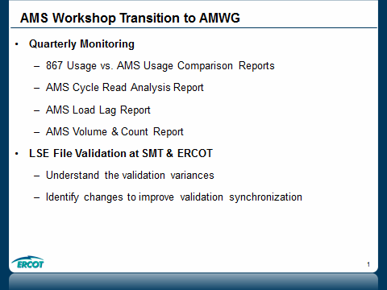

[03. 09_19_14 SMT AMS Data Validation and Sync FIlesv4](http://www.ercot.com/content/meetings/other/keydocs/2014/0919-AMSDATAWORKSHOP/03.__09_19_14_SMT_AMS_Data_Validation_and_Sync_FIlesv4.ppt)   
(09/18/2014, ppt, 352 KB)

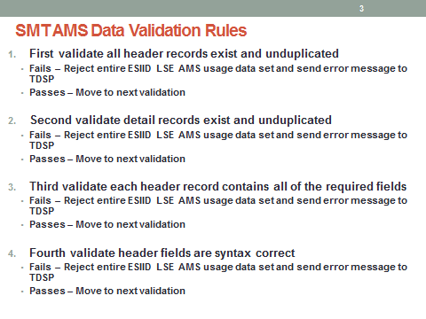

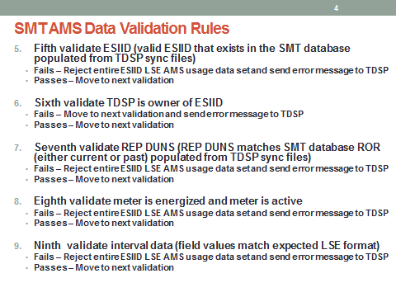

[AMS data loading error code distribution 9_19_2014](http://www.ercot.com/content/meetings/other/keydocs/2014/0919-AMSDATAWORKSHOP/AMS_data_loading_error_code_distribution_9_19_2014.ppt)   
(09/05/2014, ppt, 552.5 KB

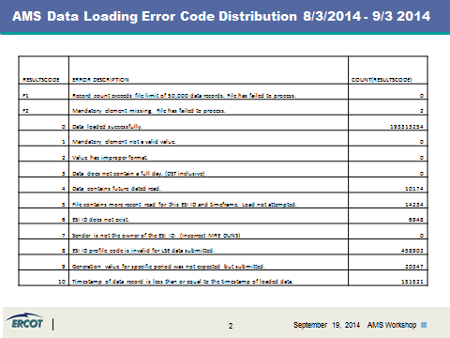

[AMS data loading result code descriptions distribution Nov](http://www.ercot.com/content/wcm/key_documents_lists/51433/AMS_data_loading_result_code_descriptions__distribution_Nov_.ppt)   
(01/19/2015, ppt, 707.5 KB)

