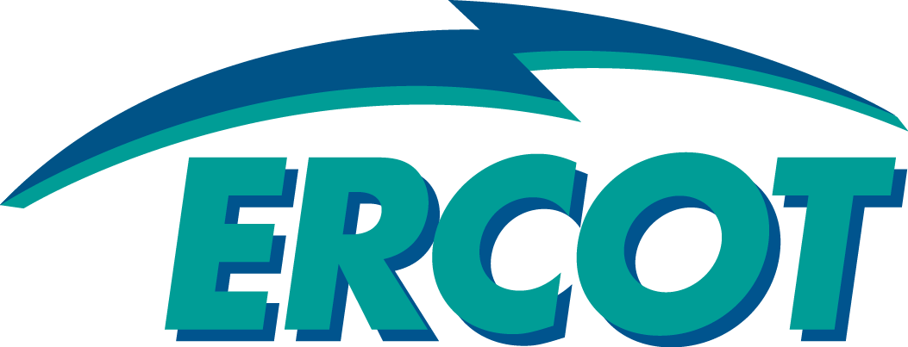 |  |  |  |  | System Planning
Monthly Status Report
April 2015

 |  |  | Report Highlights
- ERCOT is currently reviewing proposed transmission improvements with a total cost of $820.5 Million.
- Transmission Projects endorsed in 2015 total $189.8 Million.
- All projects (in engineering, routing, licensing and construction) total approximately $6.15 Billion.
- Transmission Projects energized in 2015 total about $32.8 Million.

Table of Contents

1. Regional Planning Group Project Reviews 1
2. Asynchronous Tie Interconnection 2
3. Planning Model Activities 2
4. Other Notable Activities 3

Regional Planning Group Project Reviews

- Duke-American Transmission Company has submitted the Phoenix project. This is a Tier 2 project that is estimated to cost $39 million. This project is currently under ERCOT independent review.

- CPS Energy and LCRA Transmission Services Corporation (TSC) have jointly submitted the Transmission System Additions project to address the reliability needs in the northeast San Antonio area. This is a Tier 1 project that is estimated to cost $86 million. The project was endorsed by the ERCOT Board of Directors on April 14th.

- LCRA has submitted the Goldthwaite-Lampasas Line Upgrades Project. This is a Tier 1 project that is estimated to cost $71 million. This project is currently under ERCOT independent review.

- TNMP has submitted the Flat Top 138 kV Interconnection project. This is a Tier 2 project that is estimated to cost $29 million. This project is currently under ERCOT independent review.

- Garland Power & Light has submitted the Greenville 138 kV tie project. This is a Tier 2 project that is estimated to cost $27 million. This project is currently under ERCOT independent review.

- Oncor submitted the Paul Davis-Texaco Mabee 138 kV project that is estimated to cost $9 million. This project has been submitted for RPG comments and and once the RPG comments are resolved, it will be reclassified as a Tier 4 Neutral project.

- AEPSC has submitted the Live Oak Transmission project. This is a Tier 2 project that is estimated to cost $33 million. This project is currently under ERCOT independent review.

- AEPSC has submitted the LRGV Area Transmission Improvements project. This is a Tier 1 project that is estimated to cost $621.5 million. This project has been submitted for RPG comments.

Asynchronous Tie Interconnection
Project | Notification to ERCOT | Reliability Study | RPG Review | Interconnection Agreement | In-service Year
Southern Cross HVDC (3000 MW - SERC)
Tres Amigas
(1500 MW - SPP)

Color Legend
In-Progress
Complete

Planning Model Activities
The short term calendar of major planning model events follows:
- Jul 1, 2015 Post 2015 Case Build, all cases currently known as “DSA” and “DSB”
- Jul 10, 2015 Post Updated Contingency Files
- Jul 10, 2015 Post Data Dictionary
- Aug 10, 2015 Begin 2015 Update Cycle 2
The following table shows updates since last month of interconnection projects that met Planning Guide section 6.9 (1) and were either modeled or not modeled based on submitted RARF data in accordance with Planning Guide section 6.9 (2). A non-null value in the Project ID column signifies that the project was modeled and a null value means it was not modeled. The Notes column may provide further explanation.

Other Notable Activities
- The System Protection Working Group began building the Future Year cases on April 2, 2015 with a proposed completion date of June 26, 2015.
- ERCOT has begun working on reliability analysis for the 2015 Regional Transmission Plan (RTP); The 2015 RTP start cases were posted on MIS on April 15, 2015.
- ERCOT commenced stakeholder discussions on the 2016 Long Term System Assessment (LTSA) at the April RPG meeting. ERCOT facilitated its first 2016 LTSA scenario development workshop on April 21st 2015. The next two scenario development workshops are planned for July 13 and 14.
- NERC Reliability Standard CIP-014-1, Requirement R1, states: “Each Transmission Owner shall perform an initial risk assessment and subsequent risk assessments of its Transmission stations and Transmission substations (existing and planned to be in service within 24 months) that meet the criteria specified in Applicability Section 4.1.1.” ERCOT, as Planning Coordinator and Reliability Coordinator for the Interconnection, qualifies as an unaffiliated third party and may verify risk assessments performed pursuant to CIP-014-1. ERCOT System Planning may perform a limited number of third-party verifications. Reviews will be performed on a first-requested, first-completed basis for those Transmission Owners that utilized the Steady State Working Group (SSWG), Regional Transmission Plan (RTP), or Dynamic Working Group (DWG) Base Case to conduct their risk assessments. ERCOT reserves the right to refuse verification requests. Transmission Owners interested in ERCOT performing the third-party verification should contact their ERCOT Account Manager to determine ERCOT’s availability.
- The next SSR workshop will be held on May 29 at the ERCOT Met Center.

