

**April 2015 ERCOT Monthly Operations Report**

**Reliability and Operations Subcommittee Meeting**

**June 4, 2015**

# Table of Contents

Table of Contents 2

1 Report Highlights 3

2 Frequency Control 4

2.1 Frequency Events 4

2.2 Responsive Reserve Events 5

2.3 Load Resource Events 5

3 Reliability Unit Commitment 6

4 Wind Generation as a Percent of Load 6

5 Congestion Analysis 7

5.1 Notable Constraints for April 7

5.2 Generic Transmission Constraint Congestion 8

5.3 Manual Overrides for April 8

5.4 Congestion Costs for Calendar Year 2015 9

6 System Events 10

6.1 ERCOT Peak Load 10

6.2 Load Shed Events 10

6.3 Stability Events 10

6.4 Notable PMU Events 10

6.5 TRE/DOE Reportable Events 10

6.6 New/Updated Constraint Management Plans 10

6.7 New/Modified/Removed SPS 10

6.8 New Procedures/Forms/Operating Bulletins 10

7 Emergency Conditions 10

7.1 OCNs 10

7.2 Advisories 10

7.3 Watches 10

7.4 Emergency Notices 10

8 Application Performance 11

8.1 TSAT/VSAT Performance Issues 11

8.2 Communication Issues 11

8.3 Market System Issues 11

9 Net-Forecast Bias Applied to NSRS Procurement for May 2015 11

Appendix A: Real-Time Constraints 12

# Report Highlights

* The unofficial ERCOT peak for April was 45,242 MW.
* There were three frequency events in April. PMU data indicates the ERCOT system transitioned well in each case.
* There were five instances where Responsive Reserves were deployed, three of which were the result of frequency events.
* There was one RUC commitment in April for the purpose of relieving Local Congestion.
* The level of reportable SCED congestion increased in April. This congestion was due primarily to planned outages and area load/gen patterns. There was seventeen days of activity on the Zorillo - Ajo Generic Transmission Constraint (GTC).
* There was one significant system event for the month of April. On April 27, severe storms in the interconnection caused forced outages on several lines north of Houston. These line trips also resulted in the loss of 540MW of generation.
* ERCOT Applications performed well throughout the month. There was only one event in which ERCOTs Voltage Security Assessment Tool (VSAT) was unavailable for a brief period of time.

# Frequency Control

## Frequency Events

The ERCOT Interconnection experienced three frequency events in April, all of which resulted from Resource trips. The average event duration was approximately 9.67 seconds. The event that occurred on 4/27/2015 was the result of multiple line and unit trips, resulting in three separate oscillations during the frequency event.

When analyzing frequency events, ERCOT evaluates PMU data according to industry standards. Events with an oscillating frequency of less than 1 Hz are considered to be inter-area, while higher frequencies indicate local events. Industry standards specify that damping ratio for inter-area oscillations should be 3.0% or greater. All events listed below indicate the ERCOT system met these standards and transitioned well after each disturbance. Further details on the Resource trip events can be seen in the Performance Disturbance Compliance Working Group report.

A summary of the frequency events is provided below:

|  |  |  |  |  |  |
| --- | --- | --- | --- | --- | --- |
| **Date and Time** | **Max/Min Frequency**  **(Hz)** | **Duration of Event**  **(seconds)** | **PMU Data** | | **Comments** |
| **Oscillation Mode (Hz)** | **Damping Ratio** |
| 4/9/2015 21:23:29 | 59.867 | 12 | 0.90 | 15.0% | Unit trip with approximately 583 MW |
| 4/13/2015 16:43:29 | 59.869 | 12 | 0.69 | 12.0% | Unit trip with approximately 499 MW |
| 4/27/2015 4:15:20 | 59.804 | 5 | 0.67 | 10.0% | Units tripped with approximately 540 MW |
| 0.68 | 15.0% |
| 0.70 | 22.0% |

(Note: the duration of the frequency events is defined to be the time at which the frequency was outside the range of 60±0.1 Hz)

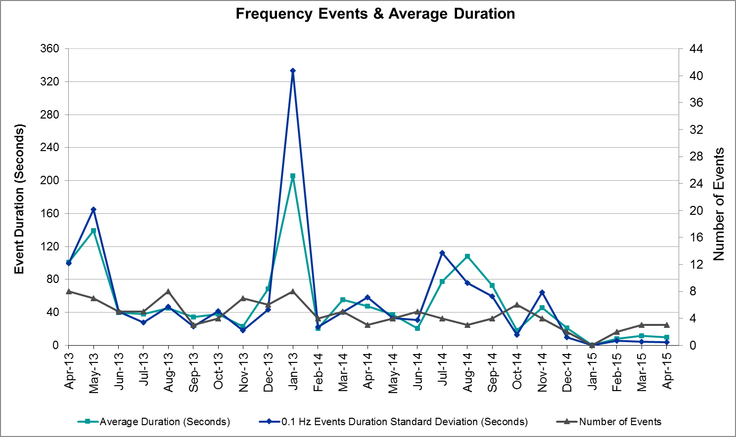

## Responsive Reserve Events

There were five events where Responsive Reserve MWs were released to SCED in April. The events highlighted in blue were related to frequency events reported in section 2.1 above.

|  |  |  |  |  |
| --- | --- | --- | --- | --- |
| **Date and Time**  **Released to SCED** | **Date and Time**  **Recalled** | **Duration of Event** | **Maximum MWs Released** | **Comments** |
| 4/9/2015 21:23:32 | 4/9/2015 21:25:40 | 0:02:08 | 267.95 |  |
| 4/13/2015 16:43:32 | 4/13/2015 16:46:04 | 0:02:32 | 376.86 |  |
| 4/14/2015 21:39:52 | 4/14/2015 21:41:44 | 0:01:52 | 297.99 | Unit run-back and trip carrying 558MW. Frequency event does not meet PDCWG FME criteria. |
| 4/17/2015 22:41:54 | 4/17/2015 22:43:10 | 0:01:16 | 148.09 | Unit trip carrying 300MW. Frequency event does not meet PDCWG criteria. |
| 4/27/2015 4:15:26 | 4/27/2015 4:18:34 | 0:03:08 | 379.36 |  |

## Load Resource Events

There were no load resource deployment events in April.

# Reliability Unit Commitment

ERCOT reports on Reliability Unit Commitments (RUC) on a monthly basis. Commitments are reported grouped by operating day and weather zone. The total number of hours committed is the sum of the hours for all the units in the specified region. Additional information on RUC commitments can be found on the MIS secure site at Grid 🡪 Generation 🡪 Reliability Unit Commitment.

There were no DRUC commitments in April.

|  |  |  |  |  |  |
| --- | --- | --- | --- | --- | --- |
| **HRUC Commitments** | | | | | |
| **Resource Location** | **# of Resources** | **Operating Day** | **Total # of Hours Committed** | **Total MWhs** | **Reason for commitment** |
| N. Central | 1 | 4/3/2015 | 8 | 944 | Local Congestion |

# Wind Generation as a Percent of Load

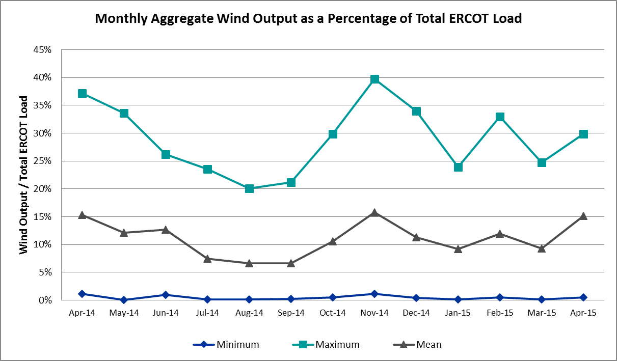

# Congestion Analysis

The number of congestion events experienced by the ERCOT system increased in April due to planned outages and area load/gen patterns. There were seventeen days of activity on the Generic Transmission Constraints (GTCs) in April.

## Notable Constraints for April

Nodal protocol section 3.20 specifies that ERCOT shall identify transmission constraints that are active or binding three or more times within a calendar month. As part of this process, ERCOT reports congestion that meets this criterion to ROS. In addition ERCOT also highlights notable constraints that have an estimated congestion rent exceeding $1,000,000 for a calendar month. These constraints are detailed in the table below. Rows highlighted in blue indicate the congestion was affected by one or more outages. For a list of all constraints activated in SCED for the month of April, please see Appendix A at the end of this report.

|  |  |  |  |  |
| --- | --- | --- | --- | --- |
| **Contingency** | **Overload** | **# of Days Constraint Active** | **Estimated Congestion Rent** | **Transmission Project** |
| Barber Lake Swich - Morgan Creek Ses 138 kV (14030) | Barber Lake Swtich - Morgan Creek Ses 138 kV (14035) | 1 | $3,040,753 | 15TPIT0087 Dec-15 |
| DCKT Burleson - Carson Creek 138 kV and Pedernales - Advanced Micro Devices AEN 138 kV | Manesium Plant - Northlan 138kV | 1 | $1,784,116 | 14TPIT0038 Jun-16 |
| Hutto - Round Rock & Gabriel 138 kV | Gilleland - McNeil LCRA 138kV | 6 | $1,748,390 | 08TPIT0033 Jun-16 |
| DCKT Calaveras-Hotwells & Laredo1 138 kV | Calaveras - Streich 138 kV | 1 | $1,377,343 | 16TPIT0011 Jun-16 |
| Moulton to Shiner (3)138/138/138 KV | Flatonia - Hallettsvile 138 kV | 3 | $895,759 |  |
| Sacroc - Sun Switch 138 kV | Sun Switch - Morgan Creek SES 138 kV | 24 | $875,130 | 4213 Dec-17 |
| Basecase | Zorillo - Ajo GTC | 10 | $620,504 |  |
| Bluff Creek T2 (3) 345/138 kV | Bluff Creek T1 (3) 345/138 kV | 4 | $552,947 |  |
| Hutto - Zorn & Gilleland 345 kV | Hutto Switch AXFMR1L 345/138 kV | 7 | $502,096 |  |
| Orange Grove Switching Station - Lon Hill 138 kV | Lon Hill - Smith 69 kV | 3 | $466,150 | 16TPIT0026 Jan-16 |
| Hutto - Zorn & Gilleland 345 kV | Hutto Switch AXFMR1H 345/138 kV | 7 | $301,563 |  |
| DCKT Ferguson - Granite Mountain and Wirtz - Starcke - Paleface 138 kV | Wirtz - Flat Rock Lcra 138 kV | 14 | $268,633 | 2014-SC10 May-19 |
| Uvalde Aep - Odlaw Switchyard 138 kV | Hamilton Road - Maverick 138 kV | 10 | $185,291 |  |
| Zenith - Singleton 345 kV | Singleton - Zenith 345 kV (SNGZEN99) | 3 | $179,585 | 2013-R63 |
| Hicks Switch - Alliance & Roanoke Switch 345 kV | Eagle Mountain SES AXFMR2 345/138 kV | 3 | $126,683 |  |
| Laquinta - Lobo 138 kV | Bruni 138_69_1 138/69 kV | 7 | $72,841 | 13TPIT0148 |
| Cottonwood Road Switch - Loftin 69 kV | Shannon - Post Oak Switch 69 kV | 19 | $28,517 |  |
| DCKT Marion - Zorn and Clear Springs 345 kV | Cibolo - Schertz 138 kV | 4 | $25,160 |  |
| Bosque Switch - Elm Mott 345 kV | Bosque Switch - Rogers Hill 138 kV | 5 | $15,153 | 2014-NC39 May-20 |
| Aspermont Aep - Spur 138 kV | Wolfgang - Rotan 69 kV | 10 | $8,949 |  |
| Scurry Switch - Sun Switch 138 kV | Wolfgang - Rotan 69 kV | 5 | $7,909 |  |
| Basecase | Ena Snyder Wind - Wkn_Bkr 69 kV | 3 | $1,595 |  |

## Generic Transmission Constraint Congestion

There were seventeen days of activity on the Zorillo - Ajo GTC in April. There was no activity on the remaining GTCs during the Month of April.

## Manual Overrides for April

|  |  |  |  |  |
| --- | --- | --- | --- | --- |
| **Date** | **# of Resources with an Override** | **Number of SCED Intervals** | **Reason** | **Type** |
| 4/29/2015 | 2 | 12 | Voltage Oscillations | HDL Override |

## Congestion Costs for Calendar Year 2015

The following table represents the top twenty active constraints for the calendar year based on the estimated congestion rent attributed to the congestion. ERCOT updates this list on a monthly basis.

|  |  |  |  |  |
| --- | --- | --- | --- | --- |
| **Contingency** | **Binding Element** | **# of 5-min SCED Intervals** | **Estimated Congestion Rent** | **Transmission Project** |
| Topeka Termination - West Levee Switch 345 kV | Cedar Hill Switch - Mountain Creek 138 kV | 305 | $8,207,201 | 13TPIT0060 |
| DCKT Hill Country - Marion and Elmcreek 345 kV | Marion - Skyline 345 kV | 1,188 | $7,610,819 | 4081 |
| DCKT Lost Pines - Austrop & Dunlop 345 kV | Fayette Plant 1 - Fayette Plant 2 345 kV | 2,975 | $6,624,462 |  |
| Orange Grove Switching Station - Lon Hill 138 kV | Lon Hill - Smith 69 kV | 5,650 | $6,052,131 | 16TPIT0026 |
| Rio Hondo (2H) Axfmr 345/138 kV | Aderhold - Elsa 138 kV | 272 | $4,912,865 |  |
| San Angelo North 138_69T1 138/69kV | San Angelo College Hills 138_69T1 138/69 kV | 352 | $4,833,944 |  |
| Bates - Frontera 138 kV | Frontera - Goodwin 138 kV | 249 | $4,074,788 |  |
| Barber Lake Swtich - Morgan Creek Ses 138 kV (14030) | Barber Lake Swtich - Morgan Creek Ses 138 kV (14035) | 93 | $3,040,753 | 15TPIT0087 Dec-15 |
| Scurry Switch - Sun Switch 138 kV | Matador - Roaring Springs 69 kV | 182 | $2,047,958 |  |
| Los Fresnos - Loma Alta Substation 138 kV | La Palma - Villa Cavazos 138 kV | 132 | $2,024,082 |  |
| Basecase | Valley Import | 32 | $1,989,446 | 14TPIT0050 |
| DCKT Burleson - Carson Creek 138 kV and Pedernales - Advanced Micro Devices AEN 138 kV | Manesium Plant - Northlan 138kV | 28 | $1,784,116 | 14TPIT0038 Jun-16 |
| Hutto - Round Rock & Gabriel 138 kV | Gilleland - McNeil LCRA 138kV | 736 | $1,748,390 | 08TPIT0033 Jun-16 |
| DCKT Calaveras-Hotwells & Laredo1 138 kV | Calaveras - Streich 138 kV | 309 | $1,378,329 | 16TPIT0011 Jun-16 |
| DCKT Flewellen - Obrien and Maso Road 138 kV | Tomball - Hockley 138 kV | 664 | $1,286,964 | 3682A, 3682B |
| Laquinta - Lobo 138 kV | Bruni 138_69_1 138/69 kV | 2,626 | $1,269,421 | 13TPIT0148 |
| Navarro - Watermill Switch 345 kV | Big Brown - Richland Chambers 345 kV | 55 | $1,251,268 | 2014-NC15, 4298 |
| Winks Sub - No Trees Switch 138 kV | Holt Switch - Amoco Midland Farms Tap 138 kV | 101 | $1,204,544 | 4243 |
| Bluff Creek T2 (3) 345/138 kV | Bluff Creek T1 (3) 345/138 kV | 471 | $1,097,662 |  |
| DCKT Jewett - Singleton 345 kV | Gibbons Creek - Singleton (SNGXGC99) | 1,458 | $897,168 | 2013-R63 |

# System Events

## ERCOT Peak Load

The unofficial ERCOT peak load for the month was 45,242 MW and occurred on April 9 during hour ending 17:00.

## Load Shed Events

None.

## Stability Events

None.

## Notable PMU Events

ERCOT analyzes PMU data for any significant system disturbances that do not fall into the Frequency Events category reported in section 2.1. The results are summarized in this section once the analysis has been completed.

There were no reportable events in April.

## TRE/DOE Reportable Events

On April 27, severe storms in the interconnection caused forced outages on several lines north of Houston. These line trips also resulted in the loss of 540MW of generation.

## New/Updated Constraint Management Plans

None.

## New/Modified/Removed SPS

None.

## New Procedures/Forms/Operating Bulletins

None.

# Emergency Conditions

## OCNs

None.

## Advisories

|  |  |
| --- | --- |
| **Date and Time** | **Description** |
| 4/24/2015 21:30 | ERCOT issued an Advisory due to ERCOTs Voltage Security Assessment Tool being unavailable from 20:42-21:19. |

## Watches

None.

## Emergency Notices

None.

# Application Performance

ERCOT system applications performed well in April. There was only one issue to report.

## TSAT/VSAT Performance Issues

ERCOTs Voltage Security Assessment Tool was unavailable from 20:42 – 21:19 on 4/24/2015.

## Communication Issues

None.

## Market System Issues

None.

# Net-Forecast Bias Applied to NSRS Procurement for May 2015

Each month, ERCOT calculates a net Forecast Bias pursuant to the ERCOT Ancillary Services Methodology for procurement of Non-Spinning Reserve Service (NSRS). The table below indicates the amount of net Forecast Bias that was applied to the NSRS procurement for specified blocks of time for the month of May, 2015.

|  |  |  |  |  |  |
| --- | --- | --- | --- | --- | --- |
| **Blocks** | **Negative Net Load Forecast Average Error - By Weather Zone for the 5 Largest Zones** | | | | |
| **Coast** | **East** | **North Central** | **South Central** | **Southern** |
| **1-2** | 0 | 0 | 0 | 0 | 0 |
| **3-6** | 0 | 0 | 0 | 0 | 0 |
| **7-10** | 0 | 0 | 0 | 0 | 0 |
| **11-14** | -22 | -4 | -27 | -13 | -7 |
| **15-18** | -65 | -11 | -77 | -39 | -20 |
| **19-22** | -101 | -17 | -120 | -60 | -31 |
| **23-24** | 0 | 0 | 0 | 0 | 0 |

# Appendix A: Real-Time Constraints

The following is a complete list of constraints activated in SCED for the month of April. Full contingency descriptions can be found in the Standard Contingencies List located on the MIS secure site at Grid 🡪 Generation 🡪 Reliability Unit Commitment.

|  |  |  |  |  |
| --- | --- | --- | --- | --- |
| **Contingency** | **Constrained Element** | **From Station** | **To Station** | **# of Days Constraint Active** |
| SSACSUN8 | 6474__A | SUNSW | MGSES | 24 |
| SCRDLOF9 | POS_SHAN_1 | SHANNON | POSTOKSW | 19 |
| DFERPAL8 | 38T365_1 | WIRTZ | FLATRO | 14 |
| BASE CASE | ZO_AJO |  |  | 10 |
| SBRAUVA8 | HAMILT_MAVERI1_1 | HAMILTON | MAVERICK | 10 |
| SSPUASP8 | ROTN_WOLFGA1_1 | WOLFGANG | ROTN | 10 |
| BASE CASE | AJO_ZO |  |  | 7 |
| DHUTHUT5 | HUTTO_MR1H | HUTTO | HUTTO | 7 |
| DHUTHUT5 | HUTTO_MR1L | HUTTO | HUTTO | 7 |
| SLAQLOB8 | BRUNI_69_1 | BRUNI | BRUNI | 7 |
| DHUTGAB8 | 211T147_1 | GILLCR | MCNEIL_ | 6 |
| SBOSELM5 | 1030__B | BOSQUESW | RGH | 5 |
| SSCUSUN8 | ROTN_WOLFGA1_1 | WOLFGANG | ROTN | 5 |
| DMARZOR5 | 293T304_1 | CIBOLO | SCHERT | 4 |
| XBL2U58 | BLUF_CRK_T1_H | BLUF_CRK | BLUF_CRK | 4 |
| BASE CASE | SNYDER_WKN_BK1_1 | ENAS | WKN_BKR | 3 |
| DHCKRNK5 | EMSES_AX2L | EMSES | EMSES | 3 |
| SMOUFLA8 | 144T132_1 | FLATON | HALLET | 3 |
| SORNLON8 | LON_HI_SMITH1_1 | LON_HILL | SMITH | 3 |
| SZENSN25 | SNGZEN99_A | SNG | ZEN | 3 |
| DCALHOT8 | N4_X3_1 | CALAVERS | X3 | 2 |
| DFPPFAY5 | 197T171_1 | AUSTRO | GIDEON | 2 |
| DJEWSNG5 | 256_A_1 | TOKSW | GIBCRK | 2 |
| DJEWSNG5 | JK_TOKSW_1 | TOKSW | JK_CK | 2 |
| DMARPA_8 | 38T365_1 | WIRTZ | FLATRO | 2 |
| DRNS_TB5 | SNGZEN99_A | SNG | ZEN | 2 |
| SGILNU78 | GILA_MORRIS1_1 | GILA | MORRIS | 2 |
| SLARLOB8 | ASHERT_CATARI1_1 | ASHERTON | CATARINA | 2 |
| SSUNMGS8 | 6240__A | SACRC | SNYDR | 2 |
| BASE CASE | LNCRK2_T2 | LNCRK2 | LNCRK2 | 1 |
| DAUSGAR5 | 197T171_1 | AUSTRO | GIDEON | 1 |
| DBURAMD8 | CKT_979_1 | MAGPLANT | NORTHLAN | 1 |
| DCC3_NED | BLESSI_LOLITA1_1 | BLESSING | LOLITA | 1 |
| DCRLLSW5 | 589_C_1 | LWSVS | CRLNW | 1 |
| DFPPFAY5 | 501T231_1 | AUSTRO | WEBBER | 1 |
| DHILELM5 | MAR_SKY_1 | MARION | SKYLINE | 1 |
| DLONOR58 | LON_HI_SMITH1_1 | LON_HILL | SMITH | 1 |
| DLWSRNK5 | 1140__C | DFWD1 | DFWCE | 1 |
| DRILEDI5 | EDITHC_GAUSS2_1 | EDITHCLA | GAUSS | 1 |
| DRNKW_D5 | 1140__C | DFWD1 | DFWCE | 1 |
| DSC_SL28 | CO_WAS84_A | CO | WAS | 1 |
| DSNGZEN5 | 155T217_1 | BELLSO | PT | 1 |
| DWH_STP5 | BLESSI_LOLITA1_1 | BLESSING | LOLITA | 1 |
| DWTRWLV5 | 3210__A | CDHSW | MCSES | 1 |
| SBIGDIL8 | BAT_CRST_1 | BATESVL | CRSTLSW | 1 |
| SBRBMGS8 | 14035__A | MGSES | BRBSW | 1 |
| SBUZLME8 | LMESA_FMR1 | LMESA | LMESA | 1 |
| SCHYWIN8 | 6090__D | HLTSW | AMMFT | 1 |
| SCISPUT8 | ABSO_VINSON1_1 | ABSO | VINSON | 1 |
| SENTTR25 | 1350__A | NCSTP | LUFKN | 1 |
| SFORYEL8 | FORTMA_MASN1_1 | FORTMA | MASN | 1 |
| SL_FLA_8 | LA_PAL_VCAVAZ1_1 | LA_PALMA | VCAVAZOS | 1 |
| SLA_RIO8 | HARLNS_OLEAND1_1 | HARLNSW | OLEANDER | 1 |
| SLARLOB8 | CATARI_PILONC1_1 | CATARINA | PILONCIL | 1 |
| SMCNMCN8 | HWRDLN_1 | HWRDTP | HWRDLN | 1 |
| SPAWCAL5 | BLESSI_LOLITA1_1 | BLESSING | LOLITA | 1 |
| SPAWLON5 | AIRCO4_RINCON1_1 | RINCON | AIRCO4 | 1 |
| SPORWHI8 | I_DUPS_WHITE_1_1 | I_DUPSW | WHITE_PT | 1 |
| SWMRCDH8 | 3200__A | CDHSW | MCSES | 1 |
| XODE58 | ODEHV_MR1L | ODEHV | ODEHV | 1 |
| XWLV258 | 6429__D | ECRSW | ENCRT | 1 |