March 2015 ERCOT Monthly Operations Report

Reliability and Operations Subcommittee Meeting
May 7, 2015

Table of Contents
Table of Contents 2
1 Report Highlights 3
Frequency Control 4
1.1 Frequency Events 4
1.2 Responsive Reserve Events 5
1.3 Load Resource Events 5
2 Reliability Unit Commitment 5
3 Wind Generation as a Percent of Load 6
4 Congestion Analysis 6
4.1 Notable Constraints for March 6
4.2 Generic Transmission Constraint Congestion 8
4.3 Manual Overrides for March 8
4.4 Congestion Costs for Calendar Year 2015 8
5 System Events 9
5.1 ERCOT Peak Load 9
5.2 Load Shed Events 9
5.3 Stability Events 10
5.4 Notable PMU Events 10
5.5 TRE/DOE Reportable Events 10
5.6 New/Updated Constraint Management Plans 10
5.7 New/Modified/Removed SPS 10
5.8 New Procedures/Forms/Operating Bulletins 10
6 Emergency Conditions 10
6.1 OCNs 10
6.2 Advisories 10
6.3 Watches 11
6.4 Emergency Notices 11
7 Application Performance 11
7.1 TSAT/VSAT Performance Issues 11
7.2 Communication Issues 11
7.3 Market System Issues 11
8 Net-Forecast Bias Applied to NSRS Procurement for April 2015 12
Appendix A: Real-Time Constraints 13

Report Highlights
- The unofficial ERCOT peak for March was 53,084 MW.
- ERCOT had a wind penetration record on March 29, 2015 at 2:12 AM. Total wind was 10,308 MW, accounting for 40.6% of the total 25,400 MW of ERCOT system load. The previous record was on December 14, 2014 at 2:50 AM where wind accounted for 39.7% of system load.
- There were three frequency events in March. PMU data indicates the ERCOT system transitioned well in each case.
- There were three instances where Responsive Reserves were deployed, all three of which were the result of frequency events.
- There were no RUC commitments in March.
- The level of reportable SCED congestion increased in March. This congestion was due primarily to planned outages and area load/gen patterns. There was six days of activity on the new Zorillo - Ajo Generic Transmission Constraint (GTC).
- There were no significant system events in ERCOT during the month of March.
- ERCOT’s Market Management System (MMS) went down at 6:13 until 7:00 on March 30, 2015 due to a hardware failure on a server that supports the MMS. ERCOT’s EMS performed well during the period controlling system frequency.

Frequency Control

Frequency Events
The ERCOT Interconnection experienced three frequency events in March, all of which resulted from Resource trips. The average event duration was approximately 11.33 seconds.

When analyzing frequency events, ERCOT evaluates PMU data according to industry standards. Events with an oscillating frequency of less than 1 Hz are considered to be inter-area, while higher frequencies indicate local events. Industry standards specify that damping ratio for inter-area oscillations should be 3.0% or greater. All events listed below indicate the ERCOT system met these standards and transitioned well after each disturbance. Further details on the Resource trip events can be seen in the Performance Disturbance Compliance Working Group report.

A summary of the frequency events is provided below:

Date and Time | Max/Min Frequency  (Hz) | Duration of Event  (seconds) | PMU Data |  | Comments
 |  |  | Oscillation Mode (Hz) | Damping Ratio
3/1/2015 21:37:13 | 59.882 | 10 | 0.67 | 12.0% | Unit trip with approximately 600 MW
3/12/2015 16:39:52 | 59.885 | 8 | 0.62 | 3.0% | Unit trip with approximately 358 MW
3/28/2015 11:01:20 | 59.804 | 16 | 0.73 | 11.0% | Unit trip with approximately 698 MW

(Note: the duration of the frequency events is defined to be the time at which the frequency was outside the range of 60±0.1 Hz)

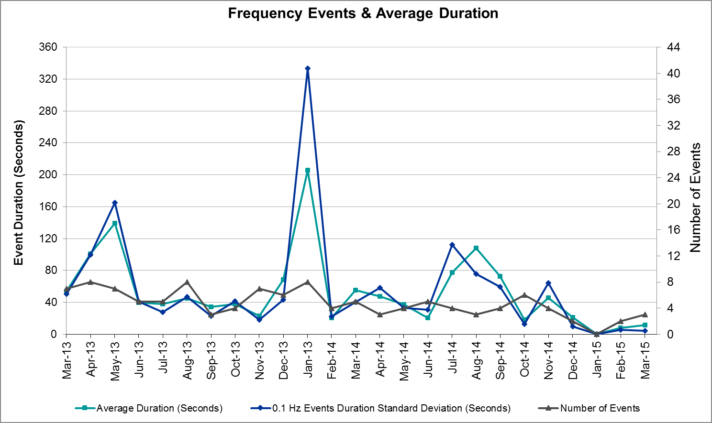

Responsive Reserve Events
There were three events where Responsive Reserve MWs were released to SCED in March. The events highlighted in blue were related to frequency events reported in section 2.1 above.

Date and Time  Released to SCED | Date and Time  Recalled | Duration of Event | Maximum MWs Released | Comments
3/1/2015 21:37:18 | 3/1/2015 21:39:54 | 0:02:36 | 255.2
3/12/2015 16:39:58 | 3/12/2015 16:43:06 | 0:03:08 | 353.08
3/28/2015 23:01:26 | 3/28/2015 23:04:02 | 0:02:36 | 791.32

Load Resource Events
There were no load resource deployment events in March.

Reliability Unit Commitment
ERCOT reports on Reliability Unit Commitments (RUC) on a monthly basis. Commitments are reported grouped by operating day and weather zone. The total number of hours committed is the sum of the hours for all the units in the specified region. Additional information on RUC commitments can be found on the MIS secure site at Grid Generation Reliability Unit Commitment.

There were no DRUC or HRUC commitments in March.

Wind Generation as a Percent of Load
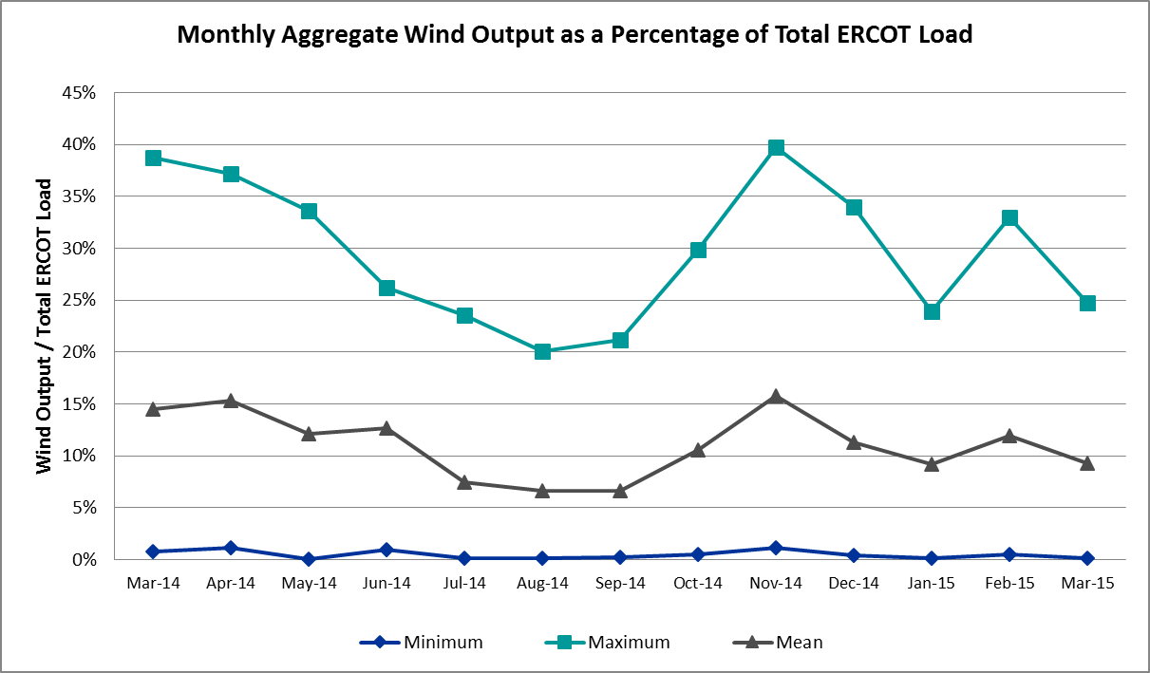

Congestion Analysis
The number of congestion events experienced by the ERCOT system increased in March due to planned outages and area load/gen patterns. There were six days of activity on the Generic Transmission Constraints (GTCs) in March.

Notable Constraints for March
Nodal protocol section 3.20 specifies that ERCOT shall identify transmission constraints that are active or binding three or more times within a calendar month. As part of this process, ERCOT reports congestion that meets this criterion to ROS. In addition ERCOT also highlights notable constraints that have an estimated congestion rent exceeding $1,000,000 for a calendar month. These constraints are detailed in the table below. Rows highlighted in blue indicate the congestion was affected by one or more outages. For a list of all constraints activated in SCED for the month of March, please see Appendix A at the end of this report.

Contingency | Overload | # of Days Constraint Active | Estimated Congestion Rent | Transmission Project
Topeka Termination - West Levee Switch 345 kV | Cedar Hill Switch - Mountain Creek 138 kV | 1 | $8,199,323 | 13TPIT0060
DCKT Lost Pines - Austrop & Dunlop 345 kV | Fayette Plant 1 - Fayette Plant 2 345 kV | 9 | $3,863,579
Orange Grove Switching Station - Lon Hill 138 kV | Lon Hill - Smith 69 kV | 18 | $1,680,457 | 16TPIT0026
Navarro - Watermill Switch 345 kV | Big Brown - Richland Chambers 345 kV | 1 | $1,251,268 | 2014-NC15, 4298
Laquinta - Lobo 138 kV | Bruni 138_69_1 138/69 kV | 11 | $450,619 | 13TPIT0148
Bluff Creek T2 (3) 345/138 kV | Bluff Creek T1 (3) 345/138 kV | 3 | $412,460
Basecase | Ajo - Zorillo 345 kV | 3 | $279,082
Cedar Bayou Plant - Chambers & Jordan 345 kV | Langston - Brine 138 kV | 4 | $269,800
Basecase | Ajo - Zorillo GTC | 6 | $261,837
DCKT Lon Hill - North Edinburg 345 kV and Orange Grove Switching Station 138 kV | Lon Hill - Smith 69 kV | 5 | $256,722 | 16TPIT0026
Nelson Sharpe - Ajo 345 kV | Las Pulgas - Raymondville 2 138 kV | 7 | $240,177 | 4496
Yellow Jacket - Fort Mason 138 kV | Fort Mason - Mason 69 kV | 3 | $199,953 | 3673
Carrolton Northwest - Lewisville Switch 345 kV | Lakepoint - Carrollton Northwest 138 kV | 4 | $199,746
Gila - Hiway 9 138 kV | Gila - Morris Street 138 kV | 3 | $192,976 | 3990
Pawnee Switching Station - Lon Hill 345 kV | Rincon - Airco Aep 138 kV | 3 | $168,731 | 08TPIT0132
Lon Hill 345_138_2 (3) 345/138 kV | Rincon - Airco Aep 138 kV | 3 | $87,059 | 08TPIT0132
Pawnee Switching Station - Lon Hill 345 kV | Lon Hill - Smith 69 kV | 4 | $65,814 | 16TPIT0026
DCKT Ferguson - Granite Mountain and Wirtz - Starcke - Paleface 138 kV | Wirtz - Flat Rock Lcra 138 kV | 8 | $44,594 | 2014-SC10
DCKT Rio Hondo - North Edinburg 345 kV and Rio - Hondo Harlingen Switch 138 kV | Weslaco Switch - Weslaco Sub 138 kV | 4 | $19,722 | 3998
Cottonwood Road Switch - Loftin 69 kV | Shannon - Post Oak Switch 69 kV | 8 | $16,100 | 15TPIT0011
Howard Lane Tap - Wells Branch 138 kV | McNeil - Howard Lane Tap 138 kV | 4 | $15,873
Scurry Switch - Sun Switch 138 kV | Wolfgang - Rotan 69 kV | 3 | $7,728
Bosque Switch - Elm Mott 345 kV | Bosque Switch - Rogers Hill 138 kV | 3 | $5,244 | 2014-NC39
Cottonwood Road Switch - Olney 69 kV | Cottonwood Road Switch - Anarene 69 kV | 3 | $2,373

Generic Transmission Constraint Congestion
There were nine days of activity on the Ajo - Zorillo GTC in March, including six days where it was an ERCOT defined GTC. This GTC was added to address ERCOT identified system stability concerns in the Ajo area during contingency conditions. More information on this new GTC can be found on the ERCOT MIS. There was no activity on the remaining GTCs during the Month of March.

Manual Overrides for March
Date | # of Resources with an Override | Number of SCED Intervals | Reason | Type
3/25/2015 | 1 | 1 | Unsolved Contingency | HDL Override

Congestion Costs for Calendar Year 2015
The following table represents the top twenty active constraints for the calendar year based on the estimated congestion rent attributed to the congestion. ERCOT updates this list on a monthly basis.
Contingency | Binding Element | # of 5-min SCED Intervals | Estimated Congestion Rent | Transmission Project
Topeka Termination - West Levee Switch 345 kV | Cedar Hill Switch - Mountain Creek 138 kV | 276 | $8,199,323 | 13TPIT0060
DCKT Hill Country - Marion and Elmcreek 345 kV | Marion - Skyline 345 kV | 1,043 | $7,607,083 | 4081
DCKT Lost Pines - Austrop & Dunlop 345 kV | Fayette Plant 1 - Fayette Plant 2 345 kV | 2,975 | $6,624,462
Orange Grove Switching Station - Lon Hill 138 kV | Lon Hill - Smith 69 kV | 5,237 | $5,585,981 | 16TPIT0026
San Angelo North 138_69T1 138/69kV | San Angelo College Hills 138_69T1 138/69 kV | 352 | $4,833,944
Rio Hondo (2H) Axfmr 345/138 kV | Aderhold - Elsa 138 kV | 272 | $4,745,658
Bates - Frontera 138 kV | Frontera - Goodwin 138 kV | 249 | $4,074,788
Scurry Switch - Sun Switch 138 kV | Matador - Roaring Springs 69 kV | 182 | $2,047,958
Basecase | Valley Import | 32 | $1,989,446 | 14TPIT0050
Los Fresnos - Loma Alta Substation 138 kV | La Palma - Villa Cavazos 138 kV | 58 | $1,575,342
DCKT Flewellen - Obrien and Maso Road 138 kV | Tomball - Hockley 138 kV | 664 | $1,286,964 | 3682A, 3682B
Navarro - Watermill Switch 345 kV | Big Brown - Richland Chambers 345 kV | 55 | $1,251,268 | 2014-NC15, 4298
Winks Sub - No Trees Switch 138 kV | Holt Switch - Amoco Midland Farms Tap 138 kV | 99 | $1,140,419
Laquinta - Lobo 138 kV | Bruni 138_69_1 138/69 kV | 2,216 | $1,139,937 | 13TPIT0148
DCKT Jewett - Singleton 345 kV | Gibbons Creek - Singleton (SNGXGC99) | 1,458 | $897,168 | 2013-R63
DCKT Tonkawa Switch - Scurry County South Switch 345 kV | Bluff Creek Switch - Exxon Sharon Ridge 138 kV | 162 | $894,593
DCKT Royse Switch - Forney Switch 345 kV | Forney Switch AXFMR3L 345/138 kV | 44 | $868,192 | 12TPIT0080
Jim Christal Substation - West Denton 138 kV | Bonnie Brae Substation - North Lakes Substation 69 kV | 56 | $847,165 | 4137
DCKT Jewett - Singleton 345 kV | Gibbons Creek - Singleton 345 kV (SNGXGC75) | 1,057 | $829,987 | 2013-R63
Victoria 138_69A2 138/69 kV | Victoria - Magruder 138 kV | 472 | $653,553

System Events

ERCOT Peak Load
The unofficial ERCOT peak load for the month was 53,084 MW and occurred on March 6 during hour ending 08:00.

Load Shed Events
None.

Stability Events
None.

Notable PMU Events
ERCOT analyzes PMU data for any significant system disturbances that do not fall into the Frequency Events category reported in section 2.1. The results are summarized in this section once the analysis has been completed.

There were no reportable events in March.

TRE/DOE Reportable Events
None.

New/Updated Constraint Management Plans
Two CMPs were added/updated in March.
- MP added for the loss of Gillespie – Live Oak 69kV line overloading the Fredericksburg 138/69 kV Autotransformer. Effective 3/4/2015.
- MP updated to reflect contingency naming change for the Loss of Andrews North Autotransformers causing low voltage on surrounding 69kV system. Effective 3/30/2015.

New/Modified/Removed SPS
One SPS was removed in March.
- Collin Switching Station SPS #19 was retired on March 31, 2015.

New Procedures/Forms/Operating Bulletins
Date | Document | Description
3/1/2015 | Power Operations Bulletin 697 | DC Tie Desk V1 Rev32
3/1/2015 | Power Operations Bulletin 698 | Real Time Desk V1 Rev35
3/1/2015 | Power Operations Bulletin 699 | Reliability Unit Commitment Desk V1 Rev28
3/1/2015 | Power Operations Bulletin 700 | Resource Desk V1 Rev33
3/1/2015 | Power Operations Bulletin 701 | Shift Supervisor Desk V1 Rev31
3/1/2015 | Power Operations Bulletin 702 | Transmission and Security Desk V1 Rev36
3/30/2015 | Power Operations Bulletin 703 | Real Time Desk V1 Rev 36
3/30/2015 | Power Operations Bulletin 704 | Shift Supervisor Desk V1 Rev 32
3/30/2015 | Power Operations Bulletin 705 | Transmission and Security Desk V1 Rev 37

Emergency Conditions

OCNs
None.

Advisories
Date and Time | Description
3/3/2015 10:36 | ERCOT issued an Advisory for Thursday, March 5, 2015 and Friday, March 6, 2015 due to the cold weather system with freezing rain, sleet and snow forecasted for the North and West zones with reduced availability of generation due to the number of generators having already begun their spring outages.
3/17/2015 9:22 | ERCOT issued an Advisory for a GMD Alert of K-7 for Tuesday, March 17, 2015 from 07:00 to 12:00. It has now been upgraded to a K-8 until further notice.
3/30/2015 13:27 | ERCOT issued an Advisory due to the postponing of the DAM solution for Operating Day Tuesday, March 31, 2015 due to a software issue causing a late start.

Watches
Date and Time | Description
3/4/2015 9:57 | ERCOT issued a Watch for Thursday, March 5, 2015 until Friday, March 6, 2015 at 12:00 due to the cold weather system with freezing rain, sleet and snow forecasted for the North and West zones with reduced availability of generation due to the number of generators having already begun their spring outages.
3/30/2015 6:30 | ERCOT issued a Watch due to a SCED Failure due to ERCOT’s Market Management System (MMS) went down at 6:13 and SCED failed to run due to a hardware failure on a server that supports the MMS. Emergency Base Points (EMBP) were activated automatically at 6:20. ERCOT Operations continued to enter EMBP Offsets to maintain the morning load ramp. The MMS was restored at 6:39 with EMBPs being deactivated at 6:58. The MMS SCED execution returned to normal operations at 7:00. ERCOT’s EMS performed well during the period controlling system frequency.
3/30/2015 6:41 | ERCOT has declared an Emergency due to the failure of the HRUC process for HE 7, starting at 06:37.

Emergency Notices
None.

Application Performance
ERCOT’s Market Management System (MMS) went down during March due to a hardware failure on a server that supports the MMS. ERCOT’s EMS performed well during the period controlling system frequency. Other ERCOT system applications performed well during March; there were no other issues to report.

TSAT/VSAT Performance Issues
None.

Communication Issues
None.

Market System Issues
Date and Time | Description
3/30/2015 6:13 | ERCOT’s Market Management System (MMS) went down at 6:13 and SCED failed to run due to a hardware failure on a server that supports the MMS. Emergency Base Points (EMBP) were activated automatically at 6:20. ERCOT Operations continued to enter EMBP Offsets to maintain the morning load ramp. The MMS was restored at 6:39 with EMBPs being deactivated at 6:58. The MMS SCED execution returned to normal operations at 7:00. ERCOT’s EMS performed well during the period controlling system frequency.

Net-Forecast Bias Applied to NSRS Procurement for April 2015
Each month, ERCOT calculates a net Forecast Bias pursuant to the ERCOT Ancillary Services Methodology for procurement of Non-Spinning Reserve Service (NSRS). The table below indicates the amount of net Forecast Bias that was applied to the NSRS procurement for specified blocks of time for the month of April, 2015.

Blocks | Negative Net Load Forecast Average Error - By Weather Zone for the 5 Largest Zones
 | Coast | East | North Central | South Central | Southern
1-2 | 0 | 0 | 0 | 0 | 0
3-6 | 0 | 0 | 0 | 0 | 0
7-10 | 0 | 0 | 0 | 0 | 0
11-14 | 0 | 0 | 0 | 0 | 0
15-18 | 0 | 0 | 0 | 0 | 0
19-22 | 0 | 0 | 0 | 0 | 0
23-24 | 0 | 0 | 0 | 0 | 0

Appendix A: Real-Time Constraints
The following is a complete list of constraints activated in SCED for the month of March. Full contingency descriptions can be found in the Standard Contingencies List located on the MIS secure site at Grid Generation Reliability Unit Commitment.

Contingency | Constrained Element | From Station | To Station | # of Days Constraint Active
SORNLON8 | LON_HI_SMITH1_1 | LON_HILL | SMITH | 18
SLAQLOB8 | BRUNI_69_1 | BRUNI | BRUNI | 11
DAUSLOS5 | 336T405_1 | FPPYD1 | FPPYD2 | 9
DFERPAL8 | 38T365_1 | WIRTZ | FLATRO | 8
SCRDLOF9 | POS_SHAN_1 | SHANNON | POSTOKSW | 8
SN_SAJO5 | LASPUL_RAYMND1_1 | LASPULGA | RAYMND2 | 7
BASE CASE | AJO_ZO |  |  | 6
DLONOR58 | LON_HI_SMITH1_1 | LON_HILL | SMITH | 5
DCBYJOR5 | BRNLAN86_A | LAN | BRN | 4
DCRLLSW5 | 591__A | LKPNT | CRLNW | 4
DRIOHAR5 | WES_MV_W_1 | WESLACO | MV_WESL4 | 4
SHWRWEL8 | 1163T163_1 | MCNEIL_ | HWRDTP | 4
SPAWLON5 | LON_HI_SMITH1_1 | LON_HILL | SMITH | 4
BASE CASE | AJO_ZORILL1_1 | ZORILLO | AJO | 3
SBOSELM5 | 1030__B | BOSQUESW | RGH | 3
SCRDOL29 | 6840__A | CRDSW | ANARN | 3
SFORYEL8 | FORTMA_MASN1_1 | FORTMA | MASN | 3
SGILNU78 | GILA_MORRIS1_1 | GILA | MORRIS | 3
SPAWLON5 | AIRCO4_RINCON1_1 | RINCON | AIRCO4 | 3
SSCUSUN8 | ROTN_WOLFGA1_1 | WOLFGANG | ROTN | 3
XBL2U58 | BLUF_CRK_T1_H | BLUF_CRK | BLUF_CRK | 3
XLO2N58 | AIRCO4_RINCON1_1 | RINCON | AIRCO4 | 3
DCBYJOR5 | CBYRNG87_A | CBY | RNG | 2
DHILELM5 | MAR_SKY_1 | MARION | SKYLINE | 2
SBRAUVA8 | HAMILT_MAVERI1_1 | HAMILTON | MAVERICK | 2
SCHYWIN8 | 6090__D | HLTSW | AMMFT | 2
SKNADMT8 | 6240__A | SACRC | SNYDR | 2
SN_SAJO5 | NEDIN_RACHAL1_1 | NEDIN | RACHAL | 2
SSCUSUN8 | SPUR_69_1 | SPUR | SPUR | 2
SSPUMW18 | JATN_SPUR_1C_1 | GIRA_TAP | DKEC | 2
SSPUMW18 | ROTN_WOLFGA1_1 | WOLFGANG | ROTN | 2
SSPUMW18 | SPUR_69_1 | SPUR | SPUR | 2
SSTABSP8 | 6620__A | STASW | MRCAP | 2
STOPNOR5 | 3210__A | CDHSW | MCSES | 2
XBSP89 | 6610__A | BUZSW | CHATP | 2
XLO2N58 | LON_HI_SMITH1_1 | LON_HILL | SMITH | 2
DAUSLOS5 | 10T211_1 | FPPYD1 | SALEM | 1
DCALSKY8 | E1_M1_1 | M1 | E1 | 1
DCBYJOR5 | EXNLH_03_A | EXN | LH | 1
DELMTEX5 | BLESSI_LOLITA1_1 | BLESSING | LOLITA | 1
DFPPFAY5 | 197T171_1 | AUSTRO | GIDEON | 1
DGARHIC8 | CKT_1027_1 | DUNLAP | DECKER | 1
DJEWSNG5 | JK_TOKSW_1 | TOKSW | JK_CK | 1
DLONOR58 | EDROY_SMITH1_1 | SMITH | EDROY | 1
DLONWAR5 | LONHILL_PAWNEE_1 | PAWNEE | LON_HILL | 1
DMARPA_8 | 38T365_1 | WIRTZ | FLATRO | 1
DNAVWTR5 | 30__A | BBSES | RCHBR | 1
DSC_SL28 | CO_WAS84_A | CO | WAS | 1
DSTPWHI5 | BLESSI_LOLITA1_1 | BLESSING | LOLITA | 1
DWH_STP5 | LON_HILL_382L | LON_HILL | LON_HILL | 1
SAJORI25 | MV_YUT_RAYMND1_1 | MV_YUTT | RAYMND2 | 1
SBUZLME8 | LMESA_FMR1 | LMESA | LMESA | 1
SCANSAN8 | MOUNTO_1AT1 | MOUNTO | MOUNTO | 1
SCOLPAW5 | COLETO_KENEDS1_1 | COLETO | KENEDSW | 1
SENSEN28 | 941__B | ENNIS | ENSSW | 1
SI_DI_48 | I_DUPP_I_DUPS2_1 | I_DUPP1 | I_DUPSW | 1
SMOOPEA8 | MOO_PEAR_1 | PEARSALL | MOORES | 1
SPADPAD9 | ROTN_WOLFGA1_1 | WOLFGANG | ROTN | 1
SPAWLON5 | CSA_ORN_1 | ORNGRVS | CASA_BLA | 1
SSACSUN8 | 6474__A | SUNSW | MGSES | 1
SSCLWF28 | 6560__B | MRKLY | RICSW | 1
SSCUSUN8 | DKE_JAT_1 | DKEC | JATN | 1
SSCUSUN8 | JATN_SPUR_1C_1 | GIRA_TAP | DKEC | 1
SSPUASP8 | ROBY_ROTN1_1 | ROBY | ROTN | 1
XCED89 | BALG_ROWE1_1 | BALG | ROWE | 1
XCGR89 | 6685__A | CLCTY | CGRSW | 1
XLO2N58 | BONIVI_RINCON1_1 | RINCON | BONIVIEW | 1
XNED258 | S104A_1 | RIOHONDO | MV_BURNS | 1
XOLN89 | 6840__A | CRDSW | ANARN | 1
XSA2C89 | SAPOWER_69T1 | SAPOWER | SAPOWER | 1

