February 2015 ERCOT Monthly Operations Report

Reliability and Operations Subcommittee Meeting
April 2, 2015

Table of Contents
Table of Contents 1
1 Report Highlights 2
2 Frequency Control 3
2.1 Frequency Events 3
2.2 Responsive Reserve Events 4
2.3 Load Resource Events 4
3 Reliability Unit Commitment 4
4 Wind Generation as a Percent of Load 5
5 Congestion Analysis 5
5.1 Notable Constraints for February 5
5.2 Generic Transmission Constraint Congestion 7
5.3 Manual Overrides for February 7
5.4 Congestion Costs for Calendar Year 2015 7
6 System Events 8
6.1 ERCOT Peak Load 8
6.2 Load Shed Events 8
6.3 Stability Events 8
6.4 Notable PMU Events 8
6.5 TRE/DOE Reportable Events 9
6.6 New/Updated Constraint Management Plans 9
6.7 New/Modified/Removed SPS 9
6.8 New Procedures/Forms/Operating Bulletins 9
7 Emergency Conditions 9
7.1 OCNs 9
7.2 Advisories 9
7.3 Watches 9
7.4 Emergency Notices 9
8 Application Performance 9
8.1 TSAT/VSAT Performance Issues 10
8.2 Communication Issues 10
9 Net-Forecast Bias Applied to NSRS Procurement for March 2015 10
Appendix A: Real-Time Constraints 11

Report Highlights
- The unofficial ERCOT peak for February was 54,505 MW.
- There were two frequency events in February. PMU data indicates the ERCOT system transitioned well in each case.
- There were three instances where Responsive Reserves were deployed, two of which were the result of frequency events.
- There were no RUC commitments in February.
- The level of reportable SCED congestion increased in February. This congestion was due primarily to planned outages and area load/gen patterns. There was no activity on the Generic Transmission Constraints (GTCs).
- There were no significant system events in ERCOT during the month of February.
- ERCOT Applications performed well throughout the month. There were no issues in February.

Frequency Control

Frequency Events
The ERCOT Interconnection experienced two frequency events in February, all of which resulted from Resource trips. The average event duration was approximately 8 seconds.

When analyzing frequency events, ERCOT evaluates PMU data according to industry standards. Events with an oscillating frequency of less than 1 Hz are considered to be inter-area, while higher frequencies indicate local events. Industry standards specify that damping ratio for inter-area oscillations should be 3.0% or greater. All events listed below indicate the ERCOT system met these standards and transitioned well after each disturbance. Further details on the Resource trip events can be seen in the Performance Disturbance Compliance Working Group report.

A summary of the frequency events is provided below:

Date and Time | Max/Min Frequency  (Hz) | Duration of Event  (seconds) | PMU Data |  | Comments
 |  |  | Oscillation Mode (Hz) | Damping Ratio
2/1/2015 18:43:10 | 59.869 | 12 | 0.686 | 8.39% | Unit trip with approximately 579 MW
2/12/2015 16:53:28 | 59.889 | 4 | 0.687 | 10.49% | Unit trip with approximately 526 MW

(Note: the duration of the frequency events is defined to be the time at which the frequency was outside the range of 60±0.1 Hz)

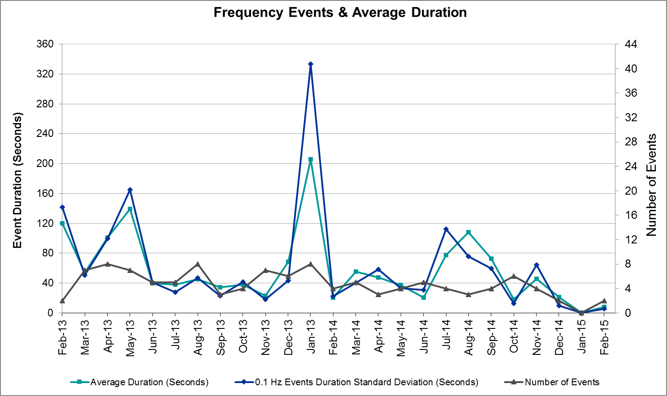

Responsive Reserve Events
There were three events where Responsive Reserve MWs were released to SCED in February. The events highlighted in blue were related to frequency events reported in section 2.1 above.

Date and Time  Released to SCED | Date and Time  Recalled | Duration of Event | Maximum MWs Released | Comments
2/1/2015 18:43:16 | 2/1/2015 18:45:44 | 0:02:28 | 214.15
2/10/2015 10:38:24 | 2/10/2015 10:40:08 | 0:01:44 | 89.35 | Two units tripped carrying 160MW and 170MW, respectively; frequency dropped to 59.904. Event does not meet criteria for PDCWG review.
2/12/2015 16:53:34 | 2/12/2015 16:57:06 | 0:03:32 | 346.67

Load Resource Events
There were no load resource deployment events in February.

Reliability Unit Commitment
ERCOT reports on Reliability Unit Commitments (RUC) on a monthly basis. Commitments are reported grouped by operating day and weather zone. The total number of hours committed is the sum of the hours for all the units in the specified region. Additional information on RUC commitments can be found on the MIS secure site at Grid Generation Reliability Unit Commitment.

There were no DRUC or HRUC commitments in February.

Wind Generation as a Percent of Load
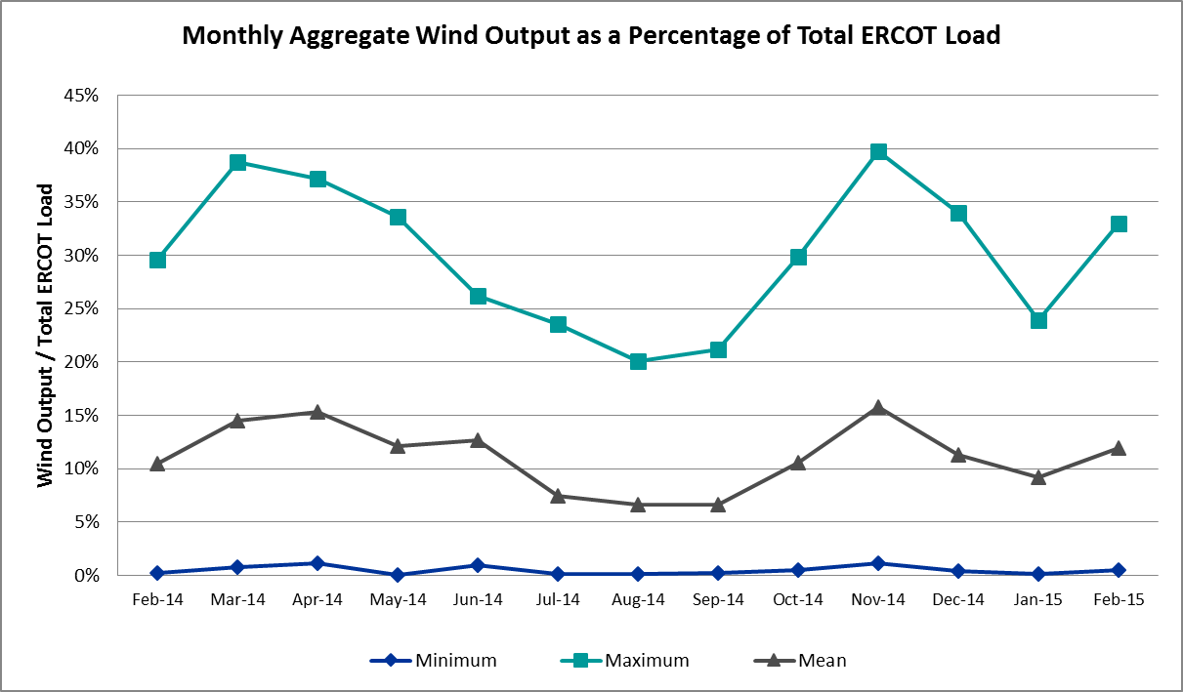

Congestion Analysis
The number of congestion events experienced by the ERCOT system increased in February due to planned outages and area load/gen patterns. There was no activity on the Generic Transmission Constraints (GTCs) in February.

Notable Constraints for February
Nodal protocol section 3.20 specifies that ERCOT shall identify transmission constraints that are active or binding three or more times within a calendar month. As part of this process, ERCOT reports congestion that meets this criterion to ROS. In addition ERCOT also highlights notable constraints that have an estimated congestion rent exceeding $1,000,000 for a calendar month. These constraints are detailed in the table below. Rows highlighted in blue indicate the congestion was affected by one or more outages. For a list of all constraints activated in SCED for the month of February, please see Appendix A at the end of this report.

Contingency | Overload | # of Days Constraint Active | Estimated Congestion Rent | Transmission Project
San Angelo North 138_69T1 138/69kV | San Angelo College Hills 138_69T1 138/69 kV | 1 | $4,833,944
Bates - Frontera 138 kV | Frontera - Goodwin 138 kV | 3 | $4,074,788
DCKT Lost Pines - Austrop & Dunlop 345 kV | Fayette Plant 1 - Fayette Plant 2 345 kV | 6 | $2,760,884
Orange Grove Switching Station - Lon Hill 138 kV | Lon Hill - Smith 69 kV | 9 | $1,792,890 | 16TPIT0026, 2012-R18
Los Fresnos - Loma Alta Substation 138 kV | La Palma - Villa Cavazos 138 kV | 1 | $1,575,342
DCKT Flewellen - Obrien and Maso Road 138 kV | Tomball - Hockley 138 kV | 9 | $1,286,964 | 3682A, 3682B
DCKT Hill Country - Marion and Elmcreek 345 kV | Marion - Skyline 345 kV | 6 | $1,171,008 | 4081
DCKT Jewett - Singleton 345 kV | Gibbons Creek - Singleton 345 kV (SNGXGC75) | 9 | $829,987 | 2013-R63
DCKT Lon Hill - North Edinburg 345 kv and Orange Grove Switching Station 138 kV | Lon Hill - Smith 69 kV | 8 | $740,561 | 16TPIT0026, 2012-R18
Victoria 138_69A2 138/69 kV | Victoria - Magruder 138 kV | 3 | $653,553
Laquinta - Lobo 138 kV | Bruni 138_69_1 138/69 kV | 7 | $467,114 | 13TPIT0148
Gila - Hiway 9 138 kV | Gila - Morris Street 138 kV | 4 | $154,973
Koch Up River - Gila 138 kV | Gila - Morris Street 138 kV | 5 | $122,648
Adamsville - Evant 138 KV | Goldthwaite 29AT2 138/69 kV | 4 | $110,676 | 4459
Lobo 1_138_69_Auto 138/69 kV | Bruni 138_69_1 138/69 kV | 3 | $70,207 | 13TPIT0148
Coleto Creek - Pawnee Switching Station 345 KV | Victoria - Magruder 138 kV | 3 | $32,491
Uvalde Aep - Odlaw Switchyard 138 kV | Hamilton Road - Maverick 138 kV | 4 | $26,242 | 06TPIT0084, 06TPIT0068, 16TPIT0024
Sandow Switch - Austrop 345 kV | Sandow Switch - Austrop 345 kV | 3 | $21,596 | 4477, 2014-SC15
Bosque Switch - Elm Mott 345 kV | Bosque Switch - Rogers Hill 138 kV | 4 | $15,505 | 4356, 2014-NC7
DCKT Ferguson - Granite Mountain and Wirtz - Starcke - Paleface 138 kV | Wirtz - Flat Rock Lcra 138 kV | 3 | $8,544 | 4465
Cottonwood Road Switch - Loftin 69 kV | Shannon - Post Oak Switch 69 kV | 4 | $8,516 | 15TPIT0011
Scurry Switch - Sun Switch 138 kV | Wolfgang - Rotan 69 kV | 5 | $3,817

Generic Transmission Constraint Congestion
There was no activity on any ERCOT GTCs in February.

Manual Overrides for February
None

Congestion Costs for Calendar Year 2015
The following table represents the top twenty active constraints for the calendar year based on the estimated congestion rent attributed to the congestion. ERCOT updates this list on a monthly basis.

Contingency | Binding Element | # of 5-min SCED Intervals | Estimated Congestion Rent | Transmission Project
DCKT Hill Country - Marion and Elmcreek 345 kV | Marion - Skyline 345 kV | 939 | $6,879,055 | 4081
Orange Grove Switching Station - Lon Hill 138 kV | Lon Hill - Smith 69 kV | 3156 | $4,812,785 | 16TPIT0026, 2012-R18
San Angelo North 138_69T1 138/69kV | San Angelo College Hills 138_69T1 138/69 kV | 352 | $4,546,381
Rio Hondo (2H) Axfmr 345/138 kV | Aderhold - Elsa 138 kV | 272 | $4,403,272
Bates - Frontera 138 kV | Frontera - Goodwin 138 kV | 249 | $3,852,440
DCKT Lost Pines - Austrop & Dunlop 345 kV | Fayette Plant 1 - Fayette Plant 2 345 kV | 1,203 | $2,792,905
Basecase | Valley Import | 32 | $1,944,267
Scurry Switch - Sun Switch 138 kV | Matador - Roaring Springs 69 kV | 182 | $1,908,900
Los Fresnos - Loma Alta Substation 138 kV | La Palma - Villa Cavazos 138 kV | 58 | $1,415,989
DCKT Flewellen - Obrien and Maso Road 138 kV | Tomball - Hockley 138 kV | 664 | $1,286,168 | 3682A, 3682B
DCKT Jewett - Singleton 345 kV | Gibbons Creek - Singleton (SNGXGC99) | 1458 | $898,604 | 2013-R63
DCKT Tonkawa Switch - Scurry County South Switch 345 kV | Bluff Creek Switch - Exxon Sharon Ridge 138 kV | 162 | $895,088
DCKT Royse Switch - Forney Switch 345 kV | Forney Switch AXFMR3L 345/138 kV | 44 | $841,394
DCKT Jewett - Singleton 345 kV | Gibbons Creek - Singleton 345 kV (SNGXGC75) | 1057 | $831,171 | 2013-R63
Jim Christal Substation - West Denton 138 kV | Bonnie Brae - North Lakes 69 kV | 56 | $792,701
Laquinta - Lobo 138 kV | Bruni 138_69_1 138/69 kV | 1478 | $756,621 | 13TPIT0148
Victoria 138_69A2 138/69 kV | Victoria - Magruder 138 kV | 469 | $686,406
Mason Aep - Fort Mason 138 kV | Coronado AT4 138/69 kV | 126 | $662,435
Winks Sub - Permian Basin Ses 138 kV | Permian Basin - Ward Gulf Tap 138 kV | 13 | $650,475
DCKT MT Enterprise - Trinidad SES & Martin Lake SES - Stryker Creek SES 345kV | Nacogdoches AXFMR1 345/138 kV | 23 | $555,695

System Events

ERCOT Peak Load
The unofficial ERCOT peak load for the month was 54,505 MW and occurred on February 23 during hour ending 20:00.

Load Shed Events
None

Stability Events
None

Notable PMU Events
ERCOT analyzes PMU data for any significant system disturbances that do not fall into the Frequency Events category reported in section 2.1. The results are summarized in this section once the analysis has been completed.

There were no reportable events in February.

TRE/DOE Reportable Events
None

New/Updated Constraint Management Plans
One RAP was removed in February: Lost Creek – Cuero Hydro 69 kV Line.
Two MPs were removed in February: Kenedy Switch 138/69 kV Autotransformer and the Kenedy Switch to Helena 69 kV Line.

All three were deleted on 2/1/2015.

New/Modified/Removed SPS
None

New Procedures/Forms/Operating Bulletins
None

Emergency Conditions

OCNs
Date and Time | Description
2/27/2015 17:13 | An OCN has been issued due to ERCOT developing a new Generic Transmission Constraint due to a local voltage stability issue in South Texas near Ajo. Further details associated with this GTC are being posted to the MIS Secure Area at this time.

Advisories
Date and Time | Description
2/20/2015 10:00 | ERCOT issued an Advisory for the cold weather system approaching late Sunday, February 22, 2015, through Monday, February 23, 2015, with freezing rain and sleet forecasted for the North and West zones.
2/28/2015 17:51 | ERCOT issued an Advisory due to the postponing of the DAM solution for Operating Day Sunday, March 1, 2015.

Watches
Date and Time | Description
2/22/2015 12:39 | ERCOT issued a Transmission Watch due to the contingency loss of Fort Mason to Gillespie 138kV line overloads Fredricksburg Phillips Tap 69kV line while a Temporary Outage Action Plan is being developed.

Emergency Notices
None

Application Performance
ERCOT system applications performed well in February. There were no issues to report.

TSAT/VSAT Performance Issues
None

Communication Issues
None

Net-Forecast Bias Applied to NSRS Procurement for March 2015
Each month, ERCOT calculates a net Forecast Bias pursuant to the ERCOT Ancillary Services Methodology for procurement of Non-Spinning Reserve Service (NSRS). The table below indicates the amount of net Forecast Bias that was applied to the NSRS procurement for specified blocks of time for the month of March, 2015.

Blocks | Negative Net Load Forecast Average Error - By Weather Zone for the 5 Largest Zones
 | Coast | East | North Central | South Central | Southern
1-2 | 0 | 0 | 0 | 0 | 0
3-6 | 0 | 0 | 0 | 0 | 0
7-10 | 0 | 0 | 0 | 0 | 0
11-14 | 0 | 0 | 0 | 0 | 0
15-18 | 0 | 0 | 0 | 0 | 0
19-22 | 0 | 0 | 0 | 0 | 0
23-24 | 0 | 0 | 0 | 0 | 0

Appendix A: Real-Time Constraints
The following is a complete list of constraints activated in SCED for the month of February. Full contingency descriptions can be found in the Standard Contingencies List located on the MIS secure site at Grid Generation Reliability Unit Commitment.

Contingency | Constrained Element | From Station | To Station | # of Days Constraint Active
DFL_MAR8 | HK_TB_66_A | TB | HK | 9
DJEWSNG5 | SNGXGC75_1 | GIBCRK | SNG | 9
SORNLON8 | LON_HI_SMITH1_1 | LON_HILL | SMITH | 9
DLONOR58 | LON_HI_SMITH1_1 | LON_HILL | SMITH | 8
SLAQLOB8 | BRUNI_69_1 | BRUNI | BRUNI | 7
DAUSLOS5 | 336T405_1 | FPPYD1 | FPPYD2 | 6
DHILELM5 | MAR_SKY_1 | MARION | SKYLINE | 6
SKOCNU28 | GILA_MORRIS1_1 | GILA | MORRIS | 5
SSCUSUN8 | ROTN_WOLFGA1_1 | WOLFGANG | ROTN | 5
SADALAM8 | GOLDTH_9AT2 | GOLDTH | GOLDTH | 4
SBOSELM5 | 1030__B | BOSQUESW | RGH | 4
SBRAUVA8 | HAMILT_MAVERI1_1 | HAMILTON | MAVERICK | 4
SCRDLOF9 | POS_SHAN_1 | SHANNON | POSTOKSW | 4
SGILNU78 | GILA_MORRIS1_1 | GILA | MORRIS | 4
DFERPAL8 | 38T365_1 | WIRTZ | FLATRO | 3
SBATFRO8 | 13998T485_1 | FRONTERA | GOODWIN | 3
SCOLPAW5 | MAGRUD_VICTOR2_1 | VICTORIA | MAGRUDER | 3
SSNDAU15 | 450__A | SNDSW | AUSTRO | 3
XLOB89 | BRUNI_69_1 | BRUNI | BRUNI | 3
XVIC89 | MAGRUD_VICTOR2_1 | VICTORIA | MAGRUDER | 3
BASE CASE | SNYDER_WKN_BK1_1 | ENAS | WKN_BKR | 2
SALII_D8 | I_DUPP_I_DUPS1_1 | I_DUPP1 | I_DUPSW | 2
SBEVASH8 | BAT_CRST_1 | BATESVL | CRSTLSW | 2
SKLELOY8 | LOYOLA_69_1 | LOYOLA | LOYOLA | 2
SL_FLA_8 | LA_PAL_VCAVAZ1_1 | LA_PALMA | VCAVAZOS | 2
SMASFOR8 | CORONA_AT4 | CORONA | CORONA | 2
SSPUASP8 | ROTN_WOLFGA1_1 | WOLFGANG | ROTN | 2
XESK89 | ABNW_ELYT1_1 | ABNW | ELYT | 2
XLY2T58 | LYTTON_S_AT1H | LYTTON_S | LYTTON_S | 2
XSA2C89 | SAPOWER_69T1 | SAPOWER | SAPOWER | 2
XSA2N89 | SACH_69T1 | SACH | SACH | 2
BASE CASE | LN_86_1 | EXN | EXN | 1
BASE CASE | LON_HI_SMITH1_1 | LON_HILL | SMITH | 1
BASE CASE | MCADO_SPUR_1A_1 | MWEC | SPUR | 1
BASE CASE | SSI_TLINE_1 | FLTCK | FLTCK | 1
DENTSCS5 | NCDSE_MR1H | NCDSE | NCDSE | 1
DGARHIC8 | CKT_1027_1 | DUNLAP | DECKER | 1
DGARHIC8 | DUNLAP_AT1 | DUNLAP | DUNLAP | 1
DLONOR58 | EDROY_MATHIS1_1 | EDROY | MATHIS | 1
DNEDPAL8 | ADERHO_ELSA1_1 | ADERHOLD | ELSA | 1
DSTPWHI5 | BLESSI_LOLITA1_1 | BLESSING | LOLITA | 1
DTRCELK5 | 960__D | JKSVL | FLINT | 1
DTRSENT5 | NCDSE_MR1H | NCDSE | NCDSE | 1
DWH_STP5 | BLESSI_LOLITA1_1 | BLESSING | LOLITA | 1
SCOLBAL8 | BALG_HUMBLT1_1 | BALG | HUMBLTAP | 1
SCOLPAW5 | COLETO_KENEDS1_1 | COLETO | KENEDSW | 1
SCRDOL29 | 6840__A | CRDSW | ANARN | 1
SECRBRA8 | 6240__A | SACRC | SNYDR | 1
SFORGIL8 | CORONA_AT4 | CORONA | CORONA | 1
SFORGIL8 | FRPHIL_GILLES1_1 | GILLES | FRPHILLT | 1
SMARZOR5 | 419T419_1 | CLEASP | MARION | 1
SOXYIN28 | I_DUPP_I_DUPS1_1 | I_DUPP1 | I_DUPSW | 1
SPAWLON5 | BONIVI_RINCON1_1 | RINCON | BONIVIEW | 1
SRICGRS8 | 6850__B | NVKSW | ARCTY | 1
SSCLWF18 | NVKSW_FMR1 | NVKSW | NVKSW | 1
SSPUASP8 | JATN_SPUR_1C_1 | GIRA_TAP | DKEC | 1
SSPUASP8 | SPUR_69_1 | SPUR | SPUR | 1
UENAENA1 | ECRSW_FMR1 | ECRSW | ECRSW | 1
XBLE58 | SAR_FRAN_1 | FRANKC | SARGNTS | 1
XLO2N58 | BONIVI_RINCON1_1 | RINCON | BONIVIEW | 1
XRIO358 | CELANE_KLEBER1_1 | CELANEBI | KLEBERG | 1
XSA2N89 | SAPOWER_69T1 | SAPOWER | SAPOWER | 1

