
January 2015 ERCOT Monthly Operations Report

Reliability and Operations Subcommittee Meeting
March 5, 2015

Table of Contents
Table of Contents 1
1 Report Highlights 2
2 Frequency Control 3
2.1 Frequency Events 3
2.2 Responsive Reserve Events 3
2.3 Load Resource Events 3
3 Reliability Unit Commitment 4
4 Wind Generation as a Percent of Load 4
5 Congestion Analysis 4
5.1 Notable Constraints for January 5
5.2 Generic Transmission Constraint Congestion 6
5.3 Manual Overrides for January 6
5.4 Congestion Costs for Calendar Year 2015 6
6 System Events 7
6.1 ERCOT Peak Load 7
6.2 Load Shed Events 7
6.3 Stability Events 7
6.4 Notable PMU Events 7
6.5 TRE/DOE Reportable Events 7
6.6 New/Updated Constraint Management Plans 7
6.7 New/Modified/Removed SPS 7
6.8 New Procedures/Forms/Operating Bulletins 7
7 Emergency Conditions 8
7.1 OCNs 8
7.2 Advisories 8
7.3 Watches 8
7.4 Emergency Notices 8
8 Application Performance 8
8.1 TSAT/VSAT Performance Issues 8
8.2 Communication Issues 8
9 Net-Forecast Bias Applied to NSRS Procurement for February 2015 9
Appendix A: Real-Time Constraints 10

Report Highlights
- The unofficial ERCOT peak for January was 56,764 MW.
- There were no frequency events in January because there were no significant unit trips that forced frequency below 59.9 Hz.
- There were no instances where Responsive Reserves were deployed in January.
- There were two RUC Commitments in January to resolve local congestion.
- The level of reportable SCED congestion increased in January. This congestion was primarily due to planned outages and activity on the Generic Transmission Constraints (GTCs).
- There were no significant system events in ERCOT during the month of January.
- ERCOT Applications performed well throughout the month. There were no issues in January.

Frequency Control

Frequency Events
The ERCOT Interconnection experienced no frequency events in January.

When analyzing frequency events, ERCOT evaluates PMU data according to industry standards. Events with an oscillating frequency of less than 1 Hz are considered to be inter-area, while higher frequencies indicate local events. Industry standards specify that damping ratio for inter-area oscillations should be 3.0% or greater. All events listed below indicate the ERCOT system met these standards and transitioned well after each disturbance. Further details on the Resource trip events can be seen in the Performance Disturbance Compliance Working Group report.

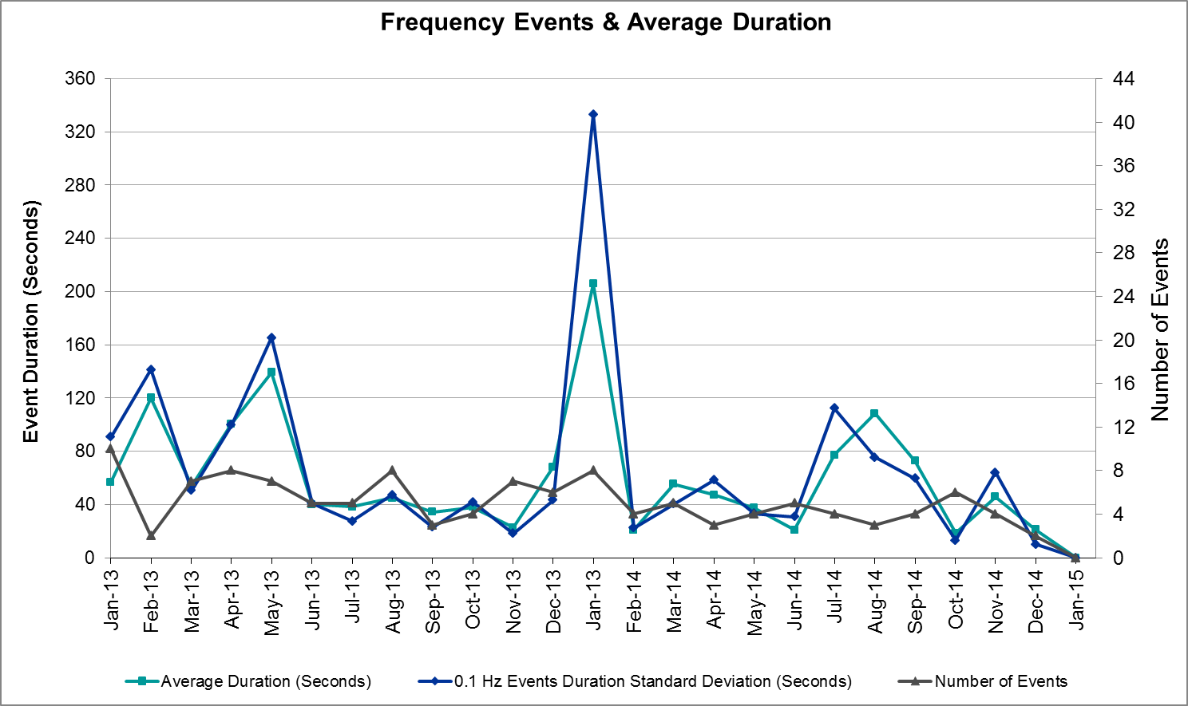

Responsive Reserve Events
There were no events where Responsive Reserve MWs were released to SCED in January. The events highlighted in blue were related to frequency events reported in section 2.1 above.

Load Resource Events
There were no load resource deployment events in January.

Reliability Unit Commitment
ERCOT reports on Reliability Unit Commitments (RUC) on a monthly basis. Commitments are reported grouped by operating day and weather zone. The total number of hours committed is the sum of the hours for all the units in the specified region. Additional information on RUC commitments can be found on the MIS secure site at Grid → Generation → Reliability Unit Commitment.

There were no DRUC commitments in January.

HRUC Commitments
Resource Location | # of Resources | Operating Day | Total # of Hours Committed | Total MWhs | Reason for commitment
Southern | 1 | 1/10/2015 | 2 | 355 | Local Congestion
Southern | 1 | 1/11/2015 | 8 | 2,065 | Local Congestion

Wind Generation as a Percent of Load
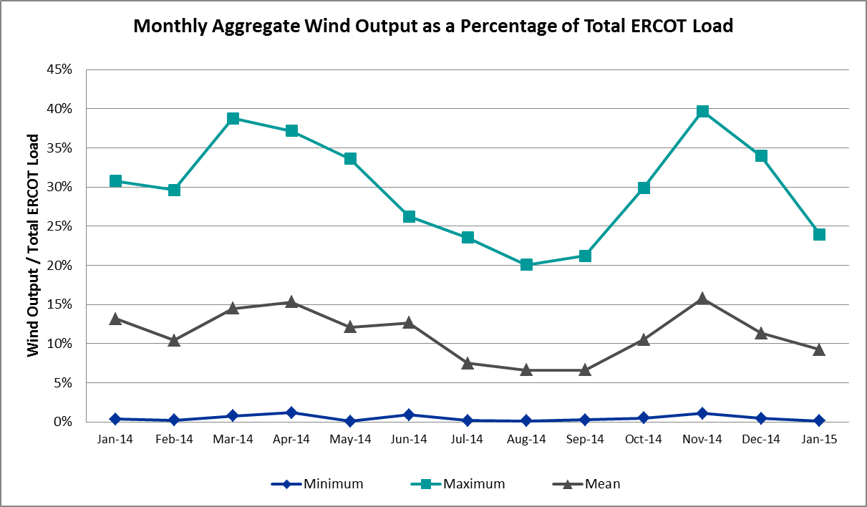

Congestion Analysis
The number of congestion events experienced by the ERCOT system increased in January due to planned outages and load/gen patterns. There were two days of activity on the Generic Transmission Constraints (GTCs) in January.

Notable Constraints for January
Nodal protocol section 3.20 specifies that ERCOT shall identify transmission constraints that are active or binding three or more times within a calendar month. As part of this process, ERCOT reports congestion that meets this criterion to ROS. In addition ERCOT also highlights notable constraints that have an estimated congestion rent exceeding $1,000,000 for a calendar month. These constraints are detailed in the table below. Rows highlighted in blue indicate the congestion was affected by one or more outages. For a list of all constraints activated in SCED for the month of January, please see Appendix A at the end of this report.

Contingency | Overload | # of Days Constraint Active | Estimated Congestion Rent | Transmission Project
DCKT Hill Country - Marion and Elmcreek 345 kV | Marion - Skyline 345 kV | 3 | $5,732,088 | 4081
Rio Hondo (2H) Axfmr 345/138 kV | Aderhold - Elsa 138 kV | 1 | $4,745,658
Orange Grove Switching Station - Lon Hill 138 kV | Lon Hill - Smith 69 kV | 13 | $2,112,633 | 16TPIT0026, 2012-R18
Basecase | Valley Import | 1 | $2,047,958
Scurry Switch - Sun Switch 138 kV | Matador - Roaring Springs 69 kV | 1 | $1,989,446
DCKT Jewett - Singleton 345 kV | Gibbons Creek - Singleton (SNGXGC99) | 11 | $897,168 | 2013-R63
DCKT Jewett - Singleton 345 kV | Twin Oak Switch - Btu_Jack_Creek 345 kV | 11 | $397,531 | 2013-R63
DCKT STP - Hillje and STP - Whitepoint 345 kV | Blessing - Lolita 138 kV | 4 | $336,237
DCKT Lon Hill - North Edinburg 345 kv and Orange Grove Switching Station 138 kV | Lon Hill - Smith 69 kV | 4 | $261,403 | 16TPIT0026, 2012-R18
Laquinta - Lobo 138 kV | Bruni 138_69_1 138/69 kV | 7 | $222,204 | 13TPIT0148
DCKT North Edinburg - West Edinburg and Palmhurst 138kV | Aderhold - Elsa 138 kV | 3 | $165,073
DCKT Greens Bayou - King 345 kV | Greens Bayou AT1 345/138 kV | 4 | $164,873
Cottonwood Road Switch - Loftin 69 kV | Shannon - Post Oak Switch 69 kV | 17 | $19,255 | 15TPIT0011
DCKT Marion - Zorn and Clear Springs 345 kV | Cibolo - Schertz 138 kV | 4 | $17,943
Scurry Switch - Sun Switch 138 kV | Wolfgang - Rotan 69 kV | 4 | $11,312
Spur - Scurry Switch 138 kV | Wolfgang - Rotan 69 kV | 4 | $8,469
Aspermont Aep - Spur 138 kV | Wolfgang - Rotan 69 kV | 3 | $934

Generic Transmission Constraint Congestion
There were two days of activity on the Valley Import GTC in January. The North-Houston and SOP110 GTCs were not activated during the month.

Manual Overrides for January
None

Congestion Costs for Calendar Year 2015
The following table represents the top twenty active constraints for the calendar year based on the estimated congestion rent attributed to the congestion. ERCOT updates this list on a monthly basis.

Contingency | Binding Element | # of 5-min SCED Intervals | Estimated Congestion Rent | Transmission Project
DCKT Hill Country - Marion and Elmcreek 345 kV | Marion - Skyline 345 kV | 370 | $5,707,059 | 4081
Rio Hondo (2H) Axfmr 345/138 kV | Aderhold - Elsa 138 kV | 260 | $4,400,941
Orange Grove Switching Station - Lon Hill 138 kV | Lon Hill - Smith 69 kV | 1,686 | $2,342,307 | 16TPIT0026, 2012-R18
Basecase | Valley Import | 32 | $1,944,267
Scurry Switch - Sun Switch 138 kV | Matador - Roaring Springs 69 kV | 182 | $1,908,900
DCKT Jewett - Singleton 345 kV | Gibbons Creek - Singleton (SNGXGC99) | 1,458 | $898,604 | 2013-R63
DCKT Tonkawa Switch - Scurry County South Switch 345 kV | Bluff Creek Switch - Exxon Sharon Ridge 138 kV | 162 | $895,088
DCKT Royse Switch - Forney Switch 345 kV | Forney Switch AXFMR3L 345/138 kV | 44 | $841,394
Jim Christal Substation - West Denton 138 kV | Bonnie Brae - North Lakes 69 kV | 56 | $792,701
Winks Sub - Permian Basin Ses 138 kV | Permian Basin - Ward Gulf 138 kV | 13 | $650,475
Fort Work Substation - West Denton 138 kV | Hickory - Locust 69 kV | 29 | $498,843
DCKT Jewett - Singleton 345 kV | Twin Oak Switch - Btu_Jack_Creek 345 kV | 911 | $397,519 | 2013-R63
DCKT STP - Hillje and STP - Whitepoint 345 kV | Blessing - Lolita 138 kV | 249 | $334,661
Winks Sub - No Trees Switch 138 kV | Holt Switch - Emma Tap 69 kV | 188 | $301,663
Basecase | Capricorn Ridge 1 Tap 138 kV | 4 | $287,625
DCKT Lewsville to Krum West and Roanoke 345 kV | Pckrus - Teasley 138 kV | 136 | $227,653
Laquinta - Lobo 138 kV | Bruni 138_69_1 138/69 kV | 655 | $221,997 | 13TPIT0148
DCKT Greens Bayou - King 345 kV | Greens Bayou AT1 345/138 kV | 653 | $165,526
Bluff Creek T2 (3) 345/138 kV | Bluff Creek T1 (3) 345/138 kV | 38 | $132,162
DCKT North Edinburg - West Edinburg and Palmhurst 138kV | Duke - Aderhold Sub 138 kV | 159 | $126,205

System Events

ERCOT Peak Load
The unofficial ERCOT peak load for the month was 56,764 MW and occurred on January 8 during hour ending 08:00.

Load Shed Events
None

Stability Events
None

Notable PMU Events
ERCOT analyzes PMU data for any significant system disturbances that do not fall into the Frequency Events category reported in section 2.1. The results are summarized in this section once the analysis has been completed.

There were no reportable events in January.

TRE/DOE Reportable Events
None

New/Updated Constraint Management Plans
None

New/Modified/Removed SPS
None

New Procedures/Forms/Operating Bulletins
None

Emergency Conditions

OCNs
None

Advisories
Date and Time | Description
1/2/2015 10:00 | ERCOT issued an Advisory for the cold weather system that is forecasted to impact most of the region with temperatures in the 20s for the evening of Sunday, January 4, 2015, through the morning of Monday, January 5, 2015.
1/6/2015 13:30 | ERCOT issued an Advisory for the extreme cold weather system forecasted to sweep through the state Wednesday, January 7, 2015, leaving temperatures in the teens and 20s for most of the region. Expecting a steep load pick up the morning of Thursday, January 8, 2015.
1/7/2015 6:30 | ERCOT issued an Advisory for a K Index 7 geomagnetic disturbance storm alert that has been issued until 09:00 for Wednesday, January 7, 2015.
1/28/2015 13:30 | ERCOT issued an Advisory due to the postponing of the DAM solution for Operating Day Thursday, January 29, 2015.

Watches
Date and Time | Description
1/7/2015 9:00 | ERCOT issued a Watch for the extreme cold weather system impacting the region leaving temperatures in the teens and 20s for most of the region. Expecting a steep load pick up the morning of Thursday, January 8, 2015.

Emergency Notices
None

Application Performance
ERCOT system applications performed well in January. There were no issues to report.

TSAT/VSAT Performance Issues
None

Communication Issues
None

Net-Forecast Bias Applied to NSRS Procurement for February 2015
Each month, ERCOT calculates a net Forecast Bias pursuant to the ERCOT Ancillary Services Methodology for procurement of Non-Spinning Reserve Service (NSRS). The table below indicates the amount of net Forecast Bias that was applied to the NSRS procurement for specified blocks of time for the month of February, 2015.

Blocks | Negative Net Load Forecast Average Error - By Weather Zone for the 5 Largest Zones
Blocks | Coast | East | North Central | South Central | Southern
1-2 | 0 | 0 | 0 | 0 | 0
3-6 | 0 | 0 | 0 | 0 | 0
7-10 | 0 | 0 | 0 | 0 | 0
11-14 | 0 | 0 | 0 | 0 | 0
15-18 | 0 | 0 | 0 | 0 | 0
19-22 | 0 | 0 | 0 | 0 | 0
23-24 | 0 | 0 | 0 | 0 | 0

Appendix A: Real-Time Constraints
The following is a complete list of constraints activated in SCED for the month of January. Full contingency descriptions can be found in the Standard Contingencies List located on the MIS secure site at Grid → Generation → Reliability Unit Commitment.

Contingency | Constrained Element | From Station | To Station | # of Days Constraint Active
SCRDLOF9 | POS_SHAN_1 | SHANNON | POSTOKSW | 17
SORNLON8 | LON_HI_SMITH1_1 | LON_HILL | SMITH | 13
DJEWSNG5 | JK_TOKSW_1 | TOKSW | JK_CK | 11
DJEWSNG5 | SNGXGC99_1 | GIBCRK | SNG | 11
SLAQLOB8 | BRUNI_69_1 | BRUNI | BRUNI | 7
DGBY_KG5 | GBY_AT1 | GBY | GBY | 4
DLONOR58 | LON_HI_SMITH1_1 | LON_HILL | SMITH | 4
DMARZOR5 | 293T304_1 | CIBOLO | SCHERT | 4
DSTPWHI5 | BLESSI_LOLITA1_1 | BLESSING | LOLITA | 4
SSCUSUN8 | ROTN_WOLFGA1_1 | WOLFGANG | ROTN | 4
SSPUMW18 | ROTN_WOLFGA1_1 | WOLFGANG | ROTN | 4
DHILELM5 | MAR_SKY_1 | MARION | SKYLINE | 3
DNEDPAL8 | ADERHO_ELSA1_1 | ADERHOLD | ELSA | 3
SSPUASP8 | ROTN_WOLFGA1_1 | WOLFGANG | ROTN | 3
BASE CASE | VALIMP |  |  | 2
DCALHOT8 | N4_X3_1 | CALAVERS | X3 | 2
DLWSRNK5 | POC_TEAS_1 | TEASLEY | POCKRUSC | 2
DNEDPAL8 | ADERHO_DUKE1_1 | DUKE | ADERHOLD | 2
DSCOTKW5 | 6216__A | SHRNE | BCKSW | 2
SBRAUVA8 | HAMILT_MAVERI1_1 | HAMILTON | MAVERICK | 2
SCHYWIN8 | 6596__F | HLTSW | EMATP | 2
SFT_BAL8 | CEDH_69_1 | CEDH | CEDH | 2
SMCDBSP8 | 6470__H | GLSCN | FRSTP | 2
SPAUSAR8 | BENF_REDCRE1_1 | REDCREEK | BENF | 2
SSCUSUN8 | MATA_ROAR1_1 | MATA | ROAR | 2
SSNDAU15 | 450__A | SNDSW | AUSTRO | 2
BASE CASE | _1 | CAPRIDGE | CAPRIDGE | 1
BASE CASE | ODEHV_MR3H | ODEHV | ODEHV | 1
DCLEZOR5 | 209T203_1 | YORKCR | SEGUIN | 1
DELMSAN5 | PLEASANT_69A1 | PLEASANT | PLEASANT | 1
DGARHIC8 | CKT_1027_1 | DUNLAP | DECKER | 1
DGARHIC8 | DUNLAP_AT1 | DUNLAP | DUNLAP | 1
DI_DWHI8 | RINCON_WHITE_2_1 | RINCON | WHITE_PT | 1
DRYSFOR5 | FORSW_MR3H | FORSW | FORSW | 1
DSN_BFP8 | RT_WC_47_A | WC | RT | 1
DTB_SNG5 | SNGZEN98_A | SNG | ZEN | 1
DTHSLCS5 | WHTNY_FMR2 | WHTNY | WHTNY | 1
DWAP_JN5 | BI_WAP50_A | WAP | BI | 1
SABSBLU8 | ABEC_ABNW2_1 | ABNW | ABEC | 1
SABSBLU8 | ABNW_CALLAH1_1 | CALLAHAN | ABNW | 1
SBIGVIS8 | GREENL_WEAVER1_1 | GREENLK | WEAVERRD | 1
SENSEN28 | 941__B | ENNIS | ENSSW | 1
SFTWW_D8 | HIC_LOCU_1 | HICKRY_D | LOCUST_D | 1
SJMCW_D8 | BB_N_LA_1 | BONBRAE | N_LAKE_D | 1
SKLELOY8 | LOYOLA_69_1 | LOYOLA | LOYOLA | 1
SMARZOR5 | 419T419_1 | CLEASP | MARION | 1
SWINPBS8 | 6545__A | PBSES | WGLFT | 1
XBL2U58 | BLUF_CRK_T1_H | BLUF_CRK | BLUF_CRK | 1
XRIO358 | ADERHO_ELSA1_1 | ADERHOLD | ELSA | 1

