
December 2014 ERCOT Monthly Operations Report

Reliability and Operations Subcommittee Meeting
January 8, 2015

Table of Contents
1 Report Highlights 2
2 Frequency Control 3
2.1 Frequency Events 3
2.2 Responsive Reserve Events 4
2.3 Load Resource Events 4
3 Reliability Unit Commitment 4
4 Wind Generation as a Percent of Load 5
5 Congestion Analysis 5
5.1 Notable Constraints for December 5
5.2 Generic Transmission Constraint Congestion 6
5.3 Manual Overrides for December 6
5.4 Congestion Costs for Calendar Year 2014 6
6 System Events 7
6.1 ERCOT Peak Load 7
6.2 Load Shed Events 7
6.3 Stability Events 7
6.4 Notable PMU Events 8
6.5 TRE/DOE Reportable Events 8
6.6 New/Updated Constraint Management Plans 8
6.7 New/Modified/Removed SPS 8
6.8 New Procedures/Forms/Operating Bulletins 8
7 Emergency Conditions 8
7.1 OCNs 8
7.2 Advisories 8
7.3 Watches 9
7.4 Emergency Notices 9
8 Application Performance 9
8.1 TSAT/VSAT Performance Issues 9
8.2 Communication Issues 9
9 Net-Forecast Bias Applied to NSRS Procurement for January 2015 9
Appendix A: Real-Time Constraints 10

Report Highlights
- The unofficial ERCOT peak for December was 48,201 MW.
- The ERCOT region reached a new wind generation record of 10,957 MW on December 25. This exceeded the previous record of 10,808 MW set on November 28.
- The ERCOT region also reached a new wind penetration record, with wind carrying 39.7% of total system load on December 14. This exceeded the previous record of 39.4% set on March 31.
- There were two frequency events in December. PMU data indicates the ERCOT system transitioned well in each case.
- There were three instances where Responsive Reserves were deployed, two of which were the result of frequency events.
- There were two RUC Commitments in December to resolve local congestion and for voltage support.
- The level of SCED congestion decreased in December. This congestion was primarily due to cold temperatures, ongoing outages and load/gen patterns.
- There were no significant system events in ERCOT during the month of December.
- ERCOT Applications performed well throughout the month. There were no issues in December.

Frequency Control

Frequency Events
The ERCOT Interconnection experienced two frequency events in December, all of which resulted from Resource trips. The average event duration was approximately 21 seconds.

When analyzing frequency events, ERCOT evaluates PMU data according to industry standards. Events with an oscillating frequency of less than 1 Hz are considered to be inter-area, while higher frequencies indicate local events. Industry standards specify that damping ratio for inter-area oscillations should be 3.0% or greater. All events listed below indicate the ERCOT system met these standards and transitioned well after each disturbance. Further details on the Resource trip events can be seen in the Performance Disturbance Compliance Working Group report.

A summary of the frequency events is provided below:

Date and Time | Max/Min Frequency  (Hz) | Duration of Event  (seconds) | PMU Data |  | Comments
Date and Time | Max/Min Frequency  (Hz) | Duration of Event  (seconds) | Oscillation Mode | Damping Ratio | Comments
12/23/2014 04:57 | 59.776 | 28 | 0.706 Hz | 13.0% | Unit trip with approximately 755 MW
12/31/2014 11:11 | 59.878 | 14 | 0.977 Hz | 13.9% | Unit trip with approximately 585 MW

(Note: the duration of the frequency events is defined to be the time at which the frequency was outside the range of 60±0.1 Hz)

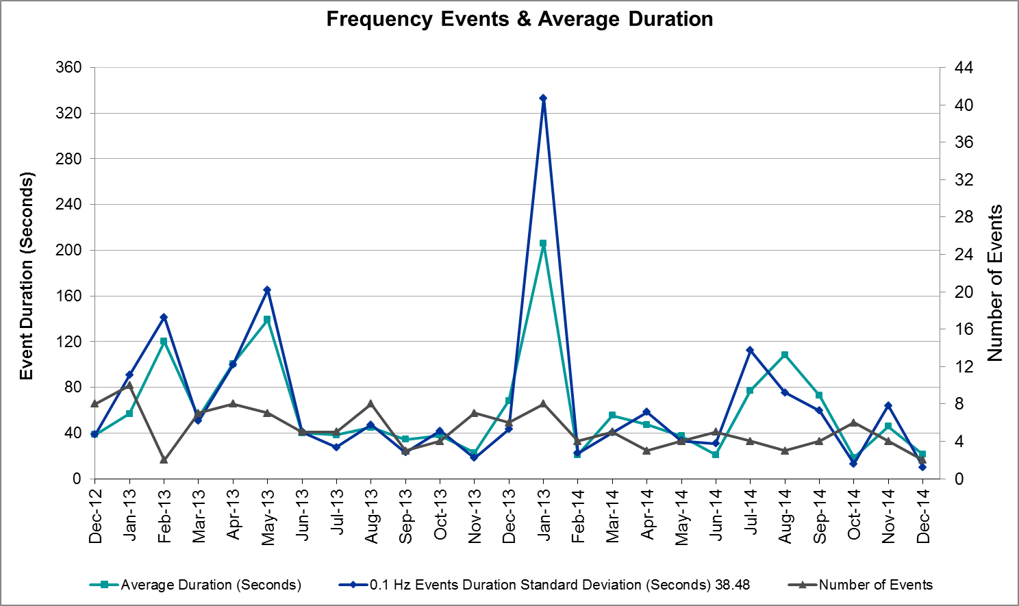

Responsive Reserve Events
There were three events where Responsive Reserve MWs were released to SCED in December. The events highlighted in blue were related to frequency events reported in section 2.1 above.

Date and Time  Released to SCED | Date and Time  Recalled | Duration of Event | Maximum MWs Released | Comments
12/23/14 04:51:58 | 12/23/14 04:54:17 | 0:02:19 | 1009.20
12/27/14 03:33:30 | 12/27/14 03:36:22 | 0:02:55 | 250.20 | Unit runback followed by trip carrying 370 MW; frequency dropped to 59.899. Event does not meet criteria for PDCWG review.
12/31/14 11:11:22 | 12/31/14 11:14:14 | 0:02:52 | 316.10

Load Resource Events
There were no load resource deployment events in December.

Reliability Unit Commitment
ERCOT reports on Reliability Unit Commitments (RUC) on a monthly basis. Commitments are reported grouped by operating day and weather zone. The total number of hours committed is the sum of the hours for all the units in the specified region. Additional information on RUC commitments can be found on the MIS secure site at Grid → Generation → Reliability Unit Commitment.

There were no DRUC commitments in December.

HRUC Commitments
Resource Location | # of Resources | Operating Day | # Hours Committed | Total MWhs | Reason for commitment
Southern | 1 | 12/1/2014 | 6 | 2,025 | Voltage Support
S. Central | 1 | 12/3/2014 | 1 | 47 | Local Congestion

Wind Generation as a Percent of Load
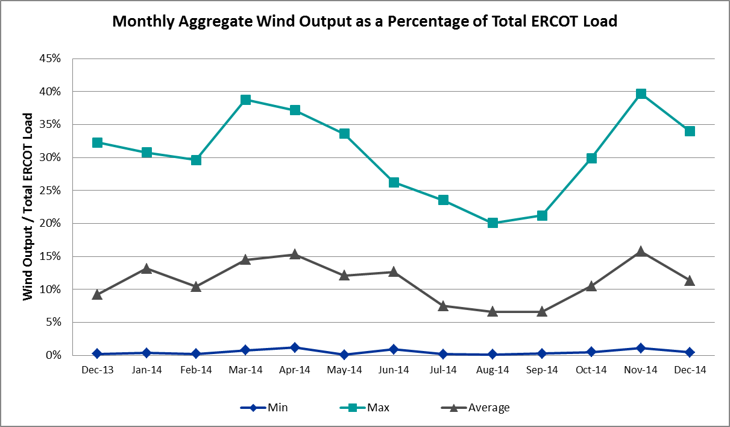

Congestion Analysis
The number of congestion events experienced by the ERCOT system decreased in December due to colder temperatures, ongoing outages and load/gen patterns. There was no activity on any of the Generic Transmission Constraints (GTCs) in December.

Notable Constraints for December
Nodal protocol section 3.20 specifies that ERCOT shall identify transmission constraints that are active or binding three or more times within a calendar month. As part of this process, ERCOT reports congestion that meets this criterion to ROS. In addition ERCOT also highlights notable constraints that have an estimated congestion rent exceeding $1,000,000 for a calendar month. These constraints are detailed in the table below. Rows highlighted in blue indicate the congestion was affected by one or more outages. For a list of all constraints activated in SCED for the month of December, please see Appendix A at the end of this report.

Contingency | Overload | # of Days Constraint Active | Estimated Congestion Rent | Transmission Project
San Angelo North 138_69T1 138/69kV | SA Power 69T1 138/69 kV | 2 | $1,605,180
Orange Grove Switching Station - Lon Hill 138 kV | Lon Hill - Smith 69 kV | 8 | $1,053,679 | 16TPIT0026
Eskota Switch Axfmr1 138/69 kV | Abilene Northwest - Ely Rea Tap 69 kV | 3 | $893,320
DCKT Calaveras-Hotwells & Laredo1 138 kV | Calaveras - Streich 138 kV | 13 | $577,597
DCKT Greens Bayou - King 345 kV | Greens Bayou AT1 345/138 kV | 3 | $285,202
DCKT South Channel - Pair and Shell 138 kV | Conial - Waburn 138 kV | 5 | $277,820 | 14TPIT0121
Laquinta - Lobo 138 kV | Bruni 138_69_1 138/69 kV | 5 | $219,368
Cottonwood Road Switch - Loftin 69 kV | Shannon - Post Oak Switch 69 kV | 20 | $27,442 | 15TPIT0011

Generic Transmission Constraint Congestion
There was no activity on any ERCOT GTCs in December.

Manual Overrides for December
None

Congestion Costs for Calendar Year 2014
The following table represents the top twenty active constraints for the calendar year based on the estimated congestion rent attributed to the congestion. ERCOT updates this list on a monthly basis.

Contingency | Binding Element | # of 5-min SCED Intervals | Estimated Congestion Rent | Transmission Project
Lytton Springs LY_AT2 345/138 kV | Lytton Springs LY_AT1 345/138 kV | 1,997 | $55,956,002
Skywest - Spraberry Switch 138 kV, Skywest - Salt Flat Road 138 kV, and Salt Mine - Barber Lake Switch 138 kV | Midland East - Buffalo 138 kV | 3,750 | $46,791,691 | 14TPIT0052
Apache Tnp - Caddo Sw Sta Tnp 138 kV | Heights Tnp HEIGHAT1 138/69 kV | 1,667 | $39,822,775
La Palma - Rio Hondo 138 kV, DCKT Rio Hondo - North Edinburg 345 kV and Harlingen Switch 138 kV | Harlingen Switch - Oleander 138 kV | 1,159 | $26,943,341
Tejas Tnp - Greenbelt Tnp 138 kV | Heights Tnp HEIGHAT2 138/69 kV | 1,104 | $26,926,033
Midland East Axfmr 1 (3) 345/138 kV, Moss Switch Axfmr 1 345/138 kV, and Midland East - Moss Switch - Odessa Ehv Switch 345 kV | Odessa North Sd3 138 kV | 5,310 | $23,944,433 | 2012-R3, 2012-R4
La Palma - Rio Hondo 138 kV, Los Fresnos - Loma Alta Sub 138 kV | Rio Hondo - East Rio Hondo 138 kV | 1,613 | $23,683,772
Moss Switch - Holt Switch 138 kV | Moss Switch - Westover 138 kV | 1,088 | $19,511,591 | 14TPIT0053
Orange Grove Switching Station - Lon Hill 138 kV, DCKT Lon Hill - North Edinburg 345 kv and Orange Grove Switching Station 138 kV, and Lon Hill 345_138_2 (3) 345/138 kV | Lon Hill - Smith 69 kV | 10,645 | $18,350,576 | 16TPIT0026, 2012-R18
DCKT Flewellen - Obrien and Maso Road 138 kV, DCKT Singleton - Zenith 345 kV | Hockley - Betka 138 kV | 773 | $15,850,200 | TPIT Project 3682A, 3682B
Basecase | Valley Import | 576 | $11,853,636
DCKT Jewett - Singleton 345 kV | Twin Oak Switch - Gibbons Creek 345 kV | 562 | $11,115,041
DCKT Paris Switch - Valley Ses and Valley South 345 kV | Paris Switch AXFMR1 (3) 345/138 kV | 2,516 | $10,129,884 | 14TPIT0093
McNeil Lcra - Gilleland 138 kV, Hutto Switch Axfmr 1 (3) 345/138 kV, Salty - Sandow Switch 138 kV, and DCKT Austrop - Sandow Switch 345 kV | Hutto Switch - Round Rock Northeast 138 kV (1661_B) | 425 | $10,033,349 | 16TPIT0062
DCKT Gabriel - Glasscock LCRA and Rivery 138 kV, Glasscock LCRA - Gabriel 138 kV, and DCKT Gabriel - Bell County - Hutto Switch 138 kV | Marshall Ford - Lago Vista 138 kV | 209 | $9,871,526 | 15TPIT0061
Koch Up River - Gila 138 kV | Gila - Hiway 9 138 kV (GILA_HIWAY_2) | 28,987 | $9,487,852
Key Sub - Willow Valley Switch 138 kV and Winks Sub - No Trees Switch 138 kV | Holt Switch - Amoco Midland Farms Tap 138 kV | 475 | $7,974,086 | 15TPIT0092
DCKT Wa Parish - Jeanetta 345 kV | Smithers - Bellaire 345 kV | 1,058 | $7,870,155
Alice - Kingsville 138 kV, Kingsville - Lon Hill 138 kV, Nelson Sharpe - Lon Hill 345 kV | Lon Hill - Calallen Sub 69 kV | 912 | $7,699,219 | 12TPIT0181, 2012-R13
Laquinta - Lobo 138 kV | Bruni 138_69_1 138/69 kV | 11,767 | $7,543,098 | 13TPIT0148

System Events

ERCOT Peak Load
The unofficial ERCOT peak load for the month was 48,201 MW and occurred on December 31 during the hour ending 19:00.

Load Shed Events
None

Stability Events
None

Notable PMU Events
ERCOT analyzes PMU data for any significant system disturbances that do not fall into the Frequency Events category reported in section 2.1. The results are summarized in this section once the analysis has been completed.

There were no reportable events in December.

TRE/DOE Reportable Events
None

New/Updated Constraint Management Plans
None

New/Modified/Removed SPS
None

New Procedures/Forms/Operating Bulletins
Date | Document | Description
12/15/2014 | Power Operations Bulletin 689 | DCTie Desk V1 Rev31
12/15/2014 | Power Operations Bulletin 690 | Real Time Desk V1 Rev33
12/15/2014 | Power Operations Bulletin 691 | Reliability Unit Commitment Desk V1 Rev 27
12/15/2014 | Power Operations Bulletin 692 | Resource Desk V1 Rev 31
12/15/2014 | Power Operations Bulletin 693 | Shift Supervisor Desk V1 Rev 30
12/15/2014 | Power Operations Bulletin 694 | Transmission and Security Desk V1 Rev 35
12/22/2014 | Power Operations Bulletin 695 | Real Time Desk V1 Rev 34
12/22/2014 | Power Operations Bulletin 696 | Resource Desk V1 Rev 32

Emergency Conditions

OCNs
Date and Time | Description
12/29/2014 10:00 | ERCOT issued an OCN for the cold weather system forecasted to hit the region December 28, 2014 and 12/29/14 with below freezing temperatures and freezing rain with possible accumulation.

Advisories
Date and Time | Description
12/10/2014 13:27 | ERCOT postponed the deadline for the posting of the DAM Solution for Operating Day December 11, 2014 due to extended solution run-time.
12/16/2014 13:30 | ERCOT postponed the deadline for the posting of the DAM Solution for Operating Day December 17th, 2014 due to long solution time.
12/30/2014 10:00 | ERCOT issued an Advisory for the cold weather system that is impacting the North, West and Far West region through the morning of December 29, 2014 with below freezing temperatures and freezing rain with possible accumulation.

Watches
None

Emergency Notices
None

Application Performance
ERCOT system applications performed well in December. There were no issues to report.

TSAT/VSAT Performance Issues
None

Communication Issues
None

Net-Forecast Bias Applied to NSRS Procurement for January 2015
Each month, ERCOT calculates a net Forecast Bias pursuant to the ERCOT Ancillary Services Methodology for procurement of Non-Spinning Reserve Service (NSRS). The table below indicates the amount of net Forecast Bias that was applied to the NSRS procurement for specified blocks of time for the month of January, 2015.

Blocks | Negative Net Load Forecast Average Error - By Weather Zone for the 5 Largest Zones
Blocks | Coast | East | North Central | South Central | Southern
1-2 | 0 | 0 | 0 | 0 | 0
3-6 | 0 | 0 | 0 | 0 | 0
7-10 | 0 | 0 | 0 | 0 | 0
11-14 | 0 | 0 | 0 | 0 | 0
15-18 | 0 | 0 | 0 | 0 | 0
19-22 | 0 | 0 | 0 | 0 | 0
23-24 | 0 | 0 | 0 | 0 | 0

Appendix A: Real-Time Constraints
The following is a complete list of constraints activated in SCED for the month of December. Full contingency descriptions can be found in the Standard Contingencies List located on the MIS secure site at Grid → Generation → Reliability Unit Commitment.

Contingency | Constrained Element | From Station | To Station | # of Days Constraint Active
SCRDLOF9 | POS_SHAN_1 | SHANNON | POSTOKSW | 20
DCALHOT8 | N4_X3_1 | CALAVERS | X3 | 13
SORNLON8 | LON_HI_SMITH1_1 | LON_HILL | SMITH | 8
DSC_SL28 | CO_WAS84_A | CO | WAS | 5
SLAQLOB8 | BRUNI_69_1 | BRUNI | BRUNI | 5
DGBY_KG5 | GBY_AT1 | GBY | GBY | 3
XESK89 | ABNW_ELYT1_1 | ABNW | ELYT | 3
DCPSES12 | 280__A | LCSES | THSES | 2
DFERPAL8 | 38T365_1 | WIRTZ | FLATRO | 2
DLONOR58 | LON_HI_SMITH1_1 | LON_HILL | SMITH | 2
DSAMTHS5 | WHTNY_FMR2 | WHTNY | WHTNY | 2
SBOSWHT5 | ELMOT_MR2L | ELMOT | ELMOT | 2
SBRAUVA8 | HAMILT_MAVERI1_1 | HAMILTON | MAVERICK | 2
SECRBRA8 | 6474__A | SUNSW | MGSES | 2
SEURTRS8 | TRSES_MR4H | TRSES | TRSES | 2
SFORYEL8 | FORTMA_MASN1_1 | FORTMA | MASN | 2
XOKL58 | VERS_69_1 | VERS | VERS | 2
XSA2N89 | SAPOWER_69T1 | SAPOWER | SAPOWER | 2
BASE CASE | CAPRIDGE_AT1 | CAPRIDGE | CAPRIDGE | 1
DAUSGAR5 | CKT_1027_1 | DUNLAP | DECKER | 1
DAUSSND5 | 211T147_1 | GILLCR | MCNEIL_ | 1
DCRLLSW5 | 591__A | LKPNT | CRLNW | 1
DGARHIC8 | CKT_1027_1 | DUNLAP | DECKER | 1
DSC_SL28 | CRNJFS94_A | JFS | CRN | 1
SASPPAI8 | MUNDAY_MUNDAY1_1 | MUNDAYST | MUNDAYR2 | 1
SBRAUVA8 | EAGLHY_ESCOND1_1 | EAGLHYTP | ESCONDID | 1
SKINFAL8 | FALFUR_PREMON1_1 | FALFUR | PREMONT | 1
SKOCNU28 | GILA_HIWAY_2_1 | GILA | HIWAY_9 | 1
SLCDYN8 | PT_SE_65_A | SE | PT | 1
SSCUSUN8 | ROTN_WOLFGA1_1 | WOLFGANG | ROTN | 1
SSPUASP8 | ROTN_WOLFGA1_1 | WOLFGANG | ROTN | 1
XASP89 | MUNDAY_MUNDAY1_1 | MUNDAYST | MUNDAYR2 | 1

