ERCOT System Planning
2015 Regional Transmission Plan
Study Scope and Process
Document Revisions
Date | Version | Description | Author(s)
10/8/2014 | 0 | Original Draft | Sandeep Borkar
11/10/2014 | 0.1 | Updated sections on Performance Criteria to add voltage deviation criteria.  Added a section on cascading analysis | Sandeep Borkar

Table of Contents

1. Introduction 2
2. Scope 2
3. Input Assumptions 2
3.1 Transmission Topology 2
3.1.1 RPG approved projects 3
3.1.2 Transmission and Generation Outages 3
3.1.3 FACTS Devices 3
3.1.4 Ratings and Interface Limits 3
3.1.5 Contingency Definitions 3
3.2 Generation 3
3.2.1 Generation Additions and Retirements 3
3.2.2 Renewable Generation Dispatch 4
3.2.3 Switchable Generation and exceptions 4
3.2.4 DC Ties 4
3.2.5 Reserves Requirement 4
3.2.6 Fuel Price and other considerations 4
3.3 Demand 4
3.4 Manage Imbalance in Cases 5
4. The RTP Process and Method of Study 6
4.1 Case Conditioning 6
4.2 Reliability Analysis 7
4.2.1 LTSA Alignment 7
4.2.2 Sensitivity Analysis 7
4.2.3 Short Circuit Analysis 7
4.3 Economic Analysis 7
5. Deliverables 7

Introduction
The Regional Transmission Plan is the result of a coordinated planning process, performed by ERCOT Staff with extensive review and input by NERC registered Transmission Planners (TPs), Transmission Owners (TOs) and other stakeholders. This process addresses regional and ERCOT -wide reliability and economic transmission needs for the six-year planning horizon. This process produces a region-wide reliability and economic study of the transmission system in accordance with NERC and ERCOT planning requirements over a six-year transmission planning horizon. Results of this process include recommendations for upgrading and improving the existing system and proposals for new transmission projects that ensure transmission system reliability and relieve significant anticipated transmission system congestion.

Scope
The 2015 RTP shall identify reliability needs and transmission upgrades and additions required to meet the system needs per criteria set in the ERCOT Planning Guide Sections 3 and 4 and NERC TPL-001-4 reliability standard.

The 2015 RTP will study the following reliability cases.
- Summer peak load cases for years 2016, 2018, 2020, and 2021.
- Minimum load case for year 2018.
- At a minimum, one sensitivity case each for years 2016 and 2020 summer peak, and 2018 minimum load.
The 2015 RTP will also identify transmission projects that meet the ERCOT economic planning criteria as stated in the Protocol Section 3.11.2. Economic analysis will be conducted for years 2018 and 2021.

To the extent practicable, projects identified in the 2015 RTP will be based on consensus between ERCOT Planning and the NERC registered TPs with input from other market participants.

All stakeholder communication regarding the RTP will be conducted through the monthly Regional Planning Group (RPG) meetings and mailing lists. Start cases and results of the analysis will be available for review via ERCOT’s MIS.

Input Assumptions

Transmission Topology
The Steady State Working Group (SSWG) Data Set B (DSB) summer peak cases for the years 2016, 2018, 2020, and 2021 will be used as start cases for reliability analysis. The SSWG DSB minimum load case for the year 2018 will be used as the off-peak start case.

RPG Approved Projects
Per ERCOT Planning Guide Section 3.4.1.1, the starting base cases for the RTP are created by removing all Tier 1, 2, and 3 projects that have not undergone RPG Project Review from the most recent SSWG base cases. Projects receiving RPG acceptance concurrently with the RTP study will be reviewed for any material impact on the analysis. These and any other model corrections, submitted by the TPs shall be documented and included in the study cases.

Transmission and Generation Outages
All known generation or transmission facilities outages with duration of at least six months are assumed to be modeled in the SSWG base cases. The list of generator outages will include the mothballed units as documented in the current Capacity, Demands, and Reserves report. Outages on seasonally mothballed units will be included in the analysis of the minimum load study case.

FACTS Devices
A data request will be sent out to TOs to confirm the list of FACTS devices which are not available for steady-state voltage support. Such FACTS devices will be turned off for the RTP analysis since they are not expected to contribute during steady-state system conditions.

Ratings and Interface Limits
All System Operating Limits (SOLs), including Stability SOLs, shall be respected in accordance with the latest ERCOT System Operating Limit Methodology. All transmission lines and transformers (excluding generator step-up transformers) 60-kV and above shall be monitored for thermal overloads to ensure that they do not exceed their pre-contingency or post-contingency ratings. Dynamic ratings will be used for both the reliability and economic portions of the analysis. These ratings will be based on the 90th percentile temperature as determined for the weather zone associated with the transmission element. The table below shows the 90th percentile temperatures used to derive the dynamic reliability rating.

Table 3.1: 90th percentile temperatures used
in the dynamic reliability ratings calculation
Weather Zone | 90th-percentile temperature (°F)
Coast | 102.4
East | 106.2
Far West | 110.4
North Central | 108.4
North | 109.0
South Central | 105.5
South | 104.0
West | 107.3

For voltage analysis all buses 100-kV and above shall be monitored to ensure that they do not exceed their pre-contingency and post-contingency limits. It will be noted in the report that Transmission Planner organizations may have different rating or voltage limit criteria than specified above. In addition to the voltage limits, 2015 RTP will also monitor the post-contingency voltage deviation for all buses 100-kV and above. This criteria is defined in the Planning Guide Section 4.1.1.4

Req. 3.3.1 of TPL-001-4 requires automatic tripping of elements where relay loadability limits are exceeded. Until such ratings are added to the models a default limit of 115% will be used. Additionally, cascading outage analysis will be conducted if transmission elements are overloaded beyond 115% of their emergency ratings and 150% of normal ratings following an N-1-1 contingency event.

Appropriate Panhandle export interface limits, as identified by the latest planning studies, will be modeled in the economic cases if the total capacity of generation in the economic cases exceeds the interface limit.

Contingency Definitions
The most current SSWG Contingency Database will be used to create the contingency set for the RTP analysis. All contingency categories P0-P7, including the extreme events conditions, will be studied in the 2015 RTP. A detailed list of definitions can be found in Table 1 of NERC TPL-001-4.

Generation

Generation Additions and Retirements
All existing generation plants are retained from the SSWG start cases. Future generation will be added to the SSWG start cases if all applicable requirements from Planning Guide Section 6.9 are met. The ERCOT Generation Interconnection Status (GIS) database will be used as a reference list containing the status of future generation. Generation identified as retired in the current CDR will be modeled as offline for appropriate cases.

Renewable Generation Dispatch
All hydro units will be modeled offline in the reliability analysis. In the reliability cases, the wind plants will be dispatched based on the 15th percentile output from AWS Truepower profiles sampled for the hours when ERCOT load is higher than the 95th percentile. The dispatch percentages resulting from this analysis are shown in Table 3.2.
Table 3.2: Wind Dispatch in the 2015 RTP by weather zone
Region | Coast | North Central | North | South | South Central | West | Far West
Output | 1% | 1% | 3% | 10% | 2% | 3% | 3%

Solar plants in the reliability analysis will be dispatched at 70% of their rated capacity, based on analysis of URS solar curves similar to that described for wind generation.

In economic analysis, an 8,760-hour profile will be used for hydro, wind, and solar units. AWS Truepower 8,760-hour profiles will be used for wind, URS solar curves will be used for solar, and historical dispatch will be used to create hydro 8,760-hour profiles.

Switchable Generation and Exceptions
Per ERCOT Protocol Section 16.5.4, upon receipt of a written notice, Switchable Generation Resource parameters used in the RTP cases will be updated to appropriately reflect the amount of switchable generation available to ERCOT for the study cases.

DC Ties
All of the existing DC ties (including those connecting to the Comisión Federal de Electricidad (CFE)) will be set based on the review of historical DC tie import/export information when ERCOT load is higher than the 90th percentile.

Reserve Requirements
The reliability analysis will be performed based on a reserve requirement of 2800 MW. In the economic analysis, generation dispatch will include 1,400 MW of responsive reserve requirements along with regulation requirements.

Fuel Price and Other Considerations
Wind and solar production cost will be $0/MWh in the economic analysis. The natural gas price will be re-evaluated at the beginning of the economic analysis. No carbon tax will be considered in the 2015 RTP. ERCOT will also monitor the output of Dallas-Fort Worth area units that do not have Selective Catalytic Reduction (SCR) to ensure that they do not exceed their NO_{x} emission restrictions. In the economic analysis, unless specified elsewhere, a discount rate of 3% will be used to determine the net present value (NPV) of the project costs and savings. The expected in-service year of the project will be used as a reference for the NPV calculation.

Demand
The load in the RTP cases is organized and evaluated by weather zones. The RTP cases will be updated with the higher of either the aggregated weather zone load in the SSWG base cases or the ERCOT 90th percentile weather zone load forecast. The ERCOT 50th percentile load forecast, plus self-serve load, will be used for the economic portion of the analysis.

ERCOT will use the “scalable load” information from the SSWG cases to identify non-conforming loads to be used in the RTP cases. Non-conforming loads will be extracted from the weather zone load and will not vary on an hourly basis in the economic portion of the analysis. When loads are scaled in a weather zone, all loads, except those identified as non-conforming within the weather zone, will be scaled by the same percentage and the P/Q ratio at each load will be kept constant.

Load modeling changes (including shifting loads between substations) and corrections provided by TPs during the course of the analysis will be documented and included in the study cases.

Managing Imbalance in Cases
If there are not sufficient generation resources to meet the load, loss, and reserve requirements of the system, the following methods may be used.
- The base case may be split into multiple study regions. A study region may be a combination of multiple weather zones, such that the load inside the study region remains at the level determined as applicable for the RTP.
- The wind generation output level for generators outside the study region may be increased to a higher value. However, this level should not exceed the percentages shown in Table 3.2, which are based on the 25th percentile output from the AWS Truepower profiles sampled for hours when ERCOT load is higher than the 95th percentile.
Table 3.3: Maximum acceptable wind Dispatch outside the study region the 2015 RTP
Region | Coast | North Central | North | South | South Central | West | Far West
Output | 4% | 3% | 5% | 18% | 4% | 7% | 7%

- Load outside the study region, starting with the higher-of load levels, may be reduced until the load and reserve requirements are met.

The RTP Process and Method of Study
Figure 1 shows the RTP study process.
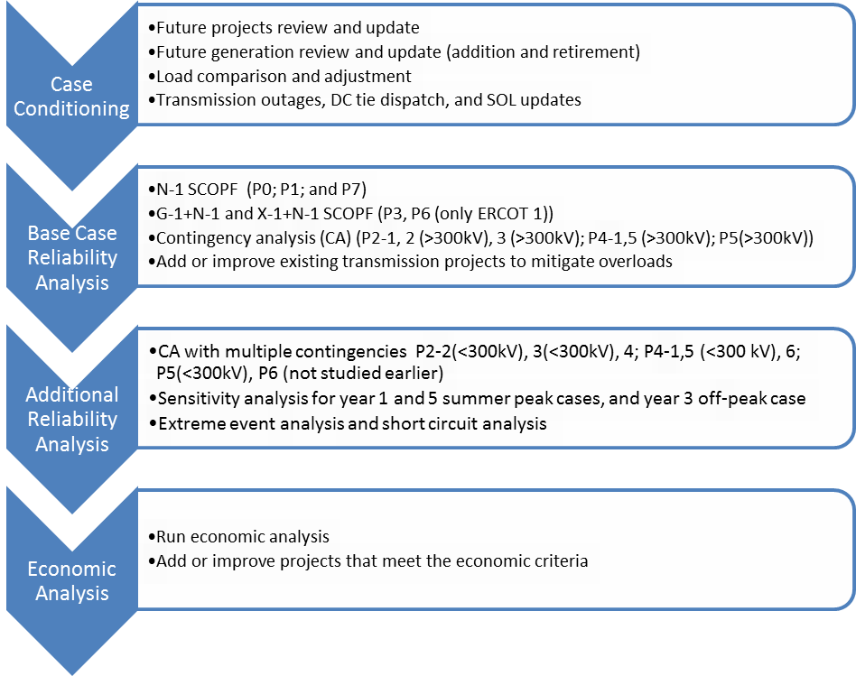
      - The Regional Transmission Plan Process

Case Conditioning
A data request will be sent out to the TSPs to review and update information to be used in the 2015 RTP cases. This request will include, but will not be limited to, the following information.
- Review the list of FACTS devices which will not be used as voltage support devices.
- Review the list of Tier 1, 2, and 3 projects in Model-On-Demand (MOD) that have not completed RPG review.
- Review the list of future generation to be added or removed, as well as existing generation to be retired from the 2015 RTP cases.
- List of generic equipment with long-lead time requirements in the TSP footprint. TPL-001-4 R2.1.5 defines the equipment to be studied in this analysis as having a lead time of one year or longer.

Following the response on the above data request, the SSWG start cases will be updated using the input assumptions discussed in this scope document. The summer peak and the minimum load cases will be prepared in this step. The reliability start cases created after case conditioning and resulting N-1 overloads will be shared with the stakeholders prior to reliability analysis.

Reliability Analysis
PowerWorld SCOPF will be run to identify unresolvable constraints in the 2021 conditioned case. Transmission upgrades or additions will be studied in collaboration with TPs to find projects to solve the constraints. Once all reliability projects have been identified (i.e. no unresolvable constraints remain) projects will be reevaluated to determine if each project is needed. The above analysis will be repeated for other cases described in the scope section of this document.

Cascading outage analysis
N-1-1 screening analysis will be used to identify the initial set of contingencies which will be short-listed for cascade analysis and load-shed analysis to evaluate their potential of causing uncontrolled separation or cascade events. Possible corrective measures, including potential mitigation plans, generator re-dispatch, controlled load interruption or curtailment, or construction of new transmission facilities will be evaluated for contingencies causing severe overloads (115% of their emergency ratings and 150% of normal ratings) and the loss of load over 1000 MW under cascading conditions.

LTSA Alignment
Large projects (e.g., 345-kV) will be further evaluated using 2014 Long-Term System Assessment (LTSA) cases to ensure project robustness and long-term effectiveness. Project concepts identified in the LTSA will be reviewed as an aid to identifying project recommendations that will provide long-term benefits either as part of a long-term plan for the development of the system or as an alternative to recommending a series of smaller incremental projects over time. Areas identified in the 2014 LTSA as requiring a significant number of system upgrades will be evaluated on a long-term basis if upgrade needs are identified in the area during the 2015 RTP analysis.

Sensitivity Analysis
[Details regarding sensitivity analysis selected for the 2015 RTP are still under review. The scope document will be updated and sent out for stakeholder review at a later date.] ERCOT staff will perform sensitivity analysis for the summer peak conditions of 2016 and 2020 and an off-peak sensitivity for 2018. The summer peak sensitivity cases will be prepared to study the impact of lower reactive resource capability. Capability of reactive resources (MVAR Rating of Generation) will be lowered by x% from the base case. The 2018 high-wind, low-load cases will be studied as an off-peak sensitivity case.

The sensitivity analysis will be performed after all the reliability constraints identified in the base case analysis are resolved. Any new constraints identified following the sensitivity analysis may require a new transmission upgrade/addition or a Congestion Management Plan.

Short Circuit Analysis
[Details regarding short circuit analysis for the 2015 RTP are still under review. The scope document will be updated and sent out for stakeholder review at a later date.] ERCOT will perform a short circuit analysis based on a three-phase fault and single-line-to-ground (SLG) fault on the 2018 and 2021 summer peak reliability cases after adding all the projects identified in 2015 RTP. The maximum level of generation and spare autotransformers shall be placed on-line within these cases in order to ascertain the worst-case short circuit current levels. Subtransient generator impedances and a pre-fault voltage of 1.0 shall be utilized in the study. A report with the short circuit current level at each bus will be provided.

Economic Analysis
The final summer peak reliability cases for 2018 and 2021 are uploaded into UPLAN as the starting economic cases. The UPLAN database will be updated using input assumptions relevant to economic analysis discussed in this document. After completing a UPLAN run, the congestion in each case will be organized by its rank and shadow price. Economic projects will be studied in collaboration with the TPs for the highest congested elements. Once economic projects have been identified to solve the highest congested elements, a project-back-out analysis is performed to determine if each project is still economically justified. The final set of economic projects will be tested in the summer peak reliability case to ensure that the reliability case is still N-1 secure.

Deliverables
In the course of the analysis, the following information, at a minimum, will be shared with the stakeholders via MIS.
- Initial conditioned start cases and list of binding constraints.
- Intermediate cases and binding constraints, and proposed reliability and economic projects as they become available.
- Steady-State AC base cases at yearly peak including all reliability and economic projects for each case.
  - Summer peak load cases for years 2016, 2018, 2020, and 2021
  - Minimum load case for year 2018.
  - Each sensitivity case each for years 2016 and 2020 summer peak and 2018 minimum load.
- A final congestion table will be posted for each study year in the economic analysis.
The results of the analysis of any constraints identified for 2015 will be forwarded to ERCOT Operations and the TPs for possible CMP or Special Protection System (SPS) development.
A tentative schedule for the RTP is described in Table 3.

        - Tentative RTP Schedule
Deliverable | Date
RTP Scope Developed | 10/18/2014
RTP Scope Sent out for stakeholder review | 2/20/2014
Data Request to TSPs Completed | 1/1/2015
Initial Conditioned Cases Posted | 2/23/2015
Reliability Analysis Complete | 7/27/2015
Economic Analysis Complete | 8/18/2015
Draft Report Sent Out for TP Review | 9/18/2015
Final Report Published | 11/16/2015

