
November 2014 ERCOT Monthly Operations Report

Reliability and Operations Subcommittee Meeting
January 8, 2015
Table of Contents
1. Report Highlights 1
2. Frequency Control 2
2.1. Frequency Events 2
2.2. Responsive Reserve Events 3
2.3. Load Resource Events 3
3. Reliability Unit Commitment 3
4. Wind Generation as a Percent of Load 5
5. Congestion Analysis 5
5.1. Notable Constraints for November 5
5.2. Generic Transmission Constraint Congestion 7
5.3. Manual Overrides for November 7
5.4. Congestion Costs for Calendar Year 2014 7
6. System Events 9
6.1. ERCOT Peak Load 9
6.2. Load Shed Events 9
6.3. Stability Events 9
6.4. Notable PMU Events 9
6.5. TRE/DOE Reportable Events 9
6.6. New/Updated Constraint Management Plans 9
6.7. New/Modified/Removed SPS 9
6.8. New Procedures/Forms/Operating Bulletins 9
7. Emergency Conditions 9
7.1. OCNs 9
7.2. Advisories 10
7.3. Watches 10
7.4. Emergency Notices 10
8. Application Performance 10
8.1. TSAT/VSAT Performance Issues 10
8.2. Communication Issues 10
9. Net-Forecast Bias Applied to NSRS Procurement for December 2014 10
Appendix A: Real-Time Constraints 11

Report Highlights
- The unofficial ERCOT peak for November was 50,677 MW.
- The ERCOT region reached a new wind generation record of 10,808 MW on November 28. This exceeded the previous record of 10,296 MW set on March 26.
- There were four frequency events in November. PMU data indicates the ERCOT system transitioned well in each case.
- There were four instances where Responsive Reserves were deployed. Each of them was the result of frequency events.
- There were 37 RUC Commitments in November to resolve local congestion, better manage the Valley Import GTC and for voltage support.
- The level of SCED congestion decreased in November. This was primarily due to cold temperatures, ongoing outages and load/gen patterns.
- There were no significant system events in ERCOT during the month of November.
- ERCOT Applications performed well throughout the month. There were no issues in November.

Frequency Control

Frequency Events
The ERCOT Interconnection experienced five frequency events in November, all of which resulted from Resource trips. The average event duration was approximately 46 seconds.

When analyzing frequency events, ERCOT evaluates PMU data according to industry standards. Events with an oscillating frequency of less than 1 Hz are considered to be inter-area, while higher frequencies indicate local events. Industry standards specify that damping ratio for inter-area oscillations should be 3.0% or greater. All events listed below indicate the ERCOT system met these standards and transitioned well after each disturbance. Further details on the Resource trip events can be seen in the Performance Disturbance Compliance Working Group report.

A summary of the frequency events is provided below:

Date and Time | Max/Min Frequency  (Hz) | Duration of Event  (seconds) | PMU Data |  | Comments
Date and Time | Max/Min Frequency  (Hz) | Duration of Event  (seconds) | Oscillation Mode | Damping Ratio | Comments
11/19/2014 23:09 | 59.899 | 1 | 0.7364 Hz | 11.4% | Unit trip with approximately 425 MW
11/21/2014 5:13 | 59.756 | 140 | 0.745 Hz | 13.6% | Unit trip with approximately 787 MW
11/21/2014 16:38 | 59.872 | 11 | 0.705 Hz | 9.8% | Unit trip with approximately 471 MW
11/28/2014 20:11 | 59.871 | 31 | No significant oscillation modes captured |  | Plant trip with approximately 479 MW

(Note: the duration of the frequency events is defined to be the time at which the frequency was outside the range of 60±0.1 Hz)

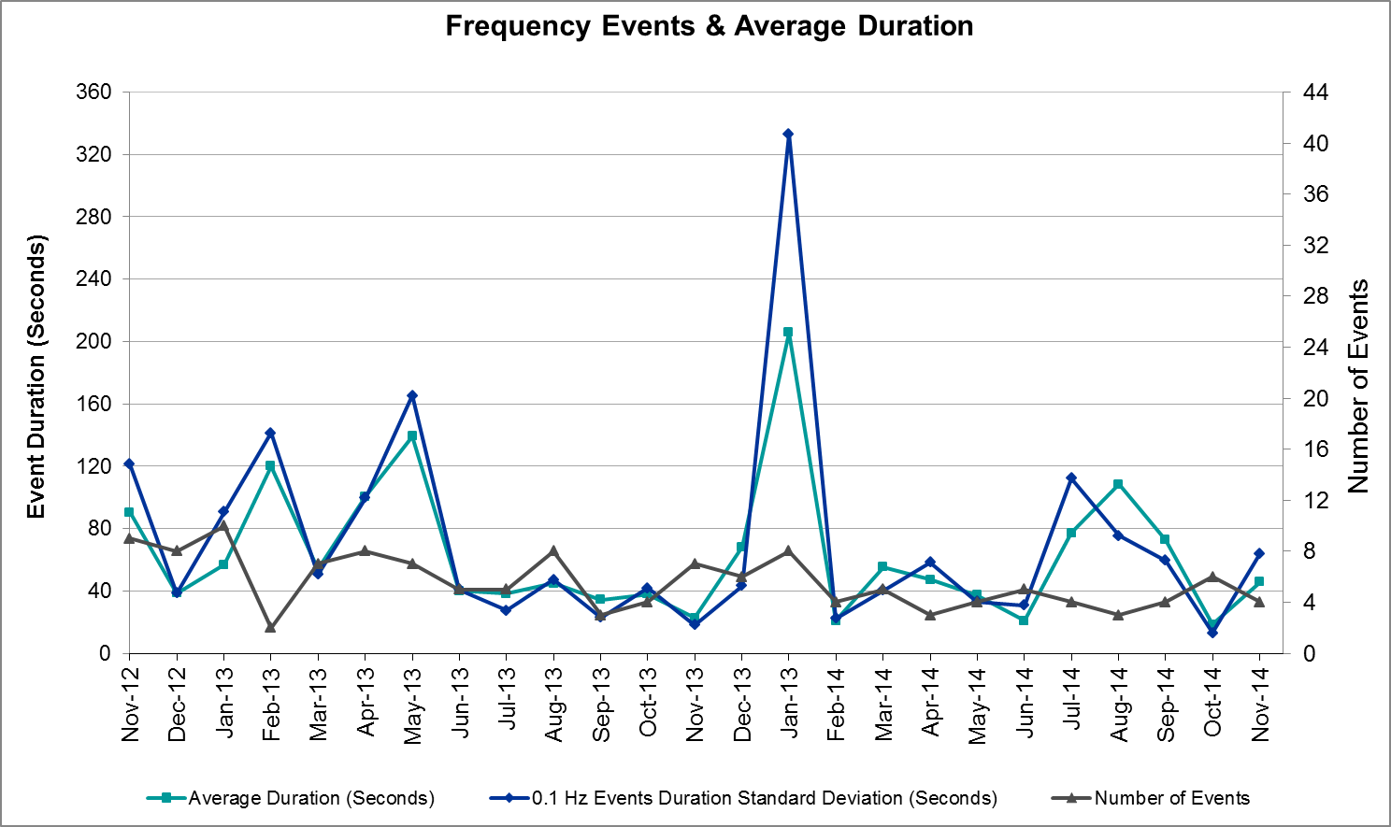

Responsive Reserve Events
There were four events where Responsive Reserve MWs were released to SCED in November. The events highlighted in blue were related to frequency events reported in section 2.1 above.

Date and Time  Released to SCED | Date and Time  Recalled | Duration of Event | Maximum MWs Released | Comments
11/19/14 23:09:18 | 11/19/14 23:12:06 | 0:02:48 | 79.054
11/21/14 5:13:42 | 11/21/14 5:18:02 | 0:04:20 | 840.43
11/21/14 16:39:14 | 11/21/14 16:42:30 | 0:03:16 | 447.04
11/28/14 20:11:54 | 11/28/14 20:15:42 | 0:03:48 | 354.96

Load Resource Events
There were no load resource deployment events in November.

Reliability Unit Commitment
ERCOT reports on Reliability Unit Commitments (RUC) on a monthly basis. Commitments are reported grouped by operating day and weather zone. The total number of hours committed is the sum of the hours for all the units in the specified region. Additional information on RUC commitments can be found on the MIS secure site at Grid → Generation → Reliability Unit Commitment.

There were no DRUC commitments in November.

HRUC Commitments
Resource Location | # of Resources | Operating Day | # Hours Committed | Total MWhs | Reason for commitment
N. Central | 3 | 11/1/2014 | 13 | 3,581 | Voltage Support
N. Central | 1 | 11/2/2014 | 9 | 5,501 | Voltage Support
Southern | 1 | 11/2/2014 | 2 | 670 | Valley Import
N. Central | 1 | 11/3/2014 | 8 | 4,788 | Voltage Support
Southern | 2 | 11/3/2014 | 26 | 6,882 | Valley Import and Local Congestion
N. Central | 1 | 11/4/2014 | 6 | 3,565 | Voltage Support
Southern | 1 | 11/4/2014 | 24 | 5,592 | Local Congestion
Southern | 1 | 11/5/2014 | 24 | 5,659 | Local Congestion
Southern | 1 | 11/6/2014 | 24 | 5,701 | Local Congestion
Southern | 1 | 11/7/2014 | 6 | 1,471 | Local Congestion
Southern | 1 | 11/8/2014 | 24 | 5,793 | Local Congestion
Southern | 1 | 11/9/2014 | 22 | 4,587 | Local Congestion
N. Central | 2 | 11/21/2014 | 15 | 3,473 | Voltage Support
N. Central | 2 | 11/22/2014 | 9 | 2,870 | Voltage Support
N. Central | 1 | 11/23/2014 | 7 | 4,321 | Voltage Support
Southern | 1 | 11/23/2014 | 7 | 1,662 | Valley Import
N. Central | 2 | 11/24/2014 | 7 | 4,359 | Voltage Support
N. Central | 2 | 11/25/2014 | 9 | 4,314 | Voltage Support
Southern | 2 | 11/25/2014 | 40 | 1,936 | Valley Import
N. Central | 2 | 11/26/2014 | 6 | 3,706 | Voltage Support
Southern | 2 | 11/26/2014 | 16 | 792 | Valley Import
N. Central | 1 | 11/27/2014 | 6 | 3,783 | Voltage Support
Southern | 2 | 11/27/2014 | 12 | 4,094 | Valley Import
Southern | 1 | 11/28/2014 | 24 | 8,282 | Valley Import
Southern | 1 | 11/29/2014 | 24 | 8,147 | Valley Import
Southern | 1 | 11/30/2014 | 24 | 8,147 | Valley Import

Wind Generation as a Percent of Load
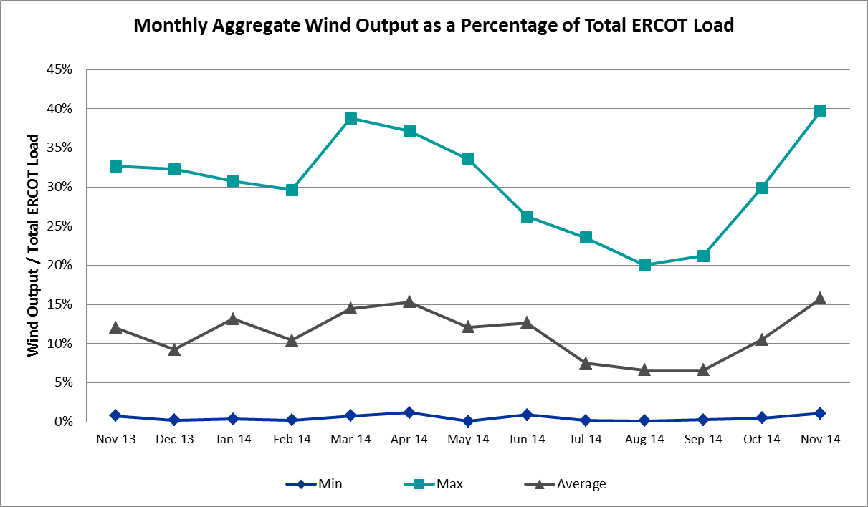

Congestion Analysis
The number of congestion events experienced by the ERCOT system decreased in November due to colder temperatures, ongoing outages and load/gen. There was one day of activity on the SOP-110 (GTC) in November.

Notable Constraints for November
Nodal protocol section 3.20 specifies that ERCOT shall identify transmission constraints that are active or binding three or more times within a calendar month. As part of this process, ERCOT reports congestion that meets this criterion to ROS. In addition ERCOT also highlights notable constraints that have an estimated congestion rent exceeding $1,000,000 for a calendar month. These constraints are detailed in the table below. Rows highlighted in blue indicate the congestion was affected by one or more outages. For a list of all constraints activated in SCED for the month of November, please see Appendix A at the end of this report.

Contingency | Overload | # of Days Constraint Active | Estimated Congestion Rent | Transmission Project
Odessa Ehv - Odessa North 138 kV | Moss Switch - Permian Basin Ses 138 kV | 2 | $3,897,272 | 4234
Apache Tnp - Caddo Sw Sta Tnp 138 kV | Heights Tnp AT1 138/69 kV | 1 | $2,924,973
DCKT Watermill Switch - West Levee Switch and Sargent Road 345 kV | Norwood Switch AXFMR1L 345/138 kV | 3 | $2,414,657 | 11TPIT0097
Odessa Ehv - Odessa North 138 kV | Permian Basin Ses - Wink Sub 138 kV | 1 | $2,060,460 | 15TPIT0058
Wink Sub - Permian Basin Ses 138 kV | Northward - Wink Sub 69 kV | 2 | $1,835,295
Bergstrom - Onion Creek 138 kV | Decker Power Plant - Walnut Creek 138 kV | 2 | $1,820,625
Orange Grove Switching Station - Lon Hill 138 kV | Lon Hill - Smith 69 kV | 7 | $1,804,029 | 16TPIT0026
DCKT Roanoke Switch - West Denton and Lewisville Switch - Krum West Switch 345 kV | Lewisville Switch - Jones Streen Tnp 138 kV | 6 | $1,766,073 | 4282
DCKT Royse Switch - Forney Switch 345 kV | Forney Switch AXFMR3L 345/138 kV | 2 | $1,420,521 | 12TPIT0080
DCKT Lon Hill - North Edinburg 345 kv and Orange Grove Switching Station 138 kV | Lon Hill - Smith 69 kV | 4 | $1,123,519 | 16TPIT0026
DCKT Watermill Switch - West Levee Switch and Sargent Road 345 kV | Norwood Switch AXFMR1H 345/138 kV | 3 | $1,117,840 | 11TPIT0097
Koch Up River - Gila 138 kV | Gila - Hiway 9 138 kV (GILA_HIWAY_2) | 8 | $795,876
DCKT Venus Switch - Liggett Switch 345 kV | Lewisville Switch - Jones Streen Tnp 138 kV | 3 | $711,766 | 4282
DCKT Greens Bayou - King 345 kV | Lyden - Deepwater 138 kV | 4 | $476,626
DCKT Sam Switch - Tradinghouse Ses 345 kV | Whitney AXFMR2 (3) 345/138 kV | 3 | $347,204
Laquinta - Lobo 138 kV | Bruni 138_69_1 138/69 kV | 6 | $250,303
Cottonwood Road Switch - Loftin 69 kV | Shannon - Post Oak Switch 69 kV | 24 | $245,215 | 15TPIT0011
Bluff Creek T2 (3) 345/138 kV | Bluff Creek T1 (3) 345/138 kV | 3 | $221,652
DCKT South Channel - Pair and Shell 138 kV | Conial - Waburn 138 kV | 4 | $206,343 | 14TPIT0121
DCKT Jewett - Singleton 345 kV | Twin Oak Switch - Gibbons Creek 345 kV | 4 | $202,229
DCKT Paris Switch - Valley Ses and Valley South 345 kV | Paris Switch AXFMR1 (3) 345/138 kV | 4 | $189,528 | 4210
Nelson Sharpe - Lon Hill 345 kV | Rio Hondo - Burns Sub 138 kV | 4 | $161,585
Scurry Switch - Sun Switch 138 kV | Wolfgang - Rotan 69 kV | 6 | $8,846

Generic Transmission Constraint Congestion
There was 1 day of activity on the SOP-110 GTC in November. The West – North, North – Houston, and Valley Import GTCs were not activated during the month.

Manual Overrides for November
None

Congestion Costs for Calendar Year 2014
The following table represents the top twenty active constraints for the calendar year to date based on the estimated congestion rent attributed to the congestion. ERCOT updates this list on a monthly basis.

Contingency | Binding Element | # of 5-min SCED Intervals | Estimated Congestion Rent | Transmission Project
Lytton Springs LY_AT2 345/138 kV | Lytton Springs LY_AT1 345/138 kV | 1,997 | $55,956,002 | (none)
Skywest - Spraberry Switch 138 kV, Skywest - Salt Flat Road 138 kV, and Salt Mine - Barber Lake Switch 138 kV | Midland East - Buffalo 138 kV | 3,750 | $46,791,691 | 14TPIT0052
Apache Tnp - Caddo Sw Sta Tnp 138 kV | Heights Tnp HEIGHAT1 138/69 kV | 1,667 | $39,822,775 | (none)
La Palma - Rio Hondo 138 kV, DCKT Rio Hondo - North Edinburg 345 kV and Harlingen Switch 138 kV | Harlingen Switch - Oleander 138 kV | 1,159 | $26,943,341 | (none)
Tejas Tnp - Greenbelt Tnp 138 kV | Heights Tnp HEIGHAT2 138/69 kV | 1,104 | $26,926,033 | (none)
Midland East Axfmr 1 (3) 345/138 kV, Moss Switch Axfmr 1 345/138 kV, and Midland East - Moss Switch - Odessa Ehv Switch 345 kV | Odessa North Sd3 138 kV | 5,310 | $23,944,433 | 2012-R3, 2012-R4
La Palma - Rio Hondo 138 kV, Los Fresnos - Loma Alta Sub 138 kV | Rio Hondo - East Rio Hondo 138 kV | 1,613 | $23,683,772 | (none)
Moss Switch - Holt Switch 138 kV | Moss Switch - Westover 138 kV | 1,088 | $19,511,591 | 14TPIT0053
Orange Grove Switching Station - Lon Hill 138 kV, DCKT Lon Hill - North Edinburg 345 kv and Orange Grove Switching Station 138 kV, and Lon Hill 345_138_2 (3) 345/138 kV | Lon Hill - Smith 69 kV | 9,839 | $16,899,256 | 16TPIT0026, 2012-R18
DCKT Flewellen - Obrien and Maso Road 138 kV, DCKT Singleton - Zenith 345 kV | Hockley - Betka 138 kV | 773 | $15,850,200 | TPIT Project 3682A, 3682B
Basecase | Valley Import | 576 | $11,853,636 | (none)
DCKT Jewett - Singleton 345 kV | Twin Oak Switch - Gibbons Creek 345 kV | 562 | $11,115,041 | (none)
DCKT Paris Switch - Valley Ses and Valley South 345 kV | Paris Switch AXFMR1 (3) 345/138 kV | 2,516 | $10,129,884 | 14TPIT0093
McNeil Lcra - Gilleland 138 kV, Hutto Switch Axfmr 1 (3) 345/138 kV, Salty - Sandow Switch 138 kV, and DCKT Austrop - Sandow Switch 345 kV | Hutto Switch - Round Rock Northeast 138 kV (1661_B) | 425 | $10,033,349 | 16TPIT0062
DCKT Gabriel - Glasscock LCRA and Rivery 138 kV, Glasscock LCRA - Gabriel 138 kV, and DCKT Gabriel - Bell County - Hutto Switch 138 kV | Marshall Ford - Lago Vista 138 kV | 209 | $9,871,526 | 15TPIT0061
Koch Up River - Gila 138 kV | Gila - Hiway 9 138 kV (GILA_HIWAY_2) | 28,956 | $9,421,904 | (none)
Key Sub - Willow Valley Switch 138 kV and Winks Sub - No Trees Switch 138 kV | Holt Switch - Amoco Midland Farms Tap 138 kV | 475 | $7,974,086 | 15TPIT0092
DCKT Wa Parish - Jeanetta 345 kV | Smithers - Bellaire 345 kV | 1,058 | $7,870,155 | (none)
Alice - Kingsville 138 kV, Kingsville - Lon Hill 138 kV, Nelson Sharpe - Lon Hill 345 kV | Lon Hill - Calallen Sub 69 kV | 912 | $7,699,219 | 12TPIT0181, 2012-R13
Laquinta - Lobo 138 kV | Bruni 138_69_1 138/69 kV | 11,366 | $7,325,024 | 13TPIT0148

System Events

ERCOT Peak Load
The unofficial ERCOT peak load for the month was 50,677 MW and occurred on November 17th during the hour ending 08:00.

Load Shed Events
None

Stability Events
None

Notable PMU Events
ERCOT analyzes PMU data for any significant system disturbances that do not fall into the Frequency Events category reported in section 2.1. The results are summarized in this section once the analysis has been completed.

There were no reportable events in November.

TRE/DOE Reportable Events
None

New/Updated Constraint Management Plans
None

New/Modified/Removed SPS
There was one removed SPS in the month of November: Stanton East Sw. Station SPS#46 was removed on November 9th, 2014.

New Procedures/Forms/Operating Bulletins
None

Emergency Conditions

OCNs
Date and Time | Description
11/10/2014 14:01 | ERCOT issued an OCN due to a strong cold front expected to impact the region during the week.

Advisories
Date and Time | Description
11/12/2014 16:15 | ERCOT moved from an OCN to an Advisory due to the strong cold front in the region.
11/14/2014 11:21 | ERCOT issued an Advisory for early next week due to a stronger surge of cold air, low temperatures projected to be in the 20s and 30s for most of the region.

Watches
Date and Time | Description
11/16/2014 16:03 | ERCOT moved from an Advisory to a Watch due to the strong surge of cold air with low temperatures in the 20s and 30s impacting the interconnection.
11/22/2014 10:23 | ERCOT issued a Watch due to a SCED failure.

Emergency Notices
None

Application Performance
ERCOT system applications performed well in November. There were no issues to report.

TSAT/VSAT Performance Issues
None

Communication Issues
None

Net-Forecast Bias Applied to NSRS Procurement for December 2014
Each month, ERCOT calculates a net Forecast Bias pursuant to the ERCOT Ancillary Services Methodology for procurement of Non-Spinning Reserve Service (NSRS). The table below indicates the amount of net Forecast Bias that was applied to the NSRS procurement for specified blocks of time for the month of December, 2014.

Blocks | Negative Net Load Forecast Average Error - By Weather Zone for the 5 Largest Zones
Blocks | Coast | East | North Central | South Central | Southern
1-2 | 0 | 0 | 0 | 0 | 0
3-6 | 0 | 0 | 0 | 0 | 0
7-10 | 0 | 0 | 0 | 0 | 0
11-14 | 0 | 0 | 0 | 0 | 0
15-18 | 0 | 0 | 0 | 0 | 0
19-22 | 0 | 0 | 0 | 0 | 0
23-24 | 0 | 0 | 0 | 0 | 0

Appendix A: Real-Time Constraints
The following is a complete list of constraints activated in SCED for the month of November. Full contingency descriptions can be found in the Standard Contingencies List located on the MIS secure site at Grid → Generation → Reliability Unit Commitment.

Contingency | Constrained Element | From Station | To Station | # of Days Constraint Active
SCRDLOF9 | POS_SHAN_1 | SHANNON | POSTOKSW | 24
SKOCNU28 | GILA_HIWAY_2_1 | GILA | HIWAY_9 | 8
SORNLON8 | LON_HI_SMITH1_1 | LON_HILL | SMITH | 7
DRNKKRW5 | 590__A | LWSSW | LWVJS | 6
SLAQLOB8 | BRUNI_69_1 | BRUNI | BRUNI | 6
SSCUSUN8 | ROTN_WOLFGA1_1 | WOLFGANG | ROTN | 6
DGBY_KG5 | DPWLYD70_A | LYD | DPW | 4
DJEWSNG5 | 256_A_1 | TOKSW | GIBCRK | 4
DLONOR58 | LON_HI_SMITH1_1 | LON_HILL | SMITH | 4
DPRSVLY5 | PRSSW_MR1H | PRSSW | PRSSW | 4
DSC_SL28 | CO_WAS84_A | CO | WAS | 4
SN_SAJO5 | S104A_1 | RIOHONDO | MV_BURNS | 4
DSAMTHS5 | WHTNY_FMR2 | WHTNY | WHTNY | 3
DVENLIG5 | 590__A | LWSSW | LWVJS | 3
DWTRWLV5 | NORSW_MR1H | NORSW | NORSW | 3
DWTRWLV5 | NORSW_MR1L | NORSW | NORSW | 3
XBL2U58 | BLUF_CRK_T1_H | BLUF_CRK | BLUF_CRK | 3
DCALHOT8 | N4_X3_1 | CALAVERS | X3 | 2
DFERPAL8 | 38T365_1 | WIRTZ | FLATRO | 2
DRYSFOR5 | FORSW_MR3H | FORSW | FORSW | 2
DTRCELK5 | 11010__A | GRDSW | SCSES | 2
DTRCELK5 | 1820__A | SCSES | TROUP | 2
DTRSTRC5 | 975__E | FGRSW | EUSSE | 2
SBERONI8 | CKT_917_1 | DECKER | WALNUT | 2
SBOSELM5 | WHTNY_HT1L | WHTNY | WHTNY | 2
SCHABSP9 | CEDH_69_1 | CEDH | CEDH | 2
SLAQLOB8 | FALFUR_69A1 | FALFUR | FALFUR | 2
SLCDYN8 | PT_SE_65_A | SE | PT | 2
SLCDYN8 | SE_WA_65_A | WA | SE | 2
SODNOD28 | 6485__A | MOSSW | PBSES | 2
SSCLWF28 | 6560__B | MRKLY | RICSW | 2
SSONFRI8 | SONR_69-1 | SONR | SONR | 2
SWINPBS8 | 6917__B | NWARD | WINKS | 2
XLOB58 | ASHERT_CATARI1_1 | ASHERTON | CATARINA | 2
BASE CASE | SNYDER_WKN_BK1_1 | ENAS | WKN_BKR | 1
BASE CASE | SOP110 |  |  | 1
DAUSGAR5 | CKT_1004_1 | TRIDGE | HWRDLN | 1
DBIGKEN5 | BONDRO_SONR1_1 | SONR | BONDROAD | 1
DCALSKY8 | E1_M1_1 | M1 | E1 | 1
DEULLIG8 | 1140__C | DFWD1 | DFWCE | 1
DOLIELM8 | OLI_BEN1_1 | OLINGR | BNDVS | 1
DTB_SNG5 | SNGZEN99_A | SNG | ZEN | 1
DWH_STP5 | SINTON_SKIDMO1_1 | SINTON | SKIDMORE | 1
SABSBLU8 | ABNW_CALLAH1_1 | CALLAHAN | ABNW | 1
SANAKR25 | 590__A | LWSSW | LWVJS | 1
SAPACAD8 | HEIGHTTN_HAT1 | HEIGHTTN | HEIGHTTN | 1
SBOSELM5 | 1030__B | BOSQUESW | RGH | 1
SBRAUVA8 | HAMILT_MAVERI1_1 | HAMILTON | MAVERICK | 1
SBRTORA8 | GRMSW_FMR1 | GRMSW | GRMSW | 1
SFRNFOR5 | 590__A | LWSSW | LWVJS | 1
SKOCNU28 | REACTOR1_SEC_1 | WHITE_PT | WHITE_PT | 1
SLOBSAN5 | ASHERT_CATARI1_1 | ASHERTON | CATARINA | 1
SODNOD28 | 6550__A | PBSES | WINKS | 1
SSCHTWI8 | BENF_REDCRE1_1 | REDCREEK | BENF | 1
SSKYSBY8 | 6146__A | MDLNE | BUFFALO | 1
SSPUASP8 | ROTN_WOLFGA1_1 | WOLFGANG | ROTN | 1
SVICCO28 | COLETO_VICTOR2_1 | COLETO | VICTORIA | 1
XBLU58 | ABNW_CALLAH1_1 | CALLAHAN | ABNW | 1
XWFA89 | 6945__A | LKWSW | WFALS | 1

