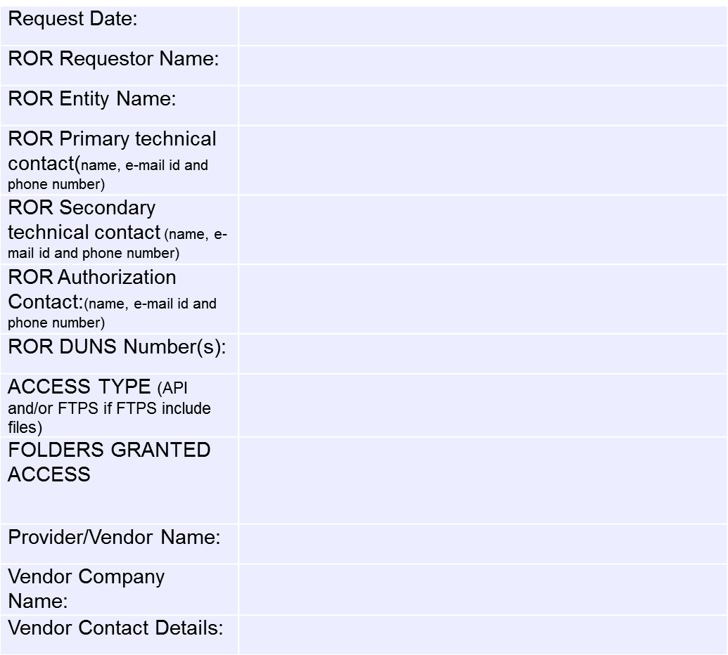
LSE Interval
Data
Ad Hoc Usage
Reports
HAN
Historical
Backfill
Subscription
New Customer
ROR REQUEST FORM FOR VENDOR ON BEHALF
API & FTP ACCESS

