Load Scaling Proposed Methodology
PLWG Meeting
August 20, 2014

- Introduction

The initial topic to be discussed by the PLWG was envisioned to be limited to the load scaling techniques that have recently been utilized in certain RTP planning studies. However, because load scaling has been utilized in planning studies when there is not enough planned generation meeting the stringent requirements of Planning Guide 6.9, it is recommended that both the load and generation assumptions be part of today’s discussion. The following quote is taken from ERCOT’s final report of the Independent Review of the Houston Import Project and describes why load scaling was resorted to previously.

“In transmission planning analysis the amount of generation available in the base case may not be enough to meet the summed non-coincident peak load of all areas of the system. In order to solve this challenge in the 2013 RTP, ERCOT split the 2018 summer peak case into two study areas, the so-called NW and SE areas. For each study area the load level was set to the forecasted peak load for that area while load outside of the area was scaled down until there was enough generation to meet the load plus an operational reserve of approximately 1375 MW (equal to the largest single unit on the ERCOT system).”

Since it is evident that the load scaling techniques are deemed necessary to have “enough generation to meet the load plus an operational reserve of approximately 1375 MW,” it is appropriate to discuss both the load and generation assumptions to ensure planning studies from the Regional Transmission Plan meet, among other things, the criteria in Planning Guide 3.1.4.1(1), which states in part: “The planning process begins with computer modeling studies of the generation and Transmission Facilities and substation Loads under normal conditions in the ERCOT System. Contingency conditions along with changes in Load and generation that might be expected to occur in operation of the ERCOT Transmission Grid are also modeled.” (emphasis added)

- Issues with Current RTP Study Assumptions

- The use of the “higher-of” SSWG or ERCOT’s 90/10 load forecasts results in extreme system loading and generation shortages that cannot reasonably be expected to occur in operations.
  - Example: from ERCOT presentation entitled “April 2014 RTP Inputs and Assumptions.”
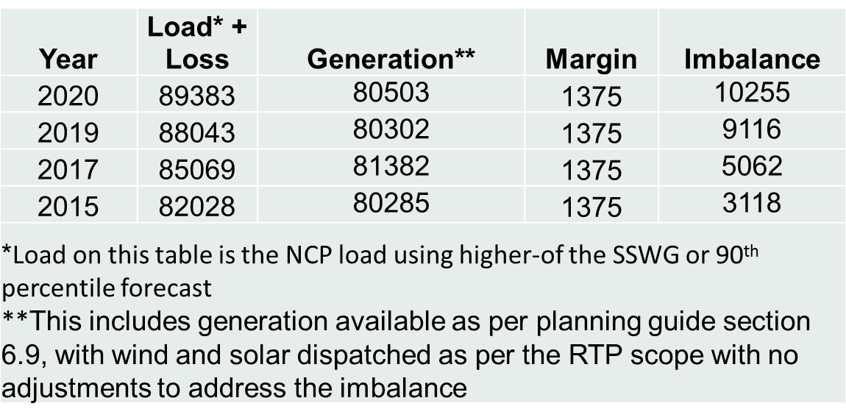
  - The loading and generation combinations above result in a severely stressed system.
  - If these system conditions were to actually occur, the system would be under EEA conditions (at least level 2 because there are only 1375 MWs of reserves left), ERS would be deployed, load resources providing RRS would be deployed, and other passive loads (such as 4CP) would be deploying in response to the higher pricing, especially with the implementation of ORDC.
  - There are no extra generating resources available, guaranteeing that transmission violations will occur (many of them) which cannot be relieved by re-dispatch, leading to countless reliability-driven projects and few, if any economic-driven projects.
  - Example of the trend in reliability projects vs. economic projects can be seen by reviewing the RTPs over the years. The 2013 RTP final report contains 104 Reliability Projects, 44 projects listed under “Mitigation plans for remaining 2014 Reliability issues,” and 1 Economic Project.

- Load scaling, which was introduced as a modeling circuit breaker for planned generation shortages, still leaves the system in a stressed condition under the planning methodology described in Section I above.
  - Even after scaling down loads, there are still only 1,375 MWs of reserves left and the problems described above all still remain (transmission overloads, no available generation to dispatch, and system still in an EEA Level 2 scenario.)

- The use of non-coincident peaks is unreasonable.
  - The highest peak condition on the grid only happens in one hour of each year, and that hour is the coincident peak hour.
  - As seen in the table above, summing the NCPs of each weather zone results in total loads that are thousands of MWs above the available generation, and clearly would not represent a reasonable target value for generation developers. Generation and load resource developers will instead place more weight on the load forecast provided in the CDR as it is one that can reasonably be anticipated to occur in the future years.
  - The sum of NCPs is not what “might be expected to occur in operation of the ERCOT Transmission Grid.” (Planning Guide 3.1.4.1)

- Severe weather is the norm (“higher of” load forecast methodology described above) in today’s transmission planning.
  - There is an inconsistency in planning if transmission is expected to be built to always serve a severe weather condition, but the generation only needs to serve the normal, expected load.
  - Is it reasonable to assume that the extreme weather load will be perfectly met by all the remaining generation in a study case? The point is that the studies are unrealistic if it is assumed that every generator, except the one taken out of service in the G-1 criteria, will be available at its full installed capability during the absolute hottest peak time. Further evidence that real-time generation operations will not always match the sum of their HSLs is that ERCOT continues to use a Reserve Discount Factor in operations.

- Recommendations for Discussion to Address the Issues Described Above

- Any study that is inter-regional in nature should start with the use of coincident peaks and the normal (50/50) load forecast.
- If we are going to count load resources, and pay them for being available (like generation), then load resources should be considered in the transmission studies as well. For example, perhaps an average of the peak Business Hour II period for the last four procurement cycles for the same summer season can be used to estimate the amount of load resources to include in the RTP studies.]
- Increase the required reserve margins in transmission studies to ensure the study doesn’t model an EEA condition. For example, perhaps the transmission models should at least model >2,000 MWs of PRC since that’s the point at which ORDC becomes extreme.
- If the total load plus reserve margin using the assumptions described in items 1-3 still result in load exceeding available resources, then utilize a dispatch procedure similar to the one described in the SSWG Procedure Manual at 4.3.3. Suggested modifications to this procedure when resource shortages occur in RTP studies could be as follows:
  - DC ties dispatched to their full capacity to increase transfers into ERCOT.
  - Increase NOIE generation with prior NOIE consent.
  - Add in mothballed units that have not announced their return to service.
  - Dispatch units that are solely for black start.
  - Add units with interconnection agreements, but have not yet met financial security requirements.
  - Add units with interconnection agreements, but have not yet met air permit or water requirements.
  - Add publicly announced plants without interconnection agreements.
  - Increase wind generation dispatch up to 25% of capability, starting with wind farms in counties bordering the coast.
  - Increase wind generation dispatch up to 50% of capability, starting with wind farms in counties bordering the coast.
  - Increase wind generation dispatch up to CDR capability for wind farms in counties not bordering the coast
- If items 1-4 still result in resource shortages, then scale the loads in each weather zone outside the study region to a percentage of its NCP when the study region is at its peak, based on a running 5 year average of the percentages. For example, utilize a table similar to the following, but in no case scale any weather zone load more than 5% below its NCP without first reexamining all model inputs for accuracy:

EXAMPLE IF COASTAL ZONE BEING STUDIED
Average % of peak load of each weather zone during the top hour peak load condition at the Coast Weather Zone
(SAMPLES ONLY – PERCENTAGES NOT VERIFIED)
 | East | South | South Central | Far West | West | North | North Central
2009 | 96.01% | 97.40% | 97.67% | 94.77% | 93.97% | 87.57% | 95.43%
2010 | 95.94% | 97.34% | 97.47% | 95.17% | 95.97% | 89.57% | 91.43%
2011 | 97.60% | 95.30% | 96.70% | 91.20% | 92.00% | 88.30% | 95.50%
2012 | 97.60% | 98.70% | 97.90% | 95.10% | 97.70% | 90.30% | 94.60%
2013 | 92.70% | 98.10% | 98.10% | 98.60% | 95.20% | 87.10% | 90.20%
avg. | 95.97 | 97.37 | 97.57 | 94.97 | 94.97 | 88.57 | 93.43

ERCOT Independent Review of Houston Import RPG Project, February 20, 2014, page 3.

