MEETING MINUTES FOR THE ERCOT PHASOR MEASUREMENT TASK FORCE GROUP MEETING (7/9/14)
ACTION ITEMS IN YELLOW
Attendees

- Bill | Blevins | ERCOT
- Carlos | Casablanca | AEP
- Christina | Doerr | LCRA TSC
- Milton | Holloway | CCET
- Kris | Koellner | LCRA TSC
- Dennis | Kunkel | AEP
- Andrew | Mattei | Brazos Electric
- Suzi | McClellan | Good Company Associates
- David | Mercado | Centerpoint
- Sarma | Nuthalapati | ERCOT
- Prashant | Palayam | EPG
- David | Penney | Texas RE
- Farnoosh | Rahmatian | Quanta
- Sidharth | Rajagopalan | ERCOT
- Alex | Rangel | CPS Energy
- Alison | Silverstein | NASPI
- Josh | Srp | LCRA TSC
- Feng | Tu | AEP
- Lauri | White | AEP
- Taylor | Woodruff | Oncor
(Additional attendees were on the WebEx, but I did not catch all the names)

- Anti-trust Admonition

Kris read the ERCOT anti-trust admonition and disclaimer.

- Roster & calendar review/update – Koellner

Kris went over the PMTF meeting schedule for the remainder of 2014. The meeting schedule is available at http://www.ercot.com/committees/board/tac/ros/pmtf/. Most meetings are paired up with the ROS meeting for that month. The August meeting will have a model validation theme.

ERCOT and EPG are planning two days of RTDMS & PGDA software application training, September 16-17 at ERCOT’s facilities in Taylor.

The Eastern Interconnect/ERCOT Joint Meeting being organized by Lisa Beard w/Entergy was moved from May to October to coincide with the NASPI meeting in Houston (October 22-23).

- Review & approval of minutes from previous meeting – Koellner

The group approved the minutes from the May 2014 meeting with no changes.

- EPG RTDMS and Event Data Demo – Palayam
Prashant Palayam w/EPG provided a demonstration of ERCOT’s RTDMS tool which presently receives data from nearly 70 on-line PMUs. The demonstration included playback of various types of system disturbances. The group discussed way to circulate “lessons learned” from these types of events, similar to NERC Lessons Learned, but on a smaller scale. The group also discussed the need for operator instructions in response to different types of events so that operators are able to take effective action in response to real-time phasor data. These items will be captured as “next steps” in the Synchrophasor technology assessment report.
- ERCOT Control Room Viewing
Bill shared a view of ERCOT’s re-designed control room and described where phasor data visibility and some of the RTDMS tool functionality will fit into the control room.
- Document Updates

  - We reviewed the ERCOT Synchrophasor Communication Handbook. We incorporated edits from Alison, Alex (CPS), and David (CNP) into a single version. The version was provided to ERCOT 7/10/14 for further edits & clean-up.
  - We reviewed the ERCOT Synchrophasor Technology Assessment. We edited several sections. Kris will accept edits from the meeting and route a clean copy.
  - We considered various alternatives for ERCOT language about PMU placement. We settled on the language pictured below as a starting point:
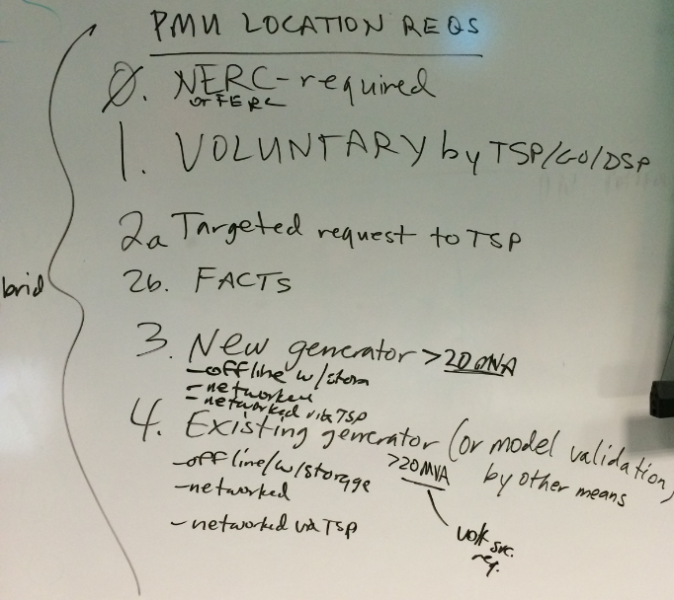
Kris will write some draft language regarding PMU placement for consideration at the August meeting.
- Wrap-up, action items
We considered moving the August meeting location to take advantage of NIWeek but ultimately were not able to due to meeting logistics.
Action items are included within the Synchrophasor Technology Assessment document and the Issues List document.

