
July 2014 ERCOT Monthly Operations Report

Reliability and Operations Subcommittee Meeting
August 7, 2014
Table of Contents
1. Report Highlights 1
2. Frequency Control 2
2.1. Frequency Events 2
2.2. Responsive Reserve Events 3
2.3. Load Resource Events 3
3. Reliability Unit Commitment 3
4. Wind Generation as a Percent of Load 4
5. Congestion Analysis 4
5.1. Notable Constraints for July 5
5.2. Generic Transmission Limit Congestion 6
5.3. Congestion Costs for Calendar Year 2014 6
6. System Events 7
6.1. ERCOT Peak Load 7
6.2. Load Shed Events 8
6.3. Stability Events 8
6.4. Notable PMU Events 8
6.5. TRE/DOE Reportable Events 8
6.6. New/Updated RAPs and PCAPs 8
6.7. New/Modified/Removed SPS 8
6.8. New Procedures/Forms/Operating Bulletins 8
7. Emergency Conditions 8
7.1. OCNs 8
7.2. Advisories 8
7.3. Watches 8
7.4. Emergency Notices 8
8. Application Performance 9
8.1. TSAT/VSAT Performance Issues 9
8.2. Communication Issues 9
9. Net-Forecast Bias Applied to NSRS Procurement for August 2014 9
10. Appendix A: Real-Time Constraints 10

Report Highlights
The load in the ERCOT Interconnection started increasing in July as the results of hot summer weather. Operations continued to note a low level of frequency events and RRS deployments. The amount of SCED congestion increased when compared to June, due to the increasing load and ongoing outages. There was a single reportable system event this month. ERCOT applications performed well in July except one missing VSAT run.

Highlights of this report:
- The unofficial ERCOT peak for July was 63,500 MW.
- There were four frequency events in July. All of them were captured by PMUs. The ERCOT system transitioned well in each case.
- There were five instances where Responsive Reserves were deployed. Four of them were the result of frequency events.
- There was only one RUC Commitment in July, which is the result of local congestion.
- The level of SCED congestion increased in July. It is mainly the results of increasing load with hot summer weather.
- There was one reportable system event this month that was the result of the loss of both transmission line and generation. System reliability was not impacted.
- ERCOT Applications performed well through the month, though VSAT missed one run due to State Estimator tuning.

Frequency Control

Frequency Events
The ERCOT Interconnection experienced four frequency events in July, which resulted from Resource trips. The average event duration was approximately 77 seconds, which was higher than the system performance observed in previous months.

When analyzing frequency events, ERCOT evaluates PMU data according to industry standards. Events with an oscillating frequency of less than 1 Hz are considered to be inter-area, while higher frequencies indicate local events. Industry standards specify that damping ratio for inter-area oscillations should be 3.0% or greater. All events listed below indicate the ERCOT system met these standards and transitioned well after each disturbance. Further details on the Resource trip events can be seen in the Performance Disturbance Compliance Working Group report.

A summary of the frequency events is provided below:

Date and Time | Max/Min Frequency  (Hz) | Duration of Event  (seconds) | PMU Data |  |  | Comments
Date and Time | Max/Min Frequency  (Hz) | Duration of Event  (seconds) | Oscillation Mode |  | Damping Ratio | Comments
7/1/2014 10:12 | 59.888 | 11 | 0.639 Hz |  | 9.68% | Unit trip with approximately 483MW
7/17/2014 17:55 | 59.844 | 43 | 0.61 Hz | 6.71% |  | Unit trip with approximately 739 MW
7/23/2014 20:09 | 59.784 | 244 | 0.924 Hz  0.6 Hz |  | 10.97%  11.83% | Unit trips with approximately 1337 MW
7/24/2014 10:24 | 59.878 | 11 | 0.6 Hz |  | 6.5% | Generation output drop with approximately 506MW

(Note: the duration of the frequency events is defined to be the time at which the frequency was outside the range of 60±0.1 Hz)

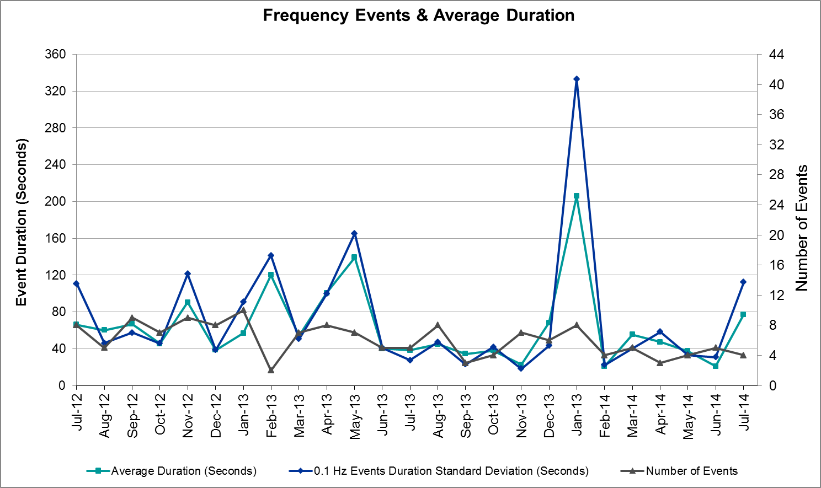

Responsive Reserve Events
There were five events where Responsive Reserve MWs were released to SCED in July. The events highlighted in blue were related to frequency events reported in section 2.1 above.

Date and Time  Released to SCED | Date and Time  Recalled | Duration of Event | Maximum MWs Released | Comments
7/1/14 10:12:24 | 7/1/14 10:14:48 | 0:02:24 | 120
7/17/14 17:55:44 | 7/17/14 18:00:52 | 0:05:08 | 555.7
7/21/14 16:53:52 | 7/21/14 16:56:57 | 0:03:05 | 150 | Unit trip with approximately 532 MW
7/23/14 20:09:30 | 7/23/14 20:16:06 | 0:06:36 | 1005.3
7/24/14 10:25:06 | 7/24/14 10:28:42 | 0:03:36 | 168.3

Load Resource Events
There were no load resource deployment events in July.

Reliability Unit Commitment
ERCOT reports on Reliability Unit Commitments (RUC) on a monthly basis. Commitments are reported grouped by operating day and weather zone. The total number of hours committed is the sum of the hours for all the units in the specified region. Additional information on RUC commitments can be found on the MIS secure site at Grid → Generation → Reliability Unit Commitment.

There were no DRUC commitments in July.

HRUC Commitments
Resource Location | # of Resources | Operating Day | Total # of Hours Committed | Total MWhs | Reason for commitment
South | 2 | 7/23/2014 | 11 | 437 | Local Congestion

Wind Generation as a Percent of Load

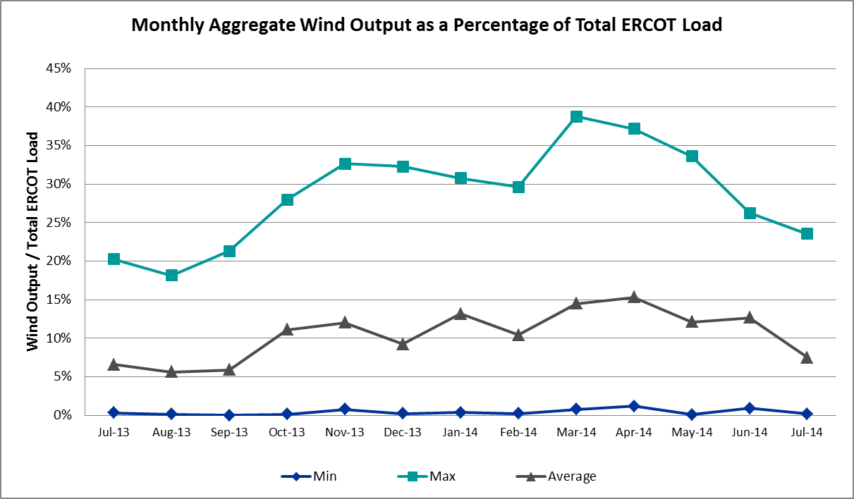

Congestion Analysis
The number of congestion events experienced by the ERCOT system increased in July since the weather was relatively hotter than in previous month. Also, more reportable congestion events were related to ongoing outages than in previous months. There was no activity on any of the GTLs in July.

Notable Constraints for July
Nodal protocol section 3.20 specifies that ERCOT shall identify transmission constraints that are active or binding three or more times within a calendar month. As part of this process, ERCOT reports congestion that meets this criterion to ROS. In addition ERCOT also highlights notable constraints that have an estimated congestion rent exceeding $1,000,000 for a calendar month. These constraints are detailed in the table below. Rows highlighted in blue indicate the congestion was affected by one or more outages. For a list of all constraints activated in SCED for the month of July, please see Appendix A at the end of this report.

Contingency | Overload | # of Days Constraint Active | Estimated Congestion Rent | Transmission Project
Salt Flat Road - Skywest 138 kV | Midland East - Buffalo 138 kV | 14 | $17,348,833 | 14TPIT0052
Salt Mine - Barber Lake Switch 138 kV | Midland East - Buffalo 138 kV | 3 | $2,282,526 | 14TPIT0052
Redwood - McCarty Lane 138kV | McCarty Lane - Ranch Road 12 138kV | 9 | $2,232,302
Orange Grove Switching Station - Lon Hill 138 kV | Lon Hill - Smith 69 kV | 17 | $2,049,363 | 16TPIT0026
Skywest - Spraberry Switch 138 kV | Midland East - Buffalo 138 kV | 2 | $1,772,560 | 14TPIT0052
Burleson AEN - Cardinal Lane 138kV | Manesium Plant - Northlan 138kV | 1 | $1,520,275 | 14TPIT0038
DCKT Singleton - Tomball 345 kV | Singleton - Zenith 345 kV (SNGZEN99) | 10 | $1,482,753 | TPIT Project 3937
Fort Lancaster - Illinois #4 138kV | Friend Rach - Ozona 69kV | 4 | $1,378,882 | 16TPIT0031, 16TPIT0032
Falcon Seaboard - Midland East 345 kV | Liquid Air - Odessa 138kV | 1 | $1,135,568 | 14TPIT0054
Laureles - La Palma 138kV | Los Fresnos - Loma Alta Substation 138kV | 1 | $1,128,119 | 16TPIT0029, 16TPIT0030
Laquinta - Lobo 138 kV | Bruni 138_69_1 138/69 kV | 19 | $956,329 | 13TPIT0158
Coyote Sharylan Utilities - Bulldog_SU 138kV | Midland East - Buffalo 138 kV | 5 | $846,858 | 14TPIT0052
McNeil Lcra - Gilleland 138 kV | Hutto Switch - Round Rock Northeast 138 kV (1661_B) | 9 | $760,177 | TPIT Project 3915
DCKT Gibbons Creek - Singleton 345 kV | Jewett - Singleton 345 kV (260_A) | 21 | $647,011 | TPIT Project 3937
Koch Up River - Gila 138 kV | Gila - Hiway 9 138 kV (GILA_HIWAY_2) | 26 | $507,354
Lobo - San Miguel 345_138 kV Switchyards 345 kV | Laquinta - Lobo 138 kV | 5 | $346,567 | 2013-R90, 2013-R100
DCKT MT Enterprise - Trinidad SES & Martin Lake SES - Stryker Creek SES 345kV | Nacogdoches SE - Herty North Switch 138kV | 3 | $235,899 | 12TPIT0078, 17TPIT0022
Salem LCRA AT4 345/138kV | Fayetteville 26AT2 345/138kV | 3 | $187,232
DCKT Gibbons Creek - Singleton 345 kV | Jewett - Singleton 345 kV (240_A) | 4 | $148,397 | TPIT Project 3937
DCKT Jewett - Singleton 345 kV | Twin Oak Switch - Btu_Jack_Creek 345 kV | 8 | $110,308 | TPIT Project 3937
DCKT Sandow Switch - Austrop 345kV | Gilleland - McNeil LCRA 138kV | 6 | $51,523 | 15TPIT0062, 08TPIT0033
Lobo - San Miguel 345_138 kV Switchyards 345 kV | San Diego - Freer 69kV | 3 | $22,318
Victoria - Coleto Creek 138 kV (COLETO_VICTOR1) | Victoria - Coleto Creek 138 kV (COLETO_VICTOR2) | 3 | $14,272 | 16TPIT0034
Gibbons Creek - Singleton 345 kV (SNGXGC75) | Gibbons Creek - Singleton 345 kV (SNGXGC99) | 6 | $12,049 | TPIT Project 3937

Generic Transmission Limit Congestion
There was no activity on any ERCOT GTLs in July.

Congestion Costs for Calendar Year 2014
The following table represents the top twenty active constraints for the calendar year to date based on the estimated congestion rent attributed to the congestion. ERCOT updates this list on a monthly basis.

Contingency | Binding Element | # of 5-min SCED Intervals | Estimated Congestion Rent | Transmission Project
Lytton Springs LY_AT2 345/138 kV | Lytton Springs LY_AT1 345/138 kV | 1,989 | $55,956,002
Skywest - Spraberry Switch 138 kV, Skywest - Salt Flat Road 138 kV, and Salt Mine - Barber Lake Switch 138 kV | Midland East - Pecan Grove 138 kV | 2,605 | $32,974,029 | 14TPIT0052
Midland East Axfmr 1 (3) 345/138 kV, Moss Switch Axfmr 1 345/138 kV, and Midland East - Moss Switch - Odessa Ehv Switch 345 kV | Odessa North Sd3 138 kV | 5,310 | $23,944,433 | 2012-R3, 2012-R4
Basecase | Valley Import | 495 | $11,577,259
Orange Grove Switching Station - Lon Hill 138 kV and Lon Hill 345_138_2 (3) 345/138 kV | Lon Hill - Smith 69 kV | 6,163 | $10,939,163 | 16TPIT0026, 2012-R18
DCKT Jewett - Singleton 345 kV | Twin Oak Switch - Gibbons Creek 345 kV | 273 | $10,912,808
DCKT Gabriel - Glasscock LCRA and Rivery 138 kV, Glasscock LCRA - Gabriel 138 kV, and DCKT Gabriel - Bell County - Hutto Switch 138 kV | Marshall Ford - Lago Vista 138 kV | 209 | $9,871,526 | 15TPIT0061
DCKT Paris Switch - Valley Ses and Valley South 345 kV | Paris Switch AXFMR1 (3) 345/138 kV | 1,442 | $9,291,357 | 14TPIT0093
DCKT Wa Parish - Jeanetta 345 kV | Smithers - Bellaire 345 kV | 1,058 | $7,870,155
Alice - Kingsville 138 kV, Kingsville - Lon Hill 138 kV, Nelson Sharpe - Lon Hill 345 kV | Lon Hill - Calallen Sub 69 kV | 912 | $7,699,219 | 12TPIT0181, 2012-R13
DCKT Flewellen - Obrien and Maso Road 138 kV, DCKT Singleton - Zenith 345 kV | Hockley - Betka 138 kV | 226 | $6,440,946
Sun Switch - Morgan Creek Ses 138 kV and Bluff Creek Switch - Ennis Creek Switch 138 kV | Snyder - Sacroc 138 kV | 509 | $6,283,276 | 09TPIT0120
Laquinta - Lobo 138 kV | Bruni 138_69_1 138/69 kV | 9,314 | $6,128,908 | 13TPIT0148
Stadium Aep - Alice 69 kV, Pawnee Switching Station - Lon Hill 345 kV, and Alice - Kingsville 138 kV | Lon Hill - Robstown Tap 69 kV | 904 | $6,091,279 | 12TPIT0180
Koch Up River - Gila 138 kV | Gila - Hiway 9 138 kV (GILA_HIWAY_2) | 15,858 | $5,016,426
Falcon Seaboard - Midland East 345 kV and Moss Switch - Odessa Ehv Switch 345 kV | Odessa - Odessa North 138 kV | 346 | $4,650,914 | 14TPIT0054
Coleto Creek - Pawnee Switching Station 345 kV, Pawnee Switching Station - Calaveras 345 kV | Coleto Creek - Kenedy Switch 138 kV | 405 | $4,490,198 | 16TPIT0034
DCKT Gibbons Creek - Singleton 345 kV | Jewett - Singleton 345 kV (260_A) | 4,172 | $4,407,609 | TPIT Project 3937
Moss Switch Axfmr 1 345/138 kV and Moss Switch - Odessa Ehv Switch 345 kV | General Tire Switch - Southwestern Portland Tap 138 kV | 1,388 | $4,182,082 | 15TPIT0097
DCKT Tonkawa Switch - Scurry County South Switch 345 kV | Bluff Creek Switch - Exxon Sharon Ridge 138 kV | 2,291 | $4,077,342

System Events

ERCOT Peak Load
The unofficial ERCOT peak load for the month of July was 63,500 MW and occurred on July 21 during the hour ending 17:00.

Load Shed Events
None

Stability Events
None

Notable PMU Events
ERCOT analyzes PMU data for any significant system disturbances that do not fall into the Frequency Events category reported in section 2.1. The results are summarized in this section once the analysis has been completed.

There are no events to report for July.

TRE/DOE Reportable Events
ERCOT experienced one reportable event this month. On July 23, one 345kV transmission line and two generators tripped. The total generation loss was 1,337 MW, but the time interval between first and second generator trips was more than one minute. System reliability was not impacted.

New/Updated RAPs and PCAPs
None

New/Modified/Removed SPS
None

New Procedures/Forms/Operating Bulletins
None

Emergency Conditions

OCNs
None

Advisories
Date and Time | Description
7/21/2014 16:23 | ERCOT issued an Advisory due to Physical Responsive Capability being below 3000 MW
7/22/2014 17:22 | Advisory issued due to ERCOT's Voltage Security Assessment Tool is currently unavailable.

Watches
None

Emergency Notices
None

Application Performance
ERCOT system applications performed well in July. There were no issues with Operations applications.

TSAT/VSAT Performance Issues
There was one issue in July related to VSAT due to one missing run during SE tuning.

Date and Time | Description
7/22/2014 17:22 | Advisory issued due to ERCOT's Voltage Security Assessment Tool is currently unavailable.

Communication Issues
None

Net-Forecast Bias Applied to NSRS Procurement for August 2014
Each month, ERCOT calculates a net Forecast Bias pursuant to the ERCOT Ancillary Services Methodology for procurement of Non-Spinning Reserve Service (NSRS). The table below indicates the amount of net Forecast Bias that was applied to the NSRS procurement for specified blocks of time for the month of August, 2014.

Blocks | Negative Net Load Forecast Average Error - By Weather Zone for the 5 Largest Zones
Blocks | Coast | East | North Central | South Central | Southern
1-2 | 0 | 0 | 0 | 0 | 0
3-6 | 0 | 0 | 0 | 0 | 0
7-10 | 0 | 0 | 0 | 0 | 0
11-14 | 0 | 0 | 0 | 0 | 0
15-18 | 0 | 0 | 0 | 0 | 0
19-22 | -15 | -2 | -18 | -9 | -5
23-24 | 0 | 0 | 0 | 0 | 0

Appendix A: Real-Time Constraints
The following is a complete list of constraints activated in SCED for the month of July. Full contingency descriptions can be found in the Standard Contingencies List located on the MIS secure site at Grid → Generation → Reliability Unit Commitment.

Contingency | Constrained Element | From Station | To Station | # of Days Constraint Active
SKOCNU28 | GILA_HIWAY_2_1 | GILA | HIWAY_9 | 26
DGIBSNG5 | 260_A_1 | JEWET | SNG | 21
SLAQLOB8 | BRUNI_69_1 | BRUNI | BRUNI | 19
SORNLON8 | LON_HI_SMITH1_1 | LON_HILL | SMITH | 17
SSALSK28 | 6146__A | MDLNE | BUFFALO | 14
DTB_SNG5 | SNGZEN99_A | SNG | ZEN | 10
SMCNGIL8 | 1661__B | HUTTO | RRNES | 9
SREDMCC8 | 102T375_1 | MCCALA | RNRD12 | 9
DJEWSNG5 | JK_TOKSW_1 | TOKSW | JK_CK | 8
DAUSSND5 | 211T147_1 | GILLCR | MCNEIL_ | 6
SGIBSNG5 | SNGXGC99_1 | GIBCRK | SNG | 6
SFAIBUL8 | 6146__A | MDLNE | BUFFALO | 5
SLOBSAN5 | LAQUIN_LOBO1_1 | LAQUINTA | LOBO | 5
DGIBSNG5 | 240__A | JEWET | SNG | 4
SILLFTL8 | FDR_OZN_1 | FRIEND_R | OZNA | 4
DENTSCS5 | 1170__A | NCDSE | HNRSW | 3
SCOLBRB8 | 6146__A | MDLNE | BUFFALO | 3
SLOBSAN5 | FREER_SAN_DI1_1 | SAN_DIEG | FREER | 3
SVICCO28 | COLETO_VICTOR2_1 | COLETO | VICTORIA | 3
XSAL258 | FAYETT_6AT2 | FAYETT | FAYETT | 3
DAUSSND5 | 1661__B | HUTTO | RRNES | 2
DSTPDOW5 | BLESSI_LAN_CT1_1 | BLESSING | LAN_CTY | 2
SGOLBRN8 | GOLDTH_9AT2 | GOLDTH | GOLDTH | 2
SRDODES8 | 940__C | ENWSW | WXHCH | 2
SSKYSBY8 | 6146__A | MDLNE | BUFFALO | 2
SSUNMGS8 | 6216__B | WLVSW | SHRNE | 2
XCDH58 | 6325__C | SHRSW | PRKRW | 2
XLOB58 | FREER_SAN_DI1_1 | SAN_DIEG | FREER | 2
XMOS258 | 6475__C | ODEHV | ODESA | 2
XSBY89 | 6620__A | STASW | MRCAP | 2
BASE CASE | CRANE_FMR1 | CRANE | CRANE | 1
BASE CASE | RIOHND_ERIOHND_1 | RIOHONDO | MV_RIOHO | 1
DAUSSND5 | 1661__A | RRNES | RNDRK | 1
DB_DAIR8 | NAVAL__N_PADR1_1 | NAVAL_BS | N_PADRE | 1
DBI_BI28 | BM_SR_81_A | BM | SR | 1
DFRAPAR8 | K2_P3_1 | SKYLINE | K2 | 1
DGABBEL8 | 1661__B | HUTTO | RRNES | 1
DHILELM5 | MAR_SKY_1 | MARION | SKYLINE | 1
DLHSCNR8 | 3650__A | LHSES | SATP1 | 1
DMARZOR5 | 293T304_1 | CIBOLO | SCHERT | 1
DRIOHAR5 | WES_MV_W_1 | WESLACO | MV_WESL4 | 1
DSTEXP12 | BLESSI_LOLITA1_1 | LOLITA | BLESSING | 1
DTRSENT5 | 1230__J | LFKSW | LFCML | 1
SADVGRO8 | CKT_979_1 | MAGPLANT | NORTHLAN | 1
SAVMBSP8 | 6251__A | MGSES | COSDN | 1
SBRAUVA8 | HAMILT_MAVERI1_1 | HAMILTON | MAVERICK | 1
SCARBU28 | CKT_979_1 | MAGPLANT | NORTHLAN | 1
SFLCMDL5 | 6510__A | GLNHV | CRM8T | 1
SFLCMDL5 | 6510__D | LIQAR | ODESA | 1
SGERCLE8 | 95T302_1 | MARION | CIBOLO | 1
SGLDSUN8 | ECRSW_FMR1 | ECRSW | ECRSW | 1
SHIWCIT8 | MORRIS_NUECES1_1 | NUECES_B | MORRIS | 1
SJMCW_D8 | POC_TEAS_1 | TEASLEY | POCKRUSC | 1
SJNSWNT8 | OLSEN_NAT1 | OLSEN | OLSEN | 1
SKENCH29 | POT_PLSN_1 | POTEETS | PLSNTOS | 1
SKEYWLV8 | 6216__B | WLVSW | SHRNE | 1
SKLELOY8 | LOYOLA_69_1 | LOYOLA | LOYOLA | 1
SL_FLA_8 | RIOHND_ERIOHND_1 | RIOHONDO | MV_RIOHO | 1
SLAQLOB8 | FALFUR_PREMON1_1 | FALFUR | PREMONT | 1
SLAULA_8 | LOMA_A_L_FRES1_1 | L_FRESNO | LOMA_ALT | 1
SLOBSAN5 | ASHERT_CATARI1_1 | ASHERTON | CATARINA | 1
SMGIENW8 | 943__A | ENWSW | ENSSW | 1
SSALFPP5 | FAYETT_6AT2 | FAYETT | FAYETT | 1
SSTELO29 | SINTON_SKIDMO1_1 | SINTON | SKIDMORE | 1
XASP89 | MUNDAY_MUNDAY1_1 | MUNDAYST | MUNDAYR2 | 1
XESK89 | ABNW_ELYT1_1 | ABNW | ELYT | 1
XLOB58 | ASHERT_CATARI1_1 | ASHERTON | CATARINA | 1
XLOB58 | PALDRO_PEARSAL_1 | PEARSALL | PALODURO | 1
XNED258 | WES_MV_W_1 | WESLACO | MV_WESL4 | 1
XSAN58 | PAWNEE_XF1 | PAWNEE | PAWNEE | 1
XSNY89 | ECRSW_FMR1 | ECRSW | ECRSW | 1
XVE2R89 | 6845__A | LKWSW | HOLDY | 1
XVE2R89 | 6850__B | NVKSW | ARCTY | 1
XWL2V58 | 3130__B | INDST | CMPST | 1

