VRTF Final Report to ROS

Executive Summary
Four utilities participated in testing the ability of voltage reduction to reduce system demand in the ERCOT interconnection. The following list highlights key interim findings of the Voltage Reduction Task Force.
- For the designated areas, independently chosen by each utility, included in voltage reduction testing, a 1% to 2% average demand reduction was observed during the test periods.
- Tests indicated that for every 1% drop in substation bus voltage an average of 0.6-1.0% drop in demand was observed.
- Results were similar to what has been observed in areas outside of ERCOT (e.g. New York ISO, New England ISO, Midwest ISO, PJM RTO, and Independent Electricity System Operator “Ontario”).
- Advancements in substation regulation controls and the installation of Advanced Metering Systems have the potential to improve voltage reduction programs.
- The availability of a deployed control system enables the remote implementation of voltage reduction schemes on a large scale within 5 to 15 minutes.
- The efficiency of voltage reduction is dependent upon circuit topography, load characteristics and system design.
- No adverse customer impact was reported as a result of the voltage reduction testing (circuits deemed to have adverse customer impacts were excluded from testing).

Introduction
The Voltage Reduction Task Force (VRTF) studied the practicality of voltage reduction as a mechanism to reduce system demand in the ERCOT interconnection during Energy Emergency Alerts (EEA). The Transmission Service Providers (TSPs) and Distribution Service Providers (DSPs) involved in the VRTF performed tests in an effort to assess and quantify the impact of voltage reduction on system demand. This interim report presents the information and findings of the utilities involved in voltage reduction testing through the winter of 2014.
This report does not provide analysis on nor attempt to explain the behavior of different types of load across a range of voltage levels. Instead, this report provides empirical data on the effect of a voltage reduction program, implemented across a wide area, on aggregate system load.
This report will discuss the following topics:
- A brief overview of voltage reduction
- A brief over view of control systems for implementing voltage reduction
- Industry experience with voltage reduction
- Historical experience with voltage reduction within ERCOT
- Quantifying methodology used to validate the effectiveness of voltage reduction
- Results from summer and winter testing of voltage reduction from VRTF participants
- A report from the Dynamics Working Group (DWG) related to voltage reduction

Voltage Reduction Overview
Voltage reduction (VR), as it currently exists in ERCOT, is a voluntary effort to reduce system demand, in response to a temporary decrease in available electricity supply, by systematically lowering the operating voltage on the distribution system. Voltage reduction is performed at ERCOT’s instruction during Energy Emergency Alert (EEA) Level 2 if deemed beneficial by the TSP, DSP, or their agents.
Voltage reduction can be applied as a strategy to address generation capacity emergencies (EEA events), to reduce demand.
It is important to note that during normal operating conditions, the voltage at the customer’s point of delivery must be maintained at 120V (+/-5%) per ANSI Standard C84.1.
EEA Events
During EEA events, voltage reduction is one of many options available to reduce system demand to maintain system frequency within an acceptable range and maintain adequate Physical Responsive Capability (PRC). It can be utilized as an additional strategy to avoid entering EEA Level 3, where shedding firm demand is required. If ERCOT does enter EEA Level 3, the utilization of voltage reduction could have the effect of offsetting demand which would otherwise be shed.
When applied in this manner, voltage reduction provides a mechanism to maintain system reliability. It currently exists in a small portion of ERCOT for this function.

Control Systems and Operational Options for Implementing Voltage Reduction
Voltage reduction is accomplished through the utilization of substation transformer load tap changers (LTCs) or substation regulators to reduce voltage at the substation’s distribution bus. This has minimal effect on the high side voltage of the transformer, and reduces the system VAR requirements.
Any large scale implementation of voltage reduction utilizing the manual operation of LTCs or regulators by field personnel is impractical due to excessive response times and the large number of personnel necessary to achieve even a minimal impact on demand. However, voltage reduction implemented through remote capabilities is viable. During the tests performed by VRTF utilities, two companies had the ability to reduce voltage remotely on some of their LTCs and regulators. The other two companies performed voltage reduction manually.
LTCs and regulators have control devices which measure voltage at the distribution bus and adjust the tap position to maintain voltage within a pre-specified bandwidth.
Historically, voltage reduction lacked efficiency due to the limited capabilities of the LTC controller and the lack of visibility into real-time distribution circuit and consumer point of service voltages. In many cases, the voltage input to the controller is artificially raised to “trick” the controller. This approach is inefficient because the potential benefit is diminished by the controller’s bandwidth. Newer LTC controls have a conservation voltage reduction mode which reduces the bandwidth to ensure that the LTC tap position is as close to the desired position as possible. These types of controls also reduce “lingering tap position” effects when resuming normal operation. The lack of visibility into real-time distribution circuit and consumer point of service voltages leads to more conservative reduction targets which do not capture the full potential benefit of voltage reduction.
Summarizing the above, two general options are:
- Using remotely controlled circuitry, the voltage can be reduced to a pre-determined value based on calculated system demand. The newer and more advanced LTC controllers will have to be utilized. This option has a lower cost but provides no visibility into the feeder lowest voltage points. This type of application is basic, and while it will provide demand savings at a lower cost, it will not optimize the voltage set points if set too conservatively. Conversely, it will not provide knowledge of low voltage points on the feeder if not set/operated conservatively.
- The voltage can be reduced to a level supported by real-time voltage values from Advanced Metering Systems (AMS) or other “consumer point of service” voltage monitoring technologies. The utilization of “consumer point of service” voltage monitoring provides the ability to maximize voltage reduction regardless of loading conditions. This option has a higher cost, but will ensure better harvesting of demand savings, knowledge of feeder voltages, and voltage optimization opportunities.
Advancements in LTC controller technology, remote system control capabilities, consumer point of service monitoring technology, modeling, monitoring and tracking tools help improve efficiency of voltage reduction.

Industry Experience with Voltage Reduction
The utilization of voltage reduction for lowering end-use demand exists today in both the U.S. and Canada. It has been implemented in combination with other smart grid applications to flatten the voltage profile along distribution lines and used to address shortages in resource capacity. Generally, areas outside of ERCOT see a 0.7% reduction in demand for every 1% reduction in voltage and limit the voltage reduction to 5%.
Nationally, harvesting the benefits of voltage reduction has improved due to better LTC controls, improved capabilities of monitoring the voltage along the distribution feeder, and the ability to flatten the voltage profile along distribution feeders using various distribution system components (e.g. capacitors, regulators, et. al.). The list of Independent System Operators (ISOs) in North America who utilize voltage reduction includes New York ISO, New England ISO, Midwest ISO, PJM RTO, and Independent Electricity System Operator (Ontario). Voltage reduction has been utilized by many utilities for various purposes.
Information on the policies of other regions regarding use of voltage reduction is outside the scope of VRTF, and therefore has not been included in this report.

Historical Experience within ERCOT
The following section contains reports from the four companies which participated in voltage reduction testing. The list of companies consists of Oncor Electric Delivery, Guadalupe Valley Electric Cooperative, CenterPoint Energy, and American Electric Power. They have provided both the methodology used to implement VR and the results from their testing.
Oncor Electric Delivery
This section of the report will describe the distribution of VR capable substations across the Oncor system, the method of VR implementation utilized at Oncor, and the potential obstacles to VR implementation.
VR Implementation
As detailed earlier in this report, VR is implemented at the request of ERCOT when the responsive reserve margin drops below 1,750MW. Once ERCOT declares an EEA Level 2, an ERCOT operator will contact the Oncor Transmission Grid Management (TGM) control room and request that VR be implemented. The control room operator will then open the VR display in the Transmission Management System (TMS) and verify that the distribution bus voltage for each VR transformer is within the appropriate limits.
The control room operator will then initiate VR in the TMS via SCADA command for each VR transformer within the appropriate bus voltage range. At the substation, the SCADA command is received and the VR circuit “tricks” the LTC into thinking the voltage is 2.5% or 5% higher than it actually is; this causes the LTC to step down and lower the bus voltage in order to get back into its set bandwidth. Because the voltage at the distribution bus is lowered, every feeder tied to that bus will have its voltage reduced. This process is repeated to raise the voltage back to normal operating levels once ERCOT declares the system to no longer be in EEA Level 2. This scheme suffers the two main deficiencies outlined earlier in the report due to LTC/regulator bandwidth and lack of voltage visibility into the feeder. Additionally, only about 20% of the “voltage reduction-capable” system is equipped with this remote circuit. This means that this can be done on many LTCs/regulators that do not have this type of communication available to them. However, even with the deficiencies above, ONCOR noticed a combined 1.67% (approximate) reduction in MW load when the above scheme is implemented during summer peak conditions (on the tested LTCs).
Guadalupe Valley Electric Cooperative (GVEC)
During the late 1980’s and early 1990’s, GVEC operated a system wide demand side management program which was SCADA operated using a power line carrier communications system. Using power line carrier technology, GVEC operated demand side management switches at the consumer level. AC and heating devices in the homes were cycled by commands send from a local SCADA control center. Residential water heaters were also turned off during peaking conditions. Customers received a monthly credit on their power bill for allowing the load control switches to be installed on heating/AC units and water heaters.
GVEC also operated a substation and distribution feeder voltage reduction program operated from the SCADA control center. Commands were sent from SCADA control to turn off down line distribution regulators by power line carrier, to basically freeze them at whatever position they were operating in before voltage reduction was implemented at the substation level. Then the SCADA control center would send a command to substation regulators and power transformer LTC’s to operate at a predetermined lower voltage level. This process would effectively lower the voltage profile over an entire circuit.
A lot of pre-engineering and evaluation took place before this system was implemented to ensure the end user maintained adequate voltage. A voltage level of 114 volts was maintained at the secondary side of distribution transformers to maintain 110 volts at the end line customer’s utilization point. Voltage reduction levels at the substation feeder level ranged from 1.5 to 3 percent reduction depending on the limiting parameters of each distribution circuit.
Do to wholesale power rate changes in ERCOT and changes in GVEC’s SCADA computer system, the power line carrier demand side management system was abandoned during the late 1990’s.
GVEC substation level voltage reduction system continues provides a way to reduce GVEC’s distribution system load by 1 to 3 percent and can be implemented within five minutes. The SCADA operation of substation level voltage reduction is maintained and was utilized during EEA events in the past.
AEP Texas
An AEP Texas study done in the 1990’s showed different results between urban and rural circuits and any benefit disappeared over a period of time. Based on the previous study AEP Texas has not invested in the voltage reduction technology.
CenterPoint Energy
CenterPoint Energy (CNP) was asked by ERCOT to reduce demand by voltage reduction (TRVR) twice in the past 7 years: once on April 17, 2006 and once on February 26th, 2008. For both those instances, TRVR was remotely activated via SCADA by the System Operator on a per substation basis. The Operator had the choice of selecting steps of 2.5% for a total reduction of up to 5%.
For the 2006 event, CNP executed TRVR at 14 stations or a total of 40 transformers. Omitting transformers for which bad data was obtained; voltage reduction was executed on 37 transformers. TRVR was executed concurrent with load shed. During the tap operation period, an 11.7 MW reduction or 1.38% was realized. After fifteen minutes, the demand reduction had been reduced to 0.97%.
For the 2008 event, CNP executed TRVR at 13 stations for a total of 32 transformers. Omitting transformers for which bad data was obtained; voltage reduction was executed on 25 transformers. Total elapsed time from the first to last TRVR transformer tap operation was seven minutes. During the tap operation period, a 12.1 MW reduction or 2.6% was realized. However, the system demand was on a downward trend which was acting in concert with the voltage reduction efforts. A review of the data showed that demand had increased to close to its post reduction minimum after thirty five minutes.
CNP and the Electric Power Research Institute (EPRI) performed a study in which they concluded that small single-phase motor loads (i.e. A/C compressors) did not respond well to the effects of reduced voltage and that during summer peak conditions, TRVR would not be as effective due to the high percentage of air conditioning load. There was also evidence that new types of power electronic loads such as HDTV’s experienced increase power consumption as voltage is reduced.
Based on this study, and on previous deployment results, CNP discontinued the use of TRVR in August 2011.

Quantifying Voltage Reduction Benefit
Consideration was given to two methods of quantifying the voltage reduction test results.
The first method is based on the comparison of the daily demand curve from the voltage reduction test day to a demand curve from a “similar day”. The difference between the two curves is used to generate a percentage of demand reduction. The similar day method requires identifying three consecutive days with similar demand profiles. The first and third days are used to create a baseline demand profile which is then compared to the second day’s demand profile where voltage reduction testing was performed. Consistency issues between the similar days and the voltage reduction testing day were found among VRTF participants attempting to utilize this method.
The second method is based on measuring the initial demand reduction at the beginning of the test period and the demand increase at the end of the test period against corresponding projected demand curves. The percentage reduction in demand over the test period is then calculated as the average of the two values.
A Conservation Voltage Reduction (CVR) factor is also calculated to indicate the amount of demand reduction observed per percent change in voltage. This is a dynamic factor, dependent on various demand influences (e.g. load characteristics, weather, feeder voltage profile, et. al.). The CVR factors calculated from testing are illustrative of such load influences at the time of testing.
The VRTF choose to utilize the second method for quantifying voltage reduction test results because it simplified calculations. This method is illustrated in Figure 1 below.

Figure 1: Recommended VR Quantification Methodology
Time
P
System Load
P₁
•
•
•
•
•
P₂ʹ
P₂
P₃
P₄
P₄ʹ
Initiation
Reset
ΔP_{init}
ΔP_{reset}
•
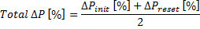

Test Results
The four VRTF participants performed voltage reduction testing during the summer months in alignment with the Testing Protocol and Testing Q&A documents produced by VRTF. Each participating company also performed a winter test in alignment with the aforementioned testing documents. These documents are available under ERCOT’s public website as key documents from VRTF’s April meeting. Testing results from the participants are provided below.
Oncor Electric Delivery
Summer testing
Total % = 3% for a 5% voltage reduction. CVR factor >0.6
Winter testing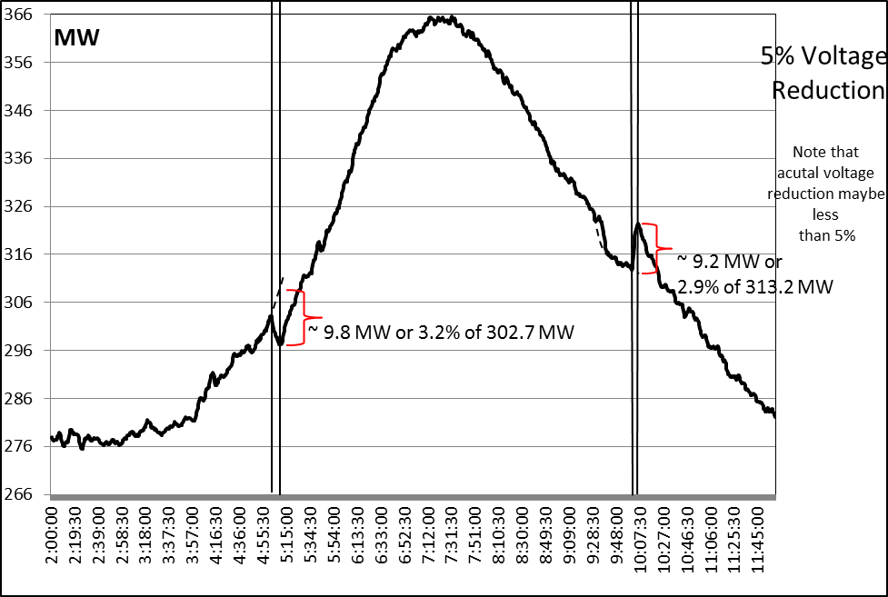
Total % = 3.05% for a 5% voltage reduction. CVR factor >0.6

AEP Texas
Summer testing
Total % = 2.9% for a 3.5% voltage reduction. CVR factor ≈0.8

Winter testing
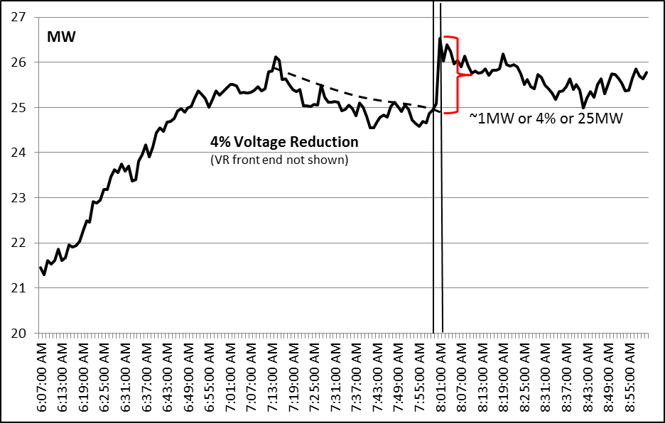
Total % = 4% for a 4% voltage reduction. CVR factor ≈1

Guadalupe Valley Electric Cooperative (GVEC)
Summer testing
155.0
160.0
165.0
170.0
175.0
180.0
185.0
190.0
8:00
8:10
8:20
8:30
8:40
8:50
9:00
9:10
9:20
9:30
9:40
9:50
10:00
10:10
10:20
10:30
10:40
10:50
11:00
11:10
11:20
11:30
11:40
11:50
12:00
12:10
12:20
12:30
12:40
12:50
13:00
MW
~3.3MW
or 2.1% of 160.7MW
~2.5MW
or 1.5% of 168MW
3% Voltage
Reduction*
*
Actual voltage
reduction a mix of
1.5% and 3%
Total % = 1.8% for a mix of 1.5% and 3% voltage reduction. CVR factor >0.6

Winter testing
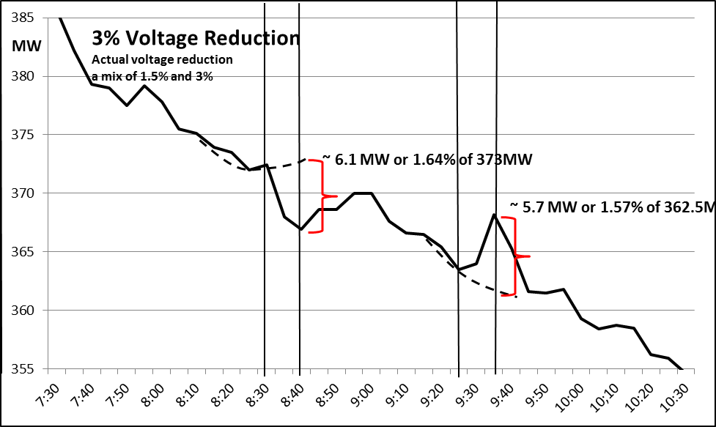
Total % = 1.6% for a mix of 1.5% and 3% voltage reduction. CVR factor >0.5

CenterPoint Energy
Summer testing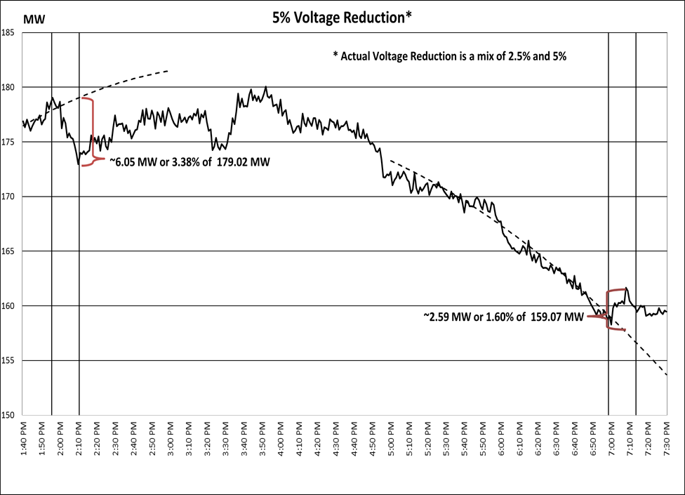
Total % = 2.49% for a 4.30% voltage reduction. CVR factor ≈0.58

Winter testing
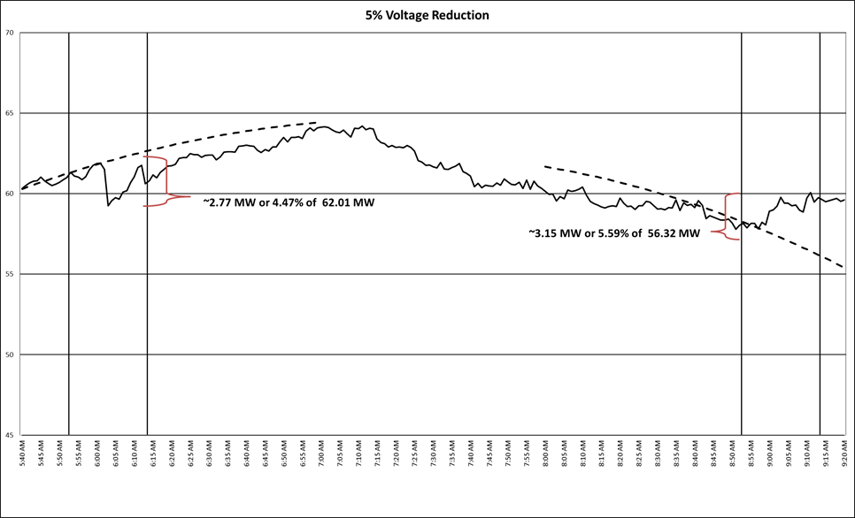Total % = 5.17% for a 5.07% voltage reduction. CVR factor ≈1.02

Report from DWG
DWG was tasked to perform a stability simulation study to determine the effects of voltage reduction on motor stalling. Pflugerville was selected as the location of focus because of the availability of data at that location.
Motor stall is a phenomenon that occurs at lower voltages. While VR (Voltage Reduction) itself would not be enough to cause motor stall, there was a concern that VR might have the potential to make motor stall more likely following a fault because of the reduced initial voltage. In order to access this risk, DWG was asked to perform a study.
The study studied several different scenarios. Three types of faults were performed: three phase normally cleared fault on nearby kV auto-transformer, three phase normally cleared fault on nearby 138 kV line, single line to ground fault with delayed 15 cycle clearing on nearby 138 kV line. In addition, several sensitivities were run during the study including: types of motor load, amount of motor load, level of VR, distribution capacitor banks enabled or disabled, and initial starting voltage on the low side of the feeder. Field Trials only used 2.5 % and 5% VR. 7.5% and 10% were studied to determine a margin level. Stall only occurred under severe conditions when a combination of a large load composed entirely of air conditioner was subjected to a three phase normally cleared fault during a period where a high level (7.5% -10%) of VR is applied.
Based on this study, DWG concludes that 2.5% and 5% VR would not result in motor stalling and there is a reasonable level of margin at the 2.5 % and 5% VR level. DWG notes that the study was done on a strong (high short circuit ratio) area. Weak areas (low short circuit ratio) may be more sensitive to changes in voltage. These areas would require a screening study to verify that the location is suitable as a VR site.

Extrapolating Results
Based on testing performed by the four VRTF participants mentioned above, VRTF has consistently seen a 1-2% reduction in system load (or a 0.6-1% CVR factor) for the areas where voltage reduction was performed. It is important to note that some distribution loads cannot participate in VR due to not having an LTC or regulator, or due to exclusion (requires circuit sensitivity).
Extrapolating results to a wide scale system requires making wide-ranging assumptions. Therefore, a couple of examples are provided:
- Assuming a 65GW load during an EEA2, with only 75% of distribution load capable of reducing voltage by 5%, and a minimum CVR factor of 0.8, then demand reduction would be
65,000MW*75%*5%*0.8 = 1950 MW
- On the other hand, Assuming a 40GW load during an EEA2, with only 75% of distribution load capable of reducing voltage by 3%, and a minimum CVR factor of 0.6, then demand reduction would be
40,000MW*75%*3%*0.6 = 540 MW
It is evident that a thorough evaluation is needed from each VR participant to create a better estimate of the distribution load capable of reducing voltage (equipped with an LTC or regulators) and an estimate or range of the applicable CVR factor.

Conclusion
This final VRTF report represents summer and winter voltage reduction results observed by the four utilities that performed testing. The VRTF has studied the feasibility of voltage reduction in the ERCOT system and coordinated testing across multiple entities. While VRTF testing was performed on a limited scale, results have shown that voltage reduction is one of many options available to reduce demand. A 0.6-1% reduction in system demand for every 1% voltage reduction has been consistently observed during the voltage reduction testing represented in this report. These results are similar to those observed by entities outside of ERCOT.
Factors such as feeder length, distribution planning criteria, voltage control scheme, load characteristics, individual customer sensitivity, availability of LTCs or substation regulators, and the capability to remotely initiate voltage reduction all affect the level of load eligible for voltage reduction consideration. These factors impact each utility differently. If voltage reduction is able to consistently achieve measurable and verifiable results, it has the potential to reduce the amount of demand shed during an EEA Level 3 event and potentially avoid EEA Level 3 altogether. VRTF completed addressing all of its scope items and recommends the dismantling of the task force unless the scope is revised to add any additional items.

