Meeting Minutes
Market Information System Users Group (MISUG) Meeting
ERCOT Austin – 7620 Metro Center Drive – Austin, Texas 78744
Tuesday, July 15, 2014 – 9:00 - 11:30 AM

Attendees:
Mike Juricek, Oncor
Julie Thomas, Luminant (Vice Chair)
Debbie McKeever, Oncor
Griselda Calzada AEP
Kaci Jacobs, TXUE (WebEx)
Carolyn Reed, Centerpoint
Jamie Lavas, ERCOT (WebEx)
Clayton Greer, Morgan Stanley (WebEx)

Antitrust Admonition, delivered by Julie Thomas

2014 Leadership

Debbie McKeever nominated Julie Thomas as Chair to replace Eric Goff; seconded by Kaci Jacobs. Julie accepted the nomination and was elected by acclamation.
Julie Thomas nominated Kaci Jacobs as Vice Chair; seconded by Mike Juracek. Kaci accepted the nomination and was elected by acclamation.

Reports to be Discontinued

Jamie Lavas reported on the download frequency over the last 12 months for the reports listed below. In many cases, the count was low enough that it could be attributed to ERCOT personnel and members of MISUG.

The following table reflects the recommendations of MISUG for reports proposed for discontinuation. The recommendation was made by Mike Juracek to ensure that our recommendations are communicated out through the rest of the Stakeholder groups to solicit feedback, avoid surprising anyone with an NPRR, and let the other Stakeholder groups know that MISUG is active again.

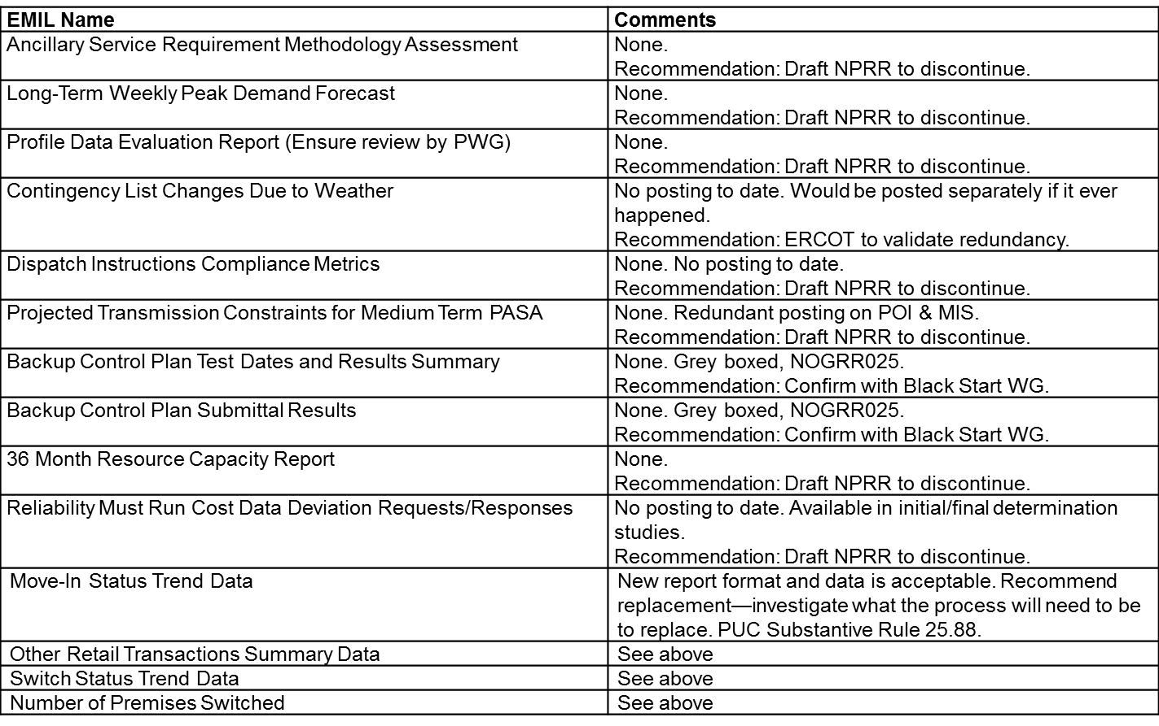

NOGRR084 – Daily Grid Operations Report

Jamie Lavas reported that ERCOT Operations has identified additional information that would be helpful to include in the report. Based on the amount of time that has elapsed and market changes that have been implemented since NOGRR084 was passed, MISUG would like to revisit the information to include in the report. MISUG will hold a workshop on the data and format of the Daily Grid Operations Report on August 27, 2014, at 9:30 AM. Julie Thomas will work with Jamie Lavas to make sure that the workshop and materials are socialized through other subcommittees and working groups.

MIS Reports Review

The following reports were reviewed prior to this meeting:

48 Hour Ancillary Services Reports (13057)

Recommendation: Description in EMIL should be corrected.
For Discussion: Data appears to be organized as an offer stack, rather than a curve. Would this confuse new users? The recommendation from MISUG was to include a review of the column headings in the 48-Hour Disclosure Reports User Guide and expand the User Guide as necessary to explain the data better.
For Validation: On 7/9/2014 there were no RRS offers on Controllable Loads offered into DAM. ERCOT agreed to validate that there should have been no data for that date.
Recommendation: In Aggregated Offers for RRS on Non-Controllable Loads report data should be sorted by Delivery Date, Hour Ending, and MW Offered.
For Discussion: Should the data in the Cleared RRS on Loads report be separated based on controllable and non-controllable loads?
For Discussion: In SAAS-RegDn and RegUp report, there are negative MW values. What do these values represent? Jamis Lavas asked that she could make sure that an SME from the ERCOT reports team would be at MISUG to answer questions if she knew which reports were going to be discussed. We agreed that would be a good idea.

48 Hour Highest Price AS Offer Selected (13018)

Discussion: Report definition references the “entity submitting the offer”; the report contains the resource name. Should the report be corrected or amended to meet the language of PUC Substantive Rule §25.505? Is was agreed that changes to the substantive rule were unlikely, so the entity ought to be added to the report.
Recommendation: Sort Data by Hour Ending, AS Type, and Resource Name. As it stands, it is only sorted by Hour Ending and Resource Name.

48 Hour Highest Price Offered in SCED (13029)

Discussion: Report definition references the “entity submitting the offer”; the report contains the resource name. Should the report be corrected or amended to meet the language of Protocol NP3.2.5(6)? Entity will be added.
Recommendation: Remove Batch ID from the report.

It was also recommended that future meetings to review the reports use a WebEx.

New Business

Jamie Lavas presented on the status of the decommissioning of the Planning (POI) website. Information will be archived or moved to the MIS, as appropriate. ERCOT will make available a mapping of the existing information and where it will end up.

Jamie also communicated that work will soon start on SCR 775 (Dashboard display for LZ Indicative LMPs). MISUG agreed to serve as the forum for the development and feedback for this project. We will ensure that other stakeholders groups as well as the sponsors for the SCR are informed as to when it will be on the agenda for MISUG.

Next MISUG Meeting

Next meeting August 27, 2014, 9:30-3:30.. Workshop 9:30. General meeting immediately following. Send out notification to COPS, PRS, ROS, WMS via their exploder lists.

Action Items:

Slide for COPS. Include heads-up for report decommissioning – Julie Thomas
Corrections to Market Reports – Julie Thomas will provide list to Jamie Lavas
Review 48-hour report column headings – Add to scope of MIS Reports Review
Socialize NOGRR084 with WMS and ROS – Julie Thomas will work with Stakeholder Services

