 |  |  |  | System Planning
Monthly Status Report
June 2014

 |  | Report Highlights
 | - ERCOT is currently tracking 230 active generation interconnection requests totaling over 60,400 MW. This includes over 25,400 MW of wind generation.
- ERCOT is currently reviewing proposed transmission improvements with a total cost of $490.4 Million.
- Transmission Projects endorsed in 2014 total $691.1 Million.
- All projects (in engineering, routing, licensing and construction) total approximately $4.98 Billion.
- Transmission Projects energized in 2014 total about $438.2 Million.

Table of Contents

1. Generation Interconnection 1
2. Regional Planning Group Project Reviews 1
3. Asynchronous Tie Interconnection 2
4. Planning Model Activities 3
5. Other Notable Activities 3

1. Generation Interconnection
Generator interconnection information has been moved to the Generator Interconnection Status (GIS) Report to be published monthly starting with May 2014 report under the Grid Information / Resource Adequacy section of the ercot.com website. Please see the exact web link below.
http://www.ercot.com/gridinfo/resource/index

Additional information regarding detailed generation interconnection and impact studies is contained in the “Generation Project Interconnection Information” folder in the “Operations and System Planning” area on the ERCOT website: http://planning.ercot.com/login/login.

Regional Planning Group Project Reviews
- Oncor has submitted the West Texas Area project. This is a Tier 2 project that is estimated to cost $45 million. This project is currently under ERCOT independent review.

- Sharyland has submitted the Brady Area project. This is a Tier 2 project that is estimated to cost $18 million. This project is currently under ERCOT independent review.

- Sharyland has submitted the West Texas projects for Stanton Area. This is a Tier 3 project that is estimated to cost $40.4 million. This project is currently under ERCOT independent review.

- AEPSC has submitted the Brady Area Improvements project. This is a Tier 2 project that is estimated to cost $26.5 million. This project is currently under ERCOT independent review.

- Denton Municipal Electric (DME), Oncor, TMPA, Brazos Electric Cooperative (BEC) and GP&L have jointly submitted the Denton Area West 345/138 kV source project. This is a Tier 2 project that is estimated to cost $44.8 million. This project is currently under ERCOT independent review.

- Duke-American Transmission Company has submitted the Phoenix project. This is a Tier 2 project that is estimated to cost $39 million. This project has received several RPG comments and it is under study mode.

- CPS Energy has submitted the Howard Road - Somerset 138 kV upgrade project. This is a Tier 2 project that is estimated to cost $18.3 million. This project is currently under ERCOT independent review.

- CPS Energy and LCRA Transmission Services Corporation (TSC) have jointly submitted the Transmission System Additions project to address the reliability needs in the northeast San Antonio area. This is a Tier 1 project that is estimated to cost $237.3 million. This project has been submitted for RPG comments.

- CenterPoint Energy has submitted the Jones Creek project. This is a Tier 1 project that is estimated to cost $79.8 million. This project has been submitted for RPG comments.

Asynchronous Tie Interconnection
Project | Notification to ERCOT | Reliability Study | RPG Review | Interconnection Agreement | In-service Year
Railroad DC tie expansion (150 MW - CFE) |  |  |  |  | 2014
Southern Cross HVDC (3000 MW - SERC)
Tres Amigas (1500 MW - SPP)

Color Legend
In progress
Complete

Planning Model Activities
- The short term calendar of major planning model events follows:
  - Jun 20, 2014 15DSA and 14 DSB update completed and posted.
  - Jun 20, 2014 June MODTPIT completed and posted.
  - Jul 11, 2014 Projected posting of Contingency Definitions
  - Jul 23, 2014 Start 15DSB case build
- ERCOT has created a tracking sheet to help identify interconnection projects that have met Planning Guides Section 6.9 since many Market Participants do not have access to the modeling data submitted by Interconnecting Entities. The assumption has been made that those entities meeting section 6.9 (1) meet the requirements to be added to the planning models. However, section 6.9 (2) also has to be met for the interconnection project to be added to the planning models.
- The following interconnection projects met Planning Guide section 6.9 (1) and were either modeled or not modeled based on submitted RARF data in accordance with Planning Guide section 6.9 (2). A non-null value in the Project ID column signifies that the project was modeled and a null value means it was not modeled. The Notes column may provide further explanation.
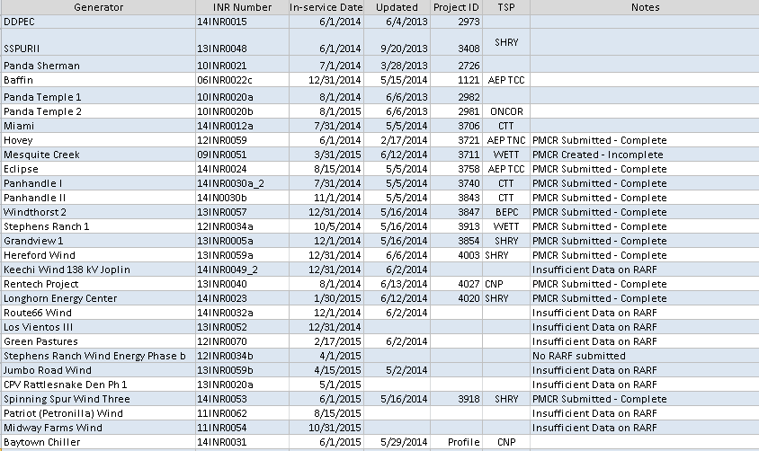

Other Notable Activities

- The System Protection Working Group 2014 Future Year (FY) base case creation has been completed.
- ERCOT’s reliability analysis of the 2014 Regional Transmission Plan (RTP) is underway. The initial N-1 SCOPF reliability analysis is complete. The generation and transformer outage screening studies are in progress.
- ERCOT's 2014 Long Term System Assessment (LTSA) study is in progress. ERCOT staff presented the results for the generation expansion plan build-out for the High Economic Growth and Stringent Environmental scenarios at the June Regional Planning Group (RPG) meeting. ERCOT staff continues to gather input data and develop generation expansion plans for remaining scenarios.
- ERCOT is planning on conducting a West-North stability limit assessment. This will be a joint study between ERCOT System Planning and Operations.
- ERCOT is planning on performing a review of the ERCOT responsive reserve requirements taking into account the new BAL-003 standard.

