MarkeTrak Users Guide
Section 1: General Section

Table of Contents

MarkeTrak Users Guide 1
1.1 MarkeTrak General Overview 3
1.1.1 Background 3
1.1.2 Digital Certificates 3
1.2.1 User Authentication Process via Market Information System (MIS) 3
1.2.2 User Authentication Process directly to MarkeTrak 3
1.2 MarkeTrak Starting Points 4
1.2.1 Launch Page 4
1.2.2 Using the Submit Pane 4
1.2.3 Home Page 4
1.2.4 My Favorites Pane 4
1.3 Full MarkeTrak Interface Overview 5
1.3.1 Interface Page 5
1.3.2 MarkeTrak Toolbar 5
1.3.4 Screen Layout 12
1.4 MarkeTrak General Issues 13
1.4.1 States and Transitions 13
1.4.2 Issue Visibility 14
1.4.3 Transition Ability 14
1.4.4 Issue Ownership Model 16
1.4.5 Workflow Principals 17
1.5 MarkeTrak Searching and Reporting 18
1.5.1 Internet Explorer Configuration Changes 18
1.5.2 Searching 20
1.5.3 Reporting+ 21
1.6 MarkeTrak Excel Format View 36
1.7 MarkeTrak Rolodex 37
1.8 MarkeTrak Issue Grouping 42
1.8.1 Grouping 42
1.9 MarkeTrak Miscellaneous 45
1.9.1 Auto Close Function 45
1.9.2 Notifications 45
1.9.3 Duplicate Checking 47
1.9.4 ERCOT Registration System Validation 48
1.9.5 Siebel Status and Sub Status 51
1.9.6 Item Lock 52
1.9.7 Auto Logoff 53
1.9.8 Issue Archiving 53
1.10 Day to Day (D2D) Issues 54
1.10.1 What Constitutes a MarkeTrak D2D Issue? 54
1.10.2 Day to Day Issue Guidelines 55
1.10.3 Day to Day Issues Required Fields 55

- MarkeTrak General Overview

Background

The MarkeTrak tool is a web based database application used to track, manage, and store data utilized by ERCOT and the Market Participants (MPs). This tool is the supported method to track ERCOT Retail market issue management and data discrepancies in the market.

The high level objectives for MarkeTrak:
- Improve reporting functionality
- Improve tracking/metrics functionality
- Create usable issue status
- Create usable issue types and sub types
- Create a method to allow users to interface the solution
- Improve search functionality
- Improve monitoring and response capabilities
- Improve the usability
- Provide all functionality that is deemed required with the legacy tool as part of the enhanced solution.

Digital Certificates

Digital Certificates identify each user to ERCOT by associating a secured identity with a MarkeTrak user. Digital Certificates are used to secure private information from Market Participants. Digital Certificates provide a “digital signature” that tells the recipient that the information actually came from the sender and has not been forged or tampered with. Without a Digital Certificate, the MarkeTrak system cannot be accessed. Digital Certificates must be renewed each year. Also a Digital Certificate is required for the API process.

User Authentication Process via Market Information System (MIS)

A MarkeTrak user attempting to access MarkeTrak via MIS should use the following steps:

- Siteminder intercepts the request and asks user for Digital Certificate
- User then selects Digital Certificate
- Siteminder takes Digital Certificate and validates it and verifies the credentials
- If Client certificate is valid individual user is logged into the MarkeTrak application.

User Authentication Process directly to MarkeTrak

A MarkeTrak user attempting to access MarkeTrak directly should use the following steps:

- Individual user access MarkeTrak via MarkeTrak URL.
- Siteminder intercepts the request and asks user for Digital Certificate
- User then selects Digital Certificate
- Siteminder takes Digital Certificate and validates it and verifies the credentials
- If Client certificate is valid individual user is logged into the MarkeTrak application.

- MarkeTrak Starting Points

Launch Page

Upon successful login, the user is initially taken to the MarkeTrak Full MarkeTrak Interface (home page). From here, the user can choose to go to the Task Page by selecting the Application Settings link on the toolbar and selecting Launch Page from the Home Page Report list. This view is a split screen of three distinct panes: Submit, Search, and Reports. You can use the Task Page as your starting point upon each login, or you can hide the Task Page and select a specific Home Page Report as your default login profile.

Using the Submit Pane

The Submit pane offers links to commonly used areas of MarkeTrak, such as submitting new MarkeTrak issues, browsing and submitting to Projects, and finding Projects to submit into. To return to the Task Page after visiting one of these areas click the Home link on the tool bar located on the top right of the screen..
The following links are available in the Submit pane based on user privileges:
- Submit a new MarkeTrak Issue - Click this link to open a list of subtypes you can submit based on user privileges and MP type.
- Browse and Submit to a Project - Click this link to open a list of Preferred Projects that the user authored. Preferred Projects allow the user to limit the list that appears in the Project list. This enables the user to quickly submit into, search, and create reports against Projects that are most frequently used.
- Find a Project to Submit into - Click this link to search for a specific Project authored by the user.
- Find Report - Click this link to open the Reports form that enables you to find existing reports by selecting the “search” button.
- Create Report - Click this link to open the Reports form that enables you to create new reports by selecting the “next” button.
- Hide This Launch Page - Click this link to hide the Launch Page and open full MarkeTrak interface. You can re-enable the Launch Page by clicking the Launch Page link located in the upper right corner of your browser window.

Home Page

If the MarkeTrak Launch Page is not defaulted as the initial starting point for a user, or if the Hide this Launch Page link is selected, the user will be directed to the Full MarkeTrak Page. The primary pane will display the report selected by the user as the default Home Page Report via the Application Settings link. Any report the user has access to (both built-in and custom) based on login credentials and privileges will be available on a drop down list to be selected as the home page.

My Favorites Pane

The My Favorites pane allows the user to view and access your customized folders and links. Favorites enable the user to add links to frequently used features, forms, items, and reports to folders that you create or that are provided by the system. Favorites provide a personal view of items in the system; other users cannot view your favorites, and vice versa.
To view a favorite link from the list, expand the desired folder and choose an item. The favorite item opens in the main browser window.
To return to your designated initial starting point in MarkeTrak, select the Home link.

- Full MarkeTrak Interface Overview

Interface Page

The full interface offers complete functionality and navigation to MarkeTrak based on login criteria and privileges. To open the full interface, open the user profile located in the top left of the screen and select the Display tab. Uncheck the Show Launch Page box and select Save Profile.

MarkeTrak Toolbar

    - SBM User Workspace Toolbar

- SBM User Workspace Toolbar - The Home, Application Settings, MIS, MarkeTrak Documentation, Legal Disclaimer, Administrator, Help, and Exit links are available across the top of each window view in the MarkeTrak application. (Fig 1.3.2.1a)

Fig 1.3.2.1a
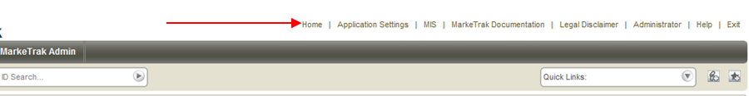

- Home - This button returns to the Home Page report. Depending on settings, this may be a custom Home Page report, a report that the MP administrator has assigned, or the Task page. Below is a sample Multi View Home Page report a user may wish to use. Details for creating and saving reports to the Home Page are located in Sections 1.5 of this guide. (Fig 1.3.2.1b)

Fig 1.3.2.1b
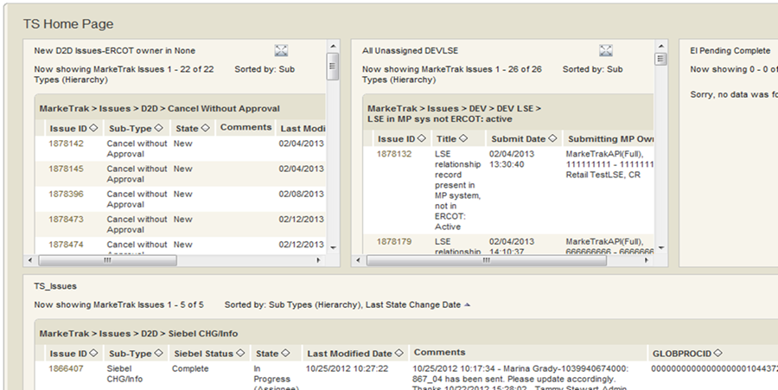

- Application Settings - Click this button to open the Application Settings form which enables the user to select a Home Page report (Fig 1.3.2.1c) and preferred projects for the application. To select a home page report the user selects it from a drop down of all available reports and Saves as indicated below. This will now be the result set(s) displayed in the main browser interface each time this user logs into the application or selects the Home button from the SBM User Workface Toolbar.

Fig 1.3.2.1c
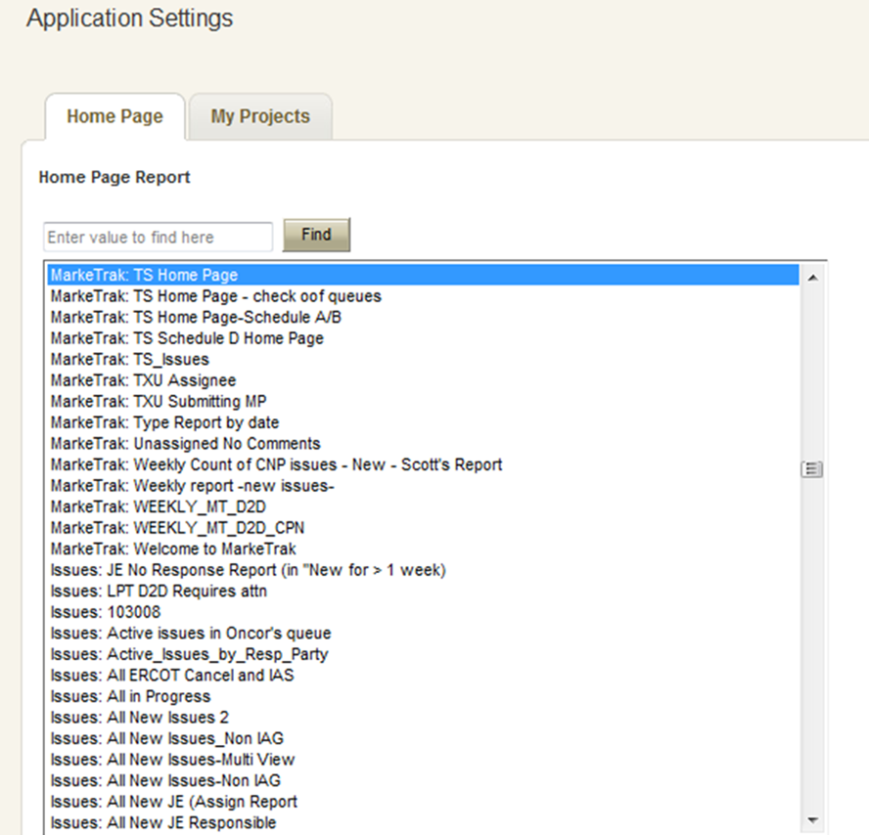

- MIS – This link will take you directly to the main page of the Market Information System website. From there, you can select the Reports and Extracts Index link which will take you to your reports and extracts. The reports and extracts that will appear will be associated with the digital certificate being used.

- MarkeTrak Documentation - This link will take you to the MarkeTrak Information page on ERCOT.com where you can open the MarkeTrak User Guide under Key Documents. The User Guide gives details of how to interact with the MarkeTrak toolset as well as associated business practices. This page also contains Tips and Tricks as well as the Administrator and Training documentation.

- Legal Disclaimer – A quick link to the legal disclaimer relevant to the MarkeTrak application entitled:
ANTITRUST GUIDELINES FOR MEMBERS OF ERCOT COMMITTEES, SUBCOMMITTEES AND WORKING GROUPS

- Help - The help feature is an indexed and searchable resource with a thorough explanation of ‘out-of-the-box’ tool functionality. The purpose of this guide and appendix is to bridge the gap between the application and the ERCOT configuration and concepts.
- Exit - This is the method to log out of the MarkeTrak tool. This will present the opportunity to re-login to the application.
- Quick Links - These are links updated to an individual user toolbar. This can include useful URLs such as ERCOT.com as indicated above or common reports a user may wish to access in one click as demonstrated below: (Fig 1.3.2.1d)

Fig 1.3.2.1d
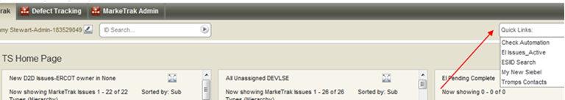

- ID Search – Populating this field with a numeric value returns a quick search of all Issue IDs that contain the value entered.

- When utilizing the ID Search box it is possible to search for multiple Issue IDs simultaneously. To do this simply input the Issue IDs you wish to retrieve with each entry separated by a space. (Fig 1.3.2.1e)

Fig 1.3.2.1e
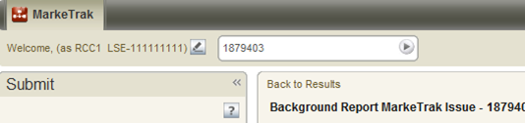

NOTE: When searching for a particular item number the most complete criteria known should be entered due to the nature of the result set. For example entering the criteria ‘7’ in the ID Search could produce a result set including Issues 7, 17, 70, 71, etc

- Add Link in your Favorites - Click this link to add any list, item, or form displayed in the main browser window to your favorites.
- Actions Drop Down (Fig 1.3d) – Available in the header of the issue details pane: (Fig 1.3.2.1f)

Fig 1.3.2.1f
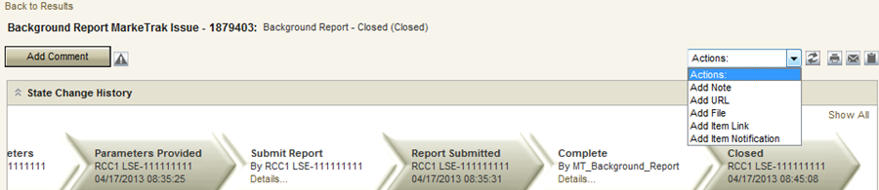

- Add Note - This allows the user to include a text message on the individual issue.

NOTE: The checkbox labeled- Unrestricted (visible by anyone who can view the item) has been disabled. Anyone with access to an issue has the ability to view notes added by other users to an issue

- Add URL - Creates a hyperlink on an individual issue to an external website
- Add File - Allows the user to locate and attach an external file to an item which will be visible by all MPs Involved This is not to be used to submit a file of ESI IDs to be researched on the issue (exception – LPA).
- Add Item Link - This action gives the user the ability to create several different kinds of links to other issues within the MarkeTrak application. In order to successfully create these links, the current user must have visibility rights to both linked items.
- Add Item Notification (Fig 1.3.2.1g) - Selecting this action allows the user to choose one of five distinct item notifications. These differ from the system generated notifications in that they are selected individually on items by any user with visibility. A complete description of these six initial options is located in this document in the section detailing Notifications.

Fig 1.3.2.1g
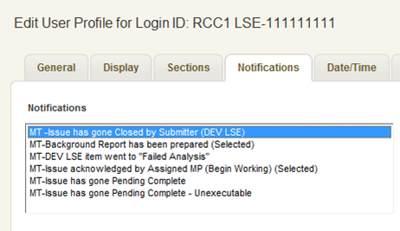

    - Setting General Options

General Options – This tab enables the user to modify name, phone number and email address. In addition, additional preferences such as the following can be set/modified: (Fig 1.3.2.2a)
- Subscribing to Notifications
- Setting Section Preferences
- Setting Date/Time Options
- Setting Advanced Options

Fig 1.3.2.2a
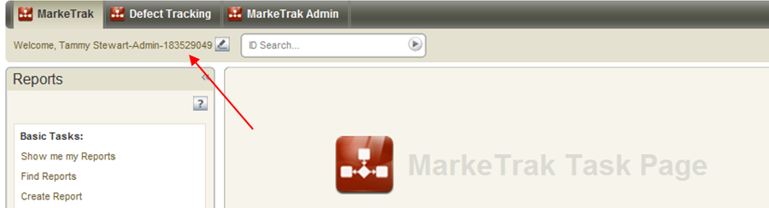

- Folders View and Functionality

The Folders View provides easy access to active items in selected reports as well as favorite and public folders.

    - Full MarkeTrak Interface Functionality

- Excel – Selecting this link from either the Item List or Item Details view converts the main browser window of the Full MarkeTrak Interface to an Excel spreadsheet format. With this functionality the user is able to perform many of the functions available in Microsoft Excel including manipulation/insertion/deletion of columns and row, formatting calls, and using formulas. In addition, this view is a convenient method of copy/pasting the data into a separate Excel spreadsheet.
- Create Link In→ - (Fig 1.3.3.1a) Available at the bottom of the screen on any Listing style Search and Report. Creates a link to the result set in any of the folders available to the user via the drop down box provided.

Fig 1.3.3.1a
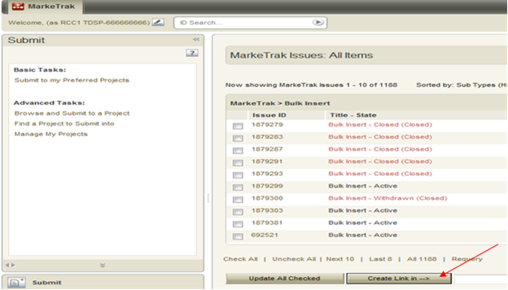

    - Navigation Pane

The navigation pane is available on the left side of the SBM User Workspace. You can do the following in the navigation pane (Fig 1.3.3.3a):

- Submit – The Submit view provides links to submit primary items into MarkeTrak projects.
  - Submit to my Preferred Projects: Enables users to Submit a subtype(s) into one of your preferred projects for MarkeTrak. If you do not have any preferred projects defined, you can navigate to a subtype in the Submit Tree.
  - Browse and Submit to a Project: Enables users to navigate the Submit Tree all subtypes for which you have submit privileges.
  - Find a Project to Submit into: Performs a keyword search for a project in the application for which you have submit privileges. Users can search on the first word of the project, or on a word contained anywhere in the project name.
- Search – Provides links to the following search features in the SBM User Workspace:

    - Search by Keyword(s): Searches for primary items by keyword.

    - Search by Submitter: Searches for primary items by submitter.

    - Advanced Search: Searches for primary and auxiliary items, archived primary items, or notes and attachments in primary and auxiliary tables, depending on your privileges. Your administrator determines which fields can be searched on the Advanced Search page.

    - Global Search: Searches for items in multiple primary and auxiliary tables at once. If you have appropriate privileges, you can save your search specifications as a Multi-Table report.

    - Use Advanced Lookup Tool: Searches for primary items using a three-pane view.

    - Knowledge Base: Searches for problems and resolutions in the Knowledge Base.
    - Manage Data: Also referred to as the Rolodex within this document. Allows the user to perform a quick search to locate contact information from any Market Participant parsed by Contact Type. This is the list owned by each MP Administrator which determines the destination of Notification Emails.

- Reports - Provides links to the reports that you have privileges to run, modify, or delete.
  - Show me my Reports: Displays all reports that you have created, as well as reports that you have created for auxiliary tables.
  - Find Reports: Searches for an existing report by title, author, or project.
  - Create Report: Enables users to create a common or advanced report.
  - Browse Reports: Depending on your privileges and the reports available to you, you can use the Browse Report links to display a listing of reports by type:

      - Application Reports – These reports are created as report definitions in SBM Composer and appear in the SBM User Workspace as read-only listing reports with an extra red stripe on the report icon. You can run one of these reports, and you can save it with a new name as an ordinary listing report. However, you cannot directly modify or delete an application report.
    - Multi-View Reports – These reports combine multiple single reports that are created from the same or different applications, auxiliary tables, or external reports.
    - Multi-Table Reports – These reports query system fields to list items from multiple primary and auxiliary tables.
    - External Reports – These reports enable you to view external data in the SBM User Workspace.
    - Auxiliary Table Reports – These reports return items from auxiliary tables. They are listed alphabetically by table.
    - Built-in Reports – These reports are available for every application tab. The default set of built-in reports depends on your product-access level. Most built-in reports return items only from the selected application tab. If you have privileges to view items in the Contacts table, the All Contacts, All Active Contacts, and All Inactive Contacts built-in reports are also available.
    - System Reports - These reports offer information about administrative aspects of the system, such as fields, user privileges, group membership, current user activity, active users, item (record) locks, and more. System reports appear if you have the privilege to run them, but cannot be modified or deleted.

- Favorites: Favorites enable users to add links to frequently used features, items, and reports to folders that you create or that are provided by the system. Favorites can provide a personal view of items in the system; other users cannot view your favorites, nor can you view other users’ favorites. Links to the following types of items can be stored in your favorites folders:
    - Any list, item, or form displayed in the content pane. When you save links to forms, selected values are saved as part of the link. For example, if you save a link to the Advanced Search page, any search criteria you have specified is saved with the link.
    - Links manually added using the Create Link In feature.
    - Items added automatically by the system.
    - Links to Web pages inside or outside of the SBM User Workspace. These links open the specified Web page in the content pane.
- Public Folders - Displays links, reports, URLs, etc that can be viewed by all other MarkeTrak users unless specifically restricted by MarkeTrak Administrators.

Fig 1.3.3.3a
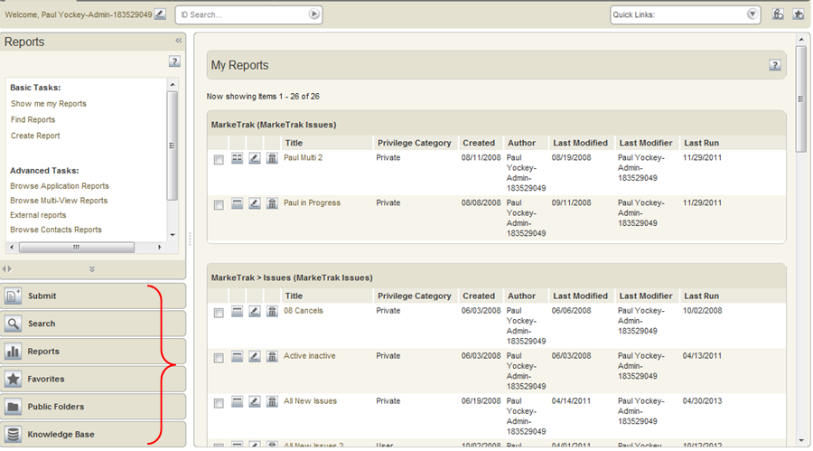

Screen Layout

In general, the main browser window contains two views.

- Item List

Item lists are typically generated from report and search queries and when you display the contents of folders. In addition, if you are viewing a Multi-View report or graphical Trend of Distribution Report, the results display in the Item List frame. (Fig 1.3.4.1a)

Fig 1.3.4.1a
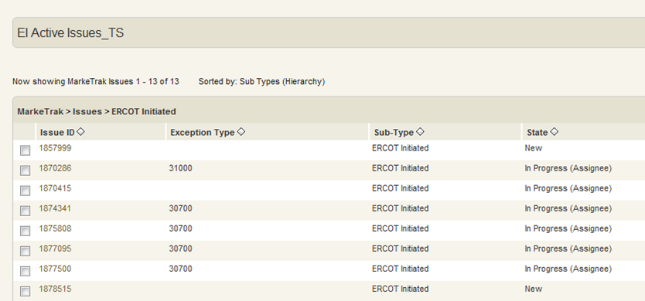

- Item Details

Item Details - The Item Details frame displays details for items selected in the Item List frame. User profile settings determine how the Item Details frame displays. For example, the user may choose to view items in a single-frame view, or in two frames with the item lists at the top and the item details at the bottom. Depending on user privileges, the user may work with individual items in the Item Details frame by updating data in them or transitioning them to another state in the workflow, or by adding comments and attachments to them. (Fig 1.3.4.2a)

Fig 1.3.4.2a
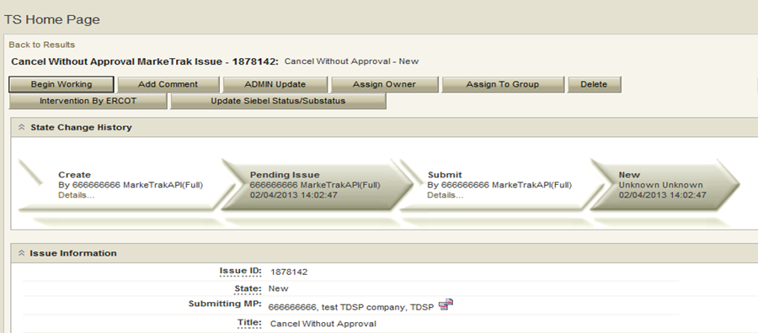

- MarkeTrak General Issues

States and Transitions

All issues in the MarkeTrak tool are routed into one of several workflows based on the Type and Sub Type selected by the submitter. Several of the more common issue types have consistent, predictable processes which are always necessary to reach a resolution. Several of these have been pre-defined in the MarkeTrak tool as a method of improving efficiency and metrics.

These Issue Type/Sub Types are: Day to Day Issues, Cancel with Approval, Cancel without Approval, and Inadvertent Gain related Sub Types as well as Data Extract Variance Issues- LSE Relationship.

All other issue Type and Sub Types combinations will be funneled into an ‘open-ended’ workflow which will allow much more flexibility as the issue moves towards a resolution.

The fundamental architecture of the MarkeTrak tool is based on States and Transitions.

A state is the position of an issue in the workflow process; this is often similar to the concept of an issue status combined with the issue’s current ‘owner’. Examples of this include: New (ERCOT), In Progress(Assignee), or Cancelled (Pending Complete).

Transitions are the movement of an issue from one state to another. Available transitions are associated on the GUI with buttons. Selection of different buttons from the same state will typically result in the issue appearing in different states when the transition successfully completes. One example is a Day to Day Issue - Cancel with Approval currently in state In Progress with TDSP. If TDSP user selects transition button ERCOT Cancel, the item will move to state Auto Complete. Alternately if the TDSP user is unable to approve the cancel and selects transition button Unable to Cancel, the issue would appear in the submitting CR’s queue in state Unable to Cancel – (PC). Some transitions, such as Unable to Cancel, require additional steps to complete; in this case completion of a required field: Comments.

Issue Visibility

Visibility to an issue is determined by several factors. These factors determine a user’s ability to find the item by directly searching for the Issue ID as well as having the issue return as part of a result set in searches and reports. The submitter of an issue is always able to view the item regardless of the state in the workflow. ERCOT is able to view all items in the MarkeTrak tool at any time. All other MPs must be selected as the assignee in order to have visibility. This occurs in several ways:
- By the submitter (often but not always during submission).
- Current assignee (as shown on the GUI in field: Responsible MP) at designated times based on workflow association.
- By ERCOT, particularly when the Market Participants may not know who the ‘other’ parties involved should be (i.e. IAG).

As soon as an MP is selected as a party to an issue (field name MPs Involved) that participant is able to view the item from that point forward.

NOTE: It is NOT possible for an MP to remove an assignee from the MPs Involved list once they have been added. If a mistake is made and the wrong assignee is selected (and confirmed) an ERCOT analyst should be notified immediately. It is necessary for ERCOT to close the issue and remove ALL proprietary information. The issue will be updated by the MarkeTrak system with data that does not contain sensitive information. The issue must then be resubmitted with appropriate assignee(s) selected.

Transition Ability

Transition ability and selection is based on the particular workflow to which an Issue Sub Type is associated. Any user at an MP that is on the MPs Involved list is able to: add comments to the issue, assign an issue to a group, or assign an individual within the same MP to an issue at any time. Other transition options are determined by the state in which the issue currently resides. Refer to the appendix (Appendix A – MarkeTrak States and Transitions) for a complete list of transitions.

- Mass Transitioning of Issues

It is possible to commit multiple like transitions simultaneously should the following conditions exist:
- Mass Transition privilege must be assigned to the user by their MP Administrator.
- User’s MP must have transition ability available on all selected issues.
- Desired transition is available on all issues selected.
- List of available issues must be returned utilizing one of the methods detailed in the list below.

The following list defines locations in the MarkeTrak tool where this functionality is available:

  - Basic Search results
  - Advanced Search results
  - Listing report preview lists
  - Listing report results
  - Built-in reports
  - ID search results

Mass updates may be performed from the following item lists:
- Global search results
- Manage Data search results
- Folder lists

From any result set that allows mass transition, a check box is located next to each issue. Items can be individually selected or deselected; or the user can select the Check All link. When all items that wish to be transitioned are selected, the user selects the Update All Checked button. (Fig 1.4.3.1a)

NOTE: Only one page can be updated or checked at one time. A checked box will be lost once Next Page button is selected.

Fig 1.4.3.1a
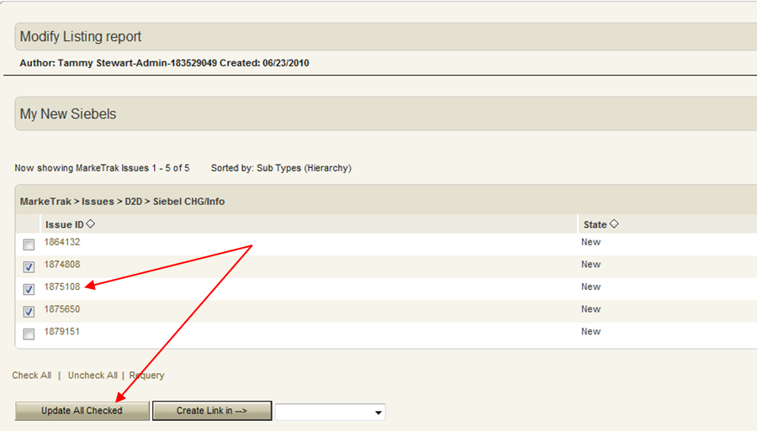

The user is now presented a drop down list of any transitions available to every issue selected. If each of these items is in the same state, a complete list of button names that would be presented on the GUI is available. If any of the selected issues in the result set are not in the same state, only three transitions will be available to be executed in mass: Add Comment from Any, Assign to Group from Any, and Assign Owner from Any. (Fig 1.4.3.1b)

Fig 1.4.3.1b
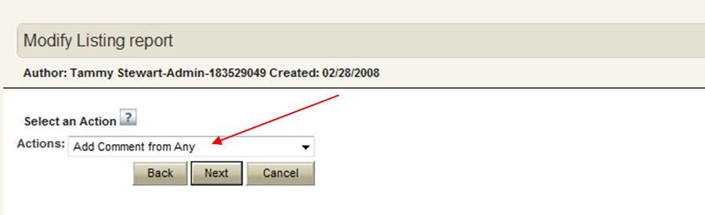

Issue Ownership Model

- Variety of Ownership

There are several varieties of ownership in the MarkeTrak application: Submitter, Responsible MP, MP’s Involved, and Assigned Owner.

- The Submitter of the item is indicated near the top of each primary data pane on the issue details window. Submitter Duns number is also incorporated into the title of each issue and listed in the MPs Involved field discussed below.
- Responsible MP is the single Duns number contained in the MPs Involved list that is considered to be the next participant responsible for transitioning the item towards a resolution. Examples include: the TDSP when an issue is waiting for approval to cancel a service order, ERCOT when the approval has been granted, and the CR when the cancel is complete and the issue is waiting for acceptance of the resolution.

- MP’s Involved is defined in MarkeTrak as a Secondary Owner. It is a list of all MP duns numbers which are party to an issue. As additional assignments are made to an item the MPs Involved field will be updated with the selected DUNs numbers, reflecting an increase in market participants with the ability to view the item. As ERCOT can always view any issue in the system, this will always be reflected in the MPs Involved list.

- Assigned Owner is null when an issue is initially assigned to a Market Participant. Assigned owners are individual users. These are assigned by the Responsible MP automatically as issue is acknowledged by way of transition, Begin Working. Taking this action will populate the associated individual’s user id as the Assigned Owner. It will also transition the issue from the state of New into an In Progress state as detailed in the workflow sections of this document. Taking primary ownership has no effect on market rules or responsibilities (i.e. notifications and market-wide metrics); it is used exclusively for contact information, ease of searching and workload management internally to a market participant.

- Assigning Individual Owners to Issues

Each entity with a unique association to an issue in MarkeTrak has the ability to assign individual ownership to that issue. Individual user assignments have no bearing on the functionality of either visibility or transition capability; the purpose of this is to facilitate workload management and provide contact information. Individuals can run a report with their username as part of the criteria which will return all in progress issues that they have been assigned. Assignment to issues can be created or overwritten at anytime the user has visibility to a given user.

There are three ways that an individual can gain ownership of an issue:

- Begin Working:
When an MP is designated as the Responsible MP on an issue they are given the option to change the state from New to In Progress via a Begin Working button. The user who executes this transition will automatically be populated as the Owner of the item for the appropriate association type.

- Assign Owner:
Anytime a user has visibility to an item (per details in 1.4.2 Issue Visibility) an Assign Owner transition is available. Executing this will present the user with a search list of individual users. The user can assign any individual in their MP to the item in this manner, overriding any previous associations.

- Mass Transition:
Assignment of individual ownership can also be handled en masse via the mass transition feature as detailed in 4.3.1 Mass Transition of Issues.

While making assignments via the search lists in methods 2 and 3, the user is able to return the entire population of assignable individuals regardless of MP. However, the selection of a user not associated with the same MP Duns will return an error message as shown below and will not execute the assignment. (Fig 1.4.4.2a)

Fig 1.4.4.2a
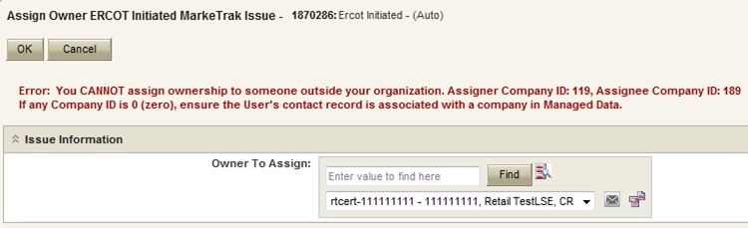

A successful assignment will populate the username into the field representing their affiliation to the item. Examples include: Submitter or Assignee Owner, Gaining MP Owner for an inadvertent switch, and ERCOT Owner. Located beside each individual’s naming convention used in MarkeTrak (user name, MP Duns, MP name, MP type) is a link to a pop up window containing contact information. This contact information is created and administered by one member of each Market Participant as detailed later in 1.7 Rolodex.

NOTE: Please See Appendix C about Mass Update Attention Message

Workflow Principals

- Common Workflow Principals

- Issue Type and Sub Type combinations that are not available to the submitter based on login credentials will not appear in the Submit Tree.
- Only the Submitter entity can Withdraw an issue.
- The Withdraw can only be performed before the issue has been acknowledged by another entity.
- Only the Submitter can be allowed to close an issue. This occurs only from a Pending Complete state either by accepting the resolution via a transition or failing to transition the issue within the prescribed Auto Close time limit (14 days). There are two exceptions to this rule:
- The Failed Analysis transition for issue types DEV-LSE as detailed later in this document.
- If proprietary information is entered on an issue and the ‘wrong’ Market Participant is inadvertently associated with the item, ERCOT has the ability to transition by using Wrong MP involved which will replace the proprietary information to an X or O. The issue will update to Intervention Complete to an Inactive state. This unilateral closing of an issue by ERCOT should not be used for any circumstances besides those described above or determined at a later date.
- Close Button functionality- allows the submitter to close the D2D issues at any time after the Withdraw function is not available. Also the submitter can close DEV issues as long as they are the responsible party and Withdraw is no longer available.
- The initial state of New has no individual owner but is owned by a market participant group.
- The assigned MP must select Begin Working to move the issue into an In Progress state before transitioning it to a new assignee.
- The state of In Progress has both an individual owner and the same participant group owner as the “New” state.
- Each of the workflows contains two Pending Complete states owned by the submitter (Cancelled, Unexecutable, etc).
- Visibility to an issue is determined by user access to the MP assigned only. Individuals for this entity not designated primary owner still have access to the same views.
- Transition capabilities function in the same manner as visibility but can be further restricted by the Managed Administrator for each Market Participant by Sub-Type.
- Admin – all functionality plus ability to add/edit/delete users within their own MP.
- Manager – all User functionality.
- User – all regular viewing and transition capability but may be further restricted based on group associated by sub-type restriction needs.
- Read-Only – read only, user will not be able to change or work issues.
- Comments can be added to an issue by any entity with visibility while it is in an active state.
- Any entity with visibility to an issue can assign it to an individual user within the same organization or to a group designation from any state.
- Transitions which indicate an inability to complete the request (i.e. No Agreement Reached, Unable to Complete) or which request Wrong MP Involved require Comments to complete.

- MarkeTrak Searching and Reporting

This section is designed as a bridge between the TeamTrack product’s built-in Help functionality and the customized design of the MarkeTrak application.

Internet Explorer Configuration Changes

The following Internet Explorer configuration change must be performed to allow MarkeTrak report/search data to be opened or saved to Excel format.

- Open the Internet Explorer browser. Select the Tools tab in the upper selection bar. Select the Internet Options selection from the drop down list. (Fig 1.5.1a)

Fig 1.5.1a
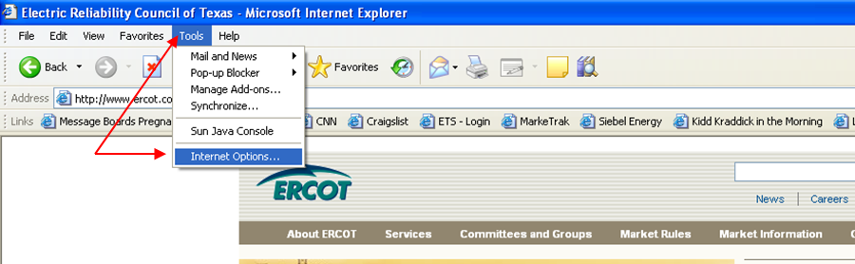

- After the Internet Options popup window displays, select the Advanced tab. (Fig 1.5.1b)

Fig 1.5.1b
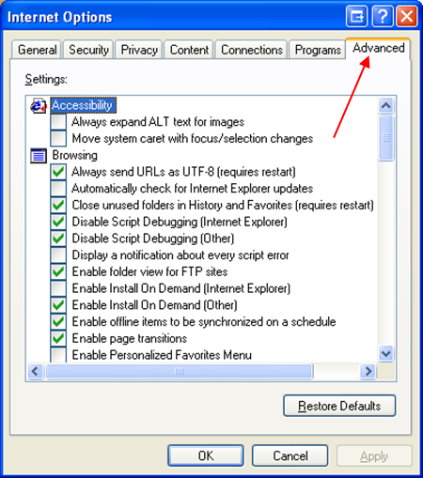

- On the Advanced tab, scroll down to the Security section. Check the box beside Do not save encrypted pages to disk. Click the OK button to save the change. (Fig 1.5.1c)

Fig 1.5.1c
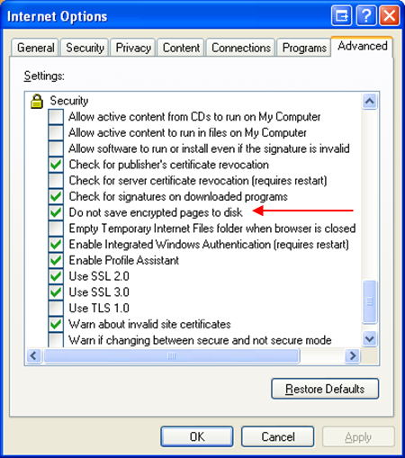

- You will now be able to open or save MarkeTrak report and search data to Excel format.

Searching

Searching in the MarkeTrak application is largely based on the visibility model described in section 1.4.2 Issue Visibility. When searching, those issues available to the user based on login credentials will be returned in any result set.

In comparison with Reports, searches are a quicker and more efficient way to reach a result set if multiple distinct criteria are not necessary.

Available fields that can be utilized are:
- Issue ID: entering a number in this field will return all issues that are visible to the user and contain the value entered. Entering multiple ID parameters separated by a space will return all appropriate results.
- Keyword(s): compares text strings populated by the user with any text fields associated with an issue. This will allow the user to search the following fields:
  - Comments
  - Description
  - ESI ID
  - Original Tran ID
- Project(s): (Fig 1.5.2a) A selection of each of the issue Sub Types the user wishes to return in the search. Multiple selections are possible via standard Shift and Control key functionality
- Submitter: UserID of the individual who submitted a particular issue. Only those items submitted by a user with the same MP DUNS association will return.
- Active/Inactive: Allows the user to decide if the result set should include only Active, only Inactive, or both Active and Inactive issues

Fig 1.5.2a
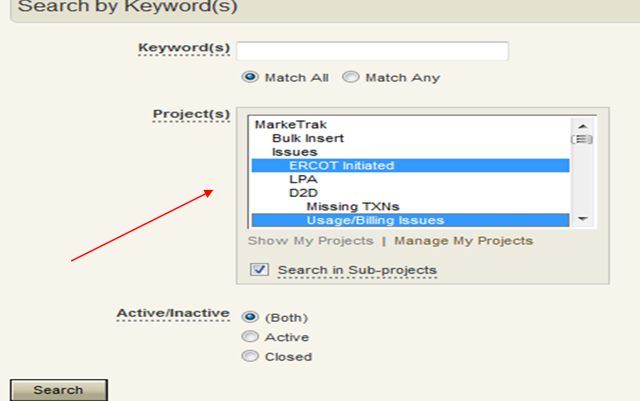

Reporting

The MarkeTrak application contains a vast amount of reporting options. Report types include Distribution, Trend, Duration, Change History, Multi-View, Summary and most commonly Listing Reports. A thorough explanation of each of these report types is available via the Help option.

- To access information regarding reporting in MarkeTrak: (Fig 1.5.3a)
- Select the Help link from the toolbar
- Click in the Search text box in the upper right corner of the screen
- In the text box type Creating Report
- Select the Title hyperlink for the report you want to create

Fig 1.5.3a
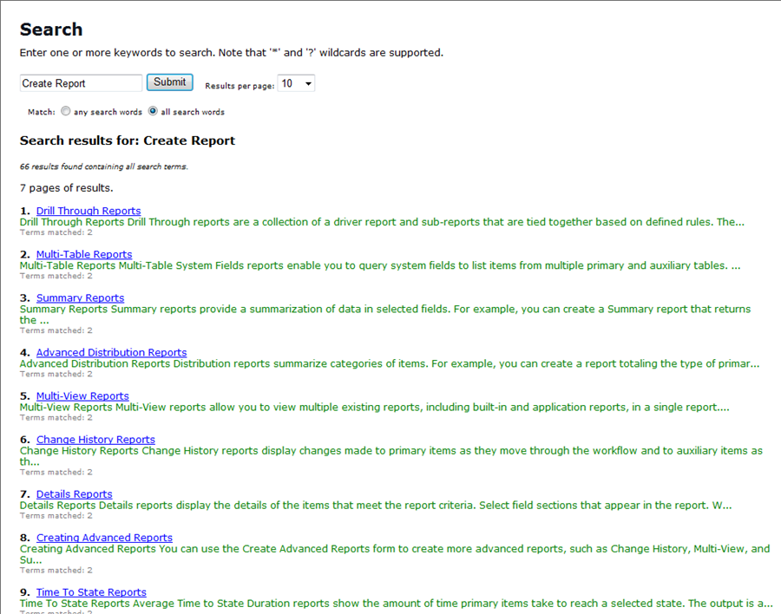

- This will provide an overview of each of the report types available in MarkeTrak as well as a link to the details of individual report types.

For example: Selecting details for Change History Reports returns the definition, steps to produce and related topics such as Specifying Content Options and Additional Options for Change History Reports. (Fig 1.5.3b)

Fig 1.5.3b
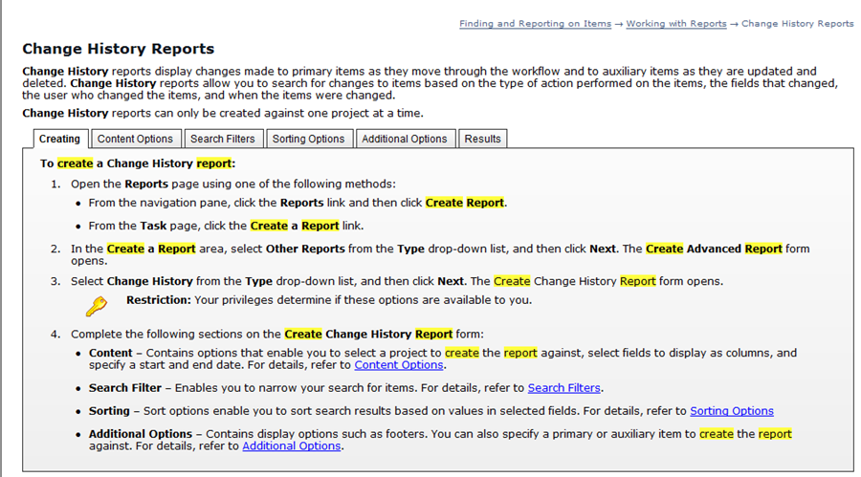

- Many of the reports that a user will find useful have already been created and saved into the application. These can be accessed in the Reports view in the Navigation Pane on the left hand side of the screen (Fig 1.5.3c) by selecting Find Reports. This method of searching for an existing report involves entering all or part of the report’s title or the report’s author.

- Create a Report

- The user can also create and save ad hoc reports through the Create a Report (Fig 1.5.3.1a) option accessed via the Reports tab.

Fig 1.5.3.1a
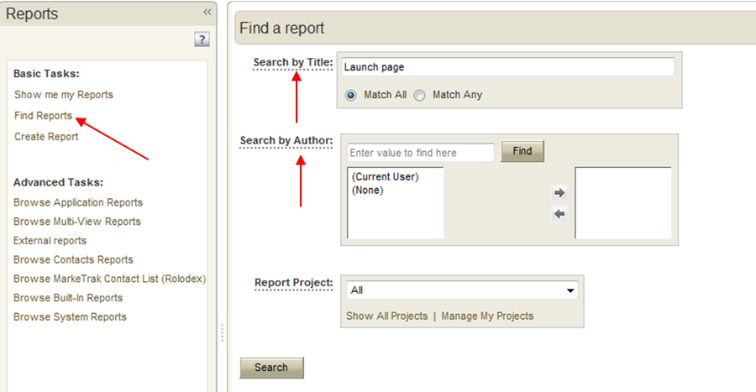

- The screen below (Fig 1.5.3.1b) will appear after selection of Create a Report, Type: Listing. Select Columns to Display: is a complete population of fields available to the user based on privileges and functions like the ‘Select’ statement of an SQL statement. Multiple fields can be selected to return in the result set and moved into the request via the left and right arrows.

Fig 1.5.3.1b
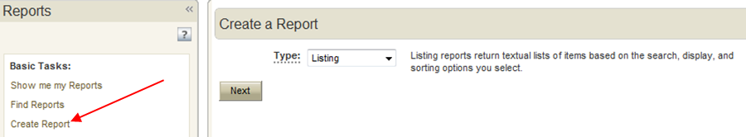

- The screen below (Fig 1.5.3.1c) will appear after selection of Create a Report, Type: Listing as indicated above. Select Columns to Display: is a complete population of fields available to the user based on privileges and functions like the ‘Select’ statement of an SQL statement. Multiple fields can be selected to return in the result set and moved into the request via the left and right arrows.

Fig 1.5.3.1c
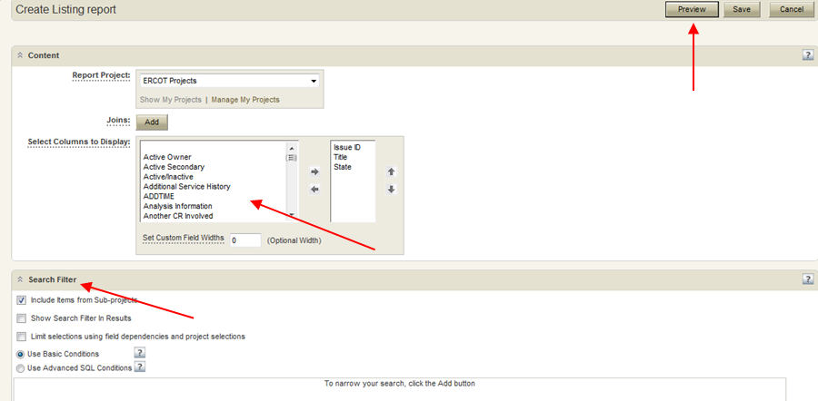

- The Search Filter: Selection of Add will allow the specification of criteria specific to the field chosen from the drop down. For example choosing Submitting MP will populate all MPs in the MarkeTrak system in the Field Values. The same functionality is available to locate the desired MP as in other MP searches, i.e. all or part of Duns number, MP Name, MP type. Executing the report below with criteria Submitting MP in ERCOT will return all issues submitting by ERCOT to which the current user has visibility. In other words, the same report will return different result sets for different MP users. (Fig 1.5.3.1d)
Adding additional criteria to the report will create additional filters for the search. Other fields many users may find most useful include: State, Responsible MP, Submit Date, and Active/Inactive.

Fig 1.5.3.1d
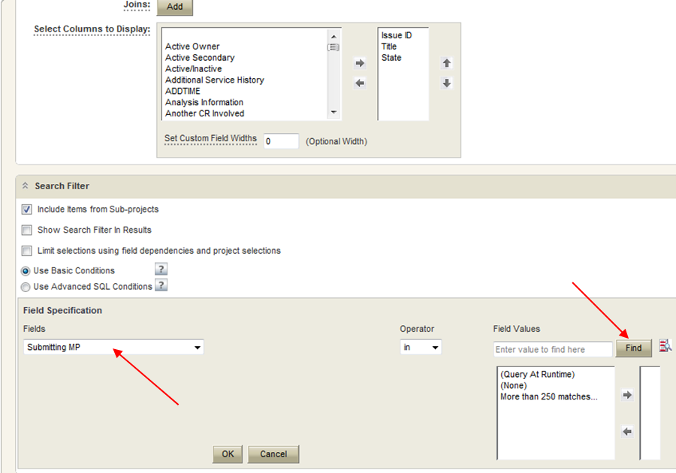

- Query at Run Time

- This feature allows the user to create a report against a field without specifying a value at the time the report is created for some number of criteria. An example of this is below (Fig 1.5.3.2a; this report will return all issues to which the user executing it has visibility and the Responsible MP is ERCOT. In addition, each time the report is run the user will be prompted for a new ESI ID to function as the third filter. If this report is saved to the user home page, each time this screen is accessed the prompt will appear.

Fig 1.5.3.2a
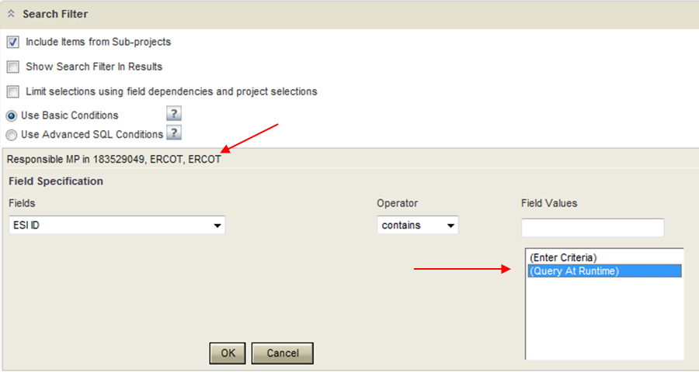

- After selecting the Preview button: (Fig 1.5.3.2b)
Fig 1.5.3.2b
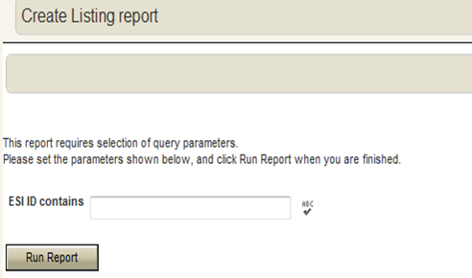

- Calculations

This feature allows the report user to determine several useful date/times pertaining to the issues returned in the data set such as:
- How long has an issue been open?
- How long has it been since this issue was transitioned?
- How long did it take to resolve/close a given issue subtype?

To include calculations in your listing reports:

- Select (Calculated Field 1) from the Select Columns to Display option as shown: (Fig 1.5.3.3a)

Fig 1.5.3.3a
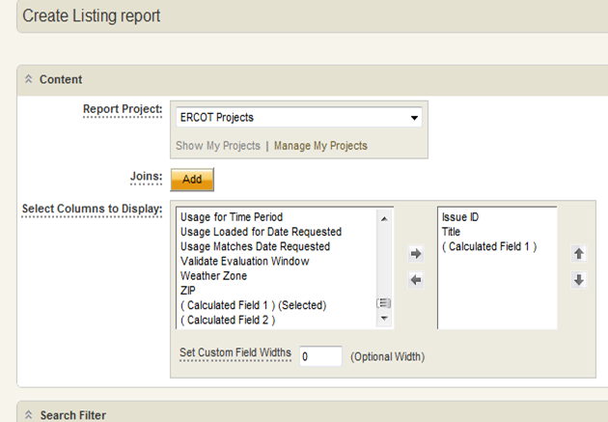

- After selecting the Search Filter criteria for your report as per usual, expand the Additional Options.
- In the section Add Columns of Calculations enter the name of the calculation you wish the report to include. For this example I will return the Days/Hours a set of issues has been open. (Fig 1.5.3.3b)
Fig 1.5.3.3b
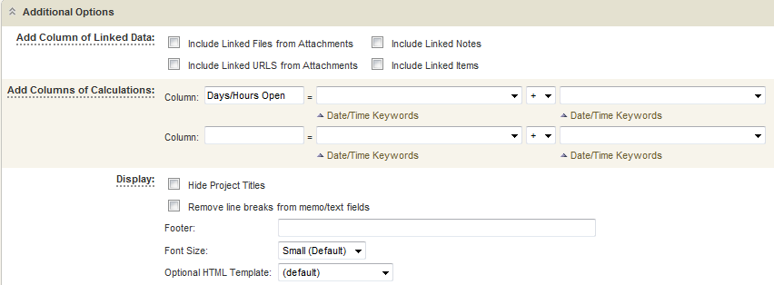

- Select the link Date/Time Keywords beneath the first calculation box following the column name you entered. Select Now from the options. (Fig 1.5.3.3c)

Fig 1.5.3.3c
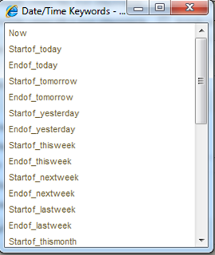

- Change the operator in the next field to a Subtraction (-) sign and expand the options in the last column utilizing the downward facing arrow to select Submit Date. (Fig 1.5.3.3d)

Fig 1.5.3.3d
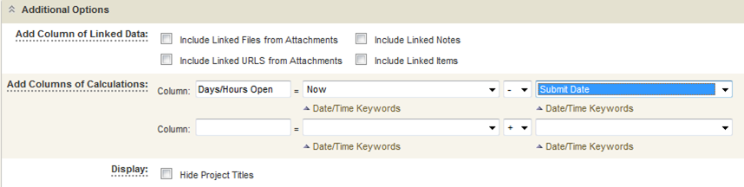

- After completing the calculation entry display the report as per usual with the Preview button at the bottom of the report screen.
- The data set will include your specified Days/Hours Open column indicating how many days_hours_minutes_seconds between the time the issue was submitted and the execution of the report. (Fig 1.5.3.3e)

Fig 1.5.3.3e
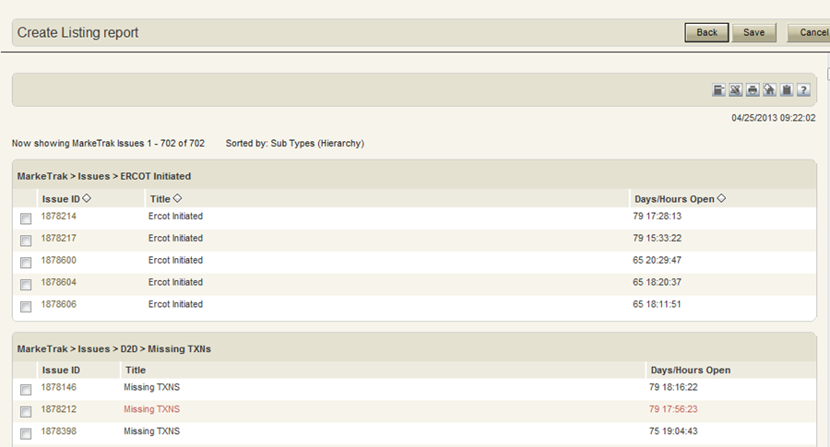

- Other Reports

These reports function in a similar manner to Listing Reports but the criteria and result sets relate to the issue change histories, details, or State Changes. To access Other/Advanced Reports, navigate to the Reports tab and on Create a Report- Type: select Other Reports followed by Next (Fig 1.5.3.4a). On the following screen Change History is defaulted as the Type: (Fig 1.5.3.4b)

Fig 1.5.3.4a
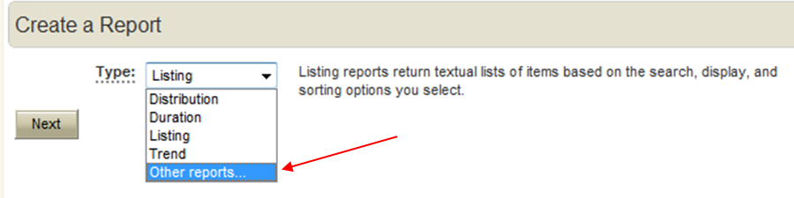
Fig 1.5.3.4b
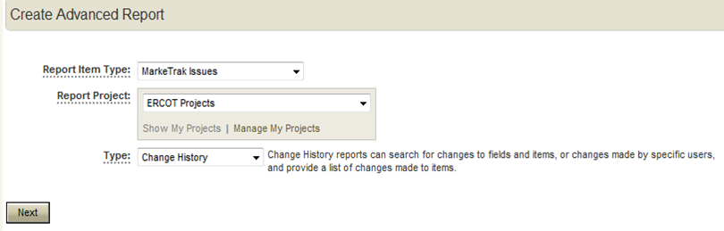

- Drill Through Reports

Drill Through reports are a collection of a driver report and sub-reports that are tied together based on defined rules. The sub-reports are populated based on selections made in the driving report.

For example, you are a supervisor who manages multiple teams and you need to know how certain MarkeTrak issues are distributed among each team. To assess possible risks, you also need to see the distribution for each team member and the trend for the length of time issues are opened and closed for each person. In the scenario you would create this Drill Through report as follows:
- Distribution of MarkeTrak issues by subtype (Fig 1.5.3.5a).
- Distribution of issues by team member (Fig 1.5.3.5b). (Driven by Team from Report 1)
- Open and Close Trend (Fig 1.6.3.5c). (Driven by team member from Report 2)

Fig 1.5.3.5a
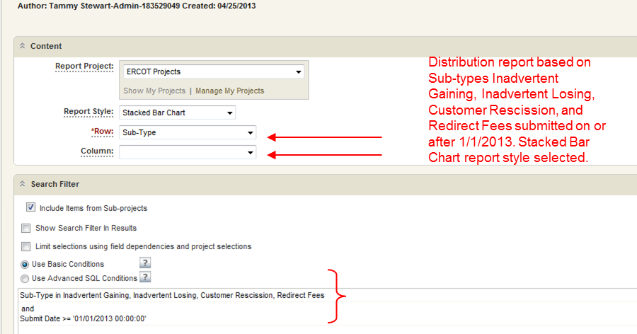

Fig 1.5.3.5b
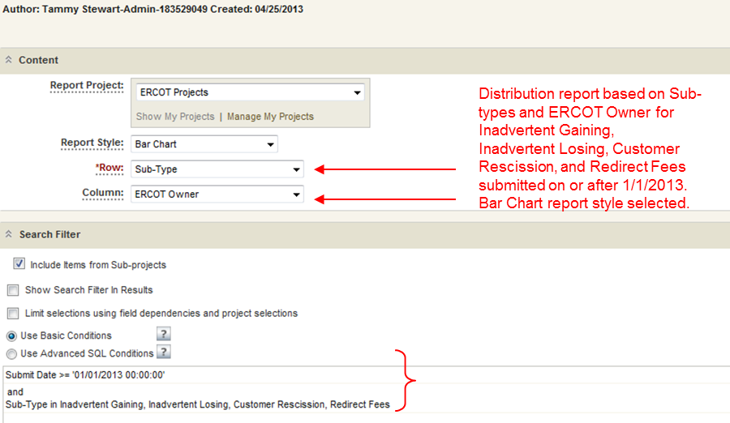

Fig 1.5.3.5c
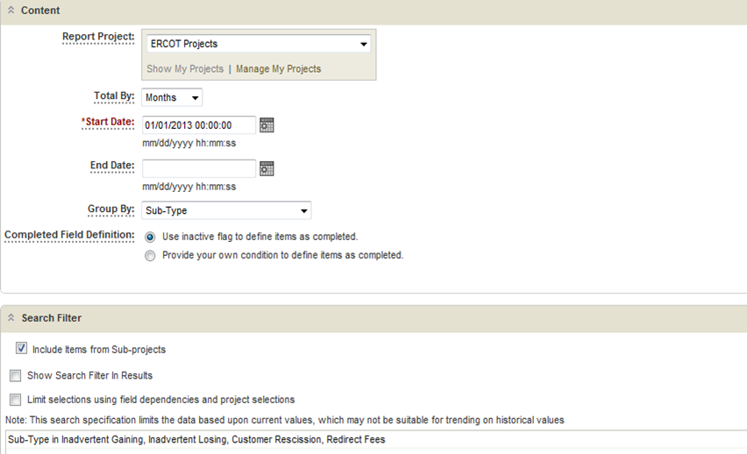

Report 1 is the main driver. Clicking on a particular subtype in Report 1 filters Report 2 to display the items broken down by team member for that subtype. Clicking a particular team member in Report 2 will drive Report 3 by displaying the trend report for that team member's items.

NOTE: Drill Through reports are different than Drill Down reports. Drill Down reports allow users to navigate from a summarized view to a listing of all the individual items. Drill Through reports allow users to see different dimensions of the same data in variable report formats.

NOTE: Both Multi-View and Drill Through reports display multiple reports on one page. The main differences are that Multi-View reports can display any report type in any order on the page while Drill Through reports are designed for Distribution reports which pass information between the different reports.

Creating a Drill Through Report:

- Create the distribution reports which will display that data.
- Create a driving report. This report is distribution report which summarizes the data and from which you will select data to drill through.
- Create one to three additional reports that will be driven by either the driving or another driven report.
- Open the Reports page using one of the following methods:
- From the navigation pane, click the Reports link and then click Create Report.
- From the Task page, click the Create a Report link.
- In the Create a Report area, select Other Reports from the Type drop-down list, and then click Next. The Create Advanced Report form opens.
- Select Drill Through from the Type drop-down list, and then click Next. The Drill Through report form opens. (Fig 1.5.3.5d)

Fig 1.5.3.5d
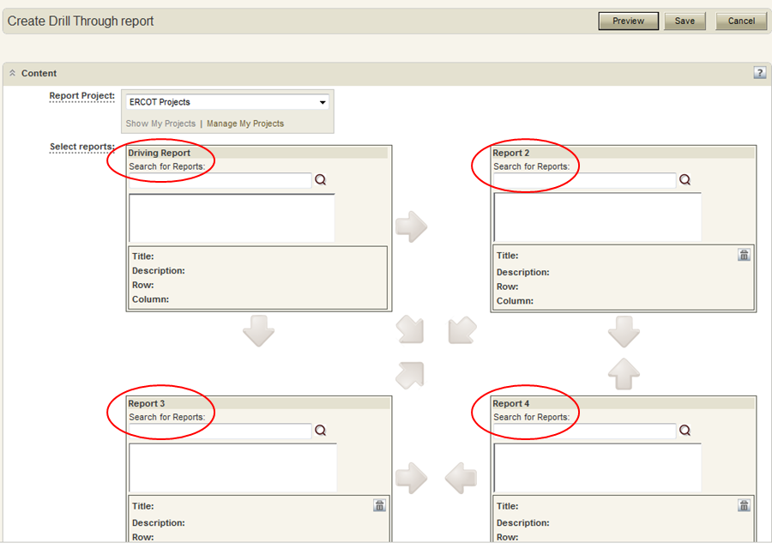

Restriction: Your privileges determine if these options are available to you.

- Select the project which the Drill Through report will be run against.
- Search for and select a Driving Report. The Driving Report report is a Distribution report that contains the data that you want to "Drill Through" to. (Fig 1.5.3.5e)

Fig 1.5.3.5e
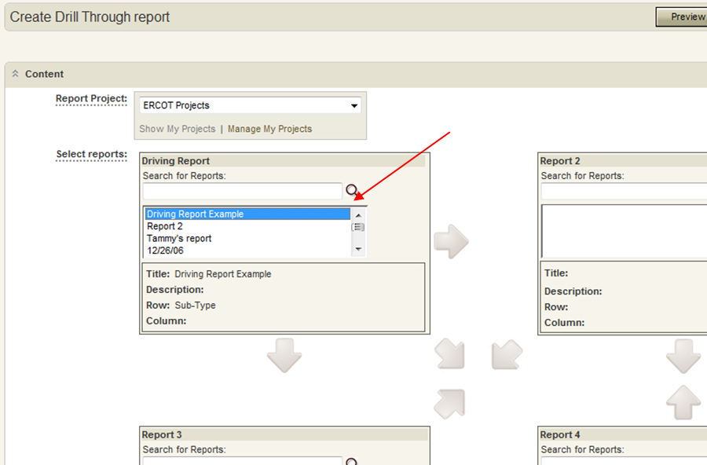

- Select Report 2, which is a report that will be driven by the Driving Report.
- Right-click on the arrow between the Driving Report and Report 2, and select the data that you want to pass from the Driving Report to Report 2. (Fig 1.5.3.5f)

Fig 1.5.3.5f
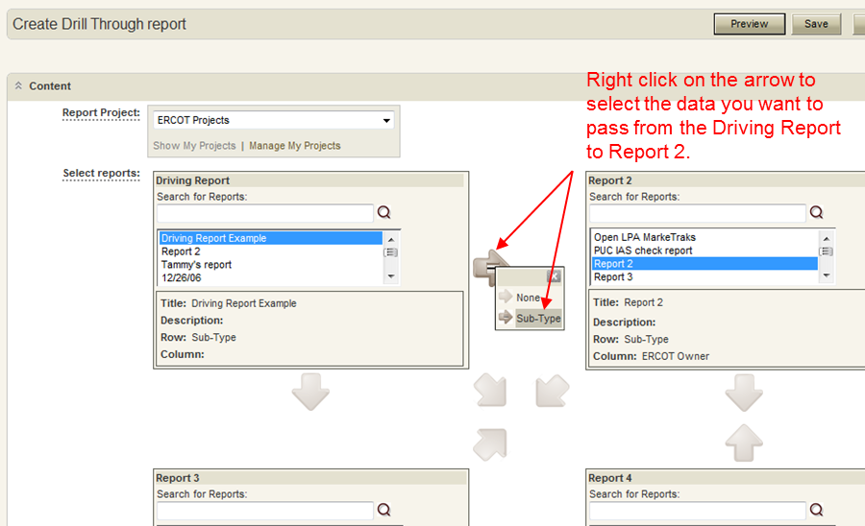

- Repeat Steps 7 and 8 to add additional reports such as Report 3 and Report 4.
- Right-click on the arrow between the Driving Report and Report 2, and select the data that you want to pass from the Driving Report to Report 2.
Important: The arrow only becomes active after you select Report 2.

- Repeat Steps 2 and 3 to add additional reports such as Report 3 and Report 4. (Fig 1.5.3.5g/1.5.3.5h) When complete, select Preview to create/view the Drill Through Report. (Fig 1.5.3.5i)

Fig 1.5.3.5g
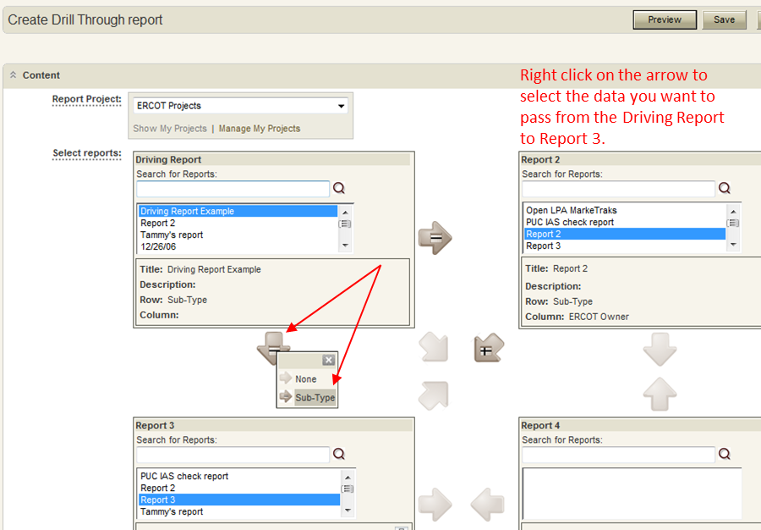

Fig 1.5.3.5h
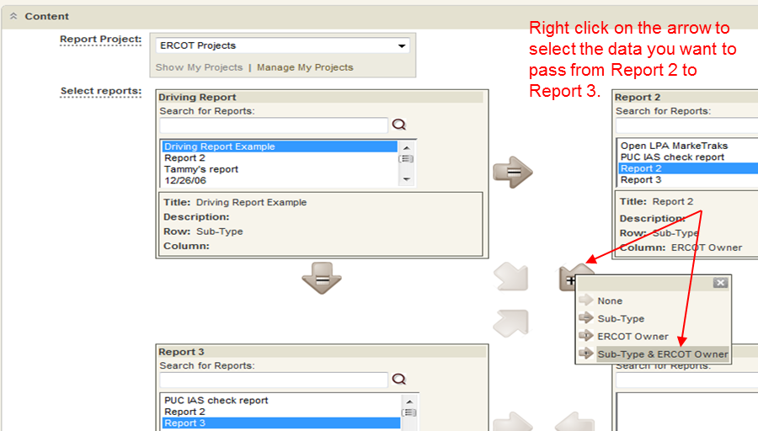

Fig 1.5.3.5i
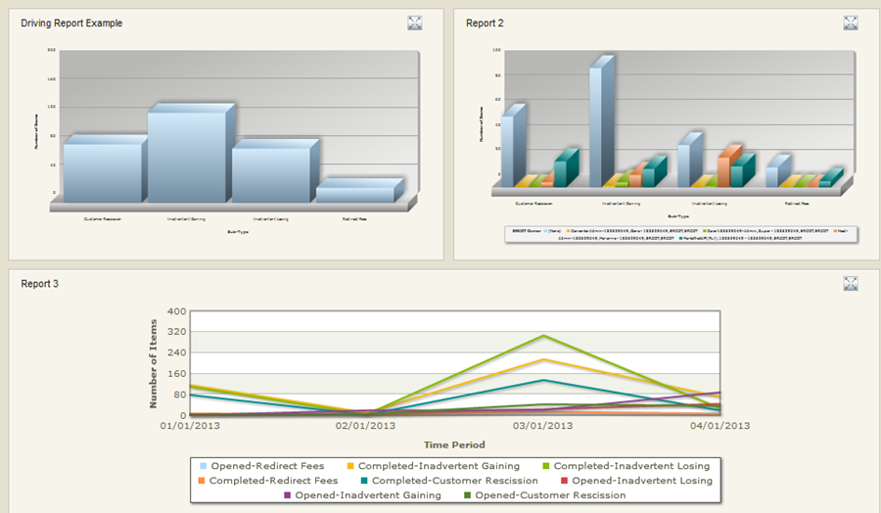

- To remove a report from the box, select it and click . This will cause all of the reports to move up one space. For example, if you delete Report 2, then Report 3 will move to Report 2's location. Note that you cannot delete the Driving Report; however, you can replace it by selecting a new one.

NOTE: Flashplayer is required for the drill through feature of this report.

- Duration Reports

Duration Reports: Provide historical trends of primary items over a specified duration. Duration reports appear as bar graphs. There are three types of Duration reports available which are Time In State Reports, Time To State Reports, and Elasped Time Reports.

Creating a Time In State Report

- Open the Reports page using one of the following methods:
    - From the navigation pane, click the Reports link and then click Create Report.
    - From the Task page, click the Create a Report link.
- Select Duration from the Report Type drop-down list in the Create a Report area, select Time in State from the second drop-down list, and then click Next. The Create ReportType Report form opens.
Restriction: Your privileges determine whether these options are available to you.

Complete the following sections on the Create ReportType Report form:

- Content – Contains options that enable you to select a project to create the report against and define report criteria. (Fig 1.5.3.6a)
    - Select Calendar: Calendar is set to a 24 Hour Calendar.
    - Select State(s): Select one or more states. For each age (see the entry for Time Interval Groups below), the report displays a colored bar for each specified state showing the number of items that have been in that state for that length of time (for example, the number of items that have been in the Assigned state for less than 10 days).
    - Time Interval Groups: Select one to four time intervals. For example, if you entered 2 days, 5 days, and 10 days, the report shows duration groupings of:
- Less than two days
- Two days to less than five days
- Five days to less than ten days
- Greater than or equal to ten days

Fig 1.5.3.6a
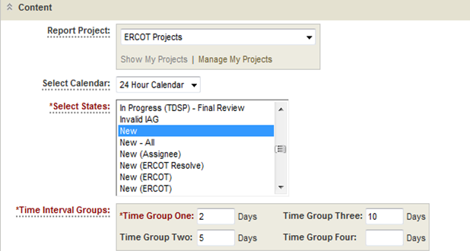

- Search Filter – Enables you to narrow your search for items. (Fig 1.5.3.6b)
- Include Items From Sub-projects: Select this check box to include items from sub-projects of the project selected from the Report Project list.
- Show Search Filter In Results: Select this option to display your Search Filter settings in the output of the report. This option allows report viewers to see which filters are used in the report. It is also helpful when you select to print a report, since it displays which Query At Runtime parameters were selected.
- Limit selections using field dependencies and project selections: When you select a field from the Fields drop-down list, the Operator drop-down list contains values appropriate for that field, and the list box underneath the list of field values contains the possible values for that field. In some cases, you see a Find button, which you can use to filter the list of values.
- Select an operator, and then select the value or values that constitute your search criterion.
- Note: If there are arrow buttons and a second list box to hold field values, you can either use the arrow buttons to move values that you want in your criterion into the right-hand box, or you can multi-select the values in the left-hand box; however, do not use both mechanisms at once.
- Click OK to save your criterion.

Fig 1.5.3.6b
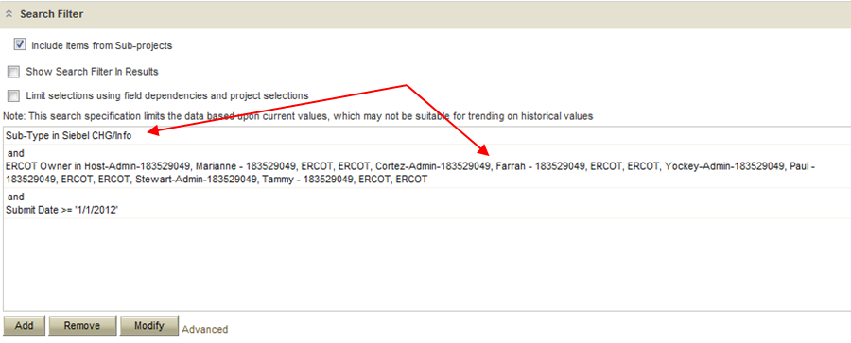

- Additional Options – Contains additional options depending on the type of Duration report. (Fig 1.5.3.6c)
    - Use Logarithmic Scale (Graphs Only): Select this check box to apply a logarithmic scale to your report. You may want to do this to reduce your report results to a manageable range if they cover a large range of values. This option only applies to certain report styles, such as line, scatter and bar charts.
    - Footer: Optionally, supply a footer for your report.
    - Report Item Type: Optionally, you can use this field to filter the items in the report by item type.

Fig 1.5.3.6c
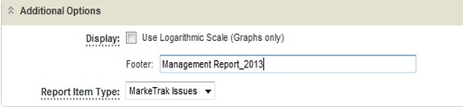

- Drill-Down Display Options – – These options enable you to specify which fields to include in the drill-down reports as well as column widths and sorting criteria. (Fig 1.5.3.6d)
    - Value Display Format: Select this check box to use the default columns for the drill-down report. Clear the check box to enable the Select Columns to Display feature.
    - Select Columns to Display: Select the fields that you want to appear as columns in the drill-down reports. To select or deselect a field, move it to or from the right-hand box using the arrow buttons.
    - Set Custom Field Widths: Optionally, specify the width (in pixels) for the columns in the drill-down reports.
    - Sorting: Select the fields on which you want to sort the data in the drill-down reports.

Fig 1.5.3.6d
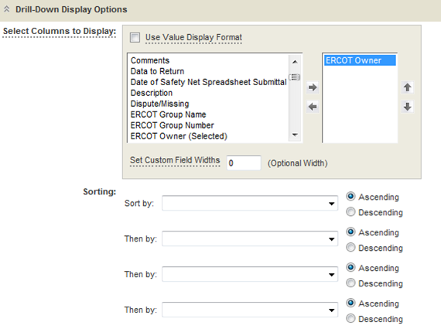

- MarkeTrak Excel Format View

The MarkeTrak application allows for the user to view (open) and export (save) data in an Excel spreadsheet format. Listing-type, tabular-formatted, and graphical reports, as well as most search results may be exported in Excel format by selecting the Export to Excel icon shown below. (Fig 1.6a) The user will be prompted to open, save, or cancel the file download.

Fig 1.6a
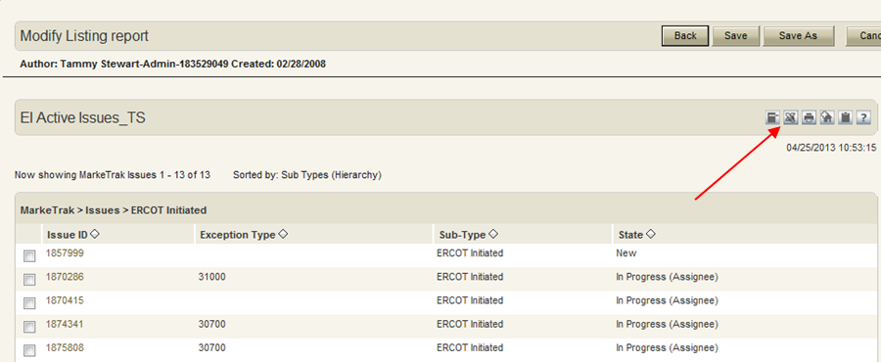

NOTE: In order for the Excel Export to work – the following change should be made to Internet Explorer:

Please refer to section: 1.5.1 Internet Explorer Configuration Changes

NOTE: There is a Microsoft built in feature that allows you to right-click in Internet Explorer and export to Excel. This is not a MarkeTrak feature and does not guarantee the correct formatting of the spreadsheet, which may result in data corruption.

Export limitation:

Exporting data sets from MarkeTrak's Excel functionality to an external source will retrieve the total number of items displayed in the main browser. The display limitation will be set for all users at one thousand (1,000) rows.

Alternate Option: Refer to Section 9 – Reporting Issue Type

- MarkeTrak Rolodex

One Admin user will be assigned to each MP. The Admin user has permission to view and edit Contact information in the “Rolodex” Contact List auxiliary table. “MP Users” have rights to view the entire Contact List (Rolodex).

- Contact Category and Issue Type/Sub-Type Relationships

Contact Category
D2D – 997 Issues
D2D – Cancel with Approval
D2D – Cancel without Approval
D2D – Customer Rescission
D2D – Inadvertent
D2D – Market Rule
D2D – Missing Enrollment TXNs
D2D – Other
D2D – Premise Type
D2D – Projects
D2D – Redirect Fees
D2D – Reject TXNs
D2D – Rep of Record
D2D – Safety Net
D2D – Service Address
D2D – Service Order – 650
D2D – Siebel CHG/Info
D2D – Usage/Billing Dispute
D2D – Usage/Billing Dispute LSE Interval Data
D2D – Usage/Billing Missing
D2D – Usage/Billing Missing LSE Interval Data
DEV – IDR & non IDR
DEV – LSE
DEV – Other All besides LSE, IDR Usage, Non-IDR Usage
LPA – Other Load Profile

- Users with permission to view the MarkeTrak Contacts list will be able to access via the Manage Data button on the Search view of their Navigation Pane: (Fig 1.7.1a)

Fig 1.7.1a
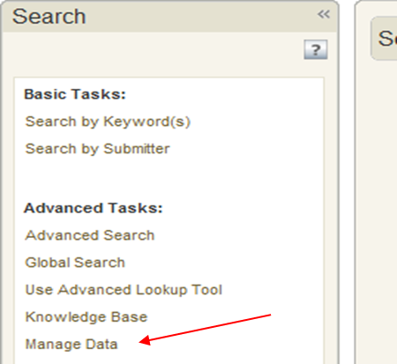

- The user can then select the MarkeTrak Contacts List for viewing (Fig 1.7.1b)

Fig 1.7.1b
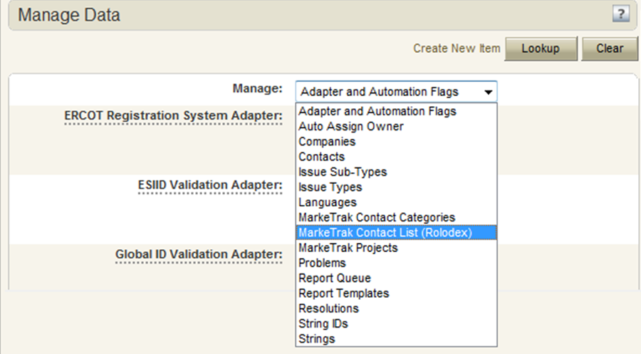

- After entering search criteria and pushing Lookup, a results list will display to the right and the 1st contact listed information will display below. User can scroll thru the list and select the contact of choice. (Fig 1.7.1c)

Fig 1.7.1c
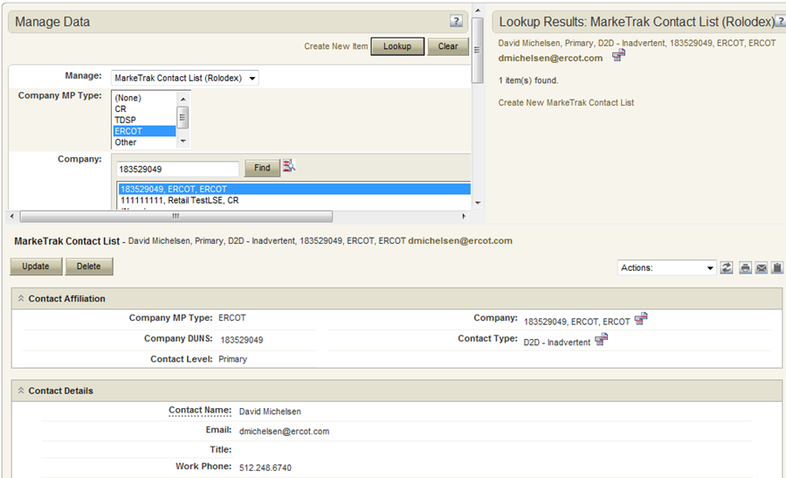

- MP Contact Information will be displayed to the user in this format: (Fig 1.7.1d)

Fig 1.7.1d
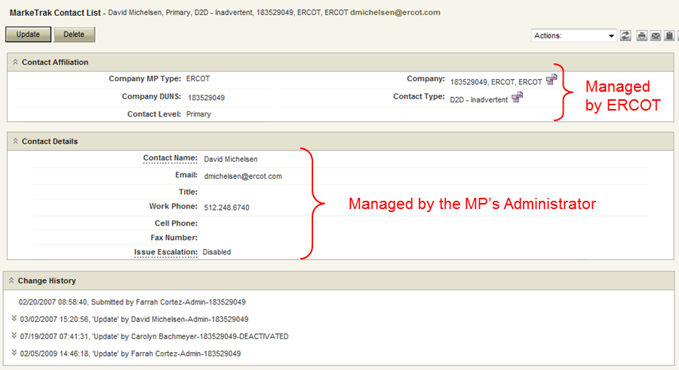

All users will have the permission to view, but not update any fields in the MarkeTrak Contacts table.

Change History will be logged for all changes to each record. The ability to view the Change History can be controlled as needed in the Privilege settings.

UPDATE
A user with proper permissions can update MarkeTrak Contacts information. The user would follow the VIEW method and by pushing the Update button, the user will be taken to an edit window. From here, the user can update the contact information. (Fig 1.7.1e)

Fig 1.7.1e
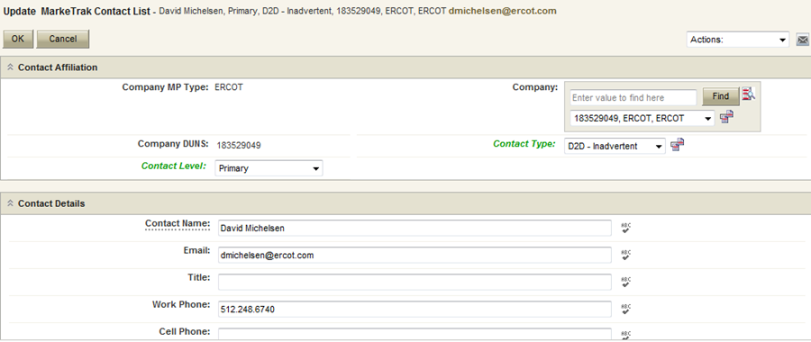

NOTE: Each contact category has an Escalation Primary and Escalation Secondary contact. A valid email address should be populated for both. It will be used by the Escalation Program to email Escalation Primary and Escalation Secondary contacts of issues that need to be transitioned. The issues identified have not proceeded down the workflow process to resolution in a “timely manner” and are in need of attention.
If an Escalation Primary or Escalation Secondary contact does not wish to receive escalation notifications, the Issue Escalation field should be disabled on the contact report.

NOTE: If Escalation contacts are disabled, then MP will not receive Escalation emails. Each MP may have only one (1) Escalation Primary and one (1) Escalation Secondary contact.

Only ERCOT may add new or delete contact categories.

- Reporting

Reports can easily be created for users to search and display MP Contacts Table information. (Fig 1.7.2a)

Fig 1.7.2a
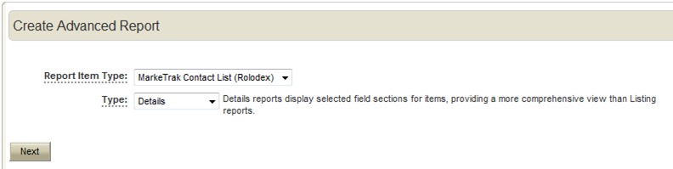

Fig 1.7.2b (Search Filter)
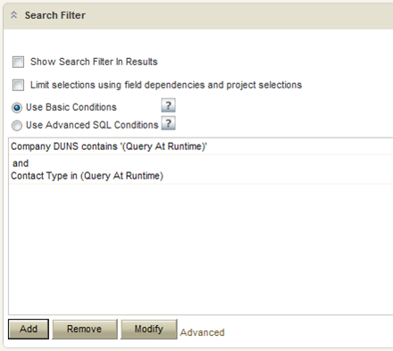

Fig 1.7.2c is an example of a MarkeTrak report that returns a list of MarkeTrak Contacts from a query based on DUNS number and Contact Type. The output of this report is displayed in a customizable column view in the browser and may also be saved as an Excel spreadsheet.

Fig 1.7.2c (Report Query)
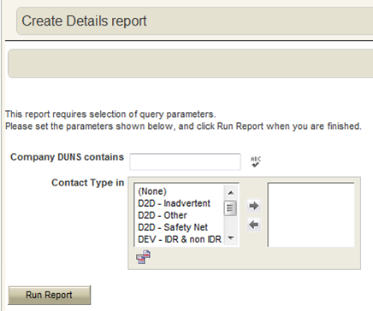

- MarkeTrak Issue Grouping

Grouping
Each individual item submitted into the MarkeTrak application (one service order to be cancelled, one UIDESIID characteristic to be changed, etc) is treated as a separate issue. However, many issue types lend themselves to being worked en masse. Examples include: all variances from an extract on one particular day that a CR wishes to track together or a service history list of many ESI IDs that are retrieved by a TDSP more efficiently collectively. To meet this need, the MarkeTrak application has been designed to allow each Market Participant associated with an issue the ability to create logical groups of items according to their unique business needs. The groups take the form of a Group Number, a Group Name, or both.

Any user with visibility to an issue can view all user groups. This is to aid with communication between different parties. All available group designations are:

Assignee Group
ERCOT Group
Gaining MP Group
Losing MP Group
Submitter Group
TDSP Group

- There are 2 primary methods of grouping items. During submission, the user has the option of updating a check box labeled Assign to Pending. If this functionality is used, the item will not be submitted to a New state when completed but will be transitioned to a state of Pending Issue as shown: (Fig 1.8.1a) Please note if the issue is not submitted and remains in a Pending Issue state for greater than three calendar days, it will auto close. An escalation email will be sent the owner of the issue.

Fig 1.8.1a
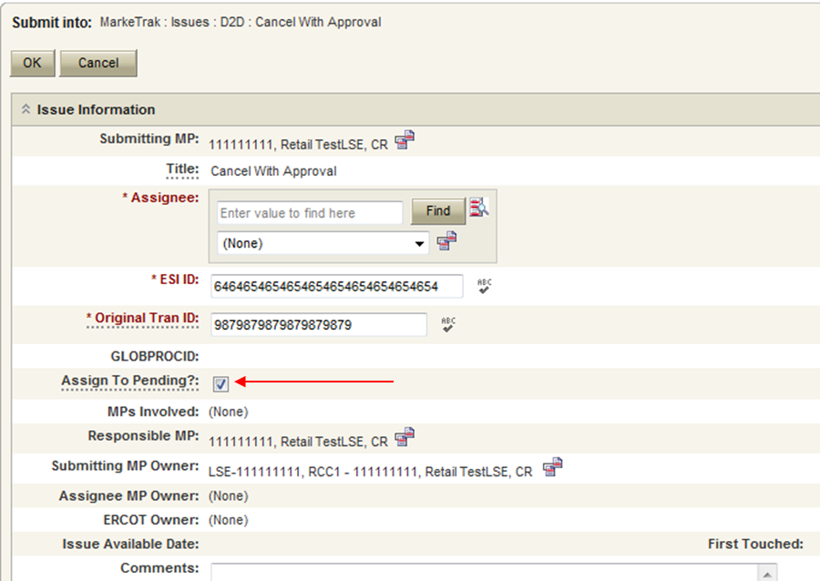

- If a user wishes to submit numerous items and have them submitted for consideration simultaneously with the same group name and/or number a report would be executed including criteria- State = Pending Issue. (Fig 1.8.1b)

Fig 1.8.1b
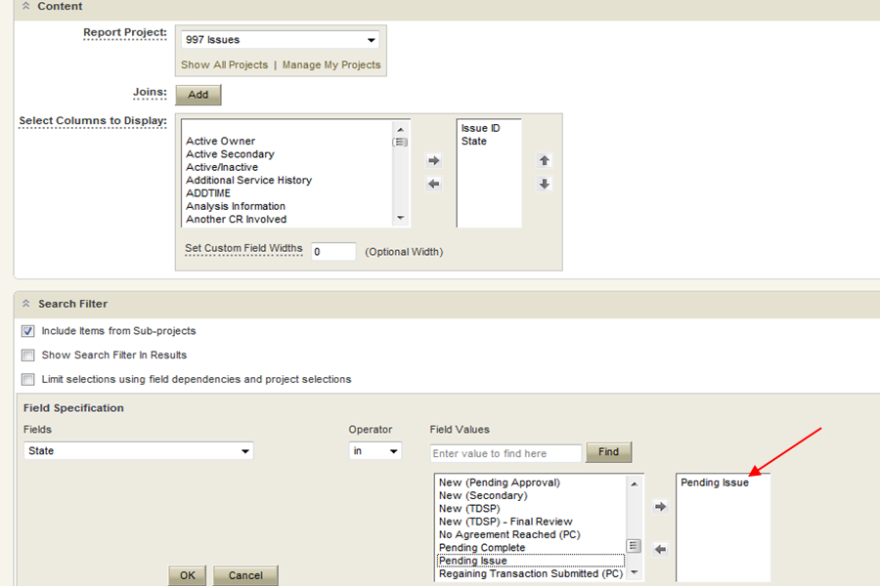

- At this point the items can all be grouped together and submitted via a Mass Transition as detailed in that section. Items that are not in the same state can also be grouped together using this method due to the fact that the Assign to Group transition is available on any issue the user has visibility to. Indicate the issues individually from the result set or select the Check All option. Select the Update All Checked button. From the drop down choose Assign to Group from Any. You will be presented a screen similar to one below: (Fig 1.8.1c) In this case you will have a choice of selecting Replace or Append; you will either choose to replace the group or append or add to the existing group. Append means to add as a supplement or appendix.

Fig 1.8.1c
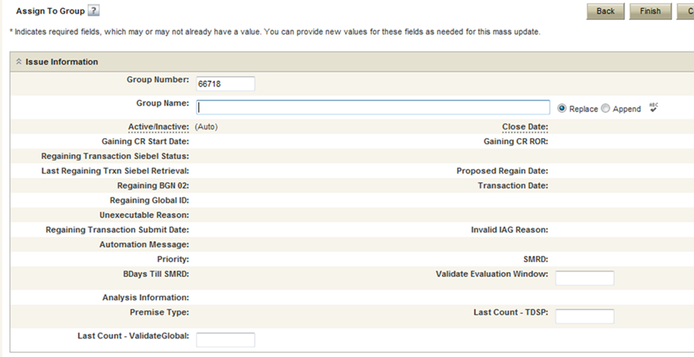

- The Group Number is defaulted as an incremented value by MarkeTrak. It can be changed to a new value. Note that if a group currently exists with this number already assigned this will cause an addition to that group.

- Grouping issues submitted via Bulk Insert functions in a similar manner. After successful submission of the issues the user wishes to group, create the report in Figure 1.8.1b substituting the criteria shown with the field Created by Bulk Insert Issue.

- Provide the Bulk Insert Issue number in the criteria field. When the result set returns select the Check All option. Select the Update All Checked button. From the drop down choose Assign to Group from Any and populate the desired Group information

- The second method of grouping involves placing a single item into a logical group via the Assign to Group transition on each visible issue: (Fig 1.8.1d)

Fig 1.8.1d
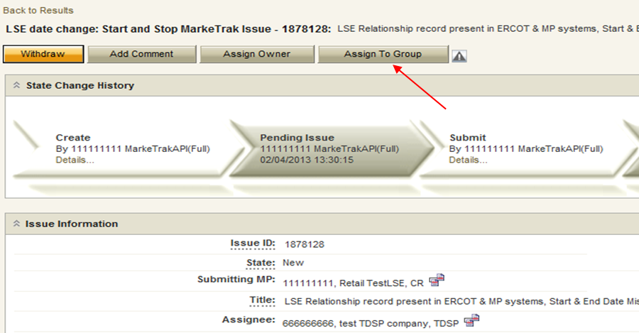

- This will present the option of choosing a Group Number and Group Name in a manner similar to that of the mass transition functionality. However, when assigning issues into groups individually, an incremented Group Number is not generated. This method is designed primarily to allow users to assign issues into preexisting logical groups.

- MarkeTrak Miscellaneous

Auto Close Function
Each of the workflows in the MarkeTrak application has two states that are designated as Pending Complete (PC). Generally one of these states equates to a successful resolution of the request and one indicates the item is Unexecutable. The issue submitter in both of these is the Responsible MP; they alone have the ability to transition the item to another assignee. If necessary the submitter may also request ERCOT Intervention if they do not agree that the issue is complete as indicated.
In the event that the submitter does not transition the item to another owner within a defined period of time (initially 14 calendar days) the issue will auto-transition to state Auto Closed. If the submitter does not agree to the resolution after this transition, a new issue will have to be submitted. Issues cannot be reopened in the MarkeTrak Application.

Notifications

- Automated Email Notifications

The notification system is comprised of emails sent to MP Administrator assigned contacts. The instruction for designating contacts is detailed in section 1.7 MarkeTrak Rolodex. If triggered, MarkeTrak will generate one email per day per contact type. Contacts are parsed in the tool based on sub type combined with escalation primary or escalation secondary designations in the Rolodex function explained in section 1.7. Included in each notification is an attachment (.csv format) containing issue specific information such as IssueID, Date Submitted, and Date of Last Update. Receipt of these emails is indication that the issue has surpassed the time allotted to complete a transition based on issue sub type. Any issue(s) indicated in the attachment not acted upon (transitioned to a different Responsible MP) before the end of the day will be included in a similar email the follow day.

States are not used exclusively to determine how long a particular MP has owned an issue. This is due to the fact that a Market Participant will typically have each item in a New state followed by an In Progress state. Therefore, MarkeTrak calculates the time an item has had the same Responsible MP. For example, a Cancel with Approval issue is submitted to a state of New with assignee designated as TDSP A. During the time the issue is both New and In Progress, it is pending TDSP approval. After 7 days, in an aggregate of these two states details of this issue would be included in an email to the primary and secondary Day to Day: Other contact for TDSP A. This contact information is available to be edited by MP Admins and viewed by all users in the Rolodex feature. For issues that remain in states of New for more than three calendar days an escalation email will be generated to the primary and secondary responsible contact.

Day to Day Issues:
Cancellation:
- Escalation after 7 days without transition
- TDSP Escalation: Siebel Status/Sub-status of the service order should be Cancelled within 24 hours
Inadvertent Switch:
- Responsible MP Escalation: after 7 calendar days without transition
- ERCOT Escalation: 48 hours to update/transition the issue from the “New (ERCOT)” or “In Progress (ERCOT)” states
- Losing MP Escalation: The Regaining Transaction Status should be “Scheduled” or “Complete” within 72 hours of the “Regaining Transaction Submitted”

NOTE: All other D2D Sub Types: Escalation after 28 days

DEV LSE Issues:
LSE Variances:
- 14 calendar days for initial validation and analysis by ERCOT
- 21 calendar days for analysis and response by TDSP or CR
- 40 calendar days for ERCOT & CR to take corrective action.
DEV NIDR and IDR Usage Variances:
- 45 calendar days for TDSP validation and analysis to be completed
- 30 calendar days for TDSP to send transactions (if necessary) or for CR to manually update their system (if needed)
DEV ESI ID Characteristics:
- 45 calendar days for TDSP validation and analysis to be completed
- 30 calendar days for TDSP to send transactions (if necessary) or for CR to manually update their system (if needed)
DEV ESI ID Existence:
- calendar days for initial validation and analysis by ERCOT
- 65 calendar days for TDSP to send transactions (if necessary)

Load Profile Assignment (LPA) Issues:
LPA Profile Type:
- Escalation after 30 days
LPA Premise Type:
- Escalation after 30 days
LPA Zip Code:
- Escalation after 45 days
LPA Meter Type:
- Escalation after 30 days
LPA Weather Sensitivity:
- Escalation after 60 days
LPA Weather Zone:
- Escalation after 90 days
LPA Sub-Station:
- Escalation after 45 days
- Individual Email Notifications

Each user with access to an item has the ability to manually select a notification related specifically to that individual issue. There are currently six such notifications created. The email address entered in MarkeTrak for the user who selects this option from the Actions: drop down list will be the destination for this email notification. (Fig 1.9.2.2a)

Fig 1.9.2.2a
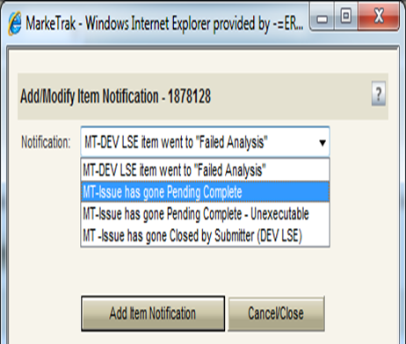

The available options are:

- MT- Issue has gone Pending Complete
Email notification will be sent to the user if the issue enters the appropriate Pending Complete state for the workflow to which it is associated.
- MT – Issue has gone Pending Complete –Unexecutable
Email notification will be sent to the user if the issue enters the appropriate Unexecutable- Pending Complete state for the workflow to which it is associated.
- MT – Issue acknowledged by Assigned MP (Begin Working)
Email notification will be sent to the user anytime an MP selects the transition Begin Working which identifies the issue owner.
- MT – DEVLSE item went to “Failed Analysis”
Email notification will be sent to the user if the DEVLSE issue enters the state Failed Analysis as detailed in the DEVLSE section of this document.
- MT – Issue has gone Closed by Submitter (DEV LSE)

NOTE: Email notification will be sent to the user if the Close button was selected on a DEV LSE issue sub-type.

- MT – Background Report has been prepared
Email notification will be sent to the user when the background report is complete.

Duplicate Checking
There are two types of duplicate checking in the MarkeTrak system: ESI ID and GLOBPROCID. These checks are designed to help avoid MPs submitting an issue if the same request is already ‘in flight’. A common example of this is an Inadvertent Switch which can be submitted by two CRs and DEVLSE issues which can be submitted by multiple CRs and the TDSP involved. As with the ESI ID Validation described above, the submitter can elect to press OK to continue with submission or Cancel if it is realized that the same request has already been submitted.
- After the ESI ID validation described in1.9.4, another check occurs exclusively in the MarkeTrak application. If this ESI ID has been submitted on an issue that the current submitting MP has visibility to, a warning message will appear indicating the Issue ID and issue sub type of those issues with a hyperlink to the issue that exist in the live database. Once selected, the issue will open in a new IE window. (Fig 1.9.3a) As detailed in the relevant section of this document, visibility is determined by the current user’s MP Duns being populated in the MPs Involved field of the potential duplicate issue.
- GLOBALPROCID (or Global_ID) functions in exactly the same manner as ESI ID above with the exception that it only occurs when both an ESI ID and Original Tran ID are included in the submission info. This will most likely occur on Day to Day (D2D) Issues. A duplicate GLOBPROCID message indicates that the exact originating transaction the submitter is requesting has already been submitted against. (Fig 1.9.3b)

Fig 1.9.3a
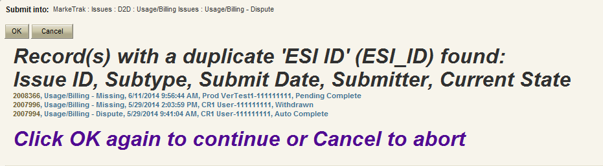

Fig 1.9.3b
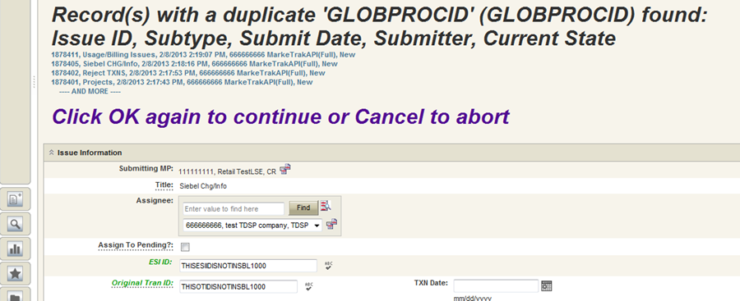

ERCOT Registration System Validation
Each time an ESI ID is submitted on an issue in MarkeTrak, a validation is performed against the ERCOT Registration System. On the first screen after the initial data is entered, a warning message could populate near the top of the Main Browser window indicating that the ESI ID does not exists at ERCOT. This is merely a warning; if the user deems the issue is nonetheless valid the screen can be bypassed by clicking on the OK button. If the user determines the ESI ID entered was entered in error, a corrected ESI ID could be populated and re-validated or Cancel could be selected to discontinue the submit process. A validation is also performed on the original tran ID and the tran ID field. An error will generate if the user attempts to enter invalid data in either of these fields. These fields cannot contain special characters.

Below is a demonstration of the message received when the ESI ID submitted does not exist in ERCOT’s Registration System.

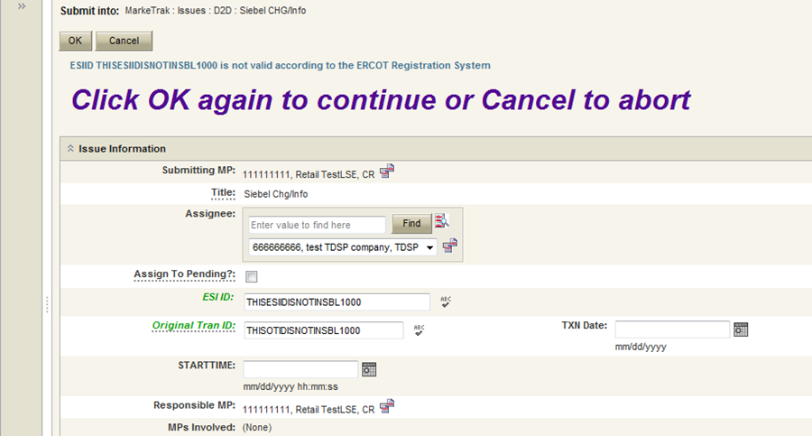

Below is an example of the message received when a date is entered into the tran id field.
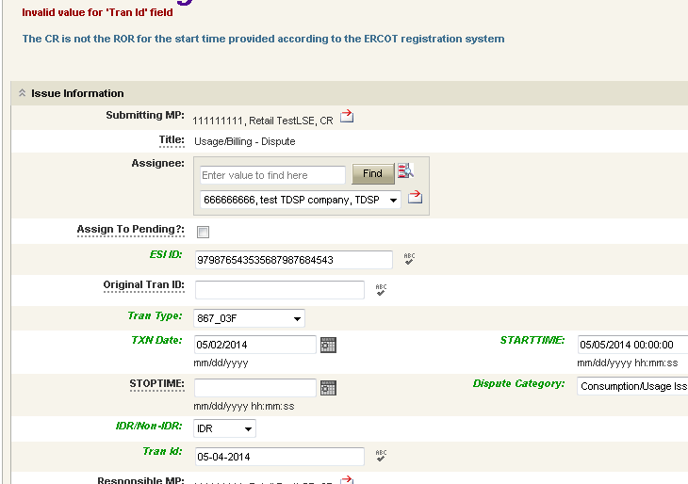

CR Validation – On Siebel Change/Info issues, if neither the Submitter nor Assignee is the Submitting LSE of the Global ID in ERCOT’S Registration System, an error message will return the following message “The ESIID / Tran ID combination provided is not associated with this CR according to the ERCOT Registration System. Correct and click OK again to continue or Cancel to Abort.”

TDSP Validation – During the Issue Submit if the TDSP returned from ERCOT’s Registration System for the ESIID involved does not match the TDSP on the issue being submitted, it will return the following error message “The ESIID provided is not associated with this TDSP according to the ERCOT Registration System. Please enter a valid ESIID to continue or Cancel to Abort”. This validation will occur on all issue types/subtypes except for Inadvertent Gains – Gaining, Inadvertent Gains – Losing, and 997.

Evaluation Window Validation

- MarkeTrak has added a validation to verify that the “Cancel With Approval” issue is being submitted within the Evaluation Window for the scheduled transaction.

  - If transaction type = 814_01(Switch) the Evaluation Window is 1 Business Day prior to the SMRD
  - If transaction type = 814_16 (Move In) the Evaluation Window is 1 Business Day prior to the SMRD
  - If transaction type = 814_24 (Move Out) the Evaluation Window is 1 Business Day prior to the SMRD
  - MarkeTrak will automatically populate the applicable Tran Type to the issue.

  - Warning Message: “Issue is being submitted outside of the Evaluation Window and transaction should be canceled using an 814_08.”

Siebel Status and Sub Status
Certain Day to Day (D2D) Issue Sub Types either require or allow the entry of both an ESI ID and Original Tran ID. In these instances a GLOBPROCID (Global_ID) will be created by the MarkeTrak application.

In these instances a Siebel Status and Siebel Sub status will be populated. (Fig 1.9.5a) This will aid both the Submitter and Assignee(s) in determining the proper resolution to the request. Additionally, the Last Siebel Status Retrieval Date is populated. Each of these three fields can be updated at any time via a transition labeled Update Siebel Status/Sub status which is available on all appropriate issues to any of the MPs Involved. The example above demonstrates a use for this data; a Cancel with Approval request has been submitted by a CR. By the time the TDSP received the issue for consideration of approval, the transaction had already cancelled due to an ERCOT Operating Rule. The TDSP could therefore select transition Already Cancelled which would place the request into a Pending Complete state. Should the Siebel Status indicate a pending status for the transaction in question, the TDSP could update the Siebel Status/Substatus via the button indicated above. This would ensure the request is still valid before the user begins work outside of the MarkeTrak application.

Fig 1.9.5a
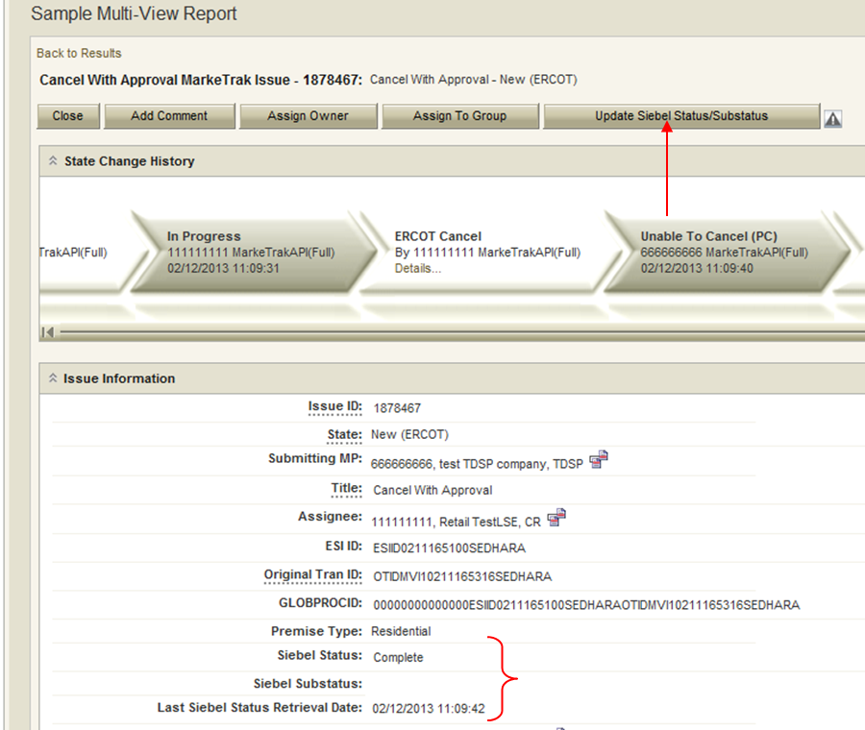

Item Lock
An item becomes locked in the MarkeTrak application when a transition is initiated and not completed. This typically results from two scenarios.
The first one involves a transition that is initiated by a user with necessary rights, but who navigates to another location in the application before completion.
A second scenario which would result in an issue being locked begins with the initiation of an invalid transition. There are circumstances in certain workflows in which a Market Participant may have visibility to a transition button but not the right to execute it. This is a result of the visibility and ownership model necessary to meet all business needs of each MP types simultaneously. This will display an error message with the reason for the failed transition. At this point if the user navigates to another location in the application without selecting the Cancel button the item will become locked. An example is provided below: (Fig 1.9.6a)

Fig 1.9.6a
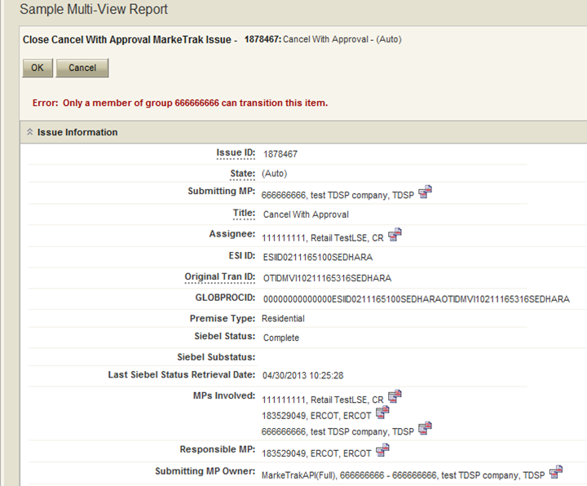

Any time an error message such as this is received indicating that the current user is not able to execute a transition, the Cancel button must be selected to avoid locking the item.

If an item has been locked and another user attempts to transition the item, a screen similar to the one below will be displayed. This will indicate that the transition cannot be completed as well as the username of the person who created the lock: (Fig 1.9.6b)

Fig 1.9.6b
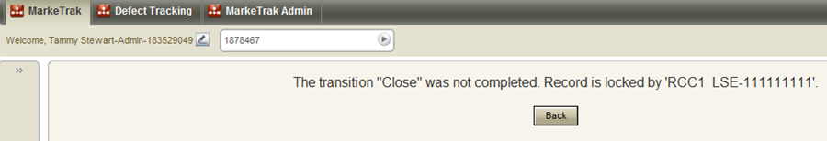

If the user who created the item lock does not Cancel the failed transition, the item will unlock itself in one of two ways. Logging out of the application will clear any locks the user has created. In addition, if the user closes the browser the MarkeTrak application is on the item will automatically unlock itself after a predetermined amount of time.

Auto Logoff

For any user that is inactive (not selecting any buttons in the application) for 2.5 consecutive hours the system will automatically log you off.

Issue Archiving

The MarkeTrak Application will archive any issue that has been closed for 7 months. Archived issues will not be returned in normal reports and searches executed thru the MarkeTrak GUI or API.

To access data about archived MarkeTrak issues, users should utilize the Background Reporting feature and in the Data to Return: radial parameter, select either Archived or Both. Selecting Archived will return only those issues which fit the parameters selected in the report that are archived. Selecting Both will return all un-archived (or Live) data as well as archived issues which fit the rest of the parameters provided in the Background Report.

NOTE: Issues which have been Closed by ERCOT will not return potentially proprietary issue details whether accessed from the Archive or Live production data.

- Day to Day (D2D) Issues

What Constitutes a MarkeTrak D2D Issue?

There are many possible scenarios that may require the logging of a MarkeTrak. The following list provides only a small sampling of some of these scenarios.

- CRs
• Questions pertaining to why an ESIID is not in ERCOT system
• Questions pertaining to Inadvertent Gains
• Questions pertaining to Siebel Reports
• Questions pertaining to Rejected transactions
• Questions pertaining to request for filenames
• Questions pertaining to 997 reports
• Questions pertaining to transaction status updates
• Questions pertaining to CSAs
• Questions pertaining to Reject Reasons (i.e. why a CR received a “Not First In” response to transaction they submitted
• Questions pertaining to missing usage transactions
• Questions pertaining to whether or not ERCOT received a specific transaction
- Questions pertaining to a premise type
- Questions pertaining to a particular service address
- CR or TDSP
• Requests for cancellation of transactions
• Questions pertaining to why a transaction was cancelled
• Questions pertaining to missing information on non-required EDI fields
• Request for processing of transactions
• Questions pertaining to Texas SET
• Questions pertaining to who ERCOT shows as the Rep of Record in ERCOT system
• Questions pertaining to the processing time of transactions (Protocols)
• Questions pertaining to MIS
• Questions pertaining to point-to-point transactions (such as 810s) with TDSPs, excluding the 867 Contingency Plan
- Questions pertaining to service order – 650 transactions
- TDSP
• Questions pertaining to Siebel not reflecting the correct status based on that the TDSP has submitted
- Requesting a CR to follow up with a backdated MVI pertaining to a safety net order request
- Requesting a CR to follow up with a MVO due to a meter removal

Day to Day Issue Guidelines

- Validating Issues

Before Submitting a D2D issue, MPs must validate the issue against the market reports and market resource:
- Service order Full Extract Report
- Located on the Market Information System website (MIS)
- ERCOT MIS ESIID Look-Up/Transaction Look-Up
- ERCOT Market Participant (MP) Transaction Report
- Located in the FTP Reports Mailbox for each Market Participant

- Submitting Issues

A MarkeTrak issue shall be opened one ESI ID per issue. An issue with multiple ESIID’S noted in the comments or provided in an attachment shall only be resolved for the ESI ID noted in the ESI ID field of the issue. A note shall be added to the comments to state that the remaining ESI ID’S must be submitted individually.

NOTE: To submit multiple issues at one time, refer to the Bulk Insert Process Section 8.

- Working Issues

ERCOT D2D issues received by noon will be worked in the queue (from New to In Progress or further along in the workflow) by 5:00 p.m. the same business day. ERCOT D2D issues received after noon will be worked in the queue by noon the next business day.

Within seven (7) business days after a MarkeTrak issue is created, the issue shall be reviewed, analyzed and resolved by the responsible MP (or ERCOT) to whom the issue is assigned. If the MP (or ERCOT) cannot resolve the issue within seven (7) business days, the MP (or ERCOT) shall provide a weekly update by adding a comment, not transitioning until the issue is resolved.

Day to Day Issues Required Fields

- Day to Day Required Fields

Refer to Section 10_Appendix – MarkeTrak “Bulk Insert” Method Appendix A – D2D Issues

- Field Descriptions

Field | Max Length/Field Description
Active/Inactive | Active, Inactive
Assign To Pending? | Leaves the issue in a Pending State with the Submitter
Assignee | MP DUNs, Name, Type
Assignee Company Duns | Text - max of 4000 characters
Assignee Group Name | Text - max of 80 characters
Assignee Group Number | Any integer
Assignee MP Owner | MarkeTrak Contact
Bday till SMRD | Business days till the Scheduled Meter Read Date
Category | ERCOT Initiated Issue
Close Date | Example: 05/02/2006 16:26:45 (19 characters)
Comments | Text - max of 4000 characters
CR Association Validation | Bulk Insert/API - Error
Description | Text - max of 4000 characters
Dispute/Missing? | Dispute or Missing
ERCOT Group Name | Text - max of 80 characters
ERCOT Group Number | Any integer
ERCOT Owner | MarkeTrak Contact
ESI ID | Text - max of 36 characters
Exception Code | Text - max of 5 characters
ESIID Duplication Check | Bulk Insert/API: 0=false or 1=true
ESIID Validation | Bulk Insert/API: 0=false or 1=true
Evaluation Window Validation | Bulk Insert/API: 0=false or 1=true
First Touched Date | Example: 05/02/2006 16:26:45 (19 characters)
First Touched by TDSP | Example: 05/02/2006 16:26:45 (19 characters)
Gaining CR ROR | Yes or No
Gaining CR Start Date | Example: 05/02/2006 00:00:00 (19 characters)
Gaining MP | MP DUNs, Name, Type
Gaining MP Group Name | Any Integer
Gaining MP Group Number | Text - max of 80 characters
Gaining MP Owner | MarkeTrak Contact
GLOBPROCID | Text - max of 128 characters
Group Name | Text - max of 80 characters
Group Number | Any integer
GS Number | Text - max of 9 characters
IDR/Non-IDR | IDR/Non-IDR
ISA Field | Text – max of 9 characters
Issue ID | Text - max of 16 characters
IssueStatus | New, Working, Withdrawn, Pending Complete, Closed
IssueAvailableDate | Example: 05/02/2006 16:26:45 (19 characters)
Issue Type | List of Issue Types
Invalid IAG Reason | List of IAG Reasons
Last Count – ESI ID | Any integer
Last Count – Global ID | Any integer
Last Modified Date | Example: 05/02/2006 16:26:45 (19 characters)
Last Modifier | MarkeTrak Contact
Last New Date/Time | Example: 05/02/2006 16:26:45 (19 characters)
Last Regaining Trxn Siebel Retrieval | Example: 05/02/2006 16:26:45 (19 characters)
Last Siebel Status Retrieval Date | Example: 05/02/2006 16:26:45 (19 characters)
Last State Change Date | Example: 05/02/2006 16:26:45 (19 characters)
Last State Change | MarkeTrak Contact
Losing MP | MP DUNs, Name, Type
Losing MP Group Name | Text - max of 80 characters
Losing MP Group Number | Any integer
Losing MP Owner | MarkeTrak Contact
Meter Removal Date | Example: 05/02/2006 16:26:45 (19 characters)
MPs Involved | Company in MarkeTrak
New Premise Type | Text - max of 64 characters
New Service Address | Text - max of 80 characters
New Service City | Text - max of 80 characters
New Service State | Text - max of 2 characters
New Service Zipcode | Text - max of 5 characters
New ZIPCODE | Text - max of 5 characters
Number Of Rows | Text
Origin | Text - max of 64 characters
Original Tran ID | Text - max of 30 characters
Owner | MarkeTrak Contact
Owner To Assign | Text - max of 64 characters
Parent Issue Number | Text – max of 16 characters
Premise Energize Date | Example: 05/02/2006
Premise Type | Text - max of 64 characters
Priority Flag | SMRD <= 2 then set to “Yes”
Proposed Regain Date | Example: 05/02/2006 00:00:00 (19 characters)
Regaining BGN 02 | Min/max length – 1/30 characters
Regaining BGN Requested Date | Example: 05/02/2006 00:00:00 (19 characters)
Regaining BGN Priority Code | Text - max of 5 characters
Regaining Transaction Siebel Status | Text - max of 80 characters
Regaining Transaction Submit Date | Example: 05/02/2006
Reject Code | List of Reject Codes
REP CODE | Text - max of 5 characters
Requested Move In Date | Example: 05/02/2006
Responsible MP | MP DUNs, Name, Type
Return CR DUNS | Text - max of 80 characters
Return TDSP DUNS | Text - max of 80 characters
Secondary Owner | MarkeTrak Contact
Service Address | Text - max of 80 characters
Service City | Text - max of 80 characters
Service State | Text - max of 2 characters
Service Zipcode | Text - max of 5 characters
Siebel Status | Text - max of 80 characters
Siebel Substatus | Text - max of 80 characters
SMRD | Example: 05/02/2006
Source | GUI, API, Bulk Insert
Spreadsheet Submit Date | Example: 05/02/2006 16:26:45 (19 characters)
State | Text - max of 64 characters
STATUS | Text - max of 64 characters
Submit Date | Example: 05/02/2006 16:26:45 (19 characters)
Submitter | MarkeTrak Contact
Submitter Group Name | Text - max of 80 characters
Submitter Group Number | Any integer
Submitting Company DUNS | Text - max of 80 characters
Submitting MP | MP DUNs, Name, Type
Submitting MP Company | Text - max of 80 characters
Submitting MP Owner | MarkeTrak Contact
Submitting MP Type | Text - max of 80 characters
Submitting MP_DUNS Number | Text - max of 64 characters
Substation Percent | Numeric – max of 11 characters
Sub-Type | All MarkeTrak Issue Sub-Types
Sub-Types | All MarkeTrak Issue Types and Sub-Types
TDSP Group Name | Text - max of 80 characters
TDSP Group Number | Any integer
TDSP Involved | DUNS
TDSP Involved Owner | MarkeTrak Contact
TDSP Validation | Bulk Insert/API: 0=false or 1=true
TIMESTAMP | Example: 05/02/2006 16:26:45 (19 characters)
Tran ID | Text – max of 30 characters
Transaction Date | Example: 05/02/2006 16:26:45 (19 characters)
Tran Type | List of values
TXN Date | Example: 05/02/2006 (10 characters)
Unexecutable Reason | List of Unexecutable Reasons
ZIP | Text - max of 5 characters

