
May 2014 ERCOT Monthly Operations Report

Reliability and Operations Subcommittee Meeting
July 10, 2014
Table of Contents
1. Report Highlights 1
2. Frequency Control 2
2.1. Frequency Events 2
2.2. Responsive Reserve Events 3
2.3. Load Resource Events 3
3. Reliability Unit Commitment 3
4. Wind Generation as a Percent of Load 4
5. Congestion Analysis 4
5.1. Notable Constraints for May 4
5.2. Generic Transmission Limit Congestion 6
5.3. Congestion Costs for Calendar Year 2014 6
6. System Events 7
6.1. ERCOT Peak Load 7
6.2. Load Shed Events 7
6.3. Stability Events 7
6.4. Notable PMU Events 7
6.5. TRE/DOE Reportable Events 7
6.6. New/Updated RAPs and PCAPs 8
6.7. New/Modified/Removed SPS 8
6.8. New Procedures/Forms/Operating Bulletins 8
7. Emergency Conditions 8
7.1. OCNs 8
7.2. Advisories 8
7.3. Watches 8
7.4. Emergency Notices 8
8. Application Performance 8
8.1. TSAT/VSAT Performance Issues 8
8.2. Communication Issues 8
9. Net-Forecast Bias Applied to NSRS Procurement for June 2014 9
10. Appendix A: Real-Time Constraints 10

Report Highlights
May was another mild month on the ERCOT Interconnection. Operations continued to note a low level of frequency events and RRS deployments. The amount of SCED congestion again held steady in May and was attributed primarily to ongoing outages. There were no reportable system events in May and no issues with ERCOT applications.

Highlights of this report:
- The unofficial ERCOT peak for May was 52,625 MW.
- There were four frequency events in May, three of which were significant enough for PMU data to be captured. The ERCOT system transitioned well in each case.
- There were four instances where Responsive Reserves were deployed. All of these were the result of frequency events.
- RUC Commitments in May were mainly the result of local congestion.
- The level of SCED congestion remained steady again in May and was mainly due to ongoing outages.
- There were no reportable system events.
- ERCOT Applications performed well. There were no issues in May.

Frequency Control

Frequency Events
The ERCOT Interconnection experienced four frequency events in May, two of which resulted from Resource trips. The average event duration was approximately 37 seconds, which was consistent with the system performance observed in previous months.

When analyzing frequency events, ERCOT evaluates PMU data according to industry standards. Events with an oscillating frequency of less than 1 Hz are considered to be inter-area, while higher frequencies indicate local events. Industry standards specify that damping ratio for inter-area oscillations should be 3.0% or greater. All events listed below indicate the ERCOT system met these standards and transitioned well after each disturbance. Further details on the Resource trip events can be seen in the Performance Disturbance Compliance Working Group report.

A summary of the frequency events is provided below:

Date and Time | Max/Min Frequency  (Hz) | Duration of Event  (seconds) | PMU Data |  | Comments
Date and Time | Max/Min Frequency  (Hz) | Duration of Event  (seconds) | Oscillation Mode | Damping Ratio | Comments
5/1/2014 15:13 | 59.852 | 22 | 0.95 Hz | 20.4% | Unit trip with approximately 584 MW
5/12/2014 0:04 | 59.884 | 87 | No significant oscillation modes captured |  | Numerous units coming offline at 00:00 and no additional URS available.
5/15/2014 4:20 | 59.854 | 17 | 0.77 Hz | 9.9% | Unit trip with approximately 520 MW
5/17/2014 0:47 | 59.810 | 23 | 0.77 Hz  0.9 Hz | 10.7%  5.56% | DC Tie trip with approximately 568 MW

(Note: the duration of the frequency events is defined to be the time at which the frequency was outside the range of 60±0.1 Hz)

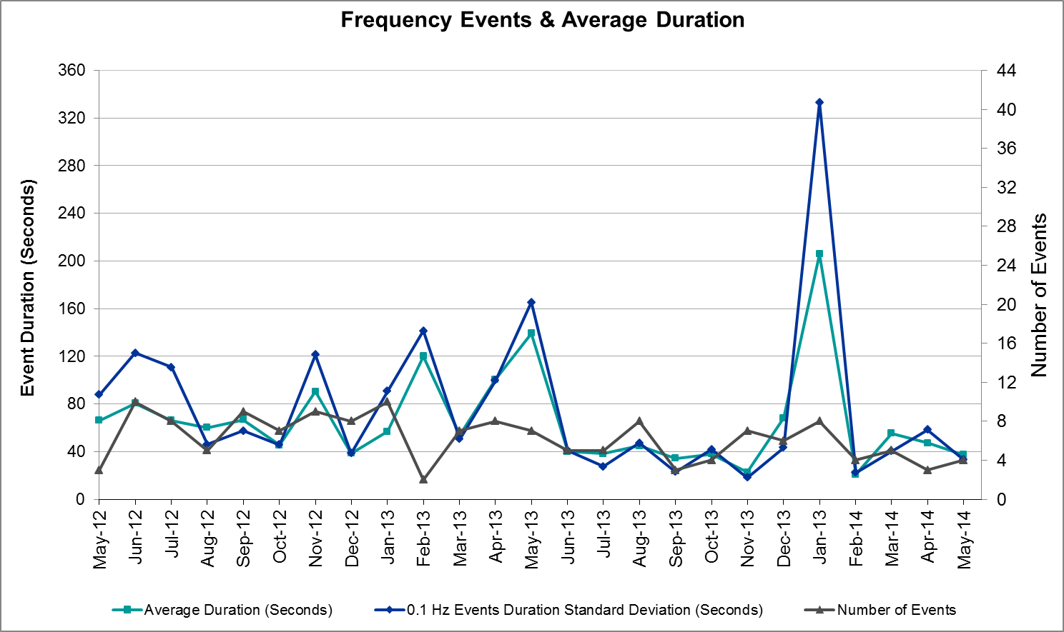

Responsive Reserve Events
There were four events where Responsive Reserve MWs were released to SCED in May. The events highlighted in blue were related to frequency events reported in section 2.1 above.

Date and Time  Released to SCED | Date and Time  Recalled | Duration of Event | Maximum MWs Released | Comments
5/1/14 15:13:56 | 5/1/14 15:17:48 | 0:03:52 | 396.09
5/12/14 0:04:23 | 5/12/14 0:09:24 | 0:05:01 | 619.7
5/15/14 4:20:34 | 5/15/14 4:23:54 | 0:03:20 | 499.68
5/17/14 0:47:34 | 5/17/14 0:50:42 | 0:03:08 | 582.05

Load Resource Events
There were no load resource deployment events in May.

Reliability Unit Commitment
ERCOT reports on Reliability Unit Commitments (RUC) on a monthly basis. Commitments are reported grouped by operating day and weather zone. The total number of hours committed is the sum of the hours for all the units in the specified region. Additional information on RUC commitments can be found on the MIS secure site at Grid → Generation → Reliability Unit Commitment.

There were no DRUC commitments in May.
HRUC Commitments
Resource Location | # of Resources | Operating Day | # Hours Committed | Total MWhs | Reason for commitment
Southern | 1 | 5/3/2014 | 5 | 1,714 | Local Congestion
N. Central | 4 | 5/6/2014 | 17 | 4,896 | Local Congestion
N. Central | 1 | 5/7/2014 | 13 | 7,384 | Local Congestion
Southern | 1 | 5/19/2014 | 7 | 1,631 | Local Congestion
S. Central | 1 | 5/19/2014 | 1 | 46 | Local Congestion
S. Central | 1 | 5/21/2014 | 9 | 414 | Local Congestion
S. Central | 1 | 5/22/2014 | 13 | 598 | Local Congestion
S. Central | 1 | 5/23/2014 | 9 | 414 | Local Congestion
N. Central | 2 | 5/29/2014 | 6 | 1,170 | Capacity

Wind Generation as a Percent of Load
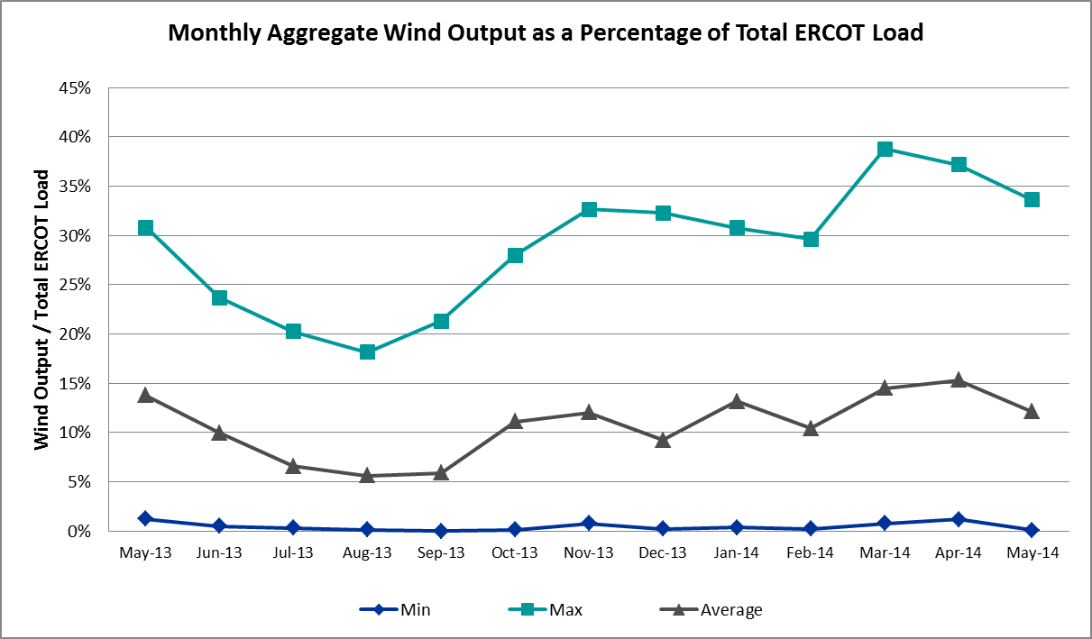

Congestion Analysis
The number of congestion events experienced by the ERCOT system remained steady again in May. Since the weather again mild for most of the month, most of the reportable congestion events were related to ongoing outages. There was no activity on any of the GTLs in May.

Notable Constraints for May
Nodal protocol section 3.20 specifies that ERCOT shall identify transmission constraints that are active or binding three or more times within a calendar month. As part of this process, ERCOT reports congestion that meets this criterion to ROS. In addition ERCOT also highlights notable constraints that have an estimated congestion rent exceeding $1,000,000 for a calendar month. These constraints are detailed in the table below. Rows highlighted in blue indicate the congestion was affected by one or more outages. For a list of all constraints activated in SCED for the month of March, please see Appendix A at the end of this report.

Contingency | Overload | # of Days Constraint Active | Estimated Congestion Rent | Transmission Project
Skywest - Spraberry Switch 138 kV | Midland East - Pecan Grove 138 kV | 2 | $6,151,682 | 14TPIT0052
Falcon Seaboard - Midland East 345 kV | Odessa - Odessa North 138 kV | 1 | $4,019,338 | 14TPIT0054
DCKT Sargent Road - Industrial Blvd 138 kV | Sargent Road - Saint Augustine Tap 2 138 kV | 1 | $3,731,995 | 19TPIT0001
Willow Valley Switch MR1H 345/138 kV | Norwood Switch - Chancellor Row 138 kV (3416_A) | 1 | $2,948,197 | 16TPIT0061
Skywest - Spraberry Switch 138 kV | Pecan Grove - Buffalo 138 kV | 1 | $2,358,632 | 14TPIT0052
West Columbia Main Tnp - West Columbia 138 kV (_WC_WCO2) | West Columbia Main Tnp - West Columbia Local Tnp 138 kV | 8 | $1,984,244
DCKT Norwood Switch - Liggett Switch and Cedar Hill Switch 345 kV | Tri Corner - Seagoville Switch 345 kV | 1 | $1,854,388 | 07TPIT0126
Orange Grove Switching Station - Lon Hill 138 kV | Lon Hill - Smith 69 kV | 10 | $1,752,515 | 16TPIT0026
Moss Switch Axfmr 1 345/138 kV | General Tire Switch - Southwestern Portland Tap 138 kV | 5 | $1,695,135
Victoria - Coleto Creek 138 kV (COLETO_VICTOR1) | Victoria - Coleto Creek 138 kV (COLETO_VICTOR2) | 18 | $1,560,164 | 14TPIT0109, 15TPIT0067, and 16TPIT0034
DCKT Jewett - Singleton 345 kV | Twin Oak Switch - Btu_Jack_Creek 345 kV | 13 | $1,471,533 | TPIT Project 3937
Odessa North - Moss Switch 138 kV | Holt Switch AXFMR1 138/69 kV | 1 | $1,355,288
Moss Switch Axfmr 1 345/138 kV | General Tire Switch - Southwestern Portland Tap 138 kV | 4 | $1,319,858 | 15TPIT0097
Laquinta - Lobo 138 kV | Bruni 138_69_1 138/69 kV | 19 | $1,262,889 | 13TPIT0148
Koch Up River - Gila 138 kV | Gila - Hiway 9 138 kV (GILA_HIWAY_2) | 8 | $1,079,921
DCKT Gibbons Creek - Singleton 345 kV | Jewett - Singleton 345 kV (260_A) | 11 | $959,673 | TPIT Project 3937
DCKT Wa Parish - Jeanetta 345 kV | Smithers - Bellaire 345 kV | 6 | $747,161 | 14TPIT3257
Gibbons Creek - Singleton 345 kV (SNGXGC75) | Gibbons Creek - Singleton (SNGXGC99) | 9 | $438,524 | TPIT Project 3937
DCKT Braunig - Brooks and Grandvew 138 kV | Kenedy Switch - Lyssy | 3 | $360,752 | 11TPIT0167
Nelson Sharpe - Lon Hill 345 kV | Celanese Bishop - Kleberg Aep 138 kV | 4 | $308,037 | 15TPIT0069
DCKT Whitepint - Lon Hill and South Texas Project 345 kV | Rincon - Airco Aep 138 kV | 8 | $196,093
Gibbons Creek - Singleton (SNGXGC99) | Gibbons Creek - Singleton 345 kV (SNGXGC75) | 5 | $104,908 | TPIT Project 3937
Bosque Switch - Whitney 138 kV | Bosque Switch - Lake Whitney Tnp 138 kV | 4 | $71,315 | 2013-R9, 2013-R13, and 2013-R42

Generic Transmission Limit Congestion
There was no activity on any ERCOT GTLs in May.

Congestion Costs for Calendar Year 2014
The following table represents the top twenty active constraints for the calendar year to date based on the estimated congestion rent attributed to the congestion. ERCOT updates this list on a monthly basis.

Contingency | Binding Element | # of 5-min SCED Intervals | Estimated Congestion Rent | Transmission Project
Lytton Springs LY_AT2 345/138 kV | Lytton Springs LY_AT1 345/138 kV | 1,989 | $55,956,002
Midland East Axfmr 1 (3) 345/138 kV, Moss Switch Axfmr 1 345/138 kV, and Midland East - Moss Switch - Odessa Ehv Switch 345 kV | Odessa North Sd3 138 kV | 5,310 | $23,944,433 | 2012-R3, 2012-R4
Basecase | Valley Import | 495 | $11,577,259
DCKT Jewett - Singleton 345 kV | Twin Oak Switch - Gibbons Creek 345 kV | 273 | $10,912,808
DCKT Gabriel - Glasscock LCRA and Rivery 138 kV, Glasscock LCRA - Gabriel 138 kV, and DCKT Gabriel - Bell County - Hutto Switch 138 kV | Marshall Ford - Lago Vista 138 kV | 209 | $9,871,526 | 15TPIT0061
DCKT Paris Switch - Valley Ses and Valley South 345 kV | Paris Switch AXFMR1 (3) 345/138 kV | 1,442 | $9,291,357 | 14TPIT0093
DCKT Wa Parish - Jeanetta 345 kV | Smithers - Bellaire 345 kV | 1,058 | $7,870,155
Alice - Kingsville 138 kV, Kingsville - Lon Hill 138 kV, Nelson Sharpe - Lon Hill 345 kV | Lon Hill - Calallen Sub 69 kV | 912 | $7,699,219 | 12TPIT0181, 2012-R13
Skywest - Spraberry Switch 138 kV and Skywest - Salt Flat Road 138 kV | Midland East - Pecan Grove 138 kV | 379 | $7,340,093 | 14TPIT0052
DCKT Flewellen - Obrien and Maso Road 138 kV, DCKT Singleton - Zenith 345 kV | Hockley - Betka 138 kV | 226 | $6,440,946
Sun Switch - Morgan Creek Ses 138 kV and Bluff Creek Switch - Ennis Creek Switch 138 kV | Snyder - Sacroc 138 kV | 245 | $6,272,042 | 09TPIT0120
Orange Grove Switching Station - Lon Hill 138 kV and Lon Hill 345_138_2 (3) 345/138 kV | Lon Hill - Smith 69 kV | 2,759 | $6,200,610 | 16TPIT0026, 2012-R18
Stadium Aep - Alice 69 kV, Pawnee Switching Station - Lon Hill 345 kV, and Alice - Kingsville 138 kV | Lon Hill - Robstown Tap 69 kV | 904 | $6,091,279 | 12TPIT0180
Falcon Seaboard - Midland East 345 kV and Moss Switch - Odessa Ehv Switch 345 kV | Odessa - Odessa North 138 kV | 346 | $4,650,914 | 14TPIT0054
Coleto Creek - Pawnee Switching Station 345 kV, Pawnee Switching Station - Calaveras 345 kV | Coleto Creek - Kenedy Switch 138 kV | 405 | $4,490,198 | 16TPIT0034
Koch Up River - Gila 138 kV | Gila - Hiway 9 138 kV (GILA_HIWAY_2) | 9,527 | $4,448,900
Laquinta - Lobo 138 kV | Bruni 138_69_1 138/69 kV | 6,334 | $4,198,823 | 13TPIT0148
Moss Switch Axfmr 1 345/138 kV and Moss Switch - Odessa Ehv Switch 345 kV | General Tire Switch - Southwestern Portland Tap 138 kV | 1,388 | $4,182,082 | 15TPIT0097
DCKT Tonkawa Switch - Scurry County South Switch 345 kV | Bluff Creek Switch - Exxon Sharon Ridge 138 kV | 2,291 | $4,077,342
DCKT Burleson - Carson Creek 138 kV and Pedernales - Advanced Micro Devices AEN 138 kV | Kingsberry - Mueller 138 kV | 75 | $4,036,986 | 11TPIT0008

System Events

ERCOT Peak Load
The unofficial ERCOT peak load for the month of May was 52,625 MW and occurred on May 30 during the hour ending 17:00.

Load Shed Events
None

Stability Events
None

Notable PMU Events
ERCOT analyzes PMU data for any significant system disturbances that do not fall into the Frequency Events category reported in section 2.1. The results are summarized in this section once the analysis has been completed.

There are no events to report for May.

TRE/DOE Reportable Events
None

New/Updated RAPs and PCAPs
None

New/Modified/Removed SPS
None

New Procedures/Forms/Operating Bulletins
None

Emergency Conditions

OCNs
None

Advisories
Date and Time | Description
5/17/2014 16:24 | ERCOT issued an Advisory due to PRC below 3000 MW.

Watches
Date and Time | Description
5/8/2014 17:18 | ERCOT issued a Watch due to the market system being unavailable for one hour due to a database upgrade.

Emergency Notices
None

Application Performance
ERCOT system applications performed well in May. There were no issues with Operations applications.

TSAT/VSAT Performance Issues
None

Communication Issues
None

Net-Forecast Bias Applied to NSRS Procurement for June 2014
Each month, ERCOT calculates a net Forecast Bias pursuant to the ERCOT Ancillary Services Methodology for procurement of Non-Spinning Reserve Service (NSRS). The table below indicates the amount of net Forecast Bias that was applied to the NSRS procurement for specified blocks of time for the month of May, 2014.

Blocks | Negative Net Load Forecast Average Error - By Weather Zone for the 5 Largest Zones
Blocks | Coast | East | North Central | South Central | Southern
1-2 | 0 | 0 | 0 | 0 | 0
3-6 | 0 | 0 | 0 | 0 | 0
7-10 | 0 | 0 | 0 | 0 | 0
11-14 | 0 | 0 | 0 | 0 | 0
15-18 | 0 | 0 | 0 | 0 | 0
19-22 | -54 | -9 | -64 | -32 | -16
23-24 | 0 | 0 | 0 | 0 | 0

Appendix A: Real-Time Constraints
The following is a complete list of constraints activated in SCED for the month of May. Full contingency descriptions can be found in the Standard Contingencies List located on the MIS secure site at Grid → Generation → Reliability Unit Commitment.

Contingency | Constrained Element | From Station | To Station | # of Days Constraint Active
SLAQLOB8 | BRUNI_69_1 | BRUNI | BRUNI | 19
SVICCO28 | COLETO_VICTOR2_1 | COLETO | VICTORIA | 18
DJEWSNG5 | JK_TOKSW_1 | TOKSW | JK_CK | 13
DGIBSNG5 | 260_A_1 | JEWET | SNG | 11
SORNLON8 | LON_HI_SMITH1_1 | LON_HILL | SMITH | 10
SGIBSNG5 | SNGXGC99_1 | GIBCRK | SNG | 9
DWH_STP5 | AIRCO4_RINCON1_1 | RINCON | AIRCO4 | 8
SKOCNU28 | GILA_HIWAY_2_1 | GILA | HIWAY_9 | 8
SWCOW2C8 | G138_18_1 | WCOLMAIN | WCOLLOCL | 8
DWAP_JN5 | BI_SMR98_A | SMITHERS | BI | 6
MXMOS58 | 6345__B | GNTSW | SPRTP | 5
SGIBSN25 | SNGXGC75_1 | GIBCRK | SNG | 5
SBOSWHT8 | OLKW_BOS_1 | BOSQUESW | LKWHITNY | 4
SN_SLON5 | CELANE_KLEBER1_1 | CELANEBI | KLEBERG | 4
XMOS58 | 6345__B | GNTSW | SPRTP | 4
DBRAGRA8 | KENEDS_LYSSY0_1 | KENEDSW | LYSSY | 3
DCOTDIL9 | UVALDE_69A1 | UVALDE | UVALDE | 2
DNORCDH5 | 220__B | TRCNR | SGVSW | 2
DSHREVR5 | 931__C | CDHIL | DCVSO | 2
DSKYCAL5 | B2_Y2_1 | B2 | Y2 | 2
DSNGZEN5 | SNGTB_74_A | SNG | TB | 2
DTB_SNG5 | 155T217_1 | BELLSO | PT | 2
SFLCMDL5 | 6475__F | ODESA | ODNTH | 2
SGRMGRS8 | 6825__A | GRMSW | GRAHM | 2
SHIWCIT8 | MORRIS_NUECES1_1 | NUECES_B | MORRIS | 2
SLOBSAN5 | LAQUIN_LOBO1_1 | LAQUINTA | LOBO | 2
SMDLODE5 | 6345__B | GNTSW | SPRTP | 2
SSCUSUN8 | ROTN_WOLFGA1_1 | WOLFGANG | ROTN | 2
SSKYSBY8 | 6146__A | MDLNE | PECN_GRV | 2
SSPUASP8 | ROTN_WOLFGA1_1 | WOLFGANG | ROTN | 2
SWOVODE8 | HLTSW_FMR1 | HLTSW | HLTSW | 2
XLOB58 | LAQUIN_LOBO1_1 | LAQUINTA | LOBO | 2
XMDL58 | MOSSW_MR1H | MOSSW | MOSSW | 2
XNED58 | S104A_1 | RIOHONDO | MV_BURNS | 2
XPAU89 | CHLC_V_VERN1_1 | VERN | CHLC_VER | 2
XVE2R89 | LIBR_PAUL1_1 | PAUL | LIBR | 2
XVE2R89 | PAUL_69-1 | PAUL | PAUL | 2
XWLV158 | 3416__A | NORSW | CHROW | 2
BASE CASE | WEC_XFMR | WEC | WEC | 1
DBRNBR28 | KENEDS_LYSSY0_1 | KENEDSW | LYSSY | 1
DEVRHLS8 | 6125__C | MSTLT | HMPHL | 1
DFERWIR8 | 342T195_1 | GRANMO | MARBFA | 1
DGIBSNG5 | 240__A | JEWET | SNG | 1
DJK_KUR8 | GRE_GIBC_1 | GIBCRK | GREENS_P | 1
DMERSOM8 | KENEDS_LYSSY0_1 | KENEDSW | LYSSY | 1
DSARIND8 | 3140__F | SARRD | SATP2 | 1
DSKYCAL5 | R4_B2_1 | CAGNON | B2 | 1
DVICEDN8 | FORMOS_JOSLIN1_1 | JOSLIN | FORMOSA | 1
DWH_STP5 | BLESSI_LOLITA1_1 | LOLITA | BLESSING | 1
DWH_STP5 | SINTON_SKIDMO1_1 | SINTON | SKIDMORE | 1
DWLV89N8 | 3410__A | ELVSW | REGST | 1
SAJORI25 | LASPUL_RIOHON1_1 | LASPULGA | RIOHONDO | 1
SAJORI25 | WES_MV_W_1 | WESLACO | MV_WESL4 | 1
SASPPAI8 | MUNDAY_MUNDAY1_1 | MUNDAYST | MUNDAYR2 | 1
SBAKAND9 | 6590__F | ANDNR | MEANS | 1
SCOLPAW5 | ALO_WAR_1 | WARBURTN | ALOES | 1
SECRBRA8 | 6240__A | SACRC | SNYDR | 1
SFLCMDL5 | 6510__A | GLNHV | CRM8T | 1
SFORYEL8 | FORTMA_MASN1_1 | FORTMA | MASN | 1
SKEYWLV8 | 6090__D | HLTSW | AMMFT | 1
SKMCKWA5 | KMCHI_KWASS2_1 | KMCHI | KWASS | 1
SLAQLOB8 | FRE_BRUN_1 | BRUNI | FREERS | 1
SLOBSAN5 | ASHERT_CATARI1_1 | ASHERTON | CATARINA | 1
SLOBSAN5 | FREER_SAN_DI1_1 | SAN_DIEG | FREER | 1
SLOBSAN5 | PALDRO_PEARSAL_1 | PEARSALL | PALODURO | 1
SLOCMEN8 | 101T158_1 | ZORN | POOLRO | 1
SLOLFOR8 | VICTOR_V_DUPS1_1 | VICTORIA | V_DUPSW | 1
SMATBEE9 | THREE_RI_69A1 | THREE_RI | THREE_RI | 1
SMCDBSP8 | CEDH_69_1 | CEDH | CEDH | 1
SMDLODE5 | 6475__F | ODESA | ODNTH | 1
SMDLODE5 | 6510__A | GLNHV | CRM8T | 1
SMENLYT8 | 101T158_1 | ZORN | POOLRO | 1
SMIDWHI9 | LON_HI_SMITH1_1 | LON_HILL | SMITH | 1
SNEDLON5 | S104A_1 | RIOHONDO | MV_BURNS | 1
SNICBLU8 | CEDH_69_1 | CEDH | CEDH | 1
SPAWLON5 | PAWNEE_XF1 | PAWNEE | PAWNEE | 1
SPAWSAN5 | PAWNEE_XF1 | PAWNEE | PAWNEE | 1
SPLYSHR8 | 6325__C | SHRSW | PRKRW | 1
SRODB_D8 | AIRLIN_CABANI1_1 | AIRLINE | CABANISS | 1
SSACSUN8 | 6437__A | BCKSW | KNAPP | 1
SSALSK28 | 6146__A | MDLNE | PECN_GRV | 1
SSKYSBY8 | 6146__C | PECN_GRV | BUFFALO | 1
SSTELO29 | SINTON_SKIDMO1_1 | SINTON | SKIDMORE | 1
STIOODE8 | 6510__A | GLNHV | CRM8T | 1
STNWRIO8 | M_69_N1_1 | TNPINION | TNFS | 1
XALI89 | FALFUR_69A1 | FALFUR | FALFUR | 1
XASP89 | MUNDAY_MUNDAY1_1 | MUNDAYST | MUNDAYR2 | 1
XKEN358 | 122T122_1 | COMFOR | RAYBAR | 1
XLOB58 | FREER_SAN_DI1_1 | SAN_DIEG | FREER | 1
XMGS558 | MGSES_MR2H | MGSES | MGSES | 1
XMOS58 | 6475__A | ODNTH | SFAMO | 1
XMOS58 | 6475__C | ODEHV | ODESA | 1
XMOS58 | 6500__D | ODESW | MOSSW | 1
XRI2O58 | STEWAR_WESLAU1_1 | STEWART | WESLAU | 1

